**The effect of Oculus Rift HMD on postural stability**

P Epure, C Gheorghe, T Nissen, L O Toader, A N Macovei, S S M Nielsen, D J Rosengren Christensen, A L Brooks, E Petersson Brooks

Department for Media Technology, Aalborg University, Niels Bohrs Vej 8, Esbjerg, DENMARK

*pepure12@student.aau.dk, cgheor12@student.aau.dk, tniss12@student.aau.dk, ltoade12@student.aau.dk, amacov12@student.aau.dk, ssmn12@student.aau.dk, djrc12@student.aau.dk, tb@create.aau.dk,ep@create.aau.dk*

*www.en.esbjerg.aau.dk*

**ABSTRACT**

This study explored how a HMD-experienced virtual environment influences physical balance of six balance-impaired adults 59-69 years-of-age, when compared to a control group of eight non-balance-impaired adults, 18-28 years-of-age. The setup included a *Microsoft* *Kinect* and a self-created balance board controlling a skiing game. Two tests were conducted: full-vision versus blindfolded and HMD versus monitor display. Results were that five of the six balance-impaired adults and six of the eight non-balance-impaired adults showed higher degree of postural stability while using a monitor display. Conclusions are that HMD, used in this context, leads to postural instability.

# INTRODUCTION

Research exploring Virtual Reality (VR) in healthcare has increased over recent decades with widespread adoption in treatment by professionals evident. A recent development in this field is the Oculus Rift (OR) head mounted display (HMD) developed by the US company Oculus VR™. A main characteristic of OR is its ability to track head movements to allow the user to seamlessly look around the virtual world. For this study, a developer kit OR unit with a resolution of 640 x 800 pixels per eye was used (Boas, 2013).

The primary objective of this study was to investigate how a Virtual Reality Environment (VE), displayed with OR, impacted the physical balance of balance-impaired adults 59-69 years-of-age and a control group, non-balance-impaired adults 18-28 years-of-age. The setup comprised of (a) a self-created balance board that controls an animated skiing game, especially designed for viewing with OR; (b) *Microsoft Kinect* (camera-based motion sensing device) to measure the angle of sway; and (c) the OR. The system setup and development are detailed in section 3. The following sections (4 and 5) details the two tests conducted with all participants (i.e. both the balance-impaired and non-balance-impaired adults), and the results. In section 6, the strengths and weaknesses of the study are discussed alongside the results and analyses that led to the conclusions presented in the closing section 7. The next section (2) presents related work.

# RELATED WORK

The aim of this section is to position an understanding about the basics of balance and sensory systems, in context to this study.

## Balance and the Sensory Systems

According to Læssøe (2007), balance is a concept used to define the interaction between different domains (mechanics, physiology, anatomy, sociology, and psychology). The main points of interest are human stability and sensory systems.

Human stability can be defined as the inherent ability of a person to maintain, achieve or restore a state of balance and also includes the sensory and the motor systems of a person. Postural control is a requirement to maintain a variety of postures and activities. As a consequence the control of balance in humans has been acknowledged as three possible broad classes of activities, namely:

* the maintenance of a definite posture, for example sitting or standing;
* voluntary movement, for example moving between postures; and
* reaction to an external disturbance, for example a slip or a push

*(Pollock, Durward, Rowe and Paul, 2000, pp. 404)*

In order to determine the impact of using a HMD related to physical balance, it is necessary to investigate how the sensory systems affect balance. There are three major sensory systems involved in balance and posture: the visual sensory system, which is the main point of interest in this study; the vestibular system; and the somatosensory system (Winter, 1995). The postural control depends on the integration of information received from the proprioceptive, vestibular, and visual sensory systems. It has been showed that extremely low frequencies of sway are best stabilized by vision. Conflicts can also arise between the senses, especially when the visual and/or proprioceptive cues differ from vestibular information (Redfern, Yardley and Bronstein, 2001).

## Studies in Rehabilitation with VE Induced through Different HMDs

Different research articles revealed contentious results regarding conflicts between the sensory systems that affect physical balance when exposed to a VE. Peli (1998) studied the potentially harmful effects on the visual system due to HMD use. When investigating functional changes, it was measured if there were any functional changes in binocular vision, accommodation and resolution when using HMDs compared to monitor display. The results showed that there were no changes in any of the outcomes. The only mentionable difference was that the HMD was less comfortable than CRT monitor (difficulty in focusing and postural discomfort). However, subsequent research revealed the contrary as Wenzel, Castillo and Baker (2002) found that aircraft workers, who used a HMD for training, testified that there were problems such as eyestrain, headache, nausea and dizziness. These problems are usually related to motion sickness, which is necessary to consider in our study (Motion sickness, 2014).

Adaptation to the VE is the key to “postimmersion” symptoms as simulator sickness, since exposure time is significant in order to provoke strong reactions (Cobb and Nichols, 1998, p. 459). Viire (1997) states that many users will not encounter motion sickness symptoms when interacting with a VE. Reed-Jones, Vallis, Reed-Jones, and Trick (2008) indicate that sensory interactions between visually perceived self-motion and static inertial cues from vestibular and proprioceptive sensory system contribute to the development of adaptation symptoms. Sensory interactions initiate postural changes that are observed following VE simulation and are related to the way visual information is used to control posture. Our study investigates if there are postural changes while using OR based on conflicting sensory input.

A number of studies have examined the effect of deliberately inducing a visual-vestibular conflict using VE (Nishiike et al., 2013; Ohyama et al., 2007; Akiduki et al., 2003). These studies state that conflicts between sensory systems induce postural instability and motion sickness. Their intention was to investigate balance during VE to test the stability during quiet stance under different conditions. It is suggested that the similarity of sway between the VE and the eyes-closed condition is occurring because the visual input from the VE induces greater head movement, thus failing to compensate for the ineffectiveness of the proprioceptive input. Horlings et al. (2009) argue that the lack of peripheral vision in a VE is also influencing the postural control in a negative way.

# DESIGN AND IMPLEMENTATION

In order to investigate how a VE displayed with OR affects postural control, a system was established to observe, measure, and analyze physical balance. As introduced earlier in this paper, the system consists of: (a) a self-created balance board controlling a skiing game, (b) *Microsoft Kinect* and (c)OR. This section details the making of the bespoke system components.

## 3.1 Balance Board

The balance board (Fig. 1 and Fig. 2) was created to measure and record the pressure exerted on it. It consists of:



1 *Spider 8* data logger - A

4 S-type load cells - B

3 connection cables for the load cells - C

8 bolts to secure the load cells - D

2 wood countertops - E

4 wood support blocks - F

**Figure 1.** Setup of the balance board

The load cells register the variables made by the bending of the metal foil inside the cell, transforming the mechanical deformation in electrical output signal. To mount the load cells, two pieces of wood countertop were used. The dimensions of the board are 600/700/130 mm. The size of the board was designed to assure the participants a state of comfort and the possibility to maintain postural stability.

A *Spider 8* data logger was connected to a *PC* through a *USB*/*RS232* converter cable in order tocommunicate with the *PC*. Most modern *PCs* no longer have the required *RS-232* serial port the device requires to transfer data through a serial connection. To overcome this, a *RS-232* to *USB* converter cord was utilized, which enables a serial communication from the device, through an *USB* port, into the computer. The load cells were calibrated before each test, to register and control the game. A library file constitutes a part of the software for Spider 8 and its function is to obtain data from the device and make it available in different programming environments. For this study, a program was created in *Visual Basic 6* to receive the data from the four load cells and send it through a local User Datagram Protocol (UDP) connection. Lastly, this was mapped to the *Unity* game engine within which the graphical VE skiing game was programmed.

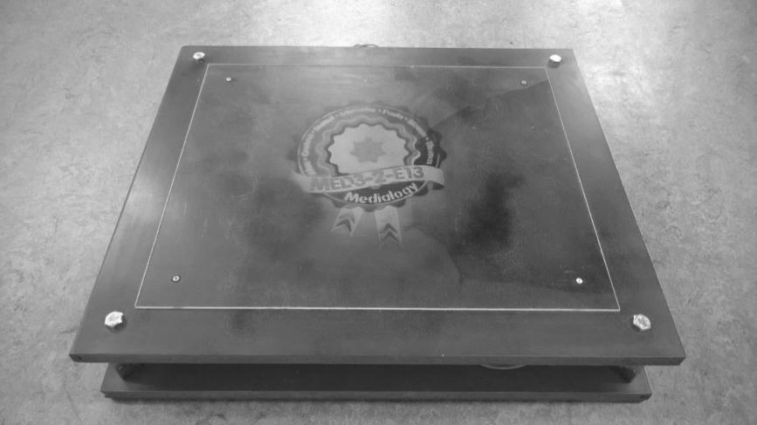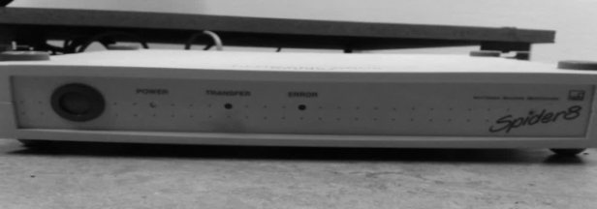

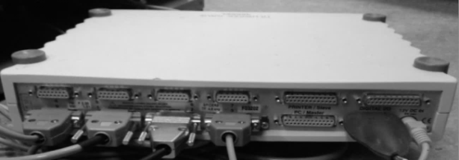

**Figure 2.** Spider 8 data logger and balance board

*3.2 Graphics*

In order to stimulate physical balance, we selected to create a skiing game to immerse the participant in a fun and engaging interactive environment. The game play contains a slide where the player has to avoid obstacles and collect cookies in approximately three minutes, by leaning left or right. The main platform used to construct the environment was *Unity,* with imported models from *Google SketchUp Pro 8* and *Autodesk Maya 2014. Unity* also provided some modelling such as icy mountains, the sky and a snowing effect. Animals, vehicles, buildings, structures and miscellaneous were created and texturized in *Google SketchUp Pro 8* and exported afterwards into *Unity*. The slide was modelled in *Autodesk Maya 2014*. (Fig. 3)

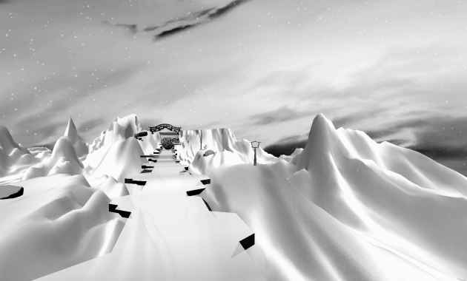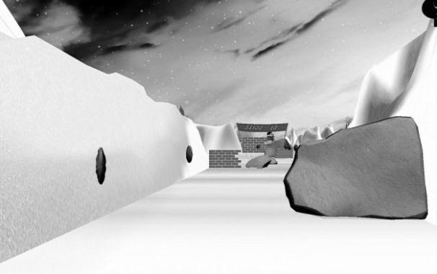

**Figure 3.** Snapshots from the game showing the ski-slide (left) and obstacles (right)

*3.3 Programming*

This section explains how the system components were connected and how they communicate.

As stated in the previous section on graphics, the game was developed in *Unity*, a game engine utilising several different programming languages. The programming languages used for development of our game were *C#* and *JavaScript*. One of the most important factors in the game was to design the in-game movement so it would communicate and respond to the balance board. The skiing-slide was programmed to have 5 lanes where the in-game character could move, each corresponding to a certain pressure value on the balance board. This value was calculated by the following formula; where “a” is the two left sensors on the balance board, and “b” represents the two right ones:

−𝑎+𝑏=𝑣𝑎𝑙𝑢𝑒

As an example, if the participant stands on the balance board and distributes their weight evenly on both sides of the board, the in-game character will remain in the middle lane. When the participant leans to the right or left, the in-game character will move to one of the right or left lanes, depending on how much body weight is distributed on the specific side. This means that the position of the in-game character is directly proportional to the distribution of the body weight on the balance board.

The OR is capable of 360 degrees of head tracking. It was utilized by setting the tracking value proportional to the rotation of the main camera in the game. Therefore, looking around through OR creates the illusion of looking around inside the game. This influences the view when leaning as the camera rotates in the direction the participant leans.

The *Microsoft Kinect* has no effect on the gameplay; however, it serves an important role along with the balance board in data gathering for the testing sessions. The *Microsoft Kinect* records the spine position and returns values on how much the participant is leaning left and right. After the game ends, it automatically creates a comma-separated values (CSV) file from the data received from the *Microsoft Kinect*. This also applies to the balance board where the different amount of pressure is written to a CSV file. These files can be opened in *Microsoft Excel* and converted to graphs, giving an overview of basic stature and weight distribution throughout the game.

# TESTING

This section describes the different testing sessions that were conducted to investigate the research question; how does a VE, displayed with OR affect postural stability. Four tests were carried out, including: (1) Pre-test – the users were asked to complete a questionnaire (2) a feasibility test, where *Microsoft Kinect* and the balance board was used, (3) full system test, where the whole setup was tried out (balance board, *Microsoft Kinect*, OR and the game), and finally (4) an evaluation study of balance-impaired adults.

A comparison test was performed between adults with impaired balance from the rehabilitation centre at *Sydvestjysk Sygehus Esbjerg*[1] in *Denmark*, and the control group. The reason behind this test was to investigate if there were any noticeable differences between the groups when exposed to a VE. This was based on information from the physiotherapist at the rehabilitation centre stating that people with impaired balance can have more intense reactions during the test.

To analyse the data, two types of graphs were created, one for *Microsoft Kinect* data and the other for the balance board data. These graphs were obtained from the CSV files and had two points of reference. The x-axis represents the time interval for each participant (approximately three minutes), while the y-axis represents either the sway-angle registered by the *Microsoft Kinect* or the value of pressure exerted on the balance board. Based on the graphs, patterns were established by evaluating the values, and line fluctuations.

*4.1 Pre-test*

The participants of the control group were requested to fill out a questionnaire (Healthy balance fitness, n.d.). The survey concerned background information, including questions about their physical condition (e.g. weight, height), their life style (e.g. nutrition, sleep habits) and physical activity (e.g. type of exercises and fitness history).

*4.2 Feasibility Test*

The feasibility test was split into two phases and took place at *Aalborg University, Esbjerg*, *Denmark*. The task for the participants from the control group was to perform a set of physical exercises while standing on the balance board. The purpose of this test was to measure the balance of the participants without being exposed to VE. In the first phase participants had full vision, and in the second they were blindfolded. The reason behind including two phases was to explore how the visual system influences physical balance.

*4.3 Full System Test*

The full system test was also split in two phases and took place at *Aalborg University, Esbjerg, Denmark*. The participants were the same control group as in the first test. The aim of the full system test was to explore how VE influences physical balance. The participants had to play the game with the OR and with a monitor display. The two phases of this test were implemented in order to explore the effect of losing peripheral vision.

The participants were split in two groups with the same number of people, to obtain reliable results. The test was semi-randomized, where one group started with monitor display while the other started with OR, to avoid training effects on the results (Horlings et al., 2009). Afterwards, a semi-structured interview was conducted to collect feedback regarding the experience.

*4.4 Evaluation Study of Balance-impaired Adults*

An evaluation study was carried out at *Sydvestjysk Sygehus Esbjerg, Denmark* to compare the data collected from the previous tests. The participants (balance-impaired adults 59-69 years-of-age) performed only the second test. The purpose was to observe if people with impaired balance are more affected by VE than the control group. Six balance-impaired adults were tested, where five of them had a poor heart condition. Due to ethical considerations, physiotherapists, who provided feedback during the session, supervised the test. Afterwards, semi-structured interviews were conducted. The interviews contained different questions: How do you feel about wearing an OR? How was the level of difficulty of the tasks? Did you experience feelings as dizziness or nausea?

# RESULTS

Based on the interpretation of the graphs and the information from semi-structured interviews and questionnaires, the results from the testing session will be presented in this section.

## Pre-test

The results from the pre-test indicated different life-style aspects. Regarding the alcohol consumption, five out of eight participants drink alcohol on a weekly basis. Only one participant is a smoker and six participants are physically active, while the rest are sedentary. Regarding their physical fitness level, a scale from 1 to 10 was used to describe it, where 1 means poor level and 10 means good level. It indicated that the average score for the physical fitness level was 5.88.

## Feasibility Test

The data from the *Microsoft Kinect* and the balance board indicated that six out of eight participants had more fluctuated graphs while performing the set of tasks blindfolded.

In Figure 4 and 5, based on the data received from *Microsoft Kinect*, the graphs show an example of a participant performing the tasks blindfolded and with full vision. When blindfolded, the line is fluctuating between seconds 17 and 20 (estimated time), as opposed to the full vision graph, where the line, registered in the same amount of time, is stable.

**Figure 4.** *Microsoft Kinect* data of the angle of sway when blindfolded **Figure 5.** *Microsoft Kinect* data representing the angle of sway without blindfold

## Full System Test

Based on the graphs, six participants experienced higher degree of sway when being exposed to a VE through the OR, when compared to playing the game on a monitor display. From the semi-structured interview, seven out of eight participants confirmed that it is harder to play the game with the OR; while one said that there is no noticeable difference. Furthermore, six participants stated that, in a matter of balance, it is not safe to use the OR and they felt they lost control over their body. When the participants were asked if they felt any kind of dizziness or nausea while playing the game with the OR, five of them expressed they could not feel anything, while three were mildly affected by motion sickness.

* 1. *Study of People with Impaired Balance*

The results from the rehabilitation centre at *Sydvestjysk Sygehus, Esbjerg* indicated thatfive out of six participants experienced higher degree of sway while playing the game with the OR. This is included in the next section discussions.

# DISCUSSION

In this section multiple assumptions are presented based on the analysis and the results obtained. The different phases of the study, its limitations and contribution to the field are discussed.

Results from the different phases of the test revealed that full vision is essential in maintaining postural stability, as the majority of participants were affected by losing it. The feasibility test showed that the balance was significantly affected when performing tasks blindfolded. Concerning the graphs, the lines tend to be more fluctuated when the participants executed the tasks blindfolded. The results from the full system test indicated that the adults felt more confident about playing the game on the monitor display. The line is more fluctuated while the control group was playing the game with the OR. The balance-impaired adults presented the same tendency to lose balance when exposed to a VE.

If the peripheral vision is diminished, the balance will be affected negatively as Horlings et al., (2009) discovered in their work. However, it is uncertain which factor influences the balance negatively: the loss of peripheral view induced by the OR or the game play. Even if the participants stated, after playing the game, that the level of difficulty was easy, they still had difficulties maintaining their balance. This may lead to the fact that the distortion of peripheral vision was the main factor influencing balance.

From the data collected, there were some contradictory points from different participants. One of the control group participants presented more postural control while using the OR. The reason can be that the participant’s balance is more dependent on the other sensory systems that affect balance, i.e. vestibular and somatosensory (Redfern, Yardley and Bronstein, 2001).

There are several risks involved when being exposed to a VE. Wenzel, Castillo and Barker (2002) testified in their work that problems such as eyestrain, headache, nausea and dizziness are potential symptoms while or after using a HMD. These symptoms appear as a common effect of the contradiction of sensory systems. This is called motion sickness, as stated by Cobb and Nichols (1998). In this matter, the findings indicated that five out of eight participants did not present any symptoms of motion sickness. Still, three participants were feeling dizzy or nauseated during or after playing the game with the OR.

According to the physiotherapists who supervised the test, the impaired-balance adults should have presented more postural instability due to their age and the poor heart condition. However, the results revealed that there were no significant differences between the groups, when exposed to a VE through the OR.

*6.1 Limitations of the Study*

By the time this study was conducted, the OR was an innovation of the market and there were limited research and related work regarding this HMD. This made it difficult to evaluate the study in the field of rehabilitation through VE. There were also limitations while using *Microsoft Kinect* as a measurement device, because it only recognized a certain kind of body movements (for example, leaning). This led to corrupted data for two of the participants. Furthermore, the questionnaire was insufficient, since the resource is more life-balance related rather than physical balance related.

*6.2 Further Development*

After the test session from the rehabilitation centre, physiotherapists provided feedback regarding the study. The balance board and *Microsoft Kinect* can be used as sensory devices and the game can be improved. This improvement refers to the physical exercises (concerning the knees and ankles) included in the game.

# CONCLUSION

The main objective of this study was to investigate if the physical balance of young adults is affected by a VE displayed with the OR. It can be concluded that the participants experienced poorer balance while using the OR. Most of the participants had difficulties maintaining their postural stability in a VE. The only notable difference in balance-impaired adults exposed to a VE compared to the control group was that the former tend to be more insecure while playing the game with the OR. Regarding the lifestyle of the participants, it cannot be concluded how it influences physical balance in connection with a VE. Although, it can be concluded that people with impaired balance that suffer of poor heart condition reacted similar to the control group, when exposed to a VE. Concerning peripheral vision, it can be concluded that it is a primordial influence for physical balance. All the participants showed a better postural stability when performing the tasks with full vision and they were physically unstable when blindfolded. The same situation occurred when they experienced the game with the OR.

In conclusion, a VE induced through the OR, has a negative impact on physical balance. The difference between postural stability while using the monitor display compared to the OR is noticeable. It was not proved if the characteristics of the OR were the main cause of the instability. Therefore, further research and testing are needed to conclude if different types of HMDs have the same effect. Based on the feedback received from specialists, the setup can be transformed into a rehabilitation device.

# REFERENCES

Akiduki, H, Nishiike, S, Watanabe, H, Matsuoka, K, Kubo, T, and Takeda, N, (2003), Visual-vestibular conflict induced by virtual reality in humans, *Neuroscience Letters*, *340*(3), pp. 197-200.

Boas, YAGV, (2013), Overview of Virtual Reality Technologies, School of Electronics and Computer Science, University of Southampton, UK, Retrieved from http://mms.ecs.soton.ac.uk/2013/papers/yavb1g12_25879847_finalpaper.pdf.

Cobb, SVG, and Nichols, SC, (1998), Static posture tests for the assessment of postural instability after virtual environment use, *Brain Research Bulletin, 47*(5), pp. 459-464.

Healthy balance fitness questionnaire, (n.d.), Retrieved from http://healthybalancefitness.com/Client_Health_Questionnaire.pdf.

Horlings, CGC, Carpenter, MG, Küng, UM, Honegger, F, Wiederhold, B, and Allum, JHJ, (2009), Influence of virtual reality on postural stability during movements of quiet stance, *Neuroscience Letters 451*(3)*,* pp. 227-231.

Læssøe, U, (2007), Assessment of Postural Control in Relation to Balance and Falls, (Doctoral Dissertation), Center for Sensory-Motor Interaction (SMI), Department of Health Science and Technology, Aalborg University, Denmark.

Motion sickness, (2014), In Encyclopaedia Britannica, Retrieved from http://www.britannica.com/EBchecked/topic/394203/motion-sickness

Nishiike, S, Okazaki, S, Watanabe, H, Akizuki, H, Imai, T, Uno, A, Kitahara, T, Horii, A, Takeda, N, and Inohara, H, (2013), The effect of visual-vestibulosomatosensory conflict induced by virtual reality on postural stability in humans, *The Journal of Medical Investigation, 60*(3), pp. 236-239.

Ohyama, S, Nishiike, S, Watanabe, H, Matsuoka, K, Akizuki, H, Takeda, N, and Harada, T (2007), Autonomic responses during motion sickness induced by virtual reality, *Auris Nasus Larynx*, *34*(3), pp. 303-306.

Peli, E, (1998), The visual effects of head-mounted display (HMD) are not distinguishable from those of desk-top computer display, *Vision Res., 1998, 38, 13,* pp. 2054-2066.

Pollock, AS, Durward, BR, Rowe, PJ, and Paul, JP, (2000), What is balance, *Clinical Rehabilitation, 14(4)*, pp. 402-406.

Redfern, MS, Yardley, L, and Bronstein, AM, (2001), Visual influences on balance, *Journal of Anxiety Disorders*, *15*, pp. 81-94.

Reed-Jones, RJ, Vallis, LA, Reed-Jones, JG, and Trick, LM, (2008), The relationship between postural stability and virtual environment adaptation, *Neuroscience Letters,* pp. 1-6.

Viire, E, (1997), Health and safety issues for VR, *Communications of the ACM, 40(8)*, pp. 40-41.

Wenzel, BM, Castillo, AR, and Baker, G, (2002), Assessment of the Virtual Environment Safe-for-Maintenance Trainer (VEST), pp. 1-19.

Winter, DA, (1995), Human balance and posture control during standing and walking, *Gait & Posture*, *3,* pp. 193-214.

1. Sydvestjysk Sygehus Esbjerg is a hospital located in Esbjerg, Denmark.