Lost in Transit
Ida Sofie Gøtzsche Lange
Lea Louise Holst Laursen
Claus Lassen
Ole B. Jensen
Department of Architecture, Design and Media Technology, Aalborg University

Abstract
The article addresses what happens, when an inhabited place obtain the properties normally connected with transit. The article explores a particular place in Denmark that is heavily influenced by transit, namely the town Hirtshals situated in the northern part of Jutland. The purpose is to gain knowledge about how such place and transit mobility influence each other. Theoretically the article analyses the case as a critical point of contact (Jensen, Morelli 2011). Methodologically this is done by exploring four influential layers: History, Flow, Materiality and Meaning. Based on this the article argues that an unbalance within the layers exist which negatively influence the functionality and experience of the place. Through an empirical and ethnography exploration the paper seeks to expose how a town primarily characterized by goods transportation and ferry transit is being challenged on its capacity to be a ‘place’ to live and of social importance to its inhabitants. The paper raises the key question: Can a place become too well connected and this in such a manner that its identity and key character becomes ‘lost in transit’?
Keywords: Critical points of contact, transit, mobilities, periphery, place

1.0 Introduction
“Issues of movement, of too little movement for some or too much for others or the wrong sort or at the wrong time, are it seems central to many people’s lives and to the operations of many small and large public, private and non-governmental organizations” (Urry, 2007, p. 6).
Thinking of Transit Places, the first sites that comes to mind will probably be airports, train stations and motorways. Such places are overall mono-functional with the embedded rationales of people’s desires to move (themselves or goods) from one place to another. Often different service functions and commerce are added to such places facilitating the accomplishment of comfortable and easy transit. Apart from those being in transit, people do not visit these places and apart from those working at such transit places, people do not stay for longer periods. Certainly people do not live or spend the whole of their daily lives here. This is on the contrary what many people do in cities and towns – places where people live, work and stay, and that they purposefully visit in their spare times. The article explores a particular place in Denmark that is heavily influenced by transit, namely the town Hirtshals situated in the northern part of Jutland and the article addresses what happens, when an inhabited place obtain the properties normally connected with transit.
The case of Hirtshals is one of several Danish peripheral cities experiencing a decreasing population. Over the past 12 years Hirtshals has lost nearly 12 percent of its population, falling from 6764 inhabitants in 2002 (Hjørring Kommune 2010) to 5959 inhabitants pr. 1st of January 2014 (Danmarks Statistik 2014). In 2010 Hjørring Municipality made a report on the inhabitants within the municipality. One of the main conclusions states that the biggest fall in population will happen in rural districts of the municipality and in the town of Hirtshals, which (for now) is the second largest town within the municipality. The report shows a municipal projection for the population in Hirtshals which continues the present decrease, predicting the number of 5908 inhabitants in 2026. Comparing earlier projections from the municipality of Hjørring with reality this can even be argued as an optimistic projection, as they had expected 6100 inhabitants in present year 2014 – 141 persons more than it turned out (see below).
On the other side, there is a large amount of mobility passing through the area in the form of tourists, business travelers, cargo and offshore industry, and Hirtshals has a national highway, and ferry connections to a number of Nordic countries. In addition, one of eight Danish transport centers (FDT, 2013) is located at Hirtshals which functions as a strategic hub that connects the infrastructure on land and port operations at sea. Thus, the port of Hirtshals is growing, both in the form of vessels, cargo and passengers flowing through. Recently, two large cruise ferries were added to the regular service from spring 2013, which has created 300 new jobs in operations, sales and service (Danske Havne, 2013). More than 90 companies in the port participated in a study on the ports business economic impact on Northern Jutland. The study documents, among other things, how Hirtshals create 2723 jobs - the operation of ferries and tourist-related activities around the port such as guided angling trips are not included. So with this in mind, the number of jobs associated with the port of Hirtshals is even greater (Hirtshals, 2008).
Thus, this article seeks to explore this relationship between growing mobility and declining population asking the question: Can a place become too well connected and this in such a manner that its identity and key character becomes ‘lost in transit’? The purpose is to gain knowledge about how place and transit mobility influence each other and what happens when a place is heavily influenced by transit.
Through an empirical and ethnography exploration, the paper seeks to expose how a town primarily characterized by goods transportation and ferry transit is being challenged on its capacity to be a ‘place’ to live and social importance to its inhabitants. From that point of departure the article will first shortly present the theoretical standpoint of place and mobility and offspring to four theoretical layers framing the case analysis. Secondly we will introduce to Critical Points of Contact as our methodological approach to the case of a port town, followed by the methods used for analysing the case. Thus, the article analyses the case of Hirtshals as a critical point of contact (Jensen, Morelli 2011) through the exploration of four influential layers: History, Flow, Materiality and Meaning. Thirdly, the analysis is presented through the four theoretical layers, ending the article with a conclusion and short discussion. Based on this the article argues that an unbalance within the layers exist which negatively influence the functionality and experience of the place.

2.0 Theoretical concept
Theoretically, the article explores the relations between transit and inhabited places with a point of departure in ‘the mobilities turn’ (or ‘the new mobilities paradigm’) (Urry 2007; Cresswell 2006; Adey 2010; Jensen 2013). This theoretical movement invitees us to understand places and people and the relationships between them from a 'mobility perspective':
“[...] a clear distinction is often drawn between places and the people travelling to the places. Places are seen as pushing or pulling people to visit. Places are presumed to be relatively fixed, given, and separate from those visiting. The new mobility paradigm argues against this ontology of distinct `places' and `people'. Rather, there is a complex relationality of places and persons connected through performances“ (Urry & Sheller 2006).
According to Jensen (2009) this new way of thinking implies a ‘relational and mobility-orientated sense of place’ (see also Massey 1991 on relational place theory). The relational understanding of place that is inherent to the mobilities turn points in the direction of a network understanding of the contemporary city (see Jensen 2013: 30-35 and 2014:190-194 on the contemporary network city). Within this framing, the notion of mobility/immobility and the idea of ‘switched on’ and ‘switched off’ localities make it meaningful to speak of places as connected or disconnected within larger networks. The specific places within such networks are then defined by their relations and thus by the connections. This feature is what we aim to capture by the theory of ’critical points of contact’ (CPC) in the following analysis (Jensen & Morelli 2011). A CPC is a node
“that connect and work as meeting points between systems that makes a difference. Some points of contacts are more interesting than others and this is what makes them ‘critical’” (Jensen & Morelli 2011, p. 38).
The notion is conceptualizing places as nodes within socio-technical networks and with a multi-scalar understanding:
CPC’s may host human-human interaction, but are to the same extent seen as assemblages of human-nonhuman interactions within semiotic as well as material layers of connected or disconnected networks at multiple scales from the very local sidewalk to the global flight corridors (Jensen & Morelli 2011, 39)
This means that the theory of CPC articulates a networked, mobility-oriented and relational understanding of place. However, as Cresswell (2006) points out, the notion of networks, nodes and mobilities are often presented to us in abstract form as spatialities outside history. This can be exemplified by the fact that places of transit such as freeways, airports or harbours often have been described as pure ‘spaces of flows’ Castells (1996) or as non-places (Augés 1995). This understanding highlights transit places as ahistorical and non-traditional space of travellers (Cresswell 2004:46) opposite to rooted and historical places. Opposite to this understanding, in his analysis of Liverpool Airport, Aday (2006) shows that even one of the most iconic non-places, such as the airport, cannot be understood as purely ahistorical and interstitial spaces disconnected from sociality. Even transit places such as airports are embedded within the times, spaces and uses from which they are produced and consumed (Adey 2006). Following Adey, in this article we therefore stress that transit nodes can not only be studied as transport networks, we must also consider what goes on within them (2006:333). This means that CPC not only consist of various forms of flows and networks but they are also produced and reproduced within a number of global-local features, interests, logistics, culture, history, place-identities etc. At the same time a transit node is a physical and experienced place that specifically affects our senses, whether we rest, move around the harbour, work there, or just move through. The article will therefore in the following focus on the Port of Hirtshals through the theory of CPC and in relation to this analytical focus, particularly on the layers of Flow, History, Materiality, and Meaning. In the following section the methodical approach associated with this research design is presented.

3.0 Methodology: Critical points of contact
The chosen layers of History, Flow, Materiality and Meaning are elements which in general are highly present in urban places and other layers of focus could have been added to display the CPC even further. However, due to practical conditions we have concentrated on the four most prevailing layers found in the display of the port town Hirtshals.
The layer of History concerns the genesis of the port town and the reasoning for its existence. The layer of Flow covers infrastructural movements of people and goods, comprising the experience of travelling through the port town. Materiality as a layer deals with the physicality of the place; thus the expression of the architecture and built environment. Finally, the layer of Meaning concerns with the identity of the port town, seen both from visitors and locals points of view. All together, the layers constitute the whole port town, se figure 1.
Each layer has been analysed due to different methods suitable for the objectives of the layer. It is important to stress, that each study did not only produce knowledge for one theoretical layer, but often for several; e.g., there can be found elements of materiality in the study of history, elements of meaning in the study of flow etc. Yet, clear theoretical distinctions have been made, dividing and scoping the analysis conducted with the methods chosen. In the following the different methods used will be presented shortly.

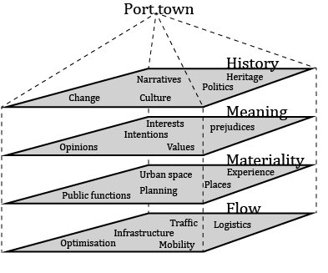
Figure 1 - Methodological model of understanding
Concerning the analysis of the layer of History, the material stems from document analysis of old plans and aerial photographs. The document analysis is conducted with a hermeneutically inspired approach (e.g. Jensen 2007; Kvale & Brinkmann 2009) meaning that plans and photos have been undergoing interpretation within the theoretical understanding of the situation. Furthermore, the analysis is based on statistic material from the Danish Bank of Statistics, featuring yearly population figures as of 1st of January.
Further, to be able to answer how flows affect Hirtshals it has been relevant to address the crux of the matter and investigate the specific mobility, materialized as transit. To gain a broad view of how such transit is performed and experienced, a survey has been conducted, asking (a) traveling tourist and (b) business travellers about their knowledge of, relations to, experiences of and opinions on Hirtshals – as a town and/or transit place. The analysis of flows is conducted through two questionnaire surveys conducted in Hirtshals in the summer 2013; one aimed at tourists, commuters and other leisure travellers and another targeted at business driving.
Annually more than 2.2 million passengers travel by ferry to and from Hirtshals, but what all these travellers really think of Hirtshals and North Jutland, has so far been an underexposed area. Furthermore, the port's cargo turnover increases year by year, now turning over more than 1.5 million tons of cargo annually, which equivalently means that more and more professional drivers are going to and from Hirtshals with at least one stop at Hirtshals Transport Centre. Therefore, the aim has been to focus on what the traveller thinks about Hirtshals - what kind of experience you get when you travel to or through Hirtshals.
It is important to emphasize that the focus of the questionnaire surveys is an ‘external gaze’ at Hirtshals and the aspects of traveling through Hirtshals, and therefore cannot say anything about either the municipality’s, the port’s, the city’s or the local citizens' perceptions and experiences of the same journey. The goal was to gain insight into the overall travel habits, attitude profiles, sociological profiles as well as experiences of Hirtshals and the specific travel by these non-local travellers with the aim to identify possible problems and potentials associated with these trips.
The surveys has resulted in a quantitative amount of empirical data for statistical analysis, but as to the character of the questions asked providing additional explanatory responses, the survey has to a large extent also provided qualitative responses.
The layer of materiality is analysed based on physical mappings conducted in Hirtshals over the past 1½ year. The mapping presented here can be categorized as structural mappings; investigating the spatial organization of the town by making simplifications in order to “read” the urban fabric, as these simplifications make it easier to embrace the complexity of the urban fabric. In this article, this simplification is conducted through a triad division of the town into built structures; open structures and infrastructures. Thus, the respective layer is isolated and thereafter compared with the others so that general patterns become obvious (De Geyter, 2002). Dividing the urban fabric into these three layers are a common organization within urban design among others seen in Kiib and Marling (årstal), Xaveer de Geyter Architects (2002) and Gottmann (1978, in Madanipour 1996).
The spatial analysis is in this paper conducted similar to the twofold analysis conducted by Xaveer De Geyter Architects; looking at the area from above and from below. This relates to Michel de Carteau and his thoughts about how people can relate to the urban in two perspectives: 1) the view created through movement through the urban and 2) the view from above looking down at the urban structures from a skyscraper (Nielsen 2000, 23). Thus, from above maps is conducted that objectively is describing what is there within the different layers whereas from below a “subjective” series of photographs of the three different layers captures the more specific and detailed conditions of the respective layers.
Empirical material for analysing the fourth layer, meaning, is collected through interviews of two specified sorts. One is be the ‘semi-structured lifeworld-interview’, defined as an interview “designed to obtain descriptions of the interviewee’s life-world in order to interpret the meaning of the phenomena described” (Kvale, Brinkmann 2009, p. 19 - own translation). The other is ‘expert/elite interviews’ (Kvale, Brinkmann 2009, p. 167) with people of central positions in Hirtshals. Interviewees are people, who are both local citizens in Hirtshals or neighbouring towns, and key actors in and around Hirtshals such as politicians, decision-makers within the planning department of the municipality and key business owners and other representatives from the business world, from retail and from the tourism industry. In the first part of the interviews, the interviewees have been asked as private persons being citizens in the local area, and in the second part asked as experts in their respective fields. Thus, the interviews have provided the analysis with valuable knowledge about the management of Hirtshals as well as more personal narratives drawing diverse pictures of Hirtshals as both a location and a mobility hub.

4.0 Analysis of the port town

4.1 History
Firstly, the article explores the layer of history. European cities and towns are often recognized as ‘old’ places with urban settlements dating back to medieval times and often further back in history. Thus, it would be a reasonable assumption to believe that also Hirtshals is such an old settlement which over time has grown into the town it is today. This is not the case, on the contrary; Hirtshals is a surprisingly young town founded in the first half of the 20th Century.
Development of a port town
In 1917 a law was enacted by the government that new fishing ports should be built at two strategic sites on the north-western coast of Denmark, one of them being the then desolate location called Hirtshals. To facilitate the port, a town would naturally materialise, but in order to handle the growth and development of such settlement a town plan was requested. The first drawings of a new town were made due to an architectural competition in 1919 where the famous Danish architect Steen Eiler Rasmussen together with architect Knud Christiansen were announced as winners. For the next five years they refined their ideas into a master plan presented in 1923. The plan was modern and built on a simple traffic diagram: a main road entering from southwest, a train track entering from southeast and a ‘blue path’ with the possibility for ships to enter from the north. Where these three modes of transportation met, an infrastructural centre would create the perfect conditions for a whole new town to flourish. The functionalistic plan followed straight axises and wherever centre-lines in the plan would meet, a square for a certain purpose was laid out. The infrastructure divided the plan in demarcated areas for different purposes: settlement of fishermen, other residential neighbourhoods with villas, an area for factories and one for rail road activities.
It is evident that mobility was seen as the main generator for this urban development. The plan was efficient with every road going straight from A to B. Though it is not the full plan that has been carried out, the functionalistic structure is largely recognized in aerial views of Hirtshals today.
The town grew rapidly up through the 20eth century, and by the municipal reform in 1970, Hirtshals became the administrative centre for the municipality. The town and the municipality kept growing until peeking in 1996, where the town of Hirtshals was inhabited by 7009 people and municipality accommodated 14729 persons. But from this year on the population has been decreasing and at a much higher pace than it was increasing before.
Table 1
Inhabitants of Hirtshals, intervals of 10 years before and after the peak in 1996
1976 | 1986 | 1996 (peak year) | 2006 | 2014 | 2016
6838 | 6898 | 7009 | 6475 | 5959 | ?

As contradistinction to the decreasing population, the activities and amounts of jobs related to the port have continued to increase. This growth even manifests itself physically, as the area of the port keeps expanding while the town stays the same size.
Summing up, Hirtshals is a relatively young town with its port as basic subsistence. The layout of the town plan is expressing a functionalistic approach favouring efficient transportation between the main nodes in the area. In the development of the town, less effort has been made to create places for everyday life experiences, casual encountering and local atmospheres. Where most European towns have had centuries to slowly develop and settle down, Hirtshals may be described as a token of a hasty history.

4.2 Flow
Secondly, the article explores the layer of flow. The city is infrastructural well connected to other parts of Denmark and Europe with direct ferry connections to several places in Norway, the Faroe Islands and Iceland, with direct motorway link to Germany and elsewhere in Europe and a modern rail connection to the national rail network. With regard to the Danish conditions, Hirtshals is located far from Copenhagen, the capital of Denmark, and according to the Ministry of Housing, Urban and Rural Affairs, the Parish of Hirtshals is a part of the so-called peripheral Denmark (Ministeriet for By, Bolig og Landdistrikter 2013). However, in spite of this ‘peripheral’ location, Hirtshals is highly accessible. The motorway system in Denmark, which is formed as a big H, stretches its left arm directly to Hirtshals. Thus one can drive all the way from Aalborg (the fourth largest city in Denmark in terms of population) to Hirtshals in 40 minutes (66 km.). Furthermore; one of the eight transport centres in Denmark (FDT, 2013) is located on the edge of Hirtshals, at the entrance to the city from the south. The transport centre is a strategic node for connecting the infrastructure on land with the port activities and ‘the leading commercial port in Northern Denmark’ (Hirtshals Havn, 2008). The transport centre includes customs clearance, freight forwarding companies, truck diesel, and fuel for cars, service outlets and a kiosk. These are facilities for servicing the transport industries as well as private cars. Furthermore the centre includes a chauffeur lounge, sleeping rooms, bathroom facilities, offices, conference rooms, a tourist office, a café and a kiosk (HTC, 2013). The Association of Danish Transport and Logistics Centres, FDT expects that in the long run there will be train connection directly to the centre in Hirtshals (FDT, 2013). And the Port of Hirtshals has already hooked up to the rail system. With connections every half hour in the morning, afternoon and evening, and every hour in the very early morning, in the late morning and in the late evening, it takes 22 minutes to commute between Hirtshals and nearest large external labour market (NT, 2013).
Survey of the travellers
The port generates an increasing amount of flows of both goods and travellers. The survey, which was carried out among the travellers in 2013 at the Port of Hirtshals (see above), shows that in general the typical traveller through the port of is a Norwegian tourist between 41 and 65 years, man or woman, traveling with family in a car, has a medium/or long-term education, an annual income of 300,000-500,000 Danish kr., and most live in a detached house. Most other travellers come from Germany, Denmark and the Netherlands.
The survey shows that 34% of the travellers have visited the town, and that it is mainly travellers from "other countries" and from Norway who have paid the town a visit. It also shows that Danes and Norwegians know the local area's attractions the best, while the Germans and the Dutch, to a lesser extent, know what North Jutland has to offer. Germans and "other nationalities" have the greatest demand for "more information about the area," while especially Norwegians and Danes have a greater knowledge of the town and the area. The Danes belong to the group with the best knowledge of the town, but at the same time they are the least likely to visit the city. The study also shows that especially the Dutch and the Germans, in different ways, attach importance to nature experiences. In relation to this, there seems to be a potential to highlight the nature that is "hiding" behind the town (see below) in order to attract more Germans and Dutch people to the town and the area around it.
The survey indicates that Hirtshals works well as a transit hub. The majority of the surveyed travellers were positive/neutral about their experience of arriving at Hirtshals. A further look at the more elaborated answers emphasizes the experience of transit, and also points to an important point, namely that Hirtshals as a town disappears in all the transit: most qualitative statements deal with the elements of infrastructure (road, highway, entrances and exits, signage and even the punctual trains) while the city, in the few cases mentioned, is described as dull and not inviting for a tourist. A German emphasizes that he has not seen Hirtshals, since the road only just headed directly to the port. Figure 2 shows a selected number of qualitative responses, stressing the same point.
Figure 2
This means that the survey reveals an image of the town, where most travellers associate the area with transit and thoroughfare. The study also shows how 65 % of the words that travellers associate with Hirtshals are related to port / infrastructure, while only 17 % have to do with city/tourist. In relation to this it is also interesting to note that less than 2% of the travellers perceive the town as a commercial town. Nevertheless, the survey also shows that about half of the travellers answered “yes” when asked whether they could imagine visiting the town of Hirtshals during a future holiday. Diving into the reasons for this offhand positive response, it is important to notice that many see this as part of their transit, for example: “Yes, but only as thoroughfare.” Others want to visit the North Sea Oceanarium (the biggest aquarium in Northern Europe) or pay a visit to the beaches. Many of the respondents, who answered "no" to the question, elaborate, often with exactly the same terms as the positively inclined respondents: transit, thoroughfare and ferry destination. Figure 3 shows a selected number of qualitative responses from the survey that emphasize this point.
Figure 3
Concerning the business travellers, the survey shows that since the Transport Centre was established in 2008 more travellers more often choose the route through Hirtshals, and that they experience greater comfort. At the same time the journey become more efficient for them. The transport centre has meant that 33 % more travellers than before now meet more frequently with national and international colleagues. Conversely, the establishment of the transport centre has resulted in that 37% experience the stay as dull compared to the past and that they less often are visiting the town and know less about what is going on in Hirtshals than before. This has, at the same time, strengthened Hirtshals as a transit town, but weakened Hirtshals’ chances of being seen as a town and a place with a history, culture and relationships with the surrounding area.
In summary, it can be noted that the Port of Hirtshals creates jobs and development not only in Hirtshals but also in the rest of the municipality and in northern Jutland. However, the port also contributes to creating a town based solely on transit seen from the perspective of the travellers. The survey results show that few travellers perceive Hirtshals as a place. Therefore it is not surprising that the port is developing, while the town is declining. Hirtshals can be seen as a ‘terminal town’ which, like an airport, has the right infrastructure to facilitate a large movement of people and goods. But as the survey of travellers also shows, Hirtshals is only to a lesser extent a place where people will want to, or are able to, make a stay.

4.3 Materiality
Thirdly, the article explores the layer of materiality through the layers of open structures, built structures and infrastructures, putting forward the town of Hirtshals’ physical and spatial characteristics.
Infrastructures
The first layer to be explored is that of infrastructure. The infrastructure is a dominating structure in Hirtshals, which corresponds with the original plan of having the infrastructure to be the overall structuring element (see above). The roads within the town is very wide, the main roads measure approximately 12-16 metres and the suburban streets 8-10 metres, including pavement in each side. But in many cases the space of the roads are not defined by built structures as parking spaces, front gardens and paved private areas extend the open spaces of the roads. Thus, the space around the main roads often measures 20 metres or more, and the suburban streets often 15 metres or even more. Further, coming to Hirtshals by car the normal route would be coming from south by the motorway. Here connection with the ferry and the good accessibility to the ferry terminals overrule the connection to the city; thus, the direct way leads you directly to the ferry terminal whereas the city is reached by taking a road exit.
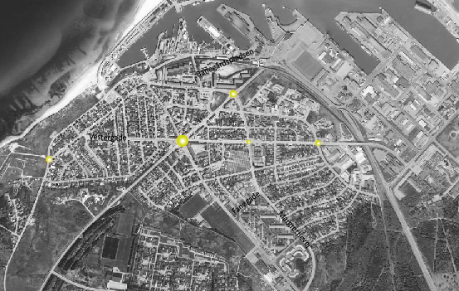
Figure 4 - Hirtshals has no less than six roundabouts distributing the wide and straight streets.
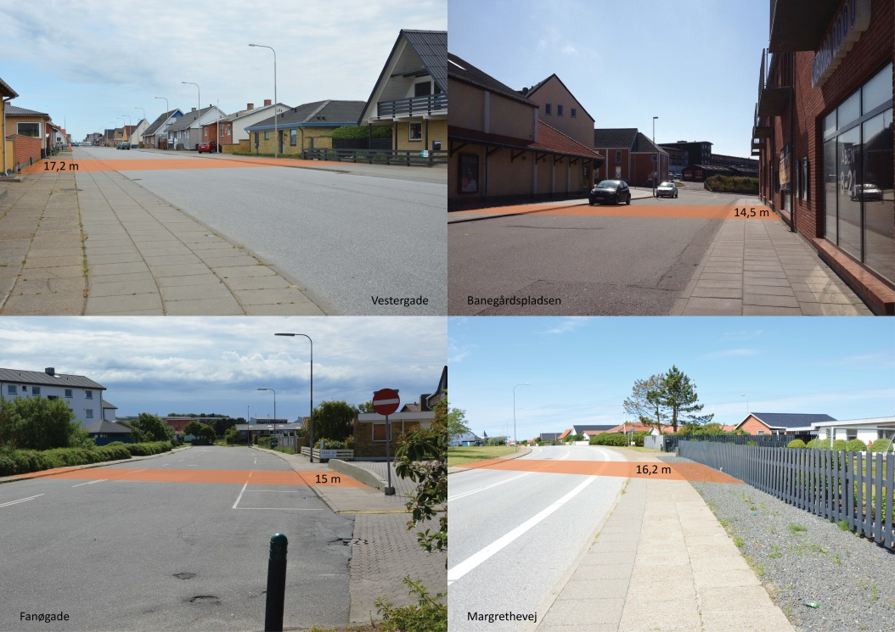
Figure 5 - Width of selected streets of Hirtshals (see also figure 4)
Open structures
In addition hereto the town entails rather many open areas of no or limited use. These areas are mostly overgrown plots waiting to be either settled with houses or designed as intent recreational space. As for now these areas appear as left over spaces leaving the urban fabric unintendedly perforated. In addition to these areas, large parking lots leave further gaps to the built environment. Further, the city has a few public spaces/squares (marked yellow in Figure 1Figure 6) were different activities takes place. They are mostly situated in the inner town close to the pedestrian lane and the shopping and leisure area of the city. Their use and character changes throughout the year, where they in the summer are used for outdoor cafes and cultural activities, they appear more abandoned and unused in wintertime.
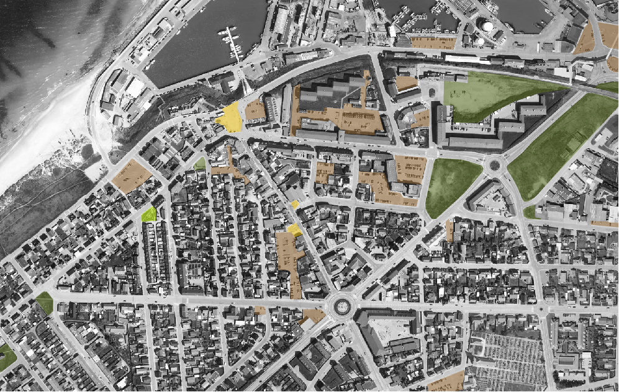
Figure 6 - Large open areas perforate the urban fabric; especially parking lots (red) and overgrown left over spaces (dark green). Few squares (yellow) and parks (light green) add to the open structure of the town.

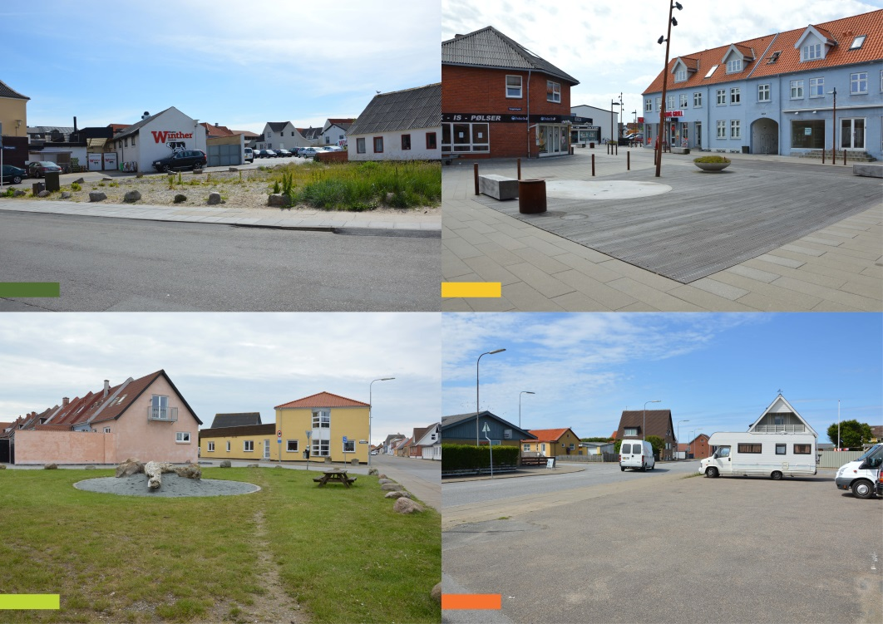
Figure 7 - Four of the smallest open structures characterizing Hirtshals

Built structures
The final layer is that of built structures which in Hirtshals is characterised by mostly low density single family houses and two-three story apartments. The town has its most dense area around the shopping street surrounded by single family houses.
Looking at the built structures of Hirtshals an aspect of the materiality influential on the overall expression of the town is the maintenance and choices of building facades. Walking in the inner town many of the shop and restaurant owners have added new facings, pasted unto the original yellow plaster façades. This can be seen as a modern form of eclecticism where the restaurants and shops wish to express their identity through the facings, leaving the general expression of the streets messy and artificial.
Other shops lack maintenance or have covered windows due to close down, leaving a bleak expression to the pedestrian streets. Exploring the residential areas and industrial districts of Hirtshals, similar worn down buildings are found impairing the general impression of the place.
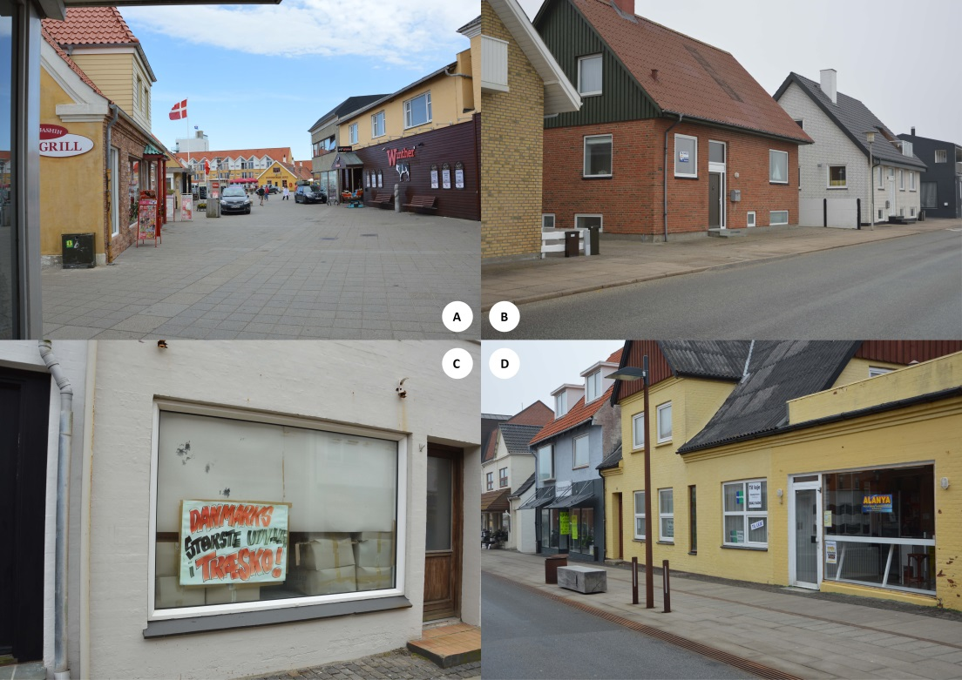
Figure 8 - A: The local butcher has chosen a dark brown wooden frontage with an American ranch look and the Chinese grill has put up a slate facing covering the original, traditional yellow plaster. B: Many houses have sale-signs instead of house plants in their windows C: Window in the shopping street: “The biggest sale of clogs in Denmark”. D: Shop for sale.

Summing up the characteristics of the materiality, Hirtshals can be described as a town with a pragmatic attitude towards planning, visible in the way functionality seem to be prioritized before aesthetics. This way Hirtshals can be viewed as an expression of an un-sentimental materiality.

4.4 Meaning
Lastly, the article explores the layer of meaning. The port is very important for the self-understanding of the citizens of Hirtshals and the neighbouring areas. Consistent in all interviews, the port is evident as main identity for Hirtshals. The following description of Hirtshals shows how the port and the derived infrastructure are fore-grounded whereas the actual town is not even mentioned:
“Well, I'll describe it [Hirtshals] as an active, business-town, that is, where things are really happening, and I will automatically come to talk about the port, automatically, because it is the port that is the magnet for it all - there are some good things [up here], that is, we are happy that we got the motorway this far north, to Hirtshals, and then we have a nice 4-lane road the last 4 km, down to the port, and that is what today causes that shipping companies and hauliers, forwarding agents and all the sorts, now stands in line to be allowed to cross this way over here, because the infrastructure is all just fine!” (Male, 61, local citizen and politician)
Not only is the port important for Hirtshals as a place for business and money-making, it is the dominant setting for leisure, experiences and childhood memories. Many local citizens have parents or at least family who work or have worked at the port, and to them the port is encoded with sensory perceptions and great impressions.
Next to the port, nature is identified as a main attraction and asset for locals and visitors. The nature is rough and exposed, hardened to withstanding the elements. The ocean is for all interviewees number one (partly connected with the port), and beaches and steep dunes follows. From the interviews, descriptions of the landscape often link to descriptions of the mentality and physical environments of the town.
“The best thing [about Hirtshals] is .. well, it is the nature up here. This rough and open landscape which Hirtshals to a degree represents.” (Male, 54, newcomer and sculptor)
The nature and the opportunity to move away and find peace to work was the main reason why this interviewee settled on a closed down farm 20 km from Hirtshals, and not in the town:
“... it is the nature here, right. But Hirtshals has it to a degree as well, this rough, unsentimental nature, just like you could say, the town [Hirtshals] is unsentimental, right!” (Male, 54, newcomer and sculptor)
A brute town
The elements that interviewees like to emphasize are the port and the nature around Hirtshals. Talking about the very town, especially the inner town is inflicted with negative connotations. Hirtshals has a name for being a brute environment, and even though the locals believe, that it has changed to a much more peaceful atmosphere, external citizens are still holding to the meaning of Hirtshals as a brute and unsafe town.
“I worked on the cargo exchange some years ago - in Hjørring. And we were going to throw a party. And then I said, I could host it, and then we could go out in the town of Hirtshals. They simply did not dare! [...] They have such an idea that they will get beaten op in Skipperkroen (local tavern), but of cause they won’t” (female, ??, local citizen and accounts assistant, Port of Hirtshals)
“It was a tough milieu. It was such a, eh, well, there was something ‘Klondyke’ and ..wild west about it. [...] So ... maybe, there can be some social in it as well uh, it's hard to draw people here because, Hirtshals has sometimes had a bit of a bad reputation, so ... also in the neighborhood and where they said; well, they all just want to fight, and stuff, and it is not true, it's very peaceful , it's today! Of cause, there are many good stories from the old days, but today it is very peaceful here.” (Male, 61, local citizen and politician)
It comes clear that the more locally engaged interviewees express more positive meanings of Hirtshals, for instance finding the un-refined build structures and public areas ‘authentic’ whereas the interviewees living in other places feel less convinced of the local atmosphere. Furthermore, the talk of the town where they come from tells the story of an intimate local community, difficult to take part in. Living in Hjørring but working in Hirtshals at the port, this interviewee does not perceive Hirtshals as an honest residential area:
“For holiday housings, yes. But it's not the same. Again, personally I would probably not move down here. I see there are some nice elements in it, ehm, because it is located close to the coast and..but I just could not see myself living down here. And I also think that's what the problem is, I think that is their struggle; there are many who see them as a resort town, but you know, I would neither move to Skagen because if you have been to Skagen in the winter, you know what, nothing happens. Everything is just dead. [...] Then I think more it is those who are down here [already] who will stay here [...]. And also again, when you hear it can be hard to get in here.” (Female, 33, living in Hjørring and marketing coordinator at The Port of Hirtshals)
Summing up, the common denominator is on one side the port and the nature as attractive aspects of the town, and on the other side the actual town as unattractive. The meanings of Hirtshals are imposed with the smell of 5 former fishmeal factories and weathered, drunken fishermen looking for trouble.

5.0 Conclusion:
Summing up, the four layers can be described as 1: Hasty history, 2: Transit flows, 3: Un-sentimental materiality and 4: Conflicting meanings. Analysing each layer apart, several findings occur.
Can a place be lost in transit? Filling out the model with key points from each analysis, it really comes clear how the layers have some common characteristics. The hasty history has sowed the seeds of a town, where mobility is in favour of place. This materializes in the transit flows, where the terminal qualities are in front. Further, the un-sentimental materiality of Hirtshals contributes with wide roads, not inviting for walking or staying. And for the somehow messy meanings of what Hirtshals is, the port as main identity overrules any idea of the actual town as an interesting place to visit. In this sense, we dare to conclude that yes, in some ways places can be lost in transit, and for the town of Hirtshals, the issue of too much movement, as expressed by John Urry, might be one of the great challenges in terms of the decreasing population.
Hirtshals is a rational town, expressing the fundamental idea of ‘form follows function’, springing from the first drawings for the new town. It becomes obvious, that the port plays a significant role in the network of physical and mental structures of Hirtshals. So much is passing through, but only little is coming of, influencing the town. If it is not possible to reroute some of these flows, one will become lost in transit.
Appointing the CPC it seems that some layers are stronger than others. Especially the transit flows are strongly influencing the town and leave less space for some of the other layers to improve. The analysis reveals an unbalance between the layers and as the layers of the CPC seem out of balance, so does the place.
Recently, when doing town planning and urban design, another parameter or even discourse is in play: ‘experience design’. People want cities where they to some extend can be surprised, walk around a corner and experience an unforeseen activity or a surprising view. The plan from 1923 was mainly drawn from above, giving only few thoughts on how the city would be experienced from the streets. The study of tourists’ and business drivers’ perceptions when encountering Hirtshals reveal very week ideas of entering a town whereas the experience of an efficient transport node prevail.
Finally, we will make a little reflection towards aesthetics, with a reference to Vitruvius, the roman architect, civil engineer and author behind the multi-volume work entitled “De Architectura” written around 15 BC. In the books he describe what is later known as the Vitruvian Triad, expressing how “a structure must exhibit the three qualities of firmitas, utilitas, venustas – that is, it must be solid, useful, beautiful”. Visualizing his ideas Figure 9 (A), one could say that normatively good, holistic architectural qualities should be able to balance aesthetics, functionality and durability. But, in the case of Hirtshals, the town is based on the two latter with little emphasis on the aesthetics, Figure 9 (B). We believe that this approach is contributing to the undermining of the lived place and supporting the place as being lost in transit.

Figure 9 - Vitruvian Triads - goal and reality

OBS: References are not updated!!!
Adey, Peter (2006) Airports and air-mindedness : spacing, timing and using the Liverpool Airport, 1929-1939. Social & Cultural Geography. 7 (3), pp. 343-363 Abingdon: Routledge, Taylor & Francis Group.
Jensen, O. B. (2007) Culture Stories: Understanding Cultural Urban Branding, Planning Theory, vol. 6(3), pp. 211-236
Jensen, O. B. (2013) Staging Mobilities, Routledge: London
Jensen, O. B. (2014) Designing Mobilities, Aalborg: Aalborg University Press
JENSEN, O.B. and MORELLI, N., 2011. Critical Points of Contact: Exploring networked relations in urban mobility and service design. Landinspektoeren.Tidsskrift for kortlaegning og Arealforvaltning., 46(1), pp. 36-49.
Lange, I. S. G, Laursen, L. L. H. and Lassen, C. (2013) Missing Links, Proceedings from the Annual Transport Conference at Aalborg University
Lanng, D. B. and Laursen, L. L. H. (2014) Urban ´snapshots´ along journey trajectories
Urry, J. (2007) Mobilities, Cambridge: Polity Press
Ministeriet for By, Bolig og Landdistrikter. (2013). Danmarkskort over områdetyper (Regional- og Landdistriktspolitisk Redegørelse 2013 ed.). Ministeriet for By, Bolig og Landdistrikter: Ministeriet for By, Bolig og Landdistrikter.

