Center for Bioscience and Technoanthropology invites to
"Seminar on Science Fiction and what it has to do with Technoanthropology"

Place: Aalborg University Copenhagen, A.C. Meyers Vænge 15, room 1.008
Time: Wednesday, November 1st 2017. 13:00 – 16.30

We also celebrate publishing of this book, which is mainly edited by Christan Baron and introduce some of the content - with a small reception after the seminar.

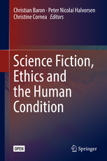 | Explores what science fiction can tell us about the human condition in a technological world, with the ethical dilemmas this entails

Speaker | Topic | Time
Mette Lübeck | An introduction to the Center for Bioscience and Techno-Anthropology and its topics of interests | 13.00-13.10
Tom Børsen | On Techno-Anthropology and Science Fiction | 13.10-13.30
Christian Baron | Science Fiction, Ethics and the Human Condition: an overview | 13.30-13.45
Break | Coffee | 13.45-14.00
Peter Westermann | A Greenhouse on Mars | 14.00-14.30
Christian Baron | The Perfect Organism: the intruder of the Alien films as a bio-fictional construct | 14.30-15.00
Dehlia Hannah | Philosophical Monsters; Thinking with imaginary creatures, places and things | 15.00-15.30

No need to register
- all are welcome

