Auld rock meets Nordic Noir: A Danish gaze on Shetlandic Scandinavian-ness
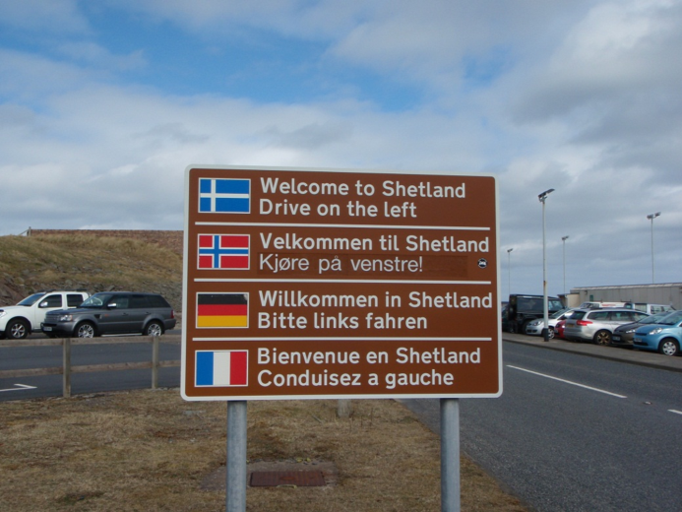
The Scandinavian traveller arriving through Sumburgh is greeted in a homely way. On the road taking drivers out of the airport area stands a multilingual sign, which welcomes voyagers in the four languages of English, Norwegian, German and French. To the Scandinavian the sign is an oddity, signalling at once historical connectivity and geographical distance. For while the choice of Norwegian acknowledges Shetland’s legacy as a nodal point connecting the string of islands making up a Viking kingdom stretching from Bergen to Dublin, any present-day visitor from Nordic Europe will inevitably arrive through British (air)ports such as Edinburgh, Glasgow or Aberdeen, which would be difficult if s/he was capable of managing in a Scandinavian language alone. To provide information in Norwegian seems unnecessary, in other words, leaving one to wonder what exactly is the purpose of the signpost at Sumburgh?

In the present paper we rely on a specific reading of signs, acknowledging their power to create simultaneously a sense of connectivity and distance. Our core concept of connectivity has been inspired by Ulf Hannerz (1996), whose theory of transnational connections acknowledges how, for instance, shared migration experiences, cultural representations, communication and trade networks can inspire in actors the sense of being related to people positioned in a different part of the world. Connectivity builds on a logic of similarity, suggesting that relationships create a feeling of we-ness (Jenkins 2004, Hylland Eriksen 2002), which is reinforced when actors choose to foreground cultural practices, traditions and symbols that seem to link a historic settler community such as Shetland, to Norway, as the Shetlanders’ imaginary ‘land of the fathers’ (Smith 1991, Anderson 1991). Arguably, the Sumburgh signpost is a physical expression of such connectivity where Norwegian, as a linguistic sign, has been selected because this can communicate both a Shetlandic desire to connect with Norway/Scandinavia and a perceived sense of distance, linguistic and cultural, to the British Mainland and Scotland in particular. Distance is the second core concept when seeking to understand Shetlandic representations of Scandinavian-ness. The Norwegian anthropologist Fredrik Barth (1969) has argued that communities can only establish a shared feeling of we-ness by stressing the elements that distinguish them from the what or the who that does not belong to the community. This makes boundary-drawing a key aspect of cultural identification. Borders rely on a logic of difference and may, for instance, be manifest in the form of a physical boundary (e.g. a national border), a linguistic divide (e.g. Welsh vs. English), an emphasis on cultural distinctivity (e.g. the ‘Scottish’ ballad vs. an ‘English’) or alternative readings of history (e.g. Shetland history vs. Scottish history). Boundary-drawing is generally used to ‘manage’ the relationship between particular communities, e.g. Scotland as WE vs. England as THEM or Shetland as WE vs. Scotland as THEM. This causes the present authors to wonder how a Shetlandic attempt to create distance to Scotland by emphasising connectivity to Scandinavia may work for Danes, who have the native’s pride in Nordic tradition and culture, but no similar need to foreground difference from Scotland. It is possible that the Danish spectator will read the Shetland signs differently, seeing an idea of the North that has become detached from its original Scandinavian context and in the process obtained a new meaning. To illustrate how this functions we should like to begin by examining three signs discovered by one author on a Shetland visit in Spring 2013. The signs offer different constructions of Scandinavian-ness, presenting the ‘Nordic’ through names in the landscape, the choice of a ‘Danish’ motto, and the import of a symbol associated with a specific place, the Danish city of Aarhus.

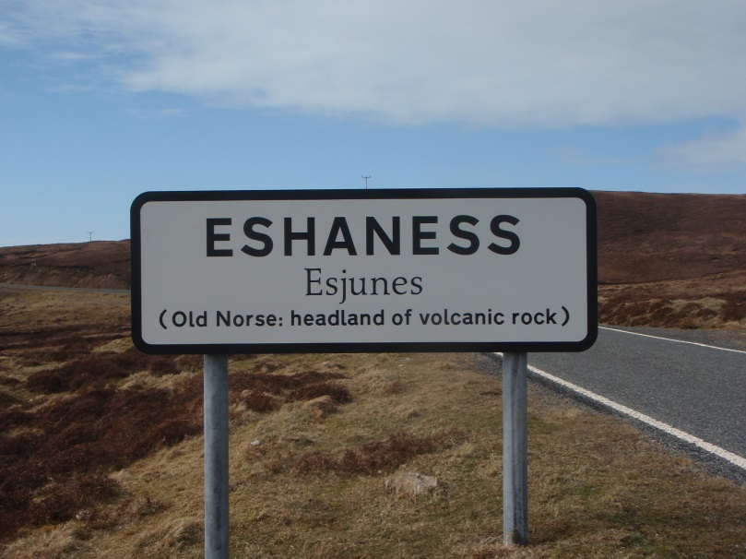
First, we shall look at a road sign situated in the northwestern part of the Shetland Mainland. The sign is bilingual, displaying the present name of the area, what is claimed to be the original, Norse name, and, finally, an explanation in English. Similar signposts can be found all over the archipelago, which creates the impression of a landscape named by people connected to a Norse-speaking homeland rather than the British mainland. To the Danish traveller, the text will invite a comparison with Denmark where numerous locations carry the suffix -ness. Yet the Dane also experiences distance, for geologically this ‘volcanic rock’ is strange, a space that cannot easily be accommodated within the scenery conventionally associated with Scandinavia. Hence, one may suggest that idea of the ‘Nordic’ is carried by naming of the landscape rather than geography itself.
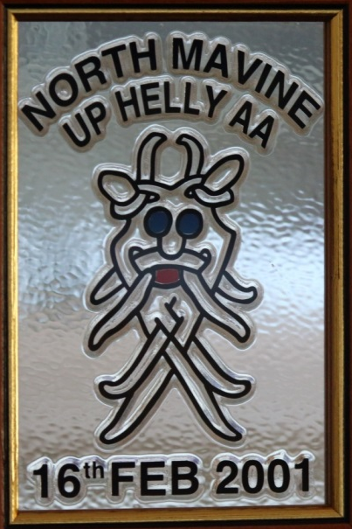
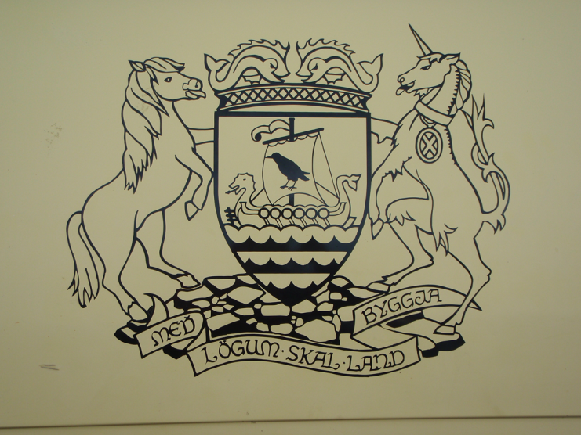
A similar effect of simultaneous connectivity and distance is produced by the second example, which is the coat of arms of the Shetland Council. The rambling Dane will recognise the motto: “Med logum skal land byggja” and probably ask what this is doing in the alien setting that is Lerwick? For the Dane versed in history knows this as the opening line of the historic Jutland Law, dated 1241, which is associated with two sites, the original ‘thing’ in Viborg, Jutland, and the neo-classic building housing the Danish supreme court in Copenhagen. So how did this piece of Danish legal history become exported to Shetland? There is a historic explanation for Shetland was once part of the twin kingdom of Norway-Denmark, which means that the Jutland Law could have applied here. Yet it seems odd to maintain an original Danish wording that few present-day Shetlanders are likely to understand. However, if one reads this as a linguistic sign instead of an actual message, one could argue that the motto is used to signal Shetlandic difference to Scotland, reminding the reader of a legal and cultural history predating the introduction of Scottish law in the 15th century.
The third example is found on a plaque awarded to participants in the Up Helly Aa celebration, North Mavine 2001. The status of the sign is different to the previous examples, produced by members of a local community rather than an official body or institution. The Nordic connection is of a more intimate kind for not all Danes will recognise the symbol, which is known to the people of Aarhus as the ‘Aros Mask’. Apparently, the design was found by the 2001 Guiser Jarl in a book about Old Norse, held in the Lerwick Library. The mask was adopted as the shield symbol for the 2001 Up Helly Aa party, thus establishing a symbolic connection between a Shetland community that may originally have been settled by Scandinavians and a Danish Viking town. It is a migrant symbol, in other words, which in Aarhus carries one meaning, but because it is here relocated in the different context of North Mavine, Shetland, comes to represent a generic Scandinavian-ness, celebrating an idea of Nordic connectivity rather than an actual historic relationship.

The understanding of the ‘Scandinavian-ness’ as a connection constructed from signs originating in an authentic Norse context, but obtaining new meanings once they are carried into a Shetland setting is a central theme in Robert Alan Jamieson’s Da Happie Laand. Jamieson’s fiction is a collage composed of diverse pieces of text, including the ‘I’ narrator David’s personal story, a ‘History of Zetland’, mail correspondences, ‘wiki’ references, and an interview with the last Shetland-born inhabitant in Tokomua, an imagined ‘New Zetland’ in the Pacific. The reader looking for symbolic ‘spaces’ find multiple reference points in Jamieson’s novel, which reflect how the narrators are positioned in/out of Shetland, ‘the North’, Scotland, Britain and the world. But places in the novel are always connected – through travel, conquest, trade, colonisation and immigration – and ambiguous in meaning, marking at once a physical location and a relationship to other places, times and people. In Da Happie Laand Lerwick becomes ‘Larvik’, represented as the entrance point that people pass through on their way to other places. The ‘I’ narrator David arrives in Lerwick on his voyage to Norbie, wondering why his father “chose to go, as far north as he could get in Britain” (p. 18). Others visitors such as the writers Walter Scott and Robert Louis Stevenson find in ‘Larvik’ a meeting place where they can interact with whalers and travellers heading for Greenland, Norway or Denmark (e.g. p. 220). Hence, Da Happie Laand contains the parallel tales of Shetland as ‘ultima Thule’, the faraway place in the North, and Shetland as a nodal point in the North Atlantic trade routes linking Scandinavia with Mainland Britain, Norse settlements in the Faroes and Iceland, and, finally, North America. Jamieson’s renaming of Lerwick as ‘Larvik’ supports our interpretation of a Shetland connected, as this name is associated with Norwegian geography rather than Shetlandic, thus acknowledging a possible relationship between ports located at different ends of a viking seaway. Other Scandinavian place names are Norbie, which carries the Norse suffix –by for township, and Thulay, which at least to many Danes will be known as the northernmost settlement in Greenland (named by the Danish explorer Knud Rasmussen in 1910). Hence, place names in Da Happie Laand refer at once to a physical Shetland setting and locations ‘beyond’ Shetland, highlighting how narrators’ understanding of the landscape depends on their reading position as Shetlanders, Scots, Britons, Scandinavians or ‘New Zetlanders’.

Turning to language, Da Happie Laand containts two stories, which emphasise distance and connectivity, respectively. One narrative is organised chronologically, relating the key events leading to a linguistic ‘Scottishisation’ of the islands. The narrator of our Zetland history explains:
So at the beginning of the seventeenth century, our remote parishioners found themselves in changed circumstances, with a reformed Church of Scotland, Scotch lairds, Scotch Law and every-increasingly, a Scotch tongue around them. Undoubtedly there must have been some Scotch spoken in the islands previously, for commerce alone, along with Dutch or Danish or German, but the Zetlander’s own primary tongue had remained the old Norse speech, with its great store of legend and superstition – yet by 1600 it was no longer the language of power. (pp. 78-79)
Language in the ‘old Zetland’ story is used to signal difference between Norse and Scots as we see, for instance, in the example of ‘Daldmana Thulay’, the last Thulay speaker of Norn, who insists that “he spoke English poorly” (p. 288). This part of the story comes to a sad conclusion, with the eventual ‘death’ of the Norn language in the islands, and is presented in a style that suggests realism, ‘documenting’ the account by bringing in historic figures such as the Faroese linguist Jakub Jakobsen. More playful is the parallel tale of the ‘auld Zetlandic’ speech that travels with the Thulay migrants to the imagined ‘New Zetland’ colony of Tokomura. ‘Auld Zetlandic’ is the medium spoken by Mimie Jeromsen and is really a hybrid language, mixing Norse and Scots: ”Me ain middir hed been a maid ta da leddy whan dey bed in Zetlan and dey wir come ta be braalie guid frieends, du sees.” (98-99) Words such as middir, dey, bed, and du are reminiscent of the Danish ‘moder’, ‘de, ‘boede’ og ‘du’, while maid, leddy, whan, guid and frieends show a linguistic influence from Scots. Arguably, the ‘Auld Zetlandic’ speaker is thus connecting simultaneously to a Nordic and Scottish heritage, which makes this speech a synthetic medium, shaped through interaction between people from diverse linguistic and cultural backgrounds. In short, Da Happie Laand represents the Norse language as, on the one hand, a Scandinavian legacy lost to the Shetlanders and, on the other, a key constituent in the invented traditions adopted to express a contemporary island identity.

The contrast between authentic history and an imagined Nordic-ness developed by cultural revivalists to express a relationship with a legendary, Scandinavian ‘home of the fathers’ is reinforced by Jamieson’s use of cultural heritage. In the fictional ‘history of the Norbie estate’ the reader learns how different ‘waves’ of settlers and rulers have left their mark on Shetland culture, highlighting how Celtic, Norse and Scottish customs have coexisted in the islands where they were performed, mixed and constantly renewed in order to capture the mood of a particular era. One example of such a cultural ritual is Op-Hell-Ya, based on an early tradition which was gentrified in the 19th century to please the respectable burghers of Lerwick:

Larvik, meanwhile, was becoming ever more Scotch, and even more civilised. The old practice of drunken wharf-rats rolling their flaming barrels of tar through the main street on Antonsmas was banned, and those wild celebrations known locally as Op-Hell-Ya were transformed by the burghers into a pageant, as was fashionable during that period, involving various costumed troupes which would each perform a short sketch, or sing a topical song. (p. 256)

Such re-appropriation of island heritage, the narrator continues, was motivated by a “sense of Zetlandicism [drawing] on the archipelago’s Nordic past” (ibid.). This suggests am ambition to foreground the cultural connection between Shetland and Scandinavia where a similar ‘rediscovery’ of Norse history and tradition occurred in the 19th century. Yet Jamieson encourages his reader to question the authenticity of Victorian ‘Nordic-ness’, stressing in the passage quoted how the performance of Up-Helly-Aaa was changed in order to accommodate the wishes of townspeople described as “Scotch”. What this implies is that one needs to look beyond Victorian pageantry for manifestations of Shetland culture that relate to the islanders’ past in a more direct way. One example of such ancient culture is midsummer, which the narrator David learns about in the sermon delivered by minister Rev. Pirie: “In the old calendar, the 24th of June was the festival of midsummer, or St John’s Day, which commemorates the life and culmination of John the Baptist. All old traditions of this festival lay stress upon the fire of midsummer.” (p. 299). The Midsummer fire is a custom that connects ancient Celtic culture and Scandinavia where bonfires are still lit on the eve of June 23rd. Hence Shetland culture contains rites that are associated with several traditions, suggesting that one interprets island heritage as a construct that is neither Scandinavia nor Scotland, Viking nor Celt, but a hybrid shaped by contact and interaction between different peoples, languages and histories.

References
Anderson, Benedict. 1991. Imagined Communities (2nd ed.; 1st ed. 1983). London and New York: Verso.
Barth, Fredrik. 1969. Introduction. In Barth (ed.), Ethnic Groups and Boundaries: The social organization of cultural difference. Oslo: Universitetsforlaget, pp.
Hannerz, Ulf. 1996. Transnational connections: Culture, people, places. London and New York: Routledge.
Hylland Eriksen, Thomas. 2002. Ethnicity and Nationalism (2nd. ed.; 1st ed 1993). London: Pluto Press.
Jamieson, Robert Alan. 2010. Da Happie Laand. Edinburgh: Luath Press.
Jenkins, Richard.2004. Social identity (2nd ed.; 1st ed. 1996). London and New York: Routledge.
Smith, Anthony. D. 1991. National identity. London: Penguin.

