Comparative PDIV and endurance studies on different insulating materials used for medium frequency transformers

Changjiang. Zheng   
AAU Energy  
Aalborg UniversityAalborg, Denmark  
czhe@energy.aau.dk

Zhan Shen  
AAU Energy  
Aalborg UniversityAalborg, Denmark  
zhs@scu.edu.cn Qian Wang  
AAU EnergyAalborg University  
Aalborg, Denmark  
qiwaau@163.com

Filipe Faria da Silva  
AAU Energy  
Aalborg UniversityAalborg, Denmark  
ffs@energy.aau.dk Huai Wang  
AAU Energy  
Aalborg UniversityAalborg, Denmark  
hwa@energy.aau.dk

Claus Leth Bak  
AAU Energy  
Aalborg UniversityAalborg, Denmark  
clb@energy.aau.dk

*Abstract—*Medium frequency transformers in the power electronic system suffer from unusual electrical stress. With short rise time and higher frequency of the PWM voltage, inter-turn/layer overvoltage and overheating can be induced in the transformer’s winding. Partial discharge may be triggered with higher probability and may lead to premature failure of the insulation. Therefore, it is necessary to improve the insulation capability of medium frequency transformers with respect to resisting partial discharge generation and deterioration under PWM-like voltage and high temperature. To achieve this goal, selection of better insulation material is critical. This paper presents comparative partial discharge inception voltage and endurance lifetime studies on three different materials including polyimide, polyester and Nomex paper, which are usually used for the insulation of medium frequency transformers. Results show that polyimide and polyester behave better than Nomex paper in resisting partial discharge inception. While polyimide shows longest endurance against continuous partial discharge.

Keywords—Medium frequency transformer, partial discharge, Insulation material

# Introduction

Transformers working in medium frequencies (from hundreds of Hz to tens of kHz) are defined as medium frequency transformers. The voltage waveform with which these transformers are working is usually PWM pulse voltage generated by power-electronic switches. Comparing with power frequency (50/60 Hz) sinusoidal voltage, PWM voltage has much shorter rise time (from several μs to tens of ns) and much higher frequency (from hundreds of Hz to tens of kHz) [1].

According to our previous study, short rise time of the PWM-like voltage can cause inter-turn and inter-layer overvoltage within the winding [2]. For a transformer with multi-layer windings, voltage drop between adjacent layers is usually very high. With the presence of the overvoltage brought from the fast voltage rising front, inter-layer insulation may be overstressed. In addition, higher frequency can obviously increase the copper loss and core loss, leading the whole transformer to higher temperature [3]. These above factors can make the probability of partial discharge (PD) inception higher in the transformer’s winding. Continuous discharge along with the high temperature can degrade the insulation faster and lead to premature breakdown [4].

Therefore, it is necessary to improve the medium frequency transformer’s insulation quality with respect to resisting PD generation and deterioration under rising temperature. To achieve this goal, selection of better materials for the transformer’s insulation is an important step. This paper chooses three different materials including polyimide, polyester and Nomex paper as study objects. These materials are often used for the medium frequency transformer’s insulation [5]. Based on a test system that can generate repetitive pulse voltage and detect high frequency PD signals with high accuracy, comparative partial discharge inception voltage (PDIV) tests under different temperatures are conducted. The results show that polyimide and polyester have higher PDIV values compared with that of Nomex paper. With the temperature rise, Nomex paper shows most obvious decrease in PDIV. Afterwards, comparative endurance lifetime tests are conducted among these materials. Under continuous PDs, Nomex paper breaks down much faster than the other two materials while polyimide has the longest lifetime against the PD degradation.

# experiment setup

## Test system

A test system shown in Figure 1 is used for the PDIV tests. HV pulse generator based on power-electronic switches and DC source can generate repetitive pulse voltage with magnitude up to 20 kV and frequency up to 50 kHz. Typical output voltage waveform of this generator is shown in Figure 2. A computer is used to control the on-off and parameter (including voltage peak value and frequency) of this generator. The insulation specimen is held by a sphere-plate electrode system seen in Figure 3 inside the oven. Current sensor can monitor the current value and send the data to the computer during tests. If overcurrent (for example, when the insulation specimen breaks down) happens, computer would stop the generator.

When conducting PD tests under pulse voltage, strong interference would be induced by the on-off of the power electronic switches, which makes the traditional PD detecting apparatus such as current sensor or HFCT unable to detect PD signals. In fact, difference exists in the energy distribution of PD signals and interference in frequency domain [6]. The energy of PD signal can spread up to more than 1.2 GHz while the energy of interference mainly distributes in frequency range below 500 MHz. Therefore, an UHF antenna with gain higher than 3 dB in the frequency range from 1 GHz to 2 GHz is utilized in this system for PD detection. It can effectively detect the PD signal and avoid the influence from the interference (seen in Figure 4). During the tests, the applied voltage waveform and PD signal would be displayed on the oscilloscope (with 20 Gs/s sampling rate and 4 GHz band width).



Figure 1. Test system



Figure 2. Repetitive pulse volage waveform with 1 kV peak value and 1 kHz frequency

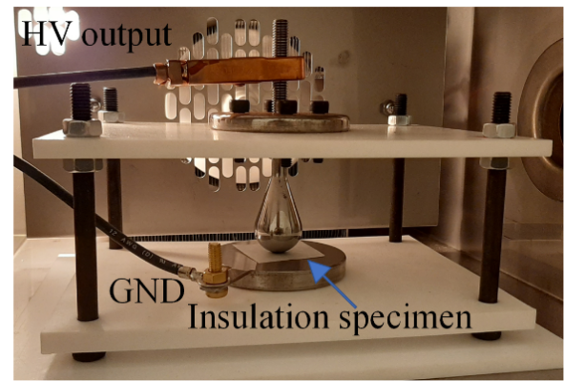

Figure 3. Sphere-plate electrode in the oven



(a) With PD



(b) Without PD

Figure 4. Signal detected from UHF antenna with and without PD

## Insulation specimen

Three different materials shown in Figure 5 are chosen as the study objects including polyimide 6050, polyester 6020 and Nomex 410 paper. All the materials are with the same thickness of 0.05 mm and are cut into the same shape (square shape with side length of 2.5 cm). Before staring the experiments, insulation specimens are all cleaned by alcohol and dried in the oven with 50 ℃ for 24 hours.

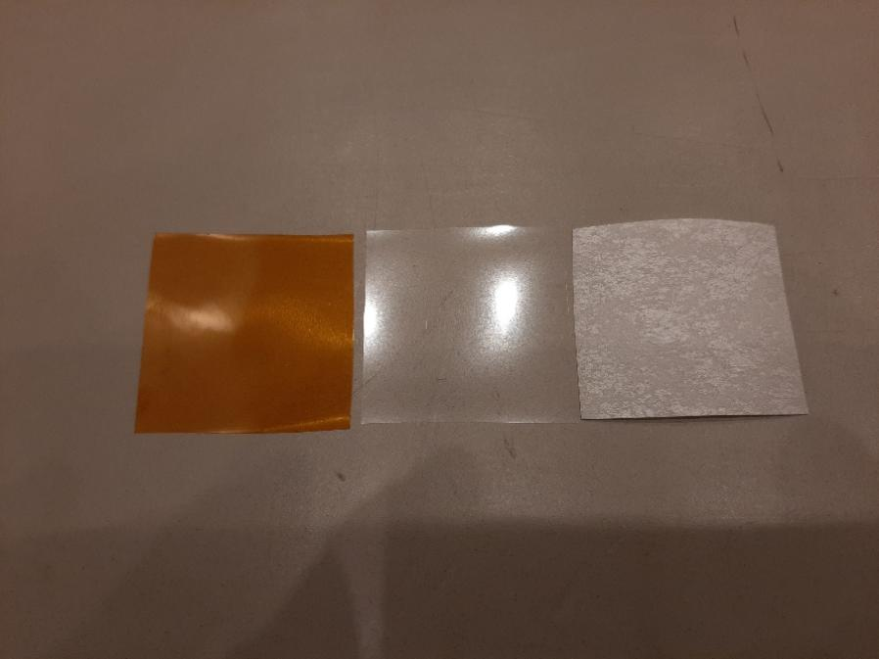

Figure 5. Polyimide (left), Polyester (middle) and Nomex paper (right) for the experiments

## Parameters for the experiments

In the comparative PDIV tests, rise time (tr) of the pulse voltage is kept as 40 ns for it fits with the range of the PWM voltage rise time that the modern SiC switches can achieve. Voltage frequency (f) is kept as 1 kHz for it is one of the typical working frequencies of the medium frequency transformer. Considering that due to the increased copper and core losses brought from higher frequency, temperature of the whole transformer can reach more than 100℃ [3], 4 different temperature values from room temperature (20℃) to 110℃ are chosen. The detailed parameters of the comparative PDIV tests are shown in TABLE I.

TABLE I. Parameters for the Comparative PDIV tests

|  |  |  |  |  |
| --- | --- | --- | --- | --- |
| **Group** | **Material** | **Rise Time** | **Frequency** | **Temperature** |
| 1 | Polyimide | 40 ns | 1 kHz | 20 ℃ |
| 2 | 50 ℃ |
| 3 | 80 ℃ |
| 4 | 110 ℃ |
| 5 | Polyester | 20 ℃ |
| 6 | 50 ℃ |
| 7 | 80 ℃ |
| 8 | 110 ℃ |
| 9 | Nomex paper | 20 ℃ |
| 10 | 50 ℃ |
| 11 | 80 ℃ |
| 12 | 110 ℃ |

In the comparative lifetime tests, rise time and frequency of the voltage is kept as same as that of PDIV tests. While the peak voltage value is raised to 1.5 times PDIV (depends on the results from the PDIV tests under highest temperature) to guarantee that PD can be triggered on every kind of the selected insulation materials in every voltage cycle. The temperature is kept as 110 ℃. The detailed parameters for the comparative lifetime tests are shown in TABLE II.

TABLE II. Parameters for the Comparative endurance lifetime tests

|  |  |  |  |  |
| --- | --- | --- | --- | --- |
| **Group** | **Material** | **Peak Voltage** | **Frequency** | **Temperature** |
| 1 | Polyimide | 1.5×PDIV | 1 kHz | 110 ℃ |
| 2 | Polyester |
| 3 | Nomex |

# Experiment resutls

## Comparative PDIV experiments

During the Comparative PDIV experiments, voltage is raised with 10V/s until the first PD is detected by the UHF antenna. 5 samples are used for each group in TABLE I. The average PDIV values of these materials with rising temperatures are shown in Figure 6. It is clear that Polyimide and Polyester can better resist the PD generation comparing with that of Nomex paper. When temperature rises from 20 ℃ to 110 ℃, PDIV of Nomex paper shows most obvious decreasing (decreases by 12.2%). In lower temperature range (from 20℃ to 80℃), polyimide has lower PDIV than that of polyester. Yet when the temperature is raised to 110℃, PDIV of polyimide is higher. When temperature rises, the air molecule density reduces, making the breakdown strength of the air gap lower [4]. That’s why in most of the situation, PDIV decreases with temperature rising. Yet, higher temperature can also increase the insulation materials’ surface conductivity [7]. Then the surface charge would be dissipated faster, making the probability of initial electron generation lower. Therefore, higher voltage magnitude would be necessary to light the PD. That’s why in some situation (for polyimide from 20℃ to 50 ℃, for polyester from 80 ℃ to 110℃), PDIV increases with temperature rising.



Figure 6. PDIV values under different temperatures

## Comparative endurance experiments

During the experiments, the insulation specimen is aged under repetitive pulse voltage until the final breakdown. Same as the PDIV tests, 5 specimens are used for each group in TABLE II. Lifetime of different materials is shown in Figure 7. Under continuous PDs generated by the pulse voltage, Nomex paper breaks down much faster than the other two materials. While polyimide behaves best in resisting the PD degradation. The appearance of breakdown area and unaged material observed by the microscope with 200 times zoom in are shown in Figure 8. For polyimide, it can be seen that near the breakdown point, a new layer filled with clusters of particles is formed due to the PD aging. For polyester, a new but relatively smooth layer can also be observed. While for the Nomex paper, the region that surrounds the breakdown point is still the same as the unaged material. It is certain that PD aging process on the Nomex paper is somewhat different from that on the polyimide and polyester films. This may contribute to the great difference of lifetime between Nomex paper and the other two materials and should be further investigated in our future studies.



Figure 7. Lifetime of different materials

(a) Polyimide

(b) Polyester

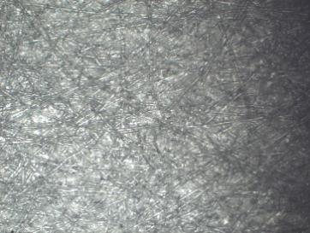

(c) Nomex paper

Figure 8. Breakdown area (left) and unaged area (right) of different materials

According to the above results, Nomex paper is most vulnerable to PD inception and degradation under medium frequency pulse voltage. If this material is used as the medium frequency transformer’s insulation, higher margin of insulation distance (thickness) should be adapted. Considering the relative high temperature faced by the medium frequency transformer and its developing trending to be smaller in size (limited insulation thickness), polyimide is the best choice among these materials because of its best behavior in resisting PD inception at high temperature and longest endurance.

# Conclusions

Using pulse voltage, PDIV tests under different temperatures and endurance lifetime tests are conducted on three different materials including polyimide, polyester and Nomex paper that are often used for the insulation of medium frequency transformer. The results show that:

1. Nomex paper has lowest PDIV among these three materials.

2. With temperature rising, the decrease of PDIV of Nomex paper is most obvious.

3. In lower temperature range, Polyimide has lower PDIV than that of polyester. When temperature rise to 110℃, PDIV of polyimide is higher.

4. Under the degradation from continuous PDs, lifetime of Nomex paper is much shorter than the other two materials. While the lifetime of polyimide is the longest.

These results indicate that for the construction of insulation of medium frequency transformer, polyimide is the best choice.

##### References

1. M Mogorovic, “Modeling and Design Optimization of Medium Frequency Transformers for Medium-Voltage High-Power Converters,” Phd dissertation, Power Electronics Laboratory., Swiss federal Institute of Technology in Lausanne, Lausanne, 2019.
2. C. Zheng, Q. Wang, H. Wang, Z. Shen and L. B. Claus, “Electrical Stress on the Medium Voltage Medium Frequency Transformer,” Energies., Vol. 14, no. 16, 2021.
3. D. Aushuman, S. Navid, K. Rahul, E. Wilson and L. Ri, “Improving Thermal Performance of High Frequency Power Transformers using Bobbinless Transformer Design,” IEEE Intersociety Conference on Thermal and Thermomechanical Phenomena in Electronic Systems, pp. 291-297, July, 2020.
4. M. Kaufhold, G. Borner, M. Eberhardt, and J. Speck, “Failure mechanism of the interturn insulation of low voltage electric machines fed by pulse controlled inverters,” IEEE Elect. Insul. Mag., vol. 12, pp. 9-16, September. 1996
5. Y. Zhao, G. Zhang and R. Guo, “The Breakdown Characteristics of Thermostable Insulation Materials under High-Frequency Square Waveform,” IEEE Trans. Dielectr. Electr. Insul., vol. 26, no. 4, pp. 1073–1080, 2019.
6. P. Wang, S. Ma, S. Akram, K. Zhou, Y. D. Chen, and M. T. Nazir, “Design of Archimedes Spiral Antenna to Optimize for Partial Discharge Detection of Inverter Fed Motor Insulation,” IEEE Access., Vol. 8, pp. 193202-193213, October. 2020.
7. T. Liu, Q. M. Li, X. W. Huang, Y. F. Lu, M. Asif, and Z. D. Wang, “Partial discharge behavior and ground insulation life expectancy under different voltage frequencies,” IEEE Trans. Dielectr. Electr. Insul., vol. 25, no. 2, pp. 603-613, April. 2018