Back to basics – the influence of DNA extraction and primer choice on phylogenetic analysis in activated sludge communities
Mads Albertsen*, Søren M. Karst, Anja S. Ziegler, Kåre L. Nielsen and Per H. Nielsen
Department of Biotechnology, Chemistry, and Environmental Engineering, Aalborg University, Aalborg, Denmark
Abstract: DNA extraction and primer choice have a large effect on the observed community structure in all phylogenetic analyses. Although the biases are well known, no comprehensive analysis have been conducted in activated sludge communities. In this study we investigated the effect of bead beating intensity and primer choice on the observed community using 16S rDNA amplicon sequencing. Quantitative fluorescence in situ hybridization (qFISH) was used as a DNA extraction independent method to evaluate the results. The bead beating intensity correlated with cell-wall strength and showed that the manufacture recommended settings were insufficient to retrieve a large part of the community. In addition, the in silico “best” primer set was found to greatly underestimate a number of important phyla when compared to qFISH results. The findings underline the need for sample specific and DNA extraction independent validation in all DNA extraction based studies.
Keywords: DNA extraction; 16S rDNA amplicon sequencing; Activated Sludge
Introduction
The choice of DNA extraction protocol and primers are pivotal to the outcome of any amplicon sequencing project. Many DNA extraction protocols have been evaluated for use in activated sludge communities (e.g. McIlroy et al., 2009) and consensus is that the method should include bead beating. However, the evaluation criteria have often been based on yield, purity or diversity indices and have not been compared to DNA extraction independent methods as qFISH. In addition, no specific test of 16S primers have been conducted in activated sludge and often primer choices have been based on evaluations in other environments such as the human gut or in silico simulations (e.g., Klindworth et al., 2013). In this study we used 16S rDNA amplicon sequencing in combination with a comprehensive qFISH survey to evaluate the effect of different levels of bead beating and primer choice on the observed microbial community.
Material and Methods
A 2 L sample was taken from the aeration tank of a full-scale EBPR activated sludge wastewater treatment plant in Denmark and divided into 1.7 ml aliquots (SS approx.. 4.5 g/L). DNA was extracted from 0.5 ml of sample using the FastDNA® Spin Kit for Soil with various degrees of bead beating. Each experiment was performed in triplicate. Three primer pairs covering different variable regions (V1-3, V3-4 and V14) were used and the 16S rDNA amplicon products sequenced using the Illumina MiSeq platform. QIIME and R were used for data analysis. qFISH was conducted with a set of 30 probes covering the diversity usually found in Danish EBPR wastewater treatment plants.
Results and Conclusions
The FastDNA® Spin Kit for Soil is a commonly used method for DNA extraction in activated sludge. As many other methods it relies on chemical lysis in combination with physical disruption using bead beating. By varying the degree of bead beating it was evident that the standard bead beating settings (6 m/s for 40 s) were insufficient in extracting DNA from many bacterial groups that are known to be hard to lyse, e.g. Gram positive bacteria and Alphaproteobacteria (Figure 1). The increase in recovery reached a plateau for most bacterial groups at 6 m/s for 4x40s. Further increase to the degree of bead beating led to a marked reduction in DNA integrity while only increasing the recovery of Alphaproteobacteria.
The three primer sets were chosen based on applications in other studies of activated sludge and high phylogenetic coverage by in silico analysis. It is evident that the different primer sets generated very different community structures (Figure 1). Compared to the qFISH results (data not shown) only the V13 primers captured a reasonable number of Chloroflexi, which are often abundant in treatment plants and responsible for much of the dynamic changes. Hence, accurate detection of this phylum is needed. In general the community structure obtained with theV13 primer set is most similar to the expected community structure obtained from qFISH, with the exception of TM7 which is only captured by the V34 primer set. The V4 primer set has often been highlighted as a good general primer set as it has one of the highest phylogenetic coverages based on in silico analysis. However, the in situ test showed that the V4 primer set greatly underestimates the abundance of Chloroflexi and Actinobacteria, which are often the predominating members of the activated sludge community.
This study highlights the need for sample specific in situ evaluations of DNA extraction protocols and primers prior to any amplicon sequencing study if the results are to be used quantitatively.
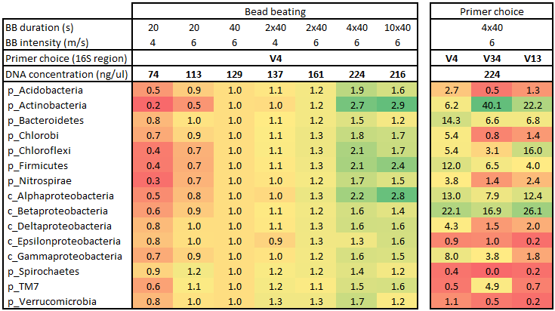
Figure 1 Effect of bead beating and primer choice on the observed microbial community. Only the 15 most abundant phyla are shown (Proteobacteria is shown at class level). All samples are averages of triplicates. The bead beating results are shown relative to the vendor recommended bead beating of 6 m/s for 40 s and have been normalized for yield by multiplying with the DNA concentration. The primer choice results are shown as percentage of the total community. BB: Bead beating.
References
McIlroy, S. J., Porter, K., Seviour, R. J. & Tillett, D (2009). Extracting nucleic acids from activated sludge which reflect community population diversity. Antonie van Leeuwenhoek 96, 593–605.
Klindworth, A., Pruesse, E., Schweer,, T., Peplies, J., Quast, C., Horn, M., Glöckner, F. O. (2013). Evaluation of general 16S ribosomal RNA gene PCR primers for classical and next-generation sequencing-based diversity studies. Nucleic Acids Res. 41, e1.

