A Hop, Skip and a Jump Away
– ‘The Art of Movement’ - examining the experiential potential in contemporary urban public space

Shelley Smith, architect MAA, PhD, Associate Professor
Institute for Architecture and Design, Aalborg University

Abstract
This paper will address spatial experience and issues of ownership, exchange and indeterminateness in urban public space.

The contemporary urban situation is characterised by media and mobility, where the potential for alienation – not only from each other, but also from the spaces we occupy, is prevalent. Themed and ‘designed’ spaces – many of the most common public spaces of the contemporary urban environment - often propagate a limitation in the diversity of their users, but they also propagate a kind of spatial inertia – an object-fixation prescribing use within a pre-determined schematic that focuses on clearly demarcated borders for containment.

The discipline of parkour – the art of movement - will be used as a lens through which to view the potential that lies in activating the indeterminate city, and accessing a sense of ownership, belonging and interconnectivity in urban public space.

The Urban and The Art of Movement

The contemporary urban is characterised by urban forms and urban life that have been influenced by increased mobility and communication. This has typically given rise to urban forms that are less dense and more physically isolated, and social patterns that are spread over larger areas and with many points of contact. Consumption and recreation have become the major driving forces behind public space development leading, seemingly, to a similarity and lack of diversity in the urban spaces available to city dwellers. The majority of these spaces are controlled – with either enforced or inferred rules dictating how they are to be used and who is welcome to use them. In general, this leads to a situation in which the diversity of potential experience of both physical and social surroundings is diminished by homogenisation of use and user. We experience the same types of people in the same types of spaces and we know how these spaces and their fitments are to be used. This raises questions of attachment and ownership in urban public space, and questions regarding public space contra public domain. Without influence on our physical environment we are relinquished of responsibility and become alienated from it. Without contact with groups other than those most like ourselves, we become alienated from the spaces we occupy and from society at large. Although contemporary urban landscapes are comprised of large areas and often viewed in motion, the experience of urban public space is most often static – being made up of contained space defined by separate and isolated objects and bounded by pre-determined rules for use and occupation. It is difficult in this description of contemporary urban public space to identify a dynamic society characterised by mobility and communication – rather this is a description of stasis and alienation, and of an urbanity, particularly in the defined public spaces of the city, that is not in sync with a rich and varied group interacting with the spaces they occupy and with each other. Theories regarding exchange (Hajer & Reijndorp, 2001; Lofland, 1998) and dynamic spatial experience (Hajer and Reijndorp, 2001; Madanipour, 2005) and their implementation in physical space and contact are rarely manifested. The gap between theory and practise - particularly it seems in the ability of architectural and urban design to contribute positively, dynamically to the articulation of public spaces that are in sync with the contemporary urban context - is great. Enter parkour. Parkour – the art of movement – is used in the context of this paper as a lens through which to view urban spatial and interactive potential –as a kind of catalyst to bridging the gap between theory and implementation. As such, the intention of this paper is to outline the contact points between parkour and urban theoretical subjects, and to identify the potential for an activation of theory that may become visible through this viewing.

Parkour is a physical discipline and it is necessary in the context of this paper to define exactly what it is referred to. Parkour has become a more visible sport through its exposure in film. Here it is extreme tricking – chases between the good guys and the bad guys involving daredevil leaps between building roofs and rolling and swinging through and around other urban objects. Net searches reveal a plentiful number of YouTube entries of both movie clips and cell phone videos of spectacular stunts. This is the pop culture side of parkour – in reality Parkour stems from a much more rigid and unlikely past than the movie world and is based on a holistic philosophy. Originally developed in France, by a military officer, Georges Hèbert, its’ use was as a training method for soldiers going to war in the jungles of Vietnam. The foundation of parkour is the method Hébert developed - the Natural Method – so called because it was inspired by Hébert’s observations of the indigenous peoples of Africa and their high level of athleticism and interaction with their environment. Hébert’s method was developed based on the natural movements of the body, e.g., running, jumping, hopping, swinging, walking on all fours, with the main function being that of moving forward. As a military training method, an obstacle course, parcours du combattant, its’ function was to train soldiers to navigate the foreign territories of the jungle as efficiently and quickly as possible using what they always had at hand – themselves. ‘Purest’ parkour is still based on this with the inherent intent of overcoming barriers – both physical and mental - and in this sense it is mainly concerned with practicality and efficiency in interaction with the environment. Today for practitioners of parkour, the jungles of Vietnam are exchanged for the concrete jungles of the contemporary city and although urban ‘in nature’, this environment can be just as foreign. Although the discipline does not practise aesthetics, as such, it is perhaps present intrinsically as a striving towards a ‘natural state’ – a kind of return to human basics and an interrelation with surroundings that is reliant on the senses.

Exceeding barriers – creating new paths, new spatialities

For the practitioners of parkour – traceurs – the focus is an individual one – an awareness of self and one’s own barriers and an attempt to exceed these through practise. Parkour however, is most often practised in community in the city, where safety can be better ensured and a positive, communal learning environment is created. Although the focus is on overcoming personal barriers, very real physical and attitude barriers also stand in the way. For many traceurs, parkour provides a freedom from social dictates about how public space is to be used. The city is always available and the possibilities are endless, but prescribed and designed spaces are barriers to be overcome, not least of all as regards using the spaces of the city in ways different than the pre-determined and in a social setting that adheres to this set of rules. Traceurs see the city as their playground/training centre and in doing so, the city becomes open and the traceur takes control, disregarding preconceived notions and expectations, and creating new situations – a trend found in other sports where freedom from rules and the freedom to choose what, how and not least of all when and where, are individual decisions to be made and not decided by the exclusivity of memberships, equipment requirements and opening and closing times. The limitation and fixed nature of the e.g., fitness club is exchanged for the unlimited and self-sufficient city experience.

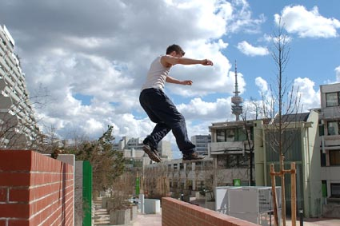
Endless possibilities in the urban playground

In the practice of parkour a number of interesting spatial observations can be made. By nature, parkour is forward propulsion, not going backward, and the traceur must find new paths, new ways of moving forward despite barriers. The word traceur is derived from the French, tracer, translating as to trace or to draw, and this points towards an interesting aspect of the activity of parkour – that of producing something new based on something existing – the act of creating. Moving through, or tracing the urban environment, the traceur selects existing elements, and in the art of movement joins them, weaving them into new spatial compositions. The stationary objects of the urban environment provide points of contact for further movement and are regarded -and utilised - in pieces. Objects are broken down into elemental parts, surfaces, materials that are seen in focus as the object itself fades into the background.

Parallels can be drawn between Parkour and the theories of the American scholar, Mitchell Schwarzer on zoomscape. Schwarzer coined the term to describe contemporary perception of the built environment and in his book, Zoomscape – architecture in media and motion, he discusses the perception of the cultural landscape, which encompasses architecture of the spectacular and the everyday, as well as large-scale entities as cities, and infrastructure, as being impacted by mechanized transportation (railroad, automobile, the airplane) and camera technologies (photography, film and television). (Schwarzer,13). However, a perceptual model based on movement and changing views is more than an altered perception, it can also result in new forms of spatiality – a spatial construct that exceeds the fixivity of the architectural object – and that addresses the object as a kind of elemental resource in the urban spatial field. The practise of parkour represents a graphic representation of changed, and constantly changing, spatial models – new spatial constructs ‘on the move’ - as the focus shifts from object to space, from stasis to flux. Characteristics common to different types of visual media and transportation modes are speed and mobility. These can be translated to the experience of the contemporary urban environment through the traversing of distance, the framing of elements, the editing process occurring at speed that chooses some parts and deletes others, the ability to clip and re-piece, to string together continually new stories and narratives from the same set of component parts. Here a perceptual shift occurs as the focus is on the elements that comprise the objects in the built environment, rather on the objects themselves. This creates a spatiality comprised of pieces connecting static objects where the connection - the space between - is just as important as the points. Traditionally it has been the static objects of the built environment in the urban field that have been the definers of space, forming the containers in which public space is held. In a form of perception of which Parkour is a graphic representation, the totality of the object fades into the background as its’ constituent parts step forward becoming self-sufficient elements in a spatial sequence.

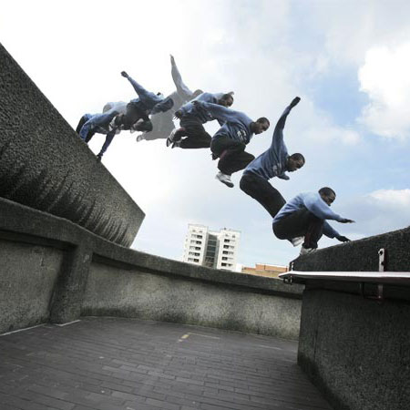
Spatial weavings and urban elements

‘The individual images of a new story – or any other program for that matter – rarely seem to matter; what matters is the succession of images, not only within programs but also from program to program. The viewing frame of television finds its peculiar energy not in image but in imaging, in what cultural theorist Raymond Williams has called flow.’ (Schwarzer, 269)

Parkour turns the stasis of the built environment into flux, into a series of new narratives and new connections between objects. The traceur is a creator of connections and a finder of paths, and in the act of observing Parkour, new spatial connections and flows are made available to non-practitioners. In this sense, the traceur also traces new spatial constructs and creates new narratives for the observer. The city becomes an open and ever-changing entity in which a kind of spatial tracing occurs that binds elements of static objects together into new configurations, telling new stories, and setting focus on the dynamic flow of space that exceeds the physical and social constraints of public space.

Contributing to Public Domains

Parkour is also representative of contemporary challenges to urban public space. Traditional public space was a container for meeting, often a centrally, inwardly-focussed space. Newer public spaces have most often taken a course based on revitalisation-by-design, shining up the old and derelict, or creating-by-design new containers with pre-determined interiors. In both cases, the public spaces created are often done so with an eye to tourism and economic gain, and design is used to this end rather than encouraging actual occupation and use. The notion of meeting is no longer entirely relevant for contemporary urban life, and the term exchange is a more fitting description of the interaction between contemporary urban dwellers (Hajer & Reijndorp; 2001). Exchange is dependent on the presence of diverse groups and public domains exist where spaces have meaning for diverse groups simultaneously, but not necessarily together. The prevalence of design as a tool for homogenisation and ‘politically correct’ space leads to a feeling of alienation from public space and promotes neither use nor exchange.

The practise and observance of parkour in the spaces of the city contributes to the creation of public domains – turning public space into a forum for exchange. ‘Public domain as a sphere or exchange and confrontation in society presupposes the mutual proximity of different spheres much more than the fully shared use of one and the same space. … The core of successful public space thus lies not so much in the shared use of space with others, let alone in the “meeting”, but rather in the opportunities that urban proximity offers for a “shift” of perspective: through the experience of otherness one’s own casual view of reality gets some competition from other views and lifestyles.’ (Hajers & Reijndorp, 89) The presence of parkour in the public spaces of the city does in fact provide this shift of perspective, as regards both the spatial – ‘the sphere of exchange’ and the members engaging in the exchange.

‘What we are searching for is the room that the design can provide for the “occupation” of the space with a multiplicity of meanings. Public domain, in this view, needs not “de-sign” but rather “re-sign”: the invitation to occupation by new meaning. (Hajers & Reijndorp, 101) The manner in which the traceur uses not only pre-defined public space, but the entire city, is exemplary of ways in which spaces can be re-signed. The act of tracing, the activity of the traceur, redraws spatialities and makes these available for exchange. The presence of such a group – identifiable as a group because of their practise in community - also lends to the notion of exchange. They provide an experience, a surprise dynamic encounter with both them and with space. Through a practise that activates the entire city, and not just the pre-defined and assigned as potential public space, spaces that may not be considered public space in a traditional definition, becomes a public domain.

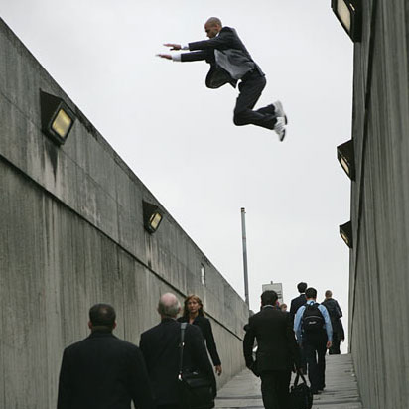
New paths and new narratives

Whose city is this anyway?

The practice of Parkour reclaims the city. Through a rejection of traditional definitions and uses of public space and through a searching for potential in the city at large, traceurs take possession of the city. It becomes their own territory and defined by their use of it. In the process of tracing and drawing new paths, a form of authorship is present that creates and redefines. In this way many of the borders that surround public space – in a spatial sense but perhaps more importantly in a perceived use sense are erased. The act of the traceur redefining in public also attaches new meanings to pre-defined space for the potential observers of Parkour.

Alienation prevalent in contemporary urban space due to the predetermination is challenged and while the intention of the traceur is a kind of self-realisation and personal journey, it encourages a reconnection with the physical environment in a very haptic way. A very physical contact is made which is personal and real – sensed and experienced. The activation of the senses is key in Parkour whether it be through the visual access of watching someone practice and thereby accessing a surface contact and fluidity that traces space in new and non-programmed ways – or in the practice itself that encourages a creative approach to navigating and accessing the city and oneself.

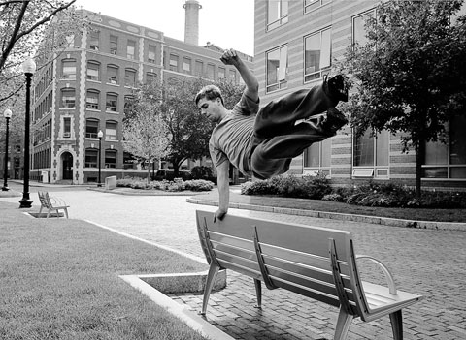
Challenging pre-determination

Scalar Shifts

The experience of the contemporary urban is often one of large scale – which is underlined by the ubiquity of mobility and communication. Large scale diminishes contact and the presence of the sensory is lost in cartographic representation. Here as well Parkour provides an interesting example for study of the potential for experiential quality in contemporary large scale urban space. As point of departure parkour is concerned with the traversing of distance, efficiently and quickly – this movement engages the large scale – the cartographic. However, the method of this discipline, the natural method, taking its point of departure in the human body engages quite another scale - the sensory. The presence of the practitioner traversing space creates immediate shifts between 2 very diverse scales, occasioning a haptic sensing of not only points of contact, but of space itself. The middle ground is conspicuously absent here, in that the context of the architectural object comes to the foreground in the one instance, while the materiality of the object – its amalgamation of surface, element and/or material comes in to the foreground the next instance. The architectural object itself becomes texture, either at the scale of the urban or at the scale of material.

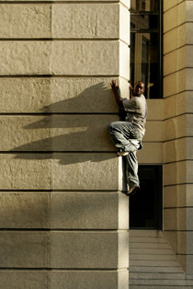
Architectural objects as texture

There is a dynamic movement in this scalar shift itself - a jolting of focus that hones the sensory in the large scale and connects the sensed in a flow of space. Parkour introduces an element of surprise, a taste of the unexpected through the speed of its happening and the indeterminateness of its route. The scale of parkour encompasses the vast scale of the urban and the minute scale of materials and surfaces and makes constant shifts between the two.

In Conclusion
Viewing with this lens, the potential lying dormant in the activation of the indeterminate city becomes visible through accessing ownership, belonging and interconnectivity in urban public space. This is a space that is much larger than determined and planned public space - this activates the entire city on a larger scale as a public space – makes the city full of potential and a landscape that is constantly changing. It activates the city as ‘mine’, fostering ownership which in turn finds new uses and creates new connections between the points – the objects – the buildings – the fitments – the surfaces – making unaccustomed shifts from horizontal to vertical – introducing the element of surprise. This is a focus on extension rather than containment and activates various scales simultaneously. Landscapes are invented and traversed, the flow of space is made visible and constantly changes, and tactile – even haptic - experience in the materials and surfaces and the space all around is realized. Perhaps lessons to be re-learned, or matters to be re-addressed by architectural and urban discourse?

References
Hajers, Maarten and Reijndorf, Arnold, (2001). In Search of New Public Domain, NAi Publishers, Rotterdam.
Lofland, Lyn, (1998). The Public Realm – exploring the city’s quintessential social territory, Aldine de Gruyter, New York.
Madanipour, Ali, (2005). Public Spaces of European Cities. In: Nordic Journal of Architectural Research, 2005:1, Aarhus, Denmark.
Schwarzer, Mitchell, (2004). Zoomscape – architecture in motion and media, Princeton Architectural Press, New York.

