Land Administration Systems:

Underpinning the Human Rights Perspective

Stig ENEMARK, Denmark

Key words: Land Administration Systems, Human Rights

SUMMARY

Land administration systems are the operational tool for conceptualizing rights, restrictions and responsibilities (RRRs) in land. Each of the rights, restrictions and responsibilities encompasses a human rights dimension that relates to the overall national land policies and should be unfolded as more than just rhetoric. This paper attempts to analyse the aspects of human rights in relation to land administration systems with a special focus on developing countries struggling to build adequate systems for governing the rights, restrictions and responsibilities in land.

Human rights are the rights inherent to all human beings without discrimination. The “constitution” of human rights is the Universal Declaration of Human Rights (UN, 1948) stating the universal rights of human beings based on the principle of respect for the individual – rights that can be enjoyed by everyone simple because of being alive. Of special interest in relation to land and property is the right to own things and the right of food and adequate housing for all. More generally, human rights should be seen as an ethical responsibility of government to ensure that people enjoy some basic rights as human beings. This relates to national political arrangements and standards for good governance and land administration systems are highly instrumental in this regard.

This paper introduces the relation between land administration and human rights. It is argued that human rights and land administration are closely linked and that every country and jurisdiction needs to ensure that efficient and effective land administration mechanisms are in place to pursue this interaction. Land administration systems should embed a human rights perspective when managing rights, restrictions and responsibilities in land. This, in turn, imposes a huge challenge and also ethical and social responsibility on the land professionals.

Land Administration Systems:

Underpinning the Human Rights Perspective

Stig ENEMARK, Denmark

- INTRODUCTION

All countries have to deal with the management of land. They have to deal with the four functions of land tenure, land value, land use, and land development in some way or another. Land administration systems are the operational tool for conceptualizing rights, restrictions and responsibilities (RRRs) in land. Property rights are normally concerned with ownership and tenure whereas restrictions usually control use and activities on land. Responsibilities relate more to a social, ethical commitment or attitude to environmental sustainability and good husbandry. Each of the rights, restrictions and responsibilities encompasses a human rights dimension that relates to the overall national land policies and should be unfolded as more than just rhetoric.

In the more developed (Western) world, the systems for governing and administering land issues have evolved over centuries to cope with cultural and economic development. Looking at the less developed world and, especially Sub-Saharan Africa, the basic systems of land registration are not in place (or serve only the elite) and the human rights perspective is largely ignored. In such cases, there is a need to improve the land governance systems more generally to cope with current and future challenges.

The paper provides an overall understanding of the concept of land administration systems for dealing with rights, restrictions and responsibilities in support of the global agenda. Second, the paper introduces the human rights perspective as an entry to analysing and discussing each of the rights, restrictions and responsibilities in more detail and with a special focus on less developed countries struggling to build adequate systems for managing land issues, which, in turn, impose a series of significant challenges and also ethical and social responsibilities on the land professionals.

The paper introduces the relation between land administration and human rights. It draws from an original and more comprehensive paper entitled Land Administration, Planning and Human Rights published in Planning Theory (Enemark, et.al. 2014).

- LAND ADMINISTRATION

Land governance is about the policies, processes and institutions by which land, property and natural resources are managed. Sound land governance requires a legal regulatory framework and operational processes to implement policies in sustainable ways. Land administration systems provide a country with an infrastructure for implementation of land policies and land management strategies in support of sustainable development (Williamson et al., 2010). Such a global land management perspective is presented in figure 1.

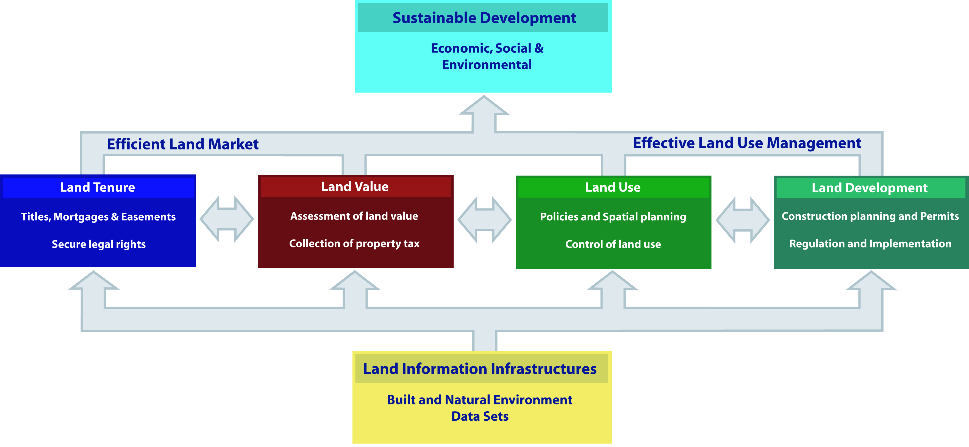

Figure 1. A global land administration perspective
(Enemark et.al. 2005, Williamson et al., 2010)

The operational component of the land management concept is the range of land administration functions that include the areas of land tenure (securing and transferring rights in land and natural resources); land value (valuation and taxation of land and properties); land use (planning and control of the use of land and natural resources); and land development (implementing utilities, infrastructure, and construction planning). These four functions interact to deliver overall objectives, and they are facilitated by appropriate land information infrastructures that include cadastral and topographic datasets linking the built and natural environment.

The four functions ensure the proper management of rights, restrictions, and responsibilities in relation to property, land and natural resources. As such, these functions are different in their professional focus, and are normally undertaken by a mix of professionals, including surveyors, engineers, lawyers, valuators, land economists, planners and developers. Furthermore, the actual processes of land valuation and taxation as well as the actual land-use planning processes are often not considered part of land administration activities. However, even if land administration is traditionally centred on cadastral activities in relation to land tenure and land information management, modern land administration systems designed as described in Figure 1 deliver an essential infrastructure and encourage integration of the four functions.

Ultimately, the design of adequate systems of land tenure and land value should support efficient land markets capable of supporting trading in simple and complex commodities. The design of adequate systems to deliver land use control and land development should lead to effective land use management. The combination of efficient land markets and effective land use management is then seen as a key component in delivering economic, social and environmental sustainable development.

Sound land administration systems deliver a range of benefits to society in terms of: support of governance and the rule of law; alleviation of poverty; security of tenure; support for formal land markets; security for credit; support for land and property taxation; protection of state lands; management of land disputes; improvement of land use planning and implementation. The systems enable the implementation of land policies to fulfil political and social objectives and to achieve sustainable development. Land policy is the set of aims and objectives put forward by governments in dealing with land issues. Land policy is part of the national policy on promoting objectives such as economic development, social justice and equity, and political stability. Land policies vary, but in most countries they include poverty reduction, sustainable agriculture, sustainable settlement, economic development, and equity among various groups within the society.

From this global perspective, land administration systems act within adopted land policies that define the legal regulatory pattern for dealing with land issues. They also act within a country’s specific institutional framework that imposes mandates and responsibilities on the various agencies and organisations. Land administration systems should, then, service the needs of individuals, businesses, and the community at large, as they contribute to deliver detailed information and reliable administration of land from the basic level of individual land parcels to the national level of policy implementation (Williamson et al., 2010).

Sound land management requires operational processes to implement land policies in comprehensive and sustainable ways. Many countries, however, tend to separate land tenure rights from land-use opportunities, thereby undermining their capacity to link planning and land-use controls with land values and the operation of the land market. These problems are often compounded by poor administrative and management procedures that fail to deliver required services. Investment in new technology will only provide limited solutions in the major task of solving a much deeper problem, namely the failure to treat land and natural resources as a coherent whole (ibid.).

- THE HUMAN RIGHTS PERSPECTIVE

The Universal Declaration of Human Rights (UN, 1948 states a range of general human rights such as “All human beings are born free and equal in dignity and rights” (Art. 1) and “Everybody has the right to life, liberty and security of person” (Art. 3). More specific rights are the freedom of thought and expression, and more social rights relates to the right of democracy, right to education, and also a duty of responsibility towards other people so that they can enjoy the rights and freedom. Of special interest in relation to land and property is the right to own things (Art. 17) and the right of food and adequate housing for all (Art. 25).

Article 17 of the Universal Declaration of Human Rights states that “Everyone has the right to own property alone as well as in association with others” and, additionally, “No one shall be arbitrarily deprived of his property.” .With regard to immovable property this global norm can be operationalised in various ways. As an example, Article 17 is implemented in the Constitutional Act of Denmark in Article 73, which states that, “The right of property shall be inviolable. No person shall be ordered to surrender his property except where required in the public interest. It shall be done only as provided by statute and against full compensation.” (Danish Parliament, 1953).

Eventually, article 17 was left out when transforming the Universal Declaration into binding international law through the two International Covenants on Civil and Political Rights (ICCPR) and on Economic, Social and Cultural Rights (ICESCR) that were both adopted 1966 (UN, 1966). Property is a controversial concept that should be seen merely as social rather than a civil right and, therefore, the ideological and regional differences could not be bridged on the matter of limitations. At regional level, however, the right to property is recognised in conventions such as the American Convention on Human Rights, adopted in 1948, which is very much in line with the original Universal Declaration of Human Rights on this matter. This is also the case with regard to the African Charter on Human and People’s Rights that was adopted in 1981, and which is to some extent rooted in the colonial history of the continent. In the European Convention on Human Rights, adopted in 1950, the property issue was included only in the first protocol adopted in 1952, whereas in the text the word property was replaced by possession.

Article 25 of the Universal Declaration of Human Rights states, in simple words, that everyone has the right to adequate standard of living including housing, food, clothing, medical help and social services. However, the content of Article 25 is not easy to interpret. The ICESCR in Article 11 does speak about the right to an adequate standard of living, but this is seen mere as a social right to “minimal property” such as “adequate food, clothing and housing”. In Comment No. 4 adopted by ICESCR (UN 1991), the right to adequate housing is explained in more detail, stating that “…the right to housing should not be interpreted in a narrow or restrictive sense which equates it with for example the shelter provided by merely having a roof over one’s head or views shelter exclusively as a commodity. Rather, it should be seen as the right to live somewhere in security, peace and dignity”. The right to adequate housing therefore cannot be viewed in isolation from other human rights contained in the two covenants mentioned above as well as other applicable international instruments. Even though adequacy of housing is determined by a number of social, economic and cultural factors, Comment No. 4 does point at legal security of tenure as a key factor (notwithstanding the type of tenure), while it also indicates that state parties should take immediate measures to ensure such protection - see also Comment No. 7 on forced evictions and the rights to adequate housing , adopted by the UN Committee on Economic, Social and Cultural Rights (UN, 1997).

The right to adequate housing has become the basis for the United Nations Centre for Human Settlement (UNCHS) known as UN-HABITAT, which was established in 1978 with the UN mandate to “…promote socially and environmentally sustainable towns and cities with the goal of providing adequate shelter for all”. In 1996, at the Habitat II conference in Istanbul, many countries committed themselves to “Expand the supply of affordable housing by enabling markets to perform efficiently and in a socially and environmentally responsible manner, enhancing access to land and credit and assisting those who are unable to participate in housing markets” (UNCHS, 1996).

From the few examples above it becomes clear that human rights and land administration are closely linked and that every state needs to ensure that efficient and effective land administration mechanisms are in place to pursue this interaction. More generally, human rights should be seen as an ethical responsibility of government to ensure that people enjoy some basic rights as human beings. This relates to national political arrangements and standards for good governance. It also relates to historical and cultural development throughout the world including colonisation and armed conflicts.

- LAND RIGHTS RESTRICTIONS AND RESPONSIBILITIES

Numerous human rights as listed above are affected by access to land and the way the use of land is regulated. A holistic approach to land administration should therefore include the human rights perspective when managing rights, restrictions and responsibilities in land.

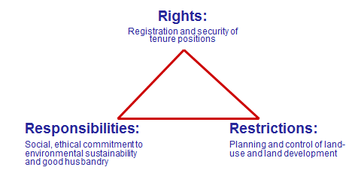

Figure 2. Land administration systems are the basis for conceptualising rights,
restrictions and responsibilities related to people, policies and places. (Enemark, 2007).

4.1 Rights

The human rights to own property and to enjoy adequate housing are fundamental and should be encouraged and promoted through building adequate systems of land administration that are relevant and accessible for poor people and serve their needs in a wider societal context. Landownership and secure tenure can be a vital source of capital, which opens personal credit markets, leads to investments in land buildings, provides a social safety net, and transfers wealth to next generation (Wickeri and Kalhan, 2010; De Soto, 2000). However, in several less developed countries most people do not have legal documents for the land they occupy or use and fall outside the formal management system. This means that most decisions are made without information. Limited land records and lack of information cause dysfunctionalities in the management of urban and rural areas from the household up to government level, which impair the lives of millions of people (UN-HABITAT, GLTN, 2012).

In less developed regions such as Sub-Saharan Africa, more than two thirds (in some countries up to 90 per cent) of the land is outside the formal systems of land registration and administration. This means that the existing formal systems do not serve the millions of people whose tenures are predominantly social rather than legal. UN-HABITAT has developed an innovative approach through the so-called Social Tenure Domain Model (FIG/GLTN, 2010) that includes a “scaling up approach” with a range of steps from informal to more formalised land rights. This continuum of land rights does not mean that the societies will develop into freehold tenure systems, but rather that each step in the process can be formalised, with registered freeholds providing a stronger protection, than at earlier stages.

Furthermore, responsible governance of tenure is now incorporated as part of the global agenda through the recently published Voluntary Guidelines on Responsible Governance of Tenure (FAO, 2012). The Guidelines promote secure tenure rights and equitable access to land as a means of eradicating hunger and poverty, supporting sustainable development and enhancing the environment. The Guidelines outline principles and practices that governments can refer to when making laws and administering land, fisheries and forests rights While the Guidelines acknowledge that responsible investments by the public and private sectors are essential for improving food security, they also recommend that safeguards be put in place to protect tenure rights of local people from risks that could arise from large-scale land acquisitions (land grapping), and also to protect human rights, livelihoods, food security and the environment. The guidelines thereby place tenure rights in the context of human rights such as right to adequate food and housing.

There is an urgent need to build simple and basic systems using a flexible and low cost approach to identifying the way land is occupied and used. When considering the resources and capacities required for building such systems and the connected basic spatial framework in less developed countries, the western concepts may well be seen as the end target but not as the point of entry. When assessing technology and investment choices the focus should be on “fit-for-purpose approach” that will meet the needs of society today and that can be incrementally improved over time (FIG/WB 2014).

4.2 Restrictions

Rights to land also include the rights of use. This right may be limited through public land-use regulations and restrictions, and various kinds of private land-use regulations such as easements, covenants, etc. Many land-use rights are therefore, in fact, restrictions that control the possible future use of the land. In general terms, there are two conflicting points of view on land-use planning: the free-market approach and the central planning approach (Williamson et al., 2010). The former approach argues that owners should have complete domain over their land and be obliged to no one. In this extreme, planning restrictions should only be imposed after compensation for lost land development opportunities is paid (Jacobs, 2007). The latter approach takes the opposite stand where the role of democratic government includes planning and regulation of land systematically for public good purposes. The tension between these two points of view is especially felt by nations seeking economic security. The question however is how to balance owners’ rights with the necessity and capacity of the government to regulate land use and development for the betterment of society.

A country’s land policy should set a reasonable balance between the ability of landowners to manage their land and the ability of the government to provide services and regulate growth for sustainable development and environmental resilience. This relates to the concept of integrated land-use management where land policies, land-use control systems and land information management are integrated to ensure that existing and future land use are consistent with current land policies and adopted planning and sectoral land-use regulations, and that decisions are based on complete and up-to-date land information systems.

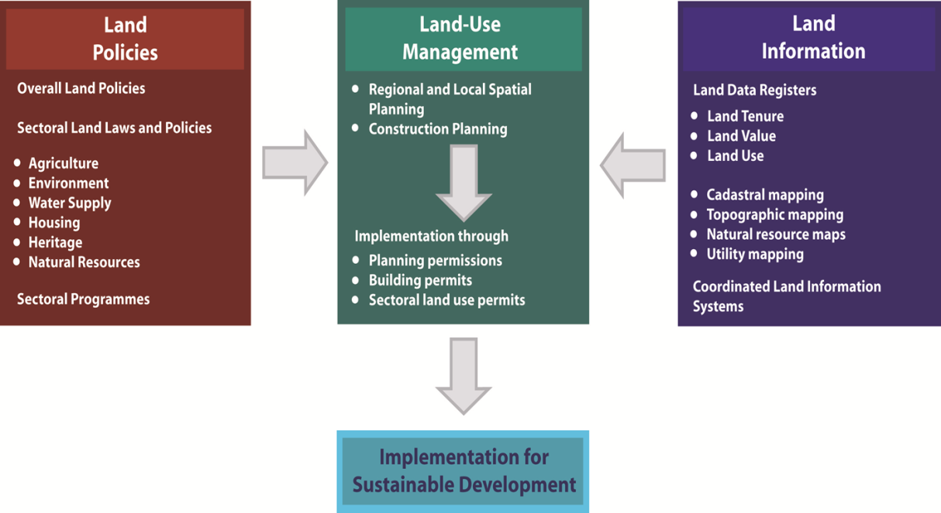

Figure 3. The concept of Integrated Land Use Management (Enemark, 2007)

A serious problem of the new millennium relates to the fact that about half of the world’s population of 7 billion is now living in urban areas, with one-third of those urbanites living in slums. City authorities tend to view most people living in slums as doing so illegally. Because of this, cities do not plan for or manage slums, and the people in them are largely overlooked and excluded. Slum dwellers thus receive none of the benefits of more affluent citizens, such as access to municipal water, roads, sanitation, and sewage. This attitude toward slum dwellers as well as the management approaches that disregard them perpetuates the levels and scale of poverty, while also causing cities to be more vulnerable to natural disasters, crises and exacerbating urban conflicts (UN- HABITAT, 2010).

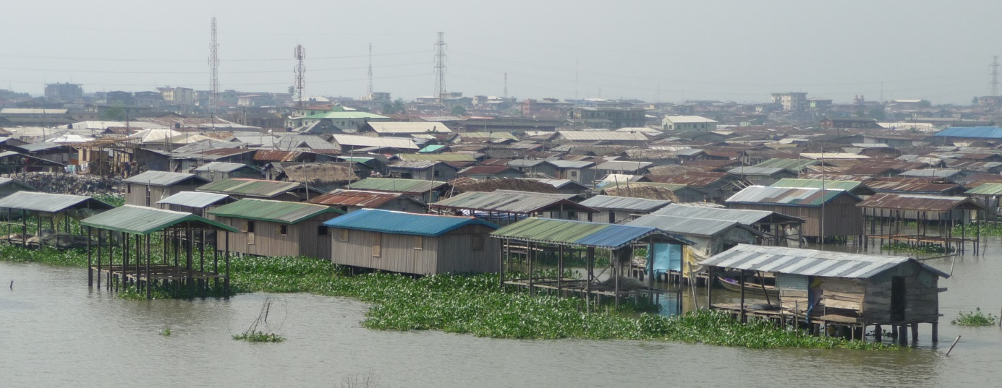

Figure 4. Lagos is one of the fastest growing cities in the world with huge slum areas expanding into the waters. photo: Enemark, 2009.

Many less developed countries is characterised by an unequal distribution of land among inhabitants, and many poor inhabitants in these countries lack access to land or lack secure rights to the land they have settled on. Lack of tenure security is very often a central characteristic of informal settlements. Informal settlements are often neglected enclaves of settlements consisting of poor inhabitants living in distinctly poor conditions caused by inadequate housing and no access to basic services.

The human right to adequate housing and the right to food and a decent living relates very much to planning and agrarian reform. Without secure tenure, slum residents face a constant risk of forced eviction, as they are not officially recognised as residents of the city. About 15 million people are displaced annually as a result of forced evictions in relation to development programmes. As stated by the United Nations Commission on Human Rights, “…the practice of forced eviction constitutes a gross violation of human rights, in particular the right to adequate housing” (UNCHR, 1993). All evictions, whether ‘legal’ or not, affect people’s lives and destroy communities and social networks that they rely upon for survival. Therefore, informal settlements should be seen as an integrated part of citywide strategic planning that includes a range of innovative planning responses to informality (UN-HABITAT, 2009; UN-HABITAT, GLTN, 2010).

4.3 Responsibilities

Property responsibilities normally refer to a duty of applying with rules for acting in a specific way according to legal provisions, or a duty to apply with more social or ethical rules of behaviour. The former is quite straightforward and is normally laid down in legally binding provisions. The latter relates to a more social, ethical commitment or attitude to environmental sustainability and good husbandry. Individuals and other actors are supposed to treat land and property in a way that conforms to cultural traditions and ways of ethical behaviour. This relates to what is accepted both legally and socially.

More generally, the people-to-land relationship is to some extent determined by the cultural and administrative development of the country or jurisdiction. This relates to cultural dimensions, namely uncertainty avoidance, that is, the preference of structured situations over unstructured or flexible ones; and power distance, which is the degree of inequality among people accepted by the population (Hofstede, 2001). These cultural dimensions determine the social and ethical behaviour of people also in relation to the way that land can be held and used within a given culture. Systems of land tenure and land-use control therefore vary throughout the world according to such cultural differences.

Rights and responsibilities can be considered as two sides of a coin. Land rights cannot be enjoyed without some kind of legal, social or ethical responsibility. This also applies for human rights, which can only be enjoyed by including the responsibility towards others so that they can also enjoy the rights and freedom. Human rights should thus become a recognised institution in society – an integrated part of the “rules of the game” (North, 1990). This understanding is relevant for land professionals who should prepare themselves in spreading their understanding with regard to the quality of ethical compromises in their everyday practice.

- THE GLOBAL AGENDA

The human rights perspective along with good land governance should be seen as a means in support of the global agenda. If a hypothetical map of the world is generated by using the Gross Domestic Product as the scale for territorial size – the so-called western regions North America, Western Europe, South Korea and Japan would “balloon” while other regions such as Africa and Central Asia would almost disappear (see map of UNEP, 2007). The global agenda is very much about bringing this map back to scale through poverty eradication, improving education and health, facilitate economic development, encourage good governance, and ensure sustainability.

The global agenda is threefold and has changed over recent decades. In the 1990s, the focus was on sustainable development; in the 2000s the Millennium Development Goals were adopted as the overarching agenda; and in the 2010s there is an increasing focus on climate change and related challenges such as natural disasters, food shortage and environmental degradation. Finally, rapid urbanisation has appeared as a general trend that in itself has a significant impact on climate change. The eight Millennium Development Goals form a blueprint agreed to by all the world’s countries and the world’s leading development institutions. The first seven goals are mutually reinforcing and are directed at reducing poverty in all its forms. The last goal - global partnership for development - is about the means to achieve the first seven. These goals are now placed at the heart of the global agenda. To track the progress in achieving the goals a framework of targets and indicators is developed. This framework includes 18 targets and 48 indicators enabling the on-going monitoring of the progress that is reported on annually (UN, 2000).

In the same way, there is a need to develop targets and indications for human rights and make them become part of the overall global agenda. This is also recognised by the UN Human Rights Council, e.g. through the report on adequate housing as a component of the right to an adequate standard of living (UN-HRC, 2007). The report states that “the HRC should consider the relationship between the right to land and congruent human rights and their implementation, in particular in regard to adequate housing and the right to food and work as a means to combat poverty, discrimination, violence, evictions and displacement.” The report points at the need for elaborating an operational framework for the realisation of the right to adequate housing, including indicators and methods of monitoring which have become more pertinent with the emergence of the Millennium development Goals. The development of rights–based indicators and monitoring tools could thus contribute to more effective implementation of the goals and to the fulfilment of relevant human rights. Furthermore, the UN Post 2015 Development Agenda (UN, 2012) is built around three fundamental principles of Human Rights, Equity and Sustainability. They provide the foundation of an agenda – with four core dimensions of inclusive social development, environmental sustainability, inclusive economic development, and peace and security – for achieving better life for all human beings and would serve to inspire and assist each society in determining how best to pursue this vision (UN 2012).

The discussion above regarding the global agenda in relation to human rights imposes a huge challenge and responsibility on land professionals. This also relates to building sustainable systems for land governance including the provision of relevant geographic information in terms of mapping and databases of the built and natural environment, as well as the delivery of secure tenure systems, systems for land valuation, land use planning, and land development. Overall, these systems constitute a “backbone” in society in pursuit of social justice, economic growth, and environmental sustainability.

- CONCLUDING REMARKS

The key argument of this paper is that land administration systems should embed a human rights perspective in support of the global agenda and in pursuit of social justice. Land administration systems reflect the social relationship between people and land, which is governed by means of allocation and controlling rights, restrictions and responsibilities in land. The Human Rights Declaration can be regarded as a Global Code of Ethics being promoted and enforced through political commitment and relevant societal institutions. Land administration systems are highly instrumental in this regard. The human right to “minimal property” – the right to live somewhere in security, peace and dignity – cannot be achieved or enforced without functioning systems of land administration managing the people to land relationship. Therefore, by reflecting and underpinning a human rights perspective and supporting the global agenda, land administration systems should achieve high-level political support and recognition.

REFERENCES

Danish Parliament (1953): The Constitutional Act of Denmark of June 5, 1953, Copenhagen.
De Soto, H. (2000): The Mystery of Capital. Basic Books.
Enemark, S., Wallace, J. and Williamson, I. (2005): Building Modern Land Administration Systems in Developed Economies. Journal of Spatial Science. Perth, Australia. Vol. 50 No 2, pp 51-68.
http://csdila.unimelb.edu.au/publication/journals/Building%20Modern%20Land%20Administration%20Systems%20in%20Developed%20Economies.pdf
Enemark, S. (2007): Property Rights, Restrictions and Responsibilities - A Global Land Management Perspective. Geoconference, Quebec, 2-5- October 2007.
http://www.fig.net/council/enemark_papers/Quebec.Enemark.October2007.Handouts.pdf
Enemark, S. Hvingel, L., Galland, D. (2014): Land Administration, Planning and Human Rights. Planning Theory, published online 10 January 2014.
http://plt.sagepub.com/content/early/2014/01/09/1473095213517882.full.pdf
FAO (2012): Voluntary Guidelines on the Responsible Governance of Tenure of Land, Fisheries and Forests in the Context of Food Security. Rome.
http://www.fao.org/docrep/016/i2801e/i2801e.pdf
FIG/GLTN (2010): The Social Tenure Domain Model. FIG Publications no 52. FIG Office, Copenhagen, Denmark. http://www.fig.net/pub/figpub/pub52/figpub52.htm
FIG/WB (2014): Fit-For-Purpose land Administration. FIG Publications No 60. FIG Office Copenhagen. http://www.fig.net/pub/figpub/pub60/figpub60.htm
Hofstede, G. (2001): Culture's Consequences: Comparing Values, Behaviours, Institutions and Organizations Across Nations, 2nd Edition, Thousand Oaks CA: Sage Publications.
Jacobs, H.M. 2007, Social Conflict Over Property Rights, Land Lines, Lincoln Institute of Land Policy, April, pp.14-19.
https://www.lincolninst.edu/pubs/dl/1222_LLA070404%20Social%20Conflict%20Over%20Property%20Rights.pdf
North, D. (1990): Institution, Institutional Change and Economic. Cambridge University Press.
UN (1948): Universal Declaration on Human Rights. UN, New York.
http://www.ohchr.org/EN/UDHR/Pages/Language.aspx?LangID=eng
UN (1966): International Covenants on Civil and Political Rights (ICCPR) and Economic, Social and Cultural Rights (ICESCR). UN, New York,
http://eycb.coe.int/compass/en/pdf/6_5.pdf
UN (1991): Committee on Economic, Social and Cultural Rights, General Comment no 4, The right to adequate housing. http://www1.umn.edu/humanrts/gencomm/econ.htm

UN (1997): Committee on Economic, Social and Cultural Rights, General Comment no 7, Forced evictions, and the right to adequate housing.
http://www1.umn.edu/humanrts/gencomm/econ.htm.
UN (2000): United Nations Millennium Declaration. Millennium Summit, New York, 6-8 September 2000. UN, New York.
http://www.un.org/millennium/declaration/ares552e.pdf
http://www.unmillenniumproject.org/goals/
UN (2012): Realising the Future We Want for All. New York.
http://www.un.org/millenniumgoals/pdf/Post_2015_UNTTreport.pdf
UNCHR (1993): Commission on Human Rights Resolution 1993/77.
http://www.unhabitat.org/downloads/docs/1341_66115_force%20evic%20chr1.htm
UNCHS (1996): United Nations Centre for Human Settlement: The Istanbul Declaration on Human Settlements. http://www.unhabitat.org/downloads/docs/2072_61331_ist-dec.pdf
UNEP (2007). World economy cartogram.
http://www.grida.no/graphicslib/detail/world-economy-cartogram_1551
UN-HABITAT (2009): Planning Sustainable Cities. Nairobi.
http://www.unhabitat.org/downloads/docs/GRHS2009Abridged.pdf
UN-HABITAT (2010): Settlement Planning. UN-Habitat in Disaster and Conflict Contexts. http://www.unhabitat.org/pmss/listItemDetails.aspx?publicationID=3193
UN-HABITAT, GLTN (2010): Citywide Strategic Planning. Nairobi.
http://www.unhabitat.org/pmss/listItemDetails.aspx?publicationID=3020
UN-HABITAT, GLTN (2012): Handling Land – Innovative Tools for Land Governance and Secure Tenure. Nairobi.
http://www.unhabitat.org/pmss/listItemDetails.aspx?publicationID=3318
UN-HRC (2007): Report of the Special Rapporteur on adequate housing as a component of the right to an adequate standard of living. UN Human Rights Council, A/HRC/4/18.
http://www2.ohchr.org/english/bodies/chr/special/sp_reportshrc_5th.htm
Wickeri, E. and Kalhan, A. (2010): Land Issues in International Human Rights Law. Malaysian journal on Human rights. Vol. 4 No. 1 2010, pp 16- 25.
http://papers.ssrn.com/sol3/papers.cfm?abstract_id=1921447
Williamson, Enemark, Wallace, Rajabifard (2010): Land Administration Systems for Sustainable Development. ESRI Academic Press, Redlands, California, USA.
http://www.esri.com/landing-pages/industries/land-administration/e-book#sthash.Lp4BYcKW.vmY1XWxG.dpbs

BIOGRAPHICAL NOTES

Stig Enemark is Honorary President of the International Federation of Surveyors, FIG (President 2007-2010) and Past President and Honorary Member of the Danish Association of Chartered Surveyors (DdL). He is Professor of Land Management at Aalborg University, Denmark, where he was head of School of Surveying and Planning for 15 years. He worked for 12 year as a licensed surveyor in private practice before entering the academic world. He is a well-known international expert in the areas of cadastre, land administration systems, land management and spatial planning, and related educational and capacity development issues. He has published widely in these areas including the recent book on Land Administration for Sustainable Development. Additionally, he has undertaken a range of consultancies on land reform programs in Eastern Europe, Asia and Sub-Sahara Africa.

CONTACTS

Professor Stig Enemark
Aalborg University, Department of Development and Planning
Skibbrogade 3 A1, Aalborg
DENMARK
Tel. +45 2242 2538
Email: enemark@land.aau.dk
Web site: http://personprofil.aau.dk/100037

