The Climate Change Challenge for Land Professionals

Stig ENEMARK, Denmark

Key words: Climate Change, Land Professionals

SUMMARY

“Climate change is the defining challenge of our time”. This statement by UN Secretary General Ban Ki Moon (2009) is still valid. The challenges of food shortage, environmental degradation and natural disasters are to a large extent caused by the overarching challenge of climate change, while the rapid urbanisation is a general trend that in itself has a significant impact on climate change. Measures for adaptation to climate change must be integrated into strategies for poverty reduction to ensure sustainable development and for meeting the Millennium Development Goals and beyond.

Sustainable monitoring systems and systems for land administration and management should serve as a basis for climate change mitigation and adaptation as well as prevention and management of natural disasters.

In facing the climate change challenge the role of land professionals is twofold:
- Monitoring change such as sea level rise and environmental degradation through global positioning infrastructures and data interpretation and presentation;
- Implementing climate change adaptation and mitigation measures into land administration systems and systems for disaster risk management.

This paper provides an overall understanding of the climate change challenge and looks at land governance as a key means of contributing to climate change adaptation as well disaster risk prevention and management. More specifically the paper looks at identifying the role of land professionals in addressing the climate change challenge in the wider context of sustainable land governance.

The linkage between climate change adaptation and sustainable development should be self-evident but is not well understood by the public in general. Land professionals should take a leading role in explaining this linkage to the wider public. This should also ensure that the land management perspective attracts high-level political support and recognition.

The Climate Change Challenge for Land Professionals

Stig ENEMARK, Denmark

- INTRODUCTION

The UN secretary general Ban Ki-moon has stated (Urban World, March, 2009) that “climate change is the defining challenge of our time”. He said that combining the impacts of climate change with the recent global financial crisis we risk that all the efforts that have been made by countries to meet the Millennium Development Goals and to alleviate poverty, hunger and ill health will be rolled back. It is clear that those who suffer the most from the increasing signs of climate change are the poor. Those that contributed the least to this planetary problem continue to be disproportionately at risk. On the other hand, in the same issue of the Urban World Magazine, the global challenge of climate change also provides a range of opportunities. The former Executive Director of UN-Habitat Dr. Anna Tibaijuka have said that prevention of climate change can be greatly enhanced through better land–use planning and building codes so that cities keep their ecological footprint to the minimum and make sure that their residents, especially the poorest, are protected as best as possible against disaster.

In facing the climate change challenge the role of land professionals is twofold: (i) Monitoring change such as sea level rise and environmental degradation through global positioning infrastructures and data interpretation and presentation; and (ii) implementing adaptation and mitigation measures into land administration systems and systems for disaster risk management.

This paper provides an overall understanding of the climate change challenge and looks at land administration as a key means of contributing to climate change adaptation as well disaster risk prevention and management. More specifically the paper looks at identifying the role of land professionals in addressing the climate change challenge in the wider context of sustainable land governance.

- UNDERSTANDING CLIMATE CHANGE

The global scientific community has a clear consensus view that the earth’s climate system is being impacted by human influence (IPCC, 2013). The average temperature of the Earth has been increasing more than natural climatic cycles would explain. This episode of “global warming” is due to human activity such as the burning of fossil fuels (coal, oil, and natural gas), land clearing, and increasing urbanisation. It began with the industrial revolution, two centuries ago, and accelerated over the last 50 years. Increasing fossil fuel burning enlarges the release of gases (particularly carbon dioxide) that trap infrared radiation. This “greenhouse effect” creates a whole system disturbance, that we call climate change. The complexity of the system as well as its impacts is illustrated in Figure1.

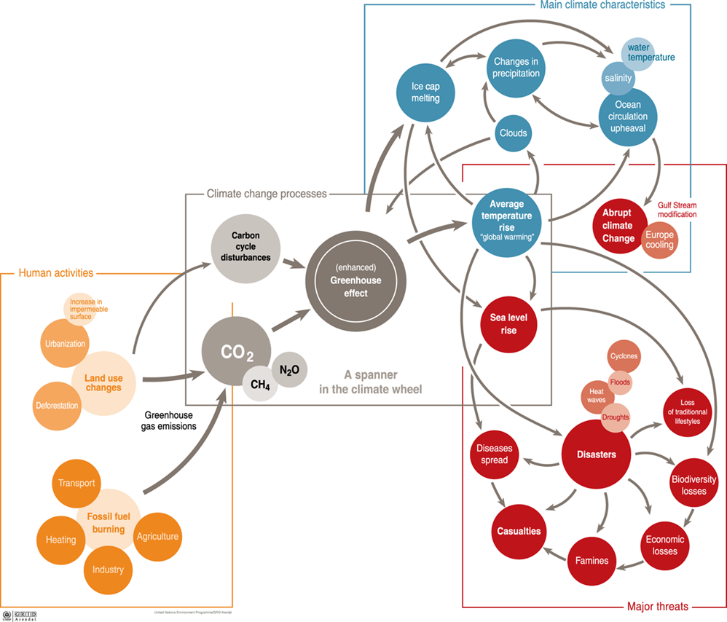

Figure 1. Climate change: processes, characteristics and threats. UNEP/GRID-Arendal, 2005
In short, the human activities in terms of fossil fuel burning and land use changes leads to increased CO2 emission that creates “greenhouse effect” leading to average temperature rise and ice cap melting. The effect is sea level rise and increase in natural disasters such as cyclones, floods, heat waves and drought. This leads to loss of traditional lifestyles, loss of biodiversity, famines, and casualties. This, in turn, leads to economic losses, and of loss of land, livelihoods and lives.

2.1 Global, regional and local perspectives
Climate change mitigation refers to efforts and means for reducing the anthropogenic drivers such as greenhouse gas emissions from human activities – especially by reducing emission of carbon dioxide (CO2) related to use of fossil fuel. These emissions steam from consumption that of course tends to be higher in rich industrialized countries. For instance, the megacity of Sao Paulo in Brazil produces one-tenth the emissions of San Diego in the United States, even though the latter is only one-quarter the size of the former (UN-HABITAT, 2008). However, the impact of this high level consumption in terms of global warming, tend to be worse for the poorest countries who do not have the resources for protection against the consequences such as possible sea-level rise, drought, floods, ect.
Vulnerable countries such as Bangladesh and most small island states therefore often claim to be the victim of climate change “crimes” caused by the richer part of the world. This issue of global responsibility is in the heart of the global climate change agenda. Bangladesh, for example, is one of the world´s poorest nations and also the country most vulnerable to sea-level rise. A sea-level rise of 1.5 meters will affect about 22,000 km2 and 17 million people that is 15% of the total population. Another example is the Himalayan counties like Nepal and Bhutan, sandwiched between two emerging economies India and China, which have high rates of CO2 emissions (in absolute terms). Considering that Nepal and Bhutan are in the receiving end of the impact from these emissions from their neighbours, and facing the risk of short-term climate change disasters, such as glacier lake outburst floods and also long-term projected decrease in water supply, they have to work diplomatically to prevent this from happening.
Loss of healthy life years as a result of global environmental change is predicted to be 500 times greater in poor African populations than in European populations. This global inequity is well presented in Figure 2 showing at the top the world in terms of carbon emissions; and at the bottom the world in terms of increased mortality from climate change.
The discussion above calls for mitigation of climate change through measures to be agreed by the developed countries such as setting targets for decreasing the emissions of carbon dioxide (CO2) related to use of fossil fuel. This is likely to be the biggest trade off issue at the global agenda at this early stage of the new millennium.
On the other hand, at the national level, the issue of climate change adaptation does not necessarily relate to the inequity between the developed and less developed countries. Adaptation to climate change can be achieved to a large extent through building sustainable and spatially enabled land administration systems. In fact, implementation of such systems will benefit all countries throughout the globe. The systems should enable control of access to land as well as control of the use of land. Such integrated land administration systems should include the perspective of possible future climate change and any consequent natural disasters.
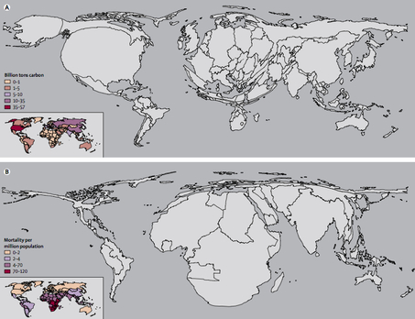

Figure 2. The world in terms of carbon emissions (top) and increased mortality (bottom)
http://voices.washingtonpost.com/ezra-klein/2009/05/why_should_america_prevent_cli.html
At the local level, at there is a need to identify, assess and manage vulnerable communities in relation to the complicated interaction between climate change, ecosystem degradation and increased disaster risk. Climate change increases the risks of climate-related disasters which cause the loss of lives and livelihoods, and weaken the resilience of vulnerable ecosystems and societies. The IPCC (2007) predicted that “The resilience of many ecosystems is likely to be exceeded by 2100 by an unprecedented combination of change in climate, associated disturbances (e.g., flooding, drought, wildfire, insects, ocean acidification), and other global change drivers (e.g., land-use change, pollution, over-exploitation of resources)”. Ecosystem degradation triggers more disasters and reduces nature´s and societies´ resilience against climate change impact. Healthy ecosystems, on the other hand, act as a buffer, protect societies from disasters and improve their ability to with the climate change impacts. Sustainable ecosystem management, therefore, should be included in the integrated land administration systems. (UNEP, 2009).
In conclusion, climate change is not a geographical local problem that can be solved by local or regional efforts alone. To address climate change, international efforts must integrate with local, national, and regional abilities (Chiu, 2009).
- SUSTAINABLE DEVELOPMENT

Sustainable development is the foundation of the global agenda that has changed over recent decades. In the 1990s the focus was on sustainable development; in the 2000s the Millennium Development Goals (MDGs) were adopted as the overarching agenda; and in the 2010s there is increasingly focus on climate change and related challenges such as natural disasters, food shortage and environmental degradation. Finally rapid urbanisation has appeared as a general trend that in itself has a significant impact on climate change and sustainability.

The global partnership for sustainable development as established through the UN Agenda 21 is a global action plan for sustainable development into the 21st century. Sustainable development is a process that aims to meet the needs of the present generation without harming the ability of future generations to meet their needs. It is not only about particular environmental issues such as species extinction and pollution but also about economic progress which meets all our needs without leaving future generations with fewer resources than we enjoy (UN 1992).

This global partnership is still the foundation of the global agenda. In striving for sustainability most countries have recognised the fundamental relationship between people and land. The overall goal of sustainable development is an equitably distributed level of economic and social well-being that can be sustained over many generations while maintaining the quality of the environment. This calls for the elimination of poverty and deprivation and it requires the conservation and enhancement of the resource base. This perspective is also enshrined in the UN Post 2015 Development Agenda (UN, 2012) with the four core dimensions of inclusive social development, environmental sustainability, inclusive economic development, and peace and security.

Land not only contributes to wealth and economic development. It is part of the social and political fabric that sustains all communities. Additionally, land represents a fundamental component of eco-systems. Managing the relationship between land and people inevitably and universally raises emotions and is at the heart of many cultural sensitivities. It is of crucial importance that the issues raised by land governance, management and administration are openly and sensitively addressed.

For environmentally sustainable economic growth and social progress, development policy issues must inform the work of the climate change community such as the two communities bring their perspectives to bear on the formulation and implementation of integrated approaches and processes that recognise how persistent poverty and environmental needs exacerbate the adverse consequences of climate change (IPCC, 2007).

In short, the linkage between climate change adaptation and sustainable development should be self-evident. Measures for adaptation to climate change will need to be integrated into strategies for poverty reduction to ensure sustainable development.

- LAND GOVERNANCE

Land governance is about the policies, processes and institutions by which land, property and natural resources are managed. Sound land governance requires a legal regulatory framework and operational processes to implement policies consistently within a jurisdiction or country, in sustainable ways. Land administration systems provide a country with an infrastructure for implementing of land policies and land management strategies in support of sustainable development.

Land management is the process by which the resources of land are put into good effect (UN-ECE 1996). Land management encompasses all activities associated with the management of land and natural resources that are required to achieve sustainable development. The organisational structures for land management differ widely between countries and regions throughout the world, and reflect local cultural and judicial settings. The institutional arrangements may change over time to better support the implementation of land policies and good governance. Within this country context, the land management activities may be described by the three components: Land Policies, Land Information Infrastructures, and Land Administration Infrastructures in support of Sustainable Development. This Land Management Paradigm is presented in Figure 3.

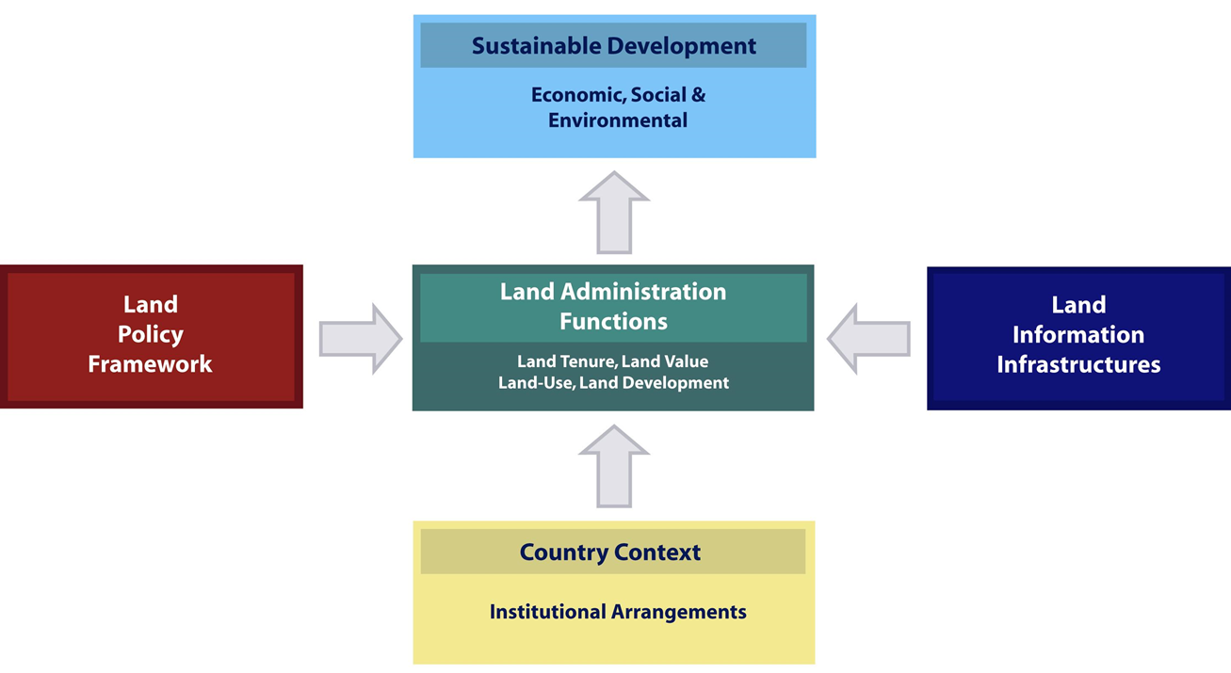

Figure 3. The Land Management Paradigm. (Enemark et.al., 2005; Williamson et.al. 2010).

The operational component of the land management paradigm is the range of land administration functions that ensure proper management of rights, restrictions, responsibilities, and risks in relation to property, land, and natural resources. These functions include the processes related to land tenure (securing and transferring rights in land and natural resources); land value (valuation and taxation of land and properties); land use (planning and control of the use of land and natural resources); and, increasingly important, land development (implementing utilities, infrastructure, and construction planning). These functions interact to deliver overall policy objectives and are facilitated by appropriate land information infrastructure that includes cadastral and topographic datasets.

Land policies vary, but in most countries, they include poverty reduction, sustainable agriculture, sustainable settlement, economic development, and equity among various groups within society. Policy implementation depends on how access to land and land-related opportunities is allocated. Governments regulate land related activities, including holding rights in land, supporting the economic aspects of land, and controlling the use of land and its development. Administration systems surrounding these regulatory patterns facilitate the implementation of land policy in the broadest sense, and in well-organized systems, they deliver sensible land management, good governance, and sustainability.

Sound land management requires operational processes to implement land policies in comprehensive and sustainable ways. Many countries, however, tend to separate land tenure rights from land-use opportunities, undermining their capacity to link planning and land-use controls with land values and the operation of the land market. These problems are often compounded by poor administrative and management procedures that fail to deliver required services. Investment in new technology will only go a small way toward solving a much deeper problem: the failure to treat land and natural resources as a coherent whole.

Land management activities reflect the development agents of globalization and technology. They stimulate the establishment of multifunctional information systems, incorporating diverse land rights, land-use regulations, and other useful data. A third force for change is sustainable development and a fourth driver could be added – namely climate change.

The climate challenge can be met to a large extent through integrated measures of land governance. Policies for climate change mitigation and adaptation can be managed and administered as part of national land administration systems. Such integrated land administration systems should include the perspective of possible future climate change and any consequent natural disasters. The systems should identify all prone areas subject to sea-level rise, drought, flooding, fires, etc. as well as measures and regulations to prevent the impact of predicted climate change. Key policy issues to be addressed should relate to protecting the citizens by avoiding concentration of population in vulnerable areas and improving resilience of existing ecosystems to cope with the impact of future climate change. Building codes may be essential in some areas to avoid damage e.g. in relation to flooding and earthquakes. Issues may also relate to plans for replacement existing settlements as an answer to climate change impacts (Enemark, 2010). This way, sustainable land administration systems can serve as a basis for addressing climate change mitigation and adaptation in an integrated way that will also function as a means of disaster risk management. This is illustrated in Figure 4.

Land Governance and climate change
Incorporating climate change into current land policies
Adapting standards for energy use, emissions, carbon stock potential, etc.
Identifying prone areas for sea level rise, flooding, drought, fires, …
Controlling the use of land in relation to climate change and disaster risks
Introducing carbon footprint assessments in relation to land use developments
Controlling building standards and emissions in relation to climate change and disaster risks
Improving resilience of existing ecosystems vulnerable to climate change.

Figure 4. Means of climate change mitigation and adaptation to be managed through sustainable land administration systems.

- THE ROLE OF LAND PROFESSIONALS

In facing the climate change challenge the role of land professionals is twofold: (i) monitoring change such as sea level rise and environmental degradation through global positioning infrastructures and data interpretation and presentation; and (ii) implementing climate change adaptation and mitigation measures into land administration systems and systems for disaster risk management. With regard to climate change surveyors, as land professionals, can make a valuable contribution to (Enemark, 2011):

- Designing and monitoring earth observation systems related to climate change

- Building data modelling systems for managing spatial data related to climate change

- Incorporating climate change measures into current land policies and regulations

- Devising and managing land governance systems using good governance and climate proof principles

- Advocating and leading policy discussions with politicians, NGO´s and civil society

The strengths of the surveyors relate to the combination of skills within surveying and mapping, spatial information management, and land management and administration. This combination is essential for contributing to the complexity of the climate change challenge. However, the linkage between climate change adaptation and sustainable development should be self-evident but is not well understood by the public in general. Land professionals should take a leading role in explaining this linkage to the wider public.

- BUILDING GLOBAL PARTNERSHIPS

The former UN Secretary General Kofi Annan observed, astutely, “While many people are aware of the terrible impact of disasters throughout the world, few realize this is a problem that we can do something about” (UN Publications, 2004).

Due to the dramatic impact on people and livelihoods and the loss of lives, there is little doubt that the increasing number of natural disasters is one the key issues of our time. Pre and post disaster risk management are therefore core areas for action. Natural disasters such as extreme weather conditions, hurricanes, flooding, draught, are often caused by the changing climate conditions. Climate change mitigation and adaptation is therefore also about managing the risk and consequences of natural disasters. The surveyors, as land professionals, have a key role to play in this regard (FIG, 2006).

Surveyors are the custodians of enabling technologies that are critically important to our future. They are experts in the measuring and mapping systems that are used for monitoring environmental change. It is incumbent upon surveyors to use this expertise to explain the purpose and need for monitoring, even minor climate related changes, thus taking a higher profile role in explaining to the wider public what climate change is all about. Surveyors, as experts in land administration and management, should also take a leading role in addressing the climate change challenge in the wider context of sustainable land governance. In this regard The International Federation of Surveyors (FIG) is committed to helping UN agencies such as UN- FAO and UN-Habitat, and the World Bank influence the global agenda in relation to the climate change challenge and designing measures for appropriate action.

One such area of co-operation lies in identifying land ownership and land use in disaster situations. Land issues are important components in the emergency relief phase of a disaster operation. While land is essential for emergency shelter and protection of displaced persons, poor selection of such sites, or poor responses, can lead to long term conflict or tenure insecurity. In addition, land is necessary for restoration of livelihoods. Land grabbing after a disaster is a key risk to effective protection and emergency shelter activity. Humanitarian actors are therefore confronted with land issues as they undertake emergency shelter and protection activity. These factors must be taken into consideration when preparing for such disasters (UN-HABITAT, 2010).

The ability to identify clearly individual land parcels and the rights attached to these parcels are essential elements of the reconstruction phase that follows the immediate humanitarian effort of saving lives and providing immediate relief. This reconstruction phase requires re-establishing the situation of legal rights to land and properties and the reconstruction of buildings and infrastructure in secure location. Sustainable land administration systems provide the basis for managing these processes.

A further area of cooperation, in this instance with the World Bank, relates to building and using land administration systems with a view towards identifying levels of potential disaster risk. Such risks can be identified as area zones in the land use plans and land information systems with the relevant risk assessments and information attached. Such disaster risk zones may relate to sea level rise, earthquakes, volcano eruption, flooding, draught, hurricanes, etc. By combining the disaster risk information with the relevant information on land tenure, land value, and land use the necessary risk prevention and mitigation measures can be identified and assessed in relation to legal, economic, physical, and social consequences.

- CLOSING REMARKS

The linkage between climate change adaptation, poverty alleviation, and sustainable development should be self-evident - but is not well understood by the public in general. Land professionals are custodians of an enabling technology and should take a lead role in explaining this linkage to the wider public and facilitating action.

In order to go down this integrated and participatory road - of bridging climate-change adaptation and development communities together to promote sustainable development - a strong political will and public commitment to promoting sustainable development is needed, focusing simultaneously on economic growth, social progress, environmental conservation and adaptation to climate change (IPCC, 2007, Chapter 20).

Overall, it is important to remember recalling that “Development needs to be climate ready, even if it cannot be climate proof” (The Economist, The World in 2011).

REFERENCES

Ban Ki-moon (2009): The time to act is now. In urban world, Vol.1, Issue 2, march 2009. UN-Habitat, Nairobi.
Chiu, Amanda (2009): The Changing Climate and a Warming world:
http://www.peopleandplanet.net/doc.php?id=754&section=8
Enemark, S. et.al. (2005): Building Modern Land Administration Systems in Developed Economies. Journal of Spatial Science, Vol. 50, No. 2, pp 51-68.
http://csdila.unimelb.edu.au/publication/journals/Building%20Modern%20Land%20Administration%20Systems%20in%20Developed%20Economies.pdf
Enemark, S. (2010): Land Governance and the Response to Climate Change, Natural Disasters and the Millennium Development Goals. Proceedings of FIG International Congress, Sydney, 11-16 April, 2010.
http://www.fig.net/pub/fig2010/papers/inv01/inv01_enemark_4661.pdf
Enemark, S. (2011): The climate change challenge; the role of land professional, Proceedings FIG Working Week, Marrakech Morocco.
http://www.fig.net/pub/fig2011/ppt/ps03/ps03_enemark_5442_ppt.pdf
FIG (2006): The Contribution of the Surveying Profession to Disaster Risk Management. FIG Publication No. 38. FIG Office, Copenhagen, Denmark.
http://www.fig.net/pub/figpub/pub38/figpub38.htm
IPCC (2007): Climate Change 2007. Fourth Assessment Report. Cambridge University Press.
IPCC (2013): Summary for Policymakers, AR5 to Working Group 1.
www.ipcc.ch/report/ar5/wg1/.
UN (1992): Agenda 21 on Sustainable Development.
http://sustainabledevelopment.un.org/content/documents/Agenda21.pdf
UN (2012): Realising the Future We Want for All. New York.
http://www.un.org/millenniumgoals/pdf/Post_2015_UNTTreport.pdf
UNEP/GRID-Arendal (2005): Vital Climate Change Graphics. Nairobi.
http://www.grida.no/files/publications/vital-climate_change_update.pdf
UNEP (2009): The Role of Ecosystem management in Climate Change Adaptation and Disaster Risk Reduction. Copenhagen Dicussion Series.
http://www.unep.org/climatechange/LinkClick.aspx?fileticket=rPyahT90aL4%3d&tabid=129&language=en-US
UN-HABITAT (2008): State of the World´s Cities 2008/2009. Harmonious Cities. Overview and Key Findings. Nairobi, Kenya.
http://www.unhabitat.org/pmss/listItemDetails.aspx?publicationID=2562
UN-HABITAT (2010). Land, Environment and Climate Change, Nairobi,
www.unhabitat.org/pmss/listItemDetails.aspx?publicationID=3022
‎Williamson, Enemark, Wallace, Rajabifard (2010): Land Administration Systems for Sustainable Development. ESRI Press. San Diego.
http://www.fig.net/news/news_shortstories.htm

BIOGRAPHICAL NOTES

Stig Enemark is Professor of Land Management at Aalborg University, Denmark. He is Honorary President of the International Federation of Surveyors, FIG (President 2007-2010) and Past President and Honorary Member of the Danish Association of Chartered Surveyors (DdL). He worked for 12 year as a licensed surveyor in private practice before entering the academic world. He is a well-known international expert in the areas of cadastre, land administration systems, land management and spatial planning, and related educational and capacity building issues. He has consulted and published widely in these areas. A full list of publications is available at: www.personprofil.aau.dk/100037

CONTACTS

Stig Enemark
Aalborg University, Department of Development and Planning
Skibbrogade 3 A1,
DK 9000 Aalborg,
DENMARK

Tel: +45 2242 2538
Email: enemark@land.aau.dk;
Web: http://personprofil.aau.dk/100037

