Building Fit-for-Purpose Land Administration Systems
- A joint FIG/World Bank Declaration

Stig ENEMARK, Denmark, Keith BELL, Australia,

Christiaan LEMMEN, Netherlands, Robin MCLAREN, United Kingdom

Key words: Land administration, Cadastre, Spatial framework

SUMMARY

Arguably sound land governance is the key to achieve sustainable development and to support the global agenda set by adoption of the Millennium Development Goals (MDGs). The operational component of land governance is the country specific land administration systems dealing with the four key functions of land tenure, land value, land, and land development.

Land administration systems - whether highly advanced or very basic – require a land parcel framework to operate. Building such a land parcel framework – showing the way land is divided into parcels and plots for specific use and possession - is not primarily about accuracy. It is about adequate identification and representation of the spatial objects and parcels; completeness to cover the total jurisdiction; and credibility in terms of reliable data being trusted by the users.

This paper is an abbreviated version of the joint FIG/Wold Bank publication no. 60 on “Fit-for-Purpose Land Administration”. It is argued that the land parcel framework should be developed using a flexible and fit-for-purpose approach rather than being guided by costly field survey procedures or over-engineered technology solutions. When considering the resources and capacities required to building such land parcel frameworks in developing countries, the western concepts may well be seen as the end target but not as the point of entry. When assessing the technology and investment choices the focus should be on building a fit-for-purpose framework that will meet the needs of society today and that can be incrementally improved over time.

The paper addresses some of the key technological, economic, legal, and social issues related to building fit-for purpose land administration systems in support of sustainable and transparent land governance especially in developing countries. Some key principles are presented and the main benefits and constraints are discussed along with the opportunities for land professionals when applying such a fit-for-purpose approach.

Building Fit-for-Purpose Land Administration Systems
-A joint FIG/World Bank Approach

Stig ENEMARK, Denmark, Keith BELL, Australia,

Christiaan LEMMEN, Netherlands, Robin MCLAREN, United Kingdom

- INTRODUCTION

This paper is an abbreviated version of the joint FIG/Wold Bank publication no. 60 on “Fit-for-Purpose Land Administration” (FIG/WB, 2014) presenting an innovative, flexible, and affordable approach to building land administration systems in developing countries that is jointly endorsed by the World Bank and the International Federation of Surveyors (FIG).

This is the result of cooperation between the World Bank and FIG over recent years to address the issue of building and sustaining land administration systems that are basically fit-for-purpose rather than blindly complying with top-end technological solutions and rigid regulations for accuracy.

The cooperation started by the joint FIG/World Bank conference in 2009 addressing the Land Governance in support of the Millennium Development Goals. A report from this conference can be found as FIG publication No 45 (FIG/WB, 2010). At the following annual World Bank Conferences on Land and Poverty concerns were raised by various stakeholders that the current procedures and requirements for mapping and boundary delineation were often too cumbersome and expensive and did not comply with the actual needs of most citizens for achieving security of tenure. Furthermore, many of the systems that have been established are costly to maintain and operate and do little to improve service delivery and access to land information. These concerns were subsequently addressed at several special seminars and workshops covering these issues including that of “Spatially Enabling Governments and Societies for Sustainable Land Administration and Management”.

Emerging from these events is the concept of “fit-for-purpose” indicating that land administration should be designed to meet the needs of people and their relationship to land, to support security of tenure for all and to sustainably manage land use and natural resources. This perspective calls for a flexible and pragmatic approach rather than requirements imposed through rigid regulations, demands for spatial accuracy and systems that may be unsustainable for less developed countries dependent on donor funding. Of course, such flexibility allows for land administration systems to be incrementally improved over time, should it be found necessary. This paper and the joint FIG/WB publication provide guidelines for the building of such fit-for-purpose land administration systems.

- JOINT FIG-WOLD BANK DECLARATION ON FIT-FOR-PURPOSE LAND ADMINISTRATION.

There is an urgent need to build cost-effective and sustainable systems which identify the way land is occupied and used and accordingly provide for secure land rights. When considering the resources and capacities required for building such systems in less developed countries, the concepts of mature, sophisticated systems as predominantly used in developed countries may well be seen as the end target, but not as the point of entry. When assessing technology and investment choices, the focus should be on a "fit-for-purpose approach" that will meet the needs of society today and that can be incrementally improved over time.

A fit-for-purpose approach includes the following elements:

- Flexible in the spatial data capture approaches to provide for varying use and occupation.

- Inclusive in scope to cover all tenure and all land.

- Participatory in approach to data capture and use to ensure community support.

- Affordable for the government to establish and operate, and for society to use.

- Reliable in terms of information that is authoritative and up-to-date.

- Attainable to establish the system within a short timeframe and within available resources.

- Upgradeable with regard to incremental improvement over time in response to social and legal needs and emerging economic opportunities.

A country’s legal and institutional framework must be revised to apply the elements of the fit-for-purpose approach. This means that the fit-for-purpose approach must be enshrined in law and that the information be made accessible to all users.

A fit-for-purpose approach will ensure that appropriate land administration systems are built within a relatively short time frame and affordable costs. The systems allow for incremental updating and upgrading. This approach will facilitate economic growth, social equity and environmental sustainability to be better supported, pursued and achieved.

- THE FIT-FOR-PURPOSE CONCEPT

The term “fit-for-purpose” is not new at all. What is new is to relate this term to building sustainable land administration systems. The term “fit-for-purpose land administration” indicates that the approach used for building land administration systems in less developed countries should be flexible and focused on serving the purpose of the systems (citizens’ needs such as providing security of tenure and control of land use) rather than focusing on top-end technical solutions and high accuracy surveys.

Flexibility is the key characteristic. It is about flexibility in terms of demands for accuracy, demands for spatial information and recording of legal and social tenure, and in shaping the legal framework to accommodate societal needs.

Another key characteristic is incremental improvement. The systems should be designed for initially meeting the basic needs of society today and have the capability to be incrementally improved over time in response to social and legal needs economic development, investment and also financial opportunities that may emerge over the longer term. Using a fit-for-purpose approach does not limit ambitions for an ultimate solution, e.g. solutions in line with some advanced systems used predominantly in developed countries.

The basic components of the fit-for-purpose concept are threefold:
- Using affordable modern technologies for building a spatial framework, e.g. orthophotos, showing the way land is occupied and used. The scale and accuracy of the mapping may vary according to building density, topography and other requirements.
- Based on the spatial framework, using a participatory approach to identifying and recording the various legal and social tenure rights associated with occupancy and use of the land.
- Adopting a legal framework that accommodates the flexibility necessary for implementing a fit-for-purpose approach. This framework may be established up front or it may be developed incrementally.

The fit-for-purpose concept directly supports what is called “Continuum of Continuums”. This term occurred in response to the view that the traditional cadastral systems - as known in most developed countries and which often operate with (high level) technical standards and a legal perspective - predominantly support freehold as the sought after form of tenure.

The concept “Continuum of Continuums” has many continuum dimensions:
• It recognizes that a continuum of tenure exists in terms of social tenure relationships, such as occupancy, usufruct, informal rights, customary rights, indigenous right and nomadic rights. In the same way, parties holding the rights may not only be natural or legal persons, but could be a family, tribe, community, village, or a farmers´ cooperative.
• Also the spatial unit may not only be a land parcel, but can also vary according to where the rights and social relationships apply, e.g. a point cadastre rather than a parcel boundary, or it could be text based or photo based.

• Similarly, one may talk about a continuum of data acquisition methods or technologies that will include what could be called “continuum of accuracy”.
• Another dimension could be a continuum of land recording and credit accessibility, ranging from informal land offices in an informal settlement to a governmental land registry.

The key point is that the systems should enable secure land rights for all and cover all land as a basis for land valuation and land use control. That also means securing the rights of the land held by the state. At the outset, the systems may vary from being very simplistic in some (rural) areas of the country while other (densely populated) areas are covered by more accurate and legally complete applications, especially where land is of high value and in short supply. Through updating and upgrading procedures the systems can then, in turn, develop into modern and fully integrated systems for land information and administration, where appropriate.

The change process necessary for implementing a fit-for-purpose approach to land administration can start today. Legal flexibility should be introduced as a basis for identifying and recording the spatial units in a more flexible way. The spatial framework, e.g. orthophotos – showing the way land is divided into specific plots for occupancy and use – can then be developed using a flexible approach and the various legal and social tenure rights can be recorded in a participatory way.

The fit-for-purpose approach implies that the role of the land professionals will significantly change. Field work will increasingly be undertaken by local field staff given the necessary short term training – while the land professionals will mainly oversee and manage the process and ensure that all aims, objectives and regulations are complied with. However, the land professionals will also benefit from this change through enlarging their base of services to include the total country population.

- LAND ADMINISTRATION AND GOVERNANCE

Land governance is about the policies, processes and institutions by which land, property and natural resources are managed. Sound land governance requires a legal regulatory framework and operational processes to implement policies consistently within a jurisdiction or country, in sustainable ways. Land administration systems provide a country with an infrastructure for implementing of land policies and land management strategies in support of sustainable development.

Such land administration systems need a spatial framework to operate. This framework may be very sophisticated and included as a basic layer of interactive land information systems, or, as suggested by the fit-for-purpose approach, it may be just an satellite/orthophoto imagery showing the way land is divided in to plots for specific use and possession. A global perspective for land management and governance is shown in Figure 1.
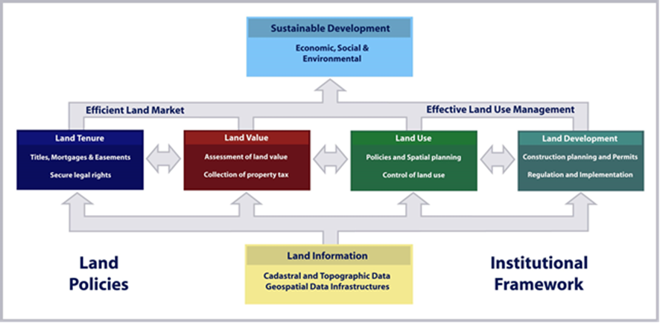

Figure 1: A global land management perspective (Williamson et.al., 2010).

The operational component of the land management concept is the range of land administration functions that include the areas of: land tenure (securing and transferring rights in land and natural resources); land value (valuation and taxation of land and properties); land use (planning and control of the use of land and natural resources); and land development (implementing utilities, infrastructure, and construction planning). These four functions interact to deliver overall policy objectives, and they are facilitated by appropriate land information infrastructures that include cadastral and topographic datasets linking the built and natural environment. Ultimately, the design of adequate systems of land tenure and land value should support efficient land markets, and adequate systems of land use control and land development should lead to effective land use management. The combination of efficient land markets and effective land use management are seen as a key component in delivering economic, social and environmental sustainability.

Sound land administration systems deliver a range of benefits to society in terms of: support of governance and the rule of law; alleviation of poverty; security of tenure; support for formal land markets; security for credit; support for land and property taxation; protection of state lands; management of land disputes; and improvement of land use planning and implementation. The systems enable the implementation of land policies to fulfil political and social objectives and to achieve sustainable development. Good land governance should also be seen as a means of supporting the global agenda such as the Millennium Development Goals (UN, 2000) and the following Post 2015 Agenda on “Realising the Future We Want for All” (UN, 2012) with the four core dimensions of inclusive social development, environmental sustainability, inclusive economic development, and peace and security.

- BUILDING FIT-FOR-PURPOSE LAND ADMINISTRATION SYSTEMS

Fit-for-purpose means that the land administration systems – and especially the underlying spatial framework of large scale mapping - should be designed for the purpose of managing current land issues within a specific country or region - rather than simply following more advanced technical standards. The land administration functions, as mentioned above and as shown in Figure 1, may place different requirements on accuracy and this again may vary depending on the context of geography and density of the use of land. Security of tenure does not in itself require accurate surveys of the boundaries. However, the important aspect is identification of the land object in relation to the connected legal or social right. The accuracy required for the purpose of planning and management of the use of land also varies considerably for different kinds of rural land uses versus the higher density of built up urban areas, and the same is the case for valuation and taxation of high value building sites versus marginally used rural areas. Such a flexible approach to building land administration systems also relates to the legal and institutional frameworks.

  - The Spatial Framework

The spatial framework is the basic large scale mapping showing the way land is divided into spatial units (such as parcels and plots) for specific use and occupancy. It provides the basis for dealing with land administration functions such as: recordation and management of legal and social tenure; assessment of land and property value and taxation; identification and management of current land use; planning for future land use and land development; delivery of utility services; and administration and protection of natural resources (see Figure 1).

In many developed regions of the world this countrywide spatial framework has been developed over about two centuries as large scale cadastral mapping and maintained through property boundary surveys conducted to a high accuracy according to long standing regulations and procedures. When considering the resources and capacities required for building spatial frameworks in less developed countries, the concepts predominantly used in developed countries should be seen as the end target, but not as the point of entry. Using such advanced technical standards of adjudication, boundary marking and field surveys are far too costly, too time consuming and capacity demanding, and in most cases simply not relevant, for providing an initial suitable spatial framework. The focus should therefore be on methods that are fast, cheap, complete, and reliable. The spatial framework can then be upgraded and updated whenever necessary or relevant in relation to land development and management activities. Also, the framework may well include volunteered information provided by citizens (crowd sourcing) where authoritative data are not required or available (Mclaren, 2013).

In relation to UN-HABITAT´s concept of the continuum of land rights, such a fit-for-purpose approach could be referred to as a “continuum of accuracy”. The key focus should be on providing secure tenure for all, and managing the use of land and natural resources for the benefit of local communities and society as a whole. The fit-for-purpose approach for providing the spatial framework can be outlined in four key principles (Enemark, 2013):
- General boundaries rather than fixed boundaries.

In the present context, the term "general boundary” means one whose position has not been precisely determined (although usually the delineation relates to physical features in the field) while “fixed” means that it has been accurately recorded. Using general boundaries will be sufficient for most land administration purposes especially in rural and semi-urban areas. Whereas fixed boundaries will contribute mainly to interoperability between legal and physical objects in advanced land information systems.

In the context of Sub-Sahara Africa – where only 30 percent of the land is included in the formal land administration systems – it is argued that use of a general boundary concept will be adequate and sufficient for incorporating the remaining 70 percent under more formalised land administration procedures. Fixed boundaries can then be used where relevant or necessary for any specific purposes or when required and paid for by the landowner/stakeholders.

- Aerial imageries rather than field surveys.

The use of high resolution satellite imagery (e.g. 50 cm pixels or better) or orthophoto imagery, e.g. in the scale of 1:2000 for rural and low density areas; and 1:500 scale for dense urban areas, will be sufficient for most land administration purposes. The required scale of the mapping depends on topography and density of development and may vary from large scale mapping in dense urban areas to smaller scale imageries in rural areas and remote regions. Boundaries can easily be identified on the imagery in most cases, depending on the visibility of the physical features. Experience, e.g. Ethiopia, shows that citizens have good spatial cognizance. They can normally easily interpret the imageries, and a participatory approach to boundary determination can then be easily applied. The remaining smaller number of non-visual boundaries can be added using hand held GPS or field survey measurements.

The use of imageries (including using Unmanned Aerial Vehicles - UAV) are considerably cheaper than field surveys and do not require the capacity of trained professionals to undertake the field work. It is estimated that compared to satellite / orthophoto imagery, field surveys are about three times more costly in rural areas and about five times in urban areas. Furthermore, the mapping methodology using imageries provides not only the spatial framework of spatial units, but also the general topography of land use and buildings and infrastructure, that is fundamental for the planning and land development functions of the land administration systems.

- Accuracy relates to the purpose rather than technical standards

Accuracy of the land information such as the parcel boundaries, should be understood as a relative issue related to the use of this information, rather than being driven by technical standards that are often inflexible and “over the top” for the purpose. In general, the need for accuracy is clearly lower in rural areas than in densely built up and high value urban regions, where accurate field surveys may be justified. But, more importantly, the need for accuracy of the various features should be determined by the purpose of using this information for supporting the various land administration functions. In this regard, the registration of legal and social tenure rights requires identification of objects, but the process does not call for a high accuracy in itself.

Also, planning and land development processes mainly require sufficient mapping for identifying physical and spatial objects rather than high accuracy per se. Any demand for accuracy may stem from issues such as high land value in dense urban areas or implementation of costly construction works. High accuracy through field surveys should therefore only be provided when needed and be paid for by the beneficiaries.

- Opportunities for updating, upgrading and improvement

Building the spatial framework is not a one off process – it should be seen in a perspective of opportunities for on-going updating, sporadic upgrading, and incremental improvement whenever relevant or necessary for fulfilling land policy aims and objectives. This of course requires that all mapping and surveys are linked to a national grid system through a positioning infrastructure based on the Global Navigation Satellite Systems (GNSS).

The requirement for on-going, updating procedures is essential in order to ensure that all data are complete and reliable. Without such procedures the investments are easily wasted over a relatively short period. The procedures should ensure that any new boundaries or changes of existing boundaries are recorded through measurements related to the existing boundaries or through provision of new imageries e.g. by using UAVs once the subdivision boundaries are established.

The opportunity for upgrading should be adopted wherever possible and allows for providing an improved map-base whenever needed for specific purposes, such as land development activities, major construction works and implementation of major infrastructure. This allows for incremental improvement that, in turn, will establish a spatial framework in line with modern and fully integrated land information systems.

The process for providing the spatial framework will include the following steps:
- Producing the satellite / orthophoto imagery at scales according to topography, land use, and building density. The imagery itself can be used for many purposes in relation to land use management processes, including compliance monitoring of land development investment, forest degradation and land cover change.
- The satellite / orthophoto imagery will be used in the field to identify, delineate and adjudicate parcel boundaries (general boundaries), which can be drawn directly on the imagery and the parcels be numbered for reference to the connected land rights (see Figure 2). This is basically a participatory approach that involves all local stakeholders.
- The resulting boundary framework can be digitised from the imagery to create a digital cadastral map to be used as a basic layer in the land information system or in combination with the satellite imagery.

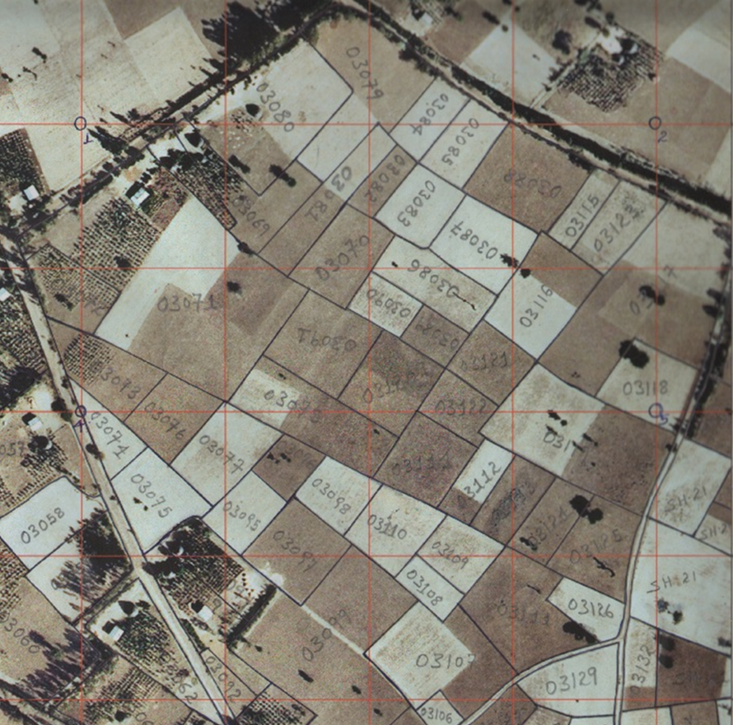
Figure 2. Orthophoto used as a field work map sheet with a georeferenced grid. The map shows the delineated parcel boundaries and parcel identification numbers (Ethiopia).

Any boundary disputes can be resolved during the adjudication process where all relevant stakeholders are present – or a special administrative body (rather than judicial) may be established for this purpose. In the longer term, boundary disputes relate to the way the boundary was determined when established in the system. It is therefore important to store the relevant map information in archives for this purpose.

  - The Legal Framework

In most less developed countries the legal framework for land administration reflects colonial times and often serves only the elite. The processes for land registration are complex, costly, time consuming and with high demands for accuracy of boundary surveys and often unnecessary legal interventions by notaries, lawyers and the court. The existing legal framework is therefore often a significant barrier for implementing a flexible approach to building land administration systems and the underlying spatial framework as described above. So, as well as the spatial framework, the legal framework should be flexible and be designed along administrative rather than judicial lines. Furthermore, the legal framework and its institutions must support both legal and social tenure, ensure that flexible regulations are enshrined in the laws and support a flexible approach as described above.

It is recognized that the legal frameworks as used in developed countries do not serve the millions of people whose tenures are predominantly social rather than legal. This relates to the Continuum of Land Rights (Figure 3) where the range of possible forms of tenure is considered as a continuum. Each continuum provides different sets of rights and degrees of security and responsibility and enables different degrees of enforcement (UN-HABITAT, GLTN 2008). As mentioned earlier, the figure does not imply that all societies will or should necessarily develop into freehold tenure systems. Importantly, the continuum of land rights indicates, that each step in the process can be formalised, with registered freeholds offering a stronger protection, than at earlier stages.

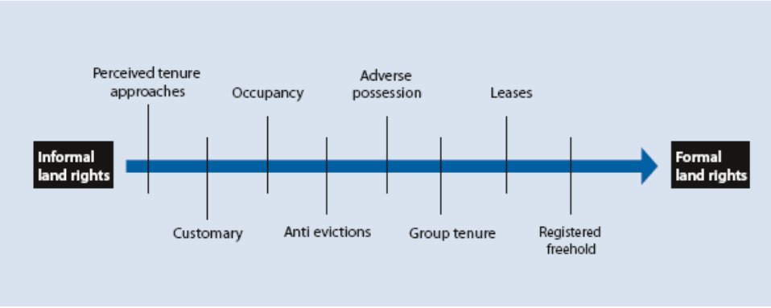
Figure 3. Continuum of land rights (UN-Habitat, 2008).

Each form of tenure has benefits and limitations in different contexts. Customary systems can meet social and economic needs and, although often not documented, can be very secure. However, this is often no longer the case as demand for communal land has surged in response to increased private investments in natural resources. Land grabbing and expropriation without proper compensation have been widely reported. Scaling up policies and registration of communal lands would help to protect the rights of local communities while reducing investment risks. By demarcating the outer boundaries of village lands the allocation and management of individual plots could be left to community institutions with the option to register individual rights as the need arises (Byamugisha, 2013).

The Social Tenure Domain Model (STDM), as mentioned earlier, supports the continuum of land rights. The STDM is a concept rather than a software package. The concept is flexible and enables all legal and social tenure rights to be captured (FIG/GLTN, 2010). The STDM is a sub-version of the new ISO standard on Land Administration Domain Model (ISO 19152, 2012) that presents a generic and inclusive solution as a way forward for building flexible land administration systems.

  - The Institutional Framework

This publication has focused on establishing the spatial framework covering all land and enabling security of land rights for all. This is due to the concern raised about often over-prescribed requirements for surveying and marking of boundaries that can be a major barrier in terms of costs, time, and available capacity. However, in addition, there is often an over-prescription of systems with high-end, expensive to maintain, enterprise geographic information systems and relational databases. Alternatives, such as open source solutions should be considered, e.g. the UN-FAO Open Source Cadastre and Registration Software (SOLA). Furthermore, the positioning/measuring equipment and systems advocated by consultants and vendors is also often over-prescribed.

It is recognised, however, that establishing the institutional framework in terms of efficient, accountable government workflows for making the systems operational is often an even bigger, expensive obstacle. This issue relates to a large extent to the political and administrative culture of the country and to the need for building sufficient capacity at societal, organisational and individual levels. The issue of capacity development is address in some detail in section 8.

- DISCUSSION

The discussion on building fit-for-purpose land administration systems – and especially the underlying spatial framework - includes a range of issue where some of these are clearly political while others relate to social equity, economic constraints, or professional standings. While most of these issues are touched upon above it is useful to address some of the key questions that are often raised in this regard.

- Why should less developed countries not have the same high level spatial framework (or cadastral systems) as is common practice in developed countries?
This question is of course relevant. The response mainly relates to the fact that the framework in most developed countries is developed over a period of about two centuries and in response to societal, institutional and technological developments. Less developed regions of course can´t wait for that. Building this spatial framework should be in response to current societal needs and available economic resources. These needs will be best addressed by adopting a fit-for-purpose approach as argued above, and the spatial framework can then be incrementally improved over time in response to societal needs and development.

- What are the constraints and barriers for adoption of fit-for-purpose approaches?
Constraints and barriers are often perceived to be political constraints, colonial legacy, lack of basic financial resources, and even lack of political will. This is compounded by a legal framework with rigid regulations that does not allow for a more flexible approach. However, this may not be entirely true. Politicians will often rely on professional bodies to advise on specific professional issues. These groups of professionals, such as lawyers, surveyors, planners, etc., are highly educated and act as custodians of existing land administration systems mainly developed by colonial powers and serving mainly the elite. It is no surprise that their professional codes support the existing systems, and there are many examples of resistance to change that will challenge their position. However, by including all land in the formal land administration systems, the land professionals will make a more significant contribution to social development and, at the same time, also enlarge their functions and clientele.

- What are the key benefits?
Experience shows that a fit-for-purpose approach is adopted mainly when there is strong political leadership for change in support of secure land rights for all. This kind of leadership, so to say, bypasses the professional arguments by setting a deadline for completing the project of identification and registration of land rights. By setting a firm deadline – say five years as was the case in Rwanda – there is no way this can be accomplished using the traditional field surveys.

Instead, new approaches have to be developed while still meeting the overall land reform aim and objectives. In this situation, the fit-for-purpose approach is the obvious choice. It is participatory and can be accomplished by using less professional personnel in the field. The use of imageries / orthophotos enables a number of further uses for land management, and the process is flexible to accommodate both in terms of accuracy needs and budgetary allowance.

Benefits arise by achieving a functional system covering all land and people within a short time, for relatively low and affordable costs, and supporting incremental improvement when relevant and required. This again will enable achievement of political aims and objectives in relation to economic growth, social and gender equity, and environmental sustainability.

- What are the opportunities for Land Professionals?
Even if the land professionals may to some extent be reluctant to comply with this kind of fit-for-purpose approach, it actually offers a range of opportunities. Firstly, the land professionals will obtain an increased client base by being able to serve the total population rather than only a small elite. Furthermore, the approach implies that land professionals will undertake a more managerial role in relation to managing and using the land related data rather than just creating them. The land professionals will be responsible of the process for establishing the system and also for training, managing and supporting the locally trained staff to carry out the field work. This managerial role also includes quality assurance and auditing as well as custodians of land information management. In the longer term the professional status of the land professionals will be improved through contributing to the overall aims and objectives for societal development.

The profession is being seriously challenged to solve land issues faster. Land professionals are at a very significant juncture and if a comprehensive journey of change is not successful then other professions or government generalists will most possibly fill the vacuum. Land Professionals need to seize this moment and great opportunity.

- CONCLUDING REMARKS

A wide range of initiatives under the umbrella of the Global Land Agenda are delivering: voluntary guidelines on responsible governance of tenure (FAO, 212); effective approaches to creating land policy frameworks (AU, ADB, UNECA, 2009); monitoring and evaluation tools to strengthen land policies and associated operations (World Bank, 2011); and tools for implementing land administration solutions (UN-HABITAT/GLTN, 2012). However, despite these interventions progress is limited, and will remain restricted, due to the lack of comprehensive information on the evidence of land rights and associated security of tenure. Although policy frameworks and guidelines are essential for good land governance, the real bottleneck is in how Land Professionals capture and maintain evidence of land rights. Current solutions are not scalable, even with new emerging generations of technology solutions, and will never realistically deliver security of tenure to the remaining 75 percent of the world’s population in appropriate timeframes.

This current security of tenure vacuum restricts access to formal land markets, severely limits engagement with economic development and is increasingly generating social instability through land disputes and land grabbing. Without access to land and security of tenure, the poor and the disadvantaged will remain trapped in poverty. This fit-for-purpose approach being proposed here offers land professionals the opportunity to make a significant improvement in global land issues. It is a realistic, participatory approach that is scalable and could make a noticeable difference in the intermediate timeframe. However, this is potentially a controversial paradigm shift for land professionals as it implies a radical change in role for the profession; a transition from a field operational to a management role.

As with all cultural and behavioural change, it has to be well managed. Otherwise opposition to change will stop this paradigm shift happening or, equally as bad, slow the process down. Ensuring advocacy for change and providing support to change management is a key role for organisations like the World Bank, UN-FAO, UN-HABITAT, FIG and other land related professional bodies. The following steps should be supported by these organisations:

- The politicians and decision makers in the land sector are key in this change process and need to become advocates of change through understanding the social and economic benefits of this journey of change. This will then allow any legal framework and professional barriers to be dismantled.
- The hearts and minds of land professionals need to be turned to fully understand and embrace the fit-for-purpose approach. This will require the benefits of such a move to be clearly articulated so that any perceived threats are dissipated.
- Effective capacity building is fundamental to success; society must understand that these simpler, less expensive and participatory methods are just as effective and secure as traditional surveying methodologies; and formal organisations such as government agencies, private sector organisations, or informal organisations such as a community based or voluntary organisations need to ensure the awareness and up-to-date skills of their members and staff.
- The largest change will be focused on the public sector where this may involve institutional and organisational reforms, including legal framework, processes and procedures, and awareness in terms of incentives and accountability.
- To drive this change process there must be effective knowledge sharing to ensure the lessons learned and good practice are widely implemented

It is hoped that the joint FIG/WB publication will pave the way forward towards implementing sustainable and affordable land administration systems enabling security of tenure for all and effective management of land use and natural resources. This, in turn, will facilitate economic growth, social equity, and environmental sustainability.

REFERENCES

AU, ADB, UNECA (2009): Framework and Guidelines on Land Policy in Africa. http://rea.au.int/en/sites/default/files/Framework%20and%20Guidelines%20on%20Land%20Policy%20in%20Africa.pdf
Enemark, S. (2013): Fit-for-purpose: Building Spatial Frameworks for Sustainable and transparent Land Governance. Paper presented at Word Bank Conference on land and Poverty, Washington D.C., 8-11 April 2013.
http://www.conftool.com/landandpoverty2013/index.php?page=browseSessions&form_session=21&presentations=show
FAO (2012): Voluntary Guidelines on the Responsible Governance of Tenure of Land, Fisheries and Forests in the Context of Food Security. Rome.
http://www.fao.org/docrep/016/i2801e/i2801e.pdf
FIG/WB (2014): Fit-For-Purpose Land Administration. FIG Publications No 60, FIG Office, Copenhagen. http://www.fig.net/pub/figpub/pub60/figpub60.htm
FIG/GLTN (2010): The Social Tenure Domain Model. FIG publication no 52, FIG Office, Copenhagen, Denmark. http://www.fig.net/pub/figpub/pub52/figpub52.htm
FIG/WB (2010): Land Governance in Support of the Millennium Development Goals – A new agenda for land professionals. FIG publication no 45, FIG Office, Copenhagen, Denmark. http://www.fig.net/pub/figpub/pub45/figpub45.htm
ISO (2012). ISO 19152:2012, Geographic Information - Land Administration Domain Model. Edition 1, Geneva, Switzerland. http://www.iso.org/iso/catalogue_detail.htm?csnumber=51206
McLaren, R. (2012). Crowdsourcing Support of Land Administration. Paper presented at Word Bank Conference on land and Poverty, Washington D.C., 23 - 26 April 2012. http://www.landandpoverty.com/agenda/pdfs/paper/mclaren_robin_paper.pdf
UN (2000): United Nations Millennium Declaration. Millennium Summit, New York, 6-8 September 2000. UN, New York. http://www.un.org/millennium/declaration/ares552e.pdf
UN (2012): Realising the Future We Want for All. New York. http://www.un.org/millenniumgoals/pdf/Post_2015_UNTTreport.pdf
UN-HABITAT, GLTN (2008): Secure Land Rights for All. https://www.responsibleagroinvestment.org/sites/responsibleagroinvestment.org/files/Secure%20land%20rights%20for%20all-UN%20HABITAT.pdf
UN-HABITAT, GLTN (2012): Handling Land – Innovative Tools for Land Governance and Secure Tenure. Nairobi. http://www.unhabitat.org/pmss/listItemDetails.aspx?publicationID=3318
Williamson, Enemark, Wallace, Rajabifard (2010): Land Administration Systems for Sustainable Development. ESRI Academic Press, Redlands, California, USA. http://www.esri.com/landing-pages/industries/land-administration/e-book#sthash.Lp4BYcKW.vmY1XWxG.dpbs
World Bank (2011): Land Governance Assessment Framework. Washington, http://www-wds.worldbank.org/external/default/WDSContentServer/WDSP/IB/2011/11/24/000386194_20111124011109/Rendered/PDF/657430PUB0EPI1065724B09780821387580.pdf.

BIOGRAPHICAL NOTES

Stig Enemark is Honorary President of the International Federation of Surveyors, FIG (President 2007-2010). He is Professor of Land Management at Department of Development and Planning, Aalborg University, Denmark.
Email: enemark@land.aau.dk

Keith Clifford Bell joined the World Bank in 2003 where he has responsibility for leading the World Bank’s land administration and management program throughout the East Asia Region. Previously he was the Surveyor General of Victoria, Australia.
Email: kbell@worldbank.org

Christiaan Lemmen is international consultant at Kadaster International, the Netherlands. He is chair of the Working Group 7.1 “Pro Poor Land Tools” of FIG Commission 7, and director of the FIG Bureau of Land Records and Cadastre, OICRF.
Email: Chrit.Lemmen@kadaster.nl

Robin McLaren is director of the independent consulting company Know Edge Ltd, UK. He has supported many national governments in formulating land reform programmes and National Spatial Data Infrastructure (NSDI) strategies.
Email: robin.mclaren@KnowEdge.com

