# Can Participatory Action Research Create Value for Business Model Innovation?

Ole Horn Rasmussen *

OHR

Birkevej 30, 9000 Aalborg, Denmark

E-mail: ole.horn.rasmussen@gmail.com

Mogens Sparre

Aalborg University, Denmark

Fibigerstraede 4, 9220 Aalborg, Denmark

E-mail: sparre@business.aau.dk

Michael Fast

Aalborg University, Denmark

Fibigerstraede 4, 9220 Aalborg, Denmark

E-mail: fast@business.aau.dk

* Corresponding author

**Abstract:** Participatory Action Research (PAR) has a longer academic history compared with the idea of business models (BMs). This paper indicates how industries gain by using the combined methodology. The research question – “Can participatory action research create value for Business Model Innovation (BMI)?” – has been investigated from five different perspectives based upon The Business Model Cube and The Where to Look Model. Using both established and newly developed tools the paper presents how. Theory and data from two cases are presented and it is demonstrated how industry increase their monetary and/or non-monetary value creation doing BMI based upon PAR. The process is essential and using the methodology of PAR creates meaning. Behind the process, the RAR methodology and its link to BM and BMI may contribute to theory construction and creation of a common language in academia around the idea of BM and BMI.

**Keywords:** Business Model Innovation; Participatory Action Research; Case Study; Business Model Cube; Where to Look Model; Process; Meaning; Language; Theory Construction.

1. Indtroduction

One of the most important elements in modern management is the ability to create and execute sustainable change in organizations. In Strategy Safari (Mintzberg, Ahlstrand & Lampel 2005) use Mintzberg the metaphor about the five blind men, who should visit and explore an elephant. One point of that metaphor is that the manager should be able to forget his own picture of his elephant, if not, he will never be able to see other possible pictures of an elephant. New pictures of elephant will always be compared to the old picture, and if it is too far away from the old picture, it will be rejected.

*"The limits of my language means the limits of my world”* (Wittgenstein 1994 (1922), chapter 5 page 6).

The Austrian language philosopher Ludwig Wittgenstein considered the language as a construction of reality. Spender who has been elaborating on the notion of strategy since his dissertation in 1980 ends up by referring to strategy as a language (Spender 2014). Spender also links the idea of strategy to business models and business models as a language. In that manner, Spender is relevant to the theoretical positions in this article. In addition (Mintzberg, Ahlstrand & Lampel 2005), Drejer and Grabow (Drejer, Grabow 2016) list 10 possible ways or schools to the phenomena strategy. All these strategy approach represent an unique picture of the elephant. In other words: There are different possible ways for the manager to create a possible picture of the future. However, even this article has focus on how Participatory Action Research (PAR) can create results for the process of business model innovation (BMI) and strengthen the strategic dimension of the work done by managers, the article is not going into an elaboration on the definition of strategy. However, exactly the main model of reference in the paper – The Where to Look Model - addresses the issue around the elephant metaphor. Consequently, the conclusion will end up with some consideration for the work with the idea of strategy in future research and how the idea of strategy is related to the theoretical and methodological foundation.

The idea of the paper can be summarized as follow. First there is a short presentation and discussion of what models the paper has as point of reference to the empiric data. Because the paper is written by two initial different kinds of theoretical perspectives both must be briefly elaborated and the idea of linking them will be presented.

Having established a common theoretical platform, the attention is turned toward the methodological issue and the use of PAR. PAR is not a paradigmatic concept but a multiple and cross-disciplinary concept. Focus is the tree elements – Action, Participation and Research. The data collection methods have been conducted using some dogma rules. These will be presented in the cases. Another element has to do with the use of tools. And third, the process of PAR must generate value for the participants to keep their engagement. The PAR method in Case one uses a quite restrictive procedure working with industry. The reason has to be found in the researchers intentions to contribute to a theory of business models and business model innovation. Here the elaboration of new tools is central- This PAR methodology and its data collection has been conducted in the period 2011-2016 with several different cases. In this paper one case has been chosen. The second PAR method represents a longitudinal study covering a three years period and is a result of a Ph.D. dissertation(Sparre 2016). Contrary to the first PAR case study the second study’s Co-researchers conducted some very restricted dogma rules without specific references to any tools or BMs. A central point in both cases is the creating of new insights and a new and shared common language about the organizational context and its BMs. The creation of a new intersubjective life-world in the organization will as Wittgenstein tells, create new limits for the future. The creation of a common language means that that participants creates common meanings - they creates a new intersubjective lifeworld in the organization. In relation to the citation from Wittgenstein, they have moved their language limitations, or the border, of there language and created something new and different.

In the conclusion, we discuss the importance of PAR in the process of BMI and how future research can contribute to a theory of BM and BMI. Part of this discussion involves the idea of generalisation versus subjectivism, because of its relevance for theory construction.

2 The Research Question and the Methodological Platform

*Our models of reference*

Our research question is: Can participatory action research create value for BMI? Consequently, the paper aims to offer a tentative answer to the research question. The theoretical and empiric contributions within this paper are initially on the one side. On the other side, some practical and theoretical positions are established and we have material, which in the future can assist us in the establishment of a contribution to a theory of BM and BMI. Basic is the idea that business and economic understanding is about models and the question of choosing a model with the potential to be capable of contributing to answer the research question. This is a statement from Keynes. He underlines this alternatively:

*The object of our analysis is, not to provide a machine, or method of blind manipulation, which will furnish an infallible answer, but to provide ourselves with an organised and orderly method of thinking out particular problems; and after we have reached a provisional conclusion by isolating the complicating factors one by one, we have to go back on ourselves and allow, as well as we can, for the probable interactions of the factors among themselves. This is the nature of economic thinking. Any other way of applying our formal principles of thought (without which, however, we shall be lost in the wood) will lead us into error (Keynes 1936 (1997), page 297)*

In appendix 1 we present two models, which are our general models of theoretical reference. Crossan et. Al (Crossan, Fry & Killing 2004, page 42) have evolved a model with reference to an organisation (industry/a business) and its surroundings. The other model is elaborated by the ecological economist Norgaard (Norgaard 1994, Norgaard 2006). Both models are a challenge to the established linear thinking from e.g. neoclassical and marxist inspired models. A main point in both models is the idea of how intertwined the elements in the model are. Of course one can discuss why there are no direct link between all the elements in the model by Crossant et.al., which e.g. is the fact in the co-evolutionary model evolved by Norgaard (Norgaard 1994, Norgaard 2006). One explanation could be that Norgaard has a macroeconomic reference while Crossan et.al model has roots in business and management? However, Crossan et. Al. point out:

*“Each variable in the Diamond-E relates directly or indirectly to each of the others”* (Crossan, Fry & Killing 2004, page 43)

Both models are part of our methodological platform. However, from a more operational point of view we have tools and research designs that also are models. In this paper we present 3 more models. The first two models have point of departure in the theoretical focus on BM and BMI and the need for tools to assist industry in their BMI process. From at methodological perspective the Cube Model (Appendix 2) and The Where to Look Models represent general models. And both models act as heuristic tools for both cases. The third model has reference to the longitudinal study (Appendix 4). That model is from another theoretical perspective. Here we have a functionalistic perspective. The functionalistic models are used in the process as tools, and not as models of explanation In practice we see our cases from at subjectivist perspective. In both cases we see our process and case as unique. From this perspective we have a descriptive view in our approach.

3. Our perspective to Action Research

Action research has become increasingly popular around the world as a form of involving practitioners in creating their own work reality (McNiff, Whitehead 2011 (2005)). A major attraction of action research is that everyone can do it, because it has a very open approach to theory of science. Within action research project communities or organizations inquiry and action evolve and address questions and issues that are significant for those who participate as co-researchers. Schön (Schön 1983) describes action research as essentially experimentation in the field. The implication for action research as an egalitarian collective problem-solving activity rooted in interpersonally sensitive and mutually supportive dialogue is that things will go better when those involved experience secure relationships on as many levels as are relevant to the activity (Wicks, Reason & Bradbury 2008, page 85).

We can then use action research when we want to improve our understanding, develop new learning or influence others learning. Don’t use action research if you want to draw comparisons, show statistical correlations or demonstrate a cause and effect relationship (McNiff, Whitehead 2011 (2005), page 16). There is no major alternative strategy, organisational change and social research than Action Research (Levin & Greenwood, 2008, p 29). It is important to remember that action research is value laden and have a morally commitment, and the researchers perceive themselves as in relation with another in the social contexts. Action researchers always see themselves in relation with others, in terms of their practice and their ideas, and with the rest of the environment. We do not adopt a spectator approach or conduct experiments on others (McNiff, Whitehead 2011 (2005), pages 29). Our practitioners are not guinea pigs in a project.

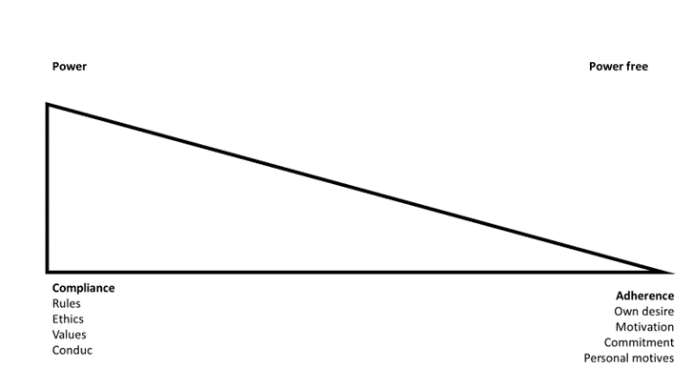

**Figure 1** (Sparre 2015, page 143)

When we invite some volunteers into an organizational development work, we are not so naive that we do not see the subjects still is a part of the usual, and normal, power structures. In our research, it is a vision to create a power free environment for our Co-researchers and we do that by empowering them as much we can. We believe that we can release a lot of internal resources if our Co-researchers participate because they want to, and not because their boss tells them to do so. The research design model for case two in appendix 4 illustrates how the process is organized.

When you work “In” the organization you are still in the overall power structure, but if we can create a room where we work “With” the organization we can soften the prevailing power structure. In our methods, we involve and engage the participant as volunteer participants.

The first case has as it point of departure a firm framework and tools as its foundation. The PAR methodology differs from the second and may be termed more pragmatic. In the second case, the participants decide the framework and the tools they chose to work with. The second PAR case has reference to Duus et.al.(Duus et al. 2012, pages 29). It was primary driven by the co-researchers. In the first case the researchers acted as facilitator and put the agenda. In both cases knowledge creation is a collaborative process where the researchers will never be able to create that knowledge by just observing or interviews. Innovative practices have developed in groups and have a shift from “I” to “We”.

**4 Empiric Cases**

*Introduction - The Business Model Cube and The Where to Look Model and the link to our cases*

We have chosen to present two BMI cases. The first case is a Danish SME industry with around 40 employees and the second case is a Danish subsidiary to a multinational company. The empiric data and the results of the process of BMI for the two businesses have different point of references to the Vertical Butterfly or what we pronounce “The Where to Look Model”. The model involves the Business Model Cube – shown in appendix 2 – that was presented in 2013 (Lindgren, Horn Rasmussen 2013). It was first presented in an article in 2015 (Horn Rasmussen, Lindgren 2015) and presented at the ISPIM conference, Boston 2016 in a revised version (Horn Rasmussen et al. 2016).

The Vertical Butterfly rests upon one crucial assumption.

*Hypothesis: Any business consists of multiple business models*

The ambition, which represents the reason for the invention of the Vertical Butterfly, was the need for putting a BM into a real life perspective where the definition of the surroundings – the meso and macro level of the economy – was an integrated part. The result of the first model is shown here:

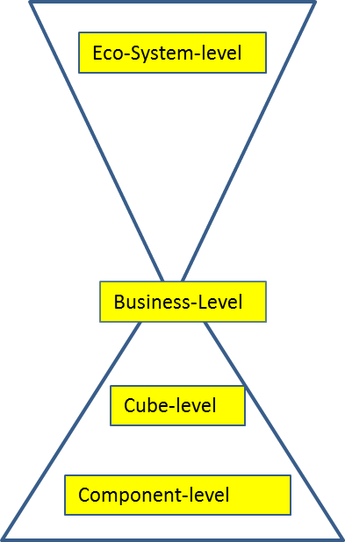

**Figure 2** The first version of The Vertical Butterfly (Horn Rasmussen 2013 (January))

The bottom triangle symbolize a definition of a business with business level, cube level and component level, while the upper triangle represent the eco-system where the business operates. This is a very simple and superflicious figur. However, the model reflects the crucial answer about “Where to Look”, when a business prepare and implements BMI processes. From a practical heuristic perspective we have different models of The Where to Look Model depending on where the BMI focus is placed. Often a business operates with a BMI focus from a business level perspective – like the model above. However, the perspective – or as we pronounce it “Level of Abstraction” – can be many. In the model beneath the different perspective is demonstrated:

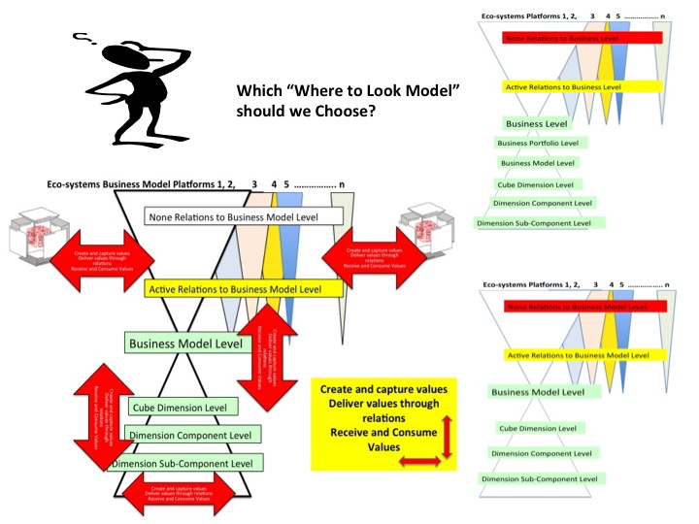

**Figure 3** Different Where To Look Models and different BMI perspective

A main point here is that exactly the question of which level of abstraction we are talking about has a fundamental influence for creation of a common language between the participants in the process of BMI. Many times we have experienced that participants mix the levels and in that sense are “speaking different language” which is an obstacle for optimization of the process of BMI.

With reference to the model we will present 5 examples of BMIs representing focus at:

1. Eco-system level
2. Business level
3. Business Model Portfolio Level
4. Business model level
5. Component level

The first case covers perspective 1-3. We have a business that implemented a multiple BMI process as they became more and more familiar with the theoretical and practical framework. The second case has a component perspective. It is a kind of post rationalistic construction, where the case ex-post has been put into order with reference to The Where to Look Model. In order to prevent confusion we must underline that the use of the Cube not only refers to BM-level but also business level and eco-system level by definition (Horn Rasmussen, Lindgren 2015, Horn Rasmussen et al. 2016).

*Case 1 – An example of BMI at cube-, portfolio-, business- and eco-system level*

*A short introduction to the organization*

A family owned business had been under heavy pressure and operated at a very competitive market dominated by price competition. The industry had 36 employees, the profit was low and the business was characterized by a kind of “day to day struggle” for survival. In 2012 an external partner entered the business with 10% of the shares. As researchers we were asked to assist the business with some guidelines. We identified a prober EU-funding-program for knowledge transfer between universities and industry and made an application. Based upon this public support program the business started a without having any deeply knowledge about its content and consequences.

*Design and methodology*

Any case has as point of departure the demand from the participants - the business. The selected case is one among several cases with the same reference concerning research design. Point of departure for the research design had been the theoretical ambition to contribute to the idea of BM and BMI. However, in order to do so it is necessary to establish close links to industry. Working together with industry means that industry must have a motive and the motive is the idea that a corporation with researchers in some way contributes to the value creation in the industry. From a methodological point of view this indicates two objects. The first object is improvement of theoretical work around the idea of BM and BMI. This includes improvement of useable practical tools for the industry. The second object is the practical process with the industry. While the first object by nature is a long term process including a process of trial and error, the second process has both elements of short, medium and long term. What dominates the second process changes from case to case. In this case point of departure for the business was the short term. Having two objects and consequently two parallel processes the research design operates with two kinds of labs. A theoretical production lab and a practical industrial case or course lab. While the researchers participate in both labs the involved business participate only in the practical lab. Normally the practical lab starts being a classroom, a camp location or a meeting room in the business where the researchers have brought different material and tools from the researchers framework. Up to now there are innovated 4 tools – The Cube, The BeeBoard, The Relation Axiom and The Vertical Butterfly/The Where to Look Model (Horn Rasmussen et al. 2016, Horn Rasmussen, Lindgren 2015). When appropriate the tools can be supported by other management tools. The work with the industry is arranged around three activities:

1. Workshops with a duration of maximum 7 hours
2. Home work done by the business – after each workshop home assignments were defined
3. Advisory service between the workshops from the researchers

Workshops are the practical cornerstone. In the workshops different tools and the theory behind the tools are presented. This is executed during a combination of lectures and discussion on the one side. On the other side the participants implement active mapping. Any activity must involve the participants and be meaningful for them. Point of departure is one of the dimensions in the cube presented in appendix 2. The participants chose where to start. Because the process of mapping can be difficult due to the complexity of the theoretical framework repetition of different elements in the dimensions normally is needed during the workshops.

Inspired by Scharmer (Scharmer 2009) mapping in different phases has become a hard core in the methodology. The phases are:

1. Downloading – how the participants define the BM - the different dimensions of the cube from their point of view
2. Seeing – how the mapped BM may be understood from other perspectives
3. Sensing – which scenarios can be chosen to improve the BM

There are few rules in the process. The most important rule is that any new idea or proposals for the BM coming up must be written down. However, the idea or proposals is parked until phase 3.

*Data collection and the BMI process*

In the process of data collection there was several sources. The industrial lab is a main source. In the case the lab evolved from being the classroom at the university in the first workshop to be a lab established in the business from the second workshop and on. After several workshops the business designed their own workshop room with the tools. The room they named their “War-Room”. During the workshops and between the workshops the researchers registered the activity, comments and question from and between the participants. The lectures and the facilitation of the process was lead by the researchers. And the researchers facilitating were also the contacts persons to the participants. In the process there suddenly came a need for going deeper into marketing and strategy of marketing. In that case there was arranged a specific workshop with lectures. The results were used in the scenario phase. In the process every new workshop started with a discussion and evaluation of the results of the home assignment. The home assignments so to speak were what linked together the process.

*Result for the Business and results for Academia*

When the business began the participants were asked independently to draw the business. They produced five very different drawings. It was obvious that the drawings reflected their different positions in the business. One could argue that the drawings represented different languages. In the end of the BMI process the participants had created another and much more firm picture of the business. First of all they had mapped 79 existing BM. s that were on-going. The BMs was arranged into 4 business model portfolios. And a fifth BM portfolio was under introduction. While the four existing BM portfolio were mapped with point of departure at business level, the fifth portfolio had its point of departure in the concrete oil and gas eco-system, which the business was familiar with. To the first workshop they brought a suitcase with different technical equipment. This was a suitcase that had been sold one time and indicated, the business had problems by exploring the potential by their existing BM. That meant their BMI process at BM-level was not successful. By modeling and introducing a new BM for a potential partner the foundation of the fifth portfolio started. The business simply arranged existing products and services into new BMs with new types of customers. The point was that the existing BM did not have any relation to eco-system where the customers BMs operated. This process from an inside focus to an outside focus changed the BMs with relevance to a new BM portfolio. Besides these results the business in general created a common language among the key-persons in the business. A rather crucial result came quite soon in the process of BMI. Based upon a longer process of mapping value flow during relations it became obvious that the business had an organizational challenge. Too many relations passed through the financial manager. The risk of stop in the value chains simply had too much potential. The business started to work on this challenge in their organization. The last result that must be mentioned has to do with lack of focus on existing BMI activities and the cost. In the start the business was asked to the innovation cost of the products in the suitcase. This was the key-BM of the fifth BM portfolio and their point of departure for the whole workshop course. They did not knew it. However, after some internal discussions they concluded that the cost nearly was 5% of the total yearly turnover of the business. Based upon one of the frameworks rules a change was implemented. From this moment any new idea and use of time on the ideas came into a more systematic system. It can be argued that the business already here changed their position towards a more strategic BMI. One may also argue that they invented and implemented a new internal organization system BM. In general many other illustrations could be mentioned. However, the point is that the business changed their methodological approach with point of departure in the PAR process. It was a change from a try and error methodology towards a more strategic and first of all a more knowledge based methodological approach. Referring to value creation the business raised its turnover so it is approximate 40% higher and the profit better. Referring to non-monetary values the business got a common language among the board members, the management and the employees, new knowledge about the business and its BMs, a more efficient value chain with less stop/go situations and a higher employee well-being.

From an Academia perspective the case is just one by several workshop courses with different industries and students that has contributed to test and evolve the theoretical and methodological approach concerning BM and the process of BMI. Without different partners including this case the framework would not have been where it is today.

*Case 2 – An Example of BMI at Component level*

*A short introduction to the organization*

After a major strategic restructuring in 2011, the organization was reduced from approximately 1200 employees to 450 in 2009. The 450 workers who remained in the organization were mostly well educated and very competent employees. About 30-40 employees had a specific function or leadership role. In 2012, 15 mill. Euro were invested in new educational facilities and training sites. In 2015, 26 mill. Euro was invested in a new test center for Engines. These to investments sent a clear signal to the employees, that there was a possible future for the organization. On this occasion management proclaimed that it wanted to create a strong service and development culture in the remaining organization in Denmark. It was in this context we decided to launch this organizational development project, which actively should influence the culture towards a more modern service culture - whatever that might mean.

*Research design and methodology*

From a BM Cube perspective focus for the BMI process was part of the dimension Competences. More specific focus was on one of the components in the dimension named Culture (Lindgren, Horn Rasmussen 2013). In appendix 4 the research design is shown. Subjects that are a part of an organization create some unique social constructions, and since these are not natural given in advance, they must be a product of cultural influence, as a specific nature is cultivated by the subjects to become a local cultural element (Sparre 2016)

Researcher and steering committee had established a common understanding that the field had to be defined and focus to deal with a leadership group of 30-40 employees.

Since we had a desire to create voluntary participation in the action research project, the involved leaders were invited to join the project by searching for a "vacancy" as a co-researcher. The Job ad, said that the project was voluntary and you would have to expect a lot of extra work which you would not be compensated for, but in return get some new personal experiences and competences. Six months into the process the Co-researchers was divided into three groups called the Culture Board, the Young Wild and the Site Manager Group. We divided the research field up into the three groups of leaders, sorted by influence and power, and the fact that we did not want the groups to be too big.

A central part of the methodology was workshops and the dogma rules in the workshops. Workshops for fellow researchers. As a frame for the future workshops created all the participants some dogma rules.

Dogma rules:

*We are all different but equal…*

*If one person is against or disagrees – we are all against or disagree...*

*All ideas are basically fine….*

*We must obtain funding for what we decide...*

*We can’t commit anyone but ourselves...*

*We are researchers and collect data…*

*Adopted at the workshop August 12, 2013*

As the dogma rules shows, the participants or Co-researchers, did not do anything unless all agreed on the specific activity. It was also the Co-researchers one responsibility to get access to the necessary resources.

In January 2013, a dialogue-office (Greenwood & Levin, 2007, p 29) was established directly in the heart of production facilities. With this location, we wanted to create a safe place for confidential dialogues. The location was far away from the organization's headquarters, so that employees could get an easy access to a non-binding and secure dialogue.

The Co-researchers took part in a joint Kick-off day where the project was initiated, but after that day the researcher had meetings with the groups separately. Next to these the researcher followed the local Site manager group, which was also involved in the project.

The dialogue meetings with the 3 groups were a combination of lectures and dialogues on behavior observed from the field. Based on the leader’s applications "interviews" with those who had reflected on the ad were conducted. The interview served as a balancing of expectations and all interested parties were "employed". Subsequently we chose to form two groups, who was called the "Cultural Board" and "The Young Wild".

*Data collection and the BMI Process*

When the three groups are in the field they are part of the organization's general power structures, and thus working "in" the organization. When the groups are in research mode, they are in another relation of power, and do therefor not work "in" organization, but "with" the organization. Among other things this articulated difference makes the participants aware of the power influence on the possible action patterns. In the organization those individual Co-researchers are subject to the many formal and informal structures and are included as resources in the organization's production.

The scientific focus is how the individual participants form their opinions about what is happening in the organization and its surroundings. The concept of life-world is central here and life-world is defined as the world that the participants experience directly (Clark, Fast 2008). As subjects, the participants have their own subjective world and through the intersubjective processes ensues an individual horizontal fusion and thus arises a "taken for granted reality" that is shared with other subjects. It is in such intersubjective intersection, the culture must be found, and therefore the researcher may enter into dialogues and work communities, to get closer to understanding, and perhaps influencing the participant’s experienced life-world.

All equations must be consecutively throughout our research design as it was based on PAR, angled into an organizational perspective in a phenomenological hermeneutic perspective. Tree cultural study in the form of a traditional quantitative/qualitative study and was implemented in 2013, 2014 and 2015.

Before the project was launched, a comprehensive cultural study consisting of both qualitative and quantitative questions about job satisfaction among the organization's leaders was conducted. In the organization, there was a tradition of implementing such quantitative studies and the top management had a desire to "measure" the impact. By conducting a major study before, during and after the project, there was a slightly naive assumption that we would be able to measure an impact of the process. The cultural study contained 96 questions, both qualitative and quantitative.

The validity of especially the quantitative studies was quite limited, but we agreed to consider these inputs as an important feedback element from the field for the dialogues on the action research project. In this way, the cultural studies became a significant contribution to the dialogues about the creation of meaning in the field, as well as the reception of the activities and actions exposed to the field. As a basis for dialogues the many studies in fact showed to be a great asset, and the changes of the studies and the results were the subject of very good processes

*Result for the Business and Academia*

The PAR project has created different results and we will separate between results for the organization and the results for academia.

*Mogens - we have always been accustomed to a consultant or a manager telling us what to do. For a long time we were a little mad at you because you did not manage the process. Today I can see what you've done to us." (Manager, 5. February 2015 )*

|  |  |
| --- | --- |
| *B: 2015- 05* | *My perception of what culture is at all times is that it basically is about "how we do things here". That perception has not been pinned as such. What, on the other hand, has changed is that it has come to my attention, how different people from the "same culture" can look at and perceive their own culture - it is very interesting.* |
| *B: 2015-06* | *That culture is more than displayed with value words hanging in the canteen. Culture is also how you walk, stand, talk, sit - how your table turns. It's all about it and is incredibly important to be aware of everything you do and are.* |
| *B: 2015-07* | *I have learned the term "culture is something we gives to each other". It is very important to say the importance of having a good culture, and that culture is something that has to be "lived" between people and not hanging on a dusty poster in a corner of a room* |
| *B: 2015-09* | *The great power a company's culture has, how difficult it is to change this has been a big surprise to me* |
| *B: 2015-10* | *Did well know that culture can move a lot, but has been surprised at how much and how quickly a culture can be moved, under a focused effort. We could quite quickly see the results of the effort* |

When we make a model available to a group of participants, we must of course explain the model's functionalist principles and purposes. Once the model is provided, it is the participating individuals who through the model create new acknowledgments, and when they are successful, they achieve an individual expansion of one internal horizon of knowledge (Gadamer 2007) and that they may share with the other participants.

We have collected extensive qualitative data with the aim of better understanding what our approach have had one the participants. We will argue that participants and practitioners of PAR need to be cautious about how they judge the results within a given context. In the table we can see that in our culture case there has been some remarkable change in the perception of the phenomena culture.

By this involving process, there is a new common intersubjectivity (Crossley 1996), which is verbalized through a new shared language on new acknowledgments about a given insight. In the case study it became apparent that the concept of culture was given a new place in the existing business model, as it was mentally moved from being something beyond the individual to being something individual individuals do to each other. Culture was in the start of our project a very complex phenomenon.

**5 Discussion**

*Introduction*

The research question - Can participatory action research create value for BMI? – has been investigated from different perspectives. In the discussion the most important perspectives has been chosen in order to contribute to an answer to the research question. There are following discussions:

1. Value creation at the component level in the competence dimension of the business model cube with specific attention on changing the culture component and language
2. Value creation at Cube Dimension Level, Business Model Portfolio Level, Business Level and Eco-System Level - Creation of Meaning
3. PAR and the methodological contribution to Strategic Business Model Innovation
4. Value creation and academia - Methodological and theoretical contribution to a theory of BM and BMI

*Value creation at Component level – Culture and Language*

There has been collected extensive qualitative data from both cases with the aim to get a better understanding of the impact of the approach with reference to the participants. We will argue that participants and practitioners of PAR need to be cautious about how they judge the results within a given context. In our culture case there has been some remarkable change in the perception of the phenomena culture.

My perception of what culture is at all times is that it basically is about "how we do things here". That perception has not been pinned as such. What, on the other hand, has changed is that it has come to my attention, how different people from the "same culture" can look at and perceive their own culture - it is very interesting.

That culture is more than displayed with value words hanging in the canteen. Culture is also how you walk, stand, talk, sit - how your table turns. It's all about it and is incredibly important to be aware of everything you do and are.

I have learned the term "culture is something we gives to each other". It is very important to say the importance of having a good culture, and that culture is something that has to be "lived" between people and not hanging on a dusty poster in a corner of a room.

The great power a company's culture has, how difficult it is to change this has been a big surprise to me

Did well know that culture can move a lot, but has been surprised at how much and how quickly a culture can be moved, under a focused effort. We could quite quickly see the results of the effort

All the above statements underpin how the individual Co-researchers have changed their perception of the phenomena culture. In both cases the PAR process has contributed to a new common intersubjectivity (Crossley 1996), which is verbalized through a new and shared language with new acknowledgments about a given insight. In the case study two it became apparent that the concept of culture was given a new meaning in the competence dimension of the business model. The organization has during BMI created a new BM. Culture was in the start of the project a very complex phenomenon. It was mentally moved from being something beyond the individual to being something individual individuals do to each other. When we change the PAR participants language and perception, we change their understanding their BMs and consequently their understanding of their business. This may or may not contribute to value creation at a business level and it may even be destructive for value creation.

*Value creation at Cube Dimension Level, Business Model Portfolio Level, Business Level and Eco-System Level – Creation of meaning*

Creation of meaning is essential in the PAR process. Humans use their experiences to create the future (Koselleck 2007). Case one works with many different levels of value creation because focus changed during the process. From the suitcase focus to the creation of an understanding that the business had 79 BMs organized into 4 portfolios. The result for the business was creation of the foundation toward a new strategic focus and creation of a fifth portfolio. In the case all the different dimension of the cube were activated. From a business point of view new value propositions and value chains resulted. Besides the changed network strategy meant a changed customers focus. Part of PAR was a question around the idea of creation of meaning. If managers can’t create a meaning in their environment, they become unsecure, afraid and create uncertainty for the future. In case two there is measurable indications that the leaders were significantly more insecure in 2013 compared with 2015. Because managers are responsible for more than one BM reference to the Where to Look Model will be at the levels above BM-level. Table 1 illustrates the indication

**Table 1 Measurements of qualitative statements.**

|  |  |  |  |
| --- | --- | --- | --- |
|  | *Qualitative statements with words such as Fear, Scared, Guilt, Uncertainty, Insecurity (A)* | *Qualitative statements with general criticism (B)* | *Qualitative positive or neutral statements*.  *(C)* |
| *2013* | *14 statements* | *76 statements* | *104 statements* |
| *2014* | *10 statements* | *37 statements* | *196 statements* |
| *2015* | *1 statement* | *25 statements* | *189 statements* |

(Sparre 2015)

In table 1 there is significant change in the statements that contained the words: Fear, Scared, Guilt, Uncertainty and Insecurity change over the ears 2013 – 2015 (Sparre, 2015). However, also statements regarding criticism and positive/neutral statements indicate significant change. The table indicates that the PAR has contributed to create a common, shared experience and produced a shared meaning for the future. So it was in case one. There has been created a new intersubjektive meaning as a product of the process. This meaning have generated a sustainable culture and security for the involved managers. Bo Westergaard has introduced a concept named “Fair Process” (Vestergaard 2011). Research in justice psychology and decision processes shows there is inspiration in the concept of process justice. It can be claimed that in case two the participating fellow researchers have experienced a fair process in such a way that the changes are sustainable and fruitful. In case one the PAR process may be claimed to have produced the same as in case two. The idea of creation of meaning and a fair process among the participant may best be illustrated by the fact that the business after the public support program has continued their corporation with the researchers. However, now they finance it by themself. This could be a forced top-down decision. But the impression is the opposite. The employees simply have learned new tools that support their daily processes of work in a value creating manner – both monetary and non-monetary values.

*PAR and the methodological contribution to Strategic Business Model Innovation*

In the perspective there is focus on the idea of eco-systems. The idea of eco-systems is young and was founded by Moore (Moore 1993, Moore 1996). Today the link between BM and Eco-systems has much research focus (Zott, Amit 2013, Shuen, Feiler & Teece 2014, Teece 2015, Heikkilä, Kuivaniemi 2012, Heikkilä 2015, Horn Rasmussen, Lindgren 2015). In the BM framework a BM is a subject, because any BM is unique per definition. Having established a common platform according to appendix 1 we may go a step further and create a link between the idea of BM, BMI, Eco-systems and the idea of a lifeworld understanding the actors involved. The subjectivity of a BM create the logic to claim that it makes sense to compare the context dependent eco-system and the systems potential for BMI with the idea of creating of a new intersubjectivity in the organization. BMI is about creation of new perspective on the future. One of the problems with the Business Model Cube is the question raised by Saghaug et.al. (Saghaug, Rasmussen & Lindgren 2013, Saghaug 2015): Where are human beings in the Business Model Cube? Until now it is placed in the competence dimension under Human Resource. However human beings are the point of departure in the PAR methodology as folded out especially in case 2. Linking PAR, BM and BMI more explicit in theory and praxis may be one of the challenges for future research. As stated in the introduction and shown by the different Where to Look Models these model used as functionalistic tools may be useful in creation of a common language and consequently an improvement of strategic BMI.

*Academia value creation - Methodological and theoretical contribution to a theory of BM and BMI*

Especially when working interdisciplinary the perspective is crucial. The Where to Look Model illustrates how important it is to be explicit with the perspective or as the model express itself: Level of abstractions. During the cases functionalist models are involved. The models offer concepts in order to understand complex issues. Using functionalist concepts and models these can also be consider from a constructivist and subjectiveistic perspective. The subjectivist perspective coupled with our two case studies (Flyvbjerg 2011) means that the results cant be an object for generalizing knowledge. The paper can´t claim that if other RAR researchers will reach the same results they will get the same useful results. On the other hand, the statements and results may inspire. And this may in the long term contribute to a theory of BM and BMI in the Lakatos sense (Latsis 1976, Lecocq, Demil & Ventura 2010). Working with Business Models, the participants are offered a mirror or a metaphor in the form of models that will make it possible to see a complex context in another and shared perspective. The process creates a dialog space for reflexive learning processes and by that it creates space for doublet loop reflection and learning in a co-learning process (Argyris, Schön 1996). The Business model is not a picture of an objective truth or an element for generalizable knowledge. It is through the reflexive process that PAR wants participants to develop a common language about their own organization, and thereby see, and recognize, new realizations and possibilities for action. When a model is presented and made available to a group of participants, the model's functionalist principles and purposes must be explained. Once the model is provided, it is the participating individuals who through the model create new acknowledgments. When they are successful, they achieve an individual expansion of one internal horizon of knowledge (Gadamer 2007) which they may share with the other participants.

**6 Conclusion and Future Research**

The research question - Can participatory action research create value for BMI? – has been investigated from different perspectives. This paper has tried to link two different kinds PAR case studies where the first case explicit operates with a combined micro- and macroeconomic foundation, while the second case study is rooted in micro and management theory. Both cases demonstrate that the process is essential. The paper indicates that using the methodology of PAR may create meaning and contribute to BM value creation during the process of BMI. In the two cases the value creation has been both monetary and non-monetary. While case two has focus on a common creation of language, meaning and culture, the first case has a more traditional focus on how a business operating at a red ocean competitive market can exploit the RAR methodology to change their business and become more competitive. In the process and based upon use of different tools and much learning the employees and the owners managed to go from trial and error BMI to a more strategic BMI. Models are in this context tools and not model of explanations. However, behind the process, the RAR methodology and its link to BM and BMI may contribute to theory construction and creation of a common language in academia around the idea of BM and BMI. Future research with industry may contribute to this theoretical challenge

**References**

Amit, R. & Zott, C. 2012, "Creating Value Through Business Model Innovation", *MIT Sloan Management Review,* vol. 53, no. 3, pp. 41-49.

Argyris, C. & Schön, D.A. 1996, "Organizational learning II: Theory, method and practice", .

Chesbrough, H. 2010, "Business Model Innovation: Opportunities and Barriers", *Long range planning,* vol. 43, no. 2, pp. 354-363.

Clark, W.W. & Fast, M. 2008, *Qualitative economics: toward a science of economics,* Coxmoor Publishing Company.

Crossan, M.M., Fry, J.N. & Killing, J.P. 2004, *Strategic analysis and action,* Pearson Prentice Hall.

Crossley, N. 1996, *Intersubjectivity: The fabric of social becoming,* Sage.

Drejer, A. & Grabow, J.B. 2016, *Fast Forward Strategi,* Jurist-og Økonomiforbundets Forlag.

Duus, G., Husted, M., Kildedal, K., Laursen, E. & Tofteng, D. 2012, *Aktionsforskning,* Samfundslitteratur.

Flyvbjerg, B. 2011, *The Sage handbook of qualitative research,* Sage.

Gadamer, H. 2007, "Sandhed og metode: Gundtræk af filosofosk hermeneutikk (2. utg.)", .

Heikkilä, M. 2015, "Triple Role of Business Model Co-Creation in Business Networks", *Journal of Multi Business Model Innovation and Technology,* vol. 3, no. 2, pp. 29-58.

Heikkilä, M. & Kuivaniemi, L. 2012, "Ecosystem under construction: an action research study on entrepreneurship in a business ecosystem", *Technology Innovation Management Review,* vol. 2, no. 6.

Horn Rasmussen, O. 2013 (January), *The first version of The vertical Butterfly*.

Horn Rasmussen, O. & Lindgren, P. 2015, "Two Black Boxes: Understanding the Coherence between Business Models &amp; Business Model Eco Systems - A Contribution toward a definition of the object for Business Model Innovation and the question of “Where to Look”", *Journal of Multi Business Model Innovation and Technology,* vol. 3, no. 3.

Horn Rasmussen, O., Lindgren, P., Pedersen, M.L., Rønnow, M.E. & Sulaiman, S. 2016, "How Important are Business Model Relations in Innovation Management?", *ISPIM Innovation Symposium*The International Society for Professional Innovation Management (ISPIM), , pp. 1.

Keynes, J.M. 1936 (1997), *General theory of employment, interest and money,* Prometheus Books, New York.

Koselleck, R. 2007, *Begreber, tid og erfaring: En tekstsamling,* Hans Reitzel.

Latsis, S.J. (ed) 1976, *Methods and Appraisal in Economics*, Cambridge University Press, Cambridge.

Lecocq, X., Demil, B. & Ventura, J. 2010, "Business models as a research program in strategic management: an appraisal based on Lakatos", *M@ n@ gement,* vol. 13, no. 4, pp. 214-225.

Lindgren, P. & Horn Rasmussen, O. 2013, "The business model cube", *Journal of Multi Business Model Innovation and Technology,* vol. 1, no. 3, pp. 135-182.

McNiff, J. & Whitehead, J. 2011 (2005), *All you need to know about action research,* Sage Publications.

Mintzberg, H., Ahlstrand, B. & Lampel, J. 2005, *Strategy Safari: A Guided Tour Through The Wilds of Strategic Mangament,* Simon and Schuster.

Moore, J.F. 1996, *The death of competition: leadership and strategy in the age of business ecosystems,* HarperBusiness New York.

Moore, J.F. 1993, "Predators and prey: a new ecology of competition", *Harvard business review,* vol. 71, no. 3, pp. 75-83.

Norgaard, R.B. 2006, *Development betrayed: The end of progress and a co-evolutionary revisioning of the future,* Routledge.

Norgaard, R.B. 1994, "Development betrayed. The end of a progress and a co-evolutionary revision of the future", , no. London and New York, Routledge.

Osterwalder, A. 2004, "The business model ontology: A proposition in a design science approach", .

Osterwalder, A. & Pigneur, Y. 2010, *Business model generation: a handbook for visionaries, game changers, and challengers,* John Wiley & Sons.

Osterwalder, A., Pigneur, Y. & Tucci, C.L. 2005, "Clarifying business models: Origins, present, and future of the concept", *Communications of the association for Information Systems,* vol. 16, no. 1, pp. 1.

Porter, M.E. 1985, "Competitive advantage: creating and sustaining competitive performance", *Competitive advantage: creating and sustaining competitive performance,* .

Porter, M.E. & Kramer, M.R. 2011, "Creating shared value", *Harvard business review,* vol. 89, no. 1/2, pp. 62-77.

Saghaug, K.F. 2015, *Revelation and Innovation of Value - Interactions between Revelatory Theology, -artistic Creativity and Small Business Owners un a Business Model Innovation Context*, PhD edn, Aalborg University, Denmark, Aalborg.

Saghaug, K.F., Rasmussen, O.H. & Lindgren, P. 2013, "The Death of God and its Relevance for Business", vol. IFKAD, Conference Paper.

Scharmer, C.O. 2009, *Theory U: Learning from the future as it emerges,* Berrett-Koehler Publishers.

Schön, D. 1983, "The Reflecting Practitioner: How Professionals Think in Action", *London: Temple Smith,* .

Shuen, A., Feiler, P.F. & Teece, D.J. 2014, "Dynamic capabilities in the upstream oil and gas sector: Managing next generation competition", *Energy Strategy Reviews,* vol. 3, no. 0, pp. 5-13.

Sparre, M. 2017, "Participant Involving in Organizational Development with PAR as a method, Danish Action Research Conference", .

Sparre, M. 2016, *Kultur er noget vi giver til hinanden (Culture is something that we give to each other) Ph.D. Dissertation,* Aalborg University Press, Aalborg.

Sparre, M. 2015, "Hvor kommer usikkerheden og frygten fra?" in *Ledelsesfilosofi og praksis  
Aalborg University Press*, eds. F. Hertel & M. Fast, pp. 135-157.

Spender, J. 2014, *Business strategy: Managing uncertainty, opportunity, and enterprise,* OUP Oxford.

Teece, D.J. 2015, "Chapter 16 - Technological Innovation and the Theory of the Firm: The Role of Enterprise-Level Knowledge, Complementarities, and (Dynamic) Capabilities" in *Handbook of the Economics of Innovation* North-Holland, , pp. 679-730.

Vestergaard, B. 2011, "Fair proces og ledelse af inkrementel innovation" in *Systemisk Ledelse* Samfundslitteratur, .

Wicks, P.G., Reason, P. & Bradbury, H. 2008, "Living inquiry: personal, political and philosophical groundings for action research practice", *The Sage handbook of action research: Participative inquiry and practice,* vol. 2, pp. 15-30.

Wittgenstein, L. 1994 (1922), *Tractatus logico-philosophicus,* Edusp.

Zott, C. & Amit, R. 2013, "The business model: A theoretically anchored robust construct for strategic analysis", *Strategic Organization,* vol. 11, no. 4, pp. 403-411.

Zott, C. & Amit, R. 2010, "Business Model Design: An Activity System Perspective", *Long range planning,* vol. 43, no. 2/3, pp. 216.

**Appendix 1: Two Theoretical models as our theoretical references**

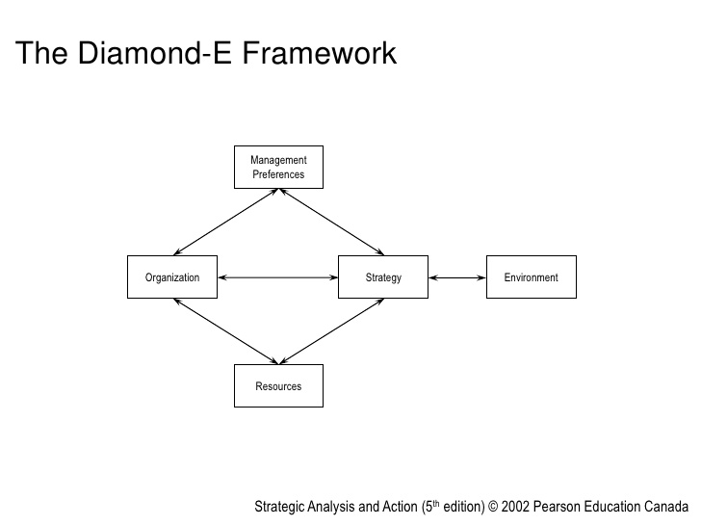

*The Norgaard Co-Evolutionary model*

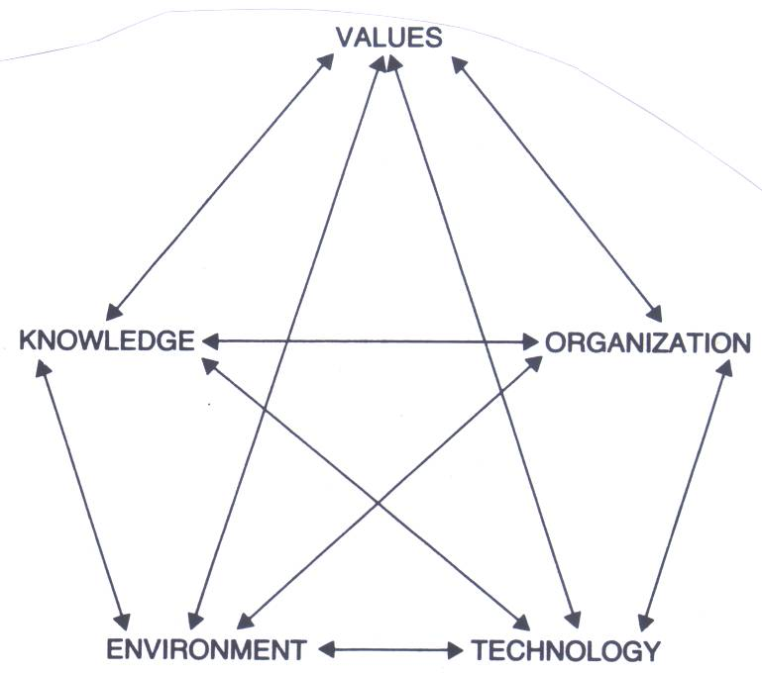

Figure 2 The Norgaard Co-Evolutionary model (Norgaard 1994, page 27)

**Appendix 2 – The Business Model Cube**

The Cube is a result of a longer theoretical work based upon working with the industry defined in the broad notion. Theoretical roots are among other (Osterwalder, Pigneur 2010, Osterwalder 2004, Osterwalder, Pigneur & Tucci 2005, Chesbrough 2010, Zott, Amit 2010, Amit, Zott 2012, Porter 1985, Porter, Kramer 2011). The Cube is still under evolution and a revision of three of the six dimensions will soon be available.This paper don´t touch upon the question of definition of “Business Model”. Internationally, there doesn’t exist a common and well established definition. There are many different definitions. However, the paper (Horn Rasmussen et al. 2016) suggests a rather technical definition. A main point is the need to abstract the definition from something dynamic. A BM is a static description (picture) to a given point of time that illustrates how the composition is in the BMs in a business with specific reference to the 6 dimensions and the relations. A recent presentation of the cube is quoted beneath.

*“The Cube and its ability to work on different levels of abstraction*

The Cube is characterized by its 7 fundamental elements. The elements are:

1. Value proportion
2. Customers/Users
3. Value Chain Functions
4. Competences
5. Network partners
6. Value formula
7. Relations

Six dimensions and relations define the Cube. Relations are defined ambiguously. However, when we have a narrow reference to the Cube, relations are the mean for value transport between the dimensions. Relation knit the dimensions together. We use the following model to illustrate the Cube.

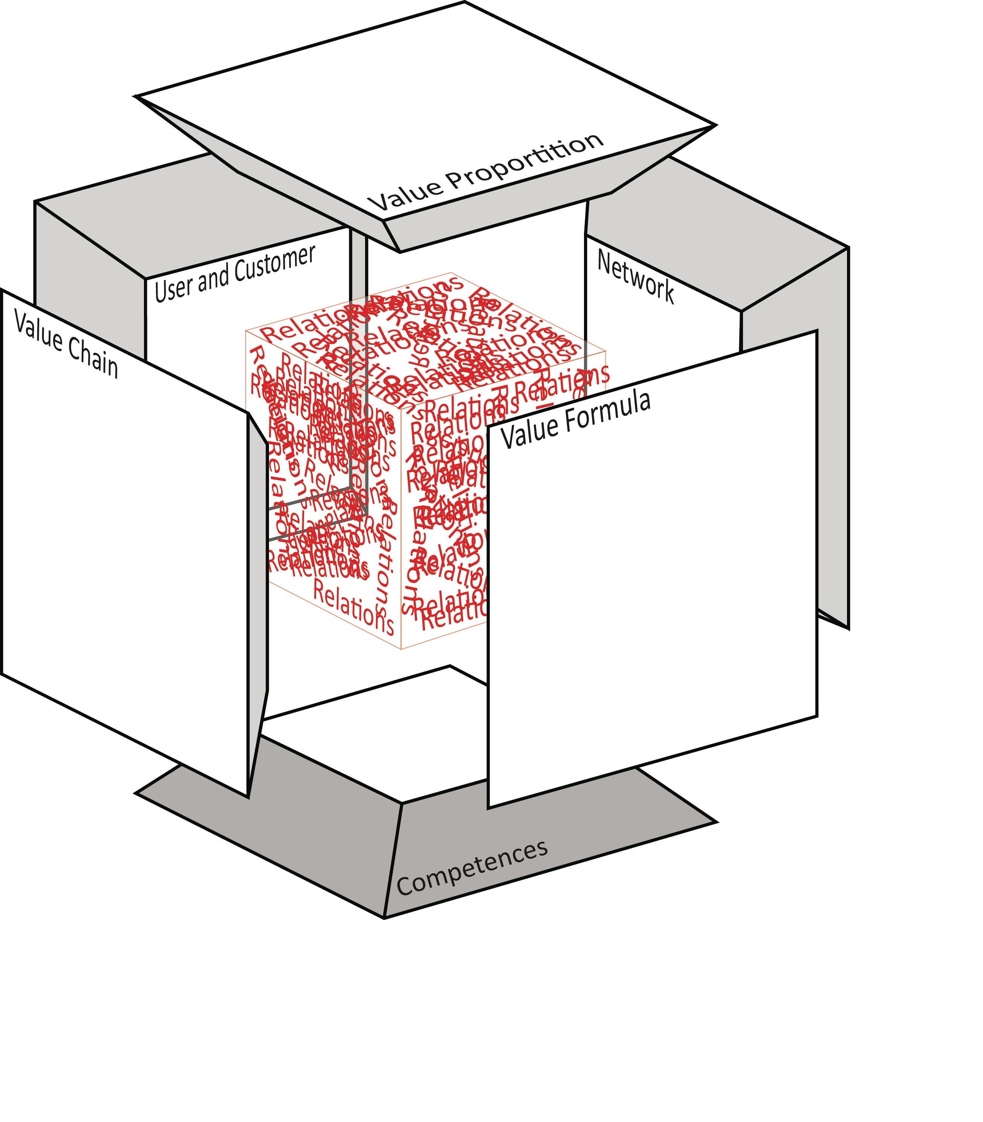”

(Horn Rasmussen et al. 2016, page 4-5)

**Appendix 3: The Where to Look Model and Value Creation**

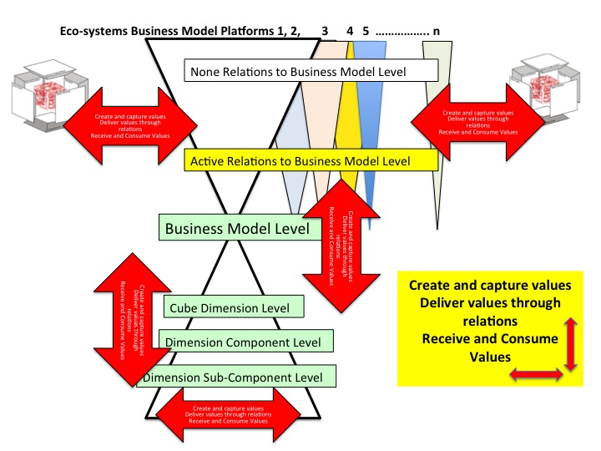

**Figure 3** The Where to Look Model at Business Model Level

*“This Vertical Butterfly Model illustrates from a BM perspective, where the BM shall “look” in order to implement strategic BMI. The red arrows illustrate where different processes potentially can work using relations as a mean for value delivering. Taken from the bottom we have focus on a BM Level. We have two different red arrows. The Vertical arrow has reference to value delivering between the dimensions in the Cube. Depending on the depth of the mapping the delivering of value can be:*

1. *From one dimension to another dimension*
2. *From one dimension to a component/sub-component of another dimension*
3. *From a component/sub-component of one dimension to a component/sub-component of another dimension*

*The horizontal arrow has reference to value delivering within a dimension. Depending on the depth of the mapping the delivering can be:*

1. *From one component to another component*
2. *From one component to a sub-component*
3. *From one sub-component to another sub-component*

*The vertical arrow between the BM Level and the Eco-Systems Business Model Platforms has reference to delivering of values between the BM in focus for a BMI process and the surroundings defined as Eco-Systems Business Model Platform 1, 2, 3, 4,*

*5…………n. In the Eco-System BM Platform we notice that in this model we have two different positions. The BM in question may or may not have active relations to the different BMs in the different BM Eco-systems. Both the active and non-active relations represent a BMI potential. The last two arrows are mostly meant as heuristic arrows and arrows which represent potential. Creating a link to The Relation Axiom the above model can be claimed to represent another way to express the relation axiom where the upper arrows represent the Out-Out quadrant. This “Where to Look Model” is both a practical tool in the BMI process and a way to express the potential for any BM with reference to implement strategic BMI” (Horn Rasmussen et al. 2016, page 10-12).*

**Appendix 4 – Case 2 – Research design – Component level**



Source: (Sparre 2017)