THE PHYSIOLOGY OF FEAR AND SOUND: WORKING WITH BIOMETRICS TOWARD AUTOMATED EMOTION RECOGNITION IN ADAPTIVE GAMING SYSTEMS

Tom A. Garner¹ and Mark N. Grimshaw²
University of Aalborg
School of Communication
AALBORG, Denmark
¹0045 71 58 73 38
²0045 99 40 91 00

ABSTRACT
The potential value of a looping biometric feedback system as a key component of adaptive computer video games is significant. Psychophysiological measures are essential to the development of an automated emotion recognition program, capable of interpreting physiological data into models of affect and systematically altering the game environment in response. This article presents empirical data the analysis of which advocates electrodermal activity and electromyography as suitable physiological measures to work effectively within a computer video game-based biometric feedback loop, within which sound is the primary affective stimuli.
KEYWORDS
Psychophysiology, biofeedback, affective sound, adaptive gameplay
1. INTRODUCTION
The overarching problem that motivates this study is the insufficient capacity of computer software (specifically recreational computer video games [CVG]) to respond to the affective state of the user. Prior research has stated that this limitation significantly damages usability between human and computer (Picard, 2000). From a CVG perspective, the absence of an affect recognition system can limit: the effectiveness of social/emotional communication between players and virtual characters, the game’s capacity to respond to undesirable gameplay experiences such as boredom or frustration, the opportunity for the system to build an affective user-profile to automatically customise game experiences, and also, the potential to communicate emotions to other live players over a network.
In the broadest sense, psychophysiology refers to study of the relationships that exist between physiological and psychological processes. Despite being a relatively young research field, that Cacioppo et al. (2007) describes as ‘an old idea but a new science’, psychophysiology has branched into a wide range of applications and has integrated with various other disciplines including dermatology (Panconesi & Hautmann, 1996) and psychopathology (Fowles et al., 1981). Modern psychophysiology was envisioned in response to the physiology/psychology divide problem (that between the two they provide a comprehensive explanation of human behaviour yet remain distinctly separate fields of study).
Psychophysiological data acquisition addresses several problems experienced when evaluating emotions via self-report, such as affect insensitivity and emotion regulation (Ohman & Soares, 1994). Research has documented circumstances in which the agendas of the individual facilitate regulation (suppression, enhancement, false presentation) of outward emotional expression, providing severe reliability concerns if relying entirely upon visual analysis and self-report to interpret emotional state (Jackson et al., 2000; Russell et al., 2003). Biometric data collection has the potential to circumvent this problem via measurement of emotional responses characteristically associated with the autonomic nervous system (ANS) and is significantly less susceptible to conscious manipulation (Cacioppo et al., 1992).
Research methodologies incorporating biometrics within the field of computer video games are diverse, with studies addressing such topics as: the influence of gaming uncertainty on engagement within a learning game (Howard-Jones & Demetriou, 2009), the impact of playing against human-controlled adversaries in comparison to bots upon biometric response (Ravaja et al., 2006) and developing biometric-based adaptive difficulty systems (Ambinder, 2011). Existing research has also supported the merit of biometric data as both a quality control tool, allowing developers an objective insight into the emotional valence and intensity that their game is likely to evoke (Keeker et al., 2004), and also as part of an integrated gaming system that connects the biometric data to the game engine, thereby creating a game world that can be manipulated by the player’s emotional state (Sakurazawa et al., 2004).
Psychophysiological research with a focus upon audio stimuli has explored the physiological effects of speech, music and sound effects to varying degrees. Koelsch et al. (2008) revealed that changes in musical expression could evoke variations in electrodermal activity (EDA), heart-rate and event-related potentials (measured via electroencephalography). As discussed in chapter 4, quantitative psychophysiological measures have been utilised to assess psychological response to sound in various academic texts (Bradley & Lang, 2000; Ekman and Kajastila, 2009). The arousal and valence experimentation concerning visual stimuli has recently been extended to address audio. Bradley and Lang (2000) collected electromyogram and electro-dermal activity data in response to various auditory stimuli. Experimentation revealed increased corrugator activity and heart rate deceleration in response to unpleasant sounds, and increased EDA in reaction to audio stimuli qualitatively classified as arousing. Jancke et al. (1996) identify muscle activation in the auxiliaries of the forehead as producing significant, high-resolution data in response to audio. Electro-dermal activity has been utilised to differentiate between motion cues, revealing increased response to approach sounds (Bach et al., 2009) and event-related potentials (collected via electroencephalography) reveal changes in brain-wave activity in response to deviant sounds within a repeated standard pattern (Alho & Sinervo, 1997).
EDA is characteristically related to the sympathetic nervous system (Nacke et al., 2009) and consequently, automated and excitatory processes (Poh et al., 2010). Yokota et al. (1962) connected EDA to emotional experience based upon a correlation between EDA and neural activity within the limbic system; an association that has been confirmed in later research via functional magnetic resonance imaging (Critchley et al., 2000). Relevant research has connected EDA to pathologic behaviour and stress (Fung et al., 2005), fear (Bradley et al., 2008) and disgust (Jackson et al., 2000) but, arguably, the most characteristic use of EDA is as a measure of general human arousal (Gilroy et al., 2012; Nacke & Mandryk, 2010). Research has suggested that EDA has the potential to measure changes in cognition and attention (Critchley et al., 2000) and, in conjunction with additional psychophysiological measures, may be capable of identifying discrete emotional states (Drachen et al., 2010).
The primary benefits of utilising EDA as a biometric include low running costs, easy application (Boucsein, 1992; Nacke & Mandryk, 2010), non-invasive sensors that allow freedom of movement and a well-established link with the common target of arousal measurement due to distinct and exclusive connectivity with the sympathetic nervous system (Lorber, 2004). Another distinct advantage to SCR is that secreted sweat is not required to reach the surface of the skin for a discernable increase to be observed, allowing researchers to identify minute changes that would certainly not be noticeable from visual observation (Bolls, Lang & Potter, 2005; Mirza-Babaei, 2011).
Electromyography (EMG) measures the voltage difference that contracts striated muscle tissue (Gilroy et al., 2012) and can be applied to various muscles around the body via either intramuscular (internal) or surface application. EMG provides very high temporal resolution (accurate to the millisecond), removes bias present in visual observation, supports automation and is capable of detecting minute muscular action potentials (Bolls, Lang & Potter, 2001). EMG analysis of particular facial muscles has been described as ‘the primary psychophysiological index of hedonic valence’ (Ravaja & Kivikangas, 2008). Studies of facial muscular activity have associated EMG to emotional valence, most typically by way of the corrugator supercilii (negative affective association) and the zygomaticus major (positive affect; see Lang et al., 1998; Larsen et al., 2003).
Academic literature has advocated physiological measures, such as EDA and EMG, for practical applications that include usability and user experience testing (Gualeni, 2012; Ravaja et al., 2006). Furthermore, these biometric measures have also featured in affect studies that employ sonic stimuli (Koelsch et al., 2008; Roy et al., 2008). Research utilising biometrics within a CVG context is becoming increasingly expansive, with forays into biometric-based adaptive difficulty systems (Ambinder, 2011), physiological measures for emotion-related CVG testing (Keeker et al., 2004) and even emotionally responsive game environments (Sakurazawa et al., 2004). The psychophysiological effects of computer game sound effects (excluding music and speech) have been underrepresented within this field of study despite a consensus that sound is a particularly evocative modality (Tajadura-Jiménez & Västfjäll, 2008).
The experimentation documented within this article takes its influence from the above research. EDA and EMG signal data is collected from two groups of participants; both playing a bespoke game level. The design of both the control and test game levels is identical, with the exception of digital signal processing (DSP) sound treatments that overlay particular sound events in the test group. DSP treatments are then compared to control datasets in a search for significant difference in arousal, corrugator supercilii activity and qualitative post-play feedback. As an exploratory study, it is hypothesised that both EDA and EMG measures will reliably reveal physiological changes in response to game sound stimuli. It is further hoped that at least some of the test sounds will generate significantly different datasets between groups. It is also expected that the physiological data will reflect subjective responses presented by participants during the debriefing. This article forms an essential element of a larger study, that aims to assess a comprehensive range of psychophysiological parameters within a CVG/sound/fear context and ultimately develop a new software biofeedback system that can accurately determine players’ emotional states and adapt the gameplay environment in real-time. It is further anticipated that such a system could be utilised beyond CVG applications with any interactive product, from cellular phones to automobiles.
2. METHODOLOGY
2.1 Bespoke Game Design
To enable effective comparison of the desired audio variables (outlined in section 1.2), a bespoke first-person perspective game level was developed, entitled The Carrier. This game places the player in the dark bowels of a sinking ship, with a race against time to reach the surface. The presence of a dangerous creature is alluded to via scripted animation sequences within the gameplay, and the intention is for the player to feel that they are being hunted. The level was produced primarily using the CryEngine 2 sandbox editor (CryTek, 2007) and all in-game graphical objects, characters and particle effects are taken from the associated game, Crysis. The game level designs follow a sequence of prescribed events designed to subtly manipulate the player’s actions. Plausible physical barriers, disabling of the run and jump functions and a logical progression of game scenes restricts the player to following a more uniform direction and pacing. These constraints are complemented by the reduced visibility settings, which provide plausibly restricted vision and movement to encourage (rather than force) players to follow the desired linear path. Graphical elements orientate and direct the player and invisible walls are utilised where (absolutely) necessary to avoid players straying or accidentally becoming locked between objects. Ambient atmospheres and sound events of indeterminate diegetic status, positioned in the darkness further the perception of a larger, open world to add some credibility and realism to the game environment, despite its notably linear design.
As the player progresses through the game level they are subjected to several, crafted in-game events utilising sound as the primary tool for evoking fear. During these events, user control is sometimes manipulated to ensure that player focus can be directed appropriately (this takes the form of forcing the player-view toward an event and then freezing the controls for a short time). The decision to use this technique is arguably a point of contention between first-person shooter titles. For example, Half-life 2 (Valve, 2004) was recognised for never manipulating the player’s perspective during single events, whilst Doom 3 (ID Software, 2004) takes full control, manipulating the camera angle to create a cut-scene effect. The former title prioritises flow and consistent diegetic narrative at the risk of the player missing parts of (or even the entire) event, whilst the latter accentuates the scene, creating a filmic style that potentially reduces gameplay-cohesion and immersion. Other games attempt to present a compromise, such as in Crysis 2 (Crytek, 2011) where the player is presented with an icon that indicates a significant event is occurring (nearby building collapsing, alien ship passing overhead) and if the player selects that option their viewing perspective is automatically manipulated to best observe the event. The custom game level built for this experiment, therefore, is intended as a compromise, ensuring that the player will fully observe the stimuli whilst minimising the disruption to flow. The manipulations themselves are relatively subtle, and occur only three times within the game.
The opening scene of the level presents the premise and endeavours to create an initial sense of familiarity and security via recognisable architecture and everyday props. This atmosphere is juxtaposed against a dark and solitary environment to create a sense of unease from within the familiar. Subsequent scenes utilise conventional survival horror environments whilst implied supernatural elements and scenarios also draw heavily from archetypal horror themes. First-person perspective is retained but the customary FPS heads-up display and weapon wielding is omitted, giving the player no indication of avatar health or damage resistance, and also removing the traditional ordnance that increases player coping ability and diminishes vulnerability-related fears. The avatar has no explicit appearance, character or gender and is anchored into the gameplay via physics-generated audio (footsteps, rustling of vegetation, interactions with objects, etc.) and the avatar’s shadow. The player is required to navigate the level and complete basic puzzles to succeed. Unbeknownst to the player, their avatar cannot be killed or suffer damage to ensure that load/save elements are unnecessary and that no player will repeat any section of gameplay, thus further unifying the collective experiences of all participants.
2.2 Game Sound Design
The Cryengine2 (Crytek, 2007) integrates the FMOD (Firelight Technologies, 2007) game audio management tool and consequently provides advanced audio development tools including occlusion simulation, volume control, three-dimensional sound positioning and physically based reverb generation. These features allow custom sounds to be easily incorporated into the game and controlled without the need for third-party DSP plugins or resource costly audio databases. Unfortunately, the engine has precision limitations and processing modalities such as attack envelopes and pitch shifting cannot be achieved with the same level of control and accuracy as could be achieved with a professional digital audio workstation. Consequently, all sounds within the test game were pre-treated in Cubase 5.1 (Steinberg, 2009) and separate sound files were generated for both variations of each key sound. For the purpose of this experiment, the seven modalities generated twelve key sounds (two sounds for each modality – to support the argument that if a DSP effect were to generate a significant difference, this would be observable when tested on two different sounds). Due to time limitations and gameplay restraints, signal/noise ratio and tempo parameters could only be tested once per game type. Two variations of each sound were developed as contrasting extremes of each modality, producing a total database of 24 files per game. Figure 1 outlines the use of sound employed throughout both test levels.

Table 1. Custom Audio Databases, Variables and Parameter Details
Sound Name | DSP modality | Control (group A) | Variant (group B)
Diegetic Music | Distortion | No additional DSP | Frequency distortion
Ship Voice | Distortion | No additional DSP | Frequency distortion
Heavy Breath | Localisation | Centralised | Left to right sweep
Monster Scream | Localisation | Centralised | Full left pan
Woman Screams | Pitch | No additional DSP | 300 cent pitch raise
Ship Groans | Pitch | No additional DSP | 500 cent pitch drop
Chamber banging | Attack | 2 second linear fade-in | 0 second attack
Monster Growl | Attack | 1 second linear fade-in | 0 second attack
Bulkhead Slams | Tempo | 20 BPM | 30 BPM
Engine Noise | Signal/noise ratio | No noise present | Noise present
Man Screaming | Sharpness | No additional DSP | 12 dB gain @ 1.7kHz
Man Weeping | Sharpness | No additional DSP | 12 dB gain @ 5kHz

2.3 Testing Environment and Equipment
The game level ran on a bespoke 64-bit PC with Windows Vista Home Premium (Service Pack 2) operating system, AMD Phenom 2 X4 955 (3.2GHz) quad core processor, 8GB RAM, ATI Radeon 4850 (1.5GB) GPU. Peripheral specification includes LG 22” LCD Monitor (supporting 1920x1080 output resolution), Microsoft Wireless Desktop 3000 mouse and keyboard, Asus Xonar 7.1 sound card and Triton AX Pro 7.1 headphones. Fraps (Beepa, 2007) screen capture software created video records of all gameplay and biometric data was collected using a Biopac MP30 data acquisition unit and Biopac Student Lab Pro v3.6.7 (Biopac, 2001) interface software. Experimentation was carried out in a small studio space, providing only artificial light and attenuation of outside environment noise.
2.4 Pre-testing
In preparation for the main trial, participants (n=8) played through a beta version of the test game whilst connected to EMG and EDA hardware. Following the trial, each participant was debriefed and asked to disclose their opinions regarding gameplay and biometric hardware experience. Recurring feedback from the players included orientation difficulty due to over-contrast and low brightness of graphics, difficulty in solving the puzzles and absence of player damage/death resulting in lack of a convincing threat. Preliminary testing aided calibration of standard decibel levels and several participants revealed difficulties operating the control interface, notably coordination of the mouse (look) and keyboard (movement) functions. In response, the final version operated using a simplified keyboard-only WSAD (basic movement controls: forward, backward, left strafe and right strafe respectively) control layout (the space bar was the only other control button, used to interact with objects), reduced the colour saturation and increased overall brightness. There remained no player death due to the significant variation in completion time it would cause in addition to requiring players to revisit sections of the level. Puzzles were simplified and steps were taken to increase usability during these sections, clarifying the correct route/action via clearer signposting. Pilot-test biometric data revealed spikes in both EMG and EDA measures immediately after application of the sensors and following being told that the test had started.
2.5 Participants, Procedure and Ethics
10 participants (9 Male, 1 Female, ages 18-27) formed two groups of 5, control and test (DSP treatment). All participants rated their prior experience and gaming confidence as moderate or high and stated familiarity with FPS type games and PC standard gaming controls. Experience in survival-horror games revealed some variation, with self-report ratings ranging from 1 to 10 (1-10 scale) with a mean score of 4.7. Participants were informed that the research aim was to explore the emotional potential of sound within a computer video game context. Each individual was also made aware of strobe lighting, visual images (that may be perceived as frightening or upsetting) and the full biometric data collection procedure. A satisfactory EMG/EDA baseline was acquired before beginning testing and synchronisation of gameplay with both the biometric and video recordings was achieved by mapping the respective start and stop actions to the same key, allowing the participant to synchronise the entire data collection process with little difficulty. The test debriefing assessed perceived game difficulty, overall intensity of experience, immersion ratings and disruption caused by the biometric sensors.
Participants were also asked to watch the video of their gameplay performance and provide a voice-over commentary, focussing upon their emotional state and identifying discrete emotions, the intention being that participants would re-experience the affective states felt during the game and be able to more accurately describe their emotions in reference to specific game events.
2.6 Data collection
EDA and EMG hardware was configured to automatically synchronise with the game engine timestamp, allowing significant biometric readings to be accurately matched with their corresponding chronological point of gameplay. An event logging system was utilised to identify overall completion time. EDA data was collected from the right index and middle fingers of each participant by way of a SS57L Biopac EDA sensor lead and isotonic electrode gel. BSL shielded SS2LB leads connected to trimmed, disposable EL501 electrodes were utilised to collect facial EMG data. Existing research warns that precise positioning of EMG electrodes is a difficult task (Huang et al., 2004), therefore utmost care was taken to apply the hardware to each participant. A light abrasive treatment was applied to the skin in and around the areas on which the sensors would be placed to reduce electrode-skin impedance (Hermens et al., 2000). Electrodes were then applied across the midline of the muscle (De Luca, 1997) and surgical tape was used to reduce motion artefacts (Huang et al., 2004). The validity of the zygomaticus major as a measure of positive affect has been questioned in response to an assertion that conscious social communication may be the primary way in which this muscle is controlled (Russell et al., 2003). Larsen et al. (2003) however, suggest that the corrugator supercilii is capable of representing both positive and negative valence (suppressed corrugator activity suggesting positive affect). In response to this information, EMG data was collected solely from the corrugator muscle.
3. RESULTS
Data obtained from both EDA and EMG acquisition was extracted in 5.00 second epochs. The baseline epoch for each participant was collected between 30.00 and 35.00 seconds of the 1 minute rest period before the game began. This was to allow time for the signal to stabilise test-start anxiety (white coat hypertension). Data relevant to each test sound was extracted as 5.00 second epochs in synchronisation with the sound’s onset. Integrated signal analysis tools within BSL Pro v.3.6.7 (Biopac, 2001) revealed descriptive statistical data across each epoch. Both EDA and EMG data was analysed for minimal and maximum peaks, mean, area and slope. Subsequent statistical analysis was carried out using PASW statistics (v.18, IBM, 2009) to calculate the difference between the baseline and each test epoch to generate a differential dataset. The descriptive statistics of the differential dataset were then analysed via a statistical t-test for independent samples, to search for statistically significant difference between the means of the control and treatment groups for each test sound. Results of the t-test revealed significant difference between groups of the muffled scream (sharpness treatment) sound in the EDA-mean (t=-2.377, p=.045), EDA-max (t=-2.357, p=.046) and EDA-min (t=-2.457, p=.039) dependent variables and was the only significant difference in the EDA output measures. Of the EMG outputs, only EMG-max revealed a significant difference between groups, at the muffled whimper (also sharpness treatment) sound (t=2.669, p=.028). Each individual sound (both treated and untreated) was separately compared but no statistical significance between any of the sounds for any measure of EDA or EMG was revealed. An overview of the descriptive statistics suggests that overly high variance between players, present even when testing the differential data, is the likely cause of an absence of significant difference between sounds.
Figure 1 (below) presents a visual overview of the EMG and EDA signal data from one subject. Overlaying biometric output with event data reveals that the majority of EDA/EMG spikes and peaks can be attributed to specific events within the game. However, not all of these events are exclusively tied to a sound and, quite often, also relate to an associated visual stimulus. Visual analysis of the biometric signals also reveals significantly raised skin conductance levels during the first 60-80 seconds of gameplay, and a steadily increasing rate of EMG activity from commencing gameplay to completing the level. These trends are generally representative of all players’ test results.
Non-parametric analysis compared the control and test groups via the Mann-Whitney U test for two independent samples to assess if any significant variation existed between the groups with regards to subjective intensity, frustration and difficulty ratings. Results revealed no statistical significance between groups for any of the three dependent variables. Descriptive statistics and the Chi-Square test was administered, including all 10 players’ results, to assess comfort of biometric sensors, perceived difficulty of the game itself, subjective frustration levels and the extent to which the sensors and wires obstructed the flow of gameplay and sense of immersion.

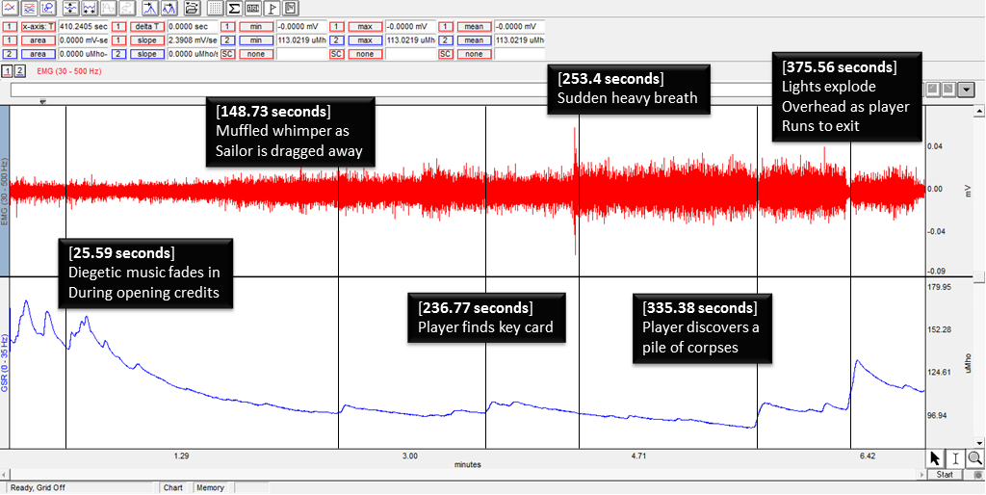

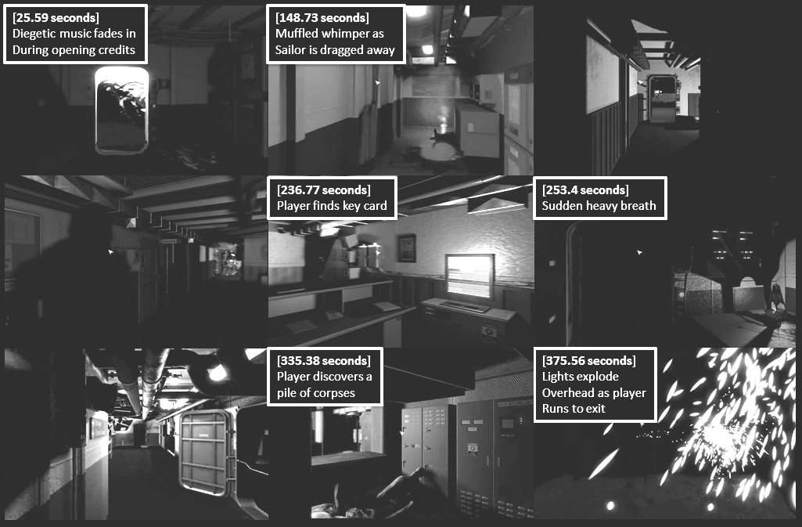

Figure 1. Full EMG(1)/EDA(2) signal output + synchronised events/related screenshots

The results of the Chi-Square test reveal statistical significance for all measures and the descriptive means reveal a relatively high level of comfort and low disruption during gameplay alongside moderately high intensity ratings, low difficulty and very low frustration levels. Information collected from qualitative discussion with participants revealed that context/situation heavily influenced how they felt about a sound. For example, many commented that the consecutive slams at the end of the level created suspense and fear by signifying urgency and a time-limit to reach the level end. Participants also commented that the alien roar sound was very intense and discomforting. Participants did not comment directly upon the fast tempo of the slam sounds or the immediate attack and high volume of the alien roar sound, suggesting limited conscious awareness of the quantitative sound techniques being employed. Figures 2 and 3 present line graph representations of particular statistical measures of both EEG and EDA, revealing the difference between sound treatment groups and individual sounds.

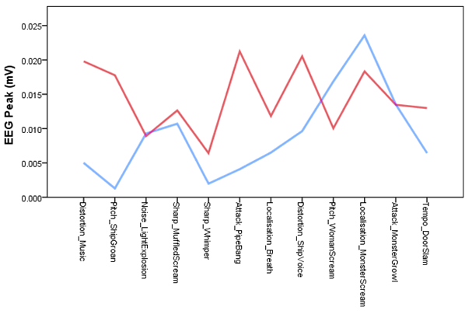
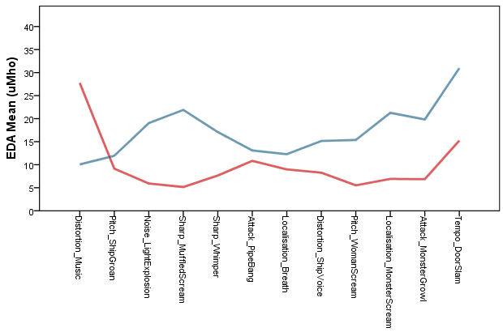

Figures 2 and 3. Line graph representing mean EEG peak values (left) and mean EDA values (right). 1=control, 2=DSP.
4. DISCUSSION
As an exploratory experiment, several concerns were foreseeable from the onset whilst others were revealed throughout the course of the study. The overarching themes, atmospheres and stylisations of a computer video game are a likely source of variation upon the perception of individual sounds and compound sound events/ambiences, the rationale being that such factors form a contextualising framework against which game stimuli are appraised. Future work will consequently incorporate two contrasting game levels, providing an opportunity to discover whether acoustic parameters could reliably alter affective states across varied contextual environments. The Biopac EDA/EMG hardware and accompanying software proved to be a powerful yet accessible solution. The integrated signal analysis features provide highly usable descriptive statistics upon which further analysis can be performed. Connection between players and sensors proved consistent, and the positive reviews from players concerning comfort of use and lack of flow/immersion disruption further advocates both the Biopac system and EDA/EMG biometrics in general as effective data acquisition tools within CVG research.
With regards to the game level design and control interface; observation of the participants’ movements, in conjunction with debrief questionnaire responses, revealed a generally high level of usability, with most players able to move effectively throughout the level. The lack of a heads-up display (HUD), text-based instruction and mini-map navigation was regarded by some players as initially confusing, but not a source of frustration.
Feedback comments also suggested that the absence of an extra-diegetic HUD improved immersion and that undetermined player-health feedback increased tension. Players also commented that an absence of weapons signified no combat and they quickly realised that they could not die, a realisation that quickly reduced fear intensity by way of removing the threat, both within the diegetic narrative (no threat of avatar damage/death) and as an extra-diegetic gameplay tension (no threat of having to repeat part of the level). With reference to EDA, it could be asserted that ecological validity and laboratory-based bias reduced the capacity to extract meaningful data. It was noted that various aspects of the testing environment (continuous presence of researcher, white-coat syndrome from biometric hardware application and, unfamiliar environment, control hardware, action-button configuration, audio setup and computer monitor / graphics setup) were likely to raise anxiety levels prior to testing. The particular durations and placement of data extraction epochs present additional potential for erroneous effects, the most notable problem being the limited time between starting the biometric recording and starting the game (within which the baseline epoch is collected). Observed EDA trends strongly suggest a consistently occurring peak in activity, lasting for up to 90 seconds after beginning the recording and a long decay extending over several minutes before a lower-level plateau is eventually reached. This suggests that a more substantial ‘settling in period’ is required between beginning the recording and the commencement of gameplay.
Whilst the lack of statistically significant difference between the test and control groups could be disheartening, it must be remembered that the primary function of the experiment was to assess the potential of EDA/EMG within an audio-centric survival horror game context, uncover potential methodological problems and present possible solutions for use in future study. Furthermore, the correlation between quantitative biometric data and qualitative debrief responses suggests that data acquisition was notably successful and that the issues are more likely to be associated with the testing environment, equipment and procedure.
5. CONCLUSIONS AND FUTURE WORK
Although the results obtained from this study do not fully support the hypothesis that quantifiable acoustic parameter changes can generate significantly different psychophysiological response datasets, they do support the use of biometrics within such experimental scenarios and present a foundation from which to build in further study. This article strongly advocates a systematic approach to game sound testing in future work, to allow for the various erroneous factors to be addressed. Ecological validity is a substantial concern and future testing will attempt to recreate a familiar and comfortable playing environment. Researcher presence should arguably be minimised and players should not be informed when recording has begun to reduce white-coat syndrome. Future testing will also integrate video tutorials (reducing live researcher presence and adding uniformity to the participant instruction process) and present the player with an interactive tutorial level, allowing them to become familiarised with the interface, control mapping, etc. and also providing time for stress factors associated with initial exposure to the testing environment to subside.
Direct experience with the psychophysiological measures of electromyography and electrodermal activity supported many of the assertions referenced within the introduction of this article. EDA proved to be a reliable indicator of arousal and in context, this could be restated as a measure of gameplay-related fear, anxiety or stress. The EDA equipment was, as expected, easy to apply and operate (Boucsein, 1992; Nacke & Mandryk, 2010) with minimal intrusion for the player (Lorber, 2004). Motor activity (Roy et al., 2008) proved not to be a source of erroneous variation and the temporal resolution, traditionally described as slow (Kivikangas et al., 2010) proved adequate for accurate synchronisation to in-game stimuli. EMG confirmed expectations for high temporal resolution and sensitivity (Bolls et al., 2001) but did not demonstrate itself to be a reliable indicator of negative valence, contradicting much previous research (Harman-Jones & Allen, 2001; Kallinen & Ravaja, 2007). This outcome does, however, support the notion that recreational fear is an ambivalent experience (Svendsen, 2008: pp. 75-76). In terms of fear experience, the data obtained from these three experiments strongly supports the concept of a complex, embodied system that is susceptible to reflexive shock, slow-building apprehensive/suspenseful terror and more subtle variations between the two. Despite strong effort to control erroneous variables during testing, between-participant differences remained noteworthy, supporting the notion of interpersonal affective influences such as gender, culture and personality (Hamann & Canli, 2004).
With regards to the secondary hypothesis of this article (assessing the emotional/affective potential of quantifiable acoustic parameters) the obtained data does reveal both resonance and dissonance when considered alongside existing research. Parameters such as immediate attack (Moncrieff et al., 2001), increasing tempo (Alves & Roque, 2009), low pitch (Parker & Heerema, 2007), and unclear localisation (Breinbjerg, 2005) are supported by the results obtained from these experiments, but not conclusively. However, sharpness (Cho et al., 2001) does, based upon obtained data, appear to be a significantly reliable approach to modulating both EDA and EMG. The notion that some sounds may have the capacity to universally evoke a particular emotional state by way of underlying evolutionary factors (Parker & Heerema, 2007) remains uncertain due to the presence of contradictory data (for example, participants producing a limited or negligible affective response to sounds specifically designed to evoke evolution-based fear responses). The assertion that sound can be processed pre-attentively (Alho & Sinervo, 1997) is supported by the notably faster response times of EMG (and, in some cases, even EDA) to stimuli than the real-time qualitative responses of players. Indirectly, the lack of clear patterns within the data could be perceived as supportive of the concepts that imply auditory processing as a complex matrix of variables. This includes the discrete modes of listening (Chion, 1994), embodied cognition factors (Wilson, 2002), attention filtering (Ekman, 2009), multi-modal effects (Adams et al., 2002) and sonification data (Grimshaw, 2007; Schafer, 1994). As a result, data obtained from this experiment indirectly supports a hypothetical framework of auditory processing that incorporates such concepts.
This article has advocated the implementation of biometric measures as means to gauge varying intensities of fear response in a survival horror game context. The experiment documented within this article is a component within a series of psychophysiological studies intending to elucidate the potential of biometrics as both reliable indicators of affective intensity and viable inputs to an emotion classification framework capable of automatically discerning the affective state of the player as discrete categories. The end-game purpose of this research consists of two alternative projects that are currently being undertaken. The first application is an emotionally-adaptive computer games system, capable of interpreting player emotions to facilitate fear difficulty (players can choose to what extent they wish the game to raise their fear-intensity levels), biometric game mechanics (diegetic game events/tasks/actions/etc. that respond to physiological input) and cross-game emotion profile building (learning machine that compiles player responses to game content to automatically generate emotioneering strategies that can be applied to any game played on that system). The second application is biometric-based emotional/social communication learning software intended to support young people diagnosed with autistic spectrum disorder or other learning difficulties relevant to these skills. Here a comparable underlying system of emotion recognition is utilised but primarily to attenuate fear-related affect (anxiety, stress) and to drive the behaviour of emotionally intelligent virtual agents that can converse with users in increasingly natural and realistic dialogues.
Both of these endeavours require a framework for automated emotion recognition, classification and appropriate response/expression that is both accurate and reliable. The results of this article provide both solid initial steps toward realisation of this framework and, possibly more importantly, reinforcement that such an ambition is achievable within the near future.
REFERENCES
Adams, W.H. et al, 2002. Semantic Indexing of Multimedia Content Using Visual, Audio, and Text Cues, EURASIP Journal on Applied Signal Processing, Vol. 2, pp.1-16
Alho, K. and Sinervo, N. 1997. Pre-attentive Processing of Complex Sounds in the Human Brain, Neuroscience Letters, Vol.233, pp.33-36
Alves, V. and Roque, L. 2009. A Proposal of Soundscape Design Guidelines for User Experience Enrichment, in: Audio Mostly 2009, September 2nd -3rd, Glasgow.
Ambinder, M. 2011. Biofeedback in Gameplay: How Valve Measures Physiology to Enhance Gaming Experience, in: Proceedings Game Developers Conference (GDC), Citeseer
Bach, D.R. et al, 2009. Looming sounds as warning signals: The function of motion cues, International Journal of
Psychophysiology, 74:1, pp.28-33
Bolls, P. et al, 2001. The Effects of Message Valence and Listener Arousal on Attention, Memory, and Facial Muscular Responses to Radio Advertisements, Communication Research, Vol.28, No.5, pp.627-651
Boucsein, W. 1992. Electrodermal activity, New York: Plenum Press
Bradley, M.M. and Lang, P. 2000. Affective reactions to acoustic stimuli, Psychophysiology, 37, pp.204-215
Bradley, M. et al, 2008. Fear of pain and defensive activation, Pain, Vol.137, No.1, pp.156-163
Breinbjerg, M. 2005. The Aesthetic Experience of Sound – staging of Auditory Spaces in 3D computer games, In: Aesthetics of Play, Bergen, Norway, October 14th-15th, http://www.aestheticsofplay.org/breinbjerg.php
Cacioppo, J.T. et al, 1992. Microexpressive facial actions as a function of affective stimuli:
replication and extension, Psychological Science, 18, pp.515-526
Cacioppo, J. T. et al, 2007. Psychophysiological Science, Handbook of psychophysiology, pp.3-26
Chion, M. 1994. Audio-Vision: Sound on Screen, C Gorbman Ed., Columbia University Press, New York
Cho, J. et al, 2001. Physiological responses evoked by fabric sounds and related mechanical and acoustical properties. Textile Research Journal, Vol.71, No.12, pp.1068-1073
Critchley, H.D. et al, 2000. Neural activity relating to generation and representation of galvanic skin conductance responses: a functional magnetic resonance imaging study. Journal of Neuroscience, Vol.20, pp.3033-3040
De Luca, C. 1997. The use of surface electromyography in biomechanics, Journal of Applied Biomechanics
Drachen, A. et al, 2010. Correlation between heart rate, electrodermal activity and player experience in First-Person Shooter games. In press for SIGGRAPH 2010, ACM-SIGGRAPH Publishers
Ekman, I. 2009. Modelling the Emotional Listener: Making Psychological Processes Audible. Audio Mostly 2009, Glasgow 2nd-3rd September
Ekman, I. and Kajastila, R. 2009. Localisation Cues Affect Emotional Judgements – Results from a User Study on Scary
Sound. Proc. AES 35th Conference on Audio for Games, London UK., CD-ROM
Fowles, D.C. et al, 1981. Publication recommendations for electrodermal measurements. Psychophysiology, 18, pp.232-
239
Fung, M. T. et al, 2005. Reduced Electrodermal Activity in Psychopathy-prone Adolescents, Journal of Abnormal Psychology, Vol.114, pp.187-196
Gilroy, S.W. et al, 2012. Exploring passive user interaction for adaptive narratives, Proceedings of the 2012 ACM International Conference on Intelligent User Interfaces, Lisbon, Portugal, 14th-17th February 2012, New York: ACM, pp.119-128
Grimshaw, M. 2007. The Resonating spaces of first-person shooter games. Proceedings of the 5th International Conference on Game Design and Technology, Liverpool, November 14th-15th, 2007

Gualeni, S. et al, 2012. How psychophysiology can aid the design process of casual games: a tale of stress, facial muscles, and paper beasts, Proceedings of the international conference on the foundations of digital games, ACM, New York, USA
Hamann, S. and Canli, T. 2004. Individual differences in emotion processing, Curr Opin Neurobiology, Vol.14, pp.233–238
Harmon-Jones, E. and Allen, J. J. B. 2001. The role of affect in the mere exposure effect: Evidence from physiological and individual differences approaches, Personality and Social Psychology Bulletin, Vol.27, pp.889–898
Hermens, H. et al, 2000. Development of recommendations for SEMG sensors and sensor placement procedures, Journal of Electromyography and Kinesiology, Vol.10, pp.361-374
Howard-Jones, P.A., and Demetriou, S. 2009. Uncertainty and engagement with learning games. Instructional Science,
37:6, pp.519–536
Huang, C. et al, 2004. The Review of Applications and Measurements in Facial Electromyography, Journal of Medical and Biological Engineering, Vol.25, No.1, pp.15-20
Jackson, D. et al, 2000. Suppression and enhancement of emotional responses to unpleasant pictures, Psychophysiology, Vol.37, pp.515-522
Jancke, L. et al,1996. Facial EMG responses to auditory stimuli. International Journal of Psychophysiology, 22, pp.85-96
Kallinen, K. and Ravaja, N. 2007. Comparing speakers versus headphones in listening to news from a computer – individual differences and psychophysiological responses, Computers in Human Behaviour, Vol.23, No.1, pp.303-317
Keeker, K. et al, 2004. The untapped world of video games, CHI'2004, pp.1610-1611
Kivikangas, J. M. et al, 2010. Review on psychophysiological methods in game research, Proc. of 1st Nordic DiGRA
Koelsch, S. et al, 2008. Effects of Unexpected Chords and of Performer's Expression on Brain Responses and Electrodermal Activity, PLoS ONE, Vol.3, No.7
Lang, P.J. et al, 1998. Motion, motivation, and anxiety: Brain mechanisms and psychophysiology, Biological Psychiatry, Vol.44, pp.1248-1263
Larsen, J. et al, 2003. Effects of positive and negative affect on electromyographic activity over zygomaticus major and corrugator supercilii, Psychophysiology, Vol.4, No.5, pp.776-785
Lorber, M. 2004. The psychophysiology of aggression, psychopathy, and conduct problems: A meta-analysis. Psychological Bulletin, Vol.130, pp.531-552
Mirza-Babaei, P. et al, 2011. Understanding the Contribution of Biometrics to Games User Research, Proceedings of
DiGRA 2011, Conference: Think Design Play., 2011
Moncrieff, S. et al, 2001. Affect computing in film through sound energy dynamics International Multimedia Conference, Proceedings of the ninth ACM international conference on Multimedia, Vol.9, pp.525-527
Nacke, L.E. et al, 2009. Playability and Player Experience Research, In: Proc. DiGRA 2009
Nacke, L. E. and Mandryk, R. L. 2010. Designing Affective Games with Physiological Input, Fun and Games, September, 2011, Leuven, Belgium
Öhman, A. and Soares, J. J. F. 1994. Unconscious anxiety: Phobic responses to masked stimuli. Journal of Abnormal
Psychology, 103, pp.231–240
Panconesi, E. and Hautmann, G. 1996. Psychophysiology of stress in dermatology: the psychobiologic pattern of
psychosomatics. Dermatol Clin, 14, pp.399–421
Parker, J.R. and Heerema, J. 2007. Audio Interaction in Computer Mediated Games, International Journal of Computer Games Technology, Vol. 2008, Article ID178923.
Picard, R.W. 2000. Toward computers that recognize and respond to user emotion, IBM Systems Journal, Vol.39, pp.3-4
Poh, M.Z. et al, 2010. Continuous Monitoring of Electrodermal Activity During Epileptic Seizures Using a Wearable Sensor, Conf Proc IEEE Eng Med Biol Soc, pp.4415-4418
Ravaja, N. et al, 2006. Spatial presence and emotions during video game playing: does it matter with whom you play? Presence Teleoperators & Virtual Environments, Vol.15, pp.381–392
Ravaja, N. and Kivikangas, J. M. 2008. Psychophysiology of digital game playing: The relationship of self-reported
emotions with phasic physiological responses, Proceedings of Measuring Behavior, pp26-29
Roy, M. et al, 2008. Modulation of the startle reflex by pleasant and unpleasant music, International Journal of Psychophysiology, Vol.71, pp.37–42
Russell, J.A. et al, 2003. Facial and vocal expressions of emotion. Ann. Rev. Psychol. 54, pp.329-349
Sakurazawa, S. et al, 2004. Entertainment Feature of a Game Using Skin Conductance Response, proceedings of ACE 2004, Advances in Computer Entertainment Technology, ACM Press, pp.181-186
Schafer, R.M. 1994. Our Sonic Environment and the Soundscape: The Tuning of the World, Destiny Books, Rochester, Vermont
Svendsen, L. 2008. A Philosophy of Fear. Reaktion books
Tajadura-Jimenez, A and Vastfjall, D. 2008. Auditory-Induced Emotion: A Neglected Channel for Communication in Human-Computer Interaction, Affect and Emotion in Human-Computer Interaction, Lecture Notes in Computer Science, Vol.4868, pp.63-74
Wilson, M. 2002. Six views of embodied cognition, Psychon. Bull. Rev., Vol.9, pp.625–36
Yokota, T. and Fujimori, B. 1962. Impedence Change of the Skin During the Galvanic Skin Reflex, Japanese Journal of Physiology, Vol.12, pp.200-209

