Principles for nearly Zero-Energy Office Buildings

Authors: Bogdan Atanasiu¹, Thomas Boermans², Kirsten Engelund Thomsen³, Markus Offermann², Andreas Hermelink², Jorgen Rose³

¹Buildings Performance Institute Europe (BPIE), Belgium

²Ecofys Germany GmbH, Germany

³Danish Building Research Institute (SBi), Denmark

Abstract
The European Union (EU) aims at drastic reductions in domestic greenhouse gas emissions (GHG) by 80% in 2050 compared to 1990 level. By 2050, more than 25% of the stock will be buildings erected from now onwards and for reaching the EU aims, all of these buildings have to be close to climate neutral and zero energy levels. The revised EU Energy Performance of Buildings Directive (EPBD) stipulates that by 2020 all new buildings shall be nearly zero-energy buildings (nZEBs). However, the EPBD doesn’t prescribe a uniform approach for implementing nZEBs and calls the EU countries to provide a national definition. Hence, there is an urgent need to establish a set of common principles, aligned to the EU longer term objectives.
This paper, based on a BPIE study launched in November 2011, defines and verifies some fundamental nZEB principles as well as provides recommendations for developing a sustainable, effective and flexible nZEB definition for the EU office buildings. The first part of the paper analyses the main technical and policy implications for shaping an effective nZEB definition, taking into account following issues;
- The emission reduction long-term goals,
- Renewable energy disparities,
- The balance between building’s energy efficiency and renewable energy supply,
- The influence of climate and building geometry
- And convergence with cost-optimal methodology.
Based on these implications, several nZEB principles are defined. The second part of the paper verifies these nZEB principles on a reference office building, considering different technology options and in three EU climate zones. The results of this reality check are further analysed in the third chapter of the paper, together with the policy impacts for moving towards nZEB office buildings within the EU.

Introduction
Throughout Europe there is a large variety of concepts and examples for very highly energy efficient buildings or climate neutral buildings: passive house, zero energy, 3-litre, plus energy, Minergie, Effinergie etc. In addition, these definitions refer to different spheres: site energy, source energy, costs or emissions. Moreover there may be further variations depending on whether new or existing, residential or non-residential buildings included. In essence the views on how nZEB should be defined differ considerably.
Generally, low-energy buildings will typically encompass a high level of insulation, energy efficient windows, high level of air tightness and balanced mechanical ventilation with heat recovery to reduce heating and cooling requirements. In order to achieve a high energy performance level, they will typically take advantage of passive design techniques and active solar technologies (solar collectors for domestic hot water and space heating or PV-panels for generating electricity). In addition other energy/resource saving measures may also be utilized, e.g. on-site windmills to produce electricity or rainwater collecting systems.
At the moment, more than half of the Member States (MS) do not have an officially assumed definition of a low or zero energy building. However, various Member States have already set up long-term strategies and targets for achieving low energy standards for new buildings. A summary of these strategies has being presented in table 1.
The existing low-energy buildings definitions among the EU Member States have common approaches and differences and there is a need to aggregate and improve the existing concepts in order to harmonize them to the nZEB requirements as indicated by the EPBD and also the Renewable Energy Directive. Therefore, there are three main issues to be considered when the existing low-energy buildings definition should evolve towards a nZEB definition:
- Most of the European countries that have definitions specify the maximum primary energy per square meter and year as a percentage in relation to the existing national building standard. However, the specific values differ among the methodologies according to what is considered as to be the specific energy demand (from heat demand only, to HVAC, hot water, lighting and electricity or different heated areas).
- The existing low-energy building definitions do not specifically indicate a certain share of renewables in the energy supply (as requested to happen by 2014 according to the RES Directive). Especially this lack of guidance for the share of renewables makes current regulations or definitions not fit with the nearly zero energy definition from the revised EPBD.
- There are various elements of existing concepts that can be used for the development of a nZEB definition, such as the principle of working with overarching targets accompanied by “sub-thresholds” on specific issues such as the passive house concept with its requirements on maximum primary energy demand and additional limits for heating energy demand, or/and imposing a threshold for the CO2 emissions.

Challenges in setting sustainable nZEB principles
Acknowledging the variety in building culture and climate throughout the EU, the EPBD does not prescribe a uniform approach for implementing nZEB and neither does it describe a calculation methodology for the energy balance. To add more flexibility, EPBD requires Member States to elaborate national definitions and to draw up specifically designed national plans for increasing the number of nZEB by taking into account national, regional or local conditions.
Consequently, it is necessary to provide supplementary guidance to the EU Member States by proposing a set of common principles that secure the sustainability of the national nZEB definitions and plans. Trying to elaborate these common principles, we identified a set of 10 main challenges, presented as questions, which have to be addressed before transposing the EPBD requirement into practice. These challenges are such as in the followings:
- To what extent do current EU energy and climate targets influence the ambition level of a nZEB definition?
- How to better define the nZEB for achieving simultaneously the same reduction levels of energy consumption and CO2 emissions of the building?
- How to deal with time disparities (e.g. monthly vs. annual energy balance) and local disparities (e.g. on-site vs. off-site energy production) in the overall energy balance of the nZEB?
- How to elaborate the nZEB definition as on open concept that enable the future evolution towards energy-positive buildings?
- When elaborating the nZEB definition, should we be looking at groups or single buildings?
- Should a nZEB definition go beyond the EPBD requirements by additionally including the household electricity (plug loads) consumption within the scope?
- Should a nZEB definition go beyond the EPBD requirements by including the energy consumption at construction and disposal phases of the building?
- How to find an optimal balance between energy efficiency and renewable energy requirements within a nZEB definition?
- How to elaborate a nZEB definition easy adaptable to different climates, building types and practices?
- How to link the nZEB definition to cost-optimal levels in order to have convergence and continuity between these two requirements of EPBD?
The analysis of these challenges has led to several important implications for the nZEB definition which are presented in the following chapters.

Table 1: Planned nZEB initiatives in the European countries
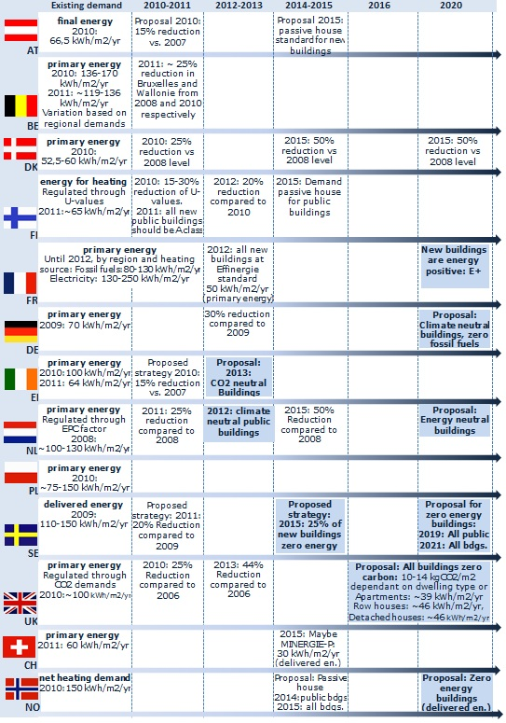

Meeting the actual policy requirements and the EU long term climate goals
If EU countries have to meet the 2050 goals for CO₂ emission reduction, then the nZEB requirements for new buildings also have to led to nearly zero carbon emissions below 3kgCO2/m²yr, which has been assumed to be the average environmental performance of an EU building in 2050. A less ambitious threshold for the CO2 emissions of new buildings may lead to an even higher and unrealistic savings requirement of “90% plus” for the renovation of today’s building stock.
In addition, the recast EPBD stipulates that the EU Member States shall ensure minimum energy performance requirements for buildings ‘with a view to achieving cost-optimal levels’. The EU Commission has to establish a comparative framework cost-optimal methodology which will offer guidance to the EU Member States to further develop the calculations methodologies at national level.
Beyond delivering information for the update of current requirements, the cost-optimal methodology may be seen as the first step in moving towards nZEB levels by 2021. Indeed, the cost-optimal methodology may be used, for instance, to calculate the needed financial support (soft loans, subsidies etc.) and market developments (cost reduction for certain technology etc.) and for facilitating a smooth and logical transition from today’s energy performance requirements towards nZEB levels in 2021.
Consequently, when determining a threshold for the energy demand for the nZEB, it is recommended to impose a fix value of minimum energy performance (e.g. 30kWh/m² or 50kWh/m²) but at the same time to leave some flexibility to this threshold to migrate towards stricter levels within a range which could be defined such as in the follows:
- The upper, least ambitious limit, defined by the energy demand of different building types, would result from applying the cost-optimal levels according to Article 5 of the EPBD recast.
- The lower, most ambitious limit, would be set by the best available technology that is available that is well-established within the market place, e.g. triple glazing for windows.
Therefore, will be easier to define specific country solutions for achieving an overarching target (primary energy/CO₂-emissions), based on the most convenient and affordable balance between minimum requirements for energy demand and for renewable energy share that will supply this demand.
At the moment, in most EU Member States there may be a gap to be bridged between cost-optimal levels and nZEB levels by 2020, while few other Member States will naturally reach the convergence between cost-optimal and nZEB levels, mainly due to the estimated increase in energy prices and expected decrease in technology costs.

Ensuring the convergence between nearly zero CO2 and nearly zero energy buildings
As it was specified earlier, the relation between “nearly Zero-Energy Buildings” and “nearly zero CO2 emission buildings” is important. The aim of the EPBD is clearly to also achieve (nearly) zero CO2 emissions through reductions in energy use. Therefore it is important to establish how a move towards “nearly zero-energy” will simultaneously contribute to a proportional reduction of CO2 emissions. Consequently, it is necessary to elaborate a consistent definition, which should contribute at the same time to both energy and CO2 emission reductions. Hence, the minimum requirements for the energy performance of the building should use an energy indicator that can properly reflect both energy and CO2 emissions of the building as the reduced energy consumption should lead to a proportional reduction of CO2 emissions.
In general, the primary energy use of a building accurately reflects the depletion of fossil fuels and is sufficiently proportional to CO2 emissions. Proportions are only distorted when nuclear electricity is involved. Nevertheless, if a single indicator is to be adopted, then the energy performance of the building should be indicated in terms of primary energy, as in line with current EPBD. However, to reflect the climate relevance of a building’s operation, CO2 emissions should be added as supplementary information.
It should be noted that there are additional requirements for ensuring a match between nZEBs and climate targets. In particular, it is very important that the conversion factors from final to primary energy are based on reality and not influenced by political considerations or by an inaccurate approximation.
Moreover the conversion factors should be adapted continuously to the real situation of the energy system.

Assessing renewable energy production and building an open nZEB concept
The EPBD asks for using ‘to a large extend’ nearby or on-site renewable energy generation for supplying the energy needs of the building. Renewable energy is on one hand generated randomly (e.g. when is enough solar resource) and on the other hand is not always available onsite or nearby. Therefore, the nZEB definition should be able to properly deal with local and temporal disparities of renewable energy production. This is necessary in order to maximise the renewable energy share and the emission reductions and to ensure a sustainable development of the local heating and cooling systems. Consequently the nZEB definition should consider the following:
- As to local disparities, the most obvious and practical solution is to accept and count all on-site, nearby and off-site production from renewable energy sources when calculating the primary energy use of the building. Allowing for only on-site and nearby renewable energy production could be a considerable barrier in implementing nZEB. Thus the nZEB definition should be flexible and adaptable to local conditions and urban development strategies and it is recommended to allow the off-site ‘green’ energy production. Moreover, by accepting the off-site renewable energy generation it will enable to transition towards energy-positive building. However, the off-site renewable energy has to be properly controlled and certified for avoiding fraud and double counting.
- Temporal disparities of nearby and on-site renewable energy supply may influence the associated CO2 emissions of the building when off-site energy is used to compensate for periods with a lower renewable energy supply than the building’s needs. Therefore, calculating the energy balance of the building on yearly basis may lead to nearly zero-energy consumption, but not necessarily also to nearly zero-CO2 emissions. The practical solution is to accept either monthly or annual balances. However, if annual balances are allowed, it will be necessary to introduce an additional verification methodology to take into account the associated CO2 emissions of the energy supply over the period. The monthly energy balances are short enough to offer a reasonable guarantee for the emissions associated with the energy supplied to the building. In order to keep the concept as simple as possible it seems reasonable to allow an energy balance on yearly consumption basis, but should leave open the option for a more accurate monthly or at least seasonal assessment.
In order to ensure maximum flexibility and to minimise the risk of lock-in situations the nZEB definition should take into account the following:
- The system boundaries should allow the inclusion of renewable energy from the grid in specific cases when on-site/nearby capacities cannot be installed due to spatial constrictions and/or limitations of local resources.
- The energy balance must take into account the quality of the energy and include a separate assessment for electricity and heating. The quality of the energy production is an important condition for avoiding a misleading nZEB concept with ineffective or counter-productive achievements.

Finding the proper balance between energy efficiency and renewable energy
For having a proper nZEB definition it is vital to identify the right balance between efficiency measures for reducing the energy demand of the building and the necessary amount of renewable energy for ‘greening’ the energy supply.
At the moment there are varied approaches, some more extreme than others, each one with pros and cons.
On the one hand, renewable energy integration aiming towards supplying 100% of the energy demand will provide the lowest amount of greenhouse gas emissions, resulting in a theoretical 100% carbon free energy supply. On the other hand, moving towards very low energy buildings by implementing energy efficiency measures may consistently reduce the energy demands of the building sector and may indirectly avoid the construction of new energy capacities or the use of more energy resources, renewable or not. This is a very conservative approach and can be seen as the most sustainable option. However, this case has several constraints:
- Efficiency has its limits and it is not possible to drive energy demand down to zero.
- Energy demand may be very close to zero according to the year’s balance but active supply also needs to balance demand peaks over a year (e.g. more heating demand during the winter).
- Consequently a need for the energy supply will still remain, so carbon emissions will still be generated through the use of fossil fuels (indeed, very low emissions).
In conclusion, it appears necessary and also in line with the EPBD’s nZEB definition to have a threshold for maximum energy demand as well as a requirement for the minimum percentage of renewables. For this reason, the renewable energy share should take into account only active supply systems such as solar systems, pellet boilers etc. The passive use of renewable energy, e.g. passive solar gains, is an important design element of nZEB, but it seems logical - and also in line with EPBD-related CEN standards to take these into account for the reduction of gross energy needs.
A threshold for energy demand could be set for each country in a given range which may be defined top-down at EU level according to the needs imposed by longer term climate targets and climate adjusted at country/regional level, e.g. based on HDD/ CDD.
The minimum share of renewables to cover the remaining nearly zero or very low energy demand of the building might be chosen in the range of 50%-90% in order to be consistent with EU energy and climate targets. There are two more reasons for choosing the above range as compulsory:
- It is in line with the nZEB definition from the EPBD which requires supplying the energy need of a building from renewable sources to a “very significant extent”.
- It is likely to satisfy all the potential requirements for achieving the energy and CO2 overarching targets.
The above proposed requirement for the renewable energy share would also contribute to a paradigm change by moving from renewable energy as a minor substitute of a fossil fuels based energy system towards an energy system where renewable energy is dominant and fossil systems exist only to a certain extent, e.g. to secure the supply during peak loads or as a backup source.
Whereas the bandwidth of the necessary share of renewable energy supply can be derived from technical and financial conditions, the exact apportionment to be achieved at EU or country levels is likely to remain subject to further political determination. A possible practical solution is to start with a certain minimum requirement for the renewable energy share as part of the nZEB definition and to stipulate a further gradual increase of the share.

Dealing with buildings in different climate, geometry and usage conditions
On one hand, a proper nZEB definition should take into account the climate, building geometry and usage conditions as follows:
- Climate: Two options are suggested for taking into account climate conditions in the nZEB definition:
  - A first option is to calculate the energy requirement for an average European building located in an average European climate on the basis of the EU’s 2050 climate target. This average energy requirement may then be corrected and adapted at national/regional level, i.e. by using the relation of national/regional vs. European cooling degree days (CDD) + heating degree days (HDD).
  - A second option is to calculate and impose a fixed value, being zero or very close to zero, and the same for each country and all over Europe. Such option would be chosen in the event that the first option appears to be too complicated or it will be necessary to have an absolute zero-energy balance for all new European buildings in order to reach the climate targets.
- Geometry: It appears unfair for buildings with an “easy” shape to have to compensate for the unfavourable geometries of other buildings. Hence, for new buildings differences in geometry do not seem to be a striking argument for differences in energy requirements (e.g. in kWh/m²yr) and the requirements should therefore be independent from geometry. On the other hand, for the existing building stock this might be seen differently and the geometry aspects should be further analysed in order to avoid additional unfair burdening of the building owners.
- Usage: All residential buildings should meet the same requirements as they typically have the same usage patterns. In addition, non-residential buildings with a similar usage pattern as residential buildings may still have the same requirements as residential buildings. The other non-residential buildings should be classified in as few categories as possible (following the main criteria of indoor temperature, internal heat gains, required ventilation etc.) and should have particular energy performance requirements.

Looking beyond EPBD requirements: building’s electricity need and life cycle approach
Revising the EPBD requirements for a nearly Zero-Energy Building definition, it may well be questioned if the EPBD lists all the relevant energy uses that are actually related to the ultimate goal of minimizing building related CO2 emissions. Based on an extensive analysis, the following is proposed:
- According to the EPBD only the energy use of equipment providing some selected “building services” which are heating, cooling, ventilation and lighting is to be considered in an nZEB definition. Nevertheless there is some further building services that should be a part of a future revised nZEB requirement, as for example, lifts and fire protection systems which represent integrated equipment in the building and are not within the scope of the actual nZEB requirement.
- At this point in time, it is not recommended to include electricity for appliances in the nZEB definition, also because it is not in the current scope of the EPBD. However, over time electricity for appliances should be included in a future version of the EPBD, e.g. via a given value per person or m2 (similar to the approach regarding the need for domestic hot water in current regulations) and consequently in the nZEB definition.
- A feasible interim solution for avoiding sub-optimal solutions might be to systemize all energy uses and clearly show the subset of uses currently included in the EPBD. The energy uses outside the scope of the EPBD do not necessarily need to be integrated in the same energy performance indicator, but they might be mentioned using the same unit along with the EPBD indicator in order to get the whole picture.
To achieve a sustainable nZEB definition it may be important to take into account all the energy uses of a building for two main reasons:
- In low-energy buildings, the amount of household electricity needs for plug loads (e.g. appliances, ICTs) and for technical systems of the building reach the same order of magnitude as the energy needs for space heating/cooling and domestic hot water.
- In Europe, on average, electricity consumption represents comparatively high amounts of primary energy consumption and related carbon dioxide emissions. The same goes for energy use in the construction of the building and its supply systems as well as for disposal of the building.
Concerning the second point from above, a life-cycle assessment (LCA) approach for nZEB is definitely far beyond the current intention of the EPBD. However, energy consumption during the construction and disposal phases of a building becomes more proportionally larger as energy consumption reduces throughout the functional occupation phase of a building’s lifecyle. Therefore, there are some practical recommendations to be considered for the time being:
- Due to insufficient consistency of results from different LCA tools it may be too early to assign threshold values. Nevertheless in principle it would make sense to include LCA information in the evaluation of a building’s energy performance.
- A practical solution would be to estimate the energy need for production and disposal and require an informative mention of this value, in addition to the indicator(s) reflecting the energy performance of the building. However, ths should be considered at a future EPBD revision.

Principles for nearly Zero-Energy Buildings
Concentrating the above findings and implications, we elaborated three basic principles and their corollaries for setting up a sustainable and practical nZEB definition. The principles and approaches for implementing them are described below.

Table 2: Principles for nearly zero-energy buildings
1st nZEB Principle:  Energy demand/need  There should be a clearly defined boundary in the energy flow related to the operation of the building that defines the energy quality of the energy demand with clear guidance on how to assess corresponding values. | 2nd nZEB Principle:  Renewable energy share  There should be a clearly defined boundary in the energy flow related to the operation of the building where the share of renewable energy is calculated or measured with clear guidance on how to assess this share. | 3rd nZEB Principle:  Primary energy and CO2 emissions  There should be a clearly defined boundary in the energy flow related to the operation of the building where the overarching primary energy demand and CO2 emissions are calculated with clear guidance on how to assess these values.
Implementation approach:  This boundary should be the energy need of the building, i.e. the sum of useful heat, cold and electricity needed for space cooling, space heating, domestic hot water and lighting (for non-residential buildings). It should also include the distribution and storage losses within the building.  Addendum:  The electricity consumption of appliances and of the other building technical systems (i.e. lifts, fire security lighting etc.) may also be included as an additional indicative fixed value. | Implementation approach:  This could be the sum of energy needs and system losses, i.e. the total energy delivered into the building from active supply systems incl. auxiliary energy for pumps, fans etc.  The eligible share of renewable energy is all energy produced from renewable sources on site (including the renewable share of heat pumps), nearby and offsite being delivered to the building. Double counting must be avoided. | Implementation approach:  This is the primary energy demand and CO2 emissions related to the total energy delivered into the building from active supply systems.  If more renewable energy should be produced than energy used during a balance period, clear national rules should be available on how to account for the net export.

Corollary of 1st nZEB Principle:  Threshold on energy demand/need  A threshold for the maximum allowable energy need should be defined. | Corollary of 2nd nZEB Principle:  Threshold on renewable energy share  A threshold for the minimum share of renewable energy demand should be defined. | Corollary of 3rd nZEB Principle:  Threshold on CO2 emissions in primary energy  A threshold for the overarching primary energy demand and CO2 emissions should be defined.
Implementation approach:  For the definition of such a threshold, it could be recommended to give the Member States the freedom to move in a certain corridor, which could be defined in the following way:  • The upper limit can be defined by the energy demand that develops for different building types from applying the principle of cost optimality according to Article 5 of the EPBD recast.  • The lower limit (most ambitious) of the corridor is set by the best available technology that is freely available and well introduced on the market. | Implementation approach:  The share of energy from renewable sources which is considered to be “very significant” should be increased step-by-step between 2021 and 2050.  The starting point should be determined based on best practice, nZEB serving as a benchmark as to what can be achieved at reasonable life-cycle cost. A reasonable corridor seems to be between 50% and 90% (or 100%). | Implementation approach:  For meeting the EU long term climate targets, the buildings CO2 emissions related to the energy demand is recommended to be below 3 kg CO2/(m2 yr).  Introducing an indicator on the CO2 emissions of buildings (linked to the primary energy indicator for the energy demand) is the single way to ensure coherence and consistence between the long-term energy and environmental goals of the EU.

Validation of nZEB Principles: Simulation of reference buildings in different climate zones
To verify and evaluate the proposed nZEB principles and implementation approaches, indicative simulations on reference buildings were performed. The main challenge of the simulation was to provide robust insights into the nZEB principles’ effect by applying them to a set of reference buildings, sufficiently representative of the wide variety of building types, while considering at the same time the influence of different European climate zones.
Within an extensive BPIE assessment of the European building stock, residential buildings turned out to represent around 75% of the EU building stock in terms of floor area, where single family houses account for 64% and multi-storey family buildings for 36%. As to non-residential buildings, 58% are multi-storey buildings consisting of offices and administrative buildings, educational buildings, hospitals and hotels. Hence, this is a clear indication that the most representative European office buildings are multi-storey buildings.
The application of the nZEB principles is simulated by these two representative buildings and takes into consideration the following three locations which correspond to the main European climate zones:
- Copenhagen, (Denmark), cold climate;
- Stuttgart (Germany), moderate climate;
- Madrid (Spain), warm climate.

Assumptions for the simulation of the nZEB principles on the reference office building
Based on the above a reference building for the verification of the nZEB principles a new multi-storey office building of 1,600 m2 net floor area was selected with the characteristics described in the following table.

Table 3: Main characteristics of the considered reference office building
Building description | Gross area of 1,653 m², distributed on 4 floors and an unheated basement. There are two open offices and one central meeting room on each floor. There are 96 working places (24 on each floor).
Building geometry | External dimensions |  | 25.2 m x 16.4 m
 | Gross area |  | 1,653 m²
 | Net floor area |  | 1,600 m²
 | Offices room height |  | 2.8 m (suspended ceiling)
 | Meeting room height |  | 2.5 m (with space for the ventilation ducts)
 | Storey height |  | 3.6 m
Building components | Southern façade | Exterior wall area | 178 m²
 |  | Window/door area | 182 m²
 | Northern façade | Exterior wall area | 178 m²
 |  | Window/door area | 182 m²
 | Eastern façade | Exterior wall area | 230 m²
 |  | Window/door area | 0 m²
 | Western façade | Exterior wall area | 0 m²*
 |  | Window/door area | 0 m²*
 | Total | Exterior wall area | 586 m²
 |  | Window/door area | 364 m²
 | The windows are located only at the north and south façade, with an external automatic solar shading (shading factor of 0.20). The building is considered to be attached to another one.
Heating | Heated by a central supply system and radiators.
 | The set-point temperatures are: minimum 20°C and maximum 26°C between 6am and 8pm (night setback: 18°C)
Heat recovery | The heat exchanger is bypassed in summer when the internal temperature rises above 23°C.
Ventilation | Constant air flow from 6am to 8pm. During summer, natural night time ventilation is activated when the internal temperature is above 23°C and below the external temperature. Ventilation rate is 1.2 l/s/m² in offices and meeting room. Infiltration is 0.07 l/s/m² heated area.
Internal heat loads (annual averages) | For people |  |  | 100 W/ workplace
 | For equipment (PCs etc.) |  |  | 150 W/workplace over the day
 |  |  |  | 1.0 W/m² over the night
The average presence and usage factor during a 9 hour work day is 0.75.
For modelling a realistic distribution with less usage in the early morning and late evening hours as well a lunch break at noon is assumed.
Hot water | Assumed to be very low (about 2 kWh/m²/yr), using decentralized electrical continuous flow heaters.
 | The horizon angle of the building is assumed to be 27°.

For the simulation of nZEB principles on the reference buildings, it was necessary to pre-define the buildings’ parameters for each location, i.e. the thermal performance of the building components and efficiency of the building’s technical systems such as presented in the following table. The main criteria for establishing these values were to be significantly better than actual minimum local building standards, but equally to exceed the current best available technology and to be close enough to economic feasibility. In other words, the intention was to apply the findings of the study and to place the energy performance of the reference buildings in the interval below the cost-optimal level (as requested by EPBD) but above the level of the best available technology. The technical systems of the reference building were considered such as in table 5.
For calculating the impact of different supply options in the building’s overall energy and CO2 balances, we considered the assumptions from Table 6.

Table 4: Main characteristics of the reference multi-storey office building
Building components’ characteristics | Copenhagen | Stuttgart | Madrid
U-Windows (average) [W/m²] | 0.74 | 0.81 | 1.1
SHCG-glazing [] | 0.51 | 0.51 | 0.33
U-Walls (average) [W/m²] | 0.17 | 0.2 | 0.24
U-Floor [W/m²] | 0.28 | 0.34 | 0.42
Specific fan power [W/m³] | 0.43 | 0.43 | 0.43
Temperature efficiency of heat recovery [%] | 85 | 80 | 80
Lighting offices* [W/m²] | 7.5 | 7.5 | 7.5
Peak power of heating system [kW] | 60 | 51 | 47

Table 5: Overview about the considered heating and cooling systems
 | Efficiency Heating/Cooling (annual weighted average) | Efficiency Hot water  (annual weighted average)
Air Source Heat Pump (SEER) | 3.5-4.1 | 3.6 – 4.3¹⁰
Brine Source Heat pump (SEER) | 4.6- 5.4¹⁰ | 3.6 – 4.2¹⁰
Biomass Boiler | 0.9 | 0.9
Gas Condensing Boiler | 1 | 0.9
District heating | 0.95 | 0.95
(Micro-) CHP Gas | 0.63/0.32 | 0.63/0.32¹¹
(Micro-) CHP Biomass | 0.63/0.32¹¹ | 0.63/0.32¹¹
(Multi-)Split cooling units for residential (COP) | 3.5 | 3.5
Central cooling system for office | 5.0 | 5.0

Table 6: General Assumptions
 | Off-site, grid electricity | Off-site, grid ‘Green’ electricity | Natural gas | Biomass | District heating | On-site electricity
CO₂ factor [kg/kWh] | 0.252 | 0.0 | 0.202 | 0.0 | 0.107 | 0.0
Renewable share [%] | 35 | 100 | 0.0 | 100 | 54 | 100
Primary energy factor¹⁴ [-] | 2.0 | 0.0 | 1.1 | 0.2 | 0.61 | 0.0

The remaining primary energy factors were taken from the actual EPBD calculation methods of Germany.
The local specific energy production of PV systems per kWp in the chosen locations is taken from http://re.jrc.ec.europa.eu/pvgis/apps3/pvest.php.

Within the simulated application of nZEB principles on the reference office building in different climate zones, the following parameters were considered and calculated:
- Specific primary energy demand detailed by building services, i.e. heating, domestic hot water (DHW), cooling, solar thermal domestic hot water, losses.
- Different technology options for providing a building’s heating, cooling and DHW: air source heat pump, brine source heat pump, biomass boiler, gas condensing boiler, district heating, micro-CHP gas, micro-CHP biomass, multi-split cooling units for residential (COP), central cooling system for offices.
- Final energy demands in several technology assumptions and detailed by building services (i.e. heating, domestic hot water, cooling, ventilation and auxiliary energy).
- The primary energy demand, the renewable energy share and the associated CO2 emissions of the reference buildings were calculated for each climate zone in two situations with or without considering the electricity consumption of appliances and other building equipment outside the scope of the EPBD.
- Renewable energy: In addition to the basic technical system presented above, the simulation considered several supplementary options such as:
  - One on-site photovoltaic (PV) system of 2kWp
  - Additional use of off-site “100%-green electricity”, which is assumed to have 100% share of renewable energy and a CO2 emission-factor of 0 kg/kWh as well as a primary energy factor of 1 kWh/kWh.
- Specific CO2 emissions and primary energy: In addition to the above-mentioned assumptions, a ‘photovoltaic compensation’ was considered to reach a 50% or 90% share of renewables.
- All analysed options assumed a well-sealed and insulated building shell with a highly efficient ventilation system, leading to a very low energy demand.

Results of nZEB principles simulation in different climate zones
The simulation results of the reference multi-storey office building in moderate climate zones are presented in the following figures. The estimated impact of the simulation is presented in relation to the suggested thresholds for renewable energy and CO2 emissions as they are defined by the nZEB principles and corollaries defined in chapter 3.
As the electricity produced by PV and CHP systems were calculated as a negative contribution, assuming the CO2 emission and primary energy factors of conventional grid electricity, negative values for the CO2 emissions and primary energy for those variants are possible. In case the on-site renewable energy production systems (PV and biogas CHP) produce more energy than the annual demand (=> plus energy buildings based on an annual balance) a share of renewable energy above 100% is possible.

The general findings of simulating the application of the proposed nZEB principles have been summarized in table 8.

Table 8: Impact of different options on renewable energy share and CO2 emissions for the examined office buildings
Renewable energy share between 50% and 90% | CO₂ emissions below 3kgCO₂/m²yr
- In office buildings, biomass and heat pump solutions reach a 50% share of renewables.  - Office buildings have a higher relative share of electricity than residential buildings. Therefore green electricity is very advantageous for all variants – except the fossil-fired variants - to reach a 90% share, usually even including appliances. Due to usual space restrictions, adding PV is less effective. | - All basic variants (excluding additional green electricity and/or PV) except the biomass micro CHP exceed the limit of 3 kg/(m²yr).  - The use of off-site green electricity significantly decreases CO₂ emissions and because of the relatively high share of electricity in office buildings all related variants stay below 3kg/(m²yr). By including the electricity demand of the appliances does not generally change the result.  - Adding PV is not very effective in office buildings. Specific CO₂ emissions below 3 kg/(m²yr) may be achieved, only without appliances, and by assuming an appropriate amount of additional on-site PV. In some cases (especially fossil heating systems in less sunny places) even this may not be possible.

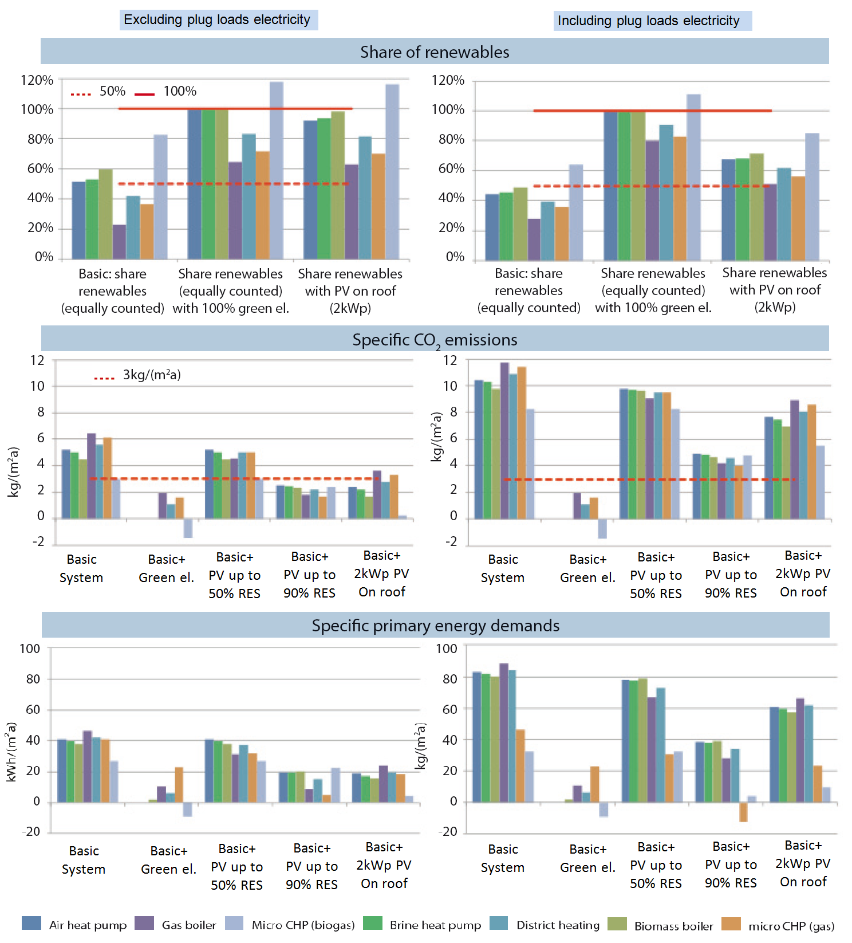
Figure 1: Simulation results: office building in Stuttgart

Financial impact of the analysed nZEB options
The financial impact of the considered nZEB options have been calculated by comparing the extra investment costs to achieve the nZEB levels and the potential savings (mostly energy costs) to a local actual new building standard.

The energy prices assumed for the different locations and usage types (residential and office) are shown in table 9. The prices are averages, based on Eurostat data and considering a period of 30 years with an annual price increase rate of 1.5% and an interest rate of 4%. For green electricity for all locations and usage types, additional costs of 0.02 €/kWh are added to the conventional electricity prices. The prices for heat pump electricity and district heat are assumed to be related to the price of gas, assuming the following correlations:
- price heat pump electricity => 2.2 x price of natural gas
- price district heat => 1.24 x price of natural gas

For the reference and the CHP options, with a comparably high demand, have to be assumed different (demand dependent) prices for gas, biomass and district heat than for the nZEB options.

The inputs related to the average assumed investment costs are described in the Table 10. However, the investment costs are dependent on specific market circumstances, contract negotiations, sale volumes and might differ substantially at the level of single projects.

Table 9: Assumed average energy prices for the period 2011-2040 for the services sector
 | Copenhagen | Stuttgart | Madrid
Electricity conventional [€/kWh] | 0.191 | 0.199 | 0.280
Electricity heat pump tariff [€/kWh] | 0.106 | 0.114 | 0.107
Green electricity [€/kWh] | 0.211 | 0.219 | 0.300
Natural gas [€/kWh] | 0.048 | 0.052 | 0.049
Biomass [€/kWh] | 0.040 | 0.043 | 0.040
District heat [€/kWh] | 0.060 | 0.064 | 0.060
Natural gas – gas CHP & reference [€/kWh] | 0.089 | 0.066 | 0.071
Biomass – wood pellets & bio-CHP [€/kWh] | 0.073 | 0.054 | 0.058
District heat (>20GJ/yr) [€/kWh] | 0.111 | -- | --

Table 10: Additional specific investment costs (Euro2010, incl. VAT)
Additional Investment costs for energy efficiency measures (euro2010, incl. VAT)
Component | Unit | City/climate zone
 |  | Madrid | Stuttgart | Copenhagen
Improved windows glazing | €/m² glazing | 150 | 50 | 0
Improved heat recovery | €/m² floor area | 20 | 25 | 15
1 cm roof insulation | €/m² | 0,69 | 0,99 | 1,27
1 cm wall insulation | €/m² | 0,91 | 1,32 | 1,69
1 cm floor insulation | €/m² | 0,86 | 1,24 | 1,59
Specific costs for the PV system | €/kWp | 3300 | 3300 | 3300
Improved lighting | €/m² | 2 | 5 | 2

Additional Investment costs for heating systems (euro2010/m², incl. VAT)¹⁷
 | Air heat pump | Brine heat pump | Biomass boiler | Gas boiler | District heating | Micro-CHP gas | Micro-CHP biomass | Gas boiler
Madrid | 26,2 | 41,2 | 21,2 | 12,4 | 7,8 | 49,8 | 60,9 | 17,5
Stuttgart | 39,4 | 62,9 | 31,7 | 18,7 | 11,7 | 77,3 | 94,5 | 37,5
Copenhagen | 54,7 | 90,4 | 45,0 | 27,2 | 17,0 | 114,7 | 140,0 | 24,5

The investment costs identified within the study are in the range of EUR 12,400 - 224,000 for the reference office building. The cheapest option is the district heating; the most expensive option is the biomass micro-CHP.
Based on the above assumptions, figure 2 shown the additional annual costs per net floor area over a period of 30 years, considering an interest rate of 4% (without inflation). For the calculation of the annual costs, the annual energy prices savings (negative) were added to the annual additional investment and potential additional maintenance costs, which are necessary to reach the nZEB options. Positive values indicate that the additional costs are higher than the achievable savings.

The average investment costs for using different heating technologies vary largely according to the local market circumstances, contract negotiations, sales volumes etc. and might differ substantially from one case to another.
The results are very much influenced by the local prices for systems, energy prices and the existence of a certain support scheme (e.g. feed in tariffs). Therefore, without insisting on detailed prices, the outcomes of the financial examination are given in the followings:
- Overall, CHP solutions tend to be the most expensive.
- Especially in southern but also in central Europe, nZEB might be even more financially attractive than the reference case. In northern Europe higher costs can be expected.
- Adding PV in northern Europe increases the overall additional cost, in central Europe (Stuttgart), the price difference to a reference case is very small while in southern Europe the more PV is added the more financially attractive the nZEB solution becomes under consideration of the assumed circumstances
Overall, keeping the CO2 emissions below 3kgCO₂/m²yr appear to be affordable in most of the considered options, but especially in the moderate and warm climate zones (figure 3). Within the CO2 proposed threshold, most of the considered options have specific additional capital costs below 3 euro/m²yr. For several considered options the additional costs are even negative which means that the necessary additional investment is lower than the expected cost savings through the anticipated reduction of the building’s energy need. Moreover, few options lead to net zero or positive CO2 emissions balance (i.e. the points on the y-axe and the ones having negative values for CO2 emissions in the below graph) with small or even negative specific additional costs.

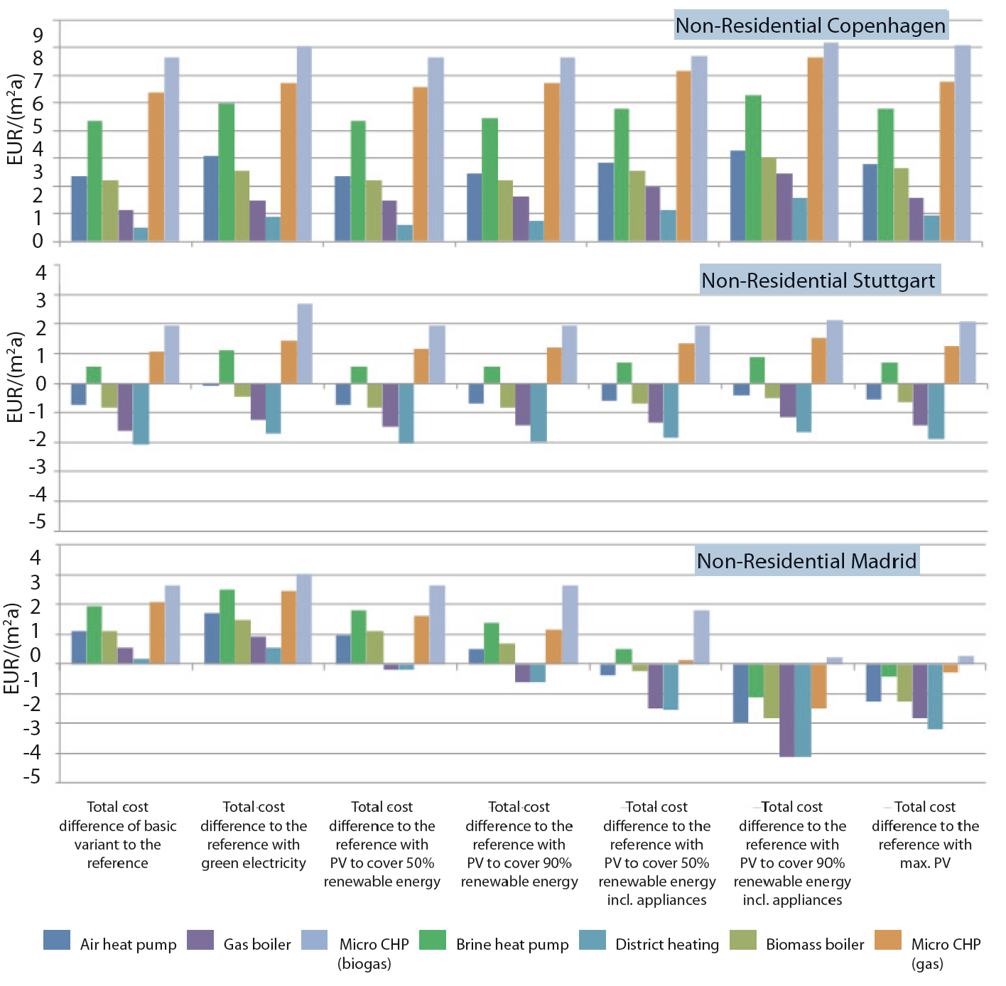
Figure 2: Specific annual costs for the considered nZEB options and climate zones
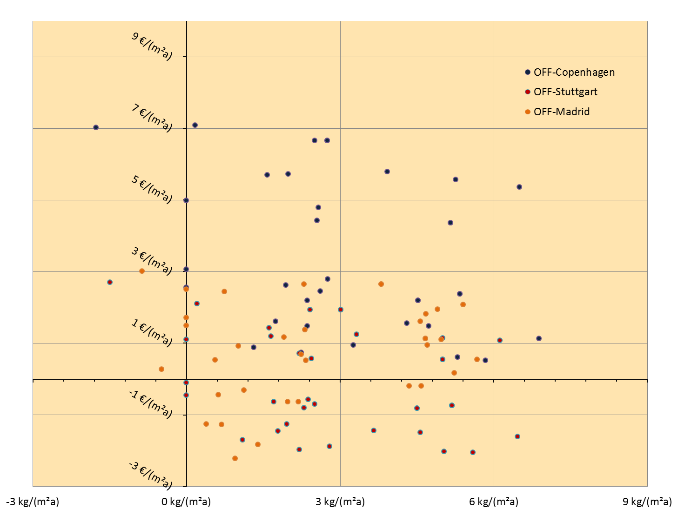
Figure 3: Specific additional capital costs of the examined nZEB solutions related to the actual local building standard (y-Axis) vs. specific CO2-emissions (x-Axis)

Final considerations: nZEB implications and steps forward
While a nZEB definition needs to deliver the framework for successful implementation of the related principles at building level, any final nZEB definition needs to and will have technological, financial and policy implications at EU level. The simulations have shown that the proposed nZEB principles are feasible and reachable with already existing technologies. Fossil fuel based technologies are not consistent with the ambition of the proposed nZEB principles.
Further improvements towards highly efficient thermal insulation materials and windows, as well as of heating, cooling and ventilation technologies, and demand control systems will enlarge the available options and will push the nZEB limits towards higher performances and potentially more affordable costs. But for achieving proper levels of market deployment for energy efficiency technologies it is necessary to up-scale the actual levels and to foster the market penetration of promising new technologies.

Apart from market barriers, barriers regarding know-how and number of professionals also exist. To date, 1% of all new buildings in Germany are built according to the passive house standard. Therefore it can be assumed that at EU level the percentage is smaller than 1%. Even considering that nZEB is not necessarily equivalent to a passive house but close to the energy level of passive houses, the factor by which the deployment of nZEBs across Europe should increase can be assumed to be beyond 100. For reaching this market level it is necessary to improve the skills of building professionals, from architects, construction engineers to the trades specialists (installers, electricians, carpenters etc).

A successful implementation of nZEB will also need technology transfer within the EU. This is especially important for technologies to reduce heating and cooling demand. The nZEB definition has to go beyond delivering a method that complies with the EPBD text, so as to fit in with particular targets connected to activities in the building sector, such as those related to energy conservation and to lowering energy consumption, efficient use of resources, climate protection and job creation.

The proposed nZEB principles directly fit with the European Union’s energy and climate targets. Moreover, the proposed nZEB principles have the potential to strongly support EU job creation targets by stimulating construction activity as well as innovation and production processes in the supply chain industry. The job creation potential of the building activity can be estimated on the basis of the job intensity in the related sectors, i.e. the turnover potential per employee. According to that calculation, the implementation of nZEB as a mandatory requirement in the future would create about 345,000 additional jobs.
The proposed nZEB principles and approaches to implementing them into practical definitions are consistent with the EPBD by assuming the cost-optimality methodology as a transitory instrument converging towards the future nZEB requirement. While the simulation of the nZEB principles has been made considering the current situation and market conditions, the future evolution will be crucial for the financial gap between cost-optimality and nZEB requirements.

Depending on the specific context by 2021, the financial gap between cost-optimality and the binding nZEB requirements may need to be bridged by additional policies and support measures. To comply with the proposed nZEB principles, current national codes need to be gradually strengthened towards more ambitious levels, together with a significant increase of the enforcement/compliance and control. Moreover, tightening the existing requirements should happen at the same time with the adaptation of the legal requirements for supporting the market deployment of buildings-related energy efficient and renewable energy technologies.

The effect of local aspects to the energy demand and supply of buildings is considerable, especially in relation to new buildings. For example, before starting the construction of a new building, careful consideration of the positioning and orientation needs to be done in order to maximise or minimize solar gain. The particulars of an urban area, such as its density, are also very important for the energy supply of a building. To further support the implementation of nZEBs, local utilities should play an important role in providing nearby renewable energy – heat, cold and power – to the future nZEBs. An integrated approach between the buildings’ and local utilities’ policies may facilitate a faster and cheaper implementation of nZEBs. Hence, the smart cities policies should consider and facilitate the introduction of nZEB by providing an energy system well-tailored to the future needs of buildings.
Therefore, the energy optimization of urban structures needs to be part of the sustainability concept for European cities. Sustainable policies in European cities have to contribute to the paradigm shift from a traditional sector-oriented approach to a more integrated approach which ensures the consistency between the district energy supply and urban development.

Principles for nearly Zero-Energy Buildings. Paving the way for effective implementation of policy requirements. Buildings Performance Institute Europe (BPIE) 2011, available online at: www.bpie.eu
Based on Erhvervs- og Byggestyrelsen: Kortlagning af strategier for lavenergibyggeri i EU Lande, Februar 2011.
Energy-positive buildings are buildings producing more energy than their energy needs.
As defined in the EPBD, the cost-optimal level means the energy performance level which leads to the lowest cost during the estimated economic lifecycle. The cost-optimal level is defined in Article 2 and described in Article 5 of the EPBD (Directive 2010/31/EU).
A roadmap for moving to a low carbon economy in 2050, European Commission 2011
Starting from CO2-emissions for the building sector of approximately 1.100 MtCO2 in 1990 (direct and indirect emissions for heating, domestic hot water and cooling) and assuming a useful floor area in 2050 of 38 billion m² in 2050, a 90% decrease of emissions would require an average CO2-emissions of maximum 3 kgCO2/(m²yr).: 1,100MtCO2 x (100%-90%) / 38 billion m² = 2.89 kg/(m²yr).
Including the national energy tax system development as part of the national activities towards more economic solutions.
Due to volume effects induced by the introduction of the nZEB requirement.
Zero-energy will inadvertently result in zero CO2, however the definition of zero is typically not the “ideal and absolute” zero, but instead a zero over a period of time (an annual mean) and a zero that might be a balance of energy production and use.
Europe’s buildings under the microscope. A country-by-country review of the energy performance of buildings, Buildings Performance Institute Europe 2011.
Lighting (2 rows) with attendance and daylight control (aim: 200 lx) plus individual workplace lighting, to be added to the basic demand
Individually calculated, mainly depending on external temperatures, assuming best actually available market products
heating/electricity production
For the purpose of this simulation, photovoltaic (PV) and micro-CHP (CHP=combined heat and power plant) were considered. It is assumed that CHP is driven as an (inefficient) heating boiler, which produces 100% “green” electricity and may be used for compensation for renewable energy, CO₂ emssions and primary energy.
There are great country differences between the CO₂ emission factors for electricity and district heating, according to the fuel mix content in the energy supply. For simplification the EU-27 average was applied. For the CO₂ emission factors of electricity and district heating average values for the years 2011 to 2040 were assumed, taking into account a constant decrease towards -90% by 2050 (according to the power-sector reduction target).
The shares of renewable energy and the primary energy factor for electricity are calculated as “2011 to 2040”- average values, based on the renewable energy projections of the Energy Environment Agency and the ECN for the EU27.
Sources: Ecofys BEAM2 model, report “Heating systems: Heating concept for Germany - Environmental impact from heating systems in Germany, for German Umweltbundesamt, 2009/2010”, and use of construction costs indicators (EUROSTAT), own investigations.
comparison to the actual new build standards at the location
Assuming an extra investment of EUR 39 billion per year and an average turnover in the EU construction industry of EUR 113,000 (in 2008) per person and year.

