Looking for great career opportunities?
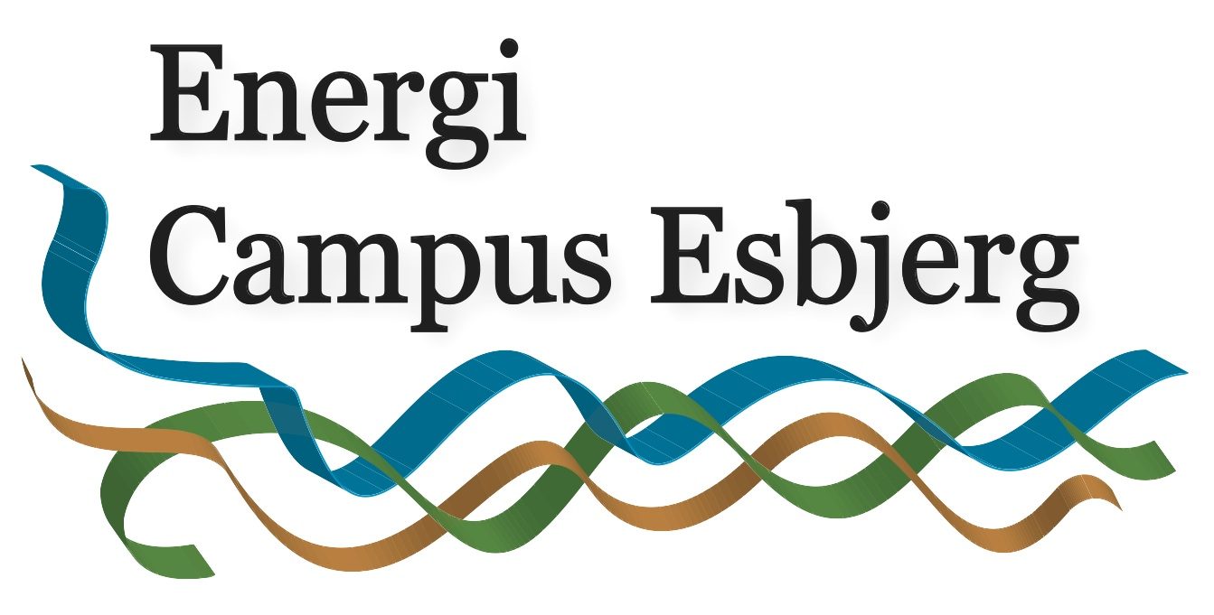

Companies in the Danish Energy Sector have a strong wish to attract highly qualified manpower to the Esbjerg area - and the municipality of Esbjerg is ready to receive and help newcomers to the area!

Are you interested in:
- Contact to the energy industry and seeing the career possibilities?
- A professional competence boost in the offshore oil and gas field?

Participate in the Offshore Oil and Gas Seminar 18 – 22 August 2014 at Aalborg University Esbjerg with an incredible exiting advanced program and establish contact with future attractive companies!
"It's a wonderful experience with people from all around the world, a chance to gain new knowledge and on top boosting your career opportunities." Stated by a former participant.
Besides boosting your professional competences in the offshore oil and gas field you meet various companies participating in Speed Business Networking, giving lectures and opening their company showing their exciting facilities and future opportunities for cooperation.

You will also meet foreigners who have already moved to Esbjerg to work and they will tell you more about living and working in the municipality of Esbjerg. On top of this you’ll get a big international network with other seminar participants from all over the world.

Participants: You can participate if you are a national or international M.Sc. student, Ph.D. student or postdoc student within the fields of energy, mechanical, structural, civil, project management, chemical, process engineer, electrical and control systems or similar engineering educations.

There is a limitation on number of participants. Become one of the selected participants!
Deadline 30th June 2014.

The seminar is free of charge and arranged by Project Energy Campus Esbjerg
More information, program and application on the webpage Oil and Gas Seminar.

On behalf of the project:
Project manager Tove Morell
Mail: morell@staff.aau.dk
Phone: +45 29 29 39 60

