Organized democracy, conflict partnership and trust. The creation of social trust in Scandinavia.
Lars Torpe
Aalborg University

Introduction
Several surveys have shown that people in Scandinavia are more trusting than people in other countries. The reasons why are still debated. From a Putnamian view and following a civil society-centered approach one would refer to the strength and character of social ties in these countries, including memberships of voluntary organizations. Following an institution-centered approach one would rather refer to the non-corrupt political institutions, to the welfare state and the resulting social equality. The truth could, however, be both, that it was the unique combination of a strong civil society and a strong welfare state and perhaps not least the integration of voluntary organizations in public decision making and implementation that laid a foundation for the creation of trust in Scandinavia.
In the following I shall first briefly discuss the two approaches mentioned above. Secondly, I shall try to illuminate how associations as part of the democratic infrastructure of society help generate trust. The overall hypothesis is that corporatist structures by the creation of a sense of conflict partnership promote social trust. The arguments are accompanied by some empirical illustrations. In the final section of the paper I shall relate this source of trust to other sources of trust and discuss the creation of trust in the light of some changes in the relationship between voluntary organizations and the state.

A civil society-centered approach versus an institution-centered approach to trust
Focus in the paper is on generalized trust, which means trust in strangers, i.e. people of whom you have no personal knowledge. Furthermore, rather than trustful behavior, trust is seen as trustful attitudes, namely the degree to which other persons are perceived as trustworthy. Accordingly, generalized trust can be defined as the belief that ‘those you potentially can interact with will behave decently’ (Dinesen & Sønderskov, 2012). A “trust-answer” is thus an indication of a positive assessment of other people’s trustworthiness. In surveys such an understanding of generalized trust is captured by the question, whether in general ‘most people can be trusted’ or whether ‘you can’t be too careful’ in dealing with people. With Delhey and Newton (2004) an answer that ´most people can be trusted’ can be interpreted as the respondent’s assessment of the moral standard of their society.
Following a civil society-centered approach voluntary associations are important for the formation of trustful attitudes. As Putnam say ‘they install in their members habits of cooperation, solidarity and public-spiritness’ (Putnam, 1993: 89-90). Although Putnam does not explicitly refer to trust in this context, he no doubt sees social trust as an important outcome of associations as ‘networks of civic engagement´ and thus as a resource for social collaboration and social capital (Ibid p. 171). In this Neo-Tocquevillian approach there is focus the internal or developmental effects of associations: Individuals develop civic skills and virtues, including trust, when they meet on an equal footing in networks and associations.
These so-called learning effects of active participation in associations have, however, been criticized by several scholars (Wollebek & Selle, 2002; Stolle, 2003; Rothstein & Stolle, 2007). First of all it has been shown that there is no or only weak correlation between associational activity and trust at the individual level. Although there are some methodological problems with these tests, without taking into account that any democratic effect of associational participation is permanent, whereas the activity changes over a lifetime, there are other reasons for questioning whether associational participation continues to have the unique democratic learning effect, it perhaps once had. To-day other societal institutions may have greater importance: The school, the family, the work place, the media etc.
Following the institution-centered approach high levels of social trust is therefore not a result of a vigorous civil society, but firstly a result of impartial and non-corrupt political institutions, where citizens are equal before the law. Secondly it is a result of a universal welfare state system, which provides citizens with the same positive rights and reduces inequality. Briefly the mechanisms through which an universal welfare state system promotes trust can be expressed as follows: If people think they live in a just society, where all are treated fair and equal by the authorities, and where other people abstain from “free-riding” or are punished if they do so, their dispositions to perceive other people as trustworthy will increase. Conversely, if citizens experience society as unjust, they lose confidence in the political institutions and lose trust in other people as well.
Although supporters of the institutional critics have correctly questioned the internal or developmental effects of associations, they may at the same time be criticized for having neglected the external effects of associations, namely the effects on trust via the role of organizations as intermediary structures of coordination and cooperation between social groups and the state. Through this mediating role voluntary organizations have become part of the democratic infrastructure of society (Wollebæk & Selle, 2007; Wollebæk & Strømsnes, 2008). Such effects have largely been overlooked in the existing research, but are indicated by strong correlations between the amount of organizational membership and generalized trust at the regional and national level of society (Wollebæk & Selle, 2007; Torpe, 2013).

Organized democracy, conflict partnership and social trust in Scandinavia
The overall hypothesis can thus be stated as follows: It is in the capacity of intermediary structures of coordination and cooperation between social groups and the state that voluntary organizations promote trust. The structures of coordination and cooperation can, however, take many forms varying from loose forms of communication between organizations and the state to permanent representation of organized interests in state institutions. The latter is called corporatism. Borrowing from Christiansen et al. (2010), corporatism can be defined as ‘the institutionalized integration of privileged organized interests in policymaking and implementation’. The degree of institutionalized integration varies from country to country. While some Western countries such as Denmark, Sweden and Austria have strong corporatist structures, other countries such as Canada, France and the United Kingdom have only weak corporatist structures.
Following the above mentioned definition, corporatism is not confined to areas such as economic, industrial relations and labour market policy, but can be identified within a multitude of policy areas, where voluntary organizations are engaged in an ‘exchange relationship’ with the state (Öberg et al., 2011). Such kind of relationships are most often analysed at the national state level between state agencies and big hierarchical structured organizations operating at that level, but particular in Scandinavia there are also a multitude of exchange relationships at the local level between local authorities and smaller local organizations in various fields. Corporatism can therefore also be described as a ‘negotiating democracy’ (Armingeon, 2002) or as an ‘organised democracy’ (Olsen, 1983) characterized by the integration of voluntary organizations in the democratic infrastructure of the society both at the state level and at the local level.

The degree of corporatism has been captured by an index made by Siaroff (1999), who have compared 24 OECD countries. The index is based on indicators from previous studies of corporatism, and they are primarily related to industrial relation and labour market policy. The index is constructed for four periods, and although the index only covers a part of what is included in the above mentioned definition of corporatism, it may give us an indication of the strength of corporatism (Torpe, 2014).

Although corporatism is an important feature of organized democracy, it requires something more to be called an organized democracy, namely a well-organized society, where most people are represented by organizations within different fields. In Figure 1 organized democracy is measured as the aggregate measure of the strength of corporatism (the Siaroff-index) on the one hand and the strength of people’s organization measured as the average proportion of the population that in four studies from 1981 to 2008 said, they were members of at least one organization.

If we relate this aggregate measure of organized democracy to generalized trust measured on the standard question, whether one believes that most can be trusted, a strong correlation appears with a standardized regression coefficient on 0,81 (Figure 1). We furthermore observe that the three Scandinavian countries are at the top on both the degree of organized democracy and the level of trust. But there are also some remarkable exceptions. Some Central European countries combine a rather high score on organized democracy with a rather low score on trust. This is particularly true for Austria, but also to some extent for Luxembourg, Germany, and Belgium. Austria’s high score on organized democracy reflects a high score on corporatism and a rather modest score on the degree of membership. This reflects the different character in Austria compared to Scandinavia.

Figure 1. Organized democracy and trust.

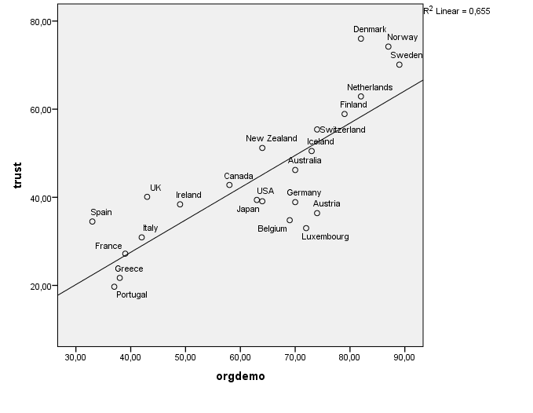
A control for other variables that previous studies have shown influence trust, namely education, ethno-cultural diversity measured as ethnic, linguistic and religious fractionalization, economic wealth, control of corruption, political representation, and inequality shows that only control of corruption and political representation have significant effects at the 0.10 level. Unfortunately, the low N allows the effect of organized democracy to be controlled for only one variable at a time.

However, although these controls give us a rather strong indication of the effect of organized democracy on trust, to demonstrate a causal relationship between the two variables, we should be able to explain the mechanisms that connect these variables: How is organized democracy linked to social trust among ordinary people?

A first answer is that corporatist processes of negotiation are not only processes of bargaining. They can also be characterized as deliberation processes with the aim to find common solutions, and such processes have shown to promote trust between the involved actors (Öberg, 2002). Such observations are in line with historical narratives showing trustful relations between representatives of opposing organizations. An example of this is the trustful relation that evolved between the chairman of the Swedish National Federation of Trade Unions and the managing director of the Swedish Employer Federation in the years after the historic agreement in Saltsjöbaden in 1938 (Rothstein, 2003).

There is, however, no automatic transference of trust from the top executives to the bottom members of the organizations (Öberg, 2002), and it is only if corporate structures are extensive and affect many people, and are stable over time, that we can assume that they contribute to the formation of trust between ordinary citizens. Furthermore, organizations should enter the corporatist processes of negotiation with a positive will to resolve conflicts and reach common solutions.

In Scandinavia these conditions were met from the 1930’s. Firstly, whereas in most countries the ‘formative period’ of corporatist structures was after World War II, in Scandinavia corporatism dates back to before World War I. In Sweden the establishment in 1912 of the National Board for Social Affairs with representatives from the trade union movement and the employers’ federation is an early example of the incorporation of associations into the political process. During World War I, both Denmark and Norway made decisive breakthroughs in advancing corporatism by involving organized interests in government. For all three countries the next ‘formative period’ of corporatism was during the economic depression of the 1930s (Blom-Hansen, 2000). From the 1940’s to the 1980’s more and more policy areas were covered by corporatist arrangements.

Secondly, although local branches initially formed the core of the organizational society, from the late 19th century on, the local and national levels were linked in a hierarchical organization based on the principles of representative democracy (Selle & Øymyr, 1995). Through their organizations, citizens in Scandinavia became integrated into the political system both at the local and the national level. Since the organizational density and membership was high, voluntary organizations became ‘real empirical intermediate structures’ between the individual and the state (Selle, 1999:149). Furthermore, in Scandinavia more generally, voluntary organizations gradually evolved into ‘bridging’ organizations. At the beginning of the twentieth century many Scandinavian organizations were still ‘bonding’ organizations with a firm class orientation. This changed during the first half of the century as the share of associations involved in culture and leisure activities increased rapidly by appealing to more people across divisions of class, gender, and age (Eriksen, 1996). Also, traditional class organizations such as trade unions, employer organizations, associations within industry and agriculture, and professional organizations gradually opened to broader cooperation and showed greater willingness to relate their own interests to the interests of society as a whole. Since these organizations represented a clear majority of employers and workers, they were able to make binding and effective agreements with other parties and with the state.

In summary, the necessary conditions for organized democracy to influence trust were established in Scandinavia during the 20th century both in terms of the scope of corporatism, the duration of corporatism, the openness and inclusiveness of organizations and the high density of organization and membership.

To understand how trustful relations between the actors in the corporatist bodies were transferred to trustful relations at the “shop flour”, it is useful to draw on the concept of collective memory. Collective memories are meanings of past events that are shared by a group (Rothstein, 2000). Collective memories are constructed from real events on a ‘battlefield of interpretation’ by ‘strategically acting political entrepreneurs who seek to further their own political goals and ambitions’ (Rothstein, 2000, p. 494). The interpretation which emerges and gains support and thus becomes ‘our’ collective memory has profound importance for how ‘we’ look at society, and for whether and how much, ‘we’ perceive other people to be trustworthy.

In the case of Scandinavia, we assume that collective memories were constructed by ‘strategically acting political entrepreneurs’ who wanted to convince their respective members that conflicts between groups and classes could be solved through negotiation and compromise, that the other parties at the negotiation table were reasonable, and that it would be in the interest of all parties to raise productivity in order to achieve greater prosperity. Such ‘memories’ constructed by socialdemocratic and liberal political entrepreneurs were disputed for many years by left-wing trade unionists, but from the 1980’s they had achieved an almost universal acceptance (Pedersen, 2011). What people accepted can be described as a perception of conflict partnership understood as the common understanding that conflicts can be handled and solved peacefully in the interest of all parties (Dølvig, 2013).

Thus, it was the construction of collective memories of how conflicting interests can be handled through joint negotiation and decision-making that paved the way to greater trust, not accurate information about what takes place in the corporative bodies. Seen from this perspective, corporatism has a meaning that goes beyond formal agreements in corporate bodies, namely the creation of structures of conflict resolution that eventually were seen as a conflict partnership. This laid a foundation for the creation of social trust across social groups and classes.

The hypothesis that organized democracy through corporatist arrangements influences trust by reducing the sense of conflict in society can be tested by including a variable from International Social Survey Program, 2009, where respondents are asked whether they see very strong conflicts, strong conflicts, not very strong conflicts and no conflicts at all between workers and management in their country. Figure 2 shows a strong correlation between organized democracy and the perception of a conflict (measured on a scale from 1 to 100, where 1 stands for very strong conflicts and 100 stands for no conflicts at all). Unfortunately only 17 countries can be included in this model. As we can see the three Scandinavian countries are in the low end concerning the perception of conflicts and in the high end concerning organized democracy.

Figure 2. Organized democracy and the perception of a conflict between workers and management
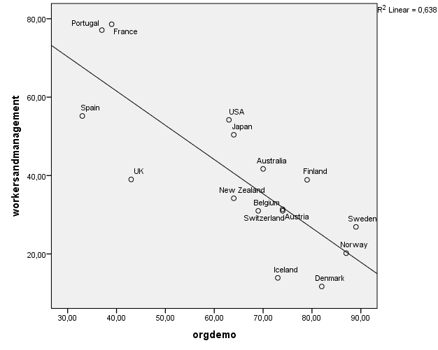

If it is a correct assumption that organized democracy via corporatist arrangements stimulates trust by the creation of a conflict partnership, we should expect the perception of a conflict between workers and management to be mediating variable between organized democracy and trust. This hypothesis is partly confirmed (Table 1) as we can see that the effect of organized democracy on trust is reduced, when the variable for the perception of conflict is added to the model. There is, however also an independent effect from the perception of conflict, as the explained variance of the model increases from 0,64 to 0,68, when the perception of a conflict between workers and management is added to the model.
Table 1. Corporatism and conflict between workers and managers and trust. Standardized regression coefficients.

 | Model 1 | Model 2
Corporatism | 0.81 | 0.52
Perception of a conflict between workers and management |  | 0.38
R2 | 0.64 | 0.68

The results are promising and invite further research into what can explain the mechanisms behind the great variations in generalized trust among the citizens of Western countries and the high level of trust in the Scandinavian countries compared to other Western countries. However, the limited number of countries in the analysis makes the results indicative rather than confirmative.

Discussion
There is thus some empirical support to the hypothesis that corporatism through a perception of conflict partnership stimulates the formation of social trust. Since there is great continuity within corporatism, there are reasons to believe that organized democracy in Scandinavia contributes to an explanation of the high levels of trust in these countries. As shown in Figure 3, the three Scandinavian countries were at the top, when social trust was measured for the first time in 1981. Although Denmark had suffered from serious economic problems, rising unemployment and social conflicts in the previous period, the measured trust was only surpassed by Sweden and Norway (figure 3).

Figure 3: Generalized trust 1981 – 2008. Pct. saying “most can be trusted”

Sources: World Values Survey and European Values Study.

But corporatism is probably not the only factor that explains the higher level of trust in Scandinavian countries compared to other Western countries. Among other factors are particularly economic equality and equality of opportunity (Wilkinson & Pickett, 2010; Rothstein & Uslaner, 2005). One of the supposed effects is that equality creates a sense of a common belonging. Such an effect is particularly clear in a universalistic type of welfare states, where people have the same social rights and belong to the same welfare institutions. From a historical perspective corporatism came before the welfare state. One may even argue that corporatism triggers welfare state expansion (Armingeon, 2002). This is particular true of Scandinavia. In these countries corporatism was established in the early twentieth century as a system for governing areas such as the labour market, agriculture, and industry, but it was after the class compromises of the 1930s and the development of universalistic welfare systems after World War II, that these countries came to be described as egalitarian -- not only in terms of income and wealth, but also in terms of equal opportunity and social mobility (Esping-Andersen, 1990). However, it should be added that Scandinavian historians have pointed out that social differences were smaller in Scandinavia at the beginning of the twentieth century than they were in other European countries at that time (Dølvig, 2013).
In all three Scandinavian countries the hey-days of corporatism are between the 1950’s and the 1980’s. Since then corporatism has according to several scholars been in decline, especially, when it comes to the labor market (Christiansen et.al., 2010). However, as appears from Figure 3, social trust has continued to rise in Scandinavia, and the gap between the Scandinavian countries and the other western countries, except the Netherlands, has even been greater. How do we explain this apparent paradox?
First, as mentioned above, corporatism is not the only determinant of trust. Secondly, though there are signs that corporatism has weakened at the central level, Scandinavian countries are still at the top in international comparisons ranking countries based on their level of corporatism (Lijphart, 2012). Finally, although some of the traditional elements of corporatism have been abandoned, particularly the representation of trade unions and employer federations in law-preparing committees, formalized cooperation between groups and between groups and the state has not diminished. In Denmark, for example, a broader range of organizations are now consulted and involved in corporative arrangements at the state level (Christiansen & Nørgaard, 2003). In addition, there has been strong growth in the involvement of organizations in public decision-making and implementation at the local level (Torpe, 2003). In the 1970s only a small number of Danish municipalities had formalized contacts with associations. Today municipalities are obliged by law to work cooperatively with associations active in areas of social life. Furthermore, municipalities have voluntarily worked with associations in other areas such as employment, health, sport, culture, and integration. In Denmark and in Sweden as well, a growing part of the welfare state is administered at the local level. Presumably, this is an important reason for the growth in local corporatism (Öberg & Svensson, 2012).
Overall, both corporatist structures and the universal welfare states and the resulting equality seem to be powerful explanations of the high level of social trust in the Scandinavian countries. They created on the one hand a conflict partnership and on the other hand a sense of community that stimulated the perception of others as trustworthy. Perhaps the combination of the two best can be described as feeling of living in a middleclass society with most people in the middle. We would therefore expect a strong relationship among nations between on the one hand the percentage in each country indicating that they live in a society with most people in the middle and trust on the other. As shown in Figure 4 the expectation is met.

Figure 4. Trust and the percentage saying the live “in a society with most in the middle”. Western societies.
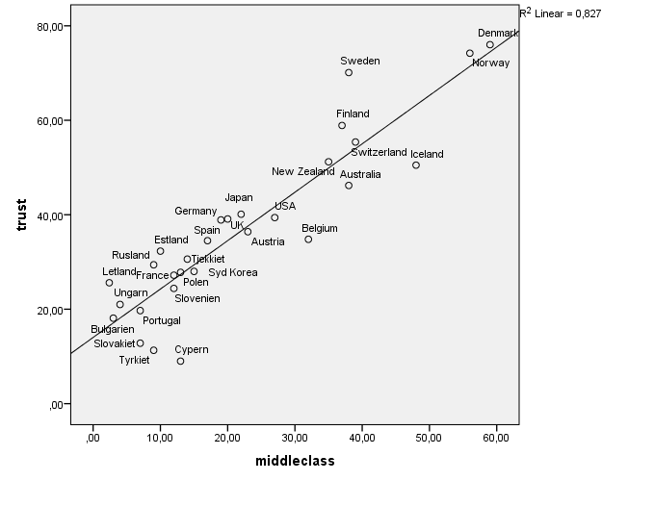
Sources: International social Survey Programme (2009), World Values Survey, 2005-08, European Values Study 2006-08.
The standardized regression coefficient is 0,82 indicating a strong relationship. As one can see a smaller proportion of people in Sweden think they live in a middle-class society than in Norway and Denmark. An obvious explanation is that income inequality has grown in Sweden. This is, however, also the case in Denmark and Norway. But, the Swedes seem to be more dissatisfied with the existing distribution of income than the Danes (Lolle & Torpe, 2010). Furthermore, the difference may reflect that institutions in Sweden always have had a more hierarchical character than in Norway and Denmark.
A tentative conclusion is that with the combination of organized democracy and the simultaneous growth of prosperity, equality, and social security former class identities have been replaced by middle-class identities in Scandinavia, which have laid a foundation for trust among strangers. At the beginning of the 1980s the Scandinavian countries were both among the most corporatist and the most egalitarian countries in the OECD area. Altogether this helps explain why these countries also proved to have the most trustful populations when in 1981 trust was measured for the first time in a number of Western countries. And even if such effects do not last forever, they have proved to be strong enough to survive a certain decline of corporatism at the central state level. Whether they also will survive a certain decline in equality, we will still have to see.

References

Armingeon, K. (2002) The effects of negotiation democracy: A comparative analysis. European Journal of Political Research 41, pp. 81-105.
Blom-Hansen, J. (2000) Still corporatism in Scandinavia? A survey of recent empirical findings. Scandinavian Political Studies, 23 (2) pp. 157-181.
Christiansen, P.M. & Nørgaard, A.S. (2003) Faste forhold – flygtige forbindelser. Stat og Interesseorganisationer i Danmark i det 20. Århundrede. Magtudredningen (Århus, Århus Universitetsforlag).
Christiansen, P. M., Nørgaard, A.S., Rommestvedt, H., Svensson, T., Thesen, G. & Öberg, P.O. (2010) Varieties of Democracy: Interest groups and corporatist commitees in Scandinavian policy making, Voluntas 21, pp. 22-40.
Delhey, J. & Newton, K. (2004) Social Trust: ‘Global pattern or Nordic exceptionalism?’ Working Paper. Wissenschatcentrum Berlin für Socialforschung.
Dinesen, P.T. & Sønderskov, K.M. (2012) Hvorfor Stiger Tilliden? Politica, 44 (1) pp. 87-110.
Dølvig, J.E. (2013). Grundpilararene i De Nordiske Modellene. Et Tilbageblik på Arbejdslivs- og Velferdsregimernes Utvikling. (Oslo, NordMod. Fafo-rapport13).
Esping-Andersen, G. (1990) The Three Worlds of Welfare Capitalism. (Princeton, Princeton University Press).
Eriksen, S. (1996) Stationernes Samfund. Folk og Foreninger i Grindsted 1880 – 1940 (Grindsted, Overgaard Bøger).
European Values Study (2011) Dataset version: Release v3.0.0 as of November 2011, Study No. 4800. Available at http://www.europeanvaluestudy.eu/frmShowpage?v_page_id-9002471901798834.
Freitag, M. & Bühlmann (2009) Crafting trust: The role of political institutions in a comparative perspective. Comparative Political Studies, 42(12), pp. 1537-1566.
International Social Survey Programme (2009) Social Inequality IV. Available at www.issp.org .
Larsen, C. A. (2013) The Rise and Fall of Social Cohesion. The Construction and De-construction of Social Trust in the US, UK, Sweden and Denmark. (Oxford, Oxford University Press).
Lijphart, A. (2012) Patterns of Democracy. Government Forms and Performance in Thirty-six Countries. Second edition. (Yale: Yale University Press).
Lolle, H. & Torpe, L. (2010). “Ethnic diversity and social trust in Denmark and Sweden” pp. 323-344 in Bengtsson, B., Strömblad, P. & Bay, Ann-Helen. Diversity, Inclusion and Citizenship in Scandinavia. Cambridge: Cambridge Scolars Publishing.
Öberg, P.O. (2002) Does administrative corporatism promote trust and deliberation? Governance: An International Journal of Policy, Administration and Institutions, 15 (4), pp. 455-475.
Öberg, P.O. & Svensson, T. (2012) Civil society and deliberative democracy: Have voluntary organizations faded from national public politics? Scandinavian Political Studies, 35 (3), pp. 246-270.
Öberg, P.O., Svensson, T., Christiansen, P.M., Nørgaard, A.S., Rommetvedt, H. & Thesen, G. (2011) Disrupted exchange and declining corporatism: Government authority and interest group capability in Scandinavia. Government and Opposition, 46 (3), pp. 365-391.
Pedersen, O.K. (2011) Konkurrencestaten. (The Competition State) (København, Hans Reitzels Forlag).
Putnam, R.D. (1993) Making Democracy Work. Civic Traditions in Modern Italy. (New Jersey, Princeton University Press).
Rothstein, B. (2000) Trust, social dilemmas and collective memories. Journal of Theoretical Politics, 12 (4), pp. 477-501.
Rothstein, B. (2001) Social capital in the social democratic welfare state. Politics and Society, 29, pp. 207-241.
Rothstein, B. (2003) Sociala Fällor och Tillitens Problem. (Stockholm, SNS-Förlag).
Rothstein, B. & Uslaner, E.M. (2005) All for all – Equality, Corruption, and Social Trust. World Politics 58, pp. 41-72.
Rothstein, B. & Stolle, D. (2007) The Quality of Government and Social Capital. A Theory of Political Institutions and Generalized Trust. Q&G Working Paper Series 2007: 2 (Göteborg, University of Göteborg)
Selle, P. (1999) The transformation of the voluntary sector in Norway. A decline in social capital? in van Deth, J.W., Maraffi, M., Newton, K., & Whiteley, P.F. Social Capital and European Democracy (Routledge, London/New York).
Selle, P. & Øymyr, B. (1995) Frivillig Organisering og Demokrati. (Oslo, Det Norska Samlaget).
Siaroff, A. (1999) Corporatism in 24 industrial democracies: Meaning and measurement. European Journal of Political Research, 36 pp. 175-205.
Stolle, D. (2003) The sources of social capital in Hooghe, M. & Stolle, D. Generating social capital. Civil ociety and institutions in comparative perspective, pp. 19-42 (London, Palgrave.
Torpe, L. (2003) Social Capital in Denmark. A Deviant Case? Scandinavian Political Studies, 26, pp. 27-48.
Torpe, L. (2013) De Stærke Samfund. Social Kapital i Skandinavien. (Copenhagen, Frydenlund Academic).
Torpe, L. (2014). Corporatism and social trust. Bringing voluntary organizations “back in”. Journal of Civil Society (forthcoming)
Wilkinson, R. & Pickett, K. (2010) The Spirit Level. Why Equality is Better for Everyone. (London, Penguin Books).
Wollebæk, D. & Selle, P. (2002) Does participation in voluntary associations contribute to social capital? The impact of intensity, scope and type. Nonprofit and Voluntary Sector Quarterly, 30 (1), pp. 32-61.
Wollebæk, D. & Selle, P. (2007) Origins of social capital: Socializations and institutionalization approaches compared. Journal of Civil Society, 3 (1) pp. 1-24.
Wollebæk, D. & Strømsnes, K. (2008) Voluntary associations, trust and civic engagement: A multilevel approach, Nonprofit and Voluntary Sector Quarterly 37, (2), pp. 249-263
World Values Survey Association (2005-2008) World Values Survey Wave 5 2005-2008 Official Aggregate v.20140429. Aggregate File Producer: Asep/JDS, Madrid SPAIN. Available at www.worldvaluessurvey.org.

In International Social Survey Programme 2009 the respondents were asked to describe which type of society they lived in. They were shown five pictures with a short description. In the middle class society most people were in the middle and only a few at the top and in the bottom (see Larsen, 2013)

