Show-Bix &
  - An Anti-re-enactment
By Sebastian Bülow, Mogens Jacobsen, and Martin Luckmann.
Curated and conceptualized by Morten Søndergaard.

In 1968 the dominant conceptual movement was the happening. In 2014, the dominant conceptual movement seems to be the re-enactment. There is an interesting story to tell in that…

Show-Bix & is an “anti-re-enactment”.
The notion of “anti-re-enactment” refers to several strata of references and ideas, which are all interlayered in the responsive environment.

First of all, it is a reference to Marcel Duchamp’s notion of ’Anti-art’, which, according to Duchamp, is an art, not a non-art. So, the anti-re-enactment is a re-enactment, not a non-re-enactment. Which means, it conveys and responds to the very ideas and formats of re-enactment, and does so conceptually. It is a conceptual game, a language game if you will, with the ideas behind and formats of the re-enactment.

Secondly, Show-Bix called their pieces ‘anti-happenings’. We attempt to capture this conceptual dialogue with the happening and the event-genre In BIX by conveying an interpretation of the dominant conceptual movement of today – which, in-line with the context of the Aarhus Rapport and the concept of the Systemics #4 exhibition, seems to be that of re-enacting ‘what went on’ in the 60s in Århus.

Thirdly, the anti-re-enactment itself is a comment, even a philosophical one, to the archive – or rather what is missing in the archives. If media-art, or performative art, is not in the archives or not part of archival practices, even if has been re-iterated lately, it is hard to re-enact it. So, anti-re-enactments kicks in… making new versions of old ideas and materials, and while doing it, playing a language game with history and consciousness.

Show-Bix & is based on the original work (dias and sound) by Show-Bix (Per Højholt, Poul Ib Henriksen and Gunner Møller Pedersen). As crossover art group, Show-bix was active in Aarhus between 1968 and 1971. For that reason, it was also included into Aarhus Rapport.
BIX is a responsive environment where access to original material from Show-Bix media-performances, which is generated by the audience’s (inter)actions.

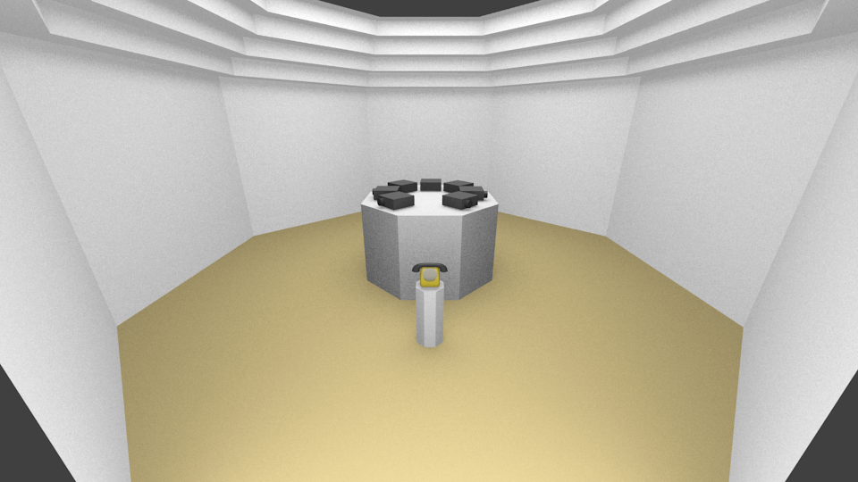

Concretely, the anti-reenactment Show-Bix & consists of 5 dias projectors. A responsive interface (explained below) enables the Dias projectors will be showing copies of original Dias images from the Show-Bix piece ”March på Stedet”, 265 images in total (examples enclosed below). The copies are made from digital scans of the original Dias images located in the collection of the Museum of Contemporary Art in Roskilde. In front of the plinth, and in front of the audience entering the space and placed on it’s own stand, is an original 60s style telephone with turning dial. Action begins when the audience lift the phone and dial a number. Any number will make the Dias change. All numbers are also assigned to specific sound documents: clips form rare interviews and the complete sound-re-enactment of the Show-Bix piece ‘Omringning’ (‘Surrounding’) in five channels (a quintophonie). This was originally produced in collaboration with Per Højholt and Gunner Møller Pedersen for the 2004 show on Per Højholt in Roskilde.

