D: Energy & sustainability
D.1. Energy and IEQ

House owners’ experience and satisfaction with Danish low-energy houses

Henrik N. Knudsen, and Jesper Kragh

Danish Building Research Institute, Aalborg University, Copenhagen, Denmark

*Corresponding email: hnk@sbi.aau.dk

Keywords: Indoor environment, Low-energy houses, Occupant satisfaction, Perceived indoor climate, Questionnaire survey

SUMMARY

The purpose of this study was to identify experience and satisfaction with new Danish detached low-energy single-family houses. A questionnaire survey was carried out in the autumn of 2013 among owners of newly built energy class 2015 houses. It included i.a. questions on their overall satisfaction, and more specifically their satisfaction with the indoor climate (temperature, draught, air quality, noise and daylight), and their experience with technical installations and heat consumption. The questionnaire was answered by 370 of 869 house owners corresponding to a response rate of 43%. The survey showed an overall satisfaction with the new low-energy houses, as 93% of the house owners would recommend living in such houses to others. The high rate of satisfaction may, among other things, be due to the fact that more than 90% of the house owners perceived the indoor environment as satisfactory both in summer and winter. The energy consumption was found to be as low as expected by 59%, while only 7% answered that it was higher than expected. Compared with previous similar studies, problems with technical installations and design have decreased. However, there is a need for continued focus on the commissioning of new, and not necessarily thoroughly tested, high-performance installations and new designs to achieve both low energy consumption and satisfied house owners.

INTRODUCTION

The Danish Building Regulations 2010 (BR10, 2010) defines minimum requirements for the energy performance of buildings. In order to encourage the development of more energy-efficient buildings, BR10 also includes the supplementary more ambitious and voluntary low-energy class 2015 and building class 2020. These classes correspond to the energy requirements suggested for the BRs forthcoming in 2015 and 2020, at the time when the requirements of BR10 were agreed. According to the current Danish Building Regulations, the yearly energy demand for heating, ventilation, cooling and hot water for a residential low-energy house 2015 should be less than (30 + 1000 /A_{e}) kWh/m², where A_{e} is the heated floor area. In 2012 and 2013, the proportion of erected low-energy houses class 2015 was approximately one third of the total building stock in Denmark. In 2013, the use of building class 2020 was still very limited and therefore this paper refers primarily to low-energy class 2015. The previous and planned energy requirements in the Danish Building Regulations for detached single-family houses in Denmark are shown in Figure 1.

Figure 1. The past and planned energy requirements for a new typical detached single-family house in Denmark.

Before the supplementary requirements for low-energy class 2015 become the standard for all new buildings in Denmark, an evaluation is desired that evaluates the experience gained among 1) house owners to identify possible negative consequences of living in such houses and 2) construction professionals to identify unforeseen consequences when designing and building to the class 2015 standard (Knudsen and Kragh, 2014). This experience can show the strengths of the low energy class, but also identify areas where changes are desirable e.g. because of new developments and new experience.

Studies have shown that previous generations of low-energy houses had problems with e.g. high room temperatures and noise from technical installations (Larsen, 2011, Knudsen et al., 2012 and 2013). These earlier studies have also shown a need for more robust and easy-to-use technical installations that are fully operational at the time of moving into the house. The undesired “overheating” in low-energy houses has been addressed in the last revised BR10, by allowing the air temperature to be above 26 °C for only 100 hours and above 27°C for only 25 hours per year.

There is a need to determine whether there are particular problems in new low-energy class 2015 houses compared with older existing houses that need to be addressed to satisfy house owners and to provide low energy consumption.

On this background, the objective of this study was to carry out an evaluation of experience and satisfaction from the first low-energy single-family houses complying with the low-energy class 2015 requirements of the Danish Building Regulation 2010, in order to identify any need for adjustments, before low-energy class 2015 becomes the minimum requirement in the next Danish Building Regulations 2015.

METHODOLOGIES

The evaluation among owners of new detached low-energy houses was conducted as a questionnaire survey. It included i.a. questions on their overall satisfaction with living in a new low-energy house, and in particular their satisfaction with the indoor climate (temperature, draught, air quality, noise and daylight) and experience with the use of technical installations and heat consumption.

It was desirable to investigate whether the indoor climate in the new low-energy houses were perceived to be worse or better than the indoor climate in the older house that the house owners came from. More than 54% came from dwellings built before 1980. As it was not feasible to ask the house owners before they moved into their new house, they were asked to compare the perceived indoor climate in their new house with the indoor climate in the house they came from.

The survey was conducted in October 2013. It was carried out by sending a letter with a brief description of the project and an invitation to participate in the survey by filling in a questionnaire, using an online survey system (SurveyXact). It was assumed that all the involved households had access to computer and internet, since 93% of household in Denmark have this access. House owners were promised anonymity. To encourage the house owners to complete the questionnaire, they were offered to participate in the draw for a gift, value about 100 Euro, for every 100 replies. By deadline, 370 house owners of a total of 869 had answered, corresponding to a response rate of 43%. This relatively high response rate might be due to the occupants’ involvement and interest in new low-energy housing. It should also be mentioned that no reminders were sent out.

The questionnaire included 40 questions about: The house, heat consumption, overall satisfaction, former house, family, perceived indoor climate (temperature, draught, air quality, noise and daylight), windows and airing habits in winter, use of technical installations and a series of supplementing open questions to allow for individual comments.

Identifying houses to be studied

Since 1997, Danish law has stipulated that all property for sale should be inspected by a trained energy consultant. The inspection is mandatory for both new and existing buildings. The energy consultant should prepare a short report with an energy label on a scale from A to G and all information registered by the consultant is compiled in the Energy Performance Certificate Scheme database (EPC, 2013). From this database, 869 low-energy single-family houses erected in 2010 (1%), 2011 (7%), 2012 (55%) and 2013 (37%) were identified.

The houses

The houses were built by approximately 130 different companies. The average floor area of the houses was 186 m² and they were mainly heated by floor heating (94%). The percentage of different types of technical installations in the houses is shown in Figure 2.
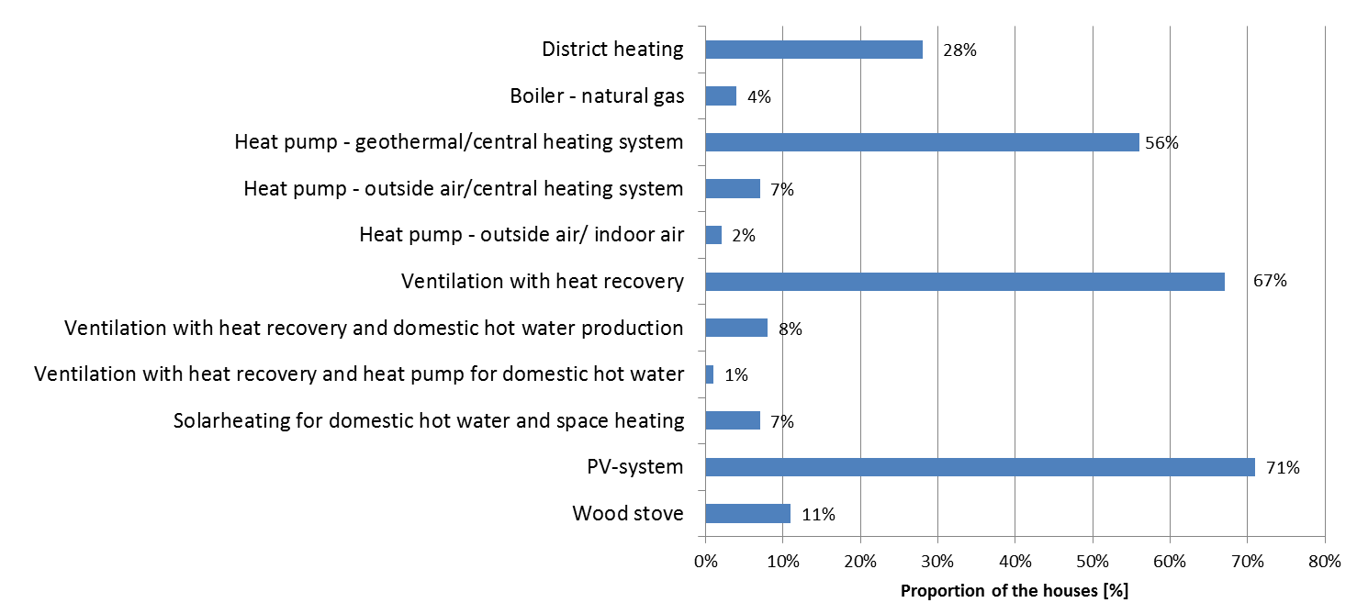

Figure 2. Technical installations in the 370 detached low-energy single-family houses whose owners responded to the questionnaire.

RESULTS

House owners’ overall satisfaction

Overall, the house owners had a positive experience of moving into and staying in their new low-energy houses, since 93% of the house owners would recommend others to stay in a low-energy house. The most important reasons were formulated by themselves as comments, i.e. good indoor climate and low energy and operating costs.

Heat consumption as experienced by house owners

Over half (59%) of the house owners experienced that their heat consumption was as low as they expected before they moved into the house, while 7% found their heat consumption not to be as low as expected. One third (34%) did not know, presumably because they had not yet lived long in their houses.

Perceived indoor climate in the new low-energy house

More than 90% of the house owners found that the indoor climate was generally satisfactory in summer (93%) and in winter (94%) with only 4% and 2% expressing dissatisfaction in summer and winter.

Temperature conditions were experienced by 84% as satisfactory in winter, while 73% experienced satisfactory temperature conditions in summer. The temperature was found by 4% to be unsatisfactory in winter, compared with 12% in summer. As in previous studies of low-energy houses, dissatisfaction was caused by temperature conditions that were too hot in summer. It was indicated by 19% and 32% that this was the case, daily and weekly, respectively. Large windows facing south were mentioned as the reason for the high summer temperatures. Some house owners commented that they had also experienced that it was hot in summer in their former house. Some house owners mentioned that their floor heating system was "slow" and could be difficult to use, but it was emphasised that there was a more constant temperature in the house.

Only few house owners experienced problems with draught as 94% and 96% never experienced problems with draught in winter or summer. Only 3% found the draught conditions unsatisfactory in winter and 2% in summer. Draught was only mentioned in connection with the opening of windows and near the inlet of the ventilation system.

The air quality was experienced as satisfactory by 88% in winter, while 90% experienced satisfactory air quality in summer. Only 4% found the air quality unsatisfactory in winter against 3% in summer. To a modest extent, it gave rise to dissatisfaction with the air quality that the air felt dry in winter. Problems with dry air were reported by 7% to be daily and 11% to be weekly. Some house owners emphasised dry air and odours from a neighbour's wood stove in connection with the question of air quality.

Noise conditions were experienced as satisfactory by 84% in winter, while 86% experienced satisfactory noise conditions in summer. 6% found the noise conditions to be unsatisfactory in winter compared with 4% in summer. To a modest extent, the ventilation system gave rise to dissatisfaction with noise conditions. Problems with noise from the ventilation system were reported by 6% to be daily and 9% to be weekly in winter against 12% and 7% respectively in summer. Other technical installations than the ventilation system caused problems with noise for 6% daily and 4% weekly in winter and 6% and 3% respectively in summer. The house owners' comments included the ventilation system and heat pump as sources of noise, but in most cases it was not a big problem, but something you could live with in light of the perceived advantages of the house. It was stated by 57% that there was no nuisance from noise in any room. The utility room was the room where most (18%) perceived annoying noise, followed by the bedroom where 13% perceive annoying noise.

Daylight conditions were experienced by 91% to be satisfactory in winter, while 94% experienced satisfactory daylight conditions in summer. Daylight conditions were found to be unsatisfactory by 2% in winter and in summer. To a modest extent, glare in summer gave rise to dissatisfaction with daylight conditions. It was indicated by 4% daily and 11% weekly that this was the case. A few house owners, 3% daily and 8% weekly, perceived that there was too much daylight. In their comments, the house owners suggested possible building solutions, including roof overhangs and exterior solar shading; some explained that they had retrofitted their house to mitigate any problems in the form of marquees, curtains and blinds.

Perceived indoor climate in the new low-energy house vs. former house

A majority of the house owners perceived the various indoor climate parameters temperature, draught, air quality, noise and daylight to be better (84, 85, 84, 67 and 77% respectively) in their new low-energy house compared with how it was in their former house, see Figure 3. A minority of house owners perceived the individual indoor climate factors temperature, draught, air quality, noise, daylight to have become worse (4, 2, 2, 8 and 2% respectively) in their new low-energy house.
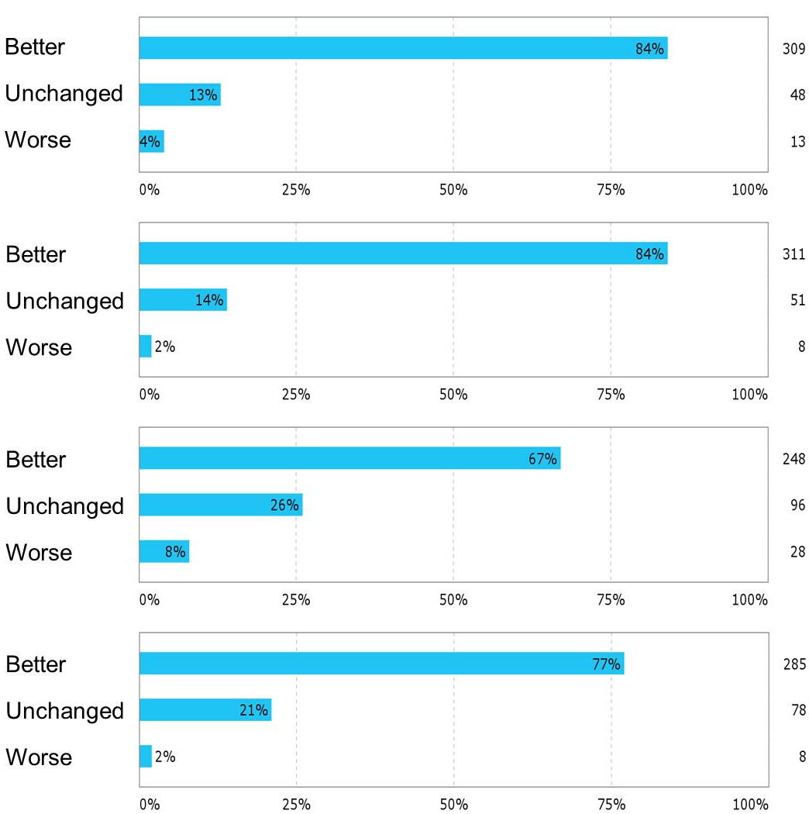
Temperature conditions
Air quality
Noise level
Daylight

Figure 3. How do you perceive the temperature conditions, air quality, noise level and daylight conditions in your new house compared with your previous home?

About half of the house owners indicated that the temperature in their new house was higher in summer (52%) and winter (48%) compared with their former house, while 19% indicated that the temperature had been lower in summer, and 6% indicated that the temperature had been lower in winter. Large windows were mentioned as the reason for the high summer temperatures.

Technical installations

House owners were asked whether they had received sufficient information on how the house's various technical installations worked. Nearly two thirds found that they had enough information, while about one third (38%) did not find that they had received sufficient information. For the latter group, 83% lacked information on the ventilation system, 49% lacked information on the heating system, 47% lacked information on the heat pump and 31% lacked information on solar cell systems for power generation.

House owners were also asked whether they had experienced small or big problems with the technical installations. Big problems had been experienced by 9% in winter and 6% had experienced big problems in summer. Small problems were experienced by 31% in winter and by 24% in summer. The house owners' comments elaborated on the problems. The recurrent problems focused on commissioning problems with the heating system, heat pump and ventilation system immediately upon moving into their new house.

Regulation and action possibilities

House owners were asked about their habits of opening windows slightly or completely in winter. About two thirds of the house owners opened windows during the day, and one third had open windows during the night. Half of the house owners opened windows for a short time during the day. The reasons given for opening windows was a wish for airing, fresh air and for cooling. The wish for a cool bedroom and airing of the bathroom was mentioned by several.

House owners were also asked whether they had experienced to be able to regulate, and whether they had used the option to regulate the room temperature, the ventilation and the solar shading. It was found by 97% that they had the option to regulate the room temperature, and 78% were using the option to regulate the temperature. It was experienced by 90% that they had the option to regulate ventilation, 55% used the option to regulate the ventilation. It was experienced by 41% that they had the option to regulate solar shading and nearly all (40%) used the option of adjusting the solar shading. Several house owners noted that solar shading was needed; several had established internal shading in the form of curtains and blinds.

DISCUSSION

Overall, the house owners had a positive experience of moving into and staying in their new low-energy houses and they would recommend others to stay in a low-energy house. They explained it by their experience of good indoor climate and low energy consumption and consequently low running costs. A majority were more satisfied with the indoor climate in their new house compared with their earlier dwelling.

Earlier studies have found that prerequisites for ensuring that occupants are satisfied with the indoor climate in low-energy houses, are, among other things, a strong focus on preventing uncomfortably high temperatures during summer and uncomfortable noise from technical installations (Larsen, 2011, Knudsen et al., 2012). Solutions are available, e.g. by combining external solar shading, appropriate size and type of windows facing the sun and facilitating effective use of natural and mechanical ventilation. Compared with previous similar studies on earlier generations of low-energy houses (Knudsen et al., 2012 and 2013), the satisfaction with the perceived indoor climate have improved.

Earlier studies have also called for robust and easy-to-use technical installations that are fully operational at the time of moving into the house. Comparing the results of this study with similar studies on earlier generations of low-energy houses (Knudsen et al., 2012 and 2013), it was found that problems with the technical installations had decreased. However, there is a need for continued focus on the commissioning of new and more or less thoroughly tested high performance installations and new designs to achieve both the desired low energy consumption and satisfied house owners.

To a greater extent than previously, the house owners in this study experienced that their heat consumption was as low as they had expected before they moved into the new house. This might be due to improved communication with house owners giving a more realistic expectation of their energy consumption in accordance with their family situation and behaviour than before.

CONCLUSIONS

The majority of house owners were satisfied with their new low-energy houses. They would recommend others to live in a low-energy house, and they perceived the indoor climate as satisfactory, and better than in their former (older and not low-energy) dwelling.

Compared with previous similar studies on earlier generations of low-energy houses, problems with perceived indoor climate and with technical installations have decreased. However, there is a need for continued focus on the commissioning of new, and not necessarily thoroughly tested, high-performance installations and new designs to achieve both low energy consumption and satisfied house owners.

This study did not uncover any specific problems in relation to the suggested low-energy class 2015 requirements. The result of this study now contributes to formulating the final version of the new BR15 which is scheduled to take effect from summer 2015.

ACKNOWLEDGEMENT

The study was supported by the Danish Energy Agency. All occupants who took time to answer the questionnaire are gratefully acknowledged.

REFERENCES

Building Regulations 2010 (BR10, 2010), Danish Energy Agency, Located at: www.ebst.dk/file/155699/BR10_ENGLISH.pdf
Energy Performance Certificate Scheme database (EPC, 2013), Danish Energy Agency, SEEB-sekretariatet, September 2013.
Knudsen, HN, Jensen, OM and Kristensen, L (2012) Occupant satisfaction with new low-energy houses, Proceedings of Healthy Buildings 2012.
Knudsen, HN and Kragh, J (2014) Evaluation of energy classes 2015 and 2020 in BR10: Experiences among owners of new low-energy single-family houses and experience of stakeholders in the construction industry. Publisher SBi, 2014. 164 s. (SBi; Nr. 7, Vol.), (In Danish).
Knudsen, HN, Thomsen, KE and Mørck, O (2013). Occupant Experiences and Satisfaction with New Low-Energy Houses. In Clima 2013, 16-19 June, Prague. 11th REHVA World Congress: Energy Efficient, Smart and Healthy Buildings.
Larsen, TS (2011). Assessment of the indoor climate in previous low energy buildings. Aalborg: Aalborg University. Department of Civil Engineering. (DCE Contract Reports; Nr. 100). (In Danish).
SurveyXact, www.surveyxact.com

