Animated flow of Rotterdam citizens based on
the Urbanism on Track edition 2012 GPS data.

Anders Sorgenfri Jensen, asje@create.aau.dk
Henrik Harder, hhar@create.aau.dk

Department of Architecture, Design and Media Technology
Aalborg University, Denmark

Paper submitted to Urbanism on Track edition 2012 March 12/13 2012
TU Delft, Faculty of Architecture, Department of Urbanism

Background
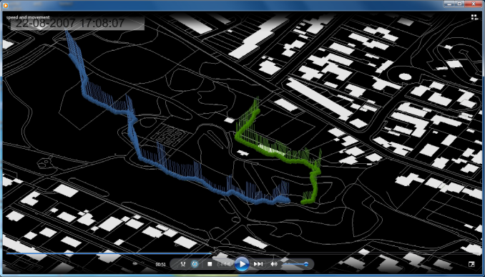
The research group Diverse Urban Spaces has worked with several aspects in GPS-based studies of individuals’ movement patterns across an array of projects since 2006. Visualisation of the gathered data sets has always been important when trying to cope with the complexity of GPS data. In our first effort to create animations, a couple of student assistants were tasked with manually exporting over 1,000 map image files using ArcGIS 9.1. These image files could consecutively be strung together to an animation. The method proved successful, albeit both cost-inefficient and bulky, as any desire of changes to the animation would require a complete reiteration of the manual exports. For this reason, the creation of animations through this method was abandoned.
Figure 1 A sample of one of the animations created through manual labour
Years later, the approach was revised during the “Helpark 2”-project – a survey of the use and satisfactory level of citizens with regards to three parks located in the Danish city of Aalborg. The goal was to achieve an animation depicting the flow of movement of park visitors in a similar fashion to the animation created by [Austwick, M & O’Brien, O (2011)] at CASA. With experience gained from previous projects, it was possible to create automatic procedures that carried out the editing and export tasks that previously had to be done manually in ArcGIS. These procedures were afterwards used for the creation of the animation of the Urbanism on Track edition 2012 GPS data.

Method
The procedures revolve around utilizing ArcGIS functionality within a Python environment. More specifically, the procedures use the ArcPy Mapping Module, which allows for dynamic changes of ArcMap documents. Through the mapping module, the definition query of the various feature classes residing within an ArcMap document can be accessed and changed. Through the definition query and the timestamp attribute of the GPS-data, it is possible to map only the data recorded during a short time interval – for instance the period 12:00:00 AM-12:02:00 AM. When put inside a loop, it is possible to map consecutive time periods. If the frequency in shift of time is set to 3 seconds, the subsequent maps will illustrate the period 12:00:03 AM-12:02:03 AM, then the period 12:00:06 AM-12:02:06 AM etc.
Afterwards, a couple of additional tools are called. For layout reasons, the points are converted to lines, and in order to depict the primary transportation corridors, the accumulated time expenditure is calculated by continuously aggregating the visualized GPS-data upon a grid of squares.
Definitions:
Overall time frame:
The time frame the animation depicts. In this context, the overall time frame is approximately 24 hours (12:00:00 AM to 11:59:59 PM)
Time interval:
The period of time which a single map image file depicts. In this context, the time interval is 2 minutes.
Time shift frequency:
The difference in the time dimension between two subsequent map image files. In this context, the time shift frequency is 3 seconds.

Essentially, the method consists of the following steps:
- Load a premade ArcMap document that contains a base map and the GPS data
- Assign the definition query of the GPS data with a specified time interval (2 minutes) with origin in the lower limit defined by the overall time frame (12:00:00 AM)
- Export the content of the ArcMap document to an image file
- Update the definition query based on the time shift frequency (3 seconds) in order to depict a slightly different time interval
- Create a square grid based on an aggregation of the points with a timestamp residing within the lower limit of the overall time frame and the upper limit of the time interval
- Convert points with mutual respondent identification number into polylines
- Loop through step 3-6 until the upper limit of the overall time frame (11:59:59 PM) is reached
The relationship between the three time definitions can be seen in Figure 2.
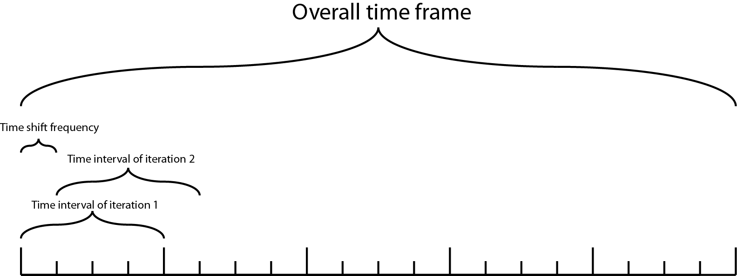
Figure 2 An illustration of the 3 time definitions

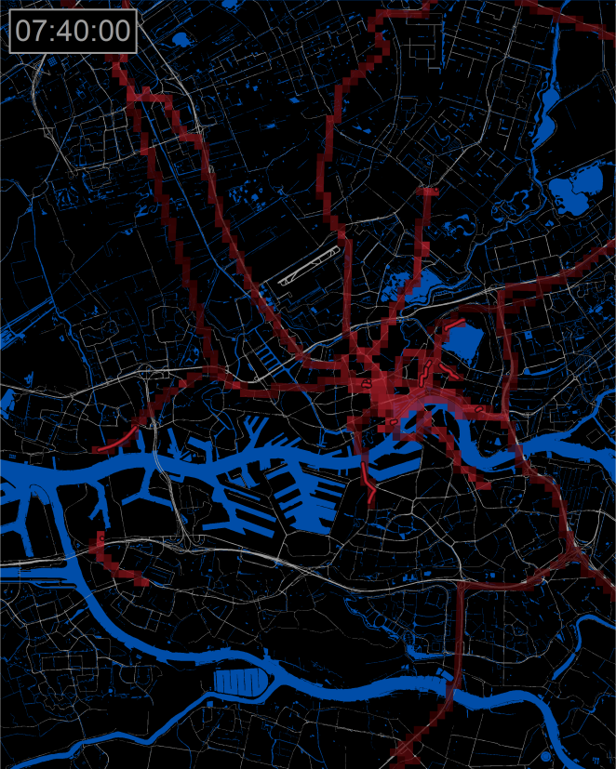
Result
Figure 3 A single map image file depicting the time interval 07:38:00 AM - 07:40:00 AM.
The result of the abovementioned method is 28,800 map image files with the specified configuration. When strung together to an animation, the product comprises a method of illustrating the relationship between space and time. Note that since the overall time frame is an aggregation of multiple dates, a single participant’s GPS-tracks across several days may be represented at the same time.

Conclusion
An animation illustrating the flow of spatial data with a time attribute contributes with a couple of conclusions which cannot be drawn from a static map image that contains all the gathered data. For instance, the fact that a single participant’s data of multiple days is visualized at the same time proves that a respondent mostly make use of the same transportation corridors on the exact some time across several days, whereas the static map only proves that the road is used frequently. Furthermore, the animation is more adept at illustrating stays, as they are easily defined by lack of movement. Conversely, a static map depicting a great amount of accumulated GPS-registrations may represent either a point of interest or simply an infrastructural node that many respondents traverse frequently. The drawback of the animation compared to a static map is that its conclusions are more subtle. A greater amount of time and perception is required in order to interpret the results.
In conclusion, animations give a good overview of data and depict patterns and behaviour that cannot be seen on static maps, but due to the aggregation across several dates, the result represents a complex reality which is not always suitable for in-depth analysis but more suitable for creating hypothesis.

References
Austwick, M & O’Brien, O (2011)
London Bike Flow Animation
Retrieved 2012-03-18 from http://www.digitalurban.org/2011/02/london-bike-flow-animation.html

