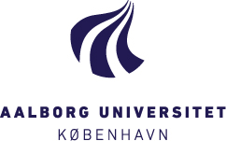

THREAD Seminar April 16th 2018, AAU-Cph (all sessions in Danish)
Styregruppemøde: 11-12.30
12.30-13.15: Frokost
13.15-14.00: Bjørn Møller, Global Refugee Studies, AAU: Flygtninge og asylansøgere.
14.00-15.00: Helene Balslev Clausen & Vibeke Andersson, AAU. De tre E’er: Empowerment, Employment, Entrepreneurship (discussant Jane Malcolm-Davies).
15.15-15.45: Helene Balslev Clausen & Vibeke Andersson: Metode og synet på ‘den anden’.
16.00-16.30:Egzona Haxha: THREAD Platform, a new idea.
16.30-17.00: Discussion

Thread Research Seminar April 17th (all sessions in English)
9.30-10.00: Wrap up from yesterday’s talks (all)
10-11.00: Discussion on forward activities and research initiatives (Everybody present ideas)
11.00-12.00: Ideas for publications and communication strategy (all)

