Performance of NF/RO membranes in a combined membrane separation and biological degradation process for treatment of pesticide contaminated drinking water
M. N. Fini¹, H. T. Madsen² and J. Muff*¹
¹ Aalborg University, Department of Chemistry and Bioscience, Section of Chemical Engineering, Esbjerg, Denmark
² Aalborg University, Department of Chemistry and Bioscience, Section of Sustainable Biotechnology, Copenhagen, Denmark
*jm@bio.aau.dk
Abstract
In Denmark, 99% of the drinking water production is based on so-called simple treatment (airation and sand filtration) of groundwater of sufficient quality evaluated based on levels of organic and inorganic contaminants as pesticides, nitrate, heavy metals etc. However, the Danish groundwater ressources are under pressure and the number of samples with concentrations of pesticides and their natural transformation products above the 0.1 µg/L threshold found during monitoring of abstraction wells are increasing. Thus new treatment concepts are required in order to meet the drinking water quality guidelines. Membrane separation using nanofiltration (NF) or reverse osmosis (RO) membranes may be part of these concepts. The current paper present results from the MEM2BIO project funded by Inovationfund Denmark, where NF/RO separation is combined with biological degradation of specific pesticides in the retentate that finally is mixed with the permeate for remineralization before being distributed to consumers.
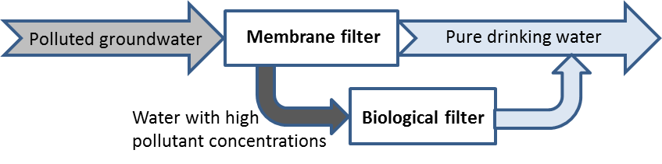
Two NF membranes and two RO membranes were evaluated for removal of MCPA, MCPP and BAM in Milli-Q water and three drinking waters of increasing hardness. Also, the influence of initial pesticide concentration was evaluated over the range of 1µg/L to 10 mg/L and the influence of increasing (10% to 90%).
Only the RO membranes were capable of achieving rejection levels > 90% for all targeted pesticides. The presence of the ionic environment in drinking waters led to an increase in all pesticide rejections for all membranes, which could be explained by membrane pore blocking by the ions, a trend also found at increasing recoveries. Rejections were comparable over the large initial concentration span.
In general, both RO membranes, XLE and BW30, showed promising performance for rejection of the target contaminants. However, regarding the water permeability results (73 l/m^{2.}h for XLE versus 30 l/m^{2.}h for BW30), the XLE membrane was the most suitable membrane for the removal of these pesticides from groundwater.
__________________________________________________________________________________
How do you wish to present your research results?
☒ Oral presentation ☐ Poster presentation

Please send this document to NOFS17@aau.bio.dk until April 10, 2018.

