Aalborg University and the Techno-Anthropology Research and Participation Group present
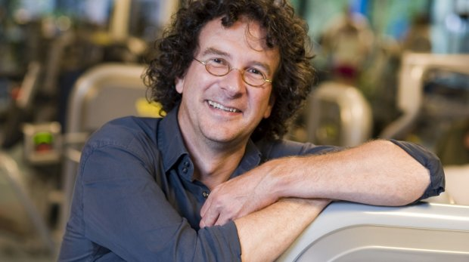
The Politics of Technology
Academic seminar with prof. Peter-Paul Verbeek
19 April 2018, Aalborg University Copenhagen

Program
19 April 2018, Thursday, 09:00 – 15:00. Seminar day.
Building ACM 15, Meeting Room 2.1.007

The Politics of Technology, Part 1: Presentations
09:00 – 09:20 - Lars Botin: Politics of the Technological Self
09:20 – 09:40 - Тom Børsen: Operationalization of Critical Theory of Technology: Presentation of an analytical model to be applied in students’ projects at Techno-Anthropology
09:40 – 10:00 - Theresa Scavenius and Rasmus Haarløv: The Politics of Transition Pathways
10:00 – 10:20 - Petko Karadechev: Policy and warfare: Artificial Intelligence R&D, South Korea and the US
10:20 – 10:40 - Peter-Paul Verbeek: The Politics of Technology
10:40 – 11:00 - Break
11:00 – 12:00 – Meeting with Morten Søndergaard
12:00 – 13:00 – Lunch
The Politics of Technology, Part 2: Reflections and Discussion
13:00 – 15:00 – Participants share feedback with each other

