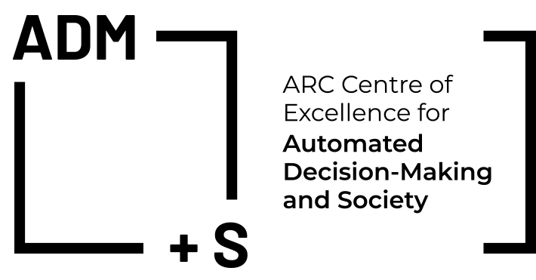
ADM in Social Security and Employment Services: Mapping what is happening and what we know
Automated Decision Making (ADM) in Social Security and Employment Services: Mapping what is happening and what we know

When: Wednesday 5 May, 2021
8:00am-9:30am Brisbane/Sydney/Melbourne
Where: Zoom
Who: ADM+S Members. Invitation only to others.

Scope
This interactive roundtable discussion is designed to map what we know about the use and effects of such ADM in social security and employment services around the world in general, and in Australia in particular. The purpose of this event is to develop a shared understanding of the key emerging issues with the intent of shaping the research agenda for the ARC Centre of Excellence for Automated Decision Making and Society (ADM+S).

Topics:
- Where is ADM being (or touted to be) used in income support and employment services?
- In what way is ADM being used in income support and employment services (e.g. benefit elgibility and payment calculation; data matching; compliance assessments; risk assessment; risk reduction; resource allocation)?
- How do professionals and administrators engage with such ADM?
- How do service users understand and experience processes that involve the use of ADM?
- What data and research knowledge are used to develop ADM?

PROGRAM
Introduction & Acknowledgement of Country Chair: TBA
What we know and what is happening (40-45 mins)
Christiaan van Veen (NYU, Director, Digital Welfare State and Human Rights Project)
Digital welfare as a human rights threat
Professor Dorte Caswell (Aalborg University, Denmark)
Title to be advised
Professor Paul Henman (University of Queensland, CoE Chief Investigator)
Automation induced transformations in social security policy and practice over time
Voices from the Field: Identifying key topics (15 mins)
Professor Terry Carney (University of Sydney; CoE Associate Investigator)
Edwina MacDonld & Dr Peter Davidson (ACOSS, CoE Partner Organisation)
TBA
Discussion: Identifying key topics and Developing a research agenda (30 mins)
Attendees will include government, advocacy, service users representatives, practioners
Short Biographies
Christiaan van Veen is the Director of the Digital Welfare State and Human Rights Project at the Center for Human Rights and Global Justice at NYU School of Law. Christiaan’s research focuses on the impact of the digitalization of government on human rights, especially in the area of the ‘welfare state’.

Dr Dorte Caswell is a Professor at the Department of Sociology and Social Work, Aalborg University, Denmark. She is the head of SAB, a research group focusing on social work at the frontline of active labour market and social policy. Her research focuses on social work under the canopy of active labour market and social policy. | 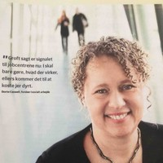
Professor Paul Henman is a Chief Investigator and the UQ node leader of the ARC Centre of Excellence (CoE) for Automated Decision Making and Society (ADM+S). He is a Professor for Digital Sociology and Social Policy at The University of Queensland. For over two decades, he has studied the nexus between digital technologies, social policy, and public administration, and the implications for citizens, public governance and power.
Professor Terry Carney is an Associate Investigator at the CoE for ADM+S. Professor Carney chaired the National Advisory Council on Social Welfare and serves for nearly 40 years as a member of the Social Services and Child Support Division of the Administrative Appeals Tribunal and its predecessor the Social Security Appeals Tribunal. Professor Carney is an Emeritus Professor of Law at Sydney Law School and a past President (2005-2007) of the International Academy of Law and Mental Health. | 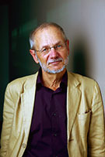
Edwina MacDonld is the Director of Policy and Deputy CEO of ACOSS. She has policy expertise across a range of areas including social security, housing and homelessness.
Dr Peter Davidson is the Principal Advisor of ACOSS. Dr Davisdson is a recognised expert in social security, employment and tax policy, and his research and policy interests include employment assistance, the labour market and unemployment, income support, poverty research, taxation and superannuation policy. He has served on a number of Government advisory bodies and contributed to major reform efforts in these areas

