Influence of microbial community composition on activated sludge floc properties and dewaterability

Hansen, S. H.*, Nierychlo, M.*, Jiang, C.* and Nielsen, P. H.*
* Center for Microbial Communities, Department of Chemistry and Bioscience, Aalborg University, Fredrik Bajers Vej 7H, DK-9220 Aalborg

Keywords: Activated sludge; Sludge floc properties; Microbial communities

Summary of key findings
By linking the microbial community structure of different sludge fractions to the sludge properties in a survey of full-scale wastewater treatment plants with nutrient removal in Denmark we found that the composition of microbial communities differs between different sludge fractions. Specific bacteria were enriched in the bulk water fraction and in the fraction loosely bound to the flocs and could therefore be characterized as poor floc formers. The genera Acrobacter and Acidovorax, which have been associated with influent wastewater, were found to be abundant in the water phase of sludge, whereas the well-known polyphosphate accumulating organism Tetrasphaera was found to be resistant to shear and thereby contributing to form large, strong flocs.

Background and relevance
The activated sludge process is key in modern wastewater treatment with nutrient removal and recovery. The microbial community composition must be stable in order to maintain the desired nutrient removal. Bacterial morphology, mode of growth, and composition of extracellular polymeric substances (EPS) determine floc size, shape, and strength, which in turn influence important sludge properties. Optimal sludge properties are important for the wastewater treatment plant operation and eventually effluent quality. The aim of this study was to establish the link between the microbial community structure and physico-chemical sludge characteristics and thereby provide a better understanding of the link between community structure and activated sludge process performance.

Results
The investigations were carried out on activated sludge samples from19 full-scale wastewater treatment plants (WWTP) with nutrient removal in Denmark. Extensive analyses of physicochemical properties and dewaterability of these sludge samples have been performed previously (Jørgensen et al., 2017). In continuation hereof, activated sludge samples were separated into three fractions; total sludge (TS), supernatant (S), and supernatant after shear (SA). Microbial community composition of the three fractions was studied using 16S rRNA gene amplicon sequencing and the MiDAS ecosystem-specific taxonomy (Dueholm et al., 2019) followed by multivariate statistics and correlation analysis (Fig. 1.1).

We found that the composition of microbial communities differed between different sludge fractions and that specific bacteria were enriched in the bulk water fraction and in the fraction loosely bound to the floc (Fig. 1.2). These could therefore be characterized as poor floc formers and have a negative influence on the effluent quality. Interestingly, Arcobacter and Acidovorax have been associated with influent wastewater (Saunders et al., 2016). Their presence outside the sludge flocs may indicate poor flocculation and removal of influent microbes, which needs further investigations and considerations in terms of plant design and operation. On the other hand, Dechloromonas and Tetrasphaera abundances decreased in supernatants and could therefore be associated as potential strong floc formers.

Several parameters describing activated sludge characteristics were found to be correlated with the bacterial species composition (e.g, SVI, filament index, floc size, floc strength, content of cations, and amount of extracellular polymeric substances). Correlation analyses of bacteria present in the different sludge fractions showed for example that high abundance of Sulfuritalea significantly correlated with high shear sensitivity, whereas the presence of Tetrasphaera correlated with low shear sensitivity.

Perspectives
These findings contribute to the ongoing refinement of the ecosystem model of microbial communities in activated sludge.The results indicate that generic properties of specific species in terms of flocculation properties exist across all nutrient removal plants, which in the future will be of key importance assuming “online” and real time monitoring of microbial communities are within reach.

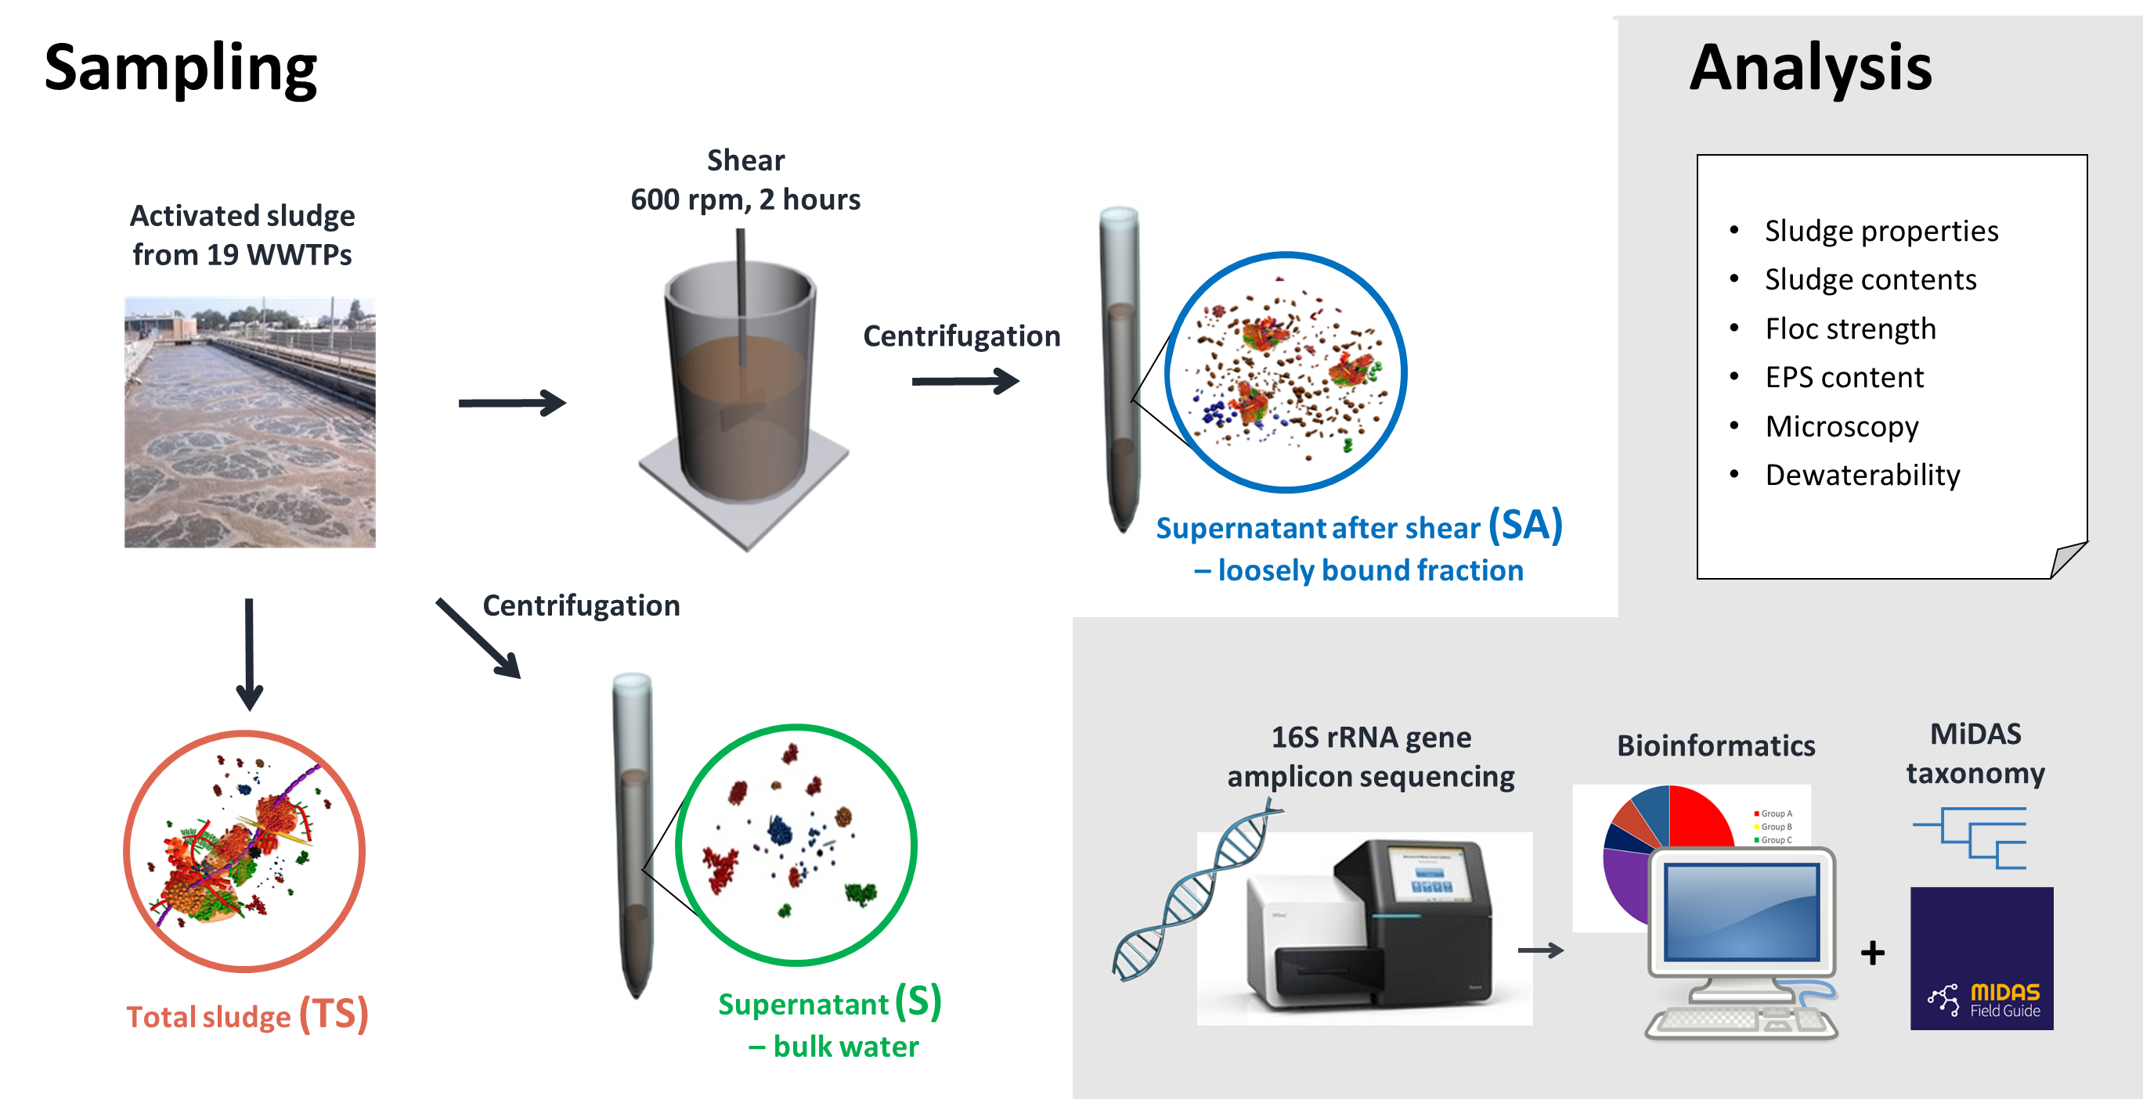
Figure 1.1 Experimental overview of study.

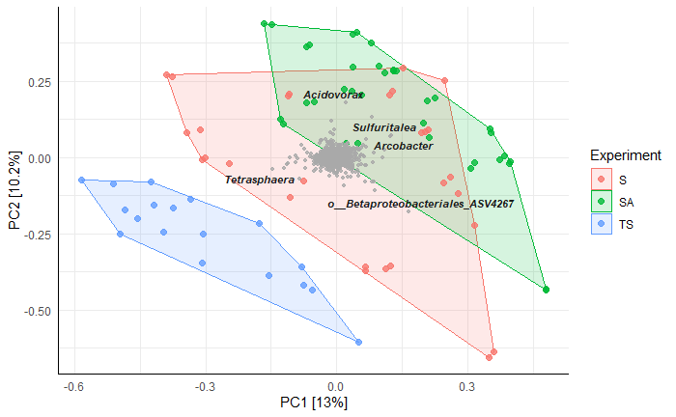
Figure 1.2 Principal Components Analysis (PCA) of 88 samples and 1751 Amplicon Sequence Variants (ASVs) showing overlay of 5 most important genera contributing to the observed differences. Prior to the analysis, ASVs in less than 0.1% relative abundance in any sample were removed. The data has been transformed by applying the hellinger transformation (Legendre and Gallagher, 2001). The relative contribution (eigenvalue) of each axis to the total inertia in the data is indicated in percent at the axis titles.

References
Dueholm, M.S., Andersen, K.S., Petriglieri, F., McIlroy, S.J., Nierychlo, M., Petersen, J.F., Kristensen, J.M., Yashiro, E., Karst, S.M., Albertsen, M., Nielsen, P.H., 2019. Comprehensive ecosystem-specific 16S rRNA gene databases with automated taxonomy assignment (AutoTax) provide species-level resolution in microbial ecology. bioRxiv 672873. https://doi.org/10.1101/672873
Jørgensen, M.K., Nierychlo, M., Nielsen, A.H., Larsen, P., Christensen, M.L., Nielsen, P.H., 2017. Unified understanding of physico-chemical properties of activated sludge and fouling propensity. Water Res. 120, 117–132. https://doi.org/10.1016/j.watres.2017.04.056
Legendre, P., Gallagher, E.D., 2001. Ecologically meaningful transformations for ordination of species data. Oecologia 129, 271–280. https://doi.org/10.1007/s004420100716
Saunders, A.M., Albertsen, M., Vollertsen, J., Nielsen, P.H., 2016. The activated sludge ecosystem contains a core community of abundant organisms. ISME J. 10, 11–20. https://doi.org/10.1038/ismej.2015.117

Presenting Author
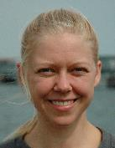 | Susan Hove Hansen, MSc, PhD  Aalborg University
Is the presenting author an IWA Young Water Professional? Y/N
Y
 | Bio: Postdoctoral fellow aiming for a more sustainable world. Studies resource recovery from a microbial ecologists point of view in the group of Prof. Per Halkjær Nielsen. Holds a MSc in biotechnology and a PhD on “omics” to study biofilms and fouling in membrane bioreactors (MBRs) for wastewater treatment.

