Time use and movement behaviour of young people in cities
The application of GPS tracking in tracing movement pattern of young people for a week in Aalborg

Henrik Harder 1,
Akkelies van Nes 2,
Anders Sorgenfri Jensen 1,
Kristian Hegner Reinau 1,
Michael Weber 1

1: Department of Architecture, Design and Media Technology Aalborg University
2: Department of Urbanism, Faculty of Architecture
Delft University of Technology

Email: hhar@create.aau.dk, a.vannes@tudelft.nl, asje@create.aau.dk, reinau@plan.aau.dk, mweber07@student.aau.dk>
,

Paper ID:
Long paper
Theme: Urban Space and Social, Economic and Cultural Phenomena
Keywords: Mobility, GPS tracking, centrality, human behavior, GIS

Abstract
This paper explores how well the space syntax methodology is capable of predicting the actual movement of people in a city. The space syntax methodology has been surrounded by a debate in recent years about its applicability, see for example the debate between (Ratti 2004a;Ratti 2004b) and (Hillier & Penn 2004), as well as guest editorial by (Steadman 2004) on developments in space syntax. To evaluate the usefulness of the space syntax methodology this paper explores one case, mobility in Aalborg, a city in Northern Jutland Denmark. The spatial centrality potential of each road in the centre of Aalborg was calculated using the space syntax methodology. As the results show, the method is capable of pinpointing the main transportation corridors for motorized traffic when a high metrical radius is used, as well as locating centres within the city when a low radius is used. The actual use of each road was investigated empirically using GPS tracking equipment on a population of 169 16-20 years old respondents taken from statistically representative sample in Aalborg, an empirical investigation conducted by researchers in the research group Diverse Urban Spaces at Aalborg University. The analysis between centrality potential and actual use is performed upon a space syntax classification where a high metrical radius is used, and the general hypothesis in the comparison is that high integration potential should equal high time consumption. However, since the respondents belong to a narrow population segment, the results are not expected to necessarily match the general hypothesis. Somewhat predictable, coherence is attained between the space syntax classification of centre areas and the time consumption registrations. More surprisingly, coherence also exists for the high classified roads which primarily serve cars.

Input – Accumulated time consumption registration maps
Recently, GPS tracking seems to be a useful tool for an exact tracing of peoples movement though a city. In a research project named “Spatial Metro” (Schaick and Spek, 2008) a group of people was equipped with a GPS for a couple of hours. Their movement traces were put on a map. Data of this kind can be useful in research project on how people orientate themselves through real built environments. In particular it can provide understandings on the spatial conditions on how strangers orientate themselves through urban areas they do not know. The drawback is that people are asked to move randomly around in cities. In this way it is difficult to gain understanding on which streets are preferred when moving from everywhere to everywhere else through an urban area.

Therefore, in the Danish city Aalborg, 169 young people who were chosen for the empirical investigation of mobility in Aalborg. Each of these participants had to carry a GPS unit for a week. This GPS unit continually logged their position, and the raw data obtained from the empirical investigation is 169 tracks, consisting of GPS waypoints obtained at intervals of approximately 10-15 seconds apart for each respondent throughout the week. It should be noted here that the time interval between each waypoint did vary due to the GPS hardware used.

The first step in the analysis was that the collected tracks were interpolated so that waypoints were constructed for each second throughout the week. This interpolation resulted in approximately 250 million waypoints in total for the 169 respondents, and these waypoints form the basis for the construction of the time consumption map.
To construct this map, Aalborg was covered by a grid with cells of 50x50 meter. Thereafter an analysis was made which counted the number of waypoints in each cell, and as such identifies the accumulated time spent by the population of young people in each cell. This aggregation into squares is necessary to handle and present the massive amount of gathered GPS data in GIS in a simple and understandable way.
The accumulated time consumption registration data can be seen in Figure 1 and 2. Note that the intervals in the colour ramp portraying the time consumption increases exponentially at a rate of approximately 1.5. Due to the size of the dataset, it depicts a representative image of young people’s movement patterns in Aalborg.
As can be seen in figure 1 and 2, the largest time was spent in the various shopping areas in Aalborg. Secondly, some high amount of time was spent on the various main routes leading through and between urban areas.
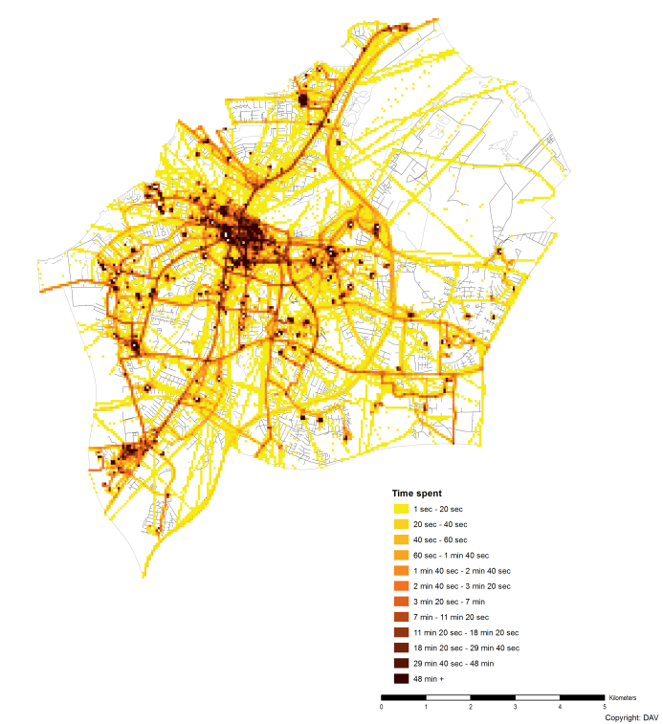.
Figure 1: Time consumption of women.

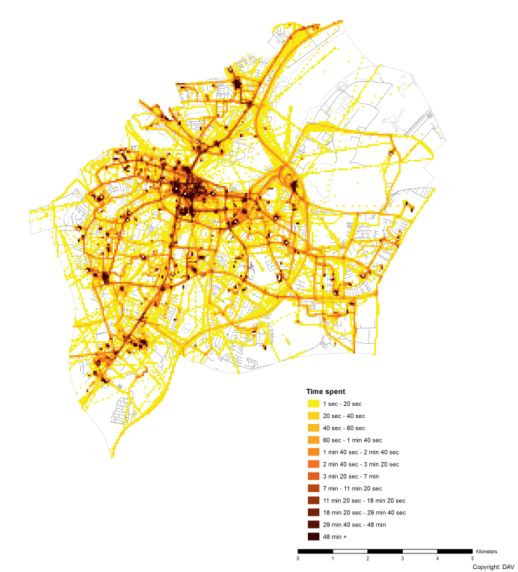
Figure 2: Time consumption of men.

Input – Road infrastructure centralisation
The road infrastructure’s centrality potential is measured through the space syntax method. Every road link is represented equally as a set of axial lines. First the to-movement potentials are calculated through the global axial integration analyses. The classification of each road is subsequently manually appended to the dataset of the Danish road infrastructure as mapped in DAV2004. The road infrastructure centralisation data can be seen in Figure 3 and 4. Note that the centrality is evaluated based on high metrical radius. Therefore, the analysis highlights road segments which have high centrality within the entire case area network – i.e., the primary transportation corridors.

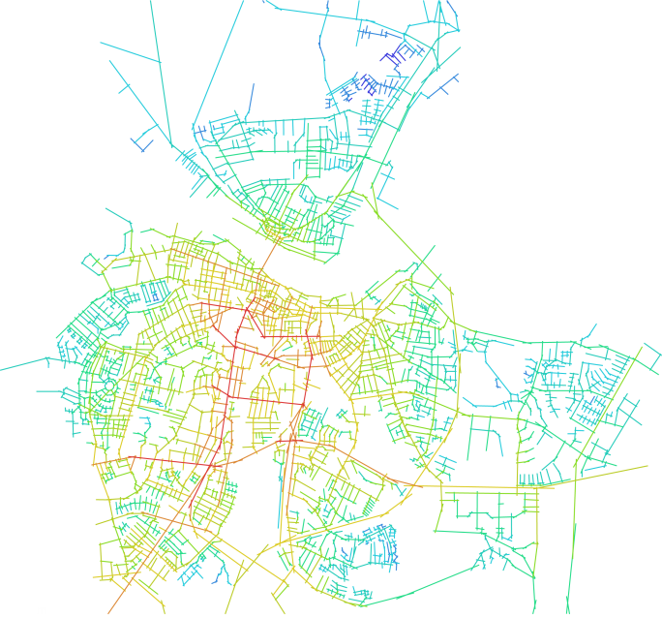
Figure 3: The original space syntrax classification network.

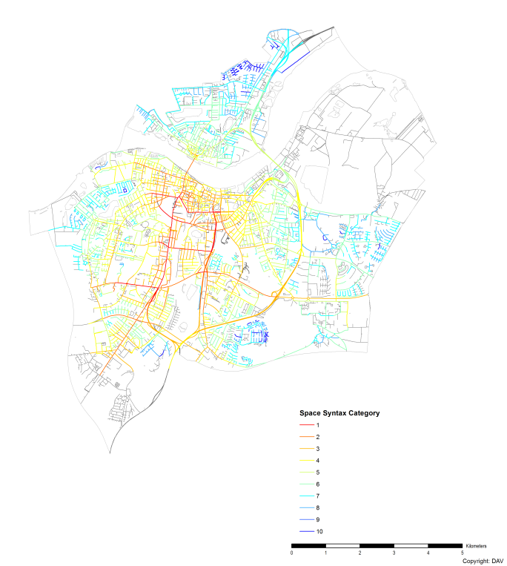
Figure 4: The classification appended to DAV2004.

Comparison method
Since the comparison is performed upon a global integration created in Space Syntax using a high metrical radius which highlights main roads within the network rather than local centres, the overarching hypothesis for the comparison method is an assumption of linear positive relationship between high integration and high time consumption. Highly classified road segments are not anticipated to have high time consumption rates because people occupy these areas for activities, but rather because people are expected to traverse through these parts of the infrastructure network at a high frequency – potentially several times a day for each respondent. However, it should be noted that the young respondents comprise a very narrow population segment, which behaves differently in terms of mobility compared to the general population due to economic boundaries. Therefore, there is no expectation as to whether or not coherence should be attained based on the overarching hypothesis.
The road infrastructure centralisation data contains 10 classification levels created in Space Syntax. Thus, each polyline segment of this data contains a number in the range of 1-10. Upon comparison, each 50x50 m square in the time consumption registration dataset which spatially intersects the polyline is selected. Based on the time consumption value of selected squares, a mean value (µ) is calculated. In order to assess whether or not there is coherence between time spent and space syntax classification, the mean value of the selected squares is compared with the expected time consumption for the polyline based on the classification. The expected value is derived by yielding 9 quantile values (q) which divide the time consumption registration dataset into 10 approximately evenly distributed groups. The general rule for determining coherence can be found in Table 1.
Table 1: Groups
Space syntax class | Coherence at
10 | µ < q₁
9 | q₁ < µ < q₂
8 | q₂ < µ < q₃
7 | q₃ < µ < q₄
6 | q₄ < µ < q₅
5 | q₅ < µ < q₆
4 | q₆ < µ < q₇
3 | q₇ < µ < q₈
2 | q₈ < µ < q₉
1 | q₉ < µ

Results
The results of the comparison through the method described above can be seen in Figure 5 and 6. Figure 7 and 8 illustrate the same procedure, except the coherence rule is loosened slightly in the sense that coherence is achieved if the mean value resides within a buffer of ± 1 quantile of the expected time consumption value. I.e., coherence is reached for the space syntax class 5 at q₄ < µ < q₇ instead of q₅ < µ < q₆. Figure 9 and 10 depict the differences and consistencies of coherence based on the difference in time consumption for the two genders. Table 4 contains the results in numbers whereas Table 2 and 3 contain general information regarding the input data.
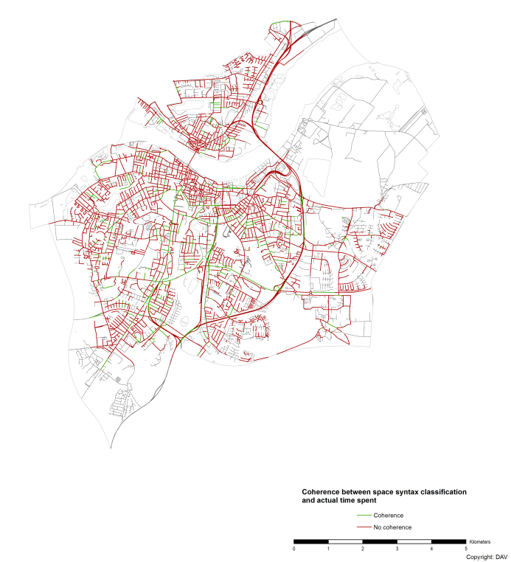
Figure 5: Coherence between space syntax classification and actual time consumption with strict coherence rule for women.

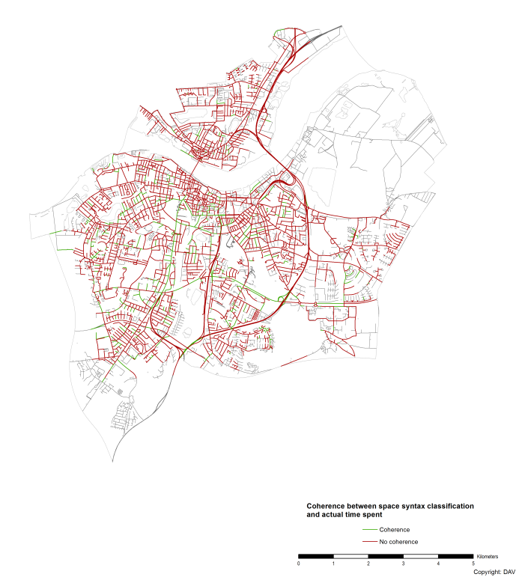
Figure 6: Coherence between space syntax classification and actual time consumption with strict coherence rule for men.

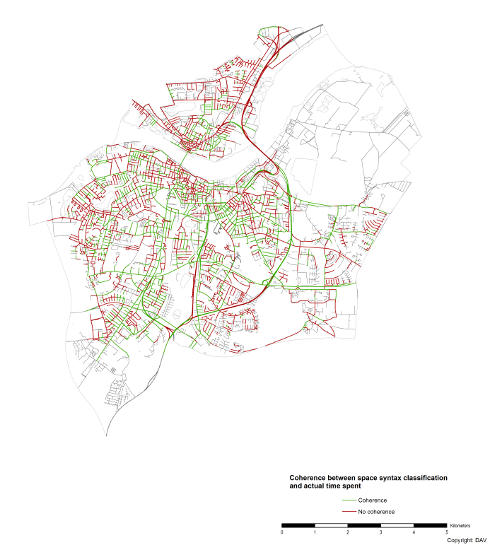
Figure 7: Coherence between space syntax classification and actual time consumption with loose coherence rule for women.

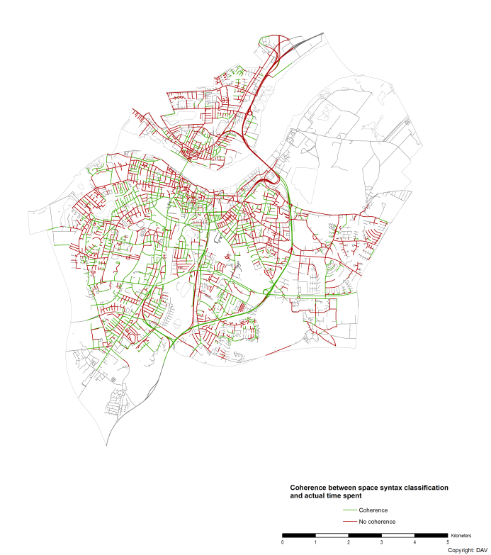
Figure 8: Coherence between space syntax classification and actual time consumption with loose coherence rule for men.
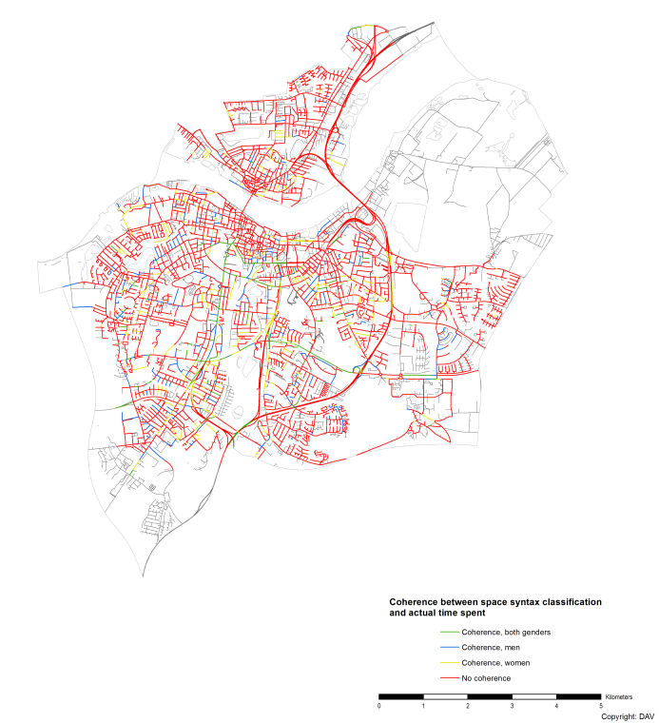
Figure 9: Difference between coherence of time consumption and space syntax classification for men and women with strict coherence.

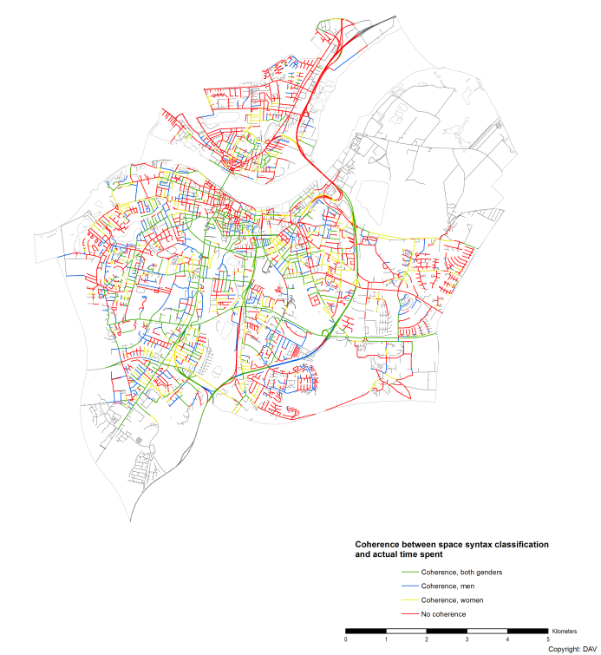
Figure 10: Difference between coherence of time consumption and space syntax classification for men and women with loose coherence rule.

Number of road segments | 5865
Table 2
 | Women | Men
Non-visited road segments | 799 | 779
Number of squares | 14,891 | 15,625
Accumulated time consumption | 15,125,711 seconds | 18,838,688 seconds
Table 3
 | Occurrences of coherence | Occurrences of lack of coherence | Coherence-ratio
Women, strict rule | 637 | 4,429 | 10.86
Men, strict rule | 625 | 4,461 | 10.65
Women, loose rule | 1,972 | 3,094 | 33.62
Men, loose rule | 1,916 | 3,170 | 32.67
Table 4

Evaluation – the overall view or the Aalborg urban area
Based on the results, a number of conclusions can be drawn. Firstly, it is remarkable that coherence is attained even with the strict rule for some of the major roads which comprise the primary transportation corridors for motorized vehicles: Hobrovej/Vesterbro, Østre Allé, Sønderbro and Theodor Saursvej. These roads are highlighted in Figure 9, which is otherwise identical to Figure 10.
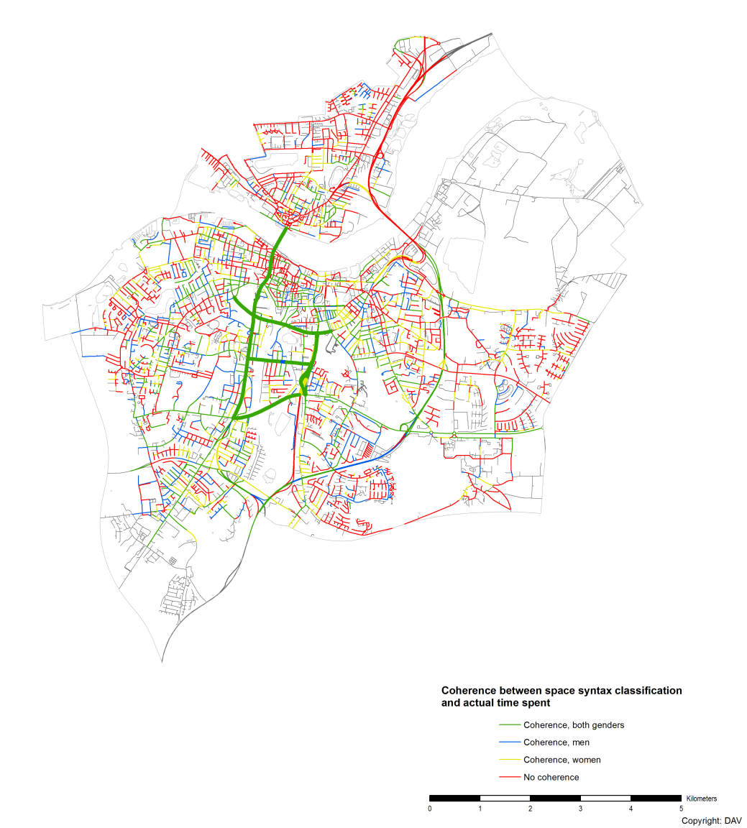
Figure 11: Coherence between space syntax classification and actual time spent.
The coherence is peculiar because the respondents used for the time consumption registration in general are high school students – a population segment which in Denmark rarely has access to a car due to very high Danish car prices. A possible explanation is that the respondents in general either:
- Have a car of their own – not very likely
- Have frequent access to their parents’ car – very likely
- Are passengers in their parents’ or a friend’s car – very likely
- Make use of the public transportation routes as these follow the major roads – very likely
Furthermore, regardless of the above 4 possibilities, the respondents make trips across the town on a daily basis. This conclusion can be drawn, as transportation is the purpose of using the major roads – there are very few shopping areas, park areas or other attractions associated with these major roads in Aalborg.

Evaluation – the narrow view or the Aalborg central city center area
Another conclusion is that there seems to be a lack of coherence for the primary pedestrian areas and shopping districts. As depicted by Figure 12 and 13, only the southernmost areas have coherence.
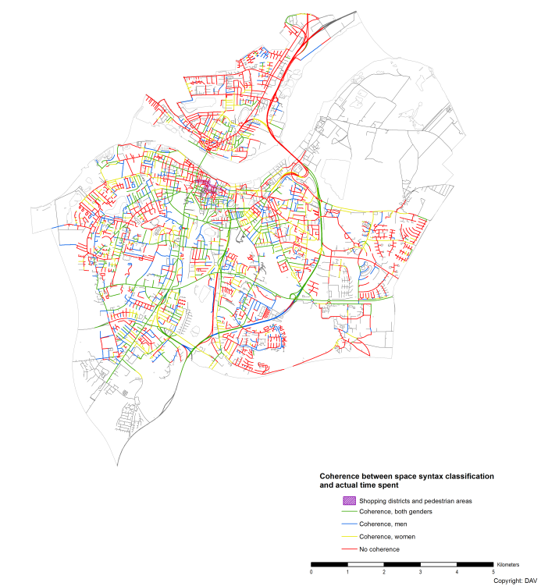
Figure 12: An indication of the primary shopping districts and pedestrian areas mapped on top of the coherence between space syntax and actual time spent for the case area.

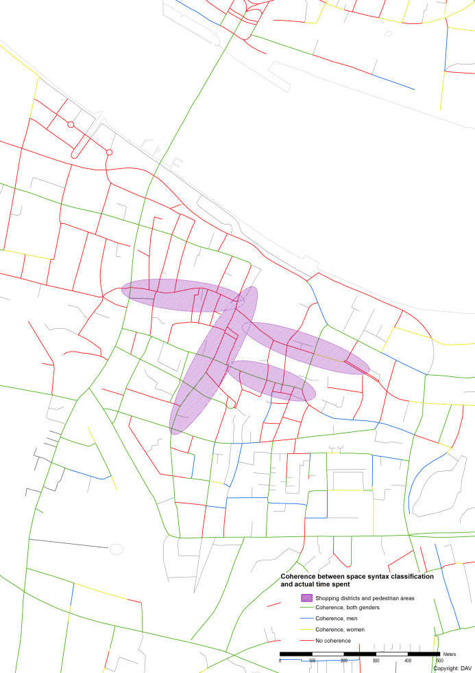
Figure 13: A close-up view of said shopping districts and pedestrian areas.
The lack of coherence is a natural consequence when the space syntax analysis is executed with a high metrical radius. As such, the northernmost shopping districts have a classification which is too low to attain coherence with the massive time consumption registered in these areas. If the space syntax classification is mapped on top of the time consumption dataset, this assumption becomes more reliable. This is illustrated in Figure 14 and 15.
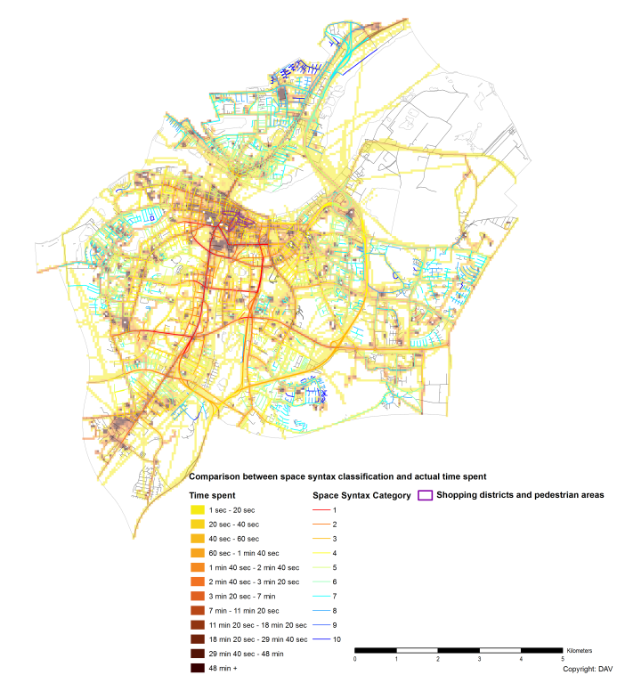
Figure 14: Space syntax classification mapped on top of the time consumption dataset with an indication of the primary shopping districts and pedestrian areas for the case area.
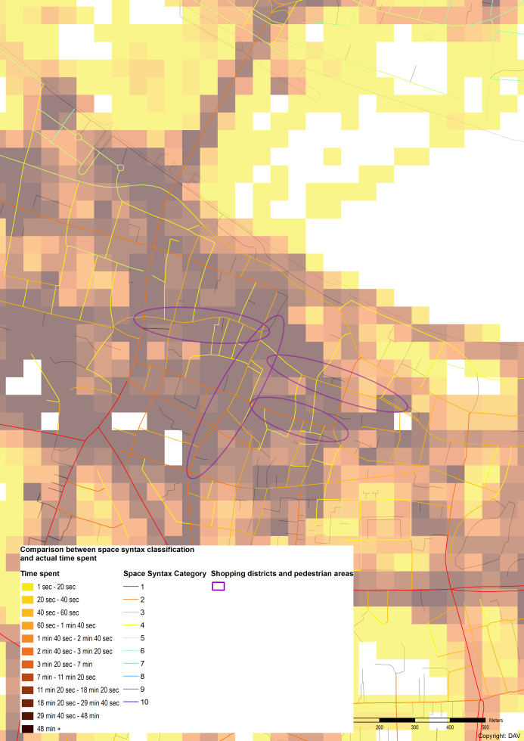
Figure 15: A close-up view of the shopping districts and pedestrian areas (right)

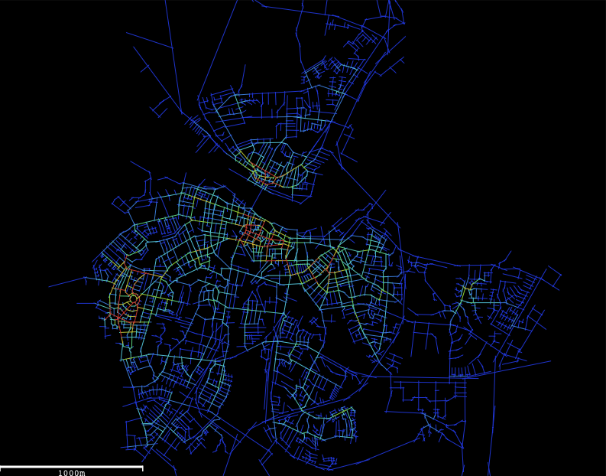
Figure 16: Spatial angular analyses with a short metrical radius.

There are correlations between the spatial parameters and the registrations of human behaviour as shown in figure 15 when applying the metrical radiuses on the local spatial analyses of Aalborg. Figure 16 shows a local angular integration analyses with a metrical radius like 300 units. It shows where the various local centres are located. The city centre and the centre in Nørresundby have high values. These centres have an inter-accessible street net within a short metrical radius. A dwelling area in Gl. Hasseris in the western districts of the city has also high values, due to the high density of pedestrian and bicycle routes.
Since most of the respondents that created the data for the time consumption maps (presumably) do not have a car, the degree of spatial integration within a low metrical radius correspond with the behavioural pattern of young people.
One of the points of criticism of the space syntax method was a lack of the metrical properties in their analyses (Ratti 2004). Now it is incorporated in the calculations. As research results show, the geometrical and topological distances correspond with the pedestrian and vehicle flow rates and the location pattern of shops more than the metrical distances. However, when applying metrical radiuses in the angular and axial analyses, some striking results can be seen. The degree of vitality of the various local areas can be seen in the analyses with a low metrical radius, while the main route network is highlighted in the analyses with a high metrical radius. Streets with high integration values with a high metrical radius tend to be the potential routes for through movement. Conversely, streets with high integration values with a low metrical radius tend to be potential meeting places for the neighbourhood. When comparing these two analyses with one another, the most vital urban areas tend to be where streets have high integration values with both high and low metrical radiuses. (van Nes, Berghauser-Pont, Maschoodi, 2011).
A third conclusion is that for the suburban areas, there is a tendency of high randomness with regards to whether or not there is coherence with both genders, either of the genders or no coherence at all. This is particularly noticeable in the westernmost part of the case area where all 4 possibilities are present with no obvious patterns. The explanation is likely that the time consumption dataset is insufficient of providing a proper statistical representation of the time consumption in these areas of the city.
The fourth and final conclusion is that the space syntax classification appears to be incapable of determining road segments which have little connectivity with the remaining road network but still consists of “bottlenecks” with regards to the actual commuter traffic. The most evident example of this phenomenon is the easternmost tunnel across Limfjorden. A possible explanation is that the connection is located in the outskirts of the case area. Therefore, the road segment appears to have fewer connections than it does in reality and as such attains an erroneously low space syntax classification.
References
dendigitalebyport.byhistorie.dk. Danmark Købstæder: Aalborg. http://dendigitalebyport.byhistorie.dk/koebstaeder/by.aspx?koebstadID=73 . 5-9-2011.
Ref Type: Electronic Citation
Hillier, B. & Penn, A. 2004, "Rejoinder to Carlo Ratti", Environment and Planning B: Planning and Design, vol. 31, pp. 501-511.
van Nes, Berghauser-Pont, Maschoodi, 2011, “Combination of Space Syntax with Spacematrix and the Mixed Use Index”, Proceedings 8th International Space Syntax Symposium, Santiago, Chile.
Ratti, C. 2004a, "Rejoinder to Hillier and Penn", Environment and Planning B: Planning and Design, vol. 31, no. 000, p. 000.
Ratti, C. 2004b, "Space syntax: some inconsistencies", Environment and Planning B: Planning and Design, vol. 31, pp. 487-499.
Schaick, J. v. and Spek, S. v. d. 2008, Urbanism on Track, IOS Press, Amsterdam, 2008
Steadman, P. 2004, "Guest editorial: Developments in space syntax", Environment and Planning B: Planning and Design, vol. 31, pp. 483-486.
www.statistikbanken.dk. Statistikbanken. http://www.statistikbanken.dk/statbank5a/default.asp?w=1486 . 5-9-2011.
Ref Type: Electronic Citation

Aalborg was founded approximately 900 A.D. (dendigitalebyport.byhistorie.dk 2011) and today it is the fourth largest city in Denmark with a total population of 124,921 inhabitants (www.statistikbanken.dk 2011).

