Fouling reversibility in a membrane bioreactor – effect of crossflow velocity

Mads Koustrup Jørgensen*, Morten Lykkegaard Christensen, Kristian Keiding

Aalborg University, Department of Biotechnology, Chemistry and Environmental Engineering, Sohngaardsholmsvej 57, 9000 Aalborg, Denmark
*Corresponding author: Tel.: +45 99407248, fax: +45 96350558, e-mail: mkj@bio.aau.dk

Abstract
The short term reversibility of fouling in a membrane bioreactor is studied based on a modeling approach developed to simulate cake buildup and compression in membrane bioreactors [1,2], This is done by studying the removal of a preformed cake at increasing shear. The model was able to simulate the permeate flux during experiments with increasing rotation speed of the membrane discs. This showed that the kinetics of cake removal was equal to the kinetics of cake formation, i.e. cake build-up was reversible.

Keywords: Membrane fouling, membrane bioreactors, cake removal, reversibility, compressibility

1. Introduction
Fouling in membrane bioreactors (MBR) is an inevitable effect of accumulation of sludge material on or in the membranes, that make operation less efficient, and places demand for physical and chemical membrane cleaning. Therefore, to improve performance it is important to understand membrane fouling so the fouling can be mitigated by operating MBR plants at non-critical conditions.
A recent study has proposed a new approach to model fouling in MBRs by describing fouling as a result of fouling layer/cake buildup and compression [1,2]. The model can simulate the development in flux in lab scale and pilot scale membrane bioreactors in short term experiments. However, the model assumes that cake buildup and compression is fully reversible, although other studies have shown irreversibility of development in fouling in membrane bioreactors [3-5]. Therefore, it will be investigated in this study, if the buildup of cake is reversible in short term experiments, by examining if cake removal follows the same kinetics as cake buildup.
The model is based on the assumption, that the development in amount of cake, can be described from a mass balance [6], with a permeation drag (J·C) transporting foulants towards the membrane minus the amount of foulants transported away from the membrane, hence back transport, J_{BT}. The back transport consists of Brownian diffusion, shear induced diffusion and interaction induced diffusion. Hence, by e.g. increasing shear, J_{BT} is higher, and the development of cake is lower.
(1)
According to eq. (1) cake is build up when J>J_{BT}, while if J<J_{BT}, and if the cake buildup is reversible, cake is removed. Hence, when starting filtration at a constant pressure, flux declines, due to cake buildup, until a steady state is reached (dω_{c}/dt=0, hence J=J_{BT}). The limiting flux is the highest steady state flux that can be obtained hence flux cannot be increased by elevating pressure, as the development in flux is controlled by the mass balance in eq. (1).
Furthermore, as the back transport is a mechanism of diffusion, it depends on the concentration gradient between the concentration at the membrane, compared to bulk. Hence, the back transport increases with the amount of deposited material, until a stagnant cake has formed. Therefore, eq. (1) has been rewritten to describe the development of cake from the limiting flux and by considering, that the back transport depends in the amount of foulants [1].

(2)
ω_{crit} is the critical amount of cake required to form a stagnant cake and J_{LIM}=J_{BT} for cake buildup and removal. At ω_{c} > ω_{crit} the back transport is constant. Though, eq. (2) is only valid to describe buildup and removal of cake if fouling is reversible. It is expected, that if both reversible and irreversible fouling occurs, then the development of cake is as follows

(3)

dω_{c,rev.}/dt is described by eq. (2) while dω_{c,irrev.}/dt is the irreversible fouling. If fouling is reversible, then dω_{c,irrev.}/dt =0, and the buildup of cake (J>J_{BT}) follows the kinetics of cake removal (J<J_{BT}) of cake.
It is in Jørgensen et al. (2012) assumed, that dω_{c,irrev.}/dt=0. In this paper it will be tested if this assumption is fair for short term experiments. This will be done by introducing shear stepping experiments. In the shear/crossflow stepping experiments, the rotation speed of ceramic membrane discs is increased stepwise, to study the flux restoration by increased back transport and detachment of fouling layers. It is then tested, if the model can describe the cake buildup and the cake removal, in order to determine whether the fouling in short term experiments is reversible.

2. Model
Jørgensen et al. (2012) has developed a model based on cake buildup from equation (2) and a model for cake compression [1]. The flux is described from Darcy’s law:

(4)

TMP is the transmembrane pressure, µ is the dynamic viscosity, R_{m} is the membrane resistance and R_{c} is the cake resistance. The cake resistance can be described as the product of the amount of cake, ω_{c}, and the specific cake resistance, α.
(5)
The formation (flux dependent, eq. (2)) and compression (pressure dependent) of a cake layer will give an increase in R_{c}. Compression and swelling is described as increasing . There is a linear profile between specific cake resistance and pressure drop over the cake ΔP_{c}. This is expressed from the following equation
(6)
Where α₀ is the specific cake resistance at no pressure, P_{a} is the pressure required to obtain specific cake resistance twice as high as the initial specific cake resistance if β=1, which is valid for highly compressible cakes.

3. Experimental
A labscale sidestream filtration system with rotating ceramic membrane discs is connected to a membrane bioreactor, shown in figure 1. The bioreactor has a sludge concentration of 10 g/L and a SRT of approx. 40 days. The bioreactor was fed with a substrate of dogs food and fish meal with a COD and BOD of 20 and 12 g/L to keep a food-to-microorganism ratio of 0.1. During filtration, particle size was measured in the bioreactor and in the recirculation outlet to the bioreactor. From this, there was not found any effect of rotation on the particle size distribution. Further details about the system are given in Jørgensen et al. (2012) [1].

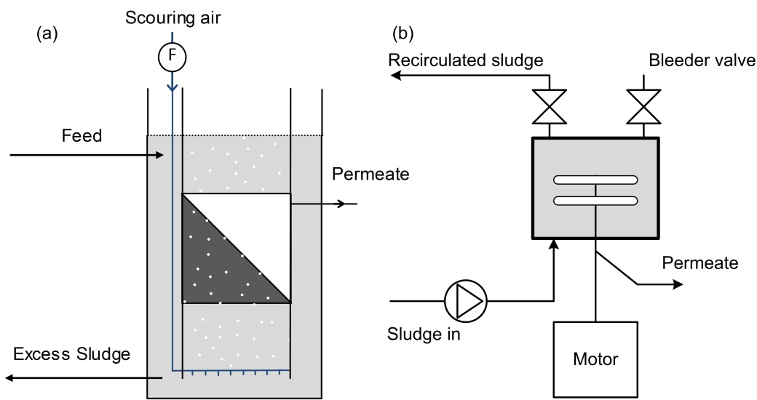
Figure 1: Illustration of experimental setup with continuously running MBR (a) and sidestream filtration unit with rotating ceramic discs.

Filtrations were performed at 1 bar TMP on cleaned membranes. The recirculation rate between the bioreactor and the sidestream filtration unit was 2 L/min. Filtration was performed in the following rpm-stepping sequences:
(1) 280 rpm 25 minutes cake buildup phase
(2) 230 rpm 25 minutes cake buildup phase → 280 rpm 20 minutes cake removal phase
(3) 180 rpm 25 minutes cake buildup phase → 230 rpm 20 minutes cake removal phase → 280 rpm 20 minutes cake removal phase
(4) 100 rpm 25 minutes cake buildup phase → 180 rpm 20 minutes cake removal phase → 230 rpm 20 minutes cake removal phase → 280 rpm 20 minutes cake removal phase

4. Results

Kinetics of cake buildup
Flux was measured for 25 minutes at 1 bar TMP and at different rotation speeds. The decline in flux was fitted to the model described in 2. Theory with the parameters α₀ = 2.7·10¹³ m/kg and P_{a} = 12000 Pa for all four experiments. J_{LIM} is changed by solver using the least squares method, to fit the experimental data. The fits are presented in Figure 2.
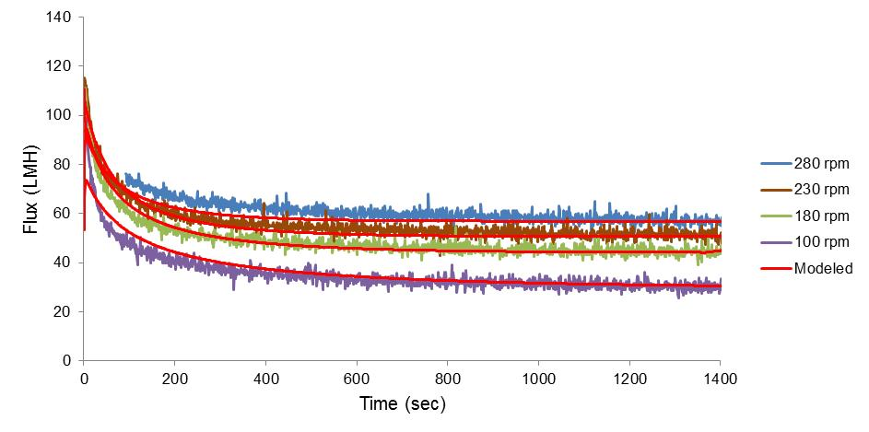
Figure 2: Experimental fluxes during cake buildup at different rotation speeds together with modeled fluxes.

From the figure it is observed that the modeled fluxes fit the measured fluxes for all four rotational speeds. The flux declines towards steady state, highest at high rotational speeds. J_{LIM} obtained from the fitting process is shown in Table I.

Table I: Limiting flux at different rotation speeds, determined from fits to data in Figure 2.
υ_{rot} (rpm) | J_{LIM} (LMH)
280 | 59.21
230 | 51.91
180 | 44.17
100 | 29.37

Reversibility of cake buildup
The limiting flux given in Table I is a parameter describing the kinetics of cake buildup according to eq. (2). Assuming that the cake is reversible, the limiting fluxes obtained are used as J_{BT} to simulate the removal of cake when increasing the rotation speed of the membranes in the crossflow-stepping experiments.

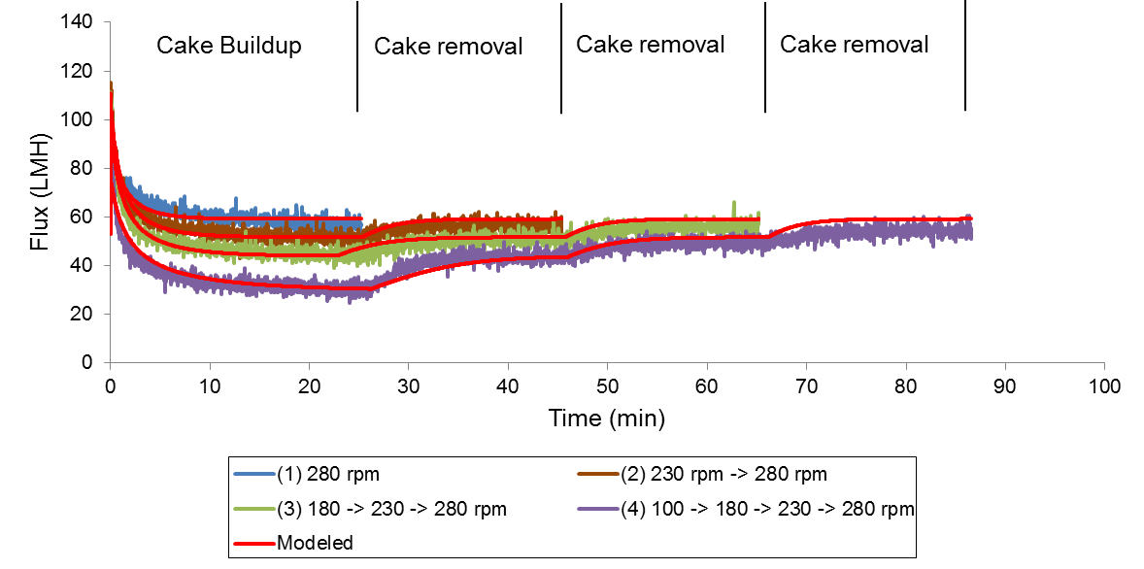
Figure 3: Crossflow-stepping experiments. Cake is build up at different rotation speeds followed by cake removal steps, where flux is restored.

Figure 3 shows the development in flux over time in the flux stepping experiments. E.g. in sequence (2), the flux declines towards the limiting flux at 230 rpm, 51.91 LMH, in the cake buildup phase. When the rotation speed is increased after 25 minutes of filtration (cake removal phase), it is observed, that the flux increases towards the flux measured in sequence (1) at 280 rpm. The development in flux in the cake buildup and cake removal phases is well simulated by the model. Only, in sequence 4 at the last cake removal step, there is a slight over prediction of the flux by the model.

5. Discussion
By describing the kinetics of cake removal from the kinetics of cake buildup, it was possible to model the development in flux during the cake removal experiments, which suggests that the kinetics of cake removal is similar to the kinetics of cake buildup. In Jørgensen et al. (2012) and Bugge et al. (2012) it is shown that the model is able to simulate the buildup of cake at high pressures and the removal of cake at lower pressures. At high pressures J>J_{BT} which gives cake buildup according to eq. (2), while at lower pressures, hence lower fluxes (J<J_{BT}), cake is removed. The current study shows, that the same model is able to simulate the development in flux, when the crossflow velocity (here rotation speed) is increased, hence cake is removed. The model is able to describe the removal of cake during relaxation and increased crossflow because it is the same mass balance that is affected; The model is based on the buildup and removal of cake from the balance between J and J_{BT} in eq. (1). When J>J_{BT}, cake builds up giving a decline in flux until J=J_{BT}. Cake removal occurs when J<J_{BT}, which can be a consequence of lower pressure (lower J during e.g. relaxation [1]) or increased crossflow (higher J_{BT}, as shown in this study).
From Figure 3 it is observed, that the flux during the cake removal steps at 280 rpm rotation speed in sequence (2-4) reaches the same level of flux, as the flux measured under cake buildup in sequence 1 at 280 rpm. This shows, that the cake buildup at the lower rotation speeds (230-100 rpm, sequence 2-4) is removable; hence the cake formation is to high extent reversible.
For potential further studies of reversibility of fouling, long term experiments where irreversible fouling occurs should be conducted. If this is done, it could be possible to use of eq. (3) instead of eq. (2) in the fit to flux restoration, to give an estimation of the irreversible buildup of cake over time, dω_{c,irrev.}/dt.

6. Conclusion
By modeling crossflow-stepping experiments, it is found that the kinetics of cake removal follows the kinetics of cake buildup. a new method to study reversibility is introduced. The results from this shows that cake formation can be described as reversible, and hereby confirms the observations in Jørgensen et al. (2012). The model has been tested on experiments lasting only a few hours, and should be tested on longer term experiments to show the formation of an irreversible fouling layer.

References

[1] M.K. Jørgensen, T.V. Bugge, M.L. Christensen, K. Keiding, Modeling approach to determine cake buildup and compression in a high-shear membrane bioreactor. J. Membr. Sci. 409-410 (2012) p. 335-345.
[2] T.V. Bugge, M.K. Jørgensen, M.L. Christensen, K. Keiding, Modeling cake buildup under TMP-step filtration in a membrane bioreactor: Cake compressibility is significant. Water Res. 46 (2012) p. 4330-4338.
[3] P. van der Marel, A. Zwijnenburg, A. Kemperman, M. Wessling, H. Temmink, W. van der Meer, An improved flux-step method to determine the critical flux and the critical flux for irreversibility in a membrane bioreactor, J. Membr. Sci. 332 (2009) 24–29
[4] C. Huyskens, E. Brauns, E. van Hoof, H. de Wever, A new method for the evaluation of the reversible and irreversible fouling propensity in MBR mixed liquor. J. Membr. Sci. 323 (2008) p. 185-192
[5] L. Defrance, M.Y. Jaffrin, Reversibility of fouling formed in activated sludge filtration, J. Membr. Sci. 157 (1999) p. 73-84
[6] P. Bacchin, P. Aimar, R.W. Field, Critical and sustainable fluxes: Theory, experiments and applications. J. Membr. Sci. 281 (2006) p. 42-69.

Nomenclature:

Α | Specific cake resistance (m/kg)
α₀ | Initial specific cake resistance (m/kg)
µ | Dynamic water viscosity (Pa·s)
Ω | Amount of cake (kg/m²)
ω_{crit} | Critical amount of cake (kg/m²)
J | Permeate flux (LMH)
J_{BT} | Back transport flux (LMH)
J_{LIM} | Limiting flux (LMH)
P_{a} | Characteristic pressure (Pa)
ΔP_{c} | Pressure drop over cake
p(ς) | Interaction between foulants and membrane
R_{c} | Cake resistance (1/m)
R_{m} | Membrane resistance (1/m)
TMP | Transmembrane pressure

