Exploring the relationship between material and organizational devices: towards a new sociology of architecture
Marianne Stang Våland*, Copenhagen Business School (msv.ioa@cbs.dk) and Susse Georg, University of Aalborg (sgeorg@plan.aau.dk)
* Corresponding author
Draft, please do not quote without permission of the authors

Abstract
The paper explores the relationship between the production of an architectural product – an office building – and the social context in which this building is being shaped and used. Based on an ethnographic case study of a merger between two government agencies, we investigate the recursive interplay between architectural and organizational design in the process of designing a new office building. Particular emphasis is given to how extensive end user participation was brought to bear in developing the architectural design. We discuss how this affected both the users’ sense of work and the work of the professional architects, responsible for the architectural design. Our findings suggest that the materiality of architecture enabled the users to engage in an organizational development project in unanticipated ways. However, this form of user participation also produced confusion as to who had what roles and responsibilities. Informed by actor-network theory, we discuss how material objects may serve as ‘organizational devices’ that not only may support organizational change, but also afford developing more distributed approaches to the process of designing that may challenge the bounds of the architects’ professional domain and perhaps even their sense of professional identity. We conclude that by attending to the socio-materiality of architectural and organizational design processes, the sociology of architecture can contribute to our understanding of how organizations are held together.

Key words: materiality of architecture, user participation, professional identity

Introduction
The relationship between the design and construction of architectural objects – the material – and the social context in which these objects are shaped and used – the social – is a key issue within the sociology of architecture. The relationship between the material and the social is a tenuous one: some tend to reify one, be it the material or the social, at the expense of the other, whereas others consider the material and the social to be “constitutively entangled” (Orlikowski, 2007:1437). In keeping with the latter perspective, we investigate the recursive interplay between the material and the social in the context of a double design process involving architectural and organizational design. Particular emphasis is given to how extensive end user participation was brought to bear in developing the architectural design and how it had implications for the users’ sense of their work and organization, as well as for the architectural designers’ sense of their professional practice.
The empirical context for our study is the construction of a new office building for a newly established municipality, created through a merger of two smaller municipalities. This entailed not only a substantial number of organizational changes, but also physically relocating the various municipal departments to one, new location. This provided a unique opportunity for the managing director of the new municipality to experiment with both the organizational and the architectural design, both of which were informed by extensive end user participation. As we shall see in the case below, this reciprocal interplay was characterized as “a double design process” by the managing director.
Based on our theoretical interests in addressing the constitutive entanglement of the material and the social in the context of architectural design, the research question pursued in the following is: what roles does the materiality of architecture play in the context of organizational change? In answering this question we draw upon insights from organizational theory and actor network theory. Although much of the literature argues that spatial organization, architectural design and material artifacts can support organizational change and development, little attention is offered to the details of how this takes place and what it can produce. Our aspiration in this paper is to explore the relationship from close range, in order to understand more about the implications these associations may cause to the arrangements or practices involved in its constitution.
The paper is structured as follows: The next section describes the paper’s theoretical backdrop and subsequent two sections describe the methodological approach and the empirical setting. We then present an example of how the materiality of architectural design enabled representatives from the organization to perceive and comprehend their organization in new ways. The example also illustrates how the encounter between users and material objects affected the relationship between user and architectural designers. In the ensuing discussion, we attend to what it means to consider these design processes as intricately interwoven.

The theoretical backdrop
The issue of organizational change and design are both salient domains within organizational theory. Although the issue of design has a long history within organizational studies (Thompson 1967, Galbraith 1973), it has for many years not been subject to much attention. Interest has, however, recently been greatly revitalized. Taking their cue from the seminal work of Herbert Simon that “Engineering, medicine, business, architecture, and painting are concerned not with the necessary but with the contingent – not how things are but how they might be – in short, with design” (Simon 1996, p. xii), many authors are making a case for design approaches in studies of organizational practice (Romme 2003), management (Boland and Collopy 2004, Yoo et al. 2006, Boland et al. 2008, Johansson-Sköldberg et al. 2013), organizational development (Bate et al. 2007), change management (Romme 1997), and to organizational theory in general (Jelinek et al. 2008, Greenwood and Miller 2010). In addition, attention has been given to what designers, for example architects or industrial designers, do and what can be learned from such designerly ways of working that can support the handling work and change in organizational life (e.g. Boland and Collopy 2004, Yoo et al. 2006, Michlewski 2008). This being said, we are still curious as to what managers actually do when they turn to architectural design and space and what implications this turn may have for the work being done in the organization.
There is a broad literature on the role of space in organization studies. Much of this work has a relatively abstract, philosophical take on the role that space can play in shaping organizational contexts (e.g. Hernes 2004, Dale 2005, Kornberger and Clegg 2003, 2004, Clegg and Kornberger 2006, Dale and Burell 2011, many of whom draw on the work of Lefebvre (1991)). There is, however, also more empirically based work that addresses questions on spatiality more directly by focusing on the relationship between organization, architecture and material artifacts, e.g. on how architectural designs that accommodate an organization’s daily practice can inform performance and collaboration (Yanow 1995, 1998, Halford, 2004, Ewenstein and Whyte 2007a, 2007b, Peltonen 2011, van Marrewijk and Yanow 2011). Several of these studies point to the importance of material artifacts; drawings and other forms of visualizations or physical devices, in bringing about organizational change. In keeping with this approach we see the spatial and the material as recursively intertwined with questions regarding organizational performance and change.
The socio-material approach allows us to sidestep the materialistic, deterministic accounts of how the architectural design of a building, office or workspace determines or regulates what employees do, and attend to the details of the role that architectural elements can play as organizational devices; how their designs evolve and how this co-evolves with the ways in which organizational members go about their everyday tasks. Our study is about tracing the socio-material associations made in developing a new organization and a new building to house the organization. In keeping with Latour (2005:9), we consider the sociology of architecture as “sociology of associations” associated with architecture. In the following we explore this in the context of a double design process that was based on extensive user involvement. We examine how the extended user involvement in this architectural design process affected, not only the perception of work and identity among members of the organization, but also the work of the professional architect.

Methodology: an ethnographic study
The paper is based on the first author’s longitudinal, ethnographic study of organized end user participation in the architectural design process of a town hall construction project (Stang Våland 2010). Data was collected in 2005–2008 and involved a number of methods: semi-structured interviews, ethnographic fieldwork, and document analysis. In this process twenty-one semi-structured interviews were conducted with representatives from the client organization (managing director, department managers and staff members) and the architects. An additional interview was conducted in the course of writing this paper. Each interview lasted approximately 1-1½ hours; all of which were tape-recorded and transcribed. All interviews were carried out in Danish, for which reason certain extracts have been translated into English by the first author. The interviews touched on several issues, including the role that user participation played in organizing the construction project; the constitution of the various participation activities and the materialities involved, and the users/architects’ experience of engaging in, orchestrating, and handling these activities.
The fieldwork included participant observations of the majority of the user participation activities included in the project: 6 full day interactive workshops or “summits” with approx. 50 participants and 2 three-hour plenary meetings, to which approximately 500 staff members were invited. The study also involved participant observations of 3 development meetings between the municipality’s top management team and the architectural designers responsible for the user participation and 4 meetings between client representatives, architects, engineers and constructors. In addition, the study comprised 3 months of full time field work among the architectural designers, responsible for the user participation. Two architectural companies were involved in the project; one responsible for the user participation activities and the interior design and one responsible for the building design (including the reception counter that is portrayed in the empirical vignette below in the paper). Being involved in the daily work of the designers, allowed for a great number of informal discussions about the planning and preparation of the user activities. In the field, notes were made by hand in workshops and informal meetings and thereby scrutinized in the first author’s individual reflection. The handwritten notes also included a number of drawings made by the informants. In more formal settings, the notes were made on a laptop computer. The data material also includes a substantial amount of documents regarding the construction of a new town hall and organizational activities involved: project descriptions and proceedings; minutes from coordination meetings and summits; presentation material for the user participation activities; material and results from the architectural competition; architectural sketches and diagrams in various versions that represented the winning proposal.
The data (interviews, documents, handwritten and computerized notes) was analyzed in an open coding process, in which extracts were subsequently examined more closely and sorted under a number of different headings (Strauss and Corbin 1998, Bryman and Bell 2008). The headings (from which several subthemes emerged) comprised of issues such as: the application of user participation (intentions, concerns and experiences); the types of participation activities (planning and development of exercises); the conditions that predefined the design process (e.g. the open office layout); the architectural design process (the architects’ experiences of integrating an unfamiliar input). As the data was collected over a three-year period, this allowed for an iterative approach in exploring subthemes that emerged in the early stages of the study, particularly in the later interviews.

Using architecture to design an organization: a case study
Our study focuses on the merger of two small, adjacent municipalities into one larger middle-sized municipality. Apart from the common organizational challenges associated with mergers, i.e. adjusting existing work processes and developing a new common culture, this merger also entailed physically relocating both municipalities’ administration into a new town hall. It allowed the municipality to integrate services and activities that hitherto had been localized in five different sites into one place.
The aim of this reform was to improve public service and cut costs, but for the managing director in the new municipality the move to a new location had another advantage as well. Constructing a new town hall provided them with an opportunity to reconsider the municipality’s organizational design. Informed by an ongoing discourse regarding the need for knowledge sharing and cross-professional collaboration in the Danish public sector (e.g. Indenrigs- og Sundhedsministeriet 2005) and inspired by research on “new ways of working” (Bjerrum and Bødker 2003, Duffy and Worthington 2004), the managing director wanted to experiment with how office design could improve their services, and how these organizational adjustments could inform the architectural design so as to create a new organization and a new building in one concurrent movement. In this way, the organizational and architectural design processes were considered as mutually reciprocal resources. According to the managing director:
I don’t think there are many people, who have yet experienced that you can actually make a double design process. And one of the tasks in orchestrating these change processes is to ensure some kind of interplay or synergy between them [the architectural and organizational design processes]. I have become aware of how vital it in fact is, not to freeze for instance the organizational development as a given precondition and then subsequently discuss space, but to continue to ensure an interaction (Emphasis added).
As the quote indicates, organizational and architectural design processes are usually considered as separate and sequential processes, and often without much involvement of the end users. This building project was developed differently – as a double design process based on extensive and organized end user participation. As the managing director explained:
[U]ser participation was brought in from the start, where we pointed out that it is especially the social workers and their colleagues, who know how work is being done here: on screen, on paper, with regards to the cases and all the rest of it. This is why a broad number of staff was invited to participate. It was an open dialogue from the start.
The employees were involved in providing input to the brief that, in turn, structured the architectural competition. Moreover, once the winning design proposal had been chosen, the employees continued to have exchanges with the architectural designers as they were developing the design. This continued, albeit to a lesser extent, during the construction process. Throughout the entire process, the key issue for the users was the implications that the spatial design would have for their work. For the managing director, the transformative effect of this was clear:
Many people see the process of moving as something that just involves the physical location of their desk. But by discussing these things in the workshops, they realized that a physical change also affects the work itself and the perception of what work, in fact, is. […] Consciously as well as unconsciously, the work affects and is affected by the physical workspace. Distance and accessibility influence culture and work processes. These things change our perception of work.
This is the double design process that was outlined in the opening quote; the interplay between changes in physical space and the organization. According to the managing director, the construction of a new town hall was:
[…] a gift to the merger. [In the new building], everyone can seize the new organization, more or less free of the past, the ‘them vs. us’ boundaries and all the rest of it. […] Our focus is on collaboration across professional boundaries; to obtain a stronger coherence in the service by supporting cross disciplinarity – to support that the many strong professions, we represent, become able to work together. To do that, we need to look at how the physical space can help or hinder this collaboration.
The double design process provided both management and employees with an opportunity to address and accommodate many of the organizational challenges associated with the merger. User participation was an important means to this end. It involved a variety of activities: a survey, in which the staff’s use of their present spatial facilities was analyzed; a range of workshops within and across departments; two plenary meetings, where the architectural designers presented the building to the staff, who could then make direct inquires about the new workspace conditions; and a staff party. A few of the events were planned and held prior to the architectural competition, and the insights that these provided were included in the competition’s brief. The majority of the events, however, took place after the winner of the competition had been selected and during the period when the design solution was being developed.
Based on the above description of the empirical context and the central activities constituting the double design process, the next section expands upon how the architectural and organizational design processes were woven together in the project. It attends to the continual redesign of a particular material artifact and illustrates how this process allows for reflections regarding changes in the organization. The purpose of this vignette is to portray the recursive relationship between the material and the social, i.e. how the materiality involved in these orchestrated interactive processes contributes to modify the organizational members’ sense of professional and organizational identity. But the story also attends to the implications that this tendency towards a more distributed approach to the process of designing may have for contemporary architects in their professional work.

Designing a reception counter: challenging professional and organizational identity
This vignette focuses on the design and subsequent re-designing of a particular part of the building – the reception counter in the town hall lobby, the design of which had been subject to some contention from the start and the materialization of which called for substantial physical changes because the counter was cast-molded into the floor of the reception hall.
The competition brief had called for developing a design for the reception that was among other things “open” and “welcoming” (interview with architectural designer 2008). Identifying what this more precisely entailed was, however, not a straightforward endeavor. In the original proposal, the architectural designers had, in fact, not envisioned it as a counter at all. Instead, they…
… saw it as a serpentine – as a winding line that ran through the underworld of this town hall; a multifunctional piece of furniture that represented everything from being something you could sit on, something you could get brochures from, where you could talk with people from each side. And at some places it [the serpentine] was completely wiped out to avoid signaling this unfortunate phenomenon where you have a divider between one side and the other.
However, the assessment committee consisting of various experts, the top management team and several staff representatives, considered this design too open. Because of their previous experience with client violence, they asked the architects to design something “more protected”. The serpentine and the revised design are depicted in figure 1 below.
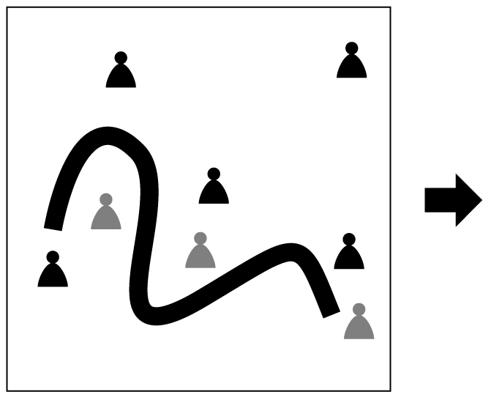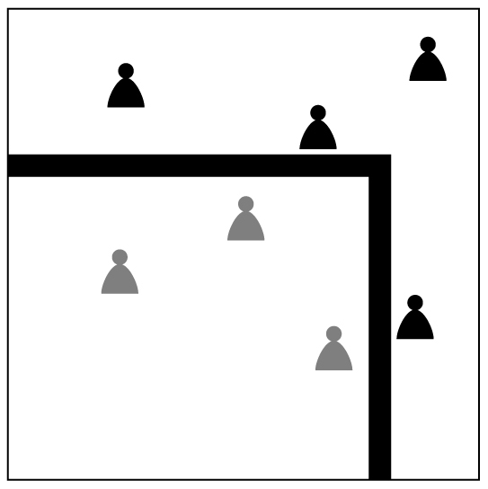
Figure 1. The initial designs. On the left: the architects’ initial proposal. On the right: management’s redesign. The grey characters represent the employees while the black characters represent the clients.

Charlotte, manager of the ‘Citizen Service Center’ and whose staff would be manning the counter, was, however, not impressed by the revised design. According to Charlotte, the design did not reflect the employees’ aspirations and expectations for the new building that in her opinion had evolved in the course of the user participation activities:
I didn’t like the reception counter. It was a desk of the worst kind. We would be very much separated from the citizens. […] I think, when we build a town hall that in all other ways are supposed to signal openness and a sense of belonging, I don’t think we can leave the citizens at such a substantial counter, with 15 of our people behind it.
Based on her interpretation of the architects’ sketches, she initiated a series of meetings with her closest colleagues, the managing director, the project team responsible for managing the construction project and with the architectural designers to renegotiate the design. She discussed work processes and identity with her fellow workers; image and economy with the managing director; time schedules and process with the project management; and with the architectural designers she talked about the form and function of both the reception and the reception counter. Charlotte was so engaged in these debates that she worked alongside the architectural designers in re-doing the sketches for the counter. The modified design, which she developed in collaboration with the architectural designers, is illustrate in the rightmost diagram in figure 2. They had, according to Charlotte, “tried to draw it up in a mutual process”.

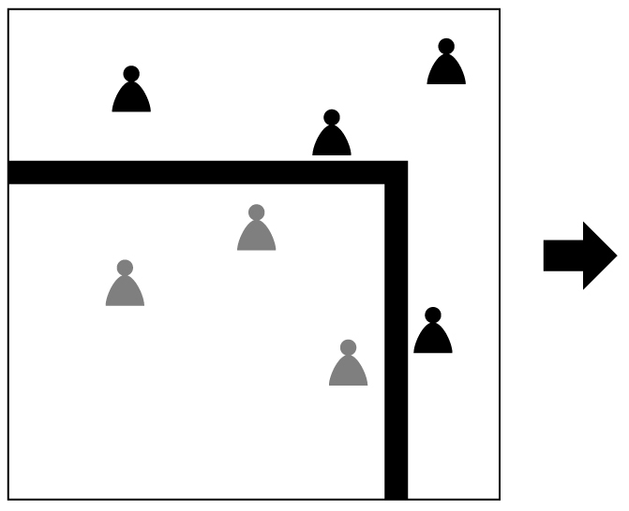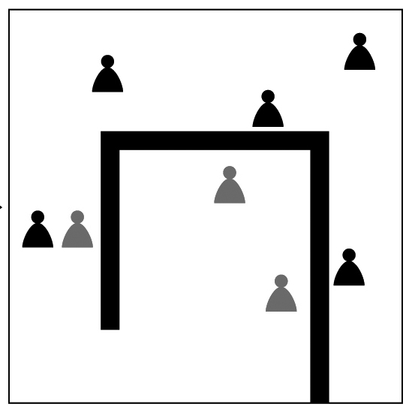
Figure 2. The reception counter’s design. From left to right: the architects’ initial proposal, top management’s redesign, and the users’ redesign.

Charlotte described the redesign in the following way:
What we have done now is to tip it in […] so the staff doesn’t stand on the opposite side [of the client] looking out. In this way, we terminated the petty official image we unfortunately struggle with.
With these architectural adjustments, clients and citizens visiting the town hall could move freely around the reception counter and get substantially closer to the staff of the Citizen Service Center. While the design suggested by top management physically separates the staff and the clients, Charlotte’s suggestion allows them to mingle. From Charlotte’s viewpoint, this design signaled less distance to the client, a gesture she found more appropriate with reference to the municipality’s overall vision for the town hall project and also more in keeping with the impression that many of the municipal employees had from taking part in the user participation activities.
Returning to the town hall building after its completion, when the ‘Citizen Service Centre’ had been functioning for a few months, the design of the reception counter was again on subject of intense debate; again on Charlotte’s initiative. This time she found the counter too open! The reception area provided too little privacy for staff and clients alike, and on this basis she initiated yet another process of re-designing. Less than 2 months after occupancy, she noted that:
[We have] already modified the layout of the reception area and made an agreement that […] the conversation bar between the expedition area and the department [of the Citizen Service center] should be moved 80 cm, in order to create [space for more] discretion for the citizens.
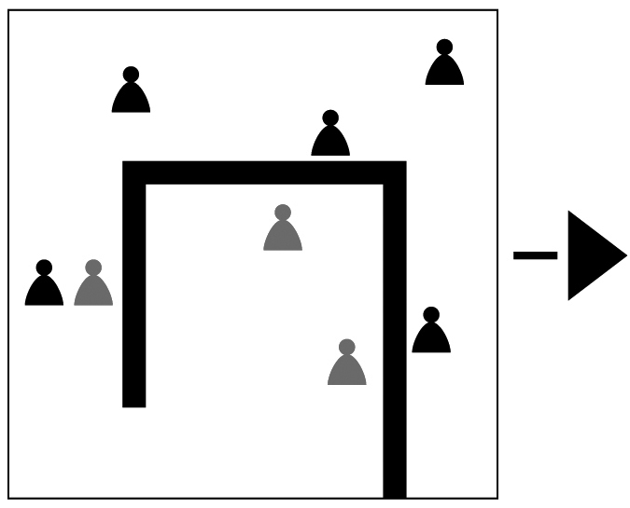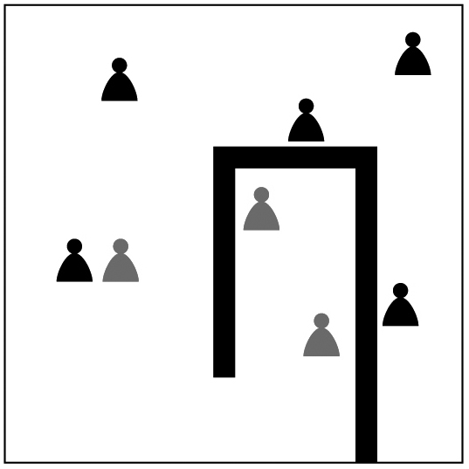
Figure 3. The next iteration of the design.

Charlotte’s description of the development is illustrated in figure 3. As can be seen in figure 3, the design was modified so as to reduce the width of the space behind the counter. Just as the counter’s physical layout was to be changed according to Charlotte and her colleague’s revised plan (illustrated in figure 3), the municipality ran into a massive expenditure cuts due to the economic ramifications of the financial crisis, which put the development of the counter on hold. The financial crisis also had other implications, among them the layoff of many employees and a succession of managing directors.
When we returned to the site three years later, several organizational changes had been introduced, including the integration of another section into the Citizen Service Center. Again, the reception counter was about to be modified – to a design very similar to the one suggested by management three years earlier, which is illustrated in figure 4. The last iteration exemplifies how the design went back to square one. Management had, however, in the meantime changed substantially.

Figure 4. The design trajectory of designs for the reception counter.

Charlotte had, by this time, left the municipality administration, but the design challenge of ensuring both openness and protection that she had emphasized, had not been resolved. Commenting on the design changes that had taken place in the course of the three years, another middle manager described the situation as follows:
When we first moved into the building, the reception area was widely used, but that’s not the case anymore. […] I think it has become a more quiet organization. I don’t think it is as dynamic as it was before. I think it is a bad development. It’s not progressive – neither with regards to work processes nor the signals it sends. […] We are some who feel we’re almost back to where we were in the old days. When Charlotte was here, we were in a process where we thought ’we can do this and this and this’. (Interview with middle manager, 2011)
The quote suggests not only that the way in which the counter was redesigned can be seen as a reflection of the changes that take place in the organization. It also indicates that in changing the counter’s shape back to the more conventional form, the ways in which people interact in the town hall lobby changed as well: it had become a less lively place. It represents the materialization of changes in the municipality’s organizational identity.
Looking at Charlotte’s gradual involvement from an architectural viewpoint, the process of redesigning the reception counter took an unexpected turned when she started working with the architectural designers in producing the necessary drawings. This followed from the extended process of user participation, and it caught both Charlotte and the designers by surprise. For Charlotte, this level of interaction went beyond her expectations: “I was thinking ‘throw me 3 sketches in return [for the input we produced as part of the user participation process] to see if that is what I want’. But that didn’t happen. I did the drawing myself, with a funny feeling thinking ‘this is not what I’m educated to do’”. The architectural designers were, however, equally (if not more) surprised. Although they had worked with user participation in other projects, they were not accustomed to the kind of involvement and interference they experienced in this project. They were caught off guard by the users’ engagement and not quite sure of how to handle the division of labor that evolved out of their interactions with Charlotte, and as a result they appeared (at least momentarily) to leave the drawing to the client/user herself. This is far from the ordinary, as professional architects traditionally keep to themselves while doing the actual sketching, not allowing the client to interfere directly in this process. In this incident, however, they seemed to have been abandoned this code of conduct. One of the architectural designers expresses his concerns as to what this level of interaction with the client organization would come to mean for architectural design work, and how it is different from the architects’ traditional way of working:
This user participation has, in fact, always been there. After all, every decent client knows his organization – ideally that is – he knows where it’s going and has a sense of what the organization wants […] This is to articulate ‘why’. That being said, I think [the user participation] is now becoming an industry – not yet ready to judge if this is good or bad . In this [project], user participation is given a priority, where you ask all the staff about their preferences. This is the shift: that these Q&A sessions have been given such priority or authority - and I think it should be discussed whether this is right. (Interview with architect 2007)
Architects have always been in a close relationship with their clients as the focus on functionality is at center stage in architectural work. But as indicated in the quote above, there are current tendencies to extend the client organization’s engagement by involving more people (e.g. staff members) in developing inputs to inform the architectural design work. In some ways it appears as if the relationship between architects and clients has drawn closer through the extended application of user participation, while the role of the architect as the natural keeper of the design solution has become somewhat dislocated. But as the same architect points out, this is also the result of an increased:
“Within the last 15 years, there has been a boom of understanding architecture as having a greater significance than being just a lump of stones. […] [Organized end user participation] comes in as a natural consequence of the fact that you can contribute to shaping your own world. I think it’s good that people have become more conscious about what architecture is, as the decisions about the things being built have been based on pure financial terms for way too long.
Our observations of the interplay between user representatives and architectural designers depicted in ‘the life’ of the reception counter are illustrative, not only of how a design can be reworked as it is taken into use, but also of the entanglements that took place between the parties in the process of designing. The design (and the subsequent redesigns) is an effect of the everyday practices and experiences of the users; the staff, clients and other visitors. The latest redesign will afford management, staff and citizens new possibilities for using the reception. In this way, we might say that as an artifact, the counter is like a building “simultaneously made and capable of making” (Thrift in Gieryn, 2002:37).

Discussion
The empirical vignette illustrates the malleability of the double design process heavily informed by user participation; one in which architectural and organizational ways of working are questioned and adjusted. Below we provide a preliminary discussion of the significance that this constitutive entanglement of the material (the reception counter) and the social (user participation) might have, not only for the staff’s perception of their work and organization, but also for the architectural designers and the way this type of interplay may affect the position that has historically constituted their professional practice. We have structured our discussion accordingly, i.e. in two sub-sections: the first regarding the issue of organizational design and the second on that of architectural design.

Material artifacts and architecture as organizational devices
Our case takes a merger between two different public organizations as its starting point, and is in this sense an example of a classical theme within organization studies – organizational design with the purpose of developing a more effective (government) organization. Developing the organizational design was, however, not a matter of managerial choice amongst a few options defined by the architects. As our vignette about the design of the reception counter shows this was much more of a fluid affair; one in which management allowed the users to contribute to the design process on an almost running basis. Although management’s acceptance of the users’ inputs can be attributed to their initial commitment to user participation, it does not capture the dynamics of these development processes and the role the material artifacts played in changing the organizational design.
The biography of the reception counter highlights three inter-related roles that material artifacts such as sketches and the counter itself can play in organizational design processes. First, they may play a communicative role; visually conveying meaning through the choice form/shape, size, material ‘finishings’, colors, etc. This was, for instance, the case when Charlotte, in seeing architectural sketch became aware of how her and her colleagues’ view of the organization had changed in the course of the user participation activities. Second, material artifacts can – as the actors engage with them physically – be powerful “artifacts of knowing” (Ewenstein and Whyte 2007b) that give those involved an embodied experience of their (coming) work space and a sense of territoriality (as for example brought out in the users’ concerns over the lack of privacy associated with the more open counter). Third, they can solicit the support/rejection of actors as they engage in using them, i.e. the artifacts afford users with different options, which they may or may not appreciate or use. Hence, the artifacts can (depending upon how the affordances are perceived) contribute to the ordering of the ways in which the actors interact with others. Together these roles can help foster a sense of progression in the design process. The material artifacts (the sketches and the counter itself) mobilized talk about work and workspace; daily routines and professional relationships; proximity and distance; acoustics; atmosphere, and more. Functional, spatial and emotional considerations came together. By giving the material objects a lead in these processes, the talk they brought forth provided a chance to think about work and the organization in new ways.
The same material artifacts are, however, likely to mean different things to different people. In organizational change processes such as the one described in our case, it is likely that the many accounts people are subjected to in the course of these processes will not necessarily hold a clear meaning. Rather they are likely to inscribe different meanings to the artifacts through the context in which they appear (Akrich 1997). This introduces an element of uncertainty into such processes as it is difficult in advance to know the ways in which the material artifacts will be inscribed. The sequence of action may thus take unexpected turns as people interact with material artifacts, and the manager cannot know of what directions this may take. Changes in spatial organization may attempt to structure patterns of human interaction, but it does not determine the patterns of interaction as the very same changes also afford new possibilities for action and interaction (Kreiner, 2010).
Material artifacts can, however, also black box or conceal aspects of the design. For instance, if for some reason they are no longer questioned, the interests imbued in their design may no longer be of interest and/or be visible. This could perhaps be the case with the reception counter. Although the user we interviewed was critical of management’s decision to revert back to a more conventional design, there may be other staff members who just see this form of counter as serving its purpose and who may be unaware of the managerial changes that our critical interviewee saw the reversion to the ‘old’ design as symbolizing.

Changes in the architectural design processes
Turning towards the architectural design and the way that Charlotte engaged with the architectural drawings in making a case for a redesign of the entrance counter surprised the architects. Not because they are unfamiliar with client feedback that affects the emergence of the design solution. But two at least things took them aback: the first was the timing of her intervention that took place just few days before the reception counter, approved of by the management, was planned to be moulded in concrete. The other – that is our focus in this paper – was the proximity of her interference; the fact that she literally engaged in the sketching. The role that Charlotte played in this design process was significantly different than the role that end users usually have within architectural design processes. Clearly, all actors engaged in such processes are not on equal footing due to differences in formal authority, expertise and the ability to enroll, enlist and persuade others about the superiority of their design ideas. Charlotte’s position as middle manager might, for example, be part of the answer to her success in enrolling other actors into the design process.
The type of user participation employed in our case has been criticized for being too compliant in following preferences of somewhat ignorant users (Suchman 2004), often producing input that resembles their present workplace design (Weick 2003, Gehry 2004). However, as our example with Charlotte’s engagement in the architectural design process reaches further than the conventional collaboration between architect and client usually does, it also gives us a chance to interpret the interactions in a different manner: we rather propose an association between the social and the material that radically adjusts the roles of the participants in the process of architectural design.
So what can this idea of a closer association; the constitutive entanglement of the material and the social (Orlikowski 2007) that qualifies the relationship between architecture and organization, mean, from the viewpoint of the architect and her sense of work and professional practice? The attention given to the changes ahead in architectural practice are most likely to vary from place to place, according to the many factors characterizing the local building sector. In Denmark, for example, the origin for the case at hand in this paper, recent reports have mapped architectural competencies and the challenges that architects are currently facing, as the complexity of contemporary building projects increases and the field of architectural design becomes more diversified (Danmarks Evalueringsinstitut 2006, Danske Ark 2007, Leer Sørensen et al. 2007, Mandag Morgen and Danske Ark 2010). These accounts outline that the new technologies introduced to the design process make it more difficult for architects to maintain their grasp on the design solution. The extended involvement of users in the early stages of the design process represents such a new (social) technology. It is acknowledged in the field that it represents a challenge to the way architectural designing is being handled, and that traditional approaches are no longer sufficient (Arkitekten 2010/6).
The situation challenges some of the basic features that generally distinguish professions – a group that share certain knowledge and skills, often obtained through formal training. It is based on the exclusiveness of this bulk of knowledge that the group maintains professional jurisdiction and societal status (e.g. Larson 1977, 1993, Abbott 1988, Freidson 2001). When “jurisdictions become vacant”, for example when new technologies or ways of working are introduced, it provides the profession with an opportunity to expand and thus to further settle (Abbott 1988: 3). It is through such vacancies, rather than inside of the profession itself, that substantial developments take place within a profession. Considering the current establishment within for example organized end user participation – characterized by one of the architects in the vignette as an “industry” – this might leave the architect profession somewhat under pressure. One the one hand, it represent a distinct vacancy on the market for architectural design. On the other, it interferes profoundly with traditional architectural design work: as processes that involve a myriad of inputs and constraints that “come together, eventually” in the architect’s office – in safe distance from client preferences.
Our aspiration in this paper, however, is to explore this situation, of which the continuous redesign of the reception counter in the town hall is an example, drawing on basic ideas from actor-network theory. As we know from a substantial body of literature, a central idea of ANT is that all types of knowledge production are based on unfolding relationships, not between cognitive subjects that negotiate and make decisions (for example architects and clients who work together in a building project). Instead they are made up by the long range of human as well as material actors that together affect and shape, not only concrete products (for example the town hall building or the reception counter, illustrated in our case), but also themselves and the many others involved in these entangled processes. The changes that occurred through the encounter between Charlotte and the architectural sketch, and later that between her and the architectural designers (when she herself drew the lines), illustrate the entanglement of these processes. In a world that predominantly considers people in certain positions as the keepers of decisions with large implications, ANT rather sees the material as that which holds the social together (e.g. Latour 1991, Law 1992/2003). It reflects what Law also calls “relational materiality” where “Materials – and so realities – are treated as relational products. They do not exist in and of themselves” (Law 2004: 42).
In architectural practice, within which the multiple materiality of e.g. buildings, furniture or cities, represents a core feature, this might seem an easy call. The substantial shift, however, is not in the perception of the design process as being complex and affected by different kinds of influence. Rather, it lies in the loss of ontological separation between the many actors involved in the process of designing; in the idea that these are inextricably linked in a continuous process of becoming. What constitutes the design process in this approach is a multiple design association, an idea that makes the notion of ‘designer’ a lot more blurry. Following another of Laws central concepts, the double design process reflected in our case might illustrate a “heterogeneous network […] in which bits and pieces from the social, the technical, the conceptual and the textual are fitted together” (Law 1992/2003: 2). In this setup the notion of the social – e.g. architects’ working together or user representatives engaging in workshops – can only form as a result of such heterogeneity. The task of sociology is thus to unfold these networks and investigate the patterns by which they shape the products, institutions, etc. that form the social (ibid: 3). Looking at it in this way, the double design process may reflect a new sociology of architecture where the focus is not on Charlotte, the reception counter, the architectural designer, the town hall building or other – but rather on the details of this entangled process: The materiality through which the perception of work and organizational identity adjusted between Charlotte and her colleagues, the complex journey through which the counter got reworked in its various versions that reflected organization in its state of mind.
Looking at design processes in this way represents a radical alteration to the interface between designer and user, as well as to notion of being a designer. Suchman suggests that the inevitable re-workings of a design should not be thought of as design failures or user resistance, but rather as the realizations of the design and thus a part of the design itself (Suchman 2004, emphasis added). Rather than treating user needs as something latent, waiting to be uncovered and articulated, she argues that user needs and potential solutions are mutually enacted and emergent. They co-evolve with the design and development process.

Conclusion
This paper has explored a case in which the organizational and architectural design of an organization were considered simultaneously; each feeding into the other, as exemplified by the design, redesign, construction and reconstruction of one particular architectural feature – a reception counter. It is also a case in which both design processes were heavily informed by user-participation; a design approach that is becoming increasingly widespread, and, hence, something with which architects are more likely to have to grapple. As illustrated in the vignette, the sketches and the counter itself are material devices that have important organizational implications: They are communicative devices, informing users of what is to come, but they also do more than to visualize – they allow the users and the architectural designers to collectively make sense of the ‘new’ organization. They are “artifacts of knowing” that affect the staff’s perceptions of the way in which they can/will receive their citizens and of the way in which they think their organization should function. They are ordering devices affecting the ways that users interact, and also the ways that architectural designers engage with users. At the same time, the organizational processes have important implications for the architectural design processes. As the architects have to contend with user inputs and in their role as ‘keepers of the design’ they may risk being displaced by other non-professional designers.
The case draws attention to the socio-materiality of organizational and architectural design that is likely to be relevant in other instances of organizational and/or architectural change, not necessarily based on user participation. The paper points to the affordances that design processes provide. In instances where there is little or no user participation, user reactions to these affordances will be delayed, not postponed. They will ‘crop up’ as the users interact with (and/or appropriate) the architectural and organizational designs in the course of their everyday work routines. If there is no formal channel for airing their views and exchanging experiences, then the sense-making processes are likely to be more individualistic and/or more covert. This could, perhaps, be one of the sources of the ‘resistance to change’, often associated with organizational change. This warrants further research.
Our aspiration in this paper is to shed light on a few of the implications that the double design process might mean to the process of designing of architecture and organization, respectively. While architecture has for centuries been seen as permanent structures or “matters of fact” made up by bricks and mortar, and organizations as stable structures, the implication of the double design process is rather to consider both as “matters of concern” (Latour 2004); subject to contestation and change.

References:
Abbott, A. (1987): The System of Professions. The University of Chicago Press
Akrich, M. (1997): The De-Scription of Technical Objects, in Bijker, W.E. and Law, J. (eds.): Shaping Technology/Building Society: Studies in Sociotechnical Change
Arkitekten (2010/6): Hvordan designer vi og hvorfor? Nr. 6, Vol. 112 [The Architect: How do we design and why?]
Bjerrum, E. and Bødker, S. (2003): Knowledge sharing in the 'new office' - possibility or problem? In Dourish, P. and Schmidt, K. (eds.) ECSCW 2003: Proceedings of the Eighth European Conference on Computer Supported Cooperative Work, Kluwer Academic Publishers
Boland, R. and Collopy, F. (eds.) (2004): Managing as Designing. Stanford: Stanford University Press
Boland, R.J., Collopy, F., Lyytinen, K., & Yoo, Y. (2008): Managing as designing: Lessons for organizational leaders from the design practice of Frank O. Gehry. Design Issues 24 (1): 10-25
Bryman, A. and Bell, E. (2008): Business Research Methods, Oxford University Press
Clegg, S. and Kornberger, M. (eds.) (2006): Space, Organizations and Management Theory. Copenhagen: Copenhagen Business School Press
Dale, K. (2005): Building a Social Materiality: Spatial and Embodied Politics in Organizational Control. Organization, 12(5): 649–678
Dale, K. and G. Burrell (2011): Disturbing Structure, Reading the Ruins. Culture and Organization, 17 (2): 107-121
DanskeArk (2007): Jeg kan – En kortlægning af danske arkitektvirksomheders hovedudfordringer og kompetenceprofiler. DanskeArk, København [I can – A Mapping of Danish architectural firms’ main challenges and competence profiles]
Duffy, F. and Worthington, J. (2004): Working without walls. An insight into the transforming government workplace. DEGW and Office of Government Commerce
EVA/Evalueringsinstituttet (2006): Transforming Tradition. International benchmarking of the Royal Danish Academy of fine Arts, School of Architecture. Copenhagen: Kunstakademiets Arkitektskole
Ewenstein, B. and Whyte, J. (2007a): Beyond Words: Aesthetic Knowledge and Knowing in Organizations. Organization Studies 28 (05): 689-708
Ewenstein, B. and Whyte, J. (2007b): Visual representations as ‘artifacts of knowing’. Building Research and Information, 35 (1): 81-89
Freidson, E. (2001): Professionalism, the Third Logic: On the Practice of Knowledge. University of Chicago Press
Galbraith, J. R. 1973. Organizational Design. Addison-Wesley,Reading, MA.
Gehry, F. (2004): Reflections on Designing and Architectural Practice, in Boland, R. and Collopy, F. (eds.): Managing as Designing, Stanford University Press
Gieryn, T. (2002): What buildings do. Theory and Society 31: 35-74
Greenwood, R. and Miller, D. (2010): Tackling Design Anew: Getting Back to the Heart of Organizational Theory. In Academy of Management Perspectives, November 2010, pp: 78-89

Halford, S. (2004): Towards a sociology of organizational space. Sociological Research Online, 9 (1)

Hernes, T. (2004): The Spatial Construction of Organization. Advances in Organization Studies, Amsterdam: John Benjamin Publishing Company
Indenrigs- og Sundhedsministeriet 2005. Kommunal Reformen – Kort Fortalt. København: Indenrigs- og Sundhedsministeriet [Ministry of the Interior and Health: The Municipal Reform – In Brief]
Jelinek, M., Romme, A. G. L., Boland, R. J. (2008): Introduction to the special issue: Organization Studies as a science for design: creating collaborative artefacts and research. Organization Studies 29(3): 317-329
Johansson-Sköldberg, U., Woodilla, J. and Cetinkaya, M. (2013): Design Thinking: Past, Present and Possible Futures. Creativity and Innovation Management 22 (2): 121-146

Kornberger, M. and Clegg, S. (2004): Bringing Space Back in. Organization Studies 25 (7): 1095-1114
Larson, M.S. (1977): The Rise of Professionalism. University of California Press
Larson, M.S. (1993): Behind the Postmodern Facade: Architectural Change in Late Twentieth-century America. University of California Press
Latour, B. (1991): Technology is Society Made Durable, in Law, J. (ed.): A Sociology of Monsters: Essays on Power, Technology and Domination. Abington: Routledge
Latour, B. (2004): Why has critique run out of steam? From matters of facts to matters of concern. Critical Inquiry 30 (2): 225-249
Latour, B. (2005): Reassembling the Social – an introduction to actor-network theory, Oxford University Press
Law, J (1992/2003): Notes on the Theory of the Actor-Network: Ordering, Strategy, and Heterogeneity, first published in Systems Practice 5 (4): 379-393, the one used here is an online version from 2003
Law, J (2004): After Method: Mess in social science research. Abington: Routledge
Leer Sørensen, L. et al. (2007): Aftagerundersøgelsen, Arkitektskolen Aarhus [Employer Survey]
Lefebvre, H. (1991): The Production of Space. Oxford: Blackwell Publishing
Mandag Morgen 2010: Fremtidens Arkitektbranche, Analyse og rapport. Copenhagen: Danske Ark [The Architecture Industry of the Future: An Analysis and Report]
Orlikowski, W. (2007): Sociomaterial Practices: Exploring Technology at Work," Organization Studies 28 (9): 1435-1448
Michlewski, K. (2008): Uncovering Design Attitude: Inside the Culture of Designers, Organization Studies 29 (3): 373-392
Peltonen, T. (2011): Multiple architectures and the production of organizational space in a Finnish university. Journal of Organizational Change Management 24 (6): 806-821
Romme, A.G.L. (1997). Work, authority, and participation: the scenario of circular organizing. Journal of Organizational Change Management, vol. 10: 156-166
Romme, A.G.L. (2003): Making a difference: Organization as design. Organization Science 14 (5): 558–573
Simon, H. A. (1996/1966): The sciences of the artificial. Boston: MIT Press
Stang Våland, M. (2010): What we talk about when we talk about space: End User Participation between Processes of Organizational and Architectural Design, Copenhagen Business School, Ph.D. dissertation
Strauss, A. and Corbin, J. (1998): Basics of Qualitative Research: Techniques and Procedures for Developing Grounded Theory. London: Sage
Strukturkommissionen (2004): Strukturkommissionens betænkning, nr. 1434, Copenhagen: Indenrigs- og Sundhedsministeriet [Structural Commission’s Report]
Suchman, L. (2004): Decentering the Manager/Designer. In Boland, R. and Collopy, F. (eds.): Managing as Designing. Stanford: Stanford University Press
Thompson, J.D. (1967): Organizations in Action. New York: McGraw-Hill.
Tryggestad, K. and Georg, S. (2011): How objects shape logics in construction. Culture and Organization 17 (3), 181 – 197
Yanow, D. (1995): Built Space as Story: The Policy Stories That Buildings Tell. Policy Studies Journal 23 (3): 407-422
Yanow, D. (1998): Space Stories: Studying Museum Buildings as Organizational Spaces While Reflecting on Interpretive Methods and Their Narration. Journal of Management Inquiry 7 (3): 215-239
Yoo, Y., Boland, R. and Lyytinen, K. (2006): From Organization Design to Organization Designing. Organization Science 17 (2): 215-229
Van Marrewijk, A. and Yanow, D. (eds.) (2011): Space, Meaning and Organisation. Oxford: Edward Elgar
Warren, S. (2008): Empirical Challenges in Organizational Aesthetics Research: Towards a Sensual Methodology. Organization Studies 29(04): 559–580
Weick, K.E. (2003): Organizational Design and the Gehry Experience, in Journal of Management Inquiry, 12 (1): 93-97

By “organized end user participation” we mean activities purposefully defined, planned and facilitated by the architectural designers to engage the users in the design processes, i.e. this involved (structured) activities that go beyond what the users usually are involved in through their everyday work encounters. Rather, the user participation activities were based upon a formal contract with the client. In what follows, this is mostly referred to simply as ‘user participation’.
The backdrop for our study is a “Structural Reform” of the Danish public sector in 2007, which altered the tasks and responsibilities of local government and reduced the number of municipalities (from 271 to 98). The rationale for this political-administrative reform was an economic one, i.e. seeking to ensure the benefits of scale and specialization in municipal (welfare) service provision (Strukturkommissionen 2004).
In this study, the end users refer to municipal employees, i.e. not citizens or politicians.
Interview with architectural designer in 2006, but from a different ethnographic study

