The architectural and technical consequences of different window details in a Danish passive house
Camilla Brunsgaard, Per Heiselberg and Rasmus L. Jensen, Aalborg University, Department of Civil Engineering
Sohngaardsholmsvej 57, 9000 Aalborg, Denmark
- Introduction
In Denmark there are several barriers to overcome before passive houses will spread widely across the country. The project “The Comfort Houses” which involves construction of the first 10 certified single family passive houses in Denmark by 10 different design and construction teams [www.komforthusene.dk] attempts to show that it is possible to build passive houses in Denmark and still respect the Danish building tradition without sacrificing architectural quality.
This paper focuses on a study of window details from “The Comfort Houses” in relation to “traditional” Danish construction solutions. The aim is to evaluate different ways of solving a window detail and to identify both architectural and technical consequences. It is important to investigate both aspects of a detail because the best technical solution might not be the best architectural solution. A proposal from “The Comfort Houses” - a brick passive house, will be used as a basis.
- Method
The following parameters are used to evaluate architectural expression:
- Spatial and form aspect: scale, proportion, repetition, mass vs. plane, materials etc
- Practical and functional aspect: functionality, layout, light and shadow etc
- Iconographical aspect: style, history and tradition [Bek 1997]
To determine the linear thermal transmittance the simulation tool THERM is used [http://windows.lbl.gov]. The linear thermal transmittance is found by an average value of the losses in the connections in the top, bottom and jambs. The calculations are based on a representative part of the wall construction [EN ISO 10077 - 1 & 2 2006].
- A traditional Danish brick house
The majority of Danish single family houses are brick houses constructed with cavity walls and many Danes regard brick houses as good quality houses with no maintenance. For the example used in this paper (Brick 1) it has been important to construct a passive house which respects “traditional” Danish brick house style. But what is at “traditional” Danish brick house?
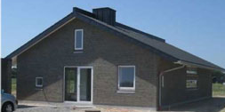 |  | Figure 1:  The picture shows  an example of a  traditional brick  house |  | Figure 2:  The illustration  shows an example of  a traditional brick  solution. The inner  wall thickness is  increased along the  head and jambs wherein the window  is fixed
a (mm) | Ψ (W/mK) | Table 1:  The linear thermal  transmittance  of constructions  with different  insulation thickness between the  rebate and wall  as illustrated  in Figure 3
10 | 0.157
20 | 0.111
40 | 0.067
60 | 0.046 |  |  | Figure 3:  Illustrates the  insulation thickness  (a) between the  rebate and the wall
80 | 0.036
100 | 0.030
120 | 0.027

- Construction, mounting and replacement
The inner wall of a brick construction is normally the load bearing part and it is connected to the outer wall by wall ties with a radius of typically 3-4 mm. The outer wall thickness is often increased along the head and jambs – a window rebate, which constitutes a solid base for fixing and sealing the window [SBI 189 1999]. The insulation thickness between the rebate and wall is typically about 30 mm, if larger it can be difficult to mount the window.
- Architectural expression
The Danish tradition is to place the window outermost in the façade. It gives an architectural expression outside of the wall and window as one surface and the windows only articulate themselves very little. At the same time the tradition and wishes are to have very slender window frames, which give a light and pure expression as well as a less disturbed view to the outside. In most cases the windows open outwards.
- Linear thermal transmittance
The linear thermal transmittance for a construction like that in Fig. 2 is about 0,1 W/mK. By increasing the insulation between the rebate and wall (a) the linear thermal transmittance becomes smaller, as shown in Tab. 1. In a passive house it is recommended to build so-called thermal bridge-free constructions, where the linear thermal transmittance is less than 0.01 W/mK. This means that it is not possible to use the traditional Danish solution shown above as a thermal bridge-free construction. The illustrated example shows in Tab. 1 that it is not possible to lower the linear thermal transmittance to the necessary level without making radical changes to the construction and mounting of the window.
- A passive Danish brick house
The construction solution in Brick 1 is solved respecting the Danish tradition, but some modifications are made to construct a more energy efficient solution with a smaller linear thermal transmittance. (See details in Fig. 4)
- Construction, mounting and replacement
The wall construction consists of an inner and outer wall of brick, with insulation in between. The wall has an average U-value of 0.1 W/(m²K). To avoid a decrease in the insulation thickness and minimise the linear thermal transmittance, the wall is built without a rebate, unlike the tradition solution. What is special is that the outer wall is displaced compared to the inner wall. The window is fixed to the wall by fittings mounted on the inside of the outer wall. After the fittings have been mounted the window can be installed. At the same time the vapour barrier is taped and jammed between the frame and the inside of the last brick on the top and at the sides. At the bottom it is taped and jammed between the frame and the window sill. It is still possible to mount the window at the inside of the outer wall when both walls are built because the cavity between them is in this case 360 mm, which makes it possible to access the inside of the walls with hands and tools. When the window is put in and fixed to the fittings the remaining insulation can be put into the wall. In the end the vapour barrier is taped to the inside of the inner wall and finally covered with a lining which also jams the vapour barrier to the wall and makes the construction airtight. Later when there is a need to replace the window you have to take off the lining and take the insulation out of the construction around the window to be able to reach the fittings.
- Architectural expression
The idea has been to place the windows as near as possible to the façade, as in the appearance of a traditional brick house, but the linear thermal transmittance had to be better. The solution in this case is to let the brick wall cover the frame. In this way the frame seems more slender from the outside and relates to the traditional slender frames in regular Danish windows, yet it is not possible at the bottom because water has to be led away. The solution results in having windows which open inwards, which is rare in a Danish context. From the inside the full size of the frames will be visible. This will make the view to the outside seem reduced and less clear.
The windows are only slightly marked in the façade as the traditional expression of a brick house. It makes the façade seem like a plane surface. If more windows are placed next to each other the wall still seem uniform because the jump in the façade will be very small. Practically the placement provides more sill space inside, because the passive wall constructions are thicker than usual. It could e.g. be an extension of the kitchen table or become a sitting space if the sill height is low. The placement also result in more passive solar heat gain, because very little overhang will create shadows. When having deep walls as in passive houses the inner finish should be kept in light colours for daylight to reflect into the rooms.
- Linear thermal transmittance
The window is placed in the insulation and results in an average linear thermal transmittance of 0.021 W/mK. This value is greater than the 0.01 W/mK recommended to avoid thermal bridges. Therefore it will be interesting to investigate some variations of the Brick 1 solution. If the linear thermal transmittance is improved, what are the architectural consequences? How will the window be mounted and insulated?
- Variations of the Brick 1 solution
In countries like Germany, Austria and Switzerland it is common to insulate the frame from the outside and thereby minimize the linear thermal transmittance. The following three variations of the placement of the window in a brick construction will be described and evaluated based on the concept of insulating the frame.

Figure 4: The different construction solutions.

 | Brick 1 | Brick 2 | Brick 3 | Brick 4
Placement | 0 mm | 115 mm | 230 mm | 0 mm
Insulated frame | No | Yes | Yes | Yes (inside, all around)
Av. Ψ (W/mK) | 0.020 | 0.009 | 0.008 | 0.000

Table 2: The table shows the linear thermal transmittance for different variations of the Brick 1
solution. Av. Ψ is an average value of the linear thermal transmittance around the
window and with the fittings (2 %)
- Construction, mounting and replacement
Brick 2: In this solution the window is moved into the middle of the wall. This means that the space between the displaced wall and window frame is filed with insulation and e.g. covered with a fibre cement board. The window is mounted with special developed fittings that are fixed in the window opening of the inner wall (see Fig. 5). The bottom of the window is supported by consoles which are fixed down 3 courses with a threaded bar. The distance for the fitting has a limit of 150 mm, meaning the distance between inner wall and window. The vapour barrier is taped and jammed between the frame and the inner lining. When replacing the window you need to take both linings and insulation in front of the frame out of your construction and put in a new window with fittings.
Brick 3: The solution is constructed the same way as Brick 2. The only difference is that the insulation in front of the frame has a greater depth.

Figure 5:
The drawing illustrates
the principle of mounting the window of Brick 2
and Brick 3

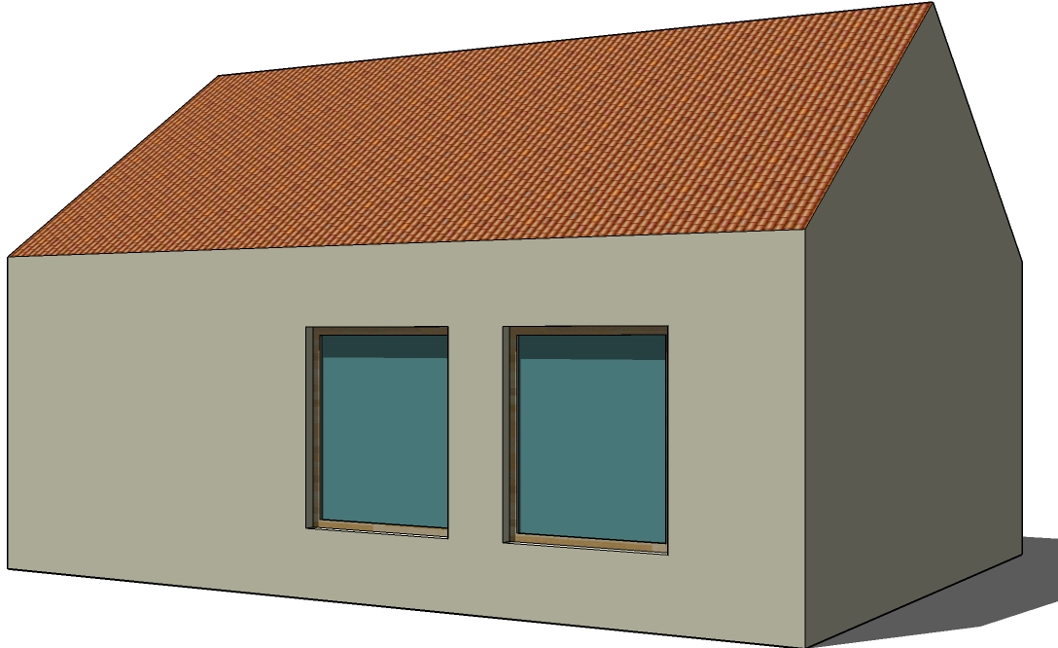

Brick 1

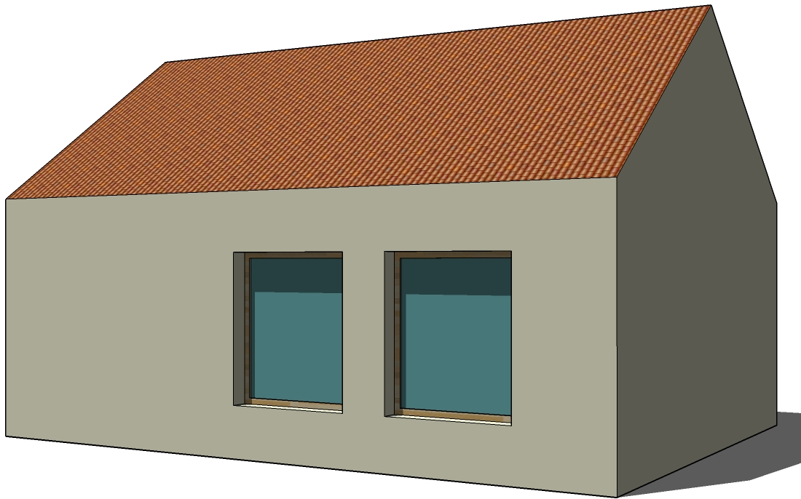

Brick 2

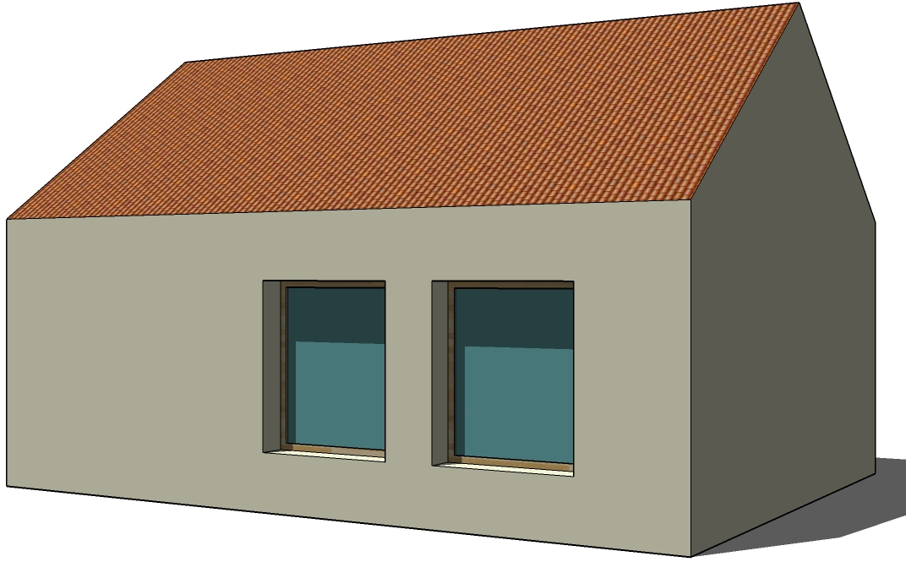

Brick 3

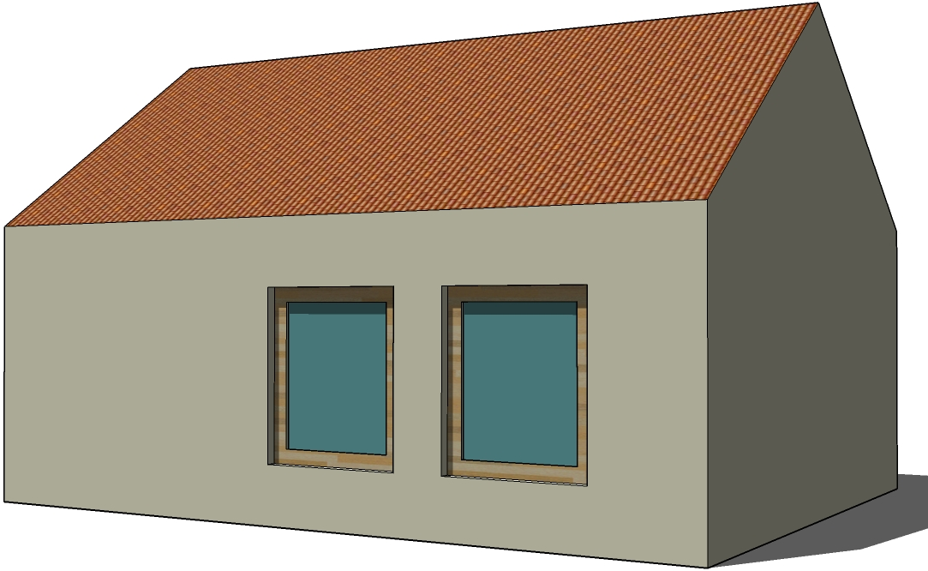

Brick 4

Figure 6:
The illustrations show
the principal in the of
different architectural
expressions
Brick 4: As desired in connection to the Danish tradition the windows open outwards in this solution. It means that the frame is insulated inside instead of outside. It also means that the displacement of the walls should be opposite as in Brick 1. The window is mounted and sealed the same way as Brick 1.
- Architectural expression
Brick 2: When pulling back the window the wall depth creates shadows on the outer façade which enhance the wall. The depth makes the wall seem more like a mass instead of a surface, or if you repeat the window the wall between them can seem like columns. On the other hand this expression might be weakened by the outer lining which in this case will be made of another material than bricks e.g. fibre cement board. In connection to daylight the colour of the outer lining can also have a big influence on the interior. The depth of the wall can work as solar shading and prevent overheating in summer. A window that is pulled back is more unusual in Denmark, therefore this solution is understood as less Danish and breaks with the traditional expression.
Brick 3: Again as in Brick 2 the shadows that the depth of wall is creating are also in this situation enhancing the wall form outside, and the colour of the outer lining will have even more influence on the daylight conditions inside because it is much deeper. By placing the window so far back in the construction it will have a big influence on the whole expression of the house. It will become a primary feature in the expression, which will be very misplaced in a typology like this – a brick house with saddle roof (see Fig. 6). Windows which are placed very deep create associations with architecture from hotter climates where the need is to keep the heat out, and that is primarily not the case in Denmark.
Brick 4: The only distinction between the expression of Brick 1 and Brick 4 is that the frame is seen as slender from the inside instead of from the outside. It gives you a more undisturbed view to the outside but gives a clumsier expression to the building from outside.

- Linear thermal transmittance
Tab. 2 shows the different calculated linear thermal transmittances. As expected, the more you insulate the frame the smaller the linear thermal transmittance of the solution becomes. Brick 4 has the lowest value because the frame is insulated all the way around and because of the different conductivity of the linings inside and outside in this situation. If one follows the recommendations and makes thermal bridge-free constructions the right solutions for this passive brick house would be to use either Brick 2, Brick 3 or Brick 4, all of which fulfil the value of 0.01 W/mK.
- Conclusion
It is one thing is to choose the solution with the best linear thermal transmittance, but do any of the solutions fulfil the structural or architectural requirements for the building? That is up to the designer to answer. Should the building express itself as a mass? Is it acceptable to have large frames exposed to the outside? This study has outlined the different consequences, and it shows that the detailing does indeed have a big impact on the whole concept and typology of the building. Therefore it is important to keep this in mind from the beginning of the design process. It is important is to produce solutions which are good both technically and at the same time architecturally, to avoid making bad compromises in the building design.
The author will not dictate what solutions are right or wrong, but maybe the future expression of a passive house might not look like the traditional Danish brick house. Maybe the future has its own architectural style called passive style? Or perhaps we need to develop new products to be able to keep the traditional expression we know, by developing new window designs especially in connection with large window frames. Then the Brick 4 solution could become a good architectural solution.
- Referneces
[Bek 1997] | Bek, Lise, Rum analyser, p. 24-28 (1997)
[http://windows.lbl.gov] | [http://windows.lbl.gov/software/therm/therm.html]
[EN ISO 10077-1 & 2 2006] | Thermal performance of windows, doors and shutters – calculation of thermal transmittance, part 1 & 2 [2006]
[SBI 189 1999] | SBI 72189 - Single family houses, p. 50-53 (1999)
[www.komforthusene.dk] | [www.komforthusene.dk]

