CHAPTER 77

ACTIVE VIBRATION CONTROL OF HYSTERETIC OSCILLATORS USING NEURAL NETWORKS

H.I. Hansen, S.R.K. Nielsen & P. Thoft-Christensen

Aalborg University, Aalborg, Denmark

ABSTRACT
This paper deals with active vibration control of single degree-of-freedom (SDOF) hysteretic oscillators, where it is assumed that only the displacement and the velocity of the oscillator may be observed whereas the hysteretic component is hidden. Hence, Incomplete Stare Observation is assumed. A partially recurrent neural network, structured as a Multi Layer Perceptron (MLP) neural network is trained to estimate the response of the oscillator. The identified model is the well-known Innovation State Space Model and the identification is based on known measurements of the loading, the displacement and the velocity, so in fact the Extended Kalman Filter problem is solved. The closed-loop controller is also modelled as a MLP partially recurrent neural network, which is trained in a way that the mean square of the responses of the oscillator is minimized. The method has been applied to a Bouc-Wen oscillator subjected to Gaussian white noise filtered through a Kanai-Tajimi filter. The output of the filter is assumed to be observed and forms the input to the system.

1 INTRODUCTION
The idea of using automatic control systems to reduce the response of civil engineering structures has been actively pursued by several researchers since it was proposed by Yao (1972). Much of the theory applied by civil engineering researches is rooted in classical and modern control techniques, which basically have been developed within the aerospace, electrical, and mechanical fields, see e.g. Soong [8].
The actual control process is initiated by sensors placed at strategic points on the structure. These sensors measure the appropriate structural response, and this information is then used to compute the feedback control forces. One well-known technique for state space estimation for control purpose is the Extended Kalman Filtering (EKF) technique; see e.g. Thesbjerg [13]. Although the EKF has been successfully used in applications, it is known that the EKF might show poor convergence properties in certain cases. The estimates may be biased and even divergence may occur. Further, the computation time required for convergence, if at all, increases quadratic with the number of degree-of-freedom of a structural system. However, the main problem with the state space estimation techniques is the extensive computing which is necessary to convert; the raw measured response data to control forces, i.e. real-time control dose not seem to be feasible and cost effective due to the computing time and resources to individual structures. It should also be mentioned that one has to do assumptions when using the traditional structural control algorithms. The assumptions that limit the accuracy of the solution are that the real structure, material, sensors, and actuators do not behave exactly as their mathematical model, i.e. that the model is controlled in stead of the rea1structure.
In order to overcome the mentioned problems much research has been done in the field of active control based on artificial neural networks. Artificial neural networks have been investigated for control of complex nonlinear systems with applications to model the nonlinear behaviour of the system, from which a control algorithm can be developed or through learning, to develop and represent the control algorithm. A survey of artificial neural networks in the realm of modelling, identification, and control of nonlinear systems is given in Hunt et al. [3]. Artificial neural networks have been used for process control in different fields such as biological and electrical systems see e.g. Hunt et at. [3]. However, in the area of structural control only few investigations have been done. Doo et al. [1] use an artificial neural network control algorithm to suppress vibrations in linear single degree-of-freedom systems subjected to dynamic loadings. Miccoli et at. [4] estimate the state in the problems of noise and vibration active control using artificial neural networks. In Rehak & Garrett [6] the applicability and use of neural computing for structural control is discussed.
The aim of this paper is to investigate the possibility of using artificial neutral networks to estimate the response of a single degree-of-freedom hysteretic oscillator for incomplete state observations. The ability of the neural network to act as and simulator is investigated. Further, the performance of the neural network controller is investigated for incomplete state observation. The response of a single-degree-of-freedom hysteretic oscillator is described in Section 2. In Section 3 the principle of the Multi Layer Perceptron neural networks used to estimate the response of the oscillator and to estimate the control force is shown. Neural network models of the hysteretic oscillator and the closed-loop controller are formulated in Section 4 and 5, respectively. As an example in Section 6 the neural network models are applied to a Bouc-Wen oscillator subjected t0 Gaussian white noise filtered through a Kanai-Tajimi filter. Conclusions and references are given in Section 7 and 9, respectively.

2 SINGLE DEGREE-OF-FREEDOM HYSTERETIC OSCILLATOR
A linear single degree-of freedom hysteretic oscillator is described by the stochastic differential equation, see e.g. Suzuki & Minai [10]
(1)
X(t) is the displacement, is the velocity, is the acceleration, and F(t) is the excitation. is the damping ratio and is the circular eigenfrequency of the corresponding linear oscillator. is the elastic fraction of the restoring force. Z(t) is the hysteretic component of the restoring force, which is assumed to be modelled by the Bouc-Wen model, see Wen [14]
(2)
n is a parameter, which controls the level of non-1inearity. If, z₀ can be interpreted as the yield displacement of the oscillator.
(1) and (2) can be written on state vector form
(3)
(4)
Normally, the state variables X(t) and can be observed, whereas Z(t) is non-observable (hidden). Assuming the excitation F(t) is constant at the value throughout the interval [t_{k-l}, t_{k}[, where , (3) can then be integrated on the following form
(5)
where. The Vector function is a non-linear and non-analytical function of X_{k-l} because of the non- analytical constitutive relation (2).
A neural network model of (5) involves in principle a replacement of by all analytical function. It is one of the aims of this paper to investigate the limits of such all approximation.

3 NEURAL NETWORKS
The neural networks are structured as Multi Layer Perceptron (MLP) neural Networks containing:
- All input layer of n_{l} neurons with linear neuron functions without offsets.
- A fictive input layer with one neuron with constant value “1“.
- A hidden layer with a sufficient number of neurons n_{H} with non-linear functions including offsets. The offsets are organized by adding the fictive input neuron. The non-linear function used is the tanh-function. The necessary number of hidden neurons can be found by trial and error.
- All output layer of n_{O} neurons with linear neuron functions without offsets.
There are connections between the n_{l} input neurons and all hidden neurons, with weights w_{hi}. In the same way there are connections between all hidden neurons and all output neurons, with weights w_{oh}. Further, there are connections between the fictive input neuron and all hidden neurons, with weights w_{h0}.
The output of the network can be calculated by feedforward based on the weights and the input to the network. The output O_{o} of the o'th neuron in tile output layer is
(6)

4 MODELLING OF HYSTERETIC OSCILLATOR BY NEURAL NETWORKS
A neural network model of the hysteretic oscillator described by (5) is formulated by a Non-linear Innovation State Space Model where p state variables are observed, see Sørensen [11]
(7)
(8)
is the estimate of the state vector at time step k and is the prediction error vector of order p at time step k. w is a vector of weights in the MLP network. Y(k) is the measured observation vector of order p at time step k. H is the observation matrix of order .
Incomplete State Information may occur, i.e., is not completely measurable. The matrix H can be chosen to , where 1_{p,p} is a unity matrix and 0_{p,3-p} is a zero matrix. In this way the elements in are equal to the first p elements of. For the hysteretic oscillator the number of observed states p can then be p = 1 if only the displacement X(k) is observed, p = 2 if the displacement X(k) and the velocity X(k) are observed and p = 3 if all three state variables X(t), and Z(t) are observed. The net is a partially recurrent network as output from the net is used as input in the next step.

4.1 Training of Neural Network
The weights w in the neural network given by (7) are found by training. The training set consists of N input time series, each of length K. Feedforward as described by (6) is used to estimate the output of the network. There are several methods for updating the weights w, see e.g. Hertz et at. [2].
Let E(n,k,w) be, the error vector between the estimates and measurements of the nth training time series at the kth time step. The following performance index J(w) is minimized
(9)
The gradient of J(w) with respect to the weights w is needed as search direction in the iteration scheme. This is calculated from
(10)
The gradient of the estimated state variables with respect to the weights w can be updated from the recursive equation
(11)
where
(12)
, , and can be found by differentiation of the output of the network in (6) with respect to the weights and input. and can be interpreted as the dynamic transfer matrix of an equivalent linear system and the corresponding extended Kalrnan filter gain, respectively.

4.2 Simulation and State Prediction by Trained Neural Network
When the trained neural network given by (7) is used as a simulator only the initial values Y(0) = HX(0) of the measurable state variables and the complete excitation time series F(k) are measured without any error, The non-observed state variables are set to 0 to obtain the initial values X(0) = X₀. As no further measurements of the state variables are made the prediction error vector E(k) is fixed to 0. The state variables in the simulator neural network are predicted by
(13)
When the trained neural network is used as a one-step ahead predictor the masureable state variables Y(k) = HX(k) and the excitation F(k) are measured at every time step. In this case the state variables are predicted by
(14)

5 MODELLING OF ACTIVE CONTROLLER BY NEURAL NETWORKS
After the model of the hysteretic oscillator (7) has been settled, an active closed-loop controller is coupled to the system. The control force C(k) is used to minimize the mean square of the observable part of the response X(k) of the hysteretic oscillator. It is assumed that the total excitation of the oscillator can be written F(k) + C(k). In the final active closed-loop control configuration the neural network model of the hysteretic oscillator is used as a one-step ahead predictor to estimate the state vector to the next time step. The control force can then be estimated by the controller network based on the estimated state variables.
Because no state variables can be measured during training of the controller neuural network the trained network given by (7) is used as a simulator to estimate the response of the controlled oscillator. Hence
(15)
The control force C(k) is modelled by a MLP neural network by using closed-loop control
(16)
where w_{c} is a vector of weights in the network modelling the controller. Obviously, the feedback part of the control law can only depend on the state variables which are measured (observed), and no noise term is present in the model.
The weights w_{c} of (16) are estimated, so the response predicted by (15) becomes minimum. At the training the same input time series F(k) are used as applied at the training of the neural network (7).

5.1 Training of Neural Network
The following performance index, which is widely used in structural control, see e.g. Soong [9], is minimized for the controller network (16)
(17)
(18)
where a is a positive scaling factor and specifies the output of (15) for the nth time series at the time step k using the controller (16) with the weights w_{c}.
The gradient of with regard to the weights w_{c} is
(19)
The gradient of the estimated state variables and the control forces with respect to the weights organized in the vector w_{c} can be updated from the recursive equations, cf. (11)
(20)
(21)
where
(22)
As seen the gradient is no longer dependent on variations of the observation noise, because this has been fixed to E = 0 during the training phase.

6 EXAMPLE
Corresponding relations F(n,k) and X(n,k) between the excitation process and the response process are obtained by numerical integration of (3). Realizations of the excitation process are obtained by filtering non-stationary white noise through a Kanai- Tajimi filter. The excitation process is then obtained from the stochastic differential equations, see Tajimi [12]
(23)
(24)
F(t) can then be interpreted as the negative of the ground surface acceleration, and andare the damping ratio and circular eigenfrequency of a single degree-of-freedom shear model of the underlying subsoil. {W(t), }is unit intensity white noise with the auto-spectral density function . The deterministic modulation function is given as follows; see Saragoni & Hart [7])
(25)
The amplitude r₀ defines the strength of the excitation. This is selected so the peak value of all excitations is normalized to 0.5g, where g is the acceleration of gravity, t₁ and t₂ are respectively the instants of time of maximum intensity and the time where the intensity has dropped to half value. The following parameters are used for the hysteretic oscillator:
Three input-output time series are generated. The first two of these, labeled A and B are for training. The last one labeled C is selected for verification. The displacement responses of cases A, B, and C are classified as small, large and medium. The minimum and maximum of the displacement x, the velocity and the hysteretic component z are shown in Table 1.
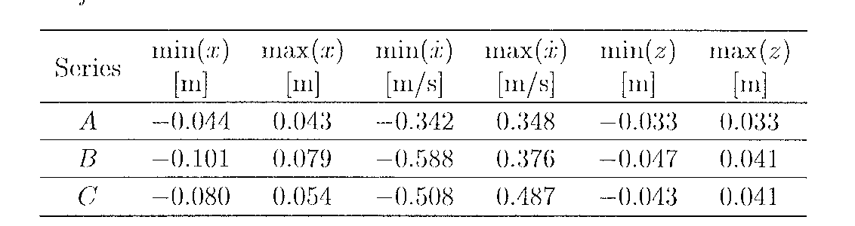
Table 1: Minimum and maximum values for data
series used for training and verification.

In this example the Broyden-Fletcher-Goldfarb-Shanno variant of the Davidon-Fletcher-Powell minimization algorithm, see Press et al. [5], is used to minimize the performance indices J(w) and J_{c}(w_{c}) with respect to the w and w_{c}. As stop criteria the performance index for case C is evaluated. When this index increases the network is overtrained. So the optimal neural network weights are obtained when the performance index has minimum for case C.
During training of the neural networks the input variables are scaled so the mean value of each variable is “0” and the standard deviation is “1”, Thereby, the components of the performance indices are of the same properties,
A MLP neural network is trained with the two training cases A and B. During training incomplete state observation is assumed with p = 2, i.e. the displacement and velocity are observed and the hysteretic component is hidden. The ability of the trained neural network to act as a simulator is shown in Fig. 1 where the displacement for case C (with minimum displacements) is shown. As seen the trained neural network is capable of approximating the non-linear and non-analytical vector unction (5) very well when it is taken into account that only two of the three state variables are observed and that the neural network is trained with two time series with smaller and larger displacements, respectively.
Next, active control of the oscillator is considered. The trained MLP neural network is used to estimate the response of the oscillator. A MLP neural network is trained with cases A and B to estimate the weights of the controller network (16). In Fig. 1 the measured displacement, the estimated uncontrolled displacement (estimated by the trained neural network acting as simulator) and the estimated controlled displacement are shown. For simplicity a = 0 has been used in (17). Thereby, there are no limits on the applied control force. As shown in Fig. 1 the neural network controller is able to decrease the displacement of case C significantly.
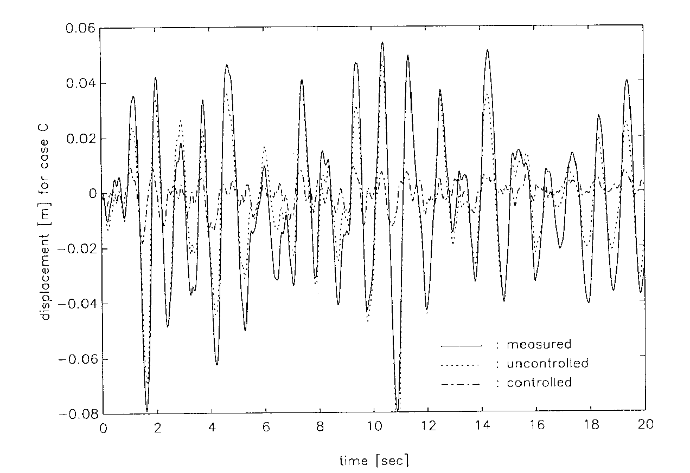

Fig. 1: Measured, uncontrolled and controlled displacement for case C.

7 CONCLUSIONS
In this paper the ability of a partially recurrent multi layer perception neural network to model the response of a single degree-of-freedom hysteretic oscillator is investigated. It is assumed that the displacement and the velocity of the oscillator at the previous time step can be measured whereas the hysteretic component is non-observable. The neural network trained with two time series with relatively small and large displacements of the oscillator shows a very good ability of simulating the displacements of the oscillator for a time series with medium displacements. Therefore, it seems possible to approximate the non-linear and non-analytical vector function modelling the response of the hysteretic oscillator by a neural network, i.e. an analytical function.
The ability of a neural network to model an active closed-loop controller of a hysteretic oscillator is next investigated. It is assumed that there is no limit on the applied control force. Again the time series with the relatively small and large displacements are used for training. During training the already trained neural network is used to simulate the response of the oscillator. The trained neural network controller is capable of reducing the displacements of the oscillator significantly when applied to a time series with medium displacements.
By using neural networks for real-time control the large computing time that usually is necessary for one-step ahead prediction of the response and determination of the control forces can be omitted as feedforward in a trained neural network is very fast. The neural networks can be updated by training, this may require a large computing time, but it can be performed off-line. Another advantage of using neural networks for control is that the neural network modelling the response can be trained with “real” data from measurements, thus a non-linear model of the real structure is controlled - not a mathematical model with assumptions about the behaviour of the structure, material, sensors and actuators.

8 ACKNOWLEDGEMENT
The present research was partially supported by The Danish Technical Council within the research program on Safety and Reliability.

9 REFERENCES
[1] Doo, L.B., C.R. Thewalt & D.R. Rehak. Neural Networks for System Identification and Pulse Control of Linear Systems. Technical Report, Department of Civil Engineering, Carnegie Mellon University, Pittsburgh, PA, 1989.
[2] Hertz, J., A. Krogh & R.G. Palmer. Introduction to the Theory of Neural Computation,. Addison-Wesley, Redwood City, CA, USA, 1991.
[3] Hunt, K.J., D. Sbarbaro, R. Zbikowski & P.J. Gawthrop. Neural Networks for Control Systems - A Survey. Automatica, Vol. 28, No.6, 1992, pp. 1083-1112.
[4] Miccoli, G., A. Concilio & L. Lecce. Research Activity on Noise and Vibration Active Control by Piezoceramic Transducers. Proceedings of the 12th International Modal Analysis Conference, 1994.
[5] Press, W.H., B.P. Flannery, S.A. Teukolsky & W.T. Vetterling. Numerical Recipes in C. Cambridge University Press, 1988..
[6] Rehak, D.R., & J.H. Garrat, Jr. Structural System Control using Neural Networks. Proceedings of the Eighth Conference on Computing in Civil Engineering, ASCE, Dallas, TX, USA, 1992.
[7] Saragoni, G.R. & G.C. Hart. Simulation of Artificial Earthquakes. Earthquakes Engineering Structural Dynamics, Vol. 2, 1974, pp. 249-267.
[8] Soong, T.T. Active Structural Control in Civil Engineering. State-of-the-art Review. Engineering Structures, Vol. 10, No.2, 1988, pp. 74-84.
[9] Soong, T.T. Active Structural Control. Theory & Practice. Longman Scientific & Technical, 1990.
[10] Suzuki, Y. & R. Minai. Seismic Reliability Analysis of Hysteretic Structures Based on Stochastic Differential Equations. ICOSSAR '85, Proceedings of the 4th international Conference on Structural Safety and Reliability, Vol. 2, 195, pp. 177-186.
[11] Sørensen, O. (1994). Neural Networks for Non-Linear Control. Proceedings of the 3th IEEE Conference on Control Applications, Glasgow, 1994, pp. 161-166.
[12] Tajimi, H. (1900). A Standard Method of Determining the Maximum Response of a Building Structure during ag Earthquake. Proceedings of the 2nd World Conference on Earthquake Engineering, Tokyo, Vol. 2, 1900, pp. 781-797.

[13] Thesbjerg, L. Optimal Vibration Control of Engineering Structures. Ph.D. Thesis, Aalborg University, Aalborg, Denmark, 1992.
[14] Wen, Y.K. Method for Random Vibration of Hysteretic Systems. Journal of the Engineering Mechanic Division, American, Society of Civil Engineering, Vol. 102, No. EM2, 1976, pp. 249-263.
[15] Yao, J.T.P. Concept of Structural Control. Journal of the Structural Division, Vol. ST7, 1972, pp. 1567-1574.

Proc. 11th World Conf. on Earthquake Engineering, Acapulco, Mexico, June 23-28, 1996. CD, Paper, no. 1266.

