**Evaluation of *in vivo* Wear of Vitamin E Stabilized Highly Cross-linked Polyethylene at Five Years: A Multicenter, RSA Study**

Vincent Galea, BAa, James Connelly, BAa, Bita Shareghi, PhDc,

Johan Kärrholm, MD, PhDc, Olof Sköldenberg, MD, PhDd, Mogens B Laursene, MD, PhD, Orhun Muratoglu, PhDa,b, Charles Bragdon, PhDa,b, Henrik Malchau, MD, PhDa,b

a Harris Orthopaedic Laboratory

Massachusetts General Hospital

55 Fruit St. GRJ 1231, Boston, MA 02114

b Harvard Medical School

Department of Orthopaedic Surgery

25 Shattuck St., Boston, MA 02115

c Institute of Clinical Sciences at Sahlgrenska Academy

Department of Orthopaedics

University of Gothenburg, Gothenburg, Sweden

d Karolinska Institutet

Department of Clinical Sciences at Danderyd Hospital, Unit of Orthopaedics

SE-182 88 Stockholm, Sweden

e Aalborg University Hospital

Department of Orthopaedics

Hobrovej 18-22, Aalborg, Denmark

**Corresponding Author:**

Henrik Malchau, M.D., Ph.D.,

Orthopaedic Department,

Massachusetts General Hospital

55 Fruit Street, GRJ 1126

Boston, Massachusetts 02114-2696

E-mail: hmalchau@mgh.harvard.edu

Tel: 617.726.3866

Fax: 617.726.3883

# **Abstract**

### **Background**

The primary purpose of the current study was to evaluate and compare the wear properties of vitamin E-doped, highly-crosslinked PE (VEPE) and one formulation of moderately cross-linked and mechanically-annealed ultra-high molecular weight PE (ModXLPE) in patients five years after primary THA. We also sought to understand whether polyethylene wear is associated with radiographic evidence of bone resorption or with deterioration in patient-reported outcome measures (PROMs).

### **Methods**

A total of 230 patients from four international centers were recruited into a prospective RSA and clinical outcomes study. Seventy-six percent (76%) of patients received VEPE (vs. ModXLPE) liners, and 36% received ceramic (vs. metal) femoral heads. PROMs and radiographs were collected preoperatively and at one, two, and five years postoperatively. In addition, RSA radiographs were collected to measure PE wear.

### **Results**

We observed similar bedding in through the one-year interval and wear through the two-year interval between the two liner types. However, there was significantly more femoral head penetration in the ModXLPE cohort compared to the VEPE cohort at the five-year follow-up (p<0.001). The only variables independently predictive of increased wear were ModXLPE (vs VEPE) liner type (β=0.22, p=0.010) and metal (vs. ceramic) femoral head type (β=0.21, p=0.013). There was no association between increased wear and radiolucency development (p=0.866) or PROMs. No patients were found to have evidence of osteolysis.

### **Conclusions**

At five-years postoperatively, patients treated with VEPE (vs. ModXLPE) and ceramic (vs. metal) femoral heads demonstrated decreased wear. At the longest follow-up (five years postoperatively), the wear rates for both liner groups were very low and have not led to any osteolysis or implant failures via aseptic loosening.

# **Introduction**

Osteolysis secondary to bearing surface wear has been identified as the leading reason for late-term implant failure via aseptic loosening in patients treated with metal-on-polyethylene (MoP) total hip arthroplasty (THA)1,2. The wear of the polyethylene (PE) bearing surface is primarily associated with the PE manufacturing process and patient factors. During the past two decades, advancements in PE manufacturing, namely PE crosslinking, have led to a dramatic decrease in revisions due to peri-prosthetic osteolysis secondary to polyethylene particulate debris3,4.

PE crosslinking is achieved by irradiating the polyethylene at a dose higher than the normal sterilization dose of approximately 25kGy5. This process induces the formation of covalent bonds between the PE polymer chains (crosslinks), which result in increased wear resistance6. However, the resulting polymer (radiation crosslinked PE) has a high free radical content and is therefore susceptible to oxidation, which leads to embrittlement and decreased wear resistance in the long term. One method used to increase oxidative stability is annealing. This method reduces the free radical content at a temperature below the melting point of the material7. Annealing may be thermal (heating below the melting point) or mechanical (hydrostatic extrusion). Mechanical annealing involves deformation of the irradiated material at a constant temperature. This process increases the free radical mobility in the crystalline domains through crystal plasticity, thereby facilitating their recombination and resulting in further crosslinking. Annealing maintains mechanical strength, but some free radicals remain trapped within the crystal domains of the material8.

An alternative approach is chemical stabilization using a free radical scavenger, such as vitamin-E (α-tocopherol). Vitamin-E can be either blended into the PE before irradiation, or diffused into a radiation crosslinked-PE9. Vitamin-E prevents the propagation of the oxidation cascade, even though the free radicals are still present10. Vitamin-E stabilization enhances the long-term oxidative resistance of crosslinked-PE while allowing the crosslinked-PE to retain its mechanical properties11–13. In 2007, vitamin E-doped crosslinked-PE (VEPE) was cleared by the FDA for clinical use in THA12. Currently, most major orthopedic manufacturers have a variation of VEPE on the market,11 and early follow-up of VEPE in THA has been promising14–16.

The primary purpose of the current study was to evaluate and compare the wear properties of VEPE to one formulation of moderately cross-linked and mechanically-annealed ultra-high molecular weight PE (ModXLPE) using radiostereometric analysis (RSA) in patients five years after their primary THA procedure. We also sought to understand whether polyethylene wear is associated with radiographic evidence of bone resorption (radiolucency or osteolysis), with deterioration in patient-reported outcome measures (PROMs), or with both.

# **Materials and Methods**

### **Patients and Implants**

A total of 230 patients from four international centers were recruited into a prospective RSA and clinical outcomes study (Table 1). The patients were diagnosed with primary osteoarthritis and subsequently treated with THA. All data were anonymized and uploaded to an academic coordinating research organization (ACRO) via secure online transfer. All patients signed an informed consent form prior to enrollment, and the study protocols were approved by the local investigational review boards (IRBs).

Patients were treated with implants from a single manufacturer (Zimmer Biomet, Warsaw, IN, USA). Seventy-six percent (76%) of patients were treated with highly-crosslinked (95 kGy) VEPE liners (E1™). The remaining patients received moderately cross-linked (50 kGy) (ModXLPE), mechanically-annealed liners (ArCom XL™). The stages involved in the production of these liners are outlined in Figure 1. Two centers (158 patients) randomized patients by liner type, while the other two centers (72 patients) implanted only VEPE liners. Two types of press-fit acetabular shells were used: (i) three centers (160 patients) used a porous titanium coated shell (average porosity of 67%) (Regenerex™), and (ii) one center (70 patients) used a plasma-sprayed shell (average porosity of 45%) (Ringloc™). Ninety-three percent (93%) of patients received a 32mm femoral head (vs. 36mm), and 64% received a metal (CoCr) femoral head (vs. ceramic (Biolox Delta™, CeramTec GmbH, Plochingen, Germany)). The stem design was selected at the discretion of each surgeon. The surgeries were performed by a total of 14 surgeons across the four centers. Either the anterolateral or posterolateral approach was used based on surgeon preference. Patient and implant variable summaries are shown in Table 2.

### **Clinical Follow-up Data and Analysis**

PROMs and plain radiographs were collected preoperatively and postoperatively at one-, two-, and five-year intervals. Hip function was assessed using the Harris Hip Score17 (0 = worst outcome; 100 = best outcome) and the Physical Function sub-score (0 = lowest; 100 = highest) of the Short Form Health Survey (SF-36)18. Average pain experienced during the past month due to the arthroplasty procedure (0 = no pain; 10 = worst imaginable) and satisfaction with the arthroplasty procedure (0 = very satisfied; 10 = dissatisfied) were assessed with a visual analogue scale (VAS). Overall health-related quality of life was assessed using the EuroQol five-dimension, three-level (EQ-5D-3L) Index19.

Postoperative radiographs were analyzed for component positioning using the Hip Analysis Suite software (University of Chicago, IL, USA) (Martell method)20. Acetabular radiolucency and osteolysis were assessed postoperatively and at the five-year follow-up interval by three trained and validated orthopedic surgeons at the ACRO, each with at least four years of experience analyzing radiographs. Inter-reader reliability was high (κ > 0.9). All radiolucent appearances were measured using the mDesk software (RSA Biomedical, Umeå, Sweden). A radiolucent line measuring ≥ 0.5mm in thickness that was present at the postoperative radiograph was defined as a “gap”. If such a radiolucent line appeared for the first time at the five-year follow-up, it was defined as “radiolucency”. A radiolucent line found on the five-year radiograph and measuring ≥ 2.0mm in thickness was also classified as osteolysis.

### **RSA**

RSA radiographs, taken postoperatively and at one-, two-, and five-year intervals, were used to quantify polyethylene wear. The images were taken with the patients in the supine position and the hip of interest centered within the uniplanar calibration cage (cage 43, RSA Biomedical). Precision measurements were calculated by all four centers using double examinations, and the mean error (ME) tolerance was set at 0.35mm21.

The UmRSA 6.0 software package (RSA Biomedical) was used to analyze the movement of the femoral head in the proximal-distal plane (proximal femoral head penetration), which was considered the primary RSA metric in this study21. Total wear is presented as the five-year penetration compared to the first postoperative film (< six months from surgery), and the steady state wear rate was calculated by comparing the five-year penetration to the two-year penetration in order to account for the bedding-in period.

### **Statistics**

The Wilcoxon signed-rank test was used to assess the change in wear for each liner group from the first to second and second to fifth postoperative year. Univariate analyses (Student’s T-test or Mann-Whitney U test depending on normality distribution) were used to identify factors associated with total wear at five years. Additionally, multivariate analysis was used to identify factors independently predictive of increased wear at five years; in addition to liner type, other factors that have been postulated to contribute to polyethylene wear were included in a linear regression. These variables included acetabular inclination, anteversion, femoral head size, femoral head material, shell type, and body mass index (BMI)(kg/m2). The backward elimination method was used to reach parsimony. A Mann-Whitney U-test was used to assess the association between wear and five-year radiolucency development, and chi-squared analysis was used to test the association between five-year radiolucency development and liner and shell type. The differences in PROMs between the two liner groups were assessed by using the Mann-Whitney U test and via linear regression, controlling for age and sex. Finally, analyses were performed to assess for possible inter-center differences in patient follow-up and demographics (Table 1).

# **Results**

### **Patient Follow-up**

A total of 194 patients (84% of enrolled) completed their five-year follow-up visit and had their data uploaded to the ACRO. The mean time to the five-year visit was 4.9 years (range, 4.1-5.5 years). Six patients were revised prior to the five-year follow-up visit; four for recurrent dislocation, one for periprosthetic fracture, and one for acute infection. No patients were revised for aseptic loosening. Four patients died before the five-year follow-up, and 14 withdrew consent, leaving 12 patients (5.8%) lost to follow-up. Patient selection and follow-up proved comparable across the contributing centers (Table 1).

### **RSA**

There was no significant increase between the one- and two-year total wear values for the VEPE (p=0.973) or the ModXLPE (p=0.557) cohorts, and there was no difference in total wear at two years between the liner types (p=0.579). However, at the five-year follow-up, total proximal femoral head penetration into the VEPE liners (median = 0.06mm; interquartile range (IQR), 0.0–0.1) was significantly lower than the penetration into the ModXLPE liners (median = 0.13mm; IQR, 0.0–0.3) (p<0.001). The median proximal penetration in the VEPE cohort did not increase between the two- and five-year follow-up visits (p=0.132). In contrast, there was a significant increase (median = 0.04mm/yr; IQR, 0.00-0.06) in femoral head penetration for the ModXLPE group (p<0.001) during that same time (Figure 2).

Multivariable linear regression showed that the only variables independently predictive of increased wear were ModXLPE (vs. VEPE) liner type (β=0.22, p=0.010) and metal (vs. ceramic) femoral head type (β=0.21, p=0.013). None of the other variables tested were associated with wear, nor did they improve the predictive ability of the multivariable model (Table 3). When the VEPE and ModXLPE cohorts were considered separately, ceramic head type was associated with decreased five-year total wear in both groups (VEPE: β=0.12, p<0.001; ModXLPE: β=0.23, p<0.001) (Figure 3).

The median steady state wear rate was 0.07 mm/yr (IQR, 0.03-0.09 mm/yr) for patients with ModXLPE liners and metal femoral heads, compared to 0.02 mm/yr (IQR, 0.00-0.06 mm/yr) for those with a ModXLPE-ceramic bearing couple (p<0.001). For the VEPE cohort, those with a metal femoral head had a steady state wear rate of 0.02 mm/yr (IQR, 0.01-0.03 mm/yr), compared to 0.00 mm/yr (IQR, -0.02-0.02 mm/yr) for those with a ceramic femoral head (p=0.019). The ModXLPE-ceramic bearing couple demonstrated wear similar to the VEPE-metal (p=0.695) and VEPE-ceramic bearing couples (p=0.581).

### **Radiolucency**

A total of 92 patients (47.4%) presented with no postoperative gap or five-year radiolucency. Sixty patients (33.0%) were found to have a postoperative gap; in 40 patients (20.6%) the gap healed, while for 20 patients (10.3%), it persisted through five years. Thirty patients (15.5%) were found to have a newly developed radiolucency at five years. There was no association between radiolucency development and five-year wear (p=0.866), liner type (p=0.151), or shell type (p=0.406). No patients were found to have any radiographic evidence of osteolysis.

### **PROMs**

There were no differences in PROMs between the liner groups, and there was no correlation between polyethylene wear and PROM levels for the cohort. In general, PROM results were excellent at the five-year follow-up, and all patients demonstrated excellent improvement from their postoperative status (Table 4).

# **Discussion**

Since the first THA devices were developed by Charnley in the 1960s, a central goal has been to provide a strong articulating surface that also minimizes the shedding of synthetic particulate debris into the periprosthetic space. The most significant step towards achieving this goal has been the development of crosslinked-PE, first cleared by the FDA in 1998. Following ubiquitous evidence of its clinical success, crosslinked-PE has been used throughout the past decade for most THA cases22. It is important to note, however, that the manufacturing process differs between crosslinked-PE formulations. Among other variables, these differences include radiation dose and post-irradiation treatment. These engineering differences yield tradeoffs between wear, mechanical, and oxidative resistance that have implications on their clinical effectiveness23. In this multicenter, RSA study, we aimed to compare the five-year *in vivo* wear performance of two formulations of crosslinked-PE, VEPE and ModXLPE. We also sought to understand whether clinical or radiographic outcomes are associated with liner wear.

We found that the VEPE and ModXLPE liner types exhibited similar bedding in and low wear through the two-year follow-up. The low wear continued through the five-year follow-up for all patients. VEPE, however, proved to be independently associated with both lower total wear at the five-year interval and wear rate between the two and five-year intervals when compared to ModXLPE. This difference was expected, as VEPE is treated with a higher radiation dose than ModXLPE, resulting in higher crosslink density of the former. In the ModXLPE cohort, the wear rates of 0.07 mm/yr observed with the metal counterface and 0.02 mm/yr observed with the ceramic counterface are both similar to those of some other formulations of highly-crosslinked PE24.

We also found that ceramic femoral heads are independently protective against total and steady-state wear when compared to metal femoral heads. Although PE wear rate has been shown to vary with the use of a metal or ceramic counterface in both hip simulator studies25 and *in vivo* studies with UHMWPE26,27, this is the first clinical study to demonstrate a difference in moderately or highly-crosslinked PE wear between metal and ceramic femoral heads. This observed difference may be due to the increased wettability and scratch-resistance of the ceramic surface. In our regression model, the effect of metal femoral head material (mean of 0.21 mm more total wear than ceramic) was similar to the effect of ModXLPE type (mean of 0.22 mm more total wear than VEPE). Although these effects are statistically significant they may not be clinically significant, as total five-year wear is low for all head-liner combinations. The findings of the current study support the safe use of VEPE and ModXLPE with either ceramic or metal heads at five-years.

None of the other factors that we controlled for, including BMI, acetabular component positioning, shell type, and femoral head size, proved to be associated with five-year total wear or the steady-state wear rate. One other recent study did find gender differences in wear for one formulation of highly crosslinked PE (Longevity™; Zimmer Biomet) at five-years, likely based on gender differences in head size distribution28. It is important to note that the aforementioned study included only 28mm and 32mm ceramic heads. Therefore, comparisons to our study should be made with caution as we instead included 32 mm and 36mm metal and ceramic femoral heads. Furthermore, firm conclusions cannot be made regarding our observed null effect of head size, as only 13 patients (6.7%) in this study cohort were implanted with 36 mm heads.

Even those patients with both risk factors for increased wear, ModXLPE liners and metal femoral heads, had median wear rates (0.07 mm/yr) below the osteolysis threshold (0.1mm/yr)2. This would explain why no cases of osteolysis were found in our cohort. Although we did find that 30 patients (15.5%) developed new radiolucencies at five-years, there was no association between radiolucency development and wear or of any of the other implant and patient demographic factors tested, including VEPE liner type. There was also no relationship between wear rate and PROMs.

The current study is the largest analysis of vitamin E-diffused polyethylene wear at five-year follow-up using the most sensitive and accurate measurement technique available: RSA. It was, however, not without limitations. First, tantalum beads were not inserted into the liners at all the centers; therefore, we measured wear by considering the proximal penetration of the femoral head with respect to the acetabular shell. The method using a combination of liner beads and points from the shell to serve as the reference frame has been shown to be the most precise29, although it has been argued that the increased precision is inconsequential15. Additionally, perfect randomization of liner type was not achieved as VEPE had become the standard of care by the time of the study at two of the four centers.

In conclusion, we observed similar bedding in through the one-year interval and wear rate through the two-year interval between the two liner types. However, there was a significantly higher wear rate in the ModXLPE cohort compared to the VEPE cohort between two and five years. There was higher total wear at the five-year follow-up for the ModXLPE cohort than for the VEPE cohort. Additionally, ceramic femoral head type was also independently predictive of lower wear rates at five years in both liner types. It will be crucial to continue RSA monitoring to understand if these patterns persist at later follow-up. Currently, the wear rates for both liner groups are low and have not led to any osteolysis or implant failures via aseptic loosening. Continued follow-up will provide a better understanding of the association between wear rate and clinical outcomes.

# **References**

1. Harris WH. Wear and periprosthetic osteolysis: the problem. *Clin Orthop Relat Res*. 2001;(393):66-70.

2. Dumbleton JH, Manley MT, Edidin AA. A literature review of the association between wear rate and osteolysis in total hip arthroplasty. *J Arthroplasty*. 2002;17(5):649-661.

3. Jasty M, Rubash HE, Muratoglu O. Highly cross-linked polyethylene: The debate is over - In the affirmative. *J Arthroplasty*. 2005;20:55-58.

4. Dumbleton JH, D'Antonio JA, Manley MT, Capello WN, Wang A. The Basis for a Second-generation Highly Cross-linked UHMWPE. *Clin Orthop Relat Res*. 2006;453:265-271.

5. Muratoglu OK, Bragdon CR, O’Connor DO, et al. Unified wear model for highly crosslinked ultra-high molecular weight polyethylenes (UHMWPE). *Biomaterials*. 1999;20(16):1463-1470.

6. McKellop H, Shen F, Lu B, Campbell P, Salovey R. Development of an extremely wear-resistant ultra high molecular weight polythylene for total hip replacements. *J Orthop Res*. 1999;17(2):157-167.

7. Wannomae KK, Bhattacharyya S, Freiberg A, Estok D, Harris WH, Muratoglu O. In Vivo Oxidation of Retrieved Cross-linked Ultra-High-Molecular-Weight Polyethylene Acetabular Components with Residual Free Radicals. *J Arthroplasty*. 2006;21(7):1005-1011.

8. Wannomae KK, Christensen SD, Freiberg AA, Bhattacharyya S, Harris WH, Muratoglu OK. The effect of real-time aging on the oxidation and wear of highly cross-linked UHMWPE acetabular liners. *Biomaterials*. 2006;27(9):1980-1987.

9. Oral E, Wannomae KK, Rowell SL, Muratoglu OK. Diffusion of vitamin E in ultra-high molecular weight polyethylene. *Biomaterials*. 2007;28(35):5225-5237.

10. Oral E, Rowell SL, Muratoglu OK. The effect of α-tocopherol on the oxidation and free radical decay in irradiated UHMWPE. *Biomaterials*. 2006;27(32):5580-5587.

11. Gigante A, Bottegoni C, Ragone V, Banci L. Effectiveness of Vitamin-E-Doped Polyethylene in Joint Replacement: A Literature Review. *J Funct Biomater*. 2015;6(3):889-900.

12. Oral E, Muratoglu OK. Vitamin E diffused, highly crosslinked UHMWPE: A review. *Int Orthop*. 2011;35(2):215-223.

13. Oral E, Christensen SD, Malhi AS, Wannomae KK, Muratoglu OK. Wear Resistance and Mechanical Properties of Highly Cross-linked, Ultrahigh–Molecular Weight Polyethylene Doped With Vitamin E. *J Arthroplasty*. 2006;21(4):580-591.

14. Nebergall AK, Troelsen A, Rubash HE, Malchau H, Rolfson O, Greene ME. Five-Year Experience of Vitamin E-Diffused Highly Cross-Linked Polyethylene Wear in Total Hip Arthroplasty Assessed by Radiostereometric Analysis. *J Arthroplasty*. 2016;31(6):1251-1255.

15. Sillesen NH, Greene ME, Nebergall AK, et al. Three Year RSA Evaluation of Vitamin E Diffused Highly Cross-linked Polyethylene Liners and Cup Stability. *J Arthroplasty*. 2015;30(7):1260-1264.

16. Nebergall AK, Greene ME, Laursen MB, Nielsen PT, Malchau H, Troelsen A. Vitamin E diffused highly cross-linked polyethylene in total hip arthroplasty at five years. *Bone Joint J*. 2017;99-B(5):577-584.

17. Harris WH. Traumatic arthritis of the hip after dislocation and acetabular fractures: treatment by mold arthroplasty. *J Bone Jt Surg*. 1969;51-A(4):737-755.

18. Ware JJ, Sherbourne C. The MOS 36-item short-form health survey (SF-36). I. Conceptual framework and item selection. *Med Care*. 1992;30(6):473-483.

19. EuroQol Group. EuroQol—a new facility for the measurement of health related quality of life. *Health Policy (New York)*. 1990;16(16):199-208.

20. Martell JM, Berdia S. Determination of polyethylene wear in total hip replacements with use of digital radiographs. *J Bone Joint Surg Am*. 1997;79(11):1635-1641.

21. Valstar ER, Gill R, Ryd L, Flivik G, Börlin N, Kärrholm J. Guidelines for standardization of radiostereometry (RSA) of implants. *Acta Orthop*. 2005;76(4):563-572.

22. Registry AJR. *Annual Report*.; 2017. http://www.ajrr.net/publications-data/annual-reports.

23. Atwood SA, Van Citters DW, Patten EW, Furmanski J, Ries MD, Pruitt LA. Tradeoffs amongst fatigue, wear, and oxidation resistance of cross-linked ultra-high molecular weight polyethylene. *J Mech Behav Biomed Mater*. 2011;4(7):1033-1045.

24. Patel JD. *The Clinical Performance of Highly Cross-Linked UHMWPE in Hip Replacements*.; 2016.

25. Clarke IC, Gustafson a. Clinical and hip simulator comparisons of ceramic-on-polyethylene and metal-on-polyethylene wear. *Clin Orthop Relat Res*. 2000;(379):34-40.

26. Meftah M, Klingenstein GG, Yun RJ, Ranawat AS, Ranawat CS. Long-Term Performance of Ceramic and Metal Femoral Heads on Conventional Polyethylene in Young and Active Patients. *J Bone Joint Surg Am*. 2013;95(13):1193-1197.

27. Wang S, Zhang S, Zhao Y. A comparison of polyethylene wear between cobalt-chrome ball heads and alumina ball heads after total hip arthroplasty: a 10-year follow-up. *J Orthop Surg Res*. 2013;8(1):20.

28. Stambough JB, Pashos G, Wu N, Haynes JA, Martell JM, Clohisy JC. Gender Differences in Wear Rates for 28- vs 32-mm Ceramic Femoral Heads on Modern Highly Cross-linked Polyethylene at Midterm Follow-Up in Young Patients Undergoing Total Hip Arthroplasty. *J Arthroplasty*. 2016;31(4):899-905.

29. Nebergall AK, Rader K, Palm H, Malchau H, Greene ME. Precision of radiostereometric analysis (RSA) of acetabular cup stability and polyethylene wear improved by adding tan- talum beads to the liner. *Acta Orthop*. 2015;86(5):563-568.

|  |  |  |  |  |  |  |
| --- | --- | --- | --- | --- | --- | --- |
| **Table I. Patient demographics, clinical outcomes, and RSA across the contributing centers** | | | | | |  |
|  | All | Massachusetts General Hospital (USA) | Aalborg University Hospital (DK) | Sahlgrenska University Hospital (SE) | Karolinska Institute (SE) | P Value |
| Total patients enrolled | 230 | 47 | 88 | 70 | 25 | - |
| Total patients followed up* | 194 (84.3) | 40 (85.1) | 69 (78.4) | 63 (90.0) | 22 (88.0) | 0.229‡ |
| Female Sex* | 81 (41.8) | 13 (32.5) | 27 (39.1) | 30 (47.6) | 11 (52.4) | 0.326‡ |
| Age at Surgery (years)† | 60.1 ± 9.7 | 56.6 ± 11.6 | 65.7 ± 6.1 | 55.4 ± 9.4 | 62.4 ± 5.7 | 0.456§ |
| BMI (kg/m2)† | 27.6 ± 4.3 | 28.5 ± 4.4 | 27.9 ± 4.2 | 26.5 ± 4.4 | 27.5 ± 3.4 | 0.148§ |
| Inclination°† | 42.5 ± 6.5 | 40.9 ± 6.9 | 43.7 ± 5.8 | 41.8 ± 6.8 | 45.4 ± 6.4 | 0.172§ |
| Anteversion°† | 14.7 ± 8.4 | 13.3 ± 7.0 | 18.7 ± 8.9 | 10.2 ± 5.6 | 11.2 ± 5.9 | 0.201§ |
| * Values given as N (% of liner group). † Values given as mean ± standard deviation. USA, United States of America. DK, Denmark. SE, Sweden. RSA, radiostereometric analysis. ‡ From chi-squared analysis. § From Mann-Whitney U Test. | | | | | | |

|  |  |  |  |  |  |  |
| --- | --- | --- | --- | --- | --- | --- |
| **Table II. Patient demographic, surgical, and clinical variables** | | | | | |  |
|  | All | | VEPE | | ModXLPE | P Value |
| Total | 194 | | 136 | | 58 |  |
| Female Sex* | 81 (41.8%) | | 55 (40.1%) | | 26 (44.8%) | 0.598 |
| Age at Surgery (years)† | 60.1 ± 9.7 | | 59.8 ± 10.3 | | 60.8 ± 8.2 | 0.492 |
| Body Mass Index (kg/m2)† | 27.6 ± 4.3 | | 27.7 ± 4.5 | | 27.5 ± 4.2 | 0.730 |
| PTC (vs. PS) Acetabular Shell | 131 (67.5%) | | 99 (72.8%) | | 32 (55.2%) | 0.016 |
| 32mm (vs. 36mm) Femoral Head* | 181 (93.3%) | | 128 (94.1%) | | 53 (91.4%) | 0.485 |
| Metal (vs. Ceramic) Femoral Head* | 125 (64.4%) | | 99 (72.8%) | | 26 (44.8%) | <0.001 |
| Inclination°† | 42.5 ± 6.5 | | 42.2 ± 6.9 | | 43.0 ± 5.6 | 0.514 |
| Anteversion°† | 14.7 ± 8.4 | | 14.0 ± 8.3 | | 16.0 ± 8.5 | 0.159 |
| * Values given as N (% of liner group). † Values given as mean ± standard deviation. PTC, porous titanium coated. PS, plasma sprayed. VEPE, vitamin E-diffused highly cross-linked polyethylene. ModXLPE, moderately cross-linked and mechanically-annealed polyethylene. | | | | | | |
|  | | | | | | |
| **Table III. Results of univariate and multivariate analyses considering outcome of five-year, proximal femoral head penetration (mm)** | | | | | | |
|  | | Unadjusted Analysis* | | Adjusted Analysis† | | |
| VEPE (vs. ModXLPE) Liner | | <0.001 | | 0.010 (0.22; 0.02-0.16) | | |
| Metal (vs. Ceramic) Femoral Head | | 0.003 | | 0.013 (0.21; 0.00-0.15) | | |
| 32mm (vs. 36mm) Femoral Head | | 0.356 | | 0.231 (-0.10; -0.20-0.05)‡ | | |
| PTC (vs. PS) Acetabular Shell | | 0.262 | | 0.228 (0.10; -0.02-0.10)‡ | | |
| Body Mass Index (kg/m2) | | 0.131 | | 0.149 (0.12; 0.00-0.01)‡ | | |
| Inclination° | | 0.681 | | 0.564 (0.05; 0.00-0.01)‡ | | |
| Anteversion° | | 0.944 | | 0.716 (0.07; 0.00-0.01)‡ | | |
| * Values given P Values. † Values given as P Values (β coefficient; 95% confidence interval). ‡ Excluded from final model. VEPE, vitamin E-diffused highly cross-linked polyethylene. ModXLPE, moderately cross-linked and mechanically-annealed polyethylene. | | | | | | |

|  |  |  |  |  |  |  |
| --- | --- | --- | --- | --- | --- | --- |
| **Table IV. Summary of patient reported outcome measures** | | | | | | |
|  | | All | VEPE | ModXLPE | P Value Unadjusted | P Value Adjusted* |
| 5-year Values† | |  |  |  |  |  |
| VAS Satisfaction | 0.5 (0.0-2.0) | 0.5 (0.0-2.0) | 0.5 (0.0-2.0) | 0.565 | 0.822 |
| VAS Pain | 0.5 (0.0-1.8) | 0.5 (0.0-1.8) | 0.5 (0.0-1.9) | 0.687 | 0.817 |
| Harris Hip Score | 96 (89-100) | 93 (88-98) | 96 (91-100) | 0.191 | 0.850 |
| SF-36 Physical Function | 51 (44-56) | 50 (42-56) | 54 (46-56) | 0.254 | 0.123 |
| EQ-5D Weighted Index | 0.9 (0.7-1.0) | 0.8 (0.7-1.0) | 1.0 (0.7-1.0) | 0.239 | 0.231 |
| Changes between Preoperative and 5-year visits† | | | |  |  |  |
| VAS Pain | -4.5 (-5.8--3.0) | -4.5 (-5.5--3.0) | -4.5 (-6.0-3.0) | 0.855 | 0.745 |
| Harris Hip Score | 41 (28-51) | 40 (27-47) | 44 (28-54) | 0.229 | 0.272 |
| SF-36 Physical Function | 13 (4-19) | 13 (4-19) | 13 (6-20) | 0.418 | 0.416 |
| EQ-5D Weighted Index | 0.1 (0.3-0.6) | 0.3 (0.1-0.6) | 0.3 (0.2-0.7) | 0.087 | 0.119 |
| * Adjusted for age and sex. † Values given as median (interquartile range). VAS, visual analogue scale. VEPE, vitamin E-diffused highly cross-linked polyethylene. ModXLPE, moderately cross-linked and mechanically-annealed polyethylene. SF-36, Short Form Health Survey. | | | | | | |

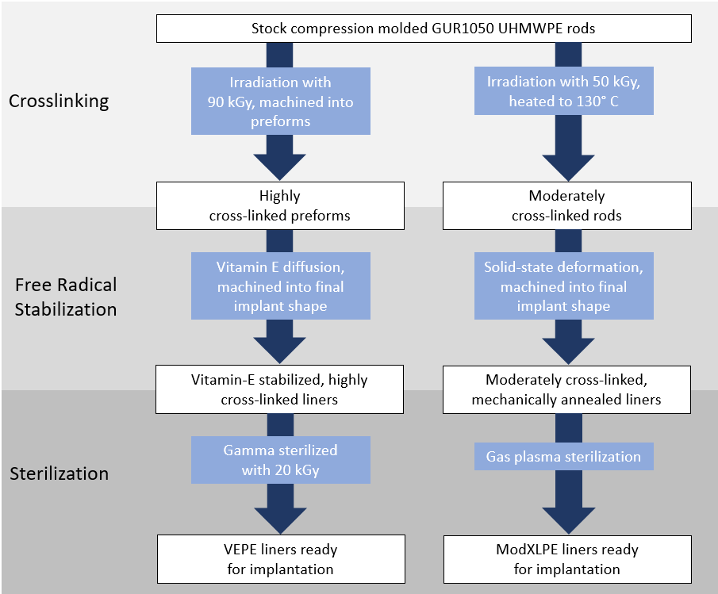

**Figure 1**. Production methods of vitamin E-diffused highly cross-linked polyethylene (VEPE) and moderately cross-linked and mechanically-annealed (ModXLPE) liners.

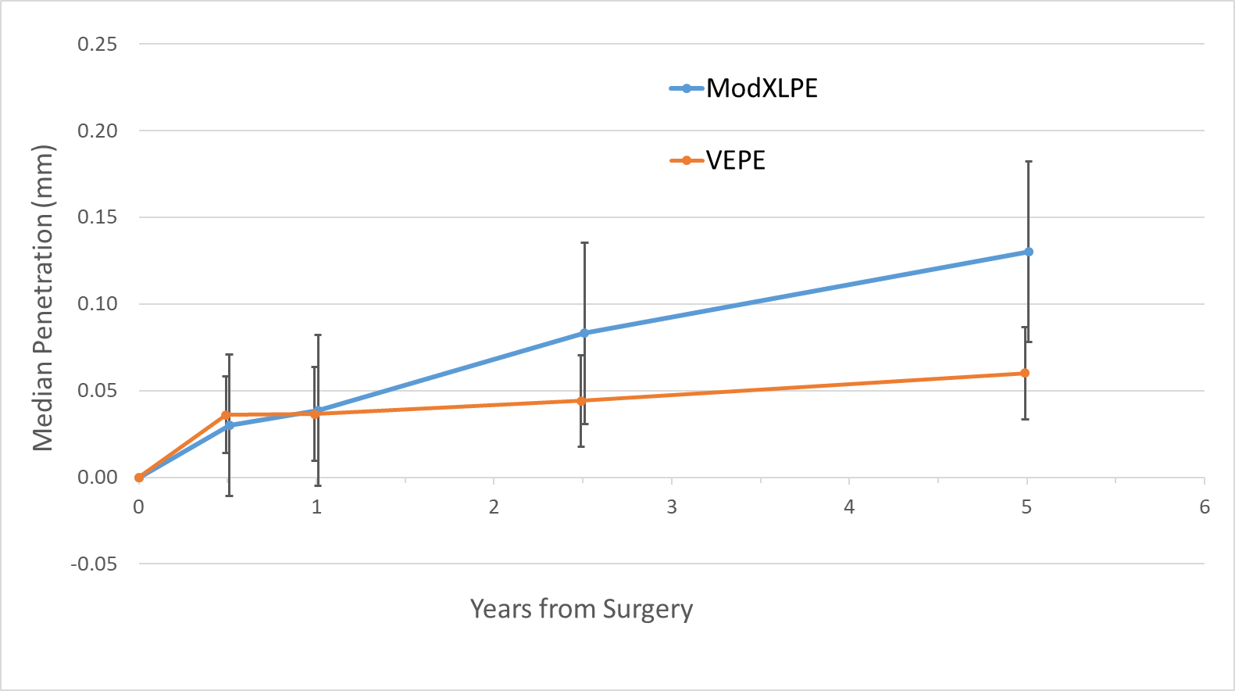

**Figure 2**. Median proximal femoral head penetration (mm) into the VEPE and ModXLPE liners over time with 95% confidence intervals. VEPE, vitamin E-diffused highly cross-linked polyethylene. ModXLPE, moderately cross-linked and mechanically-annealed polyethylene.

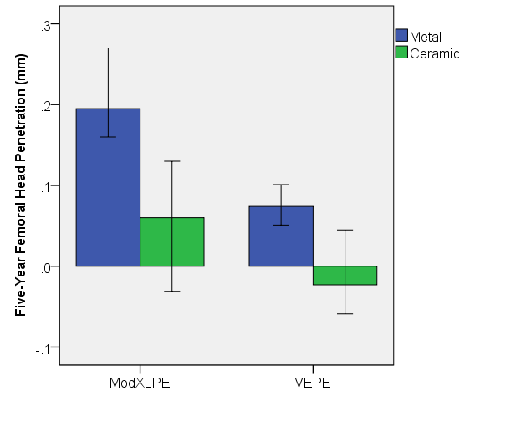

**Figure 3**. Median five-year proximal femoral head penetration (mm) into the VEPE and ModXLPE liners over time with 95% confidence intervals. Bar clusters are defined by femoral head material type. VEPE, vitamin E-diffused highly cross-linked polyethylene. ModXLPE, moderately cross-linked and mechanically-annealed polyethylene.