Journal Paper

Title:
Hygric behavior of hydrophobized brick and mortar samples

Authors:
Vasilis Soulios^{1*}, Ernst Jan de Place Hansen¹, Chi Feng², Hans Janssen³

¹: Department of the Built Environment, Aalborg University, Denmark
²: School of Architecture and Urban Planning, Chongqing University, Chong Qing 400045, PR China
³: KU Leuven, Department of Civil Engineering, Building Physics Section, Kasteelpark Arenberg 40, 3001 Leuven
* Corresponding author. Tel.: +45 29271705
E-mail address: vsou@build.aau.dk

Abstract

Moisture that penetrates into porous building materials is a major reason for their deterioration and the subsequent failure of the whole structure. Water repellency treatment could prevent serious damages to materials and components. Hydrophobization is a method with a long tradition for protecting buildings from wind-driven-rain-induced moisture absorption. Nonetheless, it remains an ambiguous practice. To understand the nature of water repellency it is important to examine how hydrophobization works, how the existing products differ from one another, and how the hygric response of the substrate changes after treatment. The aim of this article is to characterize the impact of water repellent agents on the properties of building materials mostly used in old facades: clay brick and lime mortar.
The resulting open porosity and pore size distribution, determined with vacuum saturation and mercury intrusion testing respectively, reveal only minimal change in the overall pore structure after impregnation. Our findings also show that hydrophobic treatment is nearly impermeable to liquid water, by evaluating the samples with capillary absorption tests, but still permeable to water vapour, by testing the samples with cup tests. Moreover, the water impermeability grows after exposure to water. In addition, the water repellent agent appears to spread progressively in the material for a long time after the hydrophobic treatment, yielding high final impregnation depths. These findings confirm that water repellent agents successfully hydrophobize the tested materials, with a water-tight but vapor-open hydrophobic layer that goes deep into the material, without notably changing its pore size distribution though.

1. Introduction

General background
Existing buildings will have to cover human habitation needs for many years to come, as the European building stock increases solely by 1-1.5% per year [1]. Historic buildings, most commonly with brickwork or natural stone facades, account for 10-40% of the building stock and their conservation is therefore crucial [2]. They are responsible for a sizable fraction of the energy consumption by the built environment, because they typically lack insulation. Thermal retrofitting should hence be considered, for which exterior insulation is the most efficient measure. However, to sustain the architectural and cultural values of the edifice, thermal retrofits of such historic buildings often imply internally insulating the facades [3]. Internal insulation may yield moisture problems though, such as frost damage at the exterior surface, rot of embedded wooden floor beams, or mould growth at interior surfaces [4]. Applying water repellent agents on the facades could potentially avoid such moisture problems, since it minimizes the water absorption by the facade materials [5]. However, it should be carefully examined as it is an irreversible technique [6].

Literature overview
To thoroughly investigate the behaviour of a hydrophobized masonry facade, we should define the moisture storage and transport properties of its components (brick and mortar), as well as the impregnation depth of the hydrophobic treatment.
Previous studies provide experimental results on impregnation depth of brick and mortar [7–10]. Additionally, the existence of a first strongly hydrophobized and a second partly hydrophobized region in brick samples has already been established [11,12]. However, the influence of several characteristics of the water repellent agents, such as the different percentage of silane/siloxane and different percentages of active ingredient, on the impregnation depth of brick and mortar samples and the extent of the redistribution of the active ingredient needs to be further investigated.
Whereas some previous studies examine moisture storage properties (maximum moisture content), which derives from free water uptake, on hydrophobized brick samples [5,8,11,13], the present study defines the open porosity and the pore volume distribution in order to investigate the effects of hydrophobic impregnation on the pore structure of both brick and mortar.
The most crucial function of hydrophobization is to reduce, or avoid, the spontaneous capillary absorption of wind-driven rain, which forms an important moisture source for facades [14,15]. Hydrophobization has shown to be very efficient in reducing the capillary suction of bricks [5,8,10,11,16–18], as well as cement mortars [10,19], commonly expressed by their capillary absorption coefficient (A_{cap}). However, there is a lack of similar studies on lime mortar. The question of whether hydrophobization can eliminate driving-rain absorption by providing the same level of water repellency in both brick and mortar still remains. Also, the influence of the active ingredient, the form, the diluent, and the concentration of the water repellent agent on the capillary suction, as well as the water exposure after treatment, are factors that all need to be investigated. Moreover, several researchers use different application times and curing periods during the impregnation process in lab conditions [7,8,11,17,20] and there has been relatively little analysis on the effect they have on the water repellency and the impregnation depth of the hydrophobic treatment.
Opposed to the change in the capillary suction, there seems to be no significant change in the vapour diffusion resistance factor (μ-value) of both brick and mortar, however both increases and decreases between untreated and treated samples are reported [5,7,9–11,13,21]. The question of whether and to what extent hydrophobization can influence the vapor permeability of brick and mortar requires an answer. Moreover, whether different forms of water repellent agents (liquid or cream) give different behaviors in the vapor permeability of hydrophobized materials should be investigated both in brick and mortar.

Aim and outline
The main aim of this article is to characterize the impact of water repellent agents on the hygric behavior of building materials most often used in historic facades: brick and mortar. Serving the above-mentioned aim, the first section describes the physical and chemical properties of the water repellent agents and screens the market of commercially available products. The article continues by comparing the impregnation depth between bricks and mortar and indicating the redistribution of the water repellent agent after treatment. It also considers the influence of hydrophobic impregnation on the open porosity and the pore size distribution of brick and mortar. Subsequently, it is investigated how various water repellent agents employed on different bricks and mortar affect the impregnation strength, quantified by calculating the capillary absorption coefficient. The article concludes by studying the vapour transport with cup tests.

2. Water repellent agents
2.1. The nature of water repellency
The main function of water repellent agents is to prevent liquid water from entering the impregnated surface [8,22,23]. Water is a polar material since it has a positive charge at the hydrogen ends and a negative charge at the oxygen end. Inorganic building materials, such as brick, usually have negative surface charges and therefore attract the positive end of the water molecules (i.e. they are hydrophilic). A water-repellent molecule has a polar “head” and a non-polar “tail”. The polar “heads” are attracted by the polar material and the non-polar “tails” cover the surface. In that way, the surface becomes non-polar and as a result, no longer attracts water molecules (i.e. surface becomes hydrophobic) [21].

2.2. Types of water repellent agents
Water repellent agents that are available on the market, are primarily based on the following types of materials: i) silicon-bearing compounds, ii) metal-bearing compounds and iii) organic materials [21]. Although not widely available yet, water repellent products based on nanotechnology claim to produce better results compared to the more traditional products [24–26]. However, further studies are needed first to conclude on the effectiveness and efficiency of these nanotechnology-based products.

2.2.1 Silicon-bearing compounds
Silicon-based systems are the most popular water repellents in use. Generally, all products that contain a silicon-oxygen backbone can be referred to as silicones, but their properties can vary significantly [21]. When applied, the silicon-based systems form irreversible bonds with the mineral substrate and hydrophobize the building material [22,27]. A simple classification of silicon-based water repellent agents would include silanes, siloxanes and silicon resins.

Silanes
Silanes are monomeric low-weight molecules that contain one silicon atom which is connected to alkyl (-R) and/or alkoxy (-OR) groups. These alkoxy groups (-OR) permit the compound to polymerize and to link chemically to the hydroxylated surfaces of siliceous building materials (e.g. brick, concrete, granite, sandstone), providing anchorage between hydrophobic film and building substrate [21,22]. The alkyl groups (-R) take no part in the polymerization but they provide the hydrophobic properties to the compound.
The low reactivity of silanes often gives great impregnation depths, even in alkaline substrates such as concrete. Silanes are highly volatile though and therefore high concentrations of active content are required, ranging from 25 % up to 99% (almost pure silane) [28], according to the preferred use and the desired performance [29].

Siloxanes
Siloxanes are similar in nature to silanes, but their molecular structure is more complex, since they are oligomeric or polymeric molecules based on Si-O-Si chains. Due to this complexity, siloxanes more difficultly migrate into the substrate, although their dimensions are comparable to those of silanes [22,29]. The size of silanes is 0.4 to 1.5 nm and of siloxanes 3 to 30 nm [30]. Siloxanes are more reactive compared to silanes. In fact, the fast curing process on highly alkaline substrates (e.g. concrete) does not permit siloxane molecules to penetrate deep into the substrate. For that reason, they are mostly used in more porous and more neutral mineral substrates (e.g. brick, natural stones, and aged concrete) [22]. Due to their higher molecular weight, siloxanes are less volatile than silanes, and consequently the needed active content is usually no more than 10 to 15%. Also, higher concentrations encompass the risk of darkening the surface [29].

Silicone resins
Silicone resins are highly branched polysiloxanes with high molecular weight, with a backbone consisting of silicon and oxygen atoms [22,31]. Silicone resins are already polymerized and the evaporation of the solvent is the only process that takes place after application [21]. However, silicone resins have poor solubility properties, can darken the surface and provide a beading effect, which is not always desirable [21,22]. Silicon resin products should be diluted to 5-10% solids in solvents to achieve a better penetration depth [22].

2.2.2. Metal-bearing compounds
Metal-bearing compounds are mainly based on aluminum stearate, the most popular hydrophobization agent of this kind. Metal-bearing compounds are mostly used for stone treatments, not being effective for brick masonry. Other metal-organic compounds, such as titanium stearate and butyl-ortho-titanate are used in mixtures with oligomeric siloxanes[21].

2.2.3 Organic materials
Hydrophobization agents that are based on organic materials include acrylics, polyurethanes and perfluoro-polyethers. Waxes are also organic substances of either natural or synthetic origin and they are generally used for the conservation of materials such as marble and stone. Although waxes have good hydrophobic properties, they can easily suffer from mechanical damage and color variations [21,32]. Some organic materials are also used in combination with silicon bearing materials in order to provide both water and oil repellency [33–35].

2.3 Product identification
Silicon-based water repellent agents, which are the most popular in practice, can be identified through their active ingredient, the form, the type of diluent, the concentration of the active ingredient, the alkyl group and the type of substrate that is recommended for application (see Table 1) [36].
Table 1: Product identification.
Product characteristic | Description
Active ingredient | Silane - Siloxane - Silicone resins
Product form | Liquid or Cream
Used diluent | Organic solvent - Water emulsion - Water microemulsion
Agent concentration | 1-100%, Undiluted* or Ready to use
Alkyl group | Octyl or iso-Octyl in commercial products
Intended substrate | Mineral substrate** - Masonry*** - Concrete
*Undiluted: contain no diluent and must not be diluted before application.
**Mineral substrates: concrete, brick, natural stone, mortar, concrete blocks.
***Masonry: brick, mortar and natural stone, but not for concrete (or concrete blocks).

2.3.1 Influence of the formulation and diluent
During the previous decades, combination products of both silanes and siloxanes have been marketed as more broadly applicable water repellent agents as they combine the penetration power of silanes and the reactivity of siloxanes. In order to be prepared as ready-to-use, these products have to be diluted with white spirits or alcohols, in various concentrations according to the product and the substrate [22]. However, volatile organic compounds (VOC) are released to the atmosphere when silanes, siloxanes or silicone resins are dissolved in organic solvent. For that reason, more environmentally friendly products based on water as diluent were developed [36]. Paste-like or cream products, developed since the early 2000s, provide alternative treatment methods, easy to apply and with good water repellence characteristics [22,25,37].
Water-based emulsions and creams contain emulsifiers to keep the reactive material stable in a water environment [10]. These products perform better after rain exposure and solar radiation. Solar radiation increases the temperature and consequently the reactivity, while rain exposure “washes off” the emulsifiers that impede reactions with water. Micro-emulsions do not contain classical emulsifiers and can immediately demonstrate their performance. However, micro-emulsion products should be applied within 24 hours after dilution, so there would be no reactions between active ingredients and water (personal communication with Hamont, Corne Van, Wacker’s representative)

2.3.2 Influence of concentration of the active ingredient
The concentration of the active ingredient is important for the performance of the product. Lower concentrations generally decrease the effectiveness of the treatment, which may lead to faster drying though[5,37]. De Clercq and De Witte [20] show that the influence of concentration on the effectiveness of the treatment becomes more important after ageing.

2.3.3 Influence of the alkyl groups
The alkyl groups (-R) attached to silane, siloxane and silicone resin take no part in the polymerization but provide the hydrophobic properties to the compound. Some studies have shown that long alkyl groups are not more effective than methyl groups and that the nature of the substrate played a more significant role in the performance of the treatment [21]. However, longer alkyl chains provide good resistance against alkalinity as they create a steric shield for the Si-O-Si bonds which are prone to hydrolysis [22].
If the hydrophobic compound is composed only of methyl groups, the alkaline stability may not be very strong. The influence of the alkyl group, in terms of alkali resistance, is more notable in cementitious substrates. For brick this influence may not be that important, because brick is a more neutral material than concrete with respect to alkalinity. In masonry walls the length of the alkyl group may influence the treatment, since mortar is an alkaline material. However, most formulations nowadays contain longer alkyl groups so that the alkalinity of mortar cannot cause stability problems[21,38–40]

2.3.4 Influence of the type of substrate
Compatibility between pore structure and polymer chain length can play an important role in the effectiveness of the hydrophobic treatment and the hygric behavior of the impregnated substrate. De Clercq and De Witte [20] indicate that the pore structure of the substrate is the key factor that determines the process of polycondensation. For that reason, the water repellent agents should be classified according to their polymer chain length in relation to the pore size of the substrate that will be impregnated [8]. Thus, different water repellent agents are suitable for different types of substrates.

2.4. Classification of commercially available water repellent agents
In order to select the products that will be used in the laboratory experiments, it is important to obtain an overview of the commercially available water repellent agents so that selected agents will represent a wide spectrum of the existing products. There are several distributors of water repellent agents, and they all provide a spectrum of products that can be categorized according to several characteristics: type of active ingredient, formulation, concentration and type of substrate, explained in Section 2.3.
Water repellent agents from thirteen distributing companies were classified, including five big silicon-producing companies: Wacker, Dow, BlueStar, Sika, and Momentive. The rest of the water repellent agents are selected from non-silicon-producing companies. These companies developed their own formulations using silicones from the above-mentioned silicon producing companies (see Table A 1 Appendix). In total, 77 commercially available products suitable for mineral substrates have sufficient information to be identified, although there are more products on the market.

This study focuses on water repellent agents that are used as brick masonry impregnation against wind-driven rain. This means that products against rising damp, in-plant impregnations for cement, products used for wood and products that are used as admixtures in paints or coatings, are not included.

Almost all companies use silicon-based repellents, while some of them also provide agents based on organic or metal-bearing materials which may or may not contain silicones. Almost half of the silicon-based products are mixtures of silanes and siloxanes (see Figure 1). The majority of water repellent agents are in liquid form. Most products use water as a diluent, especially if they are in the cream form (see Figure 2 left). Although some products are recommended only for application in concrete and cementitious materials, most products are recommended for mineral substrates in general (see Figure 2 right).

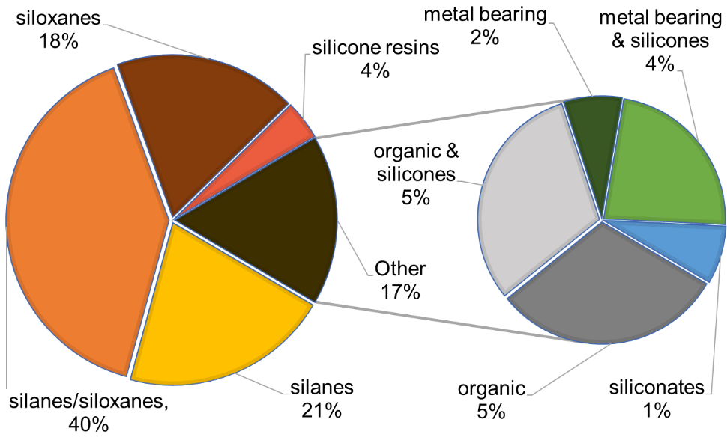
Figure 1: Types of water repellent agents. Data from 77 listed products.
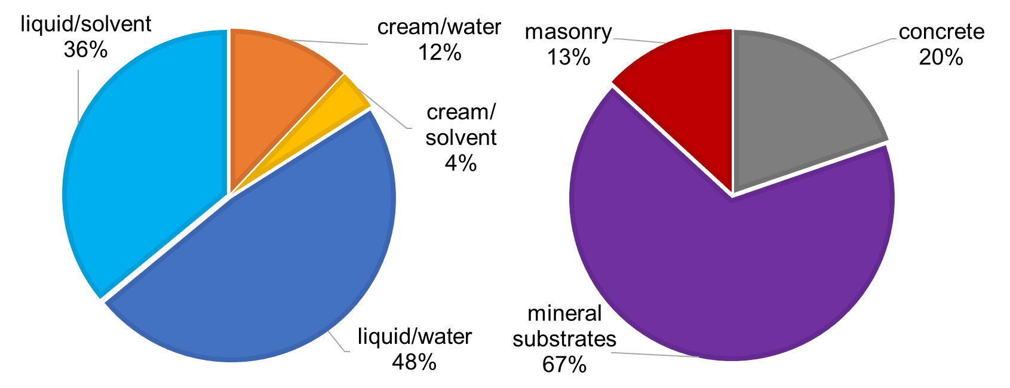
Figure 2: Form and diluent of water repellent agents (left), Type of substrate (right). Data from 77 listed products.

3. Materials and methods

3.1. Target building materials
Hydrophobic impregnation in combination with internal insulation is a retrofit measure for external walls of old/historic buildings with architectural or cultural value, for which external insulation is not a feasible solution. The external wall of such buildings is often made of solid masonry (ceramic brick and lime mortar), at least in many Northern, Western and Central European countries. Therefore, the current study looks into ceramic brick (three types) and lime mortar (one type), described in Table 2.
The Robusta and yellow soft bricks (R brick and Y brick) have been used in research projects at KU Leuven (Leuven, Belgium) and at DTU (Technical University of Denmark, Kgs. Lyngby, Denmark) respectively e.g. (Todorovic and Janssen [41]) (Hansen et al [7]) and their properties have been thoroughly examined. Samples of a historic brick (H brick) were acquired from a building in Copenhagen constructed in 1944, in order to also impregnate the exposed to weather conditions surface.
In relation to size, the brick samples were divided into three groups: 8x4x4 cm, 1x4x4 cm, and 3x8 cm (thickness x diameter) and were cut from regular bricks. Only for the H brick the exposed to weathering surface was kept on the sample. Samples with apparent cracks were excluded in the process as cracks should be repaired before impregnation according to technical data sheets of water repellent agents.
The lime mortar was selected to represent an historic type of mortar. The relative amounts of ingredients for the lime mortar (lime Saint-Astier NHL3.5) was 10 liters of water, 12.5 kg of lime, and 50 kg of sand. All ingredients were mixed in large realistic portions and the fresh mortar was placed in wooden molds to form the tested mortar samples. Mortar was kept in the molds for more than 6 months. After this period, the samples were placed in a carbonation chamber (4.7% CO₂ exposure) for 2 weeks in order to represent a carbonated historic mortar [42]. The mortar samples were tested with phenolphthalein in order to check if they were fully carbonated. Because of the small size (8x4x4 cm, 1x4x4 cm and 3x8 cm) and the composition (lime) of the mortar samples, in 10 days they became fully carbonated.
Table 2: Building material used in the current study. Properties of untreated samples.
Name | Description | A_{cap}*  [10⁻⁵kg/m²√s] | w_{cap}*  [kg/m³] | μ*
R brick | Robusta Vandersanden Belgian Brick | 60732 (2043) | 208 (2.3) | 11.3 (1.2)
H brick | Historic Danish Brick from an old building in Copenhagen (1944) | 39875 (2288) | 249 (3.9) | 8.70 (0.9)
Y brick | Yellow soft-molded Danish brick from Helligsø and Vesterled Teglværk | 30970 (4584) | 276 (19.3) | 11.9 (1.4)
L mortar | Carbonated lime mortar | 25820 (2041) | 227 (6.6) | 8.00 (0.4)
* A_{cap} and w_{cap} derived from water uptake test (each result is an average based on five samples), μ from wet cup test [RH 53.2 – 97.4%] (each result is an average based on four samples). The values in () correspond to the standard deviation. For additional properties of R brick and L mortar see Table B 1 Appendix and for the Y brick see [18].

3.2. Selected water repellent agents

The selected water repellent agents (Table 3) represent the basic variations that can be found on the market of silicon-based water repellent agents according to the characterization shown in Table 1. The selected products include different active ingredients, in liquid or cream form, water or solvent-based, with different concentrations, and recommended for different types of substrate.
The SMK products from Wacker (SILRES BS) are micro-emulsion water-based mixtures of silane/siloxane. SMK 2101 has a high percentage of silane (around 90 %) and is recommended for cementitious substrates [28]. SMK 1311 has a high percentage of siloxane (around 90 %) and SMK 2100 has a balanced mixture of silane/siloxane (approximately ratio 50/50). SMK products are available with 100% concentration and they can be diluted with tap water (preferably deionized) to produce any concentration [43,44]. The recommended concentration of active ingredient for the SMK products for brick and mortar is between 6 and 10 %. In order to investigate the influence of lower and higher than recommended concentrations, 2% and 25% are also tested.
Funcosil Remmers SNL, a solvent-based product and Funcosil Remmers WS, a water-based emulsion product [45,46], are both ready-to-use. Funcosil Remmers FC cream is a water-based silane cream that can be ordered in any possible concentration [47].
Table 3: Water repellent agents used in the current study.
Product | Company | Type | Form | Diluent | Concentration | Substrate
SMK 2101 | Wacker | 90% silane | Liquid | Water | 6, 10, 25** % | Concrete
SMK 1311 | Wacker | 90% siloxane | Liquid | Water | 6, 10, 25** % | Mineral
SMK 2100 | Wacker | Silane/siloxane | Liquid | Water | 2*, 6, 10, 25** % | Mineral
SNL | Remmers | Siloxane | Liquid | Solvent | 7 % | Mineral
WS | Remmers | Silane/siloxane | Liquid | Water | 10 % | Mineral
FC | Remmers | Silane | Cream | Water | 10,* 20, 40, 80 % | Mineral
Information derived from the technical data sheets of the products.*Concentration lower than recommended. **Concentration higher than recommended.

3.3 Hydrophobization treatment
According to the technical data sheets of the water repellent agents included in the current study, the substrate should be cleaned from dirt, dust and possible efflorescence before the impregnation [28,46,48].
The samples were washed with deionized water to avoid the absorption of extra salts and were carefully cleaned with a brush to remove dirt and dust. Afterwards, the samples were stored for drying in an oven (70 °C) for the absorbed moisture from the intense water exposure to evaporate. After reaching a stable mass (4-5 days), the samples were cooled in order to obtain room T and RH.
For the water uptake testing samples, the impregnation with liquid products followed the test practice of Wacker where samples are dipped for five minutes in the liquid agent. According to Wacker this represents two to three working operations (personal communication with Hamont, Corne Van, Wacker’s representative). In the current study, one surface of each sample was exposed to free agent uptake (contact time) for five minutes (see Figure 3). For impregnation with cream products the minimum recommended amount, 150-200 ml/m², was applied with a brush [47].
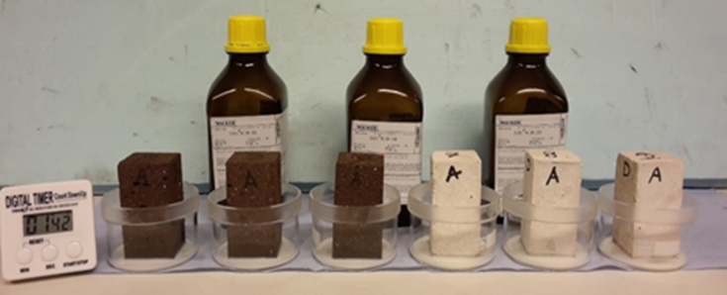
Figure 3: Impregnation of brick (left) and mortar (right) samples by exposing them to free uptake of water repellent agent (liquid products).
For the vacuum saturation, the mercury intrusion, and the cup test alternatively, the samples were fully hydrophobized, in order to obtain homogeneous specimens. The impregnation with liquid products was conducted via free agent uptake until the agent reaches the top of the sample while for the cream products, a substantial quantity of agent was applied on the top surface of the sample in order for the agent to reach the bottom surface.
Finally, the samples were stored in a climatic chamber (21 °C, 53% RH) for one-month curing, which is longer than the 14 days recommended by Wacker; however the water repellency efficiency depends on the curing time [11].

3.4 Experimental set-up
Four main factors that characterize the hydrophobic layer: i) impregnation depth (d_{p}), ii) change in the open porosity (Φ) and the pore volume distribution (f_{v}) (moisture storage), iii) reduction of the water absorption coefficient (A_{cap}) (moisture transport), and iv) change of vapour diffusion resistance factor (μ) (moisture transport), were investigated as presented in Table 4.
Table 4: Laboratory experiments. Test plan including measured properties, type of tests, sample size and amount, type of material, and type and composition of water repellent agent.
Material (No. of samples) | Product | Form | Diluent | Concentration | Study the influence of
Impregnation depth (d_{p}) (8x4x4 cm samples)
R brick (54), L mortar (45), Y brick (6),  H brick (12) | Visual inspection & capillary water uptake from  the non-impregnated side |  |  |  | Concentration of active ingredient, ratio silane/siloxane, form, diluent
Open porosity (Φ) by vacuum saturation test (1x4x4 cm samples)
R brick, L mortar (5) | Untreated |  |  |  | Substrate
R brick L mortar (5) | SMK 2100 | Liquid | Water | 10 % | Substrate
Pore volume distribution (f_{v}) by mercury intrusion (dry mass: 1.5-2.5 g samples)
R brick, L mortar (5) | Untreated |  |  |  | Substrate
R brick, L mortar (5) | SMK 2100 | Liquid | Water | 10 % | Substrate
Water absorption coefficient (A_{cap}) by capillary water uptake (8x4x4 cm samples)
R brick, L mortar, Y brick, H brick (5) | Untreated
R brick, L mortar (9) | SMK 2101 | Liquid | Water | 6, 10, 25 % | Concentration of active ingredient, ratio silane/siloxane, form, diluent  After treatment water exposure  Duration of water exposure
R brick, L mortar (9) | SMK 1311 | Liquid | Water | 6, 10, 25 %
R brick, L mortar (12) | SMK 2100 | Liquid | Water | 2, 6, 10, 25 %
R brick (3) | SNL | Liquid | Solvent | 7 %
R brick (3) | WS | Liquid | Water | 10 %
R brick, L mortar (12) | FC | Cream | Water | 10, 20, 40, 80 %
H brick, Y brick (3) | SMK 2100 | Liquid | Water | 6 % | Substrate
H brick, Y brick (3) | FC | Cream | Water | 40 % | Substrate
H brick (weathered) (3) | SMK 2100 | Liquid | Water | 6 % | Exposure to exterior conditions before impregnation
H brick (weathered) (3) | FC | Cream | Water | 40 % | Exposure to exterior conditions before impregnation
R brick (6), L mortar (3) | SMK 2100 | Liquid | Water | 6 % | Curing and application time
Water vapour diffusion factor (μ) by cup test (8 cm diameter, 3 cm height samples)
R brick, L mortar (4) | Untreated |  |  |  | Water repellent agent, substrate
R brick, L mortar (4) | SMK 2100 | Liquid | Water | 10 % | Water repellent agent, substrate
R brick, L mortar, Y brick, H brick (4) | Untreated |  |  |  | Water repellent agent, substrate
R brick, L mortar, Y brick, H brick (4) | FC | Cream | Water | 40 % | Water repellent agent, substrate
The number inside () corresponds to the number of samples tested per material. All surfaces of brick samples were sawn except where indicated (weathered).
Each result is an average based on five samples for the vacuum saturation and mercury intrusion test both for untreated and treated samples, as well as for the untreated samples of the capillary water uptake test. However, for all the treated samples of the capillary water uptake test each result is an average based on three samples. For all the latter samples, the water uptake test was repeated. Only for a few samples the water uptake test was repeated for a third time. The same samples were used for measuring the impregnation depth by visual inspection and water uptake test from the non-impregnated side. Only for a few samples the water uptake from the non-impregnated side was repeated for a third time. Between each repetition, the samples were dried in an oven at 70ºC. For cup tests, each result is an average based on four samples for both untreated and treated samples.
Hydrophobic impregnation creates a first, strongly hydrophobized layer as well as a larger volume that is partly hydrophobized [11] (see Figure 4). The impregnation depth of impregnated samples was initially measured by visual inspection (i.e. measuring the length of the surface that becomes darker after impregnation), right after the impregnation and one month later. In addition, water uptake tests were conducted from the non-impregnated side of the samples to illustrate the redistribution and the extent of spreading of the water repellent agent in the samples. On this study, by “impregnation depth”, we refer to the strong hydrophobized region plus the partly hydrophobized region.
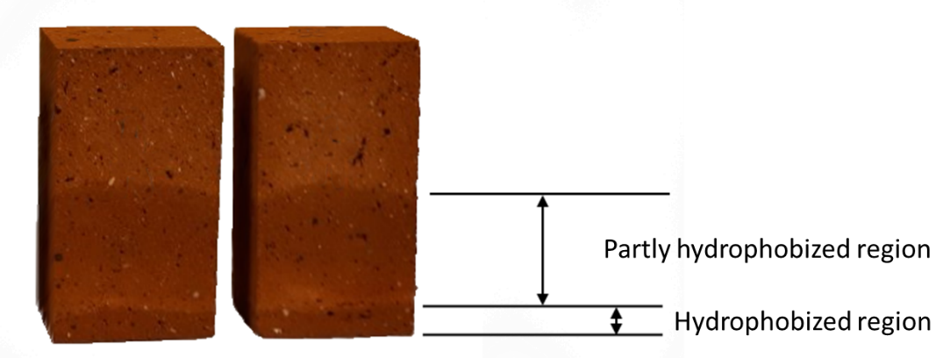
Figure 4: Impregnation depth in H brick right after the impregnation process with a liquid product. Strong hydrophobized layer at bottom (darker surface), partly hydrophobized region above.
Vacuum saturation test was conducted according to [49] (ASTM C1699-09, 2009), in order to determine open porosity (Φ), which is proportional to vacuum saturated moisture content w_{sat}, as described in [41,50].
Mercury intrusion tests were carried out to determine the pore volume distribution of hydrophobized brick and mortar according to [51] as described in [41].
Water uptake tests were conducted in order to obtain the water absorption coefficient (A_{cap}) in accordance with [52] as described in [50,53]. Since impregnation significantly reduces the capillary water uptake, the duration of the water uptake test of the impregnated samples was 24 hours and the measurement time intervals were: 10', 30', 1h, 1h 30', 2h, 3h, 4h, 7h, 9h, 24h. The water absorption coefficient A_{cap} is the slope of the first stage of the curve in relation to the square root of time and is significantly decreased in a material impregnated with a water repellent agent [8]. However, when the graph of water uptake against the square root of time does not give a straight line but a curve of some form, the absorption coefficient is defined as the measured increase in weight [g] at 24h divided by $\sqrt{86400}$ [52].
Cup tests were conducted according to [54], to determine the water vapour diffusion resistance factor (μ). After pre-conditioning, the samples, enclosed in the lids, were attached to cups containing saturated salt solutions and placed in a climatic chamber. Weighing of the samples was conducted twice per week in four weeks.

4. Results

4.1 Impregnation depth
A sufficient impregnation depth of the hydrophobic treatment is vital, since a thin hydrophobic layer may pose a risk for water penetration in the case of cracks at the exterior surface. Initially in this study the impregnation depth of impregnated samples was measured by visual inspection right after as well as one month after the impregnation process. The visual inspection indicates impregnation depths (strongly hydrophobized region plus the partly hydrophobized region) of approximately 25 mm on bricks and of 5 to 10 mm on mortar, right after impregnation with various liquid water repellent agents (for details refer to Table C 1 in Appendix). The redistribution of the agent after one month is visible only in R brick where the impregnation depth is around 30 mm. However, this section aims to illustrate that the redistribution of the agent extends the measured values coming from visual inspection and results in larger impregnation depths.
In order to thoroughly investigate the partly hydrophobized volume, water uptake tests from the impregnated and not-impregnated sides were conducted. Figure 5 gives an indication of the strength and depth of the partly hydrophobized volume by comparing the water absorption coefficient of samples from the impregnated side and the not impregnated side. The impregnated samples show water repellency even at the not-impregnated side, as the water volume absorbed by the not-impregnated side is significantly reduced compared to the untreated material. Figure 5 also illustrates that the redistribution of the agent leads to much larger impregnation depths than the ones measured by visual inspection. After the hydrophobization procedure, the active ingredient spreads further into the material, leading to a major rise in the impregnation depth. All three brick types, when impregnated with liquid products (SMK, SNL and WS), in all tested concentrations, showcase water uptake reductions from the non-impregnated side that are similar to the results for water uptake from the impregnated side (Figure 5). This leads to the conclusion that the brick samples become almost fully hydrophobized, and therefore, the impregnation depth is greater than the initial measurements via visual inspection. In the case of L mortar the reduction of A_{cap} from the non-impregnated side is also significant but the samples do not become fully hydrophobized.
Due to the less amount of agent applied with FC cream compared to that of liquid products, this effect is less evident. After 5 minutes of free liquid agent uptake, R brick absorbs around 5 to 8 ml of agent, H brick 5 to 7 ml, Y brick 5 to 6 ml, L mortar 4 to 7 ml. The minimum recommended quantity of the FC cream products (150 - 200 ml/m²) corresponds to around 0.5 ml per sample. When five times more cream agent is applied (40% concentration) in R brick and L mortar, the impregnation depth (visual inspection) is 24 and 15 mm respectively and the water absorption coefficient from the not-impregnated side is 235 and 3305 (10⁻⁵ kg/m²√s)) respectively after one-month of curing.
For SMK 2100 and Remmers FC the water uptake from the impregnated and not-impregnated side was conducted after one month of curing. In the case of SMK 2101, SMK 1311, Remmers SNL and Remmers WS, water uptake from the impregnated side was conducted after one month of curing, while the water uptake test from the not-impregnated side was conducted after five months. With longer curing times and water exposure, the agent can spread deeper, hence yielding an even better performance in R brick impregnated with SMK 2101 and WS in terms of water repellency from the not-impregnated side compared to the impregnated side with one month of curing (see Figure 5). Moreover, repeating the water uptake test from the not impregnated side for R brick and L mortar treated with FC 40% and for L mortar treated with SMK, results in further reduction of A_{cap} (see Table C 1 Appendix) building more confidence that the agent spreads deeper with time.
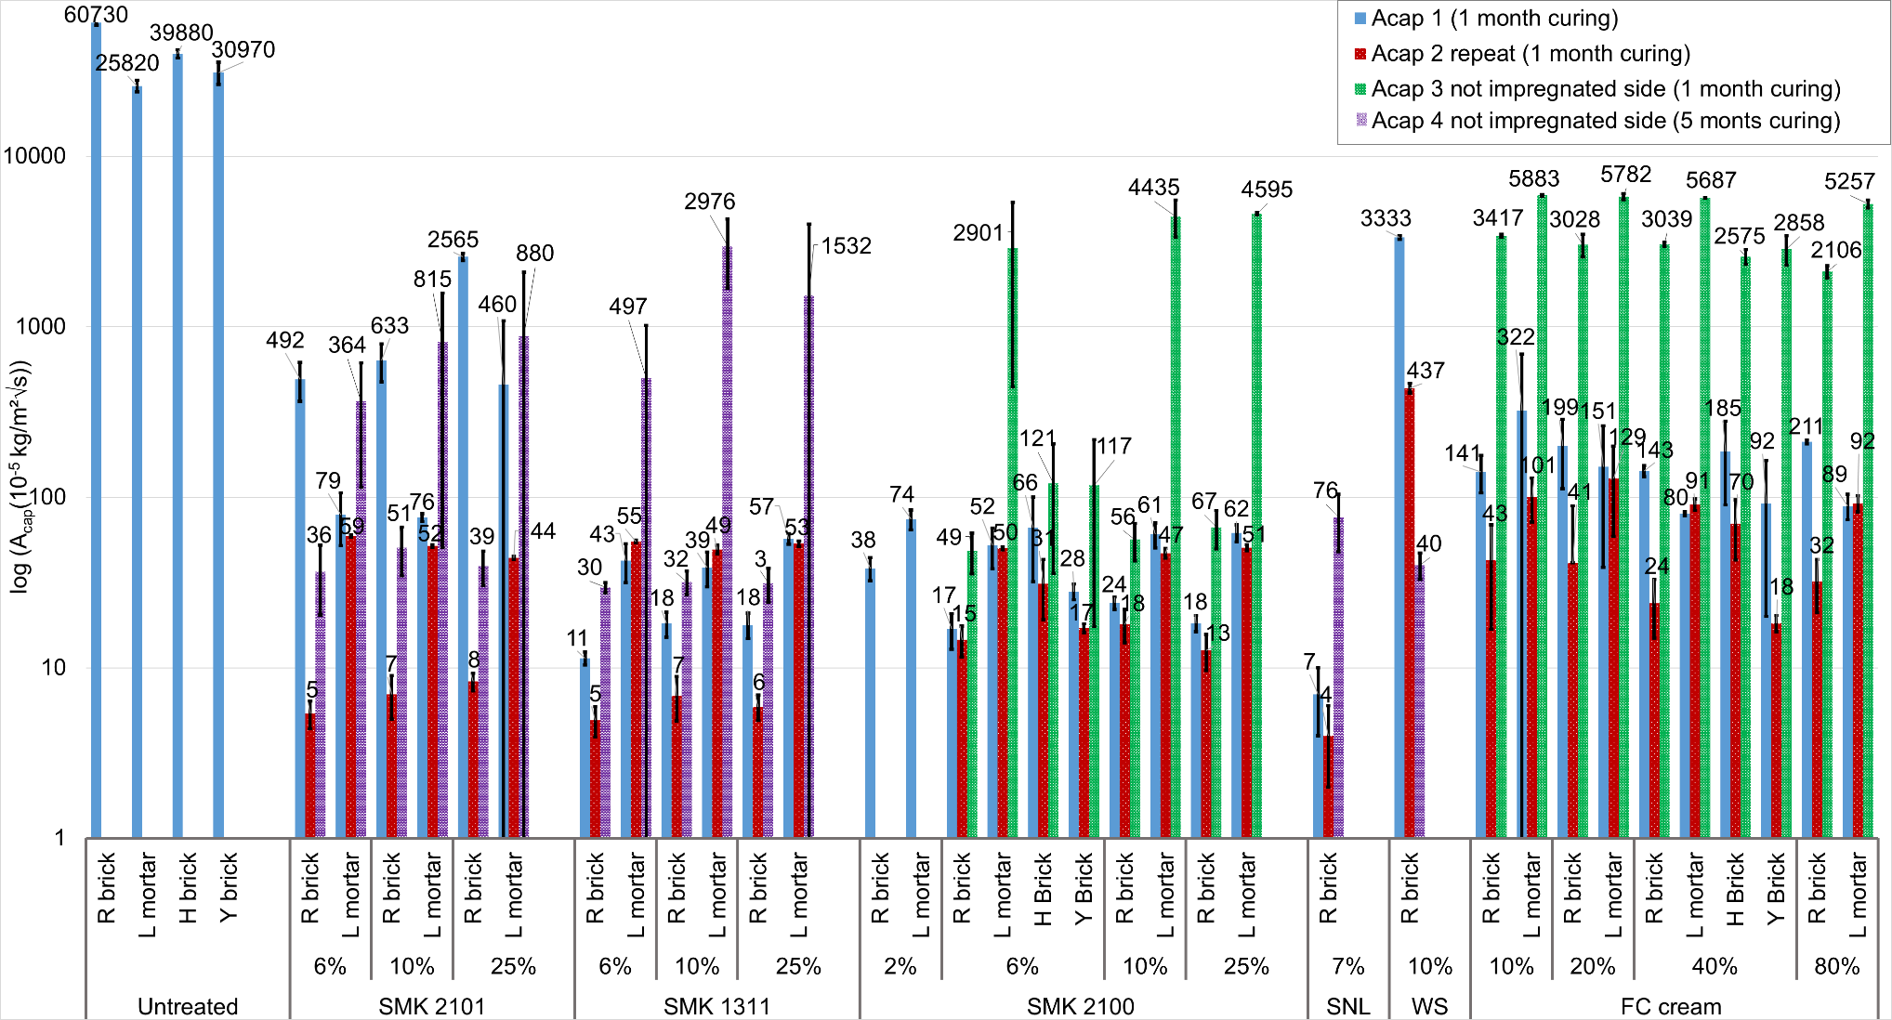
Figure 5: Water absorption coefficient, initial (A_{cap1}) after one month of curing, repeated after water exposure (A_{cap2}), from not impregnated side of the sample (height 8 cm) after one month of curing (A_{cap3}), from not impregnated side after five months of curing (A_{cap4}). R brick, L mortar, H brick and Y brick, untreated and impregnated with different water repellent agents and concentration of active ingredients. Each result is an average based on three samples, error bars correspond to standard deviation, for exact values see Table C 1 Appendix. All the results of A_{cap2} refer to 1 month of curing except for the SNL where it was measured after 5 months of curing.

4.2 Moisture storage
Neither open porosity (Φ) nor vacuum saturation moisture content (w_{sat}) seems to be significantly influenced by hydrophobic impregnation, both in R brick and L mortar as seen in Figure 6 (left). The pore volume distribution in Figure 6 (right) indicates almost the same available pore volume space in the hydrophobized material both in R brick and L mortar, that can be filled after submerging the sample and inducing a hydrostatic overpressure in the vacuum saturation testing (see Figure 6 (left)). The small reduction of the open porosity especially in the case of L mortar could be due to a limited extent of clogging in the finer pores [8].
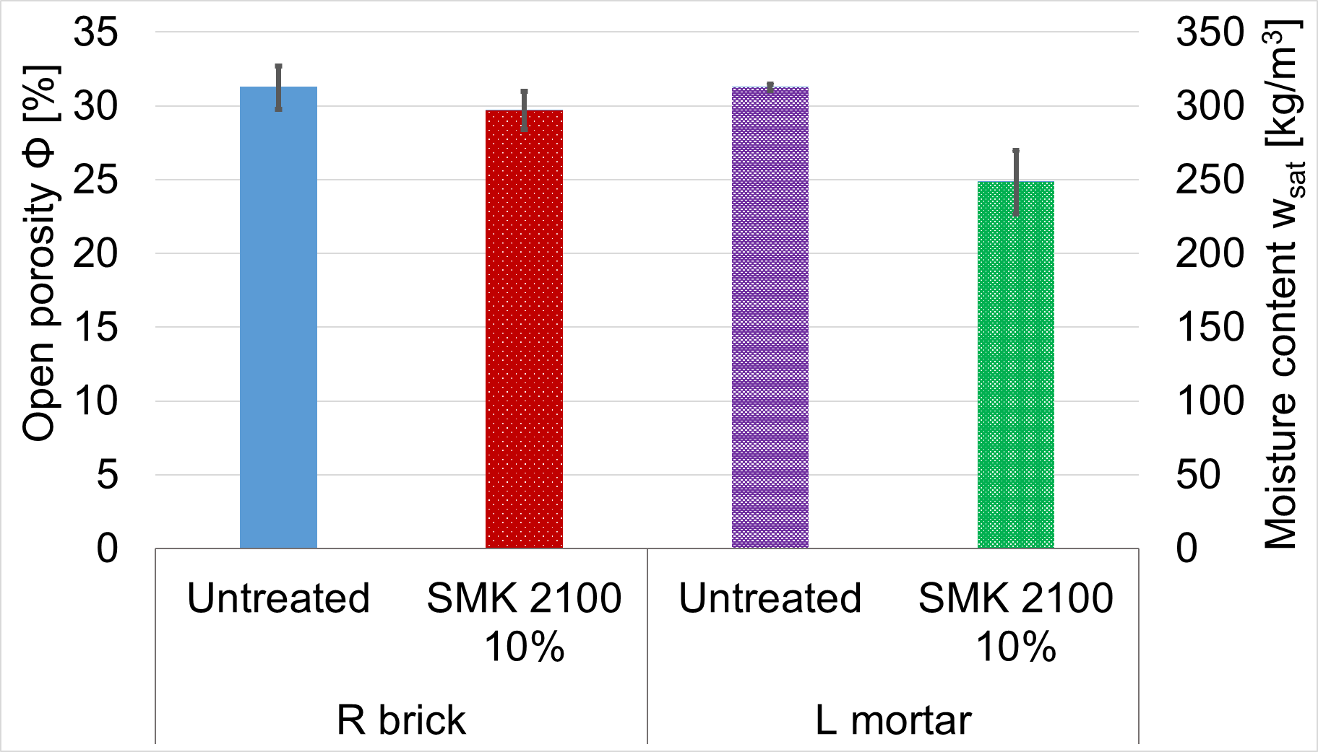 | 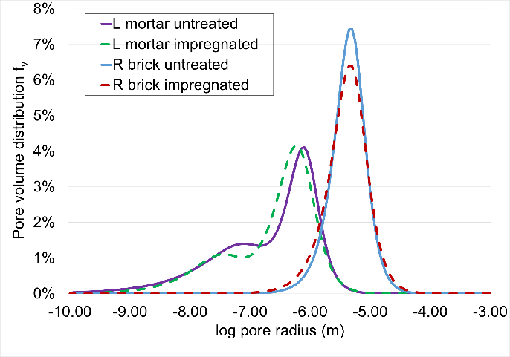
Figure 6: Open porosity and vacuum saturation moisture content (left) and pore volume distribution (right), R brick and L mortar, untreated and impregnated with SMK 2100 10 %. Each result is an average based on five samples, error bars correspond to standard deviation, for exact values see Table B 1 Appendix.

4.3 Moisture transport

4.3.1 Capillary water absorption
A majority of the silicon-based water repellent agents significantly reduce the capillary water absorption of R, H and Y brick and L mortar (Figure 5). In all cases the water absorption coefficient is negligible compared to the not impregnated samples. Only the WS water-based emulsion product in 10 % concentration and the SMK 2101 silane agent in all tested concentrations performed less well in R brick, compared to the rest of the agents in the first water uptake (A_{cap1}). However, repeating the water uptake tests (A_{cap2}) results in greater reduction of the absorbed water.
Different concentrations, diluents and percentages of silane/siloxane illustrate similar water repellency performance but differ in the time that is needed to reach their optimal performance. Silanes (SMK 2101 and FC cream) and water emulsions (WS) seem to reach an optimal performance after water exposure. In R brick samples impregnated with SMK 2101 silane 10%, Remmers WS 10% and Remmers cream 40% even after three times of water uptake, A_{cap} is still slightly reduced (see A_{cap3} in Table C 1, Appendix).
The different tested substrates do not influence the absorption coefficient reduction, since both bricks and mortar depict similar water repellency performance impregnated with SMK 2100 6% (liquid) and FC 40% (cream). Moreover, low concentrations of 2 % for liquid products and 10% for cream products still perform well, but not better than higher concentrations, as it is also described by Soulios et al [17].
Figure 7 shows that the absorption coefficient is negligible compared to untreated samples when studying the effect of the application time at impregnation, curing time, type of surface (inner (i.e. sawn) or weathered), or the duration of capillary water uptake.
The application time between the water repellent agent and the material in the process of impregnation did not affect significantly the water repellency of the R brick impregnated with SMK 2100 silane/siloxane 6% (liquid-based) even when extreme time intervals were used (10 sec and 80 min). The excess amount of hydrophobic agent absorbed using 80 min contact time is translated to a larger impregnation depth and not to a stronger water repellency, compared to the contact time of 5 min, since the R brick sample becomes fully hydrophobized (8 cm depth) in 80 min. For mortar, the performance in terms of water repellency is slightly worse with a contact time of 10 sec, compared to 5 min.
R brick impregnated with FC 40%, performs slightly worse with one-week curing time instead of one month. The performance of hydrophobic impregnation in terms of repelling liquid water is not affected if the agent – instead of an inner (sawn) surface – is applied on a weathered surface of a brick that has been thoroughly cleaned before impregnation. All the tested concentrations and the different percentages of silane/siloxane seem to have almost the same performance after longer exposure to water (continuing the water uptake for 1 week).
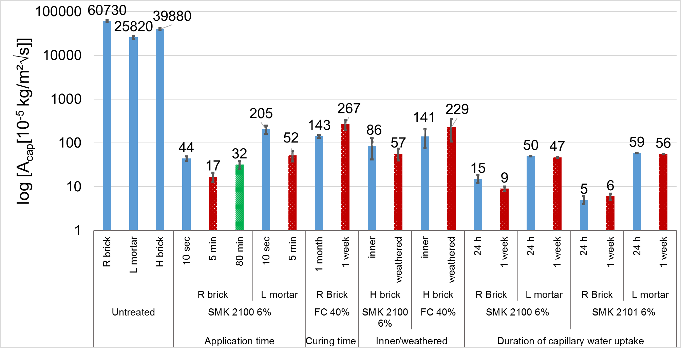
Figure 7: Capillary water uptake. Influence of application time, curing time, type of surface and duration of water exposure on the water absorption coefficient of R brick, L mortar and H brick impregnated with FC 40% and SMK 2100 6%. Each result is an average based on three samples, error bars correspond to standard deviation. Results for untreated samples are shown as reference.

4.3.2 Water vapour diffusion
Next to capillary water absorption, another key issue regarding hydrophobization is whether the vapour diffusion resistance factor (μ) of the material is altered after the hydrophobic treatment. The current findings (Figure 8) support the view that hydrophobic impregnation has a minor effect on the water vapour diffusion resistance factor [5,7,11,13,21]. There is nevertheless a small increase for all materials tested both with a liquid and a cream water repellent agent. In the case of L mortar at high RH, hydrophobization might eliminate the liquid water islands and the difference between untreated and treated samples is more obvious.

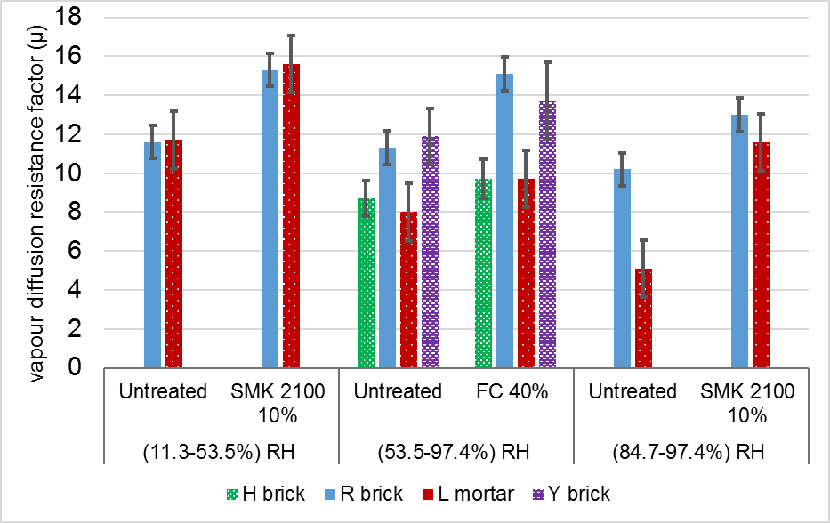
Figure 8: Water vapour diffusion resistance factor (μ) of R brick, L mortar, H brick and Y brick, untreated and impregnated with SMK 2100 10% and FC 40% in different RH range. Each result is an average based on four samples, error bars correspond to standard deviation, for exact values see Table B 2 and Table B 3 Appendix.

5. Discussion
The present study examined the effect of water repellent agents on impregnation depth and on the hygric properties of brick and mortar samples. Silicon-based water repellent agents can create a hydrophobic layer with an increasing impregnation depth over time through the redistribution of the active ingredient, a layer impermeable to liquid water but still permeable to water vapor without major alterations in the pore structure.
Hydrophobic impregnation creates a first, strongly hydrophobized layer as well as a larger volume that is partly hydrophobized [11]. Water uptake tests from the not impregnated side of the 8 cm high samples (see Figure 5) extend our understanding of a well-defined impregnation depth provided by the technical data sheets of water repellent agents [55], indicating that the active ingredient is spread deeper inside the material and the impregnation depth increases for a period of time after impregnation.
Technical data sheets refer to the strongly hydrophobized region as impregnation depth, because in the partly hydrophobized region liquid water transfer could take place. When only the strongly hydrophobized region is considered, the measured values (after one month) of H brick and Y brick (9.5 and 7.7 mm respectively) impregnated with SMK 2100 fall close to the values provided for the SMK 1311 by Wacker (6-11 mm) for ceramic brick [55]. One more parameter that affects the impregnation depth of liquid products in lab environment is the application time. Longer application time leads to more redistribution in the material, as shown by Besien et al. [12]. Both in R brick and L mortar an application time of 10 sec (similar to experiments by [7,8]), leads to lower impregnation depths than an application time of 5 min both in R brick and L mortar during which larger quantities of hydrophobic agent were absorbed (see Table C 1, Appendix). For on-site applications you flood the wall to saturation wet on wet from top to bottom two to three times with liquid products to ensure a large impregnation depth [46,56]. According to [6] 10 to 23 mm impregnation depth is sufficient with a maximum of 40 mm for highly absorbing porous building materials. In cream products it is easier to work with minimum quantities per square meter because the cream is absorbed slowly from the substrate. However, also in cream products the A_{cap} from the not impregnated side is lower when increasing the application rate from 0.5 ml to 2.5 ml, indicating larger impregnation depth (see A_{cap4} Table C 1, Appendix).
The different percentages of silane/siloxane and the different percentages of active ingredient don’t have a major influence on the impregnation depth, especially after long curing periods and water exposure after treatment. However, the substrate has an impact: the active ingredient penetrates deeper in brick than in mortar, for all tested water repellent agents. Moreover, the standard deviation of A_{cap} of the three samples for each case of L mortar treated with liquid products (from the non-impregnated side) is significantly higher, indicating a non-uniform impregnation of the samples in the case of L mortar treated with the liquid products.
Another observation is that the different behavior of the hydrophobic layer is not caused by alterations in the pore structure, since there is almost the same available pore volume space in the hydrophobized material (see Figure 6 (right)) that can be filled after submerging the sample and induce hydrostatic overpressure difference with the vacuum saturation test. The small reduction of the open porosity happens due to a limited extent of clogging in the finer pores [8] and/or the thin polymer chain creation around the perimeter of the pore wall, which is responsible along with the lack of liquid islands, for the small increase of the vapour diffusion resistance factor presented in Figure 8. However, the small shift towards smaller pores in the pore volume distribution curve of hydrophobized mortar and a more obvious change in the open porosity than brick indicates that the finer the pores the higher the possibility of available pore volume reduction in a hydrophobized material.
The different behavior of the hydrophobic layer is caused by the non-polar film (see section 2.1) that is formed on the pore-walls of the porous building materials. This comparatively thin hydrophobic film (0.4 to 1.5 10⁻⁹m for silanes and 3 to 30 10⁻⁹m for siloxanes) [30] impedes liquid transfer, which reduces the drying speed [9,17] but allows water vapour diffusion, since it does not completely occupy the pores of mortar (5 10⁻⁹ to 5 10⁻⁶ m) or brick (10⁻⁶ to 10⁻⁴ m) (see Figure 6), thus not fully impeding the drying of the material.
The present study supports previous findings on impregnated bricks, that reported similar reduction in the capillary water uptake with similar water repellent agents [5,8,10,11,16–18]. However, Hansen et al. [7] reported a high variation in terms of water repellency between different water repellent agents tested both in brick and mortar samples. Different conclusions could be caused by differences on duration of the curing period, cleaning of the samples before impregnation [11], as well as the method of impregnation and not in differences in application time (see Figure 7).
The results reported in this article indicate that the small polymer chain of silane products (0.4–1.5 10⁻⁹m) [30], especially in the case of a building material with coarse pores like brick (10⁻⁶-10⁻⁴ m) (Figure 6), need more curing time and longer water exposure after treatment to reveal improved performance, due to the time needed for hydrolysis and polycondensation to take place. Given that the silane-containing water repellent agents, originally recommended for concrete, need more curing time and after-treatment water exposure but can be very effective in both brick and mortar in terms of water repellency and impregnation depth. In a real case scenario, wind-driven rain would represent the after-treatment water exposure, perhaps increasing the impregnation strength and depth due to the washing-off of the emulsifiers, which permits the active ingredient of the water repellent agent to form stronger bonds with the pore walls of the building material. This is the reason why water-based products that contain emulsifiers, demonstrate a significantly increased performance after exposure to water. Products that contain micro-emulsions, increase their performance after water exposure, but tend to reveal their performance faster. Even the solvent-based product (SNL) shows a small reduction in terms of A_{cap} (Figure 5) but this is the result of the long curing time between the first and second water uptake tests (five months). However, even without after-treatment exposure to water, the obtained A_{cap} is already close to zero.
Although the number of samples for the investigation of the effect of curing time in the current study were limited, combining the findings in Figure 5, Figure 7, with the findings of Zhao and Meissener [11] support the view that with longer curing time the water repellency performance is increased. Another interesting fact is that for all the liquid water repellent agents tested in mortar samples, the active ingredient is absorbed with a slower rate and it needs longer application time, between the sample and the water repellent agent, than brick to be sufficiently impregnated.

6. Conclusions
In this paper the hygric behavior of ceramic bricks and carbonated lime mortar, treated with various water repellent agents, was experimentally studied. The water repellent agents penetrate deep into the materials, successfully blocking capillary effects, while still allowing water vapor diffusion, without notable alterations in the pore structure of the material. Moreover, water exposure after treatment increases the water repellency performance of the hydrophobic layer.
Future studies should include more types of mortar, especially mortars used for brickwork in historic buildings. Moreover, future research would benefit from focusing on durability tests, to study the long-term effect of the water repellency. Also hygrothermal simulations based on experimental data and real experiments in the component level will contribute towards a holistic view of hydrophobization.

Acknowledgements
The present study is part of the project ‘Moisture safe energy renovation of worth preserving external masonry walls’, funded by the Danish foundations: The Landowners' Investment Foundation, The National Building Fund and Realdania. This study is also part of RIBuild project that has received funding from Horizon 2020 under grant agreement No 637268. The authors express sincere thanks to Philip X.S. Møller (Introflex-Remmers) and Hamont Corne van (Wacker) for providing the water repellent agents and to Jimmy Van Criekingen and Bernd Salaets (KU Leuven) for cutting the samples.

Bibliography

[1] EC Adhoc Industrial Advisory Group, Energy efficient buildings Public-Private Partnership (PPP): Multi annual roadmap and longer term strategy, Brussels, 2010. https://doi.org/doi:10.2777/10074.
[2] M. Jerman, I. Palomar, V. Kočí, R. Černý, Thermal and hygric properties of biomaterials suitable for interior thermal insulation systems in historical and traditional buildings, Build. Environ. 154 (2019) 81–88. https://doi.org/10.1016/j.buildenv.2019.03.020.
[3] M. Guizzardi, D. Derome, R. Vonbank, J. Carmeliet, Hygrothermal behavior of a massive wall with interior insulation during wetting, Build. Environ. 89 (2015) 59–71. https://doi.org/10.1016/j.buildenv.2015.01.034.
[4] E. Vereecken, Hygrothermal Analysis of Interior Insulation for Renovation Projects, KU Leuven, 2013. https://doi.org/LIRIAS1729285.
[5] J. Engel, P. Heinze, R. Plagge, Adapting hydrophobizing impregnation agents to the object, Hydrophobe VII7th Int. Conf. Water Repel. Treat. Prot. Surf. Technol. Build. Mater. 20 (2014) 141–150. https://doi.org/https://doi.org/10.12900/rbm14.20.6-0042.
[6] E. Wendler, E. Von Plehwe-Leisen, Water repellent treatment of porous materials. A new edition of the WTA leaflet, in: Hydrophobe V, Fifth Int. Conf. Water Repel. Treat. Build. Mater., 2008: pp. 155–167. http://www.hydrophobe.org/pdf/bruxelles/V_13.pdf.
[7] T.K. Hansen, S.P. Bjarløv, R.H. Peuhkuri, K.K. Hansen, Performance of hydrophobized historic solid masonry – Experimental approach, Constr. Build. Mater. 188 (2018) 695–708. https://doi.org/10.1016/j.conbuildmat.2018.08.145.
[8] J. Carmeliet, G. Houvenaghel, J. Van Schijndel, S. Roels, Moisture phenomena in hydrophobic porous building material Part 1: Measurements and physical interpretations / Wechselwirkung hydrophobierter poröser Werkstoffe des Bauwesens mit Feuchtigkeit, Teil 1: Messungen und physikalische Interpretationen, Restor. Build. Monum. 8 (2002) 165–183. https://doi.org/https://doi.org/10.1515/rbm-2002-5660.
[9] K. Sandin, Surface treatment with water repellant agents, in: Hydrophobe I, Delft, 1995: pp. 1–9. http://hydrophobe.org/pdf/delft/I_18.pdf.
[10] H. Kober, Water thinnable silicone impregnating agents for masonry protection, in: Hydrophobe I Delft, 1995: pp. 1–13. http://www.hydrophobe.org/pdf/delft/I_3.pdf.
[11] J. Zhao, F. Meissener, Experimental investigation of moisture properties of historic building material with hydrophobization treatment, Energy Procedia. 132 (2017) 261–266. https://doi.org/10.1016/j.egypro.2017.09.716.
[12] T. Van Besien, S. Roels, J. Carmeliet, A laboratory study of the efficiency of a hydrophobic treatment of cracked porous building materials, in: 2nd Int. Conf. Build. Phys., 2003: pp. 1–7. https://www.irbnet.de/daten/iconda/CIB2372.pdf.
[13] K. Fukui, C. Iba, S. Hokoi, Moisture behavior inside building materials treated with silane water repellent, Energy Procedia. 132 (2017) 735–740. https://doi.org/10.1016/j.egypro.2017.10.018.
[14] H. Janssen, B. Blocken, S. Roels, J. Carmeliet, Wind-driven rain as a boundary condition for HAM simulations: Analysis of simplified modelling approaches, Build. Environ. 42 (2007) 1555–1567. https://doi.org/10.1016/j.buildenv.2006.10.001.
[15] A. Erkal, D. D’Ayala, L. Sequeira, Assessment of wind-driven rain impact, related surface erosion and surface strength reduction of historic building materials, Build. Environ. 57 (2012) 336–348. https://doi.org/10.1016/j.buildenv.2012.05.004.
[16] J. Šadauskienė, J. Ramanauskas, V. Stankevičius, Effect of Hydrophobic Materials on Water Impermeability and Drying of Finish Brick Masonry, in: Issn Mater. Sci., 2003: pp. 1392–1320. https://www.researchgate.net/profile/Jolanta_Sadauskiene/publication/237779777_Effect_of_Hydrophobic_Materials_on_Water_Impermeability_and_Drying_of_Finish_Brick_Masonry/links/53fb1c580cf27c365cf06ef8.pdf.
[17] V. Soulios, E.J. de Place Hansen, H. Janssen, Hygric properties of hydrophobized building materials, in: MATEC Web Conf., Prague, 2019: pp. 1–6. https://doi.org/https://doi.org/10.1051/matecconf/201928202048.
[18] T. Kvist Hansen, S.P. Bjarløv, R. Peuhkuri, Moisture transport properties of brick – comparison of exposed, impregnated and rendered brick, in: Proc. Int. RILEM Conf. - Mater. Syst. Struct. Civ. Eng. Segm. Moisture Mater. Struct., 2016: pp. 351–360. http://orbit.dtu.dk/ws/files/128040737/Pages_from_Moisture_conf_proceedings_3.pdf.
[19] Momentive AG, Silblock wms Technical data sheet, (2011) 1–4. https://www.momentive.com/docs/default-source/productdocuments/silblock-wms/silblock-wms-mb-indd.pdf?sfvrsn=d50e61c_14.
[20] H. De Clercq, E. De Witte, Effectiveness of commercial silicon based water repellents applied under different conditions, Restor. Build. Monum. an Int. J. = Bauinstandsetz. Und Baudenkmalpfl. Eine Int. Zeitschrift. 8 (2002) 149–164. https://doi.org/https://doi.org/10.1515/rbm-2002-5659.
[21] A.E. Charola, Water-Repellent Treatments for Building Stones: A Practical Overview, APT Bull. J. Preserv. Technol. 26 (1995) 10–17. https://doi.org/10.2307/1504480.
[22] M. Roos, F. König, S. Stadtmüller, B. Weyershausen, Evolution of silicone based water repellents for modern building protection, 5th Int. Conf. Water Repel. Treat. Build. Mater. 16 (2008) 3–16. http://www.hydrophobe.org/pdf/bruxelles/V_01.pdf.
[23] E.B. Møller, C. Rode, Hygrothermal Performance and Soiling of Exterior Building Surfaces, Technical University of Denmark, 2004. https://orbit.dtu.dk/files/5285541/byg-r068.pdf.
[24] B. Lubelli, R.P.J. van Hees, Evaluation of the effect of nano-coatings with water repellent properties on the absorption and drying behavour of brick, in: Hydrophobe VI Proc. 6th Int. Conf. Water Repel. Treat. Build. Mater., 2011: pp. 125–135. http://www.hydrophobe.org/pdf/rome/VI_12.pdf.
[25] J. MacMullen, Z. Zhang, E. Rirsch, H.N. Dhakal, N. Bennett, Brick and mortar treatment by cream emulsion for improved water repellence and thermal insulation, Energy Build. 43 (2011) 1560–1565. https://doi.org/10.1016/j.enbuild.2011.02.014.
[26] M. Stefanidou, A. Karozou, Testing the effectiveness of protective coatings on traditional bricks, Constr. Build. Mater. 111 (2016) 482–487. https://doi.org/10.1016/j.conbuildmat.2016.02.114.
[27] K. Ren, D. Kagi, Evaluation of an oil and water repellent on masonry substrates, in: Hydrophobe VIII, Hongkong, 2017: pp. 44–52. http://www.hydrophobe.org/pdf/hongkong/A-1-3.pdf.
[28] Wacker Chemie AG, Silres® bs smk 2101, Technical data sheet, (2014) 3–4. https://www.brenntag.com/media/documents/bsi/product_data_sheets/material_science/wacker_silicone_resins/silres_bs_smk_2101_pds.pdf.
[29] A. Syed, M. Donadio, Silane Sealers / Hydrophobic Impregnation - The European Perspective, (2013) 1–6. https://cdn.ymaws.com/www.icri.org/resource/resmgr/crb/2013septoct/CRBSeptOct13_Syed-Donadio.pdf.
[30] Sika Services AG, Refurbishment Sika Technology and Concepts for Hydrophobic Impregnations, (2017) 1–20.
[31] H. Mayer, Masonry protection with silanes, siloxanes and silicone resins, Surf. Coatings Int. 81 (1998) 89–93. https://doi.org/10.1007/BF02692337.
[32] T. Szymura, D. Barnat-hunek, Protection of Stone Building Structures Against Corrosion Caused by Moisture, in: 2013: pp. 65–76. http://br.wszia.edu.pl/zeszyty/pdfs/br32_07szymura.pdf.
[33] Wacker Chemie AG, Silres® bs 38, Technical data sheet, (2011) 1–2. https://www.brenntag.com/media/documents/bsi/product_data_sheets/material_science/wacker_silicone_resins/silres_bs_38_pds.pdf.
[34] Technichem S.A., Technisil Hydro Plus, W.T.C.B., (2005) 1–2.
[35] Rewah N.V, OLEOFUGE F, Technical data sheet, (2018) 1–3. http://www.rewah.com/images/products/166/technicalsheet.pdf?refresh=1572963183.
[36] E. De Witte H. De Clercq R. De Bruyn A. Pien, Systematic Testing of Water Repellent Agents, Restor. Build. Monum. 2 (1996) 133–144. https://doi.org/https://doi.org/10.1515/rbm-1996-5093.
[37] A.E. Charola, Water Repellents and Other “ Protective ” Treatments : A Critical Review, in: Hydrophobe III. 3rd Int. Conf. Surf. Technolgy with Water Repel. Agents. Aedif. Publ., 2001: pp. 3–20. http://www.hydrophobe.org/pdf/hannover/III_01.pdf.
[38] Rewah N.V, ARTISIL B10, Technical data sheet, (2016) 1–2. http://www.rewah.com/images/products/12/technicalsheet.pdf.
[39] D. Corning, Dow Corning® Z-6689 Water Repellent, Safety data sheet, (2017) 1–4. https://www.dow.com/en-us/pdp.dowsil-z-6689-water-repellent.04023290z.html.
[40] Hilde De Clercq, RC 805 ECO REYNCHEMIE NV, Test report, (2004) 1–10. http://www.reynchemie.com/Content/Bestanden/20123-RC805ECO-KIK-nl.pdf.
[41] J. Todorović, H. Janssen, The impact of salt pore clogging on the hygric properties of bricks, Constr. Build. Mater. 164 (2018) 850–863. https://doi.org/10.1016/j.conbuildmat.2017.12.210.
[42] Ö. Cizer, K. Van Balen, J. Elsen, D. Van Gemert, Real-time investigation of reaction rate and mineral phase modifications of lime carbonation, Constr. Build. Mater. 35 (2012) 741–751. https://doi.org/10.1016/J.CONBUILDMAT.2012.04.036.
[43] Wacker Chemie AG, Silres ® bs smk 1311, Technical data sheet, (2014) 1–3. http://www.vardhmanpolymers.com/wp-content/uploads/2019/01/1311.pdf.
[44] Wacker Chemie AG, Silres ® bs smk 2100, Technical data sheet, (2014) 1–2.
[45] Remmers AG, Funcosil SNL, Technical data sheet, (2016) 1–3. http://www.stonewarestudios.com/PDF/Damp Control/Funcosil SNL.pdf.
[46] Remmers AG, Funcosil WS, Technical data sheet, (2016) 1–2. http://www.bg.remmers.com/fileadmin/dam/produkte/tm/TM1_0614_EN.pdf.
[47] Remmers AG, Funcosil FC, Technical data sheet, (2016) 1–3. https://www.introflex.dk/images/pdf/DK_0711_-_08_13.pdf.
[48] Rewah NV, GELIFUGE NEW, Technical data sheet, (2016) 1–3. http://www.rewah.com/images/products/121/technicalsheet.pdf.
[49] ASTM C1699-09, Standard Test Method for Moisture Retention Curves of Porous Building Materials Using Pressure Plates, (2015). https://doi.org/10.1520/C1699-09R15.
[50] C. Feng, H. Janssen, Y. Feng, Q. Meng, Hygric properties of porous building materials: Analysis of measurement repeatability and reproducibility, Build. Environ. 85 (2015) 160–172. https://doi.org/10.1016/J.BUILDENV.2014.11.036.
[51] ASTM D4404-18, Standard Test Method for Determination of Pore Volume and Pore Volume Distribution of Soil and Rock by Mercury Intrusion Porosimetry, (2018). https://doi.org/10.1520/D4404-18.
[52] ISO 15148 : 2002, Hygrothermal performance of building materials and products Determination of water absorption coefficient by partial immersion, English version of DIN EN ISO 15148, (2003) 1–14.
[53] C. Feng, H. Janssen, Hygric properties of porous building materials (III): Impact factors and data processing methods of the capillary absorption test, Build. Environ. 134 (2018) 21–34. https://doi.org/10.1016/j.buildenv.2018.02.038.
[54] ISO 12572, Hygrothermal performance of building materials and products -transmission properties -Cup method, (2016) 1–5. https://www.sis.se/api/document/preview/920749/.
[55] Wacker Chemie AG, Hydrophobic impregnation with Silres BS, (2017) 1–22.
[56] Sika Services AG, Sikagard ® -700 S Technical data sheet, (2016) 1–3.

Appendix A Commercially available water repellent agents
Table A 1: Commercially available water repellent agents suitable for mineral substrates identified for this study.
 | Company | Product | Form | Diluent | Conc. | Substrate
No | Silanes
1 | WACKER | BS CREME C | Cream | water | 80% | concrete
2 | WACKER | BS 1701 | Liquid | undiluted | 99% | concrete
3 | WACKER | BS 17040 | Liquid | water | 40% | concrete
4 | WACKER | BS 16040 | Liquid | water | 40% | concrete
5 | SIKA | 706 Thixo | Cream | water | 80% | concrete
6 | SIKA | 705 L | Liquid | undiluted | 99% | concrete
7 | SIKA | 740 W | Liquid | water | 40% | concrete
8 | REMMERS | Funcosil IC | Cream | water | 80% | concrete
9 | REMMERS | Funcosil FC | Cream | water | 40% | masonry
10 | DOW | OFS-2306 | Liquid | solvent | 96% | mineral
11 | DOW | IE 6682 | Liquid | water | 52,5% | mineral
12 | MOMENTIVE | Silblock wms | Liquid | water | 40% | mineral
13 | REYNCHEMIE | RC SILAN | Liquid | solvent | 98% | concrete
14 | PEC | ENVIROSEAL 20 | Liquid | water | 20% | concrete
15 | REWAH | ARTISIL B10 | Liquid | solvent | 10% | concrete
16 | REYNCHEMIE | RC 900 | Liquid | solvent | 10% | mineral
 | Silane/Siloxane mixture
17 | WACKER | BS N | Cream | solvent | 25% | mineral
18 | WACKER | BS 280 | Liquid | solvent | 100% | mineral
19 | WACKER | BS 290 | Liquid | solvent | 100% | mineral
20 | WACKER | BS 39 | Liquid | water | 25% | mineral
21 | WACKER | BS 1001 | Liquid | water | 50% | mineral
22 | WACKER | BS 3003 | Liquid | water | 60% | mineral
23 | WACKER | BS 4004 | Liquid | water | 50% | mineral
24 | WACKER | BS SMK 1311 | Liquid | water | 100% | mineral
25 | WACKER | BS SMK 2100 | Liquid | water | 100% | mineral
26 | WACKER | BS SMK 2101 | Liquid | water | 100% | concrete
27 | DOW | Z-6689 | Liquid | solvent | 98% | mineral
28 | DOW | IE 6683 | Liquid | water | 40% | mineral
29 | DOW | 520 | Liquid | water | 40% | mineral
30 | DOW | IE 6694 | Liquid | water | 60% | mineral
31 | Facabelle | Fassapearl S | Liquid | solvent | 10% | mineral
32 | Facabelle | Technifuge A104 | Liquid | solvent | 10% | mineral
33 | Facabelle | Fassapearl H | Liquid | water | 10% | mineral
34 | REYNCHEMIE | RC III | Cream | water | 40% | mineral
35 | REYNCHEMIE | RC IV | Cream | water | 40% | mineral
36 | REYNCHEMIE | RC 805 | Liquid | water | 7,5% | mineral
37 | SIKA | 700 S | Liquid | solvent |  | mineral
38 | SIKA | 704 S | Liquid | solvent |  | concrete
39 | SIKA | 703 W | Liquid | water |  | mineral
40 | REMMERS | C40 | Cream | water | 40% | concrete
41 | REMMERS | WS | Liquid | water | 10% | mineral
42 | REWAH | GELIFUGE | Gel | solvent | 25% | masonry
43 | REWAH | STONEGEL | Gel | water | 25% | mineral
44 | Soudal | Soudaclear S | Liquid | solvent | 8% | mineral
45 | Soudal | Soudaclear W | Liquid | water | 6,5% | mineral
46 | PEC | ENVIROSEAL B | Liquid | water | 7% | masonry
47 | SCALP | Scalpfuge 35 | Liquid | water |  | masonry
 | Siloxanes
48 | Facabelle | Fassapearl-Gel | Cream | water | 25% | mineral
49 | REMMERS | SNL | Liquid | solvent | 7% | mineral
50 | REYNCHEMIE | RC IP500 | Liquid | solvent | 10% | mineral
51 | DOW | 1 _ 6184 | Liquid | water | 98% | masonry
52 | REMMERS | SL | Liquid | solvent | 7% | masonry
53 | BLUESTAR | WR 224 | Liquid | solvent | 69% | mineral
54 | BLUESTAR | BP-9400 | Liquid | solvent | 100% | mineral
55 | Facabelle | TECHNISIL hydro | Liquid | water | 10% | mineral
56 | REYNCHEMIE | RC SILOX | Liquid | solvent | 100% | mineral
57 | REYNCHEMIE | RC 224 | Liquid | solvent | 10% | mineral
58 | WACKER | BS 66 | Liquid | solvent | 100% | mineral
59 | REWAH | REDISIL S | Liquid | solvent | 10% | masonry
60 | REWAH | RS 8 | Liquid | water | 8% | masonry
61 | BLUESTAR | BP 9710 | Liquid | water | 44% | mineral
 | Silicone resins
62 | BLUESTAR | RES 4518 | Liquid | solvent | 70% | mineral
63 | DOW | MR 2404 | Liquid | solvent | 88,0% | mineral
64 | SCALP | AQUAFUGE 18 | Liquid | water |  | mineral
 | Organic
65 | REMMERS | OFS | Liquid | water |  | mineral
66 | APP | ThefAPP | Liquid | water | 3,1% | mineral
67 | APP | APPHD | Liquid | water | 1,9% | concrete
68 | REYNCHEMIE | RC 808 | Liquid | water | 10% | mineral
 | Silicon & Organic
69 | Facabelle | TECHNISIL Hydro plus | Liquid | water | 10% | mineral
70 | REWAH | OLEOFUGE F | Liquid | water | 10% | mineral
71 | Wacker | BS 38 | Liquid | solvent | 46% | mineral
72 | REYNCHEMIE | RC 806 | Liquid | water | 10% | mineral
 | Metal bearing
73 | SCALP | OM 70 | Liquid | solvent |  | mineral
 | Silicon & Metal bearing
74 | REWAH | ECONOSIL | Liquid | solvent | 10% | masonry
75 | Facabelle | A101 | Liquid | solvent | 10% | mineral
76 | REWAH | AVT | Liquid | solvent | 8% | masonry
 | Siliconates
77 | PEC | Thoro clear special | Liquid | water | 5,5% | limestone

Appendix B Hygric properties

Table B 1: Vacuum satruration test results. Comparison between untreated and impregnated with SMK 2100 10 % R brick and L mortar.
 | R brick |  | L mortar
 | Untreated | Impregnated | Untreated | Impregnated
Bulk density [kg/m³] | 1886.1 (35.8) | 1900.7 (33.2) | 1804.3 (5.7) | 1830.2 (11.3)
Moisture content w_{sat} [kg/m3] | 312.4 (14.8) | 296.8 (12.9) | 312.5 (2.1) | 248.2 (21.4)
Open porosity Φ [%] | 31.3 (1.5) | 29.7 (1.3) | 31.3 (0.2) | 24.9 (2.1)
Matrix density [kg/m³] | 2745.6 (9.8) | 2705.4 (5.8) | 2626.2 (2.2) | 2437.6 (73.6)
The values in brackets corresponds to the standard deviation of the measurements.

Table B 2: Cup tests, comparison between untreated and impregnated with SMK 2100 10 %, R brick and L mortar.
 |  | R brick | L mortar
Untreated, dry (11.3-53.5%) | δ_{v} [10⁻¹¹ kg/(msPa)] | 1.7 (0.1) | 1.7 (0.04)
Untreated, dry (11.3-53.5%) | μ | 11.6 (0.5) | 11.7 (0.3)
Untreated, wet (84.7-97.4%) | δ_{v} [10⁻¹¹ kg/(msPa)] | 1.9 (0.1) | 3.9 (0.2)
Untreated, wet (84.7-97.4%) | μ | 10.2 (0.5) | 5.1 (0.3)
SMK 2100 10%, dry (11.3-53.5%) | δ_{v} [10⁻¹¹ kg/(msPa)] | 1.3 (0.05) | 1.3 (0.1)
SMK 2100 10%, dry (11.3-53.5%) | μ | 15.3 (0.6) | 15.6 (1)
SMK 2100 10%, wet (84.7-97.4%) | δ_{v} [10⁻¹¹ kg/(msPa)] | 1.5 (0.1) | 1.7 (0.01)
SMK 2100 10%, wet (84.7-97.4%) | μ | 13 (0.6) | 11.6 (0.1)

Table B 3: Cup tests, comparison of untreated and impregnated with FC 40 % R brick, H brick, Y brick and L mortar.
 |  | R brick | H brick | Y brick | L mortar
Untreated | δ_{v} [10⁻¹¹ kg/(msPa)] | 1.8 (0.2) | 2.3 (0.2) | 1.7 (0.2) | 2.5 (0.1)
Untreated | μ_{(53.5-97.4%)} | 11.3 (1.2) | 8.7 (0.9) | 11.9 (1.4) | 8.0 (0.4)
FC 40% | δ_{v} [10⁻¹¹ kg/(msPa)] | 1 (0.8) | 2 (0.2) | 1 (0.2) | 2 (0.1)
FC 40% | μ_{(53.5-97.4%)} | 15.1 (0.9) | 9.7 (1) | 13.7 (2) | 9.7 (0.7)

Appendix C Hygric behavior of hydrophobized building materials
Table C 1: Impregnation depth with visual inspection (dp), agent absorbed and water absorption coefficient (A_{cap}) of R brick, H brick, Y brick and L mortar (8x4x4 cm samples).
 | Liquid products
Agent | SMK 2101 |  |  |  |  |  | SMK 1311 |  |  |  |  |  | SMK 2100 |  |  |  |  |  |  |  | SNL | WS
Conc. | 6% |  | 10% |  | 25% |  | 6% |  | 10% |  | 25% |  | 6% |  |  |  | 10% |  | 25% |  | 7% | 10%
Material | R brick | L mortar | R brick | L mortar | R brick | L mortar | R brick | L mortar | R brick | L mortar | R brick | L mortar | R brick | L mortar | H Brick | Y Brick | R brick | L mortar | R brick | L mortar | R brick | R brick
d_{p} (5 min)  (mm) | 26.7  (4.6) | 6.8  (0.2) | 22.8  (2.1) | 8.3  (0.3) | 23.3  (1.1) | 9.0  (0.9) | 23.3  (0.7) | 8.4  (0.7) | 23.0  (1.2) | 8.9  (1.4) | 21.4  (0.9) | 8.9  (0.5) | 26.0  (1.3) | 8.6  (1.5) | 27.2  (2.9) | 17.8  (1.6) | 23.2  (1.2) | 9.3  (0.6) | 22.1  (3.1) | 11.4  (1.0) | 31.2  (2.4) | 32.7  (2.7)
d_{p} (1 month)  (mm) | 28.5  (3.0) |  | 28.4  (3.0) |  | 31.2  (1.2) |  | 26.3  (0.9) |  | 29.5  (1.1) |  | 29.5  (2.4) | 9.0  (0.5) | 30.6  (0.0) |  | 9.5*  (0.5) | 7.7*  (0.1) | 31.5  (1.4) |  | 28.0  (3.0) | 12.0  (0.9) | 42.6  (0.8)
Agent absorbed (ml) | 8.2  (0.8) | 5.8  (0.3) | 6.7  (1.5) | 5.0  (0.0) | 7.8  (0.3) | 4.5  (0.5) | 8.2  (0.3) | 6.7  (0.6) | 8.8  (0.3) | 5.0  (0.0) | 6.8  (0.8) | 4.3  (0.6) | 8.7  (0.6) | 7.7  (0.6) | 6.5  (0.7) | 5.5  (0.5) | 9.0  (0.0) | 5.3  (0.6) | 6.3  (0.6) | 3.8  (0.3) | 8.5  (0.8) | 8.3  (0.7)
A_{cap1}[10⁻⁵  kg/m²√s] | 492  (127) | 79  (27) | 633  (159) | 76  (4) | 2565  (130) | 460  (623) | 11  (1) | 43  (11) | 18  (3) | 39  (9) | 18  (3) | 57  (4) | 17  (4) | 52  (14) | 66  (34) | 28  (3) | 24  (2) | 61  (10) | 18  (2) | 62  (7) | 7  (3) | 3333  (78)
A_{cap2} [10⁻⁵]  (repeat) | 5  (1) | 59  (1) | 7  (2) | 52  (1) | 8  (1) | 44  (1) | 5  (1) | 55  (1) | 7  (2) | 49  (3) | 6  (1) | 53  (2) | 15  (3) | 50  (1) | 31  (12) | 17  (1) | 18  (4) | 47  (3) | 13  (3) | 51  (2) | 4  (2) | 437  (28)
A_{cap3} [10⁻⁵]  (repeat) |  |  | 6  (0.3) |  |  |  |  |  |  |  |  |  |  |  |  |  |  |  |  |  |  | 104  (160)
A_{cap4} [10⁻⁵]  not imp side | 36  (16) | 364  (250) | 51  (16) | 815  (764) | 39  (9) | 880  (1212) | 30  (2) | 497  (521) | 32  (5) | 2976  (1304) | 31  (7) | 1532  (2473) | 49  (13) | 2901  (2458) | 121  (85) | 117  (100) | 56  (14) | 4435  (1085) | 67  (17) | 4595  (79) | 76  (28) | 40  (7)
A_{cap5} [10⁻⁵]  not imp side (repeat) |  |  |  |  |  |  |  |  |  |  |  |  |  |  |  |  |  | 1572  (2276) |  | 4113  (100)

 | Cream products |  |  |  |  |  |  |  |  |  |  |  |  | Liquid products
Agent | FC cream |  |  |  |  |  |  |  |  |  |  |  |  | SMK 2100
Conc. | 10% |  | 20% |  | 40% |  |  |  | 80% |  | 40% (2.5 ml) |  | 40% (1 week) | 2% |  | 6% (10 sec)
Material | R brick | L mortar | R brick | L mortar | R brick | L mortar | H Brick | Y Brick | R brick | L mortar | R brick | L mortar | R brick | R brick | L mortar | R brick | L mortar
d_{p} (5 min)  (mm) |  |  |  |  |  |  | 2.6  (0.4) | 2.4  (0.2) |  |  | 24.0  (2.1) | 14.9  (1.1) | 9.2  (0.6) | 40.7  (1.4) | 11.8  (1.3) | 14.2  (0.3) | 7.4  (0.3)
d_{p} (1 month)  (mm) |  |  |  |  |  |  |  |  |  |  |  |  |  |  |  | 15.5  (0.3)
Agent absorbed  (ml) | 0.5 | 0.5 | 0.5 | 0.5 | 0.5 | 0.5 | 0.5 | 0.5 | 0.5 | 0.5 | 2.5 | 2.5 | 0.5 | 9.0  (1.0) | 8.5  (1.3) | 2.2  (1.0) | 2.3  (1.2)
A_{cap1}  [10⁻⁵kg/m²√s] | 141  (35) | 322  (370) | 199  (87) | 151  (112) | 143  (11) | 80  (2) | 185  (95) | 92  (72) | 211  (5) | 89  (15) |  |  | 267  (71) | 38  (6) | 74  (10) | 44  (5) | 205  (43)
A_{cap2} [10⁻⁵]  (repeat) | 43  (26) | 101  (29) | 41  (48) | 129  (70) | 24  (9) | 91  (7) | 70  (27) | 18  (2) | 32  (11) | 92  (10) |  |  |  |  |  | 33  (3) | 66  (0.6)
A_{cap3} [10⁻⁵]  (repeat) |  |  |  |  | 5.5  (2.3) | 46.1  (2.5)
A_{cap4} [10⁻⁵]  not imp side | 3417  (68) | 5883  (85) | 3028  (462) | 5782  (234) | 3039  (84) | 5687  (11) | 2575  (253) | 2858  (560) | 2106  (168) | 5257  (281) | 235  (94) | 3305  (243)
A_{cap5} [10⁻⁵]  not imp side (repeat) |  |  |  |  | 258  (400) | 436  (37)
The values in brackets corresponds to the standard deviation of the measurements. * The impregnation depth was higher but this was the only visible darker surface with visual inspection after one month. The impregnation depth corresponds to the strong hydrophobized region plus the partly hydrophobized region.

