JOURNAL PAPER

Title:

Hygrothermal performance of hydrophobized and internally insulated masonry walls - Simulating the impact of hydrophobization based on experimental results.

Authors:

Vasilis Soulios^{1*}, Ernst Jan de Place Hansen¹, Ruut Peuhkuri¹

¹: Department of the Built Environment, Aalborg University, Denmark

* Corresponding author. Tel.: +45 29271705
E-mail address: vsou@build.aau.dk

Abstract
Buildings are accountable for around 40% of the European energy consumption. Installing thermal insulation is an effective approach to improve the energy efficiency of the building envelope. Internal insulation is often the only renovation option in the case of historic buildings with worth-preserving masonry façades. However, it can lead to several moisture problems related to the rain load, such as mould growth, wood rot and frost damage. Hydrophobizing the façade reduces water absorption by the materials, while decreasing their drying rate, threatening the desired outcome. The paper evaluates the impact of hydrophobization when combined with internal insulation. To understand the hygrothermal effect of hydrophobization on internally insulated walls, it is important to examine how the hydrophobic layer of the masonry can be accurately modelled and how the hygrothermal response of the wall configuration changes after treatment. A significant increase in the thermal conductivity of capillary saturated samples compared to dry samples was experimentally measured. The hydrophobic model is able to predict the hygrothermal behavior of the hydrophobized brick, using experimental results from water uptake and drying tests as reference, as well as in the component level, using as reference relative humidity and temperature measurements in a mock-up wall. The current results indicate that hydrophobization contributes positively towards a moisture-safe construction with reduced heat losses when applied before or in parallel with internal insulation. These findings confirm that hydrophobization can successfully be combined either with a capillary-active or a water-vapor-tight internal insulation system, providing a moisture-safe energy renovation of building enclosures.

Introduction
In the EU Member states, the building stock accounts for about 40% of the total energy consumption [1], and 10-40% of the building stock in each country consists of historic buildings (constructed before 1950) [2]. Denmark among other countries is targeting towards the sustainable energy-independent city of tomorrow where the maintenance of cultural heritage is of primary importance, requiring a renovation of the building enclosure. Historic buildings are responsible for a sizable fraction of the energy consumption by the built environment, as they typically lack thermal insulation. Approximately 33% of total heat loss in poorly insulated buildings is contributed to external walls [3]. Often such buildings have worth preserving facades making internal insulation the only feasible technique [4].
However, internal insulation significantly modifies the hygrothermal performance of the façade, yielding in moisture-related problems like frost damage, wooden beam decay, interstitial condensation, and mould growth [5,6]. In cold periods of the year, the temperature of the original structure becoming lower due to applying internal insulation makes the construction more vulnerable to moisture loads from inside. Preventing access of humid indoor air in the interface between the original wall and the internal insulation is one of the key challenges in ensuring moisture safe solutions. However, the moisture load from outside, and especially absorption of the wind-driven rain, add to the harmful impacts of moisture on internally insulated walls [7,8]. Hydrophobization of the exterior surface may have a potential to be the unique missing element for a sustainable moisture-safe energy renovation of historic buildings since it minimizes the water absorption by the façade materials [9–11].
To be able to design and assess the effect of hydrophobization on the hygrothermal behavior of internally insulated facades, the hydrophobic layer of the façade must be modeled in a realistic way. A few attempts have been made to include the effect of hydrophobization in numerical hygrothermal simulation models: by modeling the simulation of the hydrophobic layer as a water-tight surface with an additional surface diffusion resistance of 0.2 m [12], by reducing the absorption of wind-driven rain to 1% [13] or by neglecting the wind-driven rain [14,15]. Further, it is indicated that small cracks (up to 1 mm) created before impregnation, do not affect hydrophobization if thoroughly impregnated [12]. All three studies conclude that hydrophobization improves the hygrothermal performance of both uninsulated and internally insulated walls.
However, these attempts to model the hydrophobized layer may be too simple as the hydrophobic impregnation significantly alternates the behavior of a porous building material [9,11,16–20], hence creating a ‘’new” material with different properties. One previous attempt to simulate the hydrophobic layer as a new separate wall element has been made [21,22], but the modified material properties were based on limited experimental results or speculations.
The current study presents an improved attempt to model the hydrophobic layer based on experimental results measuring the hygric properties (presented in [9]) and thermal properties (presented in the current article) of brick. These are used as input parameters to the model and the attempt is to transfer the effect of hydrophobization from the material level to the component level through hygrothermal simulations in Delphin software [23].
The difference in thermal conductivity between dry and wet brick and mortar samples is found to be much larger [3] than presented in the thermal conductivity function in Delphin software [23]. Thus, an experimental work to determine the thermal conductivity of dry and capillary saturated brick and mortar samples is presented in order to update the Delphin thermal conductivity function.
Although the temperature and relative humidity in different points of the wall assembly of internally insulated buildings [24–27] have been monitored, the combined effect of hydrophobization with internal insulation has been measured only with mock-up walls [19,28,29]. The impact of combining hydrophobization with internal insulation in real inhabited buildings and the long term performance of such buildings through hygrothermal simulations should be further investigated. The average moisture content in the masonry, the risk of mould growth in the interface between masonry and internal insulation, and the additional potential energy savings of hydrophobization by keeping the wall dry would be important topics.
The main aim of this paper is to evaluate the hygrothermal performance when combining hydrophobization with internal insulation and to accurately model the behavior of the hydrophobic layer (labelled ‘hydrophobic model’). Serving the above-mentioned aim, the paper describes the input for the hydrophobic model and presents difference in thermal conductivity between dry and capillary saturated building materials. Further, it is validated whether the hydrophobic model captures the basic behavior of wetting and drying by duplicating in Delphin, the capillary absorption test and the drying test that have been conducted in the laboratory. Moreover, the hydrophobic model is validated with a mock-up wall through the comparison of relative humidity (RH) and temperature (T) in the interface between masonry and internal insulation. Subsequently, the effect of hydrophobization, when combined with internal insulation, is investigated, quantified by calculating the average moisture content in the masonry, the mould growth in the interface between masonry and internal insulation, the accumulated heat loss and the additional energy savings due to hydrophobization. Moreover, a parametric analysis is carried out taking into account orientation, climate, masonry and insulation thickness, hydrophobization before/after internal insulation, weak impregnation, and potential risk of wood degradation. Finally, the paper presents the measurements of RH in the interface between masonry and internal insulation of an inhabited Danish dwelling where the water repellent agents applied two years after internal insulation.

Methods

Hydrophobic model

Hygric properties
The complete characterization of the hygric properties of a building material requires the definition of the moisture retention curve and the moisture permeability curve. However, extracting the curves to a full extent with the existing experimental procedures is impeded, since liquid transport is significantly reduced as a result of hydrophobization [9–11,16–18,22,30,31]. Therefore for this study, values for hygric properties are derived from laboratory tests performed at hydrophobized samples [9]. This adjustment scales the moisture retention and permeability curves accordingly as well as the vapour permeability curve.
Storage properties
A previous experimental study [9] does not indicate a significant change in the moisture storage properties after hydrophobization, especially in materials with coarse pores, such as brick. In the current model, the open porosity and by extension, the moisture retention curve, are left untouched.
Transport properties
The transport properties change significantly in terms of reduced absorption coefficient (A_{cap}), whereas the vapour diffusion resistance factor (μ-value) remains almost the same both in brick and mortar [9]. Therefore, to represent a hydrophobized brick via a model that can be used for hygrothermal simulations, the absorption coefficient is reduced and this scales down the moisture permeability curve, but the moisture retention curve remains untouched. In addition, the vapour diffusion resistance factor is slightly modified to represent the small increase of μ-value in the hydrophobic layer and this scales down accordingly the vapour permeability curve (see Table 1).

Thermal properties
The thermal conductivity of dry and saturated brick samples was measured to illustrate the potential energy savings as a result of hydrophobization. Three different types of brick and one type of mortar were tested in a heat flow meter in dry condition and in capillary saturated condition in accordance with [32]. For measurement in dry condition, the samples were stored in an oven (70 °C) until they reach a stable mass, while for measurement in capillary saturated state, the samples were soaked in the water for 24 hours. Although only the thermal conductivity of Y brick (presented in Section 2.2) is used in this study, two additional brick types: Robusta Vandersanden Belgian Brick (R brick) and Historic Danish Brick from an old building in Copenhagen (1944) (H brick) and one carbonated lime mortar type: Lime Saint-Astier NHL3.5 (L mortar), described in [9], were tested as well, to build more confidence concerning the relative difference in thermal conductivity between dry and capillary saturated building materials.

Thickness of the hydrophobic layer
When simulating the hydrophobic layer, the impregnation depth is used as thickness. An impregnation depth of 11.4 mm was reported in Y brick impregnated with Funcosil Remmers cream 40% (FC 40%) [19], while [9] indicates that the active ingredient is spread even deeper inside the material after longer curing time and water exposure. Nonetheless, the minimum impregnation depth reported in [9] (2.4 mm) is used as base case. The effect of a deeper impregnation depth (40 mm) is also presented in the section 2.5 parametric analysis.

Brick properties
The Yellow soft-molded Danish brick (Y brick) from Helligsø and Vesterled Teglværk (see Table 1) was used for hygrothermal simulations in Delphin as well as for capillary water uptake tests, and drying tests. Furthermore, the solid masonry mock-up walls used for the validation of the hydrophobic layer at the component level were constructed with the same brick (section 2.3.2). It was selected due to the available Delphin material file of the untreated brick, prepared by TU Dresden, and experimental results of Y brick impregnated with Funcosil Remmers FC cream 40% (FC 40%), a water-based silane cream [9]. These specific hygric properties are used as input for the hygrothermal simulations.
Table 1: Y brick properties in untreated (Untd) and hydrophobized condition (FC 40 %).
Material property | Untd | FC 40%
Saturation moisture content (W_{sat}) [m³/m³] | 0.290 | 0.290
Capillary absorption coefficient (A_{cap}) [kg/m²s^{0.5}] | 0.32 | 0.0009
Vapour resistance factor (μ) [-] | 11.9 | 13.7
Dry thermal conductivity (λ_{dry}) [W/mK] | 0.63 | 0.63
Thermal conductivity at capillary saturation (λ_{wet}) [W/(m K)] | 1.47 | 1.47
Bulk density (ρ) [kg/m³] | 1643 | 1643
Thermal capacity (C_{p}) [J/(kg K)] | 942 | 942

Experimental validation of the hydrophobic model

Material level
After defining the methodology of simulating the hydrophobic layer based on experimental results in section 2.1, the current section validates whether the hydrophobic layer is able to capture the wetting and drying behavior at the material level.
Water uptake tests, conducted in accordance with [33,34], and drying tests were initially performed on untreated samples of Y brick and brick samples hydrophobized with FC 40% in the laboratory[9,10]. These tests are of high importance in relation to hydrophobization, since they indicate the rate of wetting and drying of the hydrophobized material compared to the untreated material. The drying test showcase the rate of drying of an untreated saturated bottom layer of one cm and an impregnated dry top layer of one cm (sample size 1x4x4 cm), while the bottom and lateral sides are sealed. The water uptake and drying tests were duplicated in a simulating environment (Delphin), aiming at achieving comparable results using the hydrophobized brick model. The drying conditions at the top surface of the top layer, both for the experimental and simulation curves are 21 °C and 53 % RH.

Component level
The hydrophobic model is also validated at the component level using a SW oriented, hydrophobized (FC 40%) mock-up wall, constructed with Y brick and air lime mortar (7.7% lime adjusted mortar, grain size 0-4 mm) to represent a Danish historic multi-story building from the period 1850-1930, internally insulated with a polyurethane foam with calcium silicate channels (iQ-therm). The wall (1x2 m) was built in a container segment at the Technical University of Denmark (DTU), on a test site in Kongens Lyngby, Denmark (55.79 °N, 12.53 °E) presented in [28]. The masonry wall was constructed in September 2014, and six months later iQ-therm was installed at the interior surface while it was hydrophobized externally (March 2015). Moreover, between December 2014 and April 2015 forced drying was performed by heating the indoor climate to 40-50 °C, resulting in an indoor relative humidity of 10-30%. Relative humidity and temperature sensors were used to measure the indoor and outdoor conditions of the container and the conditions in the interface between masonry and internal insulation.
A 1D-model was constructed in Delphin to emulate the container mock-up wall as described in Figure 1 and Table 2. The Delphin files of Y brick and air lime mortar were developed at TU Dresden based on laboratory measurements of material properties. The Delphin file of the insulation system (iQ-therm), the adhesive mortar (iQ fix), and the plaster render (iQ top) are from the Delphin material database [35]. The hydrophobized brick was modeled as a separate material with 2.4 mm thickness, as described in sections 2.2 and 2.1.
The climatic data were collected from the DTU weather station [36]. The initial moisture content in the masonry and in the air lime mortar layers corresponded to values close to 100% RH, as the initial relative humidity measurements started from this value.
For the validation, the measurement data from the sensors (RH, T) placed in the interface between masonry and internal insulation, were compared with the corresponding output from the Delphin simulations.
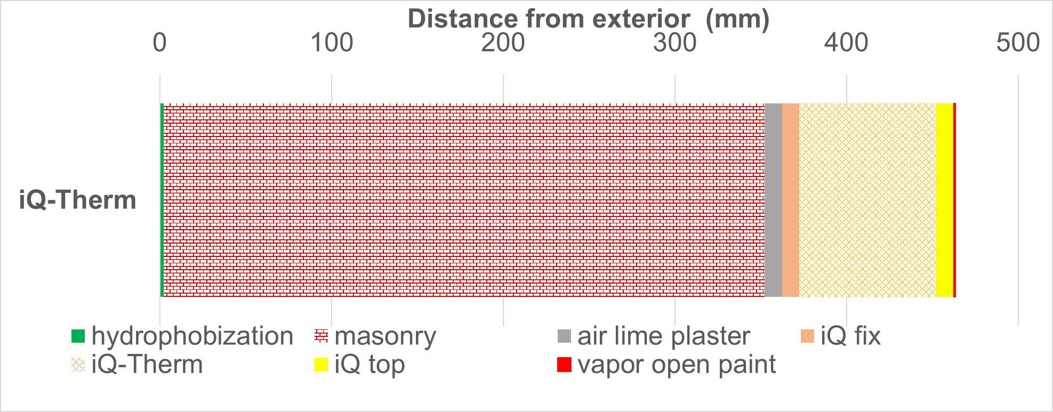
Figure 1: Configuration of the container mock-up wall. Hydrophobization: 2.4 mm impregnation depth, masonry (Y brick): 350 mm, air lime mortar: 10 mm, iQ fix, and iQ top: 10 mm, iQ-therm: 80 mm, vapor open paint sd = 0.01 m. sd: equivalent air layer thickness (μ * material thickness).
Table 2: Material properties of wall elements with iQ-therm used for hygrothermal simulation. Density (ρ), specific heat capacity (c_{p}), thermal conductivity (λ), moisture content at saturated condition (w_{sat}), capillary moisture content (w_{cap}), capillary water uptake coefficient (A_{cap}) and water vapour diffusion factor (μ).
 | ρ  [kg/m³] | c_{p}  [J/(kg K)] | Λ  [W/(m K)] | w_{sat}  [m³/m³] | w_{cap}  [m³/m³] | A_{cap}  [kg/(m²√s)] | μ  [-]
Hydrophobization | 1643 | 942 | 0.6 | 0.290 | 0.275 | 0.0009 | 13.7
Masonry (Y brick) | 1643 | 942 | 0.6 | 0.290 | 0.275 | 0.32 | 11.9
Air lime plaster | 1243 | 998 | 0.44 | 0.428 | 0.253 | 0.39 | 22.4
iQ fix | 1313 | 863 | 0.496 | 0.277 | 0.2 | 0.005 | 18.7
iQ-Therm | 49 | 1400 | 0.037 | 0.090 | 0.070 | 0.013 | 27
iQ top | 1269 | 1453 | 0.478 | 0.327 | 0.210 | 0.222 | 13.9

Simulation input
Three different wall configurations were studied by simulating the effect of hydrophobization (Figure 2). The reference case is an uninsulated 350 mm masonry wall. Two insulated configurations use either a vapor-open capillary active internal insulation (calcium silicate (CaSi)) or a vapor-tight internal insulation system (mineral wool with vapor barrier), both with a thickness of 100 mm. As interior finishing, the reference wall has 10 mm of plaster and acrylic paint. The plaster layer was kept in the configurations with an insulation system, i.e. placed in the interface between masonry and internal insulation. As interior finishing, the CaSi configuration has 12.5 mm of gypsum board and a vapor open paint, while the mineral wool configuration has a vapor barrier, 12.5 mm of gypsum board, and acrylic paint. Table 3 describes the properties of materials that were included in the simulation.
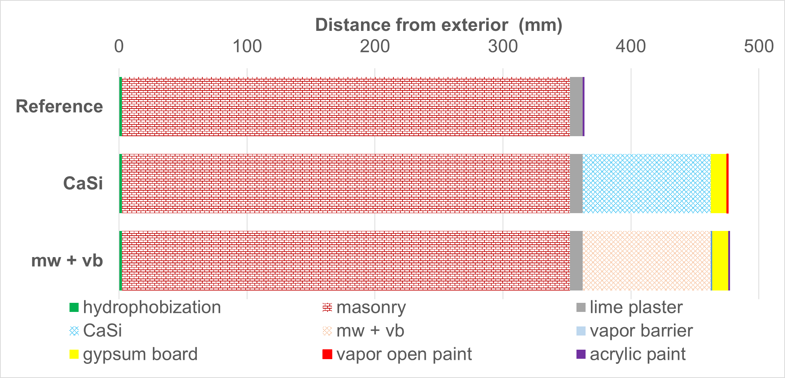
Figure 2: Wall configuration without (reference) and with internal insulation. Hydrophobization: 2.4 mm impregnation depth, masonry (Y brick): 350 mm, lime mortar: 10 mm, insulation system: 100 mm, gypsum board: 12.5 mm, vapor open paint sd = 0.01 m, vapour barrier (vb) sd = 70 m (mineral wool (mw) system) and acrylic paint sd = 0.18 m. sd: equivalent air layer thickness (μ * material thickness).
Table 3: Material properties of wall elements with CaSi or mineral wool used for hygrothermal simulation. Density (ρ), specific heat capacity (c_{p}), thermal conductivity (λ), moisture content at saturated condition (W_{sat}), capillary moisture content ( W_{cap}), capillary water uptake coefficient (A_{cap}) and water vapour diffusion factor (μ).
 | ρ  [kg/m³] | c_{p}  [J/(kg K)] | λ  [W/(m K)] | w_{sat}  [m³/m³] | w_{cap}  [m³/m³] | A_{cap}  [kg/(m²√s)] | μ  [-]
Hydrophobization | 1643 | 942 | 0.6 | 0.290 | 0.275 | 0.0009 | 13.7
Masonry | 1643 | 942 | 0.6 | 0.290 | 0.275 | 0.32 | 11.9
Lime plaster | 1800 | 850 | 0.820 | 0.285 | 0.253 | 0.127 | 12
CaSi | 351 | 902 | 0.067 | 0.850 | 0.807 | 1.330 | 9.2
Mineral wool | 134 | 840 | 0.040 | 0.900 | 0.900 | 0.000 | 1
Gypsum board | 850 | 850 | 0.200 | 0.551 | 0.400 | 0.277 | 10

Since all simulations are one-dimensional, some aspects of the construction, like mortar joints and wooden beams, were neglected. The masonry wall was thus presumed to be composed of one (untreated walls) or two (treated walls) layers of isotropic brick materials.
The climatic data were based on the Climate for Culture project [37] which contains estimations for future climate. The duration of the simulations was five years, starting 1st of January 2020 (12:00 am). Copenhagen was chosen as location and an south-west (SW) oriented facade was simulated as being worst-case scenario in Denmark with regard to wind-driven rain [38].
In the simulations, default values of exterior and interior boundary conditions were used. The exterior boundary conditions in Delphin simulations consist of convective heat exchange (exchange coefficient 25 W/m²K) and long- and short-wave radiation for the thermal part, and of convective vapor exchange (exchange coefficient 2*10⁻⁶ s/m) and wind-driven rain for the hygric part. The interior boundary conditions consist of convective heat exchange (exchange coefficient 8 W/m²K) and long-wave radiation and convective vapor exchange (exchange coefficient 3*10⁻⁸ s/m) for heat and moisture respectively, with constant indoor conditions (20 °C and 50 %RH). The simulations cover a simulation interval of five years, as it takes some time for the moisture conditions to come to a sufficiently steady response.
The primary goal of impregnating an internally insulated masonry wall at the exterior surface is the elimination or reduction of potential moisture damage. Thus, initially, the average moisture content in the masonry and mould growth at the interface between masonry and internal insulation was examined. The mould growth risk was calculated with the VTT-mould growth model [39] – being an integrated part of the Delphin simulation software – requiring values of temperature and relative humidity. The mould growth was set to have almost no decline in relation to time in order to represent the worst-case scenario and medium resistance. A side effect of hydrophobization is the energy savings achieved by keeping the wall dry. For that reason, the accumulated heat loss during the simulation period (5 years) was calculated as well as the additional energy savings induced by hydrophobization by estimating the percentage change of accumulated heat loss between treated and untreated.

Parametric analysis
A parametric analysis involving orientation (North, East, West, South, Southwest), climate (Copenhagen, Munich, and Milan), masonry thickness (350, 590, 710 mm) insulation thickness (60, 100, 300 mm), insulation system (CaSi, mw + vb, iQ-Therm, XPS Multipor, Kingspan), impregnation depth (2.4 and 40 mm) and strength (A_{cap} 0.0009 and 0.033 [kg/m²s^{0.5}]), hydrophobization before/after internal insulation represented by initial moisture content in the wall, as well as degradation of wooden beams, was conducted. The results are found in Appendix and are discussed in parallel with the base case simulations in Sections 3 and 4. To simulate the effect of hydrophobization in an already internally insulated wall, the average moisture content of the insulated wall during five years of simulation is used as the initial moisture content in the masonry at the time of becoming hydrophobized. The internally insulated hydrophobized wall is simulated for another five years.
The risk of wood decay is quantified via the VTT wood decay model, which is incorporated in Delphin. The VTT wood decay model requires the conditions (temperature, relative humidity) that the wood would be subjected to during a course of time [40]. Given that the wooden beams are not part of the current one-dimensional simulations, they are approximated with the conditions at a distance of 110 mm from the exterior part of the masonry wall, which is the expected location for the edge of the wooden beam in a typical 350 mm (1½ brick) Danish wall. The risk of wood decay is also calculated in the interface between masonry and internal insulation.

Case study building
The case study building is located by the sea, on the coast of northern Zealand in Denmark (see Figure 3). It’s a solid masonry building constructed in 1875 with three brick layers (37 cm) on east and west facades and two brick layers on north and south facades. During 2016, the house underwent an extensive renovation, including internal insulation with 80 mm of iQ-Therm. The exterior surfaces of the building were sandblasted during renovation and plastered with a thin layer of bank sand mortar.
In September 2018, FC cream 40% was applied with a paint roller in the specified amounts of 0.15-0.20 l/m². The relative humidity was monitored at the interface between masonry and internal insulation; West and South facades each had one sensor installed, North and East facades each had two sensors, one placed 50 cm above the floor, and one 50 cm below the ceiling. The built-in sensors are climaSpot sensors with accuracy ±1.8% for 10-90% RH and ±4% for 0-10% and 90-100%.The relative humidity and temperature conditions have been monitored every half hour since the summer of 2016, still measuring (June 2020). The data are stored on a server provided by fugtlog.dk, and can be downloaded from a distance.
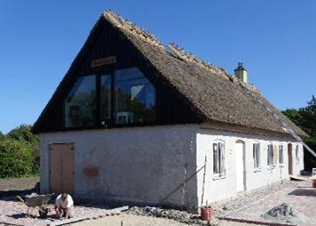
Figure 3: Location of the case building. Left: Map of Denmark, and indication of the location of the test house on the northern coast of Zealand. Right: northern façade after renovation

Results

Experimental measurements of thermal conductivity
For the tested brick and mortar types, the differences in thermal conductivity between dry and capillary saturated material are of a comparable size (Figure 4) and for Y brick the difference is larger than given in the Delphin material file. Although Y brick is the only of the tested materials for which a Delphin material file exists, it is representative for Delphin material files concerning the relationship between thermal conductivity and moisture content (m³/m³). Therefore, compared to experimental results, thermal conductivity in wet conditions seems to be underestimated in Delphin and this can underestimate the percentage of energy savings that a dry wall provides after hydrophobic treatment. For this study, the heat function in the Delphin material file is therefore modified to represent the measured thermal conductivity values derived from the heat flow meter.
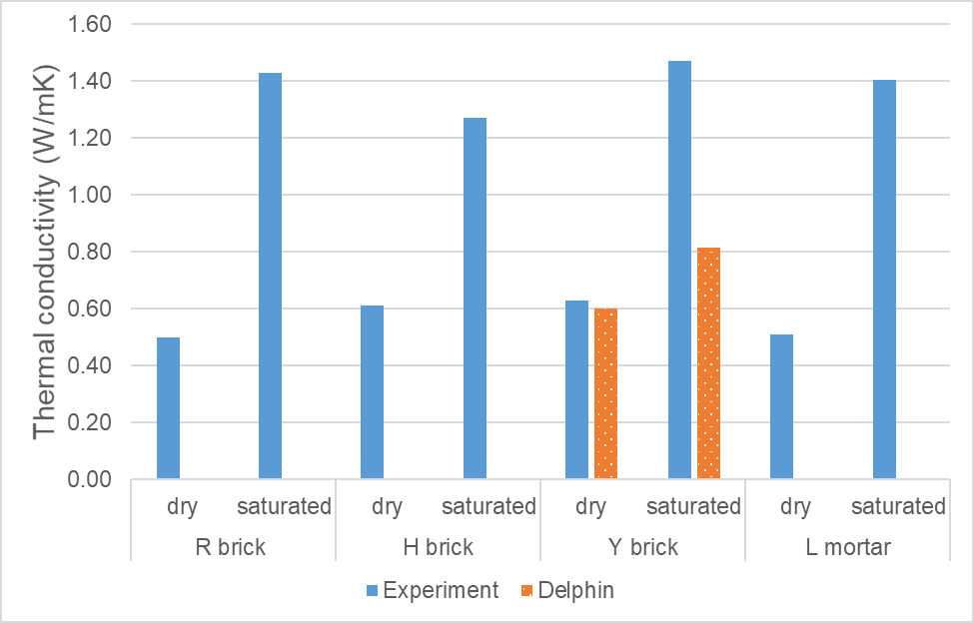
Figure 4: Thermal conductivity in dry and capillary saturated building materials: Robusta Vandersanden Belgian Brick (R brick), Historic Danish Brick from an old building in Copenhagen (1944) (H brick), Yellow soft-molded Danish brick from Helligsø and Vesterled Teglværk (Y brick), Carbonated lime mortar (L mortar), all described in [9].

Experimental validation of the hydrophobic model

Material level
The hydrophobic model seems to capture the basic characteristics of water repellency, as illustrated in Figure 5 comparing capillary absorption curves derived from experimental and simulation results of untreated and impregnated Y brick.
The simulation results for the drying test (Figure 6) however are on the safe side, as the measured drying time is lower than the simulated. The difference is explained by i) the amount of agent applied on the samples used in the drying tests being different from the amount in the water uptake tests (on which the model is based), and ii) loss of water due to imperfect sealing and time needed for preparation (attaching and sealing the samples).
The samples used in the drying test were fully impregnated to represent one cm of hydrophobic layer. To ensure that they became fully impregnated, higher than recommended amounts of water repellent agent was used. This means that the hydrophobic layer needs more curing time and exposure to water to reveal an improved performance, in terms of a reduced A_{cap} [9]. For the same curing time, samples impregnated with less agent (samples for water uptake) would have a lower A_{cap}. Since liquid transfer has an impact on the drying tests, the capillary saturated samples used in the experimental drying test, dry faster than the hydrophobized brick model, by having higher A_{cap}.

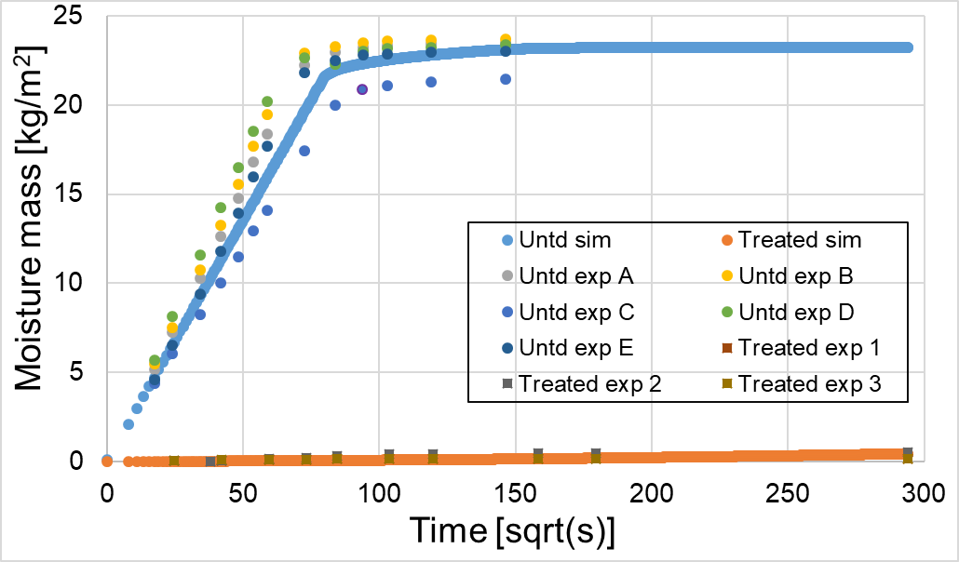
Figure 5: Water uptake of Y brick. Comparison of experimental (exp) and simulation (sim) results. Untreated (Untd) and impregnated (Treated) with FC 40%.
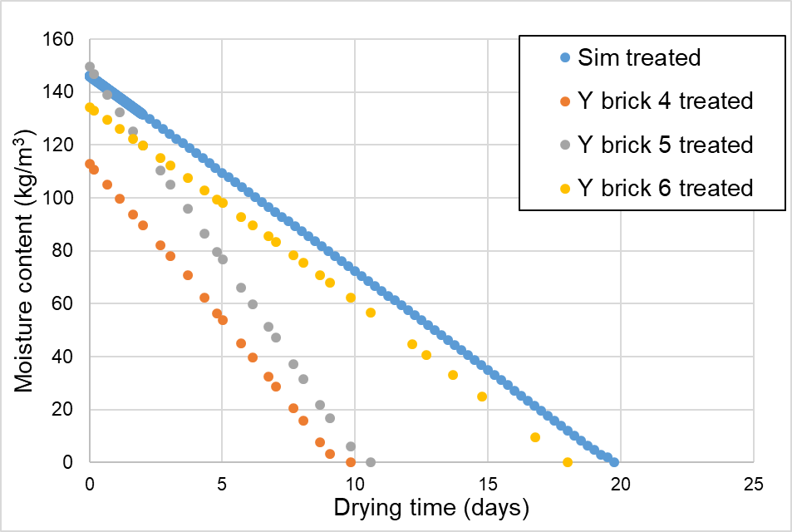
Figure 6: Drying test of Y brick impregnated with FC 40%. Comparison of experimental (Y brick) and simulation (Sim) results.

Component level
Figure 7 compares the experimental and simulation results in the interface between masonry and internal insulation, regarding the variation in relative humidity and temperature with respect to time (5 years). The results show that there is a high level of agreement between the measured and predicted values. Moreover, it appears that the model is able to predict the peaks and bottoms of both temperature and relative humidity.

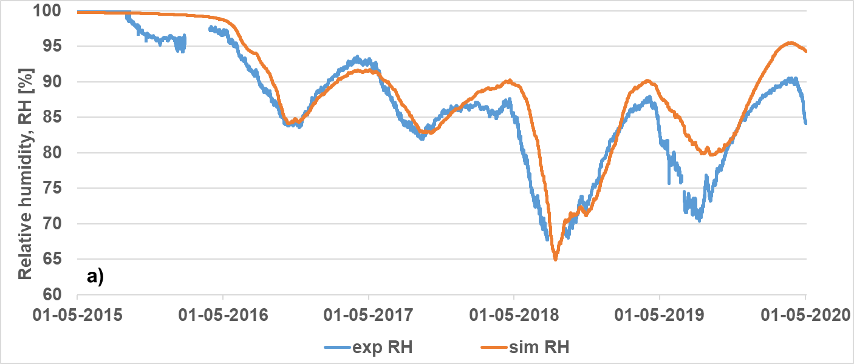
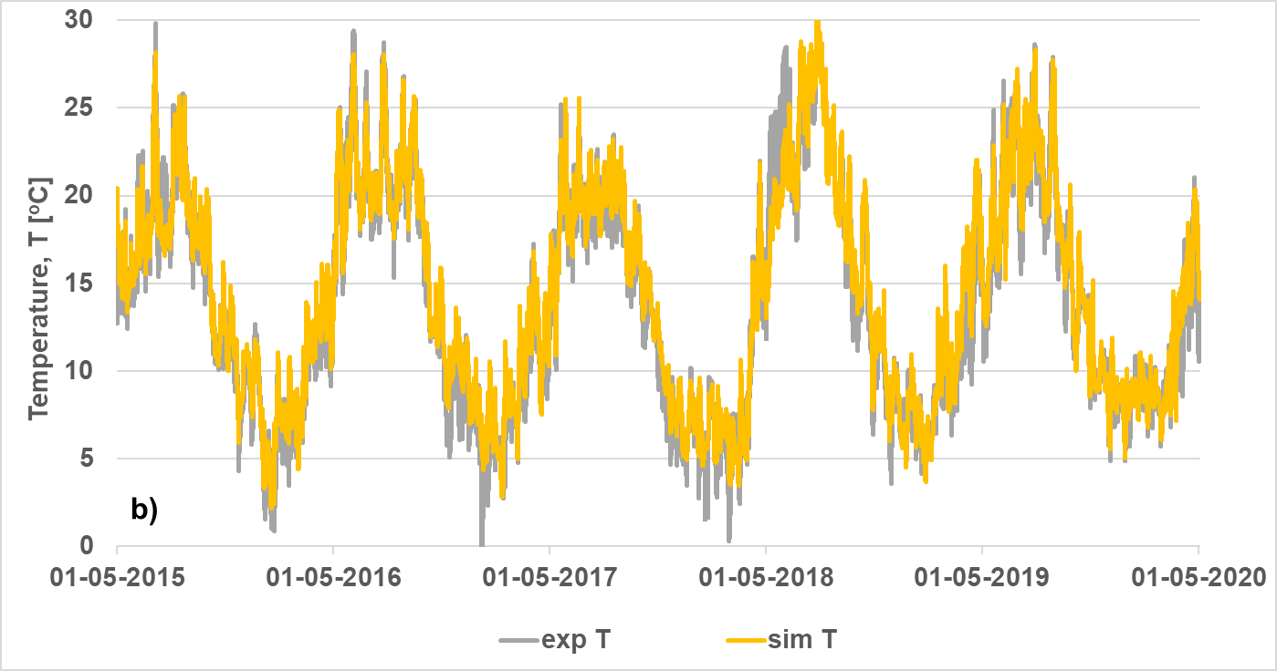
Figure 7: Relative humidity (a) and temperature (b) in the interface between hydrophobized (FC 40%) masonry and internal insulation (IQ-therm). Comparison of experimental (exp) results from [28] and simulation (sim) results using [9] as input for Delphin. The water repellent agent was applied at the same time with the internal insulation.

Simulation study

Average moisture content in masonry
After having verified the hydrophobic model, it was used to simulate different scenarios. The first analysis examined whether hydrophobization reduces the average moisture content in the masonry layer of a wall. Figure 8Figure 8 depicts the average moisture content in brick masonry in a five year period in the uninsulated case, and when insulated with CaSi or mineral wool with a vapor barrier, either with or without hydrophobization. In the hydrophobized cases, both hydrophobization and internal insulation are present when the simulation starts. As expected, adding internal insulation increases the average moisture content in the masonry wall. By ensuring a strong hydrophobic layer (low A_{cap}) the masonry wall becomes almost dry (less than 6 kg/m³), regardless of the wall configuration.
Figure 9 shows the effect of applying a water repellent agent in parallel with or five years after internal insulation. In the second case, the accumulated moisture from the first simulation period, where the internally insulated wall was exposed to wind-driven rain, needs time to dry out, depending mainly on the insulation system and the impregnation depth of the treatment. A vapor-tight internal insulation system (mw+vb) and higher impregnation depth of the treatment results in longer drying periods.

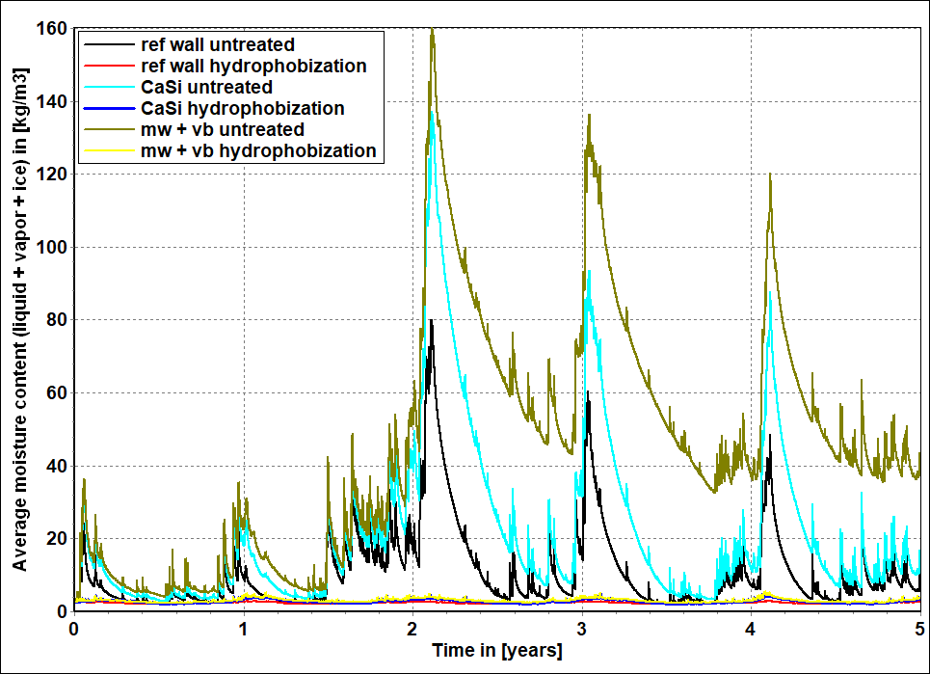
Figure 8: Average moisture content in the masonry in SW-oriented wall configurations, including a reference wall (ref wall), a wall internally insulated with calcium silicate (CaSi), and a wall internally insulated with mineral wool and a vapor barrier (mw+vb). In all three cases with or without hydrophobization. Impregnation depth 2.4 mm. Simulation based on climate data for Copenhagen 2020-2024.
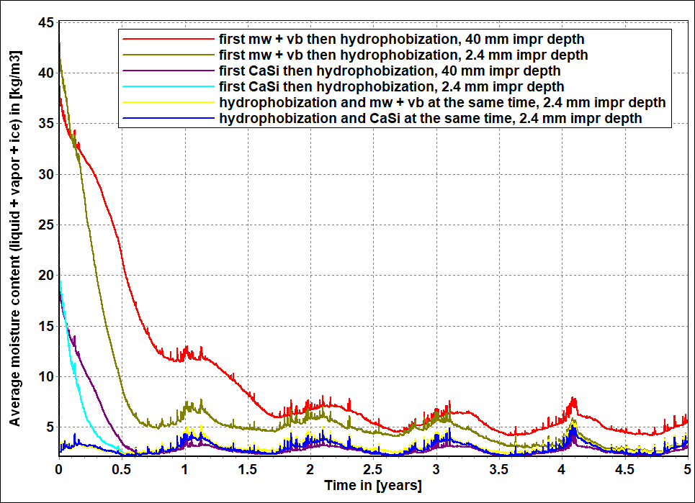
Figure 9: Average moisture content in the masonry in SW-oriented wall configurations, in the case of applying a water repellent agent at the same time as internal insulation (as in Figure 8) or five years after. Yellow and blue curves are the same as in Figure 8, while olive and turquoise curves are the continuation of curves in Figure 8. Impregnation depth 2.4 mm or 40 mm. The configurations include a wall internally insulated with calcium silicate (CaSi) and a wall internally insulated with mineral wool and a vapor barrier (mw+vb). Simulation based on climate data for Copenhagen 2020-2024.

Mould growth in the interface between masonry and internal insulation
After showing that hydrophobization is able to reduce the average moisture content markedly, the next question is whether it is possible by hydrophobizing the masonry to reduce the risk of mould growth in the interface between masonry and internal insulation, compared to not hydrophobized cases, a well-known problem in Denmark [41]. Figure 10 verifies this. The parametric analysis, focusing on different wall orientations, climates, insulation systems, masonry, and insulation thicknesses, follows the same trend: hydrophobization reduces or eliminates the increase in mould growth risk that is caused by applying internal insulation (see Appendix).
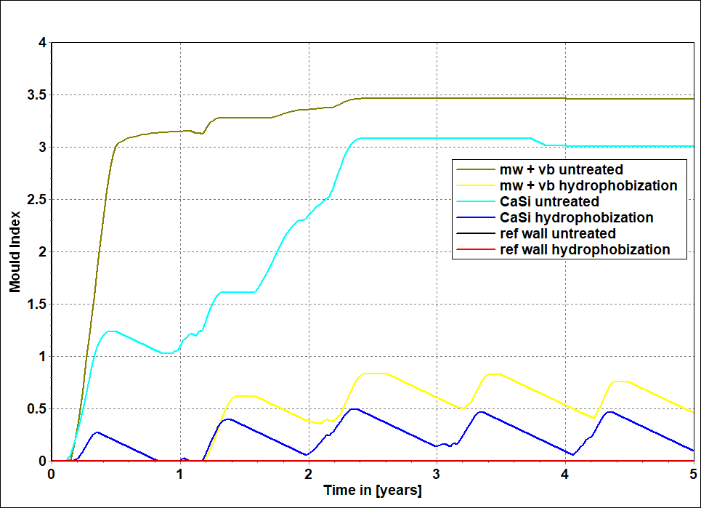
Figure 10: Mould growth expressed as mould index in the interface between masonry and internal insulation in SW-oriented wall configurations, including a reference wall (ref wall), a wall internally insulated with calcium silicate (CaSi) and a wall internally insulated with mineral wool and a vapor barrier (mw+vb). In all three cases with or without hydrophobization (applied at the same time as internal insulation). Impregnation depth 2.4 mm. Simulation based on climate data for Copenhagen 2020-2024.

Moisture safe energy savings
Hydrophobizing a wall as part of energy renovation is mainly done to reduce the driving rain load, however, hydrophobization in itself might contribute to energy savings (in terms of reduction in heat loss) by reducing the moisture content thereby lowering the thermal conductivity of the masonry. The accumulated heat loss after five years shows that hydrophobization of a SW-oriented façade located in Copenhagen produces energy savings as a single approach and produces additional energy savings when combined with internal insulation (Figure 11). Additional energy savings are also present with other wall orientations in Copenhagen or if the wall is placed in Munich or Milan, however to a lesser extent (see Appendix for different orientations and climates). Further, additional energy savings increase with increasing insulation thickness, with any type of insulation. The effect is more obvious in capillary active systems where energy savings increases from 18 % to 32 % by replacing 100 mm of CaSi-insulation with 300 mm (see Appendix for different insulation thickness). Moreover, hydrophobization exhibits 50 % additional energy savings when it is combined with Kingspan, much higher than CaSi (18 %) and mineral wool (15 %) (see Appendix for different insulation systems). Interestingly, a weak hydrophobic layer (A_{cap} 0,033 kg/(m²√s)) results in energy loss instead of energy savings (see Appendix, ‘Weak impregnation’).

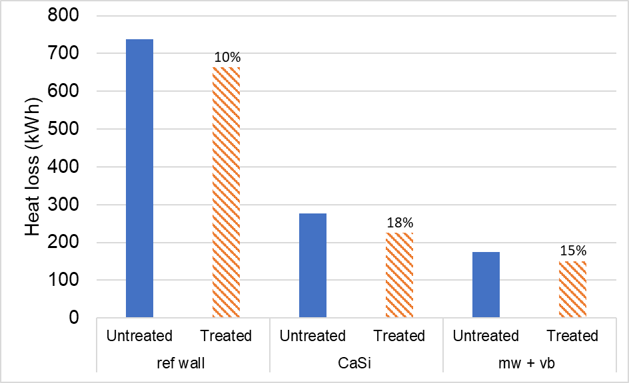
Figure 11: Accumulated heat loss in SW-oriented wall configurations, including a reference wall (ref wall), a wall internally insulated with calcium silicate (CaSi), and a wall internally insulated with mineral wool and a vapor barrier (mw+vb). In all three cases without (untreated) with (treated) hydrophobization, applied at the same time as internal insulation. Impregnation depth 2.4 mm. Simulation based on climate data for Copenhagen 2020-2024.The percentages indicate the additional energy savings due to hydrophobization.

Case study building
Figure 12 illustrates four years of monitoring of relative humidity at the interface between masonry and internal insulation in the case building. Hydrophobization lessens RH peaks but further time is needed for RH to reach lower levels due to the build-in moisture that stems from applying internal insulation two years before hydrophobization. The west façade still experiences 100% RH but RH is expected to drop like in the rest of the orientations.

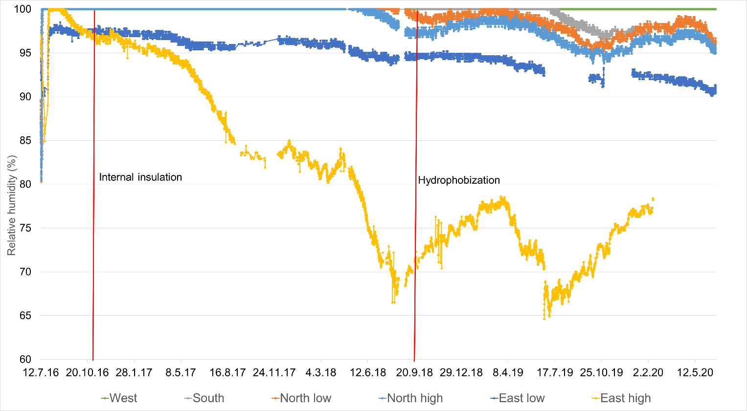
Figure 12: Relative humidity during a four year period (2016 – 2020) in the interface between masonry and internal insulation (iQ-Therm) in case building. West (green), South (grey), North (orange and light blue), and East (blue and yellow) oriented wall configurations.

Discussion
The present study examined the effect of hydrophobization combined with internal insulation. A hydrophobized brick model has been evaluated through hygrothermal simulations and has been deemed able to predict the hygrothermal behavior both at the material level (wetting and drying) (Figure 5 and Figure 6) and at the component level (relative humidity and temperature in the interface between masonry and internal insulation) (Figure 7). Numerical simulations show that hydrophobization eliminates the moisture-related problems in solid external brick masonry walls, induced by internal insulation (Figure 8 and Figure 10). Furthermore, a noteworthy rise in thermal conductivity between dry and saturated brick samples (Figure 4), results in energy savings of hydrophobization as a single approach and additional energy savings when combined with internal insulation (Figure 11). The case study building in combination with numerical simulations illustrate that in the case where internal insulation is not part of the construction, hydrophobization should be done before or at the same time as internal insulation, otherwise, the hygrothermal response of the wall could be worse the first years but in the long-run, hydrophobization will be still beneficial (Figure 9 and Figure 12).
The results of this study provide support for the view that hydrophobization improves the hygrothermal performance of both uninsulated and internally insulated walls [12–14]. Although the method of excluding wind driven rain [14,15] (see Appendix, ‘Exclude wind driven rain method’) captures the wetting behavior when the capillary water absorption coefficient (A_{cap}) of the impregnated material is close to zero, it does not capture the drying behavior (Figure 13). Similarly, the method of reducing the absorption of wind-driven rain to 1% [13] does not capture the drying behavior when initial moisture content exists in the wall (Figure 13).
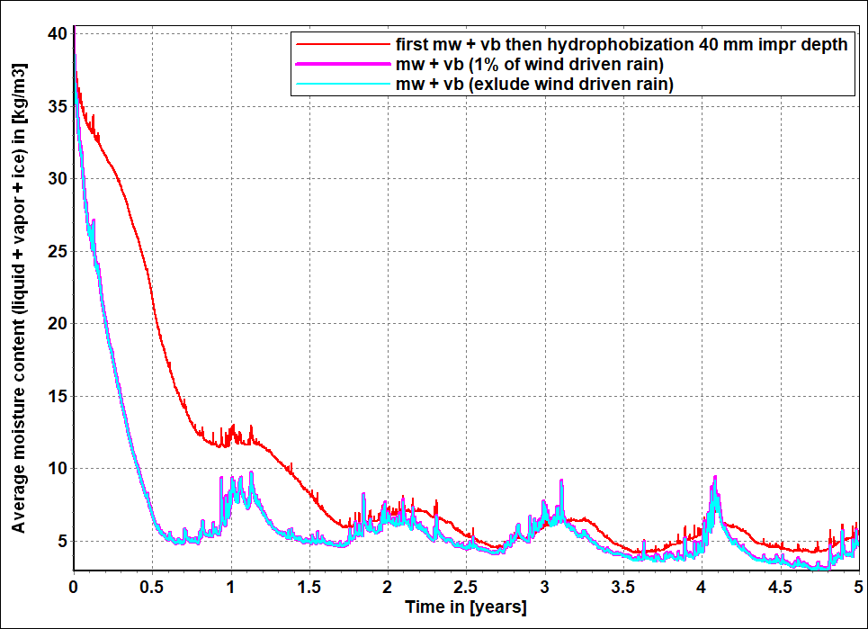
Figure 13: Average moisture content in the masonry in SW-oriented wall configurations, including the method of the current article (red curve), the method of keeping 1% of wind-driven rain provided by [13] (magenta curve) and the method of excluding driving rain provided by [14,15] (turquoise curve). In all three cases, the initial moisture content represents the moisture content at hydrophobization, taking place five years after implementing internal insulation. Simulation based on climate data for Copenhagen 2020-2024.
The level of relative humidity in the interface between masonry and internal insulation has been thoroughly analyzed in the literature [5,24,28] due to its critical nature for mould formation and interstitial condensation and the fact that it is easy to install a sensor in that location, during the renovation of a building. Relative humidity in the interface between masonry and internal insulation has three main sources of moisture: wind-driven rain transported by liquid transfer, outdoor RH, and indoor RH transported via diffusion and air leakages. Hydrophobization blocks liquid transfer but allows vapor transport [9]. The drying speed of the moisture present in the newly hydrophobized masonry wall depends on whether the hydrophobic agent is applied before or after the internal insulation is installed, although other factors also play a role, such as the hygric properties of the building materials and the climate at the location. Applying a water repellent agent at the same time as installing internal insulation can help in eliminating build-in moisture due to wind-driven rain fast enough to avoid moisture problems at a later stage (see Figure 7). By hydrophobizing the wall after the internal insulation, longer time is needed for the build-in moisture load to be eliminated. However, hydrophobization is again beneficial in the long run (see Figure 9 and Figure 12).
Due to the fact that hydrophobization allows vapor transport, RH in the interface between masonry and internal insulation in a North European climate follows the seasonal wetting (winter period, high levels of outdoor RH) and drying (summer period, lower levels of RH outdoor). However, hydrophobization gradually decreases the RH peaks in the winter period due to the elimination of one of the three moisture loads (wind-driven rain) (Figure 7 and Figure 12). However, in the case of a very high outdoor RH during winter or/and high internal moisture load, RH in the interface between masonry and internal insulation can reach high values even when hydrophobization has played its role in eliminating the wind-driven rain load. Given these considerations, the mould growth and interstitial condensation risk are high in cases where the levels of RH in the interface between masonry and internal insulation remain elevated (close to 100% RH) for many years after hydrophobization, during the whole year. However, the mock-up wall (Figure 7) and five of the six sensors in the case building (Figure 12) illustrate that after hydrophobization, the RH levels gradually decrease, following the seasonal wetting and drying. One sensor in the west façade shows 100% RH two years after hydrophobization, indicating that two years of monitoring is not enough time to draw final conclusions.
All the different internal insulation systems included in this study, vapor-tight (XPS, mw + vb, Kingspan), vapor-open (CaSi, Multipor) and vapor-tight with capillary open channels (iQ-Therm) cause the average moisture content in brick masonry wall to increase compared to the situation prior to internal insulation, but after hydrophobization the average moisture content becomes almost zero. This observation is independent of orientation and climate (see Appendix).
Increasing the insulation thickness increases the average moisture content in the masonry but the combination of hydrophobization and internal insulation results in a moisture safe masonry wall configuration. However, a weak impregnation (A_{cap} 0,033 kg/(m²√s)) results in increased moisture levels in the (un)insulated wall configurations compared to a strong impregnation (A_{cap} 0,0009 kg/(m²√s)). This is due to water being able to penetrate the masonry in the case of a weak impregnation (i.e. A_{cap} 0,033 kg/(m²√s)), combined with a significantly reduced drying rate, yielding in trapped moisture inside the wall. A weak impregnation (low level of water repellency) might exacerbate the hygrothermal behavior of the external wall. However, the weak impregnation (A_{cap} 0,033 kg/(m²√s)) derives from a water repellent agent (water-based liquid emulsion) that improves the water repellency performance with longer curing time and water exposure, so in the long term, the A_{cap} will decrease and there will be no negative effect on the hydrothermal performance of the wall [9]. A permanent weak impregnation could arise from not cleaning the facade before impregnation [9,18].
The most crucial properties needed to capture the hygrothermal behavior of a hydrophobized building material is the capillary water absorption coefficient and the thermal conductivity. The default thermal conductivity function used in Delphin underestimates the additional energy savings due to hydrophobization; by using the corrected thermal conductivity function of brick, energy savings in the base case scenario are 10% for the reference wall instead of 4.3% with the existing thermal conductivity function from Delphin, 18.1% instead of 15.7% for CaSi and 14.8% instead of 12% for ‘mw + vb’ (see Default thermal conductivity change between dry and saturated brick, Appendix). One limitation of this study is that it does not experimentally measure the difference of thermal conductivity between dry and saturated insulation materials, and that could be larger than the one presented in Delphin library (as for brick and mortar). This affects especially the cases of capillary active insulation systems, like CaSi, which can have much higher thermal conductivity after becoming wet.
The presented work in this paper illustrates that the elimination of the rain load induces additional energy savings by keeping the whole structure dry and as a consequence, the thermal conductivity of the materials at a low (dry) level. This is also the reason why hydrophobization performs better in terms of energy savings, in climates with high rain loads like Copenhagen (14.8 % energy savings) or Munich (10.8% energy savings) than in climates with low rain loads such as Milan (1.3 % energy savings) (see Different climates in Appendix).
The results also showed that hydrophobization completely eliminates the risk of wooden beam decay in the three wall configurations, both 110 mm from the exterior part of the wall and in the interface between masonry and internal insulation (see wooden beam degradation in Table A2 Appendix). Since the conditions applied to the model correspond to those in the brick and not in the wooden beam ends, the predictions of wood degradation cannot be considered reliable and are useful only as indications regarding the possible risk of wood decay and to compare the different wall configurations.
Ever since water repellent agents was introduced as a way to treat building surfaces, one of the main hesitations has been how to deal with cracks, as they may allow water to enter the existing masonry and cause freeze-thaw damage, because of water films at the backside of the water repellent layer [42]. This may be due to the transfer of indoor air by convection through cracks to the cold masonry, where it condenses. It might also be due to rain leakage at penetrations especially at windows, small cracks that form after treatment, or large cracks present before treatment. The current and previous [9] studies indicate that vapor transport through the hydrophobic layer is still possible, making the problem of cracks less critical, but the liquid transport is still impeded.
A major limitation of the present study is the assumption that larger cracks have been repaired before treatment and small possible cracks after treatment do not go deeper than the impregnation depth. Further, that workmanship is sufficient, especially in the areas around windows and doors. The water repellency performance and the impregnation depth on the Y brick reported in this study as well as other bricks and mortars reported in [9] may be sufficient. But for buildings with other types of materials and especially monumental buildings with historical value it is recommended to extract samples of building materials from the masonry wall, before applying the water repellent treatment to the whole building and test the water repellency and the impregnation depth after treatment, as failures resulting from the use of hydrophobization have been also reported [42–44].
Due to a low exposure to wind-driven rain, hydrophobization appears unnecessary at north-oriented facades. However, they experience the lowest temperature and after internally insulating the façade the temperature of the masonry further declines. In that sense, hydrophobization is recommended as a way to reduce the possible risk of frost damage. Furthermore, the very low mould growth index in the interface between masonry and internal insulation in all the simulated cases after hydrophobization is an indication of a lower risk of interstitial condensation.

Conclusions
In this paper, the hygrothermal performance of internally insulated hydrophobized walls was studied. The developed hydrophobic model captures the main impacts of water repellent treatments. Hydrophobization decreases the moisture level and the possibility of moisture-related damage in exposed facades, successfully blocking the wind-driven rain, while it produces energy savings on its own and additional energy savings when combined with internal insulation. The presented results support the idea of hydrophobization being a missing element for a sustainable and moisture safe energy renovation of historic buildings. Moreover, the results indicate that in order for hydrophobization to be more beneficial for the wall configuration, it should be applied before or at the same time as internal insulation to avoid moisture being trapped during the first period after installation. However, in the case where internal insulation is already part of the construction, hydrophobization can still be recommended, since it yields much better hygrothermal performance in the long run compared to the untreated internal insulated case.
Future studies should include experiments in the component level with real buildings and the hydrophobic model should be further validated by comparing the results of numerical simulations with in-situ measurements in real buildings. Moreover, 2D and probably 3D simulations, including possible cracks after treatment, would help in building more confidence about the performance of the hydrophobic treatment. Furthermore, future research would benefit from focusing on durability tests, to study the long-term effect of the water repellency. Also, life cycle cost assessment of hydrophobization in combination with internal insulation as well as the payback period and a financial analysis will contribute towards a holistic view of hydrophobization.

Acknowledgements
The present study is the second journal article after Ref. [9] in a series of articles reviewing hydrophobization treatment at the Department of the Built Environment, Aalborg University Copenhagen. The study is part of the project ‘Moisture safe energy renovation of worth preserving external masonry walls’ funded by the Danish foundations: The Landowners’ Investment Foundation, The National Building Fund, and Realdania. The experimental part at the material level took place at the KU Leuven Building Physics department. The first author and his supervisors express their gratitude to Professor Hans Janssen who hosted the first author during his stay. Also, Dr. Wouter Van De Walle is acknowledged for his supervision on the use of the thermal conductivity meter. We are grateful to Professor Eva B. Møller and her Ph.D. student Nickolaj Feldt Jensen from DTU, for granting us access to their experimental data of mock-up walls that were used in the validation of the hydrophobic model in the component level. We would like to offer our thanks to Dr. Tessa Kvist Hansen who contributed to the collection of the monitoring data of the case study building.

Bibliography
[1] C.A. Balaras, A.G. Gaglia, E. Georgopoulou, S. Mirasgedis, Y. Sarafidis, D.P. Lalas, European residential buildings and empirical assessment of the Hellenic building stock, energy consumption, emissions and potential energy savings, Build. Environ. 42 (2007) 1298–1314. https://doi.org/10.1016/j.buildenv.2005.11.001.
[2] M. Jerman, I. Palomar, V. Kočí, R. Černý, Thermal and hygric properties of biomaterials suitable for interior thermal insulation systems in historical and traditional buildings, Build. Environ. 154 (2019) 81–88. https://doi.org/10.1016/j.buildenv.2019.03.020.
[3] J. MacMullen, Z. Zhang, E. Rirsch, H.N. Dhakal, N. Bennett, Brick and mortar treatment by cream emulsion for improved water repellence and thermal insulation, Energy Build. 43 (2011) 1560–1565. https://doi.org/10.1016/j.enbuild.2011.02.014.
[4] M. Guizzardi, D. Derome, R. Vonbank, J. Carmeliet, Hygrothermal behavior of a massive wall with interior insulation during wetting, Build. Environ. 89 (2015) 59–71. https://doi.org/10.1016/j.buildenv.2015.01.034.
[5] E. Vereecken, Hygrothermal Analysis of Interior Insulation for Renovation Projects, KU Leuven, 2013. https://doi.org/LIRIAS1729285.
[6] E. Vereecken, S. Roels, Wooden beam ends in combination with interior insulation: An experimental study on the impact of convective moisture transport, Build. Environ. 148 (2019) 524–534. https://doi.org/10.1016/j.buildenv.2018.10.060.
[7] H. Janssen, B. Blocken, S. Roels, J. Carmeliet, Wind-driven rain as a boundary condition for HAM simulations: Analysis of simplified modelling approaches, Build. Environ. 42 (2007) 1555–1567. https://doi.org/10.1016/j.buildenv.2006.10.001.
[8] A. Erkal, D. D’Ayala, L. Sequeira, Assessment of wind-driven rain impact, related surface erosion and surface strength reduction of historic building materials, Build. Environ. 57 (2012) 336–348. https://doi.org/10.1016/j.buildenv.2012.05.004.
[9] V. Soulios, E. J de Place Hansen, C. Feng, H. Janssen, Hygric behavior of hydrophobized brick and mortar samples, Build. Environ. 176 (2020) 106843. https://doi.org/10.1016/j.buildenv.2020.106843.
[10] V. Soulios, E.J. de Place Hansen, H. Janssen, Hygric properties of hydrophobized building materials, in: MATEC Web Conf., Prague, 2019: pp. 1–6. https://doi.org/https://doi.org/10.1051/matecconf/201928202048.
[11] J. Engel, P. Heinze, R. Plagge, Adapting hydrophobizing impregnation agents to the object, Hydrophobe VII7th Int. Conf. Water Repel. Treat. Prot. Surf. Technol. Build. Mater. 20 (2014) 141–150. https://doi.org/https://doi.org/10.12900/rbm14.20.6-0042.
[12] H.M. Künzel, K. Kießl, Drying of brick walls after impregnation, Bauinstandsetzen. 2 (1996) 87–100. https://wufi.de/literatur/Künzel, Kießl 1996 - Drying of brick walls.pdf.
[13] G.R. Finken, S.P. Bjarløv, R.H. Peuhkuri, Effect of façade impregnation on feasibility of capillary active thermal internal insulation for a historic dormitory - A hygrothermal simulation study, Constr. Build. Mater. 113 (2016) 202–214. https://doi.org/10.1016/j.conbuildmat.2016.03.019.
[14] A. Abdul Hamid, P. Wallentén, Hygrothermal assessment of internally added thermal insulation on external brick walls in Swedish multifamily buildings, Build. Environ. 123 (2017) 351–362. https://doi.org/10.1016/j.buildenv.2017.05.019.
[15] V. Soulios, E. J de Place Hansen, R. Peuhkuri, Hygrothermal simulation assessment of internal insulation systems for retrofitting a historic Danish building, in: Cent. Eur. Symp. Build. Phys., 2019: pp. 1–6. https://doi.org/10.1051/matecconf/201928.
[16] J. Carmeliet, G. Houvenaghel, J. Van Schijndel, S. Roels, Moisture phenomena in hydrophobic porous building material Part 1: Measurements and physical interpretations / Wechselwirkung hydrophobierter poröser Werkstoffe des Bauwesens mit Feuchtigkeit, Teil 1: Messungen und physikalische Interpretationen, Restor. Build. Monum. 8 (2002) 165–183. https://doi.org/https://doi.org/10.1515/rbm-2002-5660.
[17] H. Kober, Water thinnable silicone impregnating agents for masonry protection, in: Hydrophobe I Delft, 1995: pp. 1–13. http://www.hydrophobe.org/pdf/delft/I_3.pdf.
[18] J. Zhao, F. Meissener, Experimental investigation of moisture properties of historic building material with hydrophobization treatment, Energy Procedia. 132 (2017) 261–266. https://doi.org/10.1016/j.egypro.2017.09.716.
[19] T.K. Hansen, S.P. Bjarløv, R.H. Peuhkuri, K.K. Hansen, Performance of hydrophobized historic solid masonry – Experimental approach, Constr. Build. Mater. 188 (2018) 695–708. https://doi.org/10.1016/j.conbuildmat.2018.08.145.
[20] E.B. Møller, C. Rode, Hygrothermal Performance and Soiling of Exterior Building Surfaces, Technical University of Denmark, 2004. https://orbit.dtu.dk/files/5285541/byg-r068.pdf.
[21] V. Metavitsiadis, V. Soulios, H. Janssen, S. Roels, Wall hydrophobization and internal insulation: the impact of impregnation strength and depth on moisture levels and moisture damages, in: Hydrophobe III, 2017: pp. 69–76. http://www.hydrophobe.org/pdf/hongkong/C-1-1.pdf (accessed April 26, 2020).
[22] T. Kvist Hansen, S.P. Bjarløv, R. Peuhkuri, Moisture transport properties of brick – comparison of exposed, impregnated and rendered brick, in: Proc. Int. RILEM Conf. - Mater. Syst. Struct. Civ. Eng. Segm. Moisture Mater. Struct., 2016: pp. 351–360. http://orbit.dtu.dk/ws/files/128040737/Pages_from_Moisture_conf_proceedings_3.pdf.
[23] A. Nicolai, J. Grunewald, User Manual and Program Reference Delphin 5, (2015) 1–171. http://bauklimatik-dresden.de/downloads/documentation/DELPHIN5-reference_manual_en.pdf.
[24] T. Odgaard, S.P. Bjarløv, C. Rode, Interior insulation – Experimental investigation of hygrothermal conditions and damage evaluation of solid masonry façades in a listed building, Build. Environ. 129 (2018) 1–14. https://doi.org/10.1016/j.buildenv.2017.11.015.
[25] M. Harrestrup, S. Svendsen, Internal insulation applied in heritage multi-storey buildings with wooden beams embedded in solid masonry brick façades, Build. Environ. 99 (2016) 59–72. https://doi.org/10.1016/j.buildenv.2016.01.019.
[26] T.K. Hansen, S.P. Bjarløv, R.H. Peuhkuri, M. Harrestrup, Long term in situ measurements of hygrothermal conditions at critical points in four cases of internally insulated historic solid masonry walls, Energy Build. 172 (2018) 235–248. https://doi.org/10.1016/j.enbuild.2018.05.001.
[27] M. Morelli, L. Rønby, S.E. Mikkelsen, M.G. Minzari, T. Kildemoes, H.M. Tommerup, Energy retrofitting of a typical old Danish multi-family building to a “nearly-zero” energy building based on experiences from a test apartment, Energy Build. 54 (2012) 395–406. https://doi.org/10.1016/j.enbuild.2012.07.046.
[28] N.F. Jensen, T.R. Odgaard, S.P. Bjarløv, B. Andersen, C. Rode, E.B. Møller, Hygrothermal assessment of diffusion open insulation systems for interior retrofitting of solid masonry walls, Article in press, Build. Environ. (2020).
[29] T. Odgaard, S.P. Bjarløv, C. Rode, Influence of hydrophobation and deliberate thermal bridge on hygrothermal conditions of internally insulated historic solid masonry walls with built-in wood, Energy Build. 173 (2018) 530–546. https://doi.org/10.1016/j.enbuild.2018.05.053.
[30] J. Šadauskienė, J. Ramanauskas, V. Stankevičius, Effect of Hydrophobic Materials on Water Impermeability and Drying of Finish Brick Masonry, in: Issn Mater. Sci., 2003: pp. 1392–1320. https://www.researchgate.net/profile/Jolanta_Sadauskiene/publication/237779777_Effect_of_Hydrophobic_Materials_on_Water_Impermeability_and_Drying_of_Finish_Brick_Masonry/links/53fb1c580cf27c365cf06ef8.pdf.
[31] Momentive AG, Silblock wms Technical data sheet, (2011) 1–4. https://www.momentive.com/docs/default-source/productdocuments/silblock-wms/silblock-wms-mb-indd.pdf?sfvrsn=d50e61c_14.
[32] ASTM Int., C518-15: Standard Test Method for Steady-State Thermal Transmission Properties by Means of the Heat Flow Meter Apparatus, ASTM Int. 04 (2015) 1–15. https://doi.org/10.1520/C0518-10.2.
[33] ISO 15148 : 2002, Hygrothermal performance of building materials and products Determination of water absorption coefficient by partial immersion, English version of DIN EN ISO 15148, (2003) 1–14.
[34] C. Feng, A.S. Guimarães, N. Ramos, L. Sun, D. Gawin, P. Konca, C. Hall, J. Zhao, H. Hirsch, J. Grunewald, M. Fredriksson, K.K. Hansen, Z. Pavlík, A. Hamilton, H. Janssen, Hygric properties of porous building materials (VI): A round robin campaign, Build. Environ. 185 (2020). https://doi.org/10.1016/j.buildenv.2020.107242.
[35] A. Nicolai, J. Grunewald, J.J. Zhang, Recent improvements in HAM simulation tools: Delphin 5 / CHAMPS-BES, in: Conf. Proc. 12th Symp. Build. Phys., 2007: pp. 866–876. https://www.researchgate.net/profile/Andreas_Nicolai/publication/278673185_Recent_improvements_in_HAM_simulation_tools_Delphin_5_CHAMPS-BES/links/558296eb08aeab1e4666fbad/Recent-improvements-in-HAM-simulation-tools-Delphin-5-CHAMPS-BES.pdf.
[36] DTU Climate station data, The Technical University of Denmark, Department of Civil Engineering, (2020). http://climatestationdata.byg.dtu.dk/.
[37] Frannhofer, Climate for Culture, (2015). www.climateforculture.eu.
[38] T.K. Hansen, S.P. Bjarløv, R. Peuhkuri, The effects of wind-driven rain on the hygrothermal conditions behind wooden beam ends and at the interfaces between internal insulation and existing solid masonry, Energy Build. 196 (2019) 255–268. https://doi.org/10.1016/j.enbuild.2019.05.020.
[39] S.E. Viitanen H., Toratti T., Makkonen L., Thelandersson S., Isaksson T., Früwald E., Jermer J., Eng-lund F., Modelling of service life and durability of wooden structures, in: 9th Nord. Symp. Build. Phys., Tampere, Finland, 2011.
[40] H. Viitanen, · T Toratti, · L Makkonen, · R Peuhkuri, · T Ojanen, · L Ruokolainen, · J Räisänen, Towards modelling of decay risk of wooden materials, Eur. J. Wood Prod. 68 (2010) 303–313. https://doi.org/10.1007/s00107-010-0450-x.
[41] M. Morelli, E.B. MØller, Energy savings and risk of mold growth in apartments renovated with internal insulation, Sci. Technol. Built Environ. 25 (2019) 1199–1211. https://doi.org/10.1080/23744731.2019.1629241.
[42] G. Hilbert, H. Neumann, E. Wendler, Hydrophobization – One Target , Several Possibilities, Restor. Build. Monum. 18 (2012) 3–12. https://doi.org/10.1515/rbm-2012-6495.
[43] A.E. Charola, Water Repellents and Other “ Protective ” Treatments : A Critical Review, in: Hydrophobe III. 3rd Int. Conf. Surf. Technolgy with Water Repel. Agents. Aedif. Publ., 2001: pp. 3–20. http://www.hydrophobe.org/pdf/hannover/III_01.pdf.
[44] R.P.J. van Hees, The performance of surface treatments for the conservation of historic brick masonry, Compat. Mater. Prot. Eur. Cult. Herit. [Volume 2]. (1998) 279–287.

Appendix
Table A1: Hygrothemral simulation results. Average moisture content (kg/m³), mould growth in the masonry - internal insulation interface (index), heat loss (kWh), and energy savings due to hydrophobization (%) for different simulated wall configurations. Msy thick: Masonry thickness, Insul: Insulation, Ins thick: Insulation thickness, dp: Impregnation depth, Acap: Absorption coefficient, μ: vapour diffusion resistance factor, Clim: Climate, Orien: Orientation, mw + vb: mineral wool plus vapor barrier, CPH: Copenhagen, MUC: Munich, MXP: Milan.
Wall configuration |  |  |  |  |  |  |  | Numerical Results
Msy thick | Insul | Ins thick | dp | Acap | μ | Clim | Orien | Moisture content | Mould growth | Heat Loss | Energy savings
mm |  | mm | mm | kg/m²√s |  |  |  | kg/m³ (min-max) | index | KWh | %
Base case scenario
350 | - |  |  | 0.32 | 11.9 | CPH | SW | 11.1 (2 - 80.1) | 0 | 737 | 10.0
350 | - |  | 2.4 | 0.0009 | 13.4 | CPH | SW | 2.3 (2 - 3.2) | 0 | 663 | 10.0
350 | CaSi | 100 |  | 0.32 | 11.9 | CPH | SW | 22.1 (2.5 - 137.1) | 3 | 276 | 18.1
350 | CaSi | 100 | 2.4 | 0.0009 | 13.4 | CPH | SW | 2.9 (2.1 - 5.3) | 0.5 | 226 | 18.1
350 | mw+vb | 100 |  | 0.32 | 11.9 | CPH | SW | 45.5 (2.5 - 160.3) | 3.5 | 175 | 14.8
350 | mw+vb | 100 | 2.4 | 0.0009 | 13.4 | CPH | SW | 3.1(2.3 - 5.6) | 1 | 149 | 14.8
Different orientations
350 | - |  |  | 0.32 | 11.9 | CPH | N | 2.8 (2 - 22.1) | 0 | 691 | 1.2
350 | - |  | 2.4 | 0.0009 | 13.4 | CPH | N | 2.4 (2 - 3.1) | 0 | 683 | 1.2
350 | CaSi | 100 |  | 0.32 | 11.9 | CPH | N | 4 (2.2 - 24.2) | 1.2 | 237 | 2.1
350 | CaSi | 100 | 2.4 | 0.0009 | 13.4 | CPH | N | 2.9 (2.2 - 4.9) | 0.5 | 232 | 2.1
350 | mw+vb | 100 |  | 0.32 | 11.9 | CPH | N | 5.2 (2.5 - 25.7) | 3 | 156 | 1.7
350 | mw+vb | 100 | 2.4 | 0.0009 | 13.4 | CPH | N | 3.1 (2.3 - 5.5) | 0.9 | 153 | 1.7
350 | - |  |  | 0.32 | 11.9 | CPH | E | 5 (1.9 - 41.7) | 0 | 669 | 4.3
350 | - |  | 2.4 | 0.0009 | 13.4 | CPH | E | 2.3 (1.9 - 3.1) | 0 | 640 | 4.3
350 | CaSi | 100 |  | 0.32 | 11.9 | CPH | E | 7.5 (2.2 - 46.3) | 2 | 233 | 6.4
350 | CaSi | 100 | 2.4 | 0.0009 | 13.4 | CPH | E | 2.8 (2 - 5.1) | 0.3 | 218 | 6.4
350 | mw+vb | 100 |  | 0.32 | 11.9 | CPH | E | 10.2 (2.5 - 52.6) | 3.2 | 155 | 7.1
350 | mw+vb | 100 | 2.4 | 0.0009 | 13.4 | CPH | E | 2.9 (2.2 - 5.5) | 0.6 | 144 | 7.1
350 | - |  |  | 0.32 | 11.9 | CPH | S | 9.4 (2 - 61.3) | 0 | 710 | 9.0
350 | - |  | 2.4 | 0.0009 | 13.4 | CPH | S | 2.3 (1.9 - 3.1) | 0 | 646 | 9.0
350 | CaSi | 100 |  | 0.32 | 11.9 | CPH | S | 17.6 (2.3 - 107.5) | 3.0 | 260 | 15.5
350 | CaSi | 100 | 2.4 | 0.0009 | 13.4 | CPH | S | 2.8 (2.1 - 5.2) | 0.4 | 218 | 15.5
350 | mw+vb | 100 |  | 0.32 | 11.9 | CPH | S | 30 (2.5 - 129) | 3.5 | 169 | 13.7
350 | mw+vb | 100 | 2.4 | 0.0009 | 13.4 | CPH | S | 3 (2.2 - 5) | 0.6 | 146 | 13.7
350 | - |  |  | 0.32 | 11.9 | CPH | W | 6.1 (2 - 51.6) | 0 | 723 | 6.4
350 | - |  | 2.4 | 0.0009 | 13.4 | CPH | W | 2.4 (2 - 3) | 0 | 677 | 6.4
350 | CaSi | 100 |  | 0.32 | 11.9 | CPH | W | 11.3 (2.5 - 69.4) | 2.6 | 258 | 10.5
350 | CaSi | 100 | 2.4 | 0.0009 | 13.4 | CPH | W | 2.9 (2.1 - 5) | 0.5 | 230 | 10.5
350 | mw+vb | 100 |  | 0.32 | 11.9 | CPH | W | 17.1 (2.5 - 77.7) | 3.4 | 170 | 10.3
350 | mw+vb | 100 | 2.4 | 0.0009 | 13.4 | CPH | W | 3.1 (2.3 - 5.7) | 1 | 153 | 10.3
Different climates
350 | - |  |  | 0.32 | 11.9 | MUC | SW | 6.2 (2.3 - 34.9) | 0 | 717 | 7.3
350 | - |  | 2.4 | 0.0009 | 13.4 | MUC | SW | 2.2 (1.9 - 2.5) | 0 | 664 | 7.3
350 | CaSi | 100 |  | 0.32 | 11.9 | MUC | SW | 8.6 (2.4 - 38.5) | 2.1 | 251 | 9.9
350 | CaSi | 100 | 2.4 | 0.0009 | 13.4 | MUC | SW | 2.5 (1.9 - 3.5) | 0.2 | 226 | 9.9
350 | mw+vb | 100 |  | 0.32 | 11.9 | MUC | SW | 11.4 (2.4 - 42.2) | 3.4 | 167 | 10.2
350 | mw+vb | 100 | 2.4 | 0.0009 | 13.4 | MUC | SW | 2.4 (2 - 3.3) | 0 | 150 | 10.2
350 | - |  |  | 0.32 | 11.9 | MXP | SW | 2 (1.6 - 10.5) | 0 | 208 | 1.2
350 | - |  | 2.4 | 0.0009 | 13.4 | MXP | SW | 1.9 (1.6 - 2.5) | 0 | 205 | 1.2
350 | CaSi | 100 |  | 0.32 | 11.9 | MXP | SW | 2.1 (1.5 - 10.3) | 0 | 71 | 1.3
350 | CaSi | 100 | 2.4 | 0.0009 | 13.4 | MXP | SW | 2 (1.4 - 2.5) | 0 | 70 | 1.3
350 | mw+vb | 100 |  | 0.32 | 11.9 | MXP | SW | 2.1 (1.7 - 10.5) | 0 | 47 | 1.3
350 | mw+vb | 100 | 2.4 | 0.0009 | 13.4 | MXP | SW | 2 (1.4 - 2.5) | 0 | 46 | 1.3
Different masonry thickness
590 | - |  |  | 0.32 | 11.9 | CPH | SW | 13.1 (2.5 - 67) | 0 | 491 | 11.5
590 | - |  | 2.4 | 0.0009 | 13.4 | CPH | SW | 2.4 (2 - 3.2) | 0 | 435 | 11.5
590 | CaSi | 100 |  | 0.32 | 11.9 | CPH | SW | 25.8 (2.5 - 91.5) | 2.5 | 229 | 17.0
590 | CaSi | 100 | 2.4 | 0.0009 | 13.4 | CPH | SW | 2.8 (2.2 - 4.2) | 0.16 | 190 | 17.0
590 | mw+vb | 100 |  | 0.32 | 11.9 | CPH | SW | 37.1 (2.5 - 101.1) | 3.4 | 155 | 13.7
590 | mw+vb | 100 | 2.4 | 0.0009 | 13.4 | CPH | SW | 2.9 (2.4 - 4.5) | 0 | 134 | 13.7
710 | - |  |  | 0.32 | 11.9 | CPH | SW | 14.4 (2.5 - 61.7) | 0 | 422 | 12.1
710 | - |  | 2.4 | 0.0009 | 13.4 | CPH | SW | 2.4 (2.1 - 3.2) | 0 | 371 | 12.1
710 | CaSi | 100 |  | 0.32 | 11.9 | CPH | SW | 26.1 (2.5 - 79.3) | 2.3 | 210 | 15.8
710 | CaSi | 100 | 2.4 | 0.0009 | 13.4 | CPH | SW | 2.7 (2.2 - 3.9) | 0.07 | 177 | 15.8
710 | mw+vb | 100 |  | 0.32 | 11.9 | CPH | SW | 33.2 (2.5 - 86.5) | 3.4 | 145 | 12.7
710 | mw+vb | 100 | 2.4 | 0.0009 | 13.4 | CPH | SW | 2.9 (2.4 - 4.2) | 0 | 127 | 12.7
Different insulation thickness
350 | CaSi | 60 |  | 0.32 | 11.9 | CPH | SW | 19.4 (2.2 - 125.2) | 2.8 | 354 | 14.6
350 | CaSi | 60 | 2.4 | 0.0009 | 13.4 | CPH | SW | 2.8 (2 - 4.8) | 0.3 | 303 | 14.6
350 | mw+vb | 60 |  | 0.32 | 11.9 | CPH | SW | 37.5 (2.5 - 148.3) | 3.4 | 259 | 16.8
350 | mw+vb | 60 | 2.4 | 0.0009 | 13.4 | CPH | SW | 2.9 (2.2 - 5.1) | 0.16 | 215 | 16.8
350 | CaSi | 300 |  | 0.32 | 11.9 | CPH | SW | 28 (2.5 - 161) | 3.2 | 146 | 31.6
350 | CaSi | 300 | 2.4 | 0.0009 | 13.4 | CPH | SW | 3.1 (2.3 - 6) | 0.6 | 99 | 31.6
350 | mw+vb | 300 |  | 0.32 | 11.9 | CPH | SW | 56.2 (2.5 - 178.6) | 3.5 | 65 | 9.6
350 | mw+vb | 300 | 2.4 | 0.0009 | 13.4 | CPH | SW | 3.4 (2.3 - 6.4) | 1.7 | 59 | 9.6
Different insulation systems
350 | XPS | 100 |  | 0.32 | 11.9 | CPH | SW | 57.4 (2.5 - 174.6) | 3.5 | 122 | 9.3
350 | XPS | 100 | 2.4 | 0.0009 | 13.4 | CPH | SW | 3.2 (2.3 - 5.9) | 1.4 | 111 | 9.3
350 | iQ-Therm | 100 |  | 0.32 | 11.9 | CPH | SW | 34.5 (2.5 - 156.8) | 3.5 | 177 | 20.7
350 | iQ-Therm | 100 | 2.4 | 0.0009 | 13.4 | CPH | SW | 3.1 (2.3 - 5.6) | 1.4 | 140 | 20.7
350 | Multipor | 100 |  | 0.32 | 11.9 | CPH | SW | 25 (2.5 - 147.2) | 3.3 | 218 | 23.8
350 | Multipor | 100 | 2.4 | 0.0009 | 13.4 | CPH | SW | 3.1 (2.1 - 5.7) | 1.4 | 166 | 23.8
350 | Kingspan | 100 |  | 0.32 | 11.9 | CPH | SW | 26.9 (2.5 - 153.3) | 3.4 | 178 | 50.2
350 | Kingspan | 100 | 2.4 | 0.0009 | 13.4 | CPH | SW | 3.3 (2.4 - 6.2) | 1 | 89 | 50.2
Weak impregnation
350 | - |  | 2.4 | 0.033 | 13.4 | CPH | SW | 52.4 (2.2 - 222.7) | 2.7 | 876 | -18.8
350 | CaSi | 100 | 2.4 | 0.033 | 13.4 | CPH | SW | 77.7 (2.5 - 251.2) | 3.3 | 399 | -44.5
Default thermal conductivity change between dry and saturated brick (in Delphin)
350 | - |  |  | 0.32 | 11.9 | CPH | SW | 11.9 (2 - 87.8) | 0 | 693 | 4.3
350 | CaSi | 100 |  | 0.32 | 11.9 | CPH | SW | 22.5 (2.5 - 139.4) | 3 | 268 | 15.7
350 | mw+vb | 100 |  | 0.32 | 11.9 | CPH | SW | 45.2 (2.5 - 161.5) | 3.5 | 170 | 12.1
Exclude wind driven rain method [13,14]
350 | - |  |  | 0.32 | 11.9 | CPH | SW | 2.4 (2-3.3) | 0 | 661 | 10.3
350 | CaSi | 100 |  | 0.32 | 11.9 | CPH | SW | 3.3 (2.1-7) | 0.5 | 226 | 18.0
350 | mw+vb | 100 |  | 0.32 | 11.9 | CPH | SW | 3.9 (2.5-8.8) | 2.3 | 149 | 15.0
Impregnation depth
350 | - |  | 40 | 0.0009 | 13.4 | CPH | SW | 2.3 (2-3.1) | 0 | 662 | 10.2
350 | CaSi | 100 | 40 | 0.0009 | 13.4 | CPH | SW | 2.7 (2.1-4.6) | 0.2 | 225 | 18.4
350 | mw+vb | 100 | 40 | 0.0009 | 13.4 | CPH | SW | 2.6(2.2-4.8) | 0 | 149 | 15.0
Initial moisture content in the masonry (starting point: the average moisture content of the 5 years simulation)
350 | - |  | 2.4 | 0.0009 | 13.4 | CPH | SW | 2.5 (2 - 11) | 0.06 | 665 | 9.7
350 | CaSi | 100 | 2.4 | 0.0009 | 13.4 | CPH | SW | 3.3 (2.1 - 22) | 1.5 | 230 | 16.7
350 | mw+vb | 100 | 2.4 | 0.0009 | 13.4 | CPH | SW | 6.5 (2.5 - 45.2) | 3.4 | 156 | 11.3
350 | - |  | 40 | 0.0009 | 13.4 | CPH | SW | 2.5 (2 - 10.1) | 0.05 | 665 | 9.8
350 | CaSi | 100 | 40 | 0.0009 | 13.4 | CPH | SW | 3.4 (2.1 - 19.9) | 1.8 | 230 | 16.7
350 | mw+vb | 100 | 40 | 0.0009 | 13.4 | CPH | SW | 9.4 (4.1 - 40.6) | 3.4 | 163 | 7.1
Initial moisture content in the masonry (starting point: the maximum moisture content of the 5 years simulation)
350 | - |  | 2.4 | 0.0009 | 13.4 | CPH | SW | 4.9 (2 - 79.5) | 1.5 | 683 | 7.4
350 | CaSi | 100 | 2.4 | 0.0009 | 13.4 | CPH | SW | 10.3 (22.9 - 136.2) | 3.2 | 254 | 7.9
350 | mw+vb | 100 | 2.4 | 0.0009 | 13.4 | CPH | SW | 27.3 (38.1 - 159.2) | 3.5 | 171 | 2.7

Table A2: Numerical simulation results of wooden beam degradation
Wall configuration |  |  |  |  |  |  |  | Wood beam loss (% of wood loss)
Msy thick | Insul | Ins thick | dp | Acap | μ | Clim | Orien | 110 mm from the exterior surface | Interface between Masonry and Internal Insulation
mm |  | mm | mm | kg/m²√s |  |  |  | % | %
350 | - |  |  | 0.32 | 11.9 | CPH | SW | 63 | 0
350 | - |  | 2.4 | 0.0009 | 13.4 | CPH | SW | 0 | 0
350 | CaSi | 100 |  | 0.32 | 11.9 | CPH | SW | 85.6 | 0
350 | CaSi | 100 | 2.4 | 0.0009 | 13.4 | CPH | SW | 0 | 0
350 | mw+vb | 100 |  | 0.32 | 11.9 | CPH | SW | 100 | 100
350 | mw+vb | 100 | 2.4 | 0.0009 | 13.4 | CPH | SW | 0 | 0

