**Circular Economy potential within the building stock - mapping the embodied greenhouse gas emissions of four Danish examples**

**Abstract.** Circular Economy (CE) can help reduce the building industry’s immense environmental impact. Life cycle assessment (LCA) can facilitate CE decision-making by identifying the largest environmental impact reduction opportunities throughout a building’s life cycle, but it does not suffice in a design situation. Thus, aggregated LCA knowledge is needed. However, existing building LCAs lack transparency, coherence and a closer coupling with the building context. Performing in-depth systematic LCA on four Danish case-study buildings (a school, an office, a residential building and a hospital), this study identifies where the largest embodied greenhouse gas emissions (EG) exist. The study also identifies which building design and construction strategies should be in focus in transitioning the building sector to a CE. The LCA generalisations found that all the buildings exhibited considerable EG originating from production and replacement of floors and ceilings, outer walls, inner walls and roofs. Thus, to come closer to meeting climate goals, a combination of different strategies going across and beyond the life cycles of buildings, components and materials is needed. These strategies include reusing existing buildings, components and materials; avoiding, substituting or reducing the use of EG-intensive and short-lived materials; and enabling future reuse, recycling and/or energy recovery options for materials. Differences between the buildings were also found. Thus, it is suggested to combine generalised learnings with LCA of buildings on a case-to-case basis, and to focus on optimising EG-intensive components and materials based on their different use-contexts and interconnectedness rather than on optimising the entire building.

**Keywords:** life cycle assessment (LCA), buildings, environmental performance, circular economy (CE)

# Introduction

The building sector accounts for 40% of energy consumption, 33% of greenhouse gas emissions, 30% of raw materials consumption and 40% of solid waste production globally [1, 2]. Thus, the building sector plays a crucial role in pursuing sustainability-oriented goals such as the UN Sustainable Development Goals (SDGs) [3] and reducing greenhouse gas emissions by 40% by 2030 and 80% by 2050 compared to 1990 [4]. Similarly, the European Union (EU) aims at net-zero emissions buildings by 2050 [5]. Circular economy (CE) can help provide a better alternative to the current linear economy of “take-make-use-dispose” [6]. CE is a restorative and regenerative system in which resource use, waste and emissions are minimised by narrowing (efficient resource use), slowing (extended use) and closing (cycling) material and energy loops [7] through principles such as reuse, repair, refurbish, recycle and recover [7]. These CE principles can be aided by a multitude of different design and construction strategies such as design for disassembly, adaptability, durability, use of low-impact materials, reducing the amount of materials used etc. [8].

In the transition towards a circular built environment, many decisions need to be made. The design stage plays a crucial role, as design-stage decisions significantly influence a building’s life cycle, environmental impacts and resource consumption [9–11]. Hence, methods and tools are needed to help guide these design decisions. Life cycle assessment (LCA) is a scientifically based and ISO-standardised method for assessing resource consumption and environmental performance of a given product, service or system over its entire life cycle, i.e. from raw material extraction, production, use to end-of-life (i.e. cradle to grave) [12–15]. LCA is an accepted method to verify buildings’ environmental impacts [12] and can facilitate CE decision-making by identifying the largest environmental-impact reduction opportunities throughout a building’s life cycle [16]. However, current LCA tools do not suffice in a design situation for several reasons, including: data intensiveness, lack of available data in the design stage, and decision makers’ lack knowledge on how to perform and interpret LCAs [17, 18]. For these reasons, LCA is primarily used as a final assessment of the completed building’s environmental impact rather than an iterative design and performance optimisation tool [17]. While design-stage LCA developments to utilise the optimisation opportunities provided in the design stage are ongoing [19], in the meantime the building sector would greatly benefit from aggregated LCA knowledge that helps the building industry identify environmental impact focus areas in buildings.

Accordingly, in this study we aim to identify where the largest potential impact reductions exist in buildings within a Danish context. The paper is structured in six sections. Section 2 gives a theoretical background. Section 3 presents the research method. Section 4 presents the results of quantifying the embodied greenhouse gas emission (EG) of four Danish case study buildings using LCA. From the results we analyse where the largest EG reduction potentials are located in the four buildings as well as key observations derived from the results. Based on the buildings’ EG hotspots, with reference to existing studies and estimated potential EG savings for the four buildings section 5 provides a discussion on which building design and construction strategies should be in focus in transitioning the building sector to a CE to help reach climate goals. Finally, section 6 concludes by recapping the research contribution and limitations.

# Theoretical background

The growing political interest in CE has spawned different initiatives in recent years. For example, the EU has published its CE strategy [20], including waste minimisation guidance and indicators and promoting utilising existing buildings as material banks. The Danish government complimented with its own CE strategy [21].

So far, environmental impact regulations in the EU building sector have primarily focused on the operational stage, resulting in the development of energy-efficient buildings [9]. However, the embodied environmental impacts of building materials (from production, construction, maintenance and disposal) are a significant contributor to global emissions, and today they can be considered as representing a significant and increasing share of a building’s life-cycle-aggregated environmental impact [22]. For example, building materials can account for more than 50% of the whole life cycle impacts [23], 70% for some cases in the UK [1] and in Denmark the continued focus on energy efficient buildings has reduced the operational energy requirements by two-thirds per m2 living area over the last 25 years [24]. EG is frequently used in building LCAs in the EU and the Deutches Gesellschaft für Nachhaltiges Bauen (DGNB) certification system [25]. EG is not universally correlated to all impact categories (e.g. human toxicity potential) [26]. However, EG is a relatively good indicator for several impact categories in more comprehensive impact assessment methods (e.g. ReCiPe) in a building context, given a high coverage in the life cycle inventory (LCI) [27].

Compared to other commodities, buildings are long-lived, dynamic and unique entities. They consist of a multitude of components and materials. These each have different characteristics, degradation and replacement rates, and they provide different and/or several functions (e.g. simultaneous structural support and thermal insulation, or a combination of materials to fulfil a specific function). Thus a material can have both direct and indirect impacts on other functions, and EG improvement opportunities depend on this complex context [28]. However, this is often not adequately accounted for in current LCAs, or else it is reported in an unclear way [29]. For example, concrete is generally stated as having a high contribution to a buildings’ total EG [30–32]. However, the EG contribution is not differentiated between the different functions that concrete provides. For example, the concrete used in foundations provides a load-bearing capacity, while the concrete used in inner walls might not provide a load-bearing capacity, making it easier to substitute with other, less environmentally impactful materials.

Numerous building LCAs currently exist [9, 11, 33]. For example, LCAs have been performed on buildings in Denmark for several years in relation to the DGNB certification system [34]. Despite differences between buildings (i.e. type, shape, size, design solution and material use, etc.) it is assumed that there are certain trends that can be synthesized from a thorough and systematic analysis of the material composition and the typical input and output of resources throughout the life cycle of the buildings. Although some systematic analyses of existing building LCAs exist, e.g. in Switzerland [30, 35, 36], reviews and comparisons of building LCAs often state the lack of a consistent systematic analytical approach prevents comparability and generalized learnings [11, 33]. For example, differences in what is included/excluded in the assessment, reference study periods, functional units, databases, impact assessment methods, etc. [11, 29, 32, 37]. Consequently, building designers potentially end up focusing on optimizing building components and materials of less environmental importance.

A multitude of building design and construction strategies are being linked to CE [8]. For example, strategies such as, but not limited to, design for disassembly, flexible/adaptable buildings, long lasting buildings, use of low-impact materials, reducing the amount of materials used etc. [8]. However, the choice of which design and construction strategy to use predominantly relies on intuition rather than research-based knowledge about the actual environmental performance of strategies, which is often not assessed [8]. In addition, there are still limited studies which calculate the EG reduction from most of these strategies [9]. This has in return caused fragmented CE development in the building industry [8].

The limitations of the current practice described above call for broader systematic and standardised LCAs that also provide detailed information about the building context to identify environmental-impact optimisation opportunities that can be applied by the industry in the decision-making process.

# Methodology

Four Danish case-study buildings (a school, an office, a residential building and hospital) were selected due to their status as commonly constructed building types, larger constructions, and temporally representative according to the Danish contractor MT Højgaard. Table 1 provides an overview of the four case-study buildings assessed.

|  |  |  |  |  |
| --- | --- | --- | --- | --- |
| **Building type** | **Year of construction** | **Floors** | **Total gross floor area [m2]** | **Description** |
| School | 2019 | 5 | 9819 | * Concrete outer walls * Corrosion-resistant aluminium façade lamellas and plates * Steel structure with in-situ concrete slabs, prefabricated concrete columns and wall elements |
| Office | 2016 | 4 + basement | 12944 | * Flexible office concept with versatile floor plans * Glass/aluminium curtain wall system * Prefabricated wall elements, hollow core slabs, columns and beams along the façade * Steel profiles used for a large glass atrium at the entrance of the building |
| Hospital | 2018 | 3 + basement | 19518 | * Prefabricated concrete wall, beams and floor elements * Non-load-bearing inner walls are made of aerated concrete * Brick facades |
| Residential  (terraced houses,  apartments and shops) | 2019 | 6, 5 and 2  + basement | 20174 | * Prefabricated concrete hollow core slabs * Load-bearing prefabricated concrete wall elements * A few composite concrete/steel beams * Brick facades in ground floor * Low-maintenance glass façade finish on the three upper floors |

**Table 1.** Case buildings and their main characteristics

The four case-study buildings were assessed using LCA. To aggregate knowledge about where the largest optimisation opportunities existed, the four buildings were systematically assessed and compared on multiple levels (i.e. building, component and material level) in order to unravel the link between the EG and the building context. Visual representations of the buildings’ EG profiles were used to support the analysis.

The product-system modelling was conducted in LCAbyg, the Danish LCA tool for buildings [38]. The Ökobau 2016 database was used for the LCI. The LCA complies with ISO 14040 [13], ISO14044 [14] and EN 15978 [12]. The present study applies attributional LCA, used by Ökobau, quantifying the environmental impacts that can be attributed to the product system, as opposed to consequential LCA that applies broader system modelling to quantify potential environmental consequences of system changes [39]. The life cycle impact assessment was performed using baseline characterisation factors from CML-baseline v4.1.

The system boundaries of the LCAs include the modules A1-A3 (production), B4 (replacement), C3-C4 (end-of-life) and D (potential reuse, recycling and energy recovery) described in EN 15978 [12]: raw material extraction (A1), transportation (A2) and production (A3) of materials and components; replacement of building materials and components during the use stage (B4); waste recovery (C3) and disposal (C4) and credits for potential reuse, recycling and energy recovery of materials and components in subsequent product systems (i.e. avoided impacts) (D). In this paper, B4 includes the production of replacement materials, whereas waste management and potential reuse, recycling and energy recovery of the replaced material is placed in C4-C3 and D, respectively, in order to evaluate these separately. LCAbyg does not include module D and therefore, if it is available in the Ökobau data sets, it has been manually added to the LCA shown as negative contributions to EG, and reported separately according to EN 15978 [12]. Energy consumption for operation was not part of the scope. All building components and materials were modelled, and the functional unit was set to 1 m2 of the gross floor area of each building per year for a reference study period of 100 years according to the Danish LCA practice [40, 41]. Only the EG was assessed for the four case buildings using the midpoint impact category global warming potential (GWP).

Project-specific data, e.g. building information models provided by the construction company, were used to determine the buildings’ material quantities for the LCI of the foreground system, see the supplementary material. Where data were lacking, supplier information, estimation procedures and assumptions were applied (e.g. technical datasheets and EPDs).

Throughout the reference study period, replacement of components and materials occurs at the end of their service life, and hence a component or material can be replaced several times during the reference period [40]. In the absence of projected datasets, future replacements are modelled using present day representative datasets. Consequently, future replacements result in the same emissions as today. As the Ökobau database only provides limited end-of-life options, in some cases the end-of-life scenarios are dominated by landfill and incineration. However, in Denmark a large fraction of waste building materials is recycled. Hence, the environmental impacts resulting from the end-of-life processes available may, for some components or materials, not provide representative results. Where recycling datasets were provided, recycling rates were set according to existing recycling markets [42].

# Results

## 4.1 Embodied greenhouse gas emissions hotspots

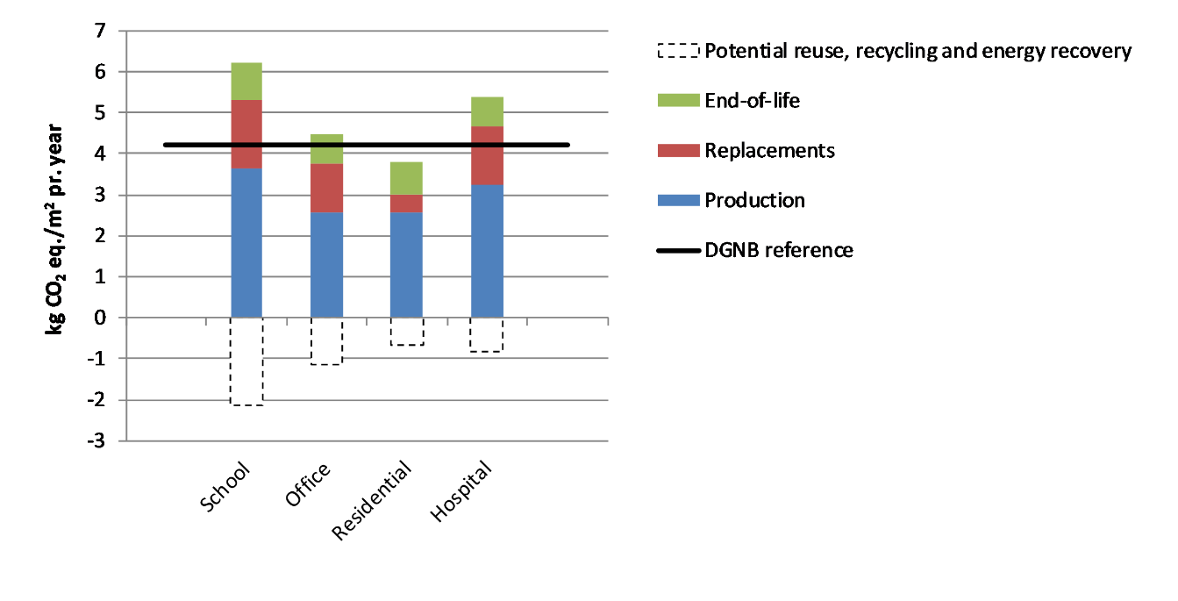

**Figure 1.** Total GWP contribution of each life cycle stage induced by each building type compared to the DGNB reference value for 100 years. *Note* module D is reported separately

Figure 1 shows the contribution to the buildings total EG at different life cycle stages. Even though the reference study period is 100 years (i.e. many material replacements take place during this time), the EG contribution primarily originates from the production of the buildings, contributing 59%, 58%, 68% and 60% of the buildings total EG, respectively for the school, office, residential building and hospital. However, component and material replacements during operation of the buildings also make up a noticeable share of the buildings’ EG, with 27%, 27%, 11% and 26% of the school, office, residential building and hospital, respectively. The end-of-life stage makes up a smaller contribution to the buildings’ total EG with 14%, 16%, 21% and 13% of the school, office, residential building and hospital respectively. Figure 1 also compares the buildings’ total EG contribution with the DGNB reference value of 4.2 kg CO2 eq./m2 per year for a reference study period of 100 years [43]. Only the residential building is below the DGNB reference value for EG when not including potentially avoided impacts. However, it was found that 34%, 26%, 18% and 16% of the total EG of the school, office, residential building and hospital, respectively could potentially be avoided through future reuse, recycling and/or energy recovery at the building materials’ end-of-life.

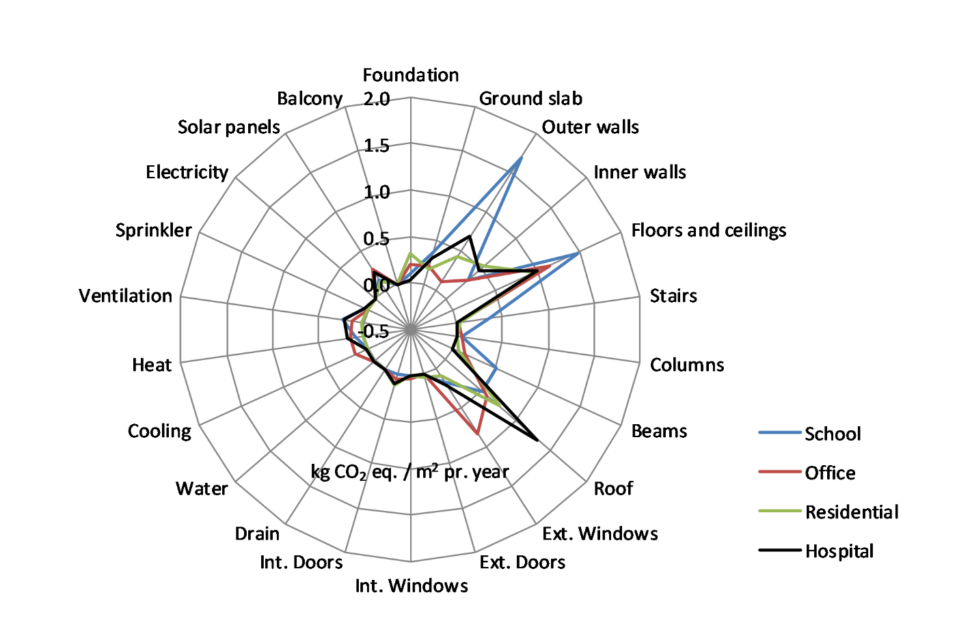

**Figure 2**. Contributions of building components to GWP for each building type. *Note* module D is not included.

Figure 2 shows the contribution to EG of the individual building components for each building. The outer walls of the school are the largest contributor to EG and far greater compared to the outer walls of the other buildings. Some similarities are observed for the buildings’ component contributions to EG. For example, similar high contributions to EG are seen for the floors and ceilings and the roofs. The outer walls of the office building consist of large glass and aluminium curtain walls, which are included in the exterior windows component group. Counting the façade system of the office as part of its outer walls yields high contributions from the outer walls for all the buildings. In comparison, foundations, columns, balconies, internal windows and doors as well as the technical building services yield small contributions to EG for all buildings.

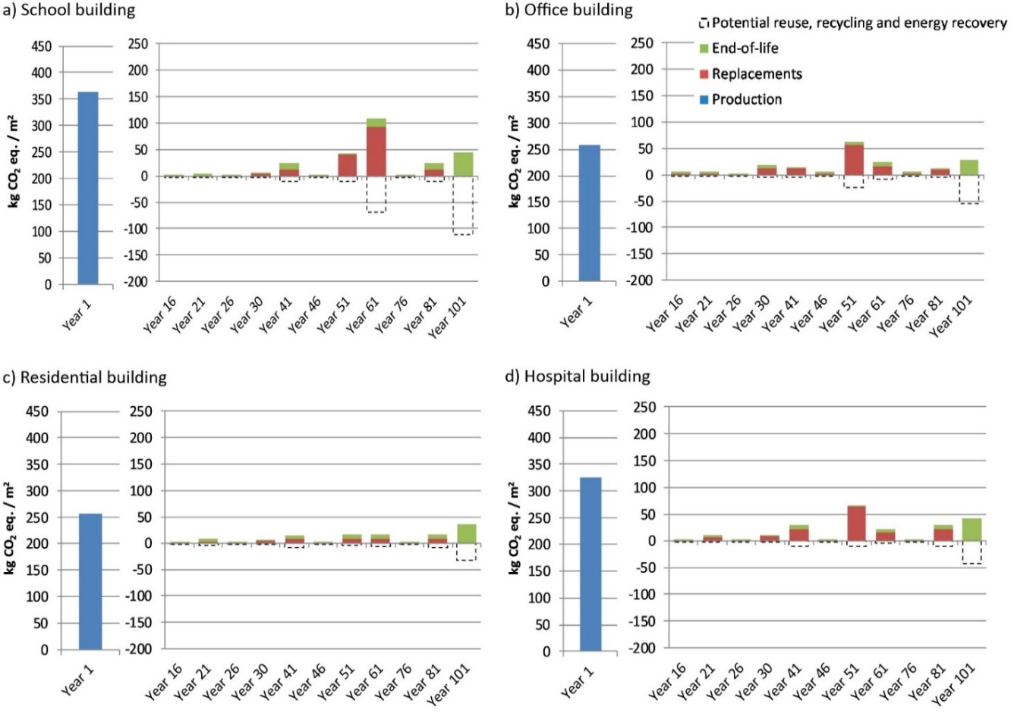

**Figure 3.** Temporal distribution of the buildings’ GWP. Note: year 1 is separated from the other years due to a higher GWP in the production year compared to the subsequent years. *Note* module D is reported separately below 0.

Figure 3 shows the temporal distribution of the buildings’ EG at different life cycle stages. As the majority of the EG is at the production stage in year 1 for all the buildings, the graph distinguishes between EG contribution from production in year 1, and component and material replacements up until year 101, when the buildings’ end-of-life stage takes place. Similar to Figure 1, EG avoided if the materials are reused, recycled or incinerated for energy recovery in the future is displayed as a negative impact. Replacements with a minor EG contribution take place throughout the buildings’ service lives. However, in year 61, larger, ‘EG-intensive’, replacements take place for the school and in year 51 for the office and hospital.

|  |  |  |
| --- | --- | --- |
|  | |  |
| **Figure 4.** GWP contribution of component groups and materials for school and office building. Note module D is reported separately below 0. Primary axis bars: blue: production, red: replacements, green = end-of-life, dotted line: potential for reuse, recycling and energy recovery. Secondary axis line = number of material replacements during 100 years. | | |
|  |  | |
| **Figure 5.** GWP contribution of component groups and materials for the residential building and hospital. Note module D is reported separately below 0. Primary axis bars: blue: production, red: replacements, green = end-of-life, dotted line: potential for reuse, recycling and energy recovery. Secondary axis line = number of material replacements during 100 years. | | |

Figures 4 and 5 show the contributions from component groups and inherent materials to the buildings’ total EG. Each component group’s relative contribution to the total EG of the building is stated to the right of each graph and ranked according to the component groups with the highest share of the building’s total EG. Each material’s relative contribution to the total EG of the building is indicated on the primary axis, and is divided between the EG from production, replacement, and end-of-life, as well as the potential for reuse, recycling and energy recovery. Furthermore, the number of replacements of each material during the 100-year reference study period is indicated on the secondary axis.

Figure 4 and Figure 5 reveal certain similarities between the buildings in terms of which building components and inherent materials are responsible for the highest share of the buildings’ total EG. As also shown in Figure 2, the floors and ceilings of all the buildings have a large contribution to EG, with 24%, 26%, 25% and 21% for the school, office, residential building and hospital, respectively. The EG contribution from the floors and ceilings primarily stems from the production of concrete, accounting for 8%, 13%, 11% and 10% of the total EG of the school, office, residential building and hospital, respectively. The remainder of the EG primarily stems from continuous replacements of floor coverings such as varnishes, plastic, wood and carpets as well as mineral wool, gypsum and fibre cement panels. For example, the carpets in the office building are replaced five times during the building’s service life, contributing 7% of the building’s total EG.

As was also seen in Figure 2, all the buildings’ outer walls have a large EG contribution, with 27%, 19%, 12% and 14% for the school, office, residential building and hospital, respectively. For all the buildings, the EG contribution stems from the use of EG-intensive materials. For example, the exceptionally large EG contribution from the outer walls of the school building compared to the other buildings (see Figure 2) comes from the production and replacement of the aluminium lamellas and plates on the façade. The aluminium lamellas and plates on the façade alone are responsible for 24% of the building’s total EG, although the aluminium only makes up 1% of the building’s total mass. Although aluminium is a non-scarce mineral with a supply horizon of up to 20,000 years after 2050 [44], it is EG-intensive due to the energy requirements in relation to production. For the office, the sizeable contribution to EG of the outer walls stems from the production and replacement of the large glass and aluminium curtain wall, contributing 16% of the building’s total EG. For the residential building, the contribution of the outer walls to the building’s total EG primarily comes from the production of bricks and production and replacement of mineral wool, contributing 5% and 3% respectively to the building’s total EG. For the hospital, the outer walls contribution originates from the production of concrete and production and replacement of mineral wool, with 8% and 3%, respectively.

The roof accounts for a large share of the buildings’ EG, with 8%, 13%, 20% and 27% of the school, office, residential building and hospital respectively. As the structural build-up of the roofs of the buildings are similar, the same materials are responsible for the roofs’ large EG. These materials include roof felt and insulation materials such as mineral wool and EPS. The frequent replacement and especially the disposal of roof felt by incineration accounts for 3%, 4%, 11% and 5% of the total EG of the school, office, residential building and hospital, respectively. The production, replacement and disposal of EPS accounts for 6% and 4% of the total EG of the office and residential building. The production and replacement of mineral wool contributes 3% and 14% of the total EG of the school and hospital.

The inner walls also show a noticeable contribution to the total EG of the office, residential building and hospital, accounting for 7%, 14% and 10% of the total EG, respectively. Although concrete makes up the largest share of the inner walls’ EG, with 3%, 7% and 3% for the office, residential building and hospital, respectively, the remaining EG induced by the inner walls originates from a much more even distribution between the other materials in the inner walls.

The above results are summarised in Table 2.

|  |  |
| --- | --- |
| **Component** | **Material** |
| Floors and ceilings | Production of concrete  Frequent replacement of floor coverings e.g. carpets |
| Outer walls | Production and replacement of aluminium facade covering  Production and replacement glass/aluminium curtain walls  Production of bricks  Production and replacement of stone wool  Production of concrete |
| Roof | Frequent replacement of roof felt  Production and replacement of insulation materials such as stone wool and EPS |
| Inner walls | Production of concrete |

**Table 2.** Summary of similar component and material EG hotspots between the buildings

## 4.2 Key observations

Figures 4 and 5 show that the large EG from production in some cases originates from a few materials (e.g. the aluminium on the school facades). However, in most of the buildings, the EG contribution from the production stage comes from a combination of the production of several different materials used in different component groups, for example the residential building on Figure 5, where the significance of the blue bars is spread across several component groups.

Materials with a high replacement rate, such as the roof felt, result in a noticeable EG contribution. However, Figures 4 and 5 also reveal that materials with a high replacement rate do not always result in a large EG contribution. For example, paint on the inner walls covers a large surface area of the buildings and is replaced five times during the reference study period, but has a low EG compared to some of the other materials. In comparison, some ‘once only’ produced materials, as well as materials with few replacements such as mineral wool in the roof of the hospital or aluminium on the facades of the school, exhibit a large EG contribution.

Figures 4 and 5 also show that the similarities between the buildings are not always for the same reasons. For example, some component groups have a similar high ranking for the buildings, but due to different material compositions. For example, the outer walls are ranked high for all the buildings assessed. However, for the outer walls of the school, the high ranking is due to the large EG contribution stemming from the massive amount of aluminium in the façade, which is also replaced once during the reference study period. In contrast, the outer walls of the hospital are ranked high because of the contribution stemming from the large amount of ‘once only’ produced prefabricated load-bearing concrete elements. In these cases, it is not easy to make general conclusions between buildings.

Similarly, optimisation opportunities can also be difficult to identify in cases such as the outer walls of the hospital building, with an EG contribution of 14%, because the 14% stems from a combination of several different materials (the concrete results in 8% of the EG contribution and the remaining 6% comes from a mix of the other materials). In such cases, only a little is saved by replacing the concrete in the outer walls rather than considering re-designing the entire component, for example. As the hospital building only consist of three floors, the use of prefabricated load-bearing concrete elements for the outer walls could be avoided by designing the structural system to use a lighter wood structure yielding a lower EG contribution, for example.

Figures 4 and 5 also show that, when accumulated, some material groups account for a high percentage of the total EG of the building (e.g. concrete has a total contribution of 27% of the school’s total EG). However, this gross summation of materials is not very helpful from an optimisation perspective as it is easy to overlook that the concrete is used in different areas of the buildings to provide different functions. For example, Figure 4 shows that concrete of three different strengths is used for the floor slabs, ground slab and foundations. Hence, substituting the concrete altogether may prove difficult, as the alternative needs to compensate for all the functions the concrete provides.

Decomposing a building into its components and inherent materials, as shown in Figures 4 and 5, can more clearly help identify opportunities for optimisation within each building by not only showing impacts of individual components and materials but also by showing their relation to each other in understanding the context of their use and ensuring that crucial functions of each component as well as material are guaranteed, despite EG optimisations. For example, it is clearly seen for the office building on Figure 4 that the self-carrying reinforced concrete floor slabs contribute a noticeable share of the building’s EG, amounting to 12% of the total EG. However, the self-carrying slabs are necessary due to the large building span width. Substituting the slabs with a less EG-intensive alternative could in return result in trade-offs such as a redesign of the building to minimise the building span width or placing additional columns to carry the slabs, potentially resulting in the redesign of the entire floor-plan layout. Additional columns would also mean additional EG from this component group. Thus, questions also arise about whether the EG benefits from substituting the slabs outweigh the additional EG from the extra columns. However, as seen on Figure 4, easier optimisations can be made. For example, it is easier to substitute the carpets, which have a high impact due to frequent replacement, with an alternative with less EG contribution.

There is an obvious need to find a better alternative to the aluminium on the school’s facades due to its huge contribution (24%) to the building’s total EG. However, the hotspots of the other buildings are more evenly distributed among the materials. For example, the roof felt seems to be a hotspot in the residential building, but it only contributes 11% of the building’s total EG. Thus, further optimisations of the residential building’s EG need to come from a combination of several initiatives. Similar results are found for the office and the hospital building.

The above observations are summarised in Table 3.

|  |  |
| --- | --- |
|  | **Description** |
| 1. | The production stage’s high EG contribution does not always originate from the production of a single material, but can come from a combination of the production of several different materials used in different component groups |
| 2. | Frequently replaced materials do not always result in a high EG contribution e.g. paint |
| 3. | Some materials that are frequently replaced result in a high EG contribution e.g. roof felt |
| 4. | Some materials with few replacements have a high EG e.g. stone wool and aluminium |
| 5. | Some materials exhibit a very high EG from production e.g. aluminium on the facades of the school |
| 6. | Similar component and material EG hotspots between the buildings (i.e. EG hotspots) do not always exist for the same reasons due to differences in material compositions and functions |
| 7. | Some component groups have a high EG due to a combination of several materials and not due to a single material. In these instances, a complete redesign of the component should be considered rather than sub-optimising single materials within it. |
| 8. | Certain material groups may contribute to a high percentage of a building’s total EG (e.g. concrete) but this overlooks that the same material may provide many different functions in different areas of the building, which is important to know when identifying optimisation potentials. |
| 9. | Unnecessary use of EG-intensive materials should be avoided e.g. use of aluminium on the façade of the school |
| 10. | Optimisations of singular component groups or materials may not provide high EG reductions, suggesting that further optimisations can only be provided from combining several different initiatives. |

**Table 3.** Summary of key observations derived from the results

# Discussion

In line with previous research [33], most of the buildings’ EG contribution is already induced in the production stage. To come closer to achieving climate goals (e.g. reducing greenhouse gas emissions by 40% by 2030), design and construction strategies that reduce buildings’ production impacts are very important. Ultimately, reuse (i.e. life prolongation) of existing buildings can avoid or postpone production of new buildings and result in large environmental and economic benefits due to increased resource efficiency [9, 45]. Reusing existing components and/or materials can also substantially reduce buildings’ EG originating from production. For example, in Canada, reusing a high-rise building’s structure compared to complete demolition and new construction showed a 33% EG saving [46]. Likewise, a 38.5% potential energy saving (also translating into EG savings) was assessed for a maximum deconstruction for reuse of the materials and components in a concrete-framed high-rise building in China at its end of life [47]. Reuse of the concrete structure of the hospital compared to complete demolition and new construction could potentially yield a 31% EG saving.

Similarly, as construction of new buildings cannot be avoided altogether, when designing new buildings, it is also worth considering how their service life can be prolonged to avoid future demolition and new construction. For example, buildings with non-load-bearing and easily adaptable or removable facades, as well as column structures as opposed to load-bearing walls, have been found to have a lower mortality rate and EG [48]. Such building features are also of particular importance, as buildings always go through several retrofitting phases [49]. In that regard, design for disassembly of building components for easier assembly and disassembly could enhance buildings’ future ease of adaptation to and accommodation for future changes according to new use patterns and user preferences [50].

The results of the case study buildings also show that correct selection of components and materials is vital to reduce buildings’ EG from production. If possible, use of a high-impact material should be avoided or substituted with a suitable lower-EG alternative that can deliver the required function. Similar suggestions have been made in previous studies [11] [32]. For example, use of recycled or recovered materials or bio-based materials [9] has shown considerable potential to reduce embodied impacts. The school building’s total EG could be reduced by 19% by substituting the EG-intensive virgin aluminium facade plates and lamellas with recycled aluminium produced using hydro energy in Norway. A 24% reduction can be obtained by substituting the aluminium façade plates and lamellas with wood. If high-impact materials cannot be avoided or substituted, the material amount should be reduced as much as possible. For example, as found in other studies, concrete elements exhibit a large EG [46]. However, concrete elements are often over-dimensioned, with unnecessarily large amounts of concrete and reinforcement in the finished buildings [51]. According to Jensen [51], approximately 18 kg CO2 per m2 of a concrete building can be saved. For the residential building, this would yield a 5% EG saving.

Replacements also induce a noticeable EG during the buildings’ service lives. It is also important to reduce EG from future material replacements, as these emissions take place before the climate goals for 2030 and 2050. Depending on the material to be replaced, the EG can come from: 1) production of the replacement material (e.g. mineral wool, glass and aluminium), 2) end-of-life treatment of the material to be replaced (e.g. incineration of roof felt and carpets), 3) a high replacement rate (e.g. carpet’s service life of 15 years) or a combination. Similar to production, correct selection of materials is also important to reduce EG from replacements (i.e. avoiding, substituting or reducing EG-intensive and short-lived materials in replacements). For example, the glass and aluminium curtain wall of the office building contributes to 11% of the building’s total EG, and where 5% alone comes from replacement in year 50. Lützkendorf et al. [49] suggest substituting metal-based curtain walls with wooden alternatives in order to reduce emissions significantly. For the office building, this would result in a 10% EG reduction. Furthermore, 6% of the total EG of the office can be saved by substituting the carpets with wood floors. The EG of replacements related to end-of-life can be reduced by ensuring reuse and recycling options of the replaced material rather than disposal. For example, by recycling the frequently replaced roof felt of the hospital and residential building instead of incineration, 5% and 9% of the buildings’ total EG can be reduced, respectively.

Compared to production and replacements, end-of-life only accounts for a very small share of the buildings’ total EG, thereby creating a minimal potential for further EG reductions. However, the results indicate a noticeable potential for avoiding EG through future reuse, recycling and/or recovery of materials at end-of-life. It is important to note that potential EG benefits (i.e. avoided impacts) are only gained when, and if, reuse, recycling, and energy recovery occurs. Hence, as some materials’ end-of-life occurs in the distant future, the circumstances and how much EG is avoided are not obvious or guaranteed. For example, the rates and efficiencies of reuse and recycling technologies may change dramatically in the future. However, as all components and materials eventually reach their final end-of-life, it is important to take measures that ensure that their reuse, recycling and/or energy recovery potential can be realised in the future. In addition to enhancing adaptability, design for disassembly can also ease future recovery and repurposing of individual components and materials, thereby minimising future emissions from production and consumption of virgin materials and freeing up resources [52]. For example, Eberhardt et al. [28] found that design for disassembly of the prefabricated concrete elements used in an office building could potentially save 15% and 21% of the building’s EG when used two or three times respectively. If the prefabricated concrete elements (i.e. floor slabs, columns and beams) of the office building were designed for disassembly and reused at the building’s end-of-life, they would save what amounts to 16% of the office building’s total EG.

|  |  |  |
| --- | --- | --- |
| **Building** | **Optimisation** | **Potential reduction of the building’s total EG [%]\*** |
| School | Substituting virgin aluminium façade plates and lamellas with secondary aluminium produced using hydro energy in Norway | 19% |
|  | Substituting virgin aluminium plates and lamellas on the facades with wood | 24% |
| Office | Substituting the aluminium curtain walls with timber curtain walls | 10% |
|  | Design for disassembly of the prefabricated concrete elements (i.e. floor slabs, columns and beams) for reuse at the building’s end-of-life | 16% |
|  | Substituting the carpets with wood floors | 6% |
| Hospital | Recycling roof felt instead of incineration at end of life | 5% |
|  | Reuse of the concrete structure compared to complete demolition and new construction | 31% |
| Residential | Recycling roof felt instead of incineration at end of life | 9% |
|  | Lean design of concrete elements (i.e. avoiding over-dimension) can yield approximately 18 kg CO2 reduction per m2 building | 5% |

**Table 4.** Optimisation scenarios and potential EG reductions

*for a reference study period of 100 years

From the above observations, we find that components and materials cannot necessarily be classified as ‘good’ or ‘bad’ in terms of EG performance, without also considering their entire use context. For example, the production, use and disposal of concrete elements may induce large amounts of EG, whereas the production and subsequent reuse of concrete elements can potentially reduce the components’ EG. The optimisation scenarios mentioned for the buildings assessed and the potential EG reductions are summarised in Table 4. A combination of all the optimisation scenarios would contribute significantly to reducing the buildings’ EG. Hence, it is clear that a combination of CE design and construction initiatives going across and beyond the entire life cycle of buildings, components and materials is needed to reduce EG both now and in the future, and to help achieve climate goals. Similar suggestions have been proposed by others [9, 11].

# 6. Conclusion

CE can help reduce the building industry’s immense environmental impact by narrowing, slowing and closing material loops by reusing, repairing, refurbishing, recycling and recovering through design and construction strategies such as design for disassembly, adaptability, durability, low-impact materials etc. However, the industry suffers from a lack of aggregated knowledge about where the largest environmental impact reduction potentials for buildings are to be found. Such knowledge is fundamental for pointing out which building design and construction strategies should be in focus when transitioning the building industry to a CE. Accordingly, this paper has assessed the EG-reduction opportunities of four Danish case-study buildings (a school, an office, a residential building and a hospital) using LCA.

From the LCA results presented, generalisations between the buildings were identified. The EG primarily comes from the production of the case buildings. However, component and material replacements also make up a noticeable EG contribution. The EG contribution from production and replacements was found to stem from the same component groups and materials: floors and ceilings (concrete and floor coverings), outer walls (aluminium, glass, bricks, mineral wool and concrete), roof (roof felt, mineral wool and EPS insulation) and inner walls (concrete). Although the end-of-life of the components and materials only accounted for a smaller share of the buildings’ total EG, a noticeable potential for avoiding EG at end-of-life exists if reuse, recycle and/or energy recovery options exist for the components and materials, instead of disposal.

To help achieve climate goals (e.g. 70% CO2 reduction in 2030 compared to 1990), three main focus areas clearly emerged from the analysis. First, buildings need to reduce their EG now (from production) and in the future (from replacements). Second, this means that EG-reducing initiatives going across and beyond the life cycles of the buildings, components and materials are needed. This also means that buildings, components and materials cannot necessarily be classified as ‘good’ or ‘bad’ in terms of EG as to a large extent this is determined by how they are used throughout their life cycle. Third, a combination of several different EG-reducing initiatives is required. Hence, it is recommended to focus on CE building design and construction strategies such as reuse of existing buildings, components and materials; correct selection of materials (i.e. avoid, substitute or reduce the use of EG-intensive and short-lived materials); and enabling future reuse, recycling and/or energy recovery options for materials.

These generalisations can provide some guidance in the early design and decision-making process of new buildings. However, ‘one-off’ projects are trending in the industry, and the generalisations also found variances between the assessed buildings. For that reason, it is suggested to use a combination of generalised learnings as well as continuing to assess buildings on a case-to-case basis to capture the buildings’ unique features and to determine how to best reduce EG for the particular building in question.

The research also highlights the interconnectedness between the building, components and materials as a determining factor for identifying feasible EG-reduction opportunities in the decision-making process. Hence, we suggest that buildings should be considered as a composite of components and materials with different contextually dependent functions. Such decomposition of buildings provides a better decision basis, allowing for efforts to be focused on optimising EG-intensive components and materials, rather than focusing on optimising the entire building at once. As this approach requires the assessor to model the building system in a more detailed manner than is common practice, further implementation-oriented development of the LCA method is needed. Furthermore, this approach may yield great variation between buildings in terms of which optimisation initiatives are most suitable to reduce EG as well as the amount of obtainable EG savings. As this may exacerbate the already fragmented CE development in the building industry, we recommend that industry stakeholders co-create new CE design and construction concepts (i.e. decide which design strategies can be used and applied and whether one or more of the strategies will have to be adjusted to a specific context). These concepts should be designed to fit a flexible and diverse building context.

The case buildings that form the basis for this paper are representative for the type of concrete structures frequently built in Denmark, and they were all built by the same contractor. For that reason, the results may only apply to these case buildings. Hence, more cases from different data sources, preferably including other building types (e.g. steel and wood structures) are needed to validate the results and generalisations presented here. However, this study has contributed to the limited LCA knowledge on where the largest EG optimisation potentials occur in buildings and which CE design and construction strategies should be considered to reduce EG from buildings.

**Acknowledgement**

This study was conducted in close collaboration with the Danish building contractor MT Højgaard A/S. The authors would therefore like to thank MT Højgaard for providing valuable information and data on the case study buildings used in the paper.

# References

[1] Ibn-Mohammed T, Greenough R, Taylor S, et al. Operational vs. embodied emissions in buildings - A review of current trends. *Energy Build* 2013; 66: 232–245.

[2] United Nations Environmental Programme. Protocol for Measuring Energy Use and Reporting Greenhouse Gas Emissions from Building Operations. *Sustain Build Clim Initiat*.

[3] United Nations. About the Sustainable Development Goals, https://www.un.org/sustainabledevelopment/sustainable-development-goals/ (accessed 23 March 2020).

[4] Amanatidis G. European policies on climate and energy towards 2020, 2030 and 2050. *Eur Union* 2019; 12.

[5] European Commission. *Going climate neutral by 2050 a strategic longterm vision for a prosperous, modern, competetive and climate-neutral EU economy*. Luxemborg, 2019.

[6] Ellen MacArthur Foundation. *Completing the Picture: How the Circular Economy Tackles Climate Change*, www.ellenmacarthurfoundation.org/publications (2019).

[7] Reike D, Vermeulen WJV, Witjes S. The circular economy: New or Refurbished as CE 3.0? — Exploring Controversies in the Conceptualization of the Circular Economy through a Focus on History and Resource Value Retention Options. *Resour Conserv Recycl* 2018; 135: 246–264.

[8] Eberhardt LCM, Birkved M, Birgisdottir H. Building design and construction strategies for a circular economy. *Archit Eng Des Manag* 2020; 0: 1–21.

[9] Malmqvist T, Nehasilova M, Moncaster A, et al. Energy & Buildings Design and construction strategies for reducing embodied impacts from buildings – Case study analysis. *Energy Build* 2018; 166: 35–47.

[10] Winkler H. Closed-loop production systems-A sustainable supply chain approach. *CIRP J Manuf Sci Technol* 2011; 4: 243–246.

[11] Pomponi F, Moncaster A. Embodied carbon mitigation and reduction in the built environment – What does the evidence say? *J Environ Manage* 2016; 181: 687–700.

[12] EN 15978. *Sustainability of construction works - Assessment of environmental performance of buildings - Calculation method*. 2011.

[13] ISO 14040. *Environmental management - Life cycle assessment - Principles and framework*. 2008.

[14] ISO 14044. *Environmental management - Life cycle assessment - Requirements and guidelines*. 2006.

[15] ISO 21931-1. *Sustainability in building construction Framework for methods of assessment of the environmental performance of construction works Part 1: Buildings*. 2010.

[16] Pomponi F, Moncaster A. Circular economy for the built environment : A research framework. *J Clean Prod* 2017; 143: 710–718.

[17] Cavalliere C, Habert G, Dell’Osso GR, et al. Continuous BIM-based assessment of embodied environmental impacts throughout the design process. *J Clean Prod* 2019; 211: 941–952.

[18] Means P, Guggemos A. Framework for Life Cycle Assessment (LCA) Based Environmental Decision Making during the Conceptual Design Phase for Commercial Buildings. *Procedia Eng* 2015; 118: 802–812.

[19] Röck M, Hollberg A, Habert G, et al. LCA and BIM : Visualization of environmental potentials in building construction at early design stages. *Build Environ* 2018; 140: 153–161.

[20] Dodd N, Cordella M, Traverso M, et al. Level(s) – A common EU framework of core sustainability indicators for office and residential buildings. Parts 1 and 2: Introduction to Level(s) and how it works. 2017; 1–68.

[21] The Danish Government, Miljø- og Fødevareministeriet, Erhvervsministeriet. Strategi for cirkulær økonomi.

[22] Röck M, Ruschi Mendes Saade M, Balouktsi M, et al. Embodied GHG emissions of buildings – The hidden challenge for e ff ective climate change mitigation. *Appl Energy* 2019; 258: 114107.

[23] Crawford RH. *Life Cycle Assessment in the Built Environment*. 1st ed. London: Taylor and Francis, 2011. Epub ahead of print 2011. DOI: 10.4324/9780203868171.

[24] Energistyrelsen. Strategi for energirenovering af bygninger. 2014; 31.

[25] Editor S, Rosen KH. An INTRODUCTION to DGNB. *Green Build Counc Denmark*.

[26] Laurent A, Olsen SI, Hauschild MZ. Carbon footprint as environmental performance indicator for the manufacturing industry. *CIRP Ann - Manuf Technol* 2010; 59: 37–40.

[27] Heinonen J, Säynäjoki A, Junnonen JM, et al. Pre-use phase LCA of a multi-story residential building: Can greenhouse gas emissions be used as a more general environmental performance indicator? *Build Environ* 2016; 95: 116–125.

[28] Eberhardt LCM, Birgisdóttir H, Birkved M. Life cycle assessment of a Danish office building designed for disassembly. *Build Res Inf* 2018; 0: 1–15.

[29] Resch E, Andresen I. A database tool for systematic analysis of embodied emissions in buildings and neighborhoods. *Buildings*; 8. Epub ahead of print 2018. DOI: 10.3390/buildings8080106.

[30] Rønholt J, Eberhardt L, Birkved M. Tracing the environmental impact origin within the existing building portfolio of prevailing building typologies. In: *Submitted to 1sr Nordic Conference on Zero Emission and Plus Energy Buildings*. 2019.

[31] Blengini GA. Life cycle of buildings, demolition and recycling potential: A case study in Turin, Italy. *Build Environ* 2009; 44: 319–330.

[32] Birgisdóttir H, Houlihan-Wiberg A, Malmqvist T, et al. *IEA EBC ANNEX 57 - Subtask 4: Case studies and recommendations for the reduction of embodied energy and embodied greenhouse gas emissions from buildings*. 2016.

[33] Anand CK, Amor B. Recent developments, future challenges and new research directions in LCA of buildings: A critical review. *Renew Sustain Energy Rev* 2016; 67: 408–416.

[34] Birgisdóttir H, Madsen SS. *Bygningers indlejrede energi og miljøpåvirkninger, vurderet for hele bygningens livscyklus*. 2017.

[35] John V. Derivation of reliable simplification strategies for yje comparative LCA of individual and ‘typical’ newly built Swiss apartment buildings.

[36] Birgisdottir H, Moncaster A, Wiberg AH, et al. IEA EBC annex 57 ‘evaluation of embodied energy and CO2eq for building construction’. *Energy Build* 2017; 154: 72–80.

[37] Nygaard F, Malmqvist T, Moncaster A. Analysing methodological choices in calculations of embodied energy and GHG emissions from buildings. *Energy Build* 2018; 158: 1487–1498.

[38] Birgisdottir H, Rasmussen FN. Development of LCAbyg: A National Life Cycle Assessment Tool for Buildings in Denmark. *IOP Conf Ser Earth Environ Sci*; 290. Epub ahead of print 2019. DOI: 10.1088/1755-1315/290/1/012039.

[39] Hauschild M, Rosenbaum RK, Olsen SI. *Life Cycle Assessment - Theory and practice*. 2018. Epub ahead of print 2018. DOI: 10.1007/978-3-319-56475-3.

[40] Aagaard N-J, Brandt E, Aggerholm S, et al. *Levetider af bygningsdele ved vurdering af bæredygtighed og totaløkonomi*. 2013.

[41] Green Building Council Denmark. DGNB DK, https://www.dk-gbc.dk/english/ (accessed 28 February 2020).

[42] Copenhagen Cleantech Cluster. CLEAN RAPPORT 2014 Kortlægning af genbrugsmarke- der for byggematerialer Indholdsfortegnelse. 2014; 120.

[43] Statens Byggeforskningsinstitut (SBi). *Referenceværdier for bygningsdele og drift i LCAbyg [Reference values for building parts and operation in LCAbyg]*. Copenhagen, 2017.

[44] Henckens MLCM, van Ierland EC, Driessen PPJ, et al. Mineral resources: Geological scarcity, market price trends, and future generations. *Resour Policy* 2016; 49: 102–111.

[45] Akanbi LA, Oyedele LO, Akinade OO, et al. Salvaging building materials in a circular economy: A BIM-based whole-life performance estimator. *Resour Conserv Recycl* 2018; 129: 175–186.

[46] Assefa G, Ambler C. To demolish or not to demolish : Life cycle consideration of repurposing buildings. *Sustain Cities Soc* 2017; 28: 146–153.

[47] Chau CK, Xu JM, Leung TM, et al. Evaluation of the impacts of end-of-life management strategies for deconstruction of a high-rise concrete framed office building. 2017; 185: 1595–1603.

[48] Blok R, Teuffel PM. Demolition versus Transformation, ‘mortality of building structures’ depending on their technical building properties. *IOP Conf Ser Earth Environ Sci*; 225. Epub ahead of print 2019. DOI: 10.1088/1755-1315/225/1/012016.

[49] Lützkendorf T, Balouktsi M, Frischknecht R, et al. *Strategies for Reducing Embodied Energy and Embodied GHG Emissions - Part 2*. 2016.

[50] Rios FC, Chong WK, Grau D. Design for Disassembly and Deconstruction - Challenges and Opportunities. *Procedia Eng* 2015; 118: 1296–1304.

[51] Jensen NJJ. Beregningssoftware giver CO2-besparelser [Calculation software results in CO2 savings], http://www.dagensbyggeri.dk/artikel/93549-beregningssoftware-giver-co2-besparelser (2017).

[52] Cossu R, Williams ID. Urban mining: Concepts, terminology, challenges. *Waste Manag* 2015; 45: 1–3.