
H2020-LC-SC3-2018-ES-SCC
EUROPEAN COMMISSION
Innovation and Networks Executive Agency
Grant agreement no. 824441

Multi Utilities Smart Energy GRIDS

WP3 – “Multiple energy grids planning tool”
D3.3 – Interaction of local energy grids in demonstration sites

Due date of deliverable: 31/10/2021
Actual submission date: 31/10/2021

Organisation name of lead contractor for this deliverable: AAU

Authors: Rasmus Magni Johannsen, Poul Alberg Østergaard, Sara Abd Alla, Giorgio Bonvicini, Steffen Nielsen, Diana Carolina Moreno Saltos, Peter Sorknæs

Dissemination Level (Specify with “X” the appropriate level)
CO | Confidential
PU | Public | X

Project Contractual Details
Project Title | Multi Utilities Smart Energy GRIDS
Project Acronym | MUSE GRIDS
Grant Agreement No. | 824441
Project Start Date | 01-11-2018
Project End Date | 31-10-2022
Duration | 48 months
Supplementary notes:
This document is only for use among the Partners of MUSE GRIDS

Table of contents
1 Background 4
2 Demo site: Osimo 5
2.1 The area 5
2.2 Energy demands 6
2.2.1 Electricity 6
2.2.2 Heating and cooling 7
2.2.3 Transport 10
2.2.4 Industry 11
2.3 Energy supply 11
2.3.1 Power plants 11
2.3.2 District heating 11
2.3.3 Wind power 11
2.3.4 Photovoltaics 11
2.3.5 Hydropower 12
2.4 Renewable energy potentials 12
2.4.1 Wind 13
2.4.2 Photovoltaics 14
2.4.3 Biomass 14
2.4.4 Geothermal 16
2.4.5 Industrial excess heat 16
2.5 Summary of demo site inputs 17
3 Demo site: Oud-Heverlee 18
3.1 The area 18
3.2 Energy demands 19
3.2.1 Electricity 19
3.2.2 Heating and cooling 20
3.2.3 Transport 21
3.2.4 Industry 22
3.3 Renewable energy resources 23
3.3.1 Wind resources 23
3.3.2 Solar resources 24
3.3.3 Industrial excess heat 25
3.4 Energy supply and production technologies 26
3.4.1 Renewable electricity production 26
3.4.2 Power plants and electricity connections 28
3.4.3 Transport vehicles 29
3.4.4 Individual heating 30
3.4.5 District heating 31
3.5 Summary of demo site inputs 31
4 Energy system scenarios: Osimo 32
4.1 Scenario overview 32
4.1.1 Reference scenario 33
4.1.2 Heat scenarios 34
4.1.3 Transport scenarios 34
4.2 Energy demands and fuel consumption 35
4.3 Renewable energy production and integration 37
4.4 Costs 41
4.5 Summary of scenario outcomes 42
5 Energy system scenarios: Oud-Heverlee 43
5.1 Scenario overview 43
5.1.1 Reference scenario 44
5.1.2 Heat scenarios 44
5.1.3 Transport scenarios 46
5.2 Energy demands and fuel consumption 47
5.3 Renewable energy production and integration 51
5.4 Costs 54
5.5 Summary of scenario outcomes 55
6 MUSE GRIDS Energy Planning Tool - application experiences 56
7 References 57

Background
The purpose of this report is to document the tool testing conducted for the MUSE GRIDS Energy Planning Tool, applied to the energy systems of Osimo (Italy) and Oud-Heverlee (Belgium) as part of WP3 Task 3.5. Reference and future scenarios are developed using the MUSE GRIDS Energy Planning Tool, a modified version of EnergyPLAN [1], suitable for developing and analysing scenarios for local energy systems, i.e., cities and municipalities. This report documents the inputs needed to conduct such analyses illustrates the potential results that can be extracted from the tool, and finally, reflects on the experiences gathered from applying and testing the tool. The conducted energy system analyses furthermore investigate the interoperability of energy sectors and grids to quantify the role of such cross-sector interactions.
The MUSE GRIDS Energy Planning Tool, along with reports describing 1) how to gather the required input data, and 2) the general tool framework and user manual, are available online at:
https://www.energyplan.eu/musetool/
In the future energy system scenarios developed a relatively short time horizon of 2030 is considered, to align both with the typical nature of municipal planning and the MUSE GRIDS project in general, focusing on present-day implementations and technological improvements in the form of energy grid interactions. The purpose of modelling future energy scenarios with the MUSE GRIDS Energy Planning Tool is two-fold; to establish relevant and tangible energy futures for the demo site municipalities, and equally important, to test the applicability and capability of the MUSE GRIDS Energy Planning Tool in a municipal context.
Primary data sources for input data are local climate reports and energy strategies, existing energy models for Italy and Belgium based on national data, and data collected directly within the MUSE Grids Energy Planning Tool through the use of included assessment tools (e.g., heat/cooling demands, weather resources, wind/solar resources etc.).
The following sections present the demo sites Osimo and Oud-Heverlee in terms of local energy demands, local energy supply capacity, and renewable energy potentials. This is followed by an introduction of the reference energy system scenario and the proposed future scenarios. Future scenarios investigate pathways for transitioning the heat sector and the potential for district heating expansion, in addition to pathways for renewable transportation. The future scenarios are combined with increased deployment of renewable energy production technologies, thereby evaluating energy system and grid interactions, in addition to the practical operation of the MUSE GRIDS Energy Planning Tool.

Demo site: Osimo
This section focuses on the Osimo demo site, providing a description of the area, the current energy demand, the current energy supply, and the potential for the introduction of renewable sources.

The area
The town of Osimo is a historical city on top of a hill in the Marche Region in Italy in the province of Ancona. The small municipality has approximately 35,000 inhabitants living in 14,388 households, mainly apartment buildings characterized by low efficiency and old natural gas boilers.
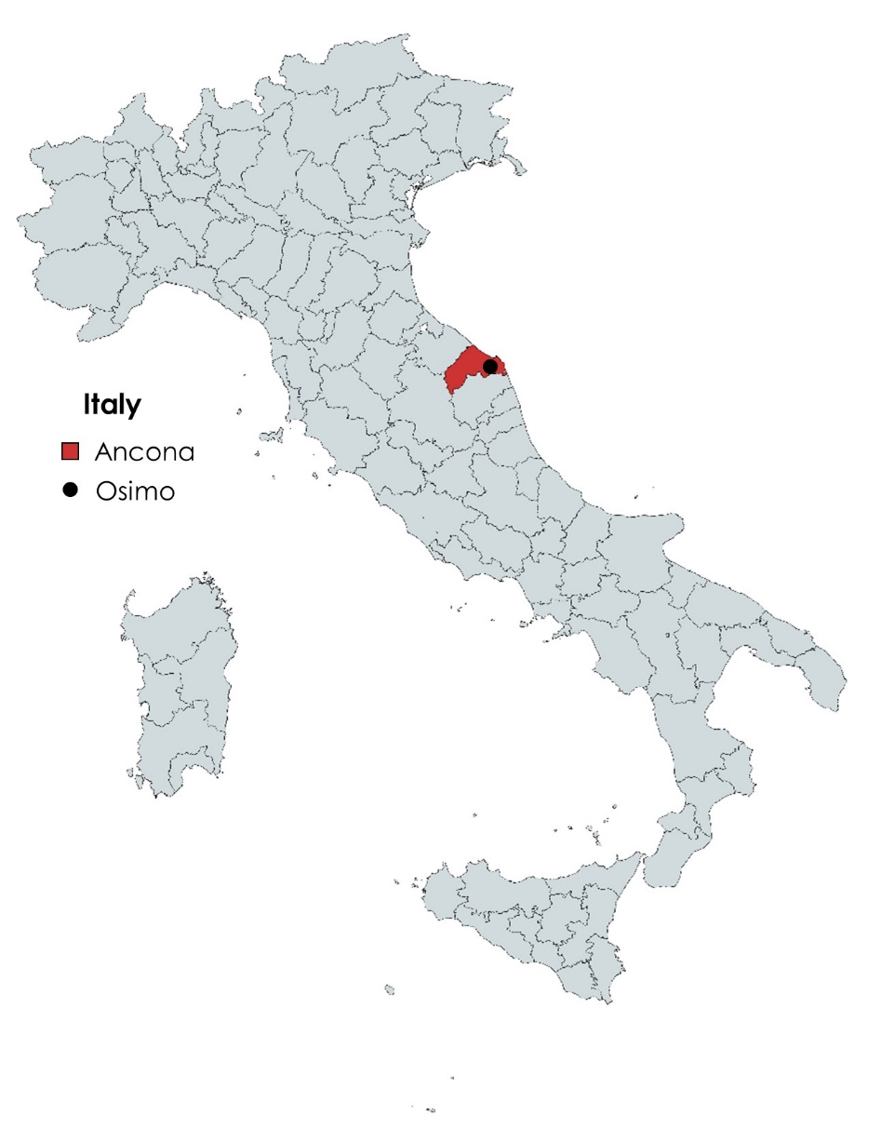
Figure 1: Osimo municipality in the Ancona province in Italy.
Since it has just one point of connection with the national electricity transmission grid, Osimo considers itself as a municipal microgrid with a grid connection of 30 MW [2]. Osimo also has a district heating network operated by ASTEA, a single municipality-owned holding company that is in charge of managing, through its subsidies, several commodities including electricity, district heating, natural gas, and water. Moreover, the town can be considered a multi-energy microgrid with its single coupling with the national transmission system and a significant amount of distributed electricity generation sources within its boundaries.
Since 2015, Osimo municipality has expressed an interest in climate change impacts and held several public discussions towards the participation in the Covenant of Mayor initiative, however, participation has not been formalized yet.
The boundaries of Osimo Municipality are shown in Figure 2.
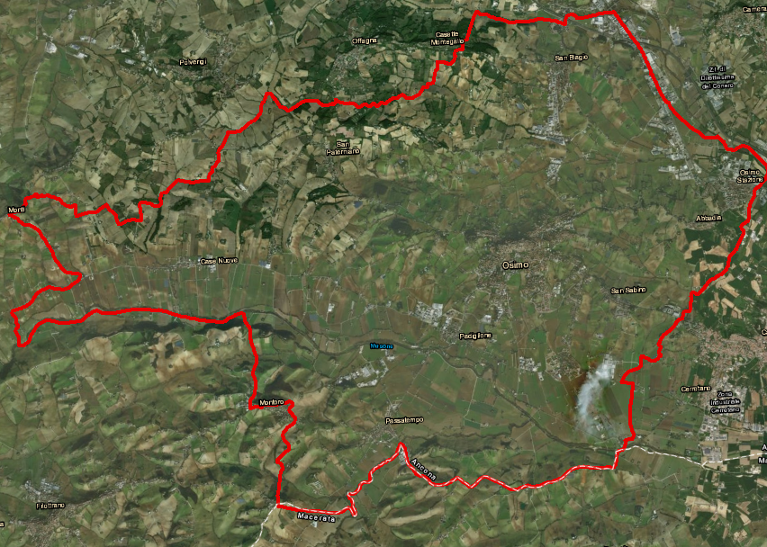
Figure 2: Outline of Osimo Municipality.

Energy demands
In the following sections, Osimo’s energy demands and the applied methods for data collection are described. In particular, the hourly profiles of energy demand are collected for electricity, individual heating and district heating. Data regarding the transport vehicles stock and consumption are gathered at the annual level. The industry sector is assessed and considered non-relevant for this analysis’ purpose due to the very low impact on the urban energy system energy consumption. The model is based on 2018 data since it represents the most recent year with good data availability.

Electricity
According to the data provided by the local utility company ASTEA [2], the total electricity demand of Osimo Municipality amounted to 40.9 GWh/year in 2018. The hourly distribution is shown in Figure 3. It can be noticed that summer cooling has a very low impact on the distribution. In addition, the lower peaks are related to the holiday periods in August and December. Because locally measured data was available from Astea this was preferred to other demand assessment methods.

Figure 3: Hourly distribution for electricity demand in Osimo municipality [2].

Heating and cooling
In this paragraph, the district heating network demand (DHN) and the individual heating and cooling demand are described with particular attention to the data sources included in the study.
ASTEA is the local utility company in charge of the Osimo district heating network, supplying an annual heat demand of approximately 14.4 GWh [2]. The hourly district heating demand distribution provided by ASTEA is shown in Figure 4. It should be mentioned that ASTEA also supplies the domestic hot water demand all year round. According to ASTEA, the annual average heat loss for the DH grid is estimated to be 30%.

Figure 4: Hourly distribution for district heating demand (including domestic hot water) used in the analyses of Osimo.
The heat demand for individual households in Osimo (including domestic hot water) amounts to approximately 194.4 GWh [2]. The hourly profile for individual heating is assumed to follow the same pattern as the district heating demand and is shown in Figure 5.

Figure 5: Hourly distribution for individual heating demand (including domestic water).
To determine cooling demand and distribution the assessment tool for identifying demands, included with the MUSE GRIDS Energy Planning Tool, is applied. This tool is further described in MUSE GRIDS D3.1 [3]. For the execution of the tool, some data has been downloaded in advance: a map of Osimo from OpenStreetMap (OSM) and climate data from MERRA-2. In the configuration of the assessment tool the following information about Italy is needed:
- TABULA typologies data for residential buildings
- Building Stock Observatory typologies data for non-residential buildings
- Building Stock Observatory electricity data
- Distribution of building year of construction
- Comfort temperatures
The tabulated data contains energy demand for the entire municipality (see Table 1), divided into heating, cooling and hot water demands; the percentage of energy consumed per energy vector (see Table 2); and, finally, the hourly data for the HDD, CDD, heating, cooling and hot water demand for an entire year. It has to be mentioned that the estimated cooling demand (5.496 GWh) was input in the MUSE GRIDS Energy Planning Tool based on an external assessment.
Table 1: Results of the tool energy demand calculation in Osimo.
Energy demand | [GWh]
Heating demand | 150.134
Cooling demand | 5.496
HW demand | 42.170

Table 2: Distribution of the energy consumption per vector for individual heating in Osimo municipality.
Energy vector | [%]
Gas | 93.48
Oil | 3.82
Biomass | 0
Coal | 0.80
Electricity | 0.92
Electricity related to Gas boilers | 0.96

It is important to note that, although the tool can calculate the percentage of the Biomass energy consumption vector, in the information offered by TABULA there are no Biomass boilers present in Osimo municipality.
The map elaboration of the data in Figure 6 and Figure 7 is proposed based on the assessment tool embedded in the MUSE GRIDS Energy Planning Tool, to be used as an alternative in case of lack of primary data. Firstly, a GeoJSON file is created and proposes the sum of the heating demand and hot water demand for each building (see Figure 6) and, secondly, a raster file (in tiff format) shows the sum of the heating demand and hot water demand but in this case for each 100m x 100m tile (see Figure 7).
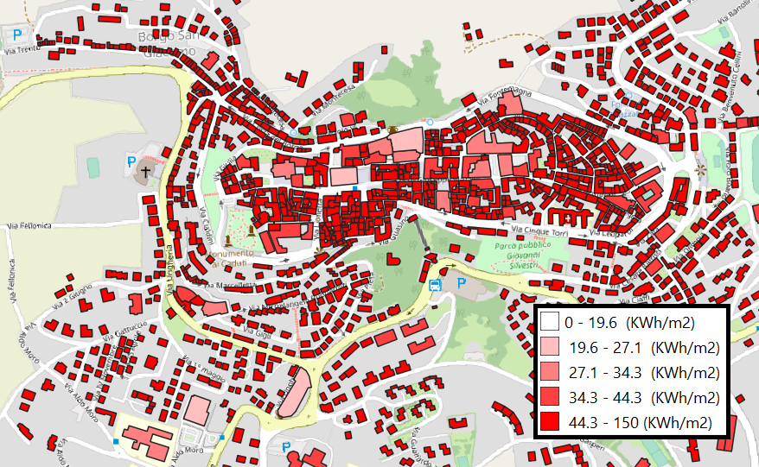
Figure 6: Heating and Hot water demand per building in Osimo municipality.

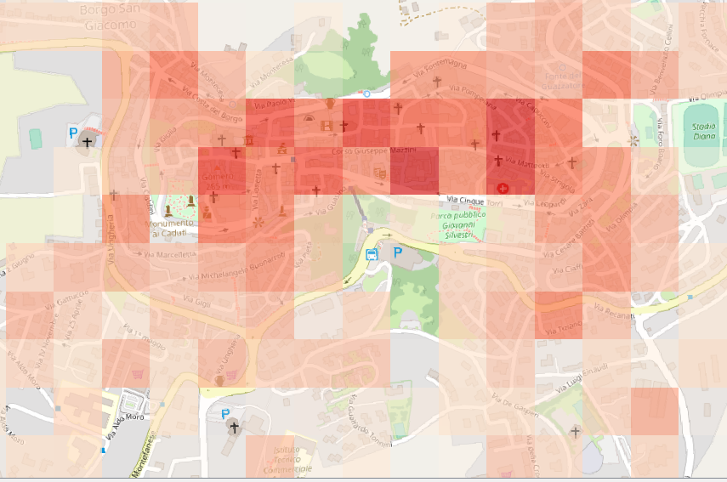
Figure 7: Heating and Hot water demand in Osimo municipality in 100mx100m grid.

Transport
Osimo is characterized by a fleet of vehicles mainly based on petrol and diesel. As reported in Table 3, electricity, methane and LPG cars represent a minority. The municipality has no electric vehicles (EVs) with the sole exception of two electric vehicles owned by ASTEA. In 2018, the total energy consumption for transport amounted to 291.72 GWh. Because local data was available from ASTEA this was preferred to national statistics.
Table 3: Number of vehicles and energy consumption per engine type [2].
Vehicle type | Number of Vehicles | Energy Consumption [GWh/year]
EVs | 2 | -
Diesel | 13,260 | 154.88
Petrol | 7,280 | 85.03
Methane | 3,900 | 37.01
LPG | 1,560 | 14.80
Total | 26,000 | 291.72

Some considerations can be made on driving routines and displacement typologies considering the province of Ancona where Osimo belongs. There is no available data on driving routines in official databases in Italy, hence, the most reliable source of relevant data is a survey by an Italian insurance company, whose summary of results can be consulted online [4]. The data for the Marche region can be extracted from the latest report (2019), where it is indicated that the cars are utilized 293 days per year, with an average use of 43 kilometres per day, a yearly value of 12,698 kilometres, 4.42% of driving by night, 1.21 hours per day of driving and an average speed of 32.2 km/h. There are no hourly distribution values to be shown in charts.
Considering the links with the energy demand and consumption in buildings, the only source for the evaluation of energy balances is the electricity consumed by electric and plug-hybrid vehicles. As it can be seen in Table 3, the current electricity consumption in the transport sector is negligible. In Osimo it amounts to around 16 MWh/year for the whole municipality, the equivalent to 90 modern fridges and less than 2 kWh/year distributed among all the dwellings. In simple words, currently, the impact of transport on household electricity consumption is unremarkable.

Industry
Osimo has two small zones of industrial activities, one between the villages of Pignocco and San Biaggio and the other one north to Osimo Stazione. The industrial activity regarding manufacturing processes is as low as 11.6% of all the economic activities. The extrapolation of these data serves to consider the industrial energy demand to not be relevant for the overall picture of the energy system of Osimo.

Energy supply
In the following sections, Osimo’s energy supply system is presented. The power plants and the district heating network is described. In addition, the renewable energy supply is introduced with particular attention to wind turbines, photovoltaics, and hydropower.

Power plants
Osimo relies mainly on electricity imported from the national grid. There are no local power plants except for biomass systems for a total of 2.2 MW of capacity. The biomass power plants include a 2 MW biogas plant and two bioliquids-based power plants for a total power of 2 MW. In addition, according to 2017 data reported by the Confederation of European Waste-to-Energy Plants (CEWEP) [5], no waste incineration plant is present within Osimo Municipality.

District heating
The district heating network is fed by 13.4 MW of gas boilers coupled with a CHP (1.2 MW_{e}) and a high-temperature heat pump (35 kW_{e}, COP 4.6) to optimize the management of the CHP making it more efficient. The network losses are around 30%. The DHN supplies a heating demand of 15 GWh annually and there is a high potential for the expansion of the network.
Data related to the district heating demand was presented in Section 2.2.2.

Wind power
According to 2018 data reported by “Comuni Rinnovabili” [6], no wind power capacity is present in Osimo Municipality, so installed power is zero and electricity production is zero. The hourly profile for wind energy production is presented in Section 2.4.1 focusing on wind power potentials.

Photovoltaics
According to 2018 data reported by “Comuni Rinnovabili”[6], currently, 35.89 MWp of photovoltaic plants are present in Osimo Municipality. Considering an average productivity of 1,300 MWh/y/MWp as reported by PVGIS [7], the annual electricity production from photovoltaics are estimated to be 46.66 GWh/y.
The monthly distribution of electricity production is presented in Figure 8 whereas its hourly distribution is shown in Figure 9. These data are measured data gotten outside the MUSE GRIDS Energy Planning tool and applied here for the analyses.
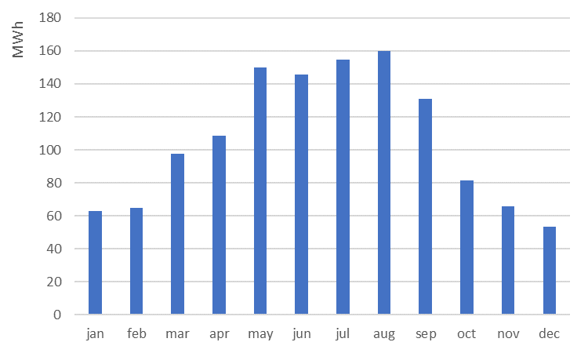
Figure 8: Monthly distribution of PV electricity production in Osimo (data for a 1 kWp plant).
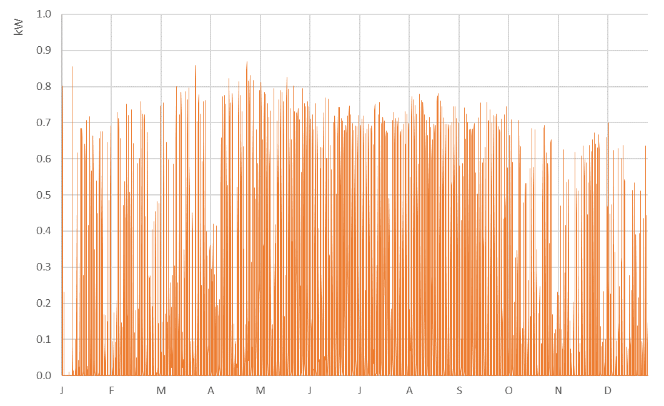
Figure 9: Hourly distribution of PV electricity production in Osimo (data for a 1 kWp plant).

Hydropower
According to 2018 data reported by “Comuni Rinnovabili” [6], only one hydropower plant is currently present in Osimo Municipality with a capacity of 126 kW. No data regarding the electricity production of this plant are available, neither annual nor monthly or hourly data. However, based on the size and type of plant, it can be estimated that an annual production of at least 250 MWh/y of electricity could be achieved.

Renewable energy potentials
In this section the potential for implementation of additional renewable energy resources, in terms of technical potential limited by geography and not by other constraints.

Wind
Hourly data are taken from the NASA Modern-Era Retrospective Analysis for Research and Applications (MERRA-2) [8] regarding wind speed in Osimo are presented in Figure 10. Based on these values and the characteristic curve of a suitable market-available wind turbine, the website renewables.ninja [9] generated the hourly power generation curve presented in Figure 11. This is the same approach with is also internalised in the MUSE GRIDS Energy Planning Tool, though here applied exogenously.
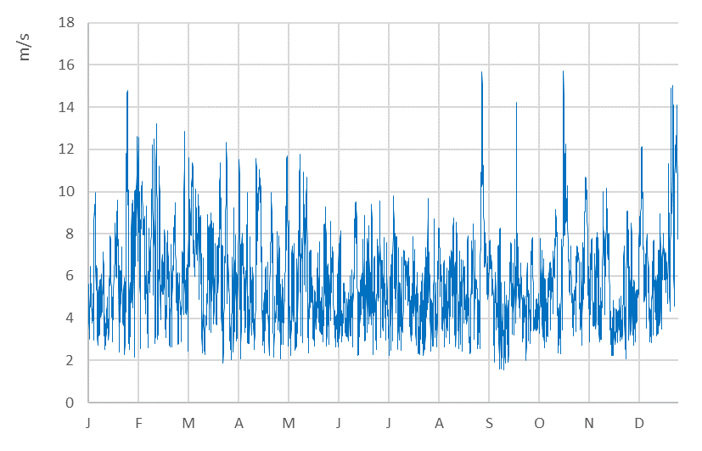
Figure 10: Hourly distribution of wind speed at 80 m height in Osimo.
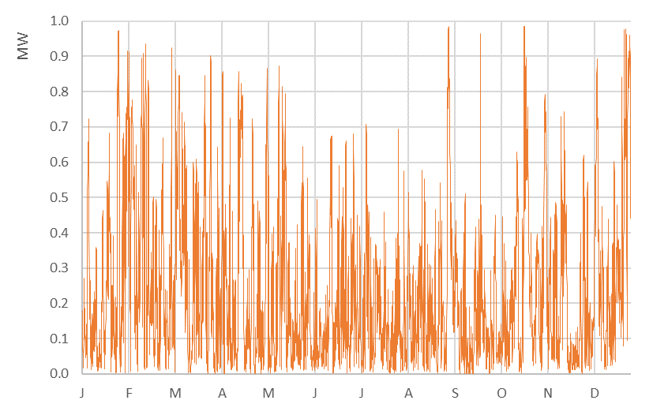
Figure 11: Hourly distribution of wind electricity production in Osimo (data for a 1 MWp plant).
Data regarding wind speed are in line with those reported by the Global Wind Atlas [10], presented in Figure 12, which show an average wind speed of 5.5-6.0 m/s. Figure 13 presents the wind frequency rose for the Osimo area, where it can be noticed that wind is generally oriented along North-West/South-East direction.
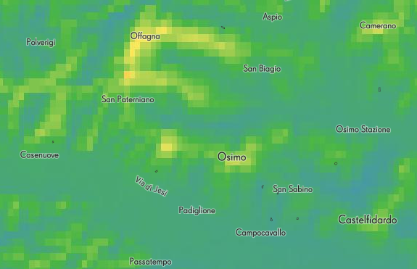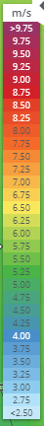
Figure 12: Map of average wind speed map for the Osimo area [10].
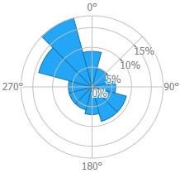
Figure 13: Annual wind frequency rose for the Osimo area [10].

Photovoltaics
As shown in section 2.3.4, according to PVGIS [7] data, the annual electricity production of a photovoltaic plant in Osimo is generally 1,300 kWh/y/kWp. The monthly and hourly distribution of electricity production has already been presented in Figure 8 and Figure 9, respectively.

Biomass
The biomass availability is estimated based on data from Copernicus Programme Corine Land Cover [11] about surface and location of arable land and forests (an example of which is shown in Figure 14) and on typical values of net annual increment (t/ha/y) and net calorific value of different biomasses. Several projects have already adopted this approach to estimate the energy available from biomass; among these, data were taken from the Pan-European Thermal Atlas developed by Heat Roadmap Europe 4 project [12] which are available at NUTS3 level (i.e., in Osimo case, for Ancona province, as shown in Figure 15).
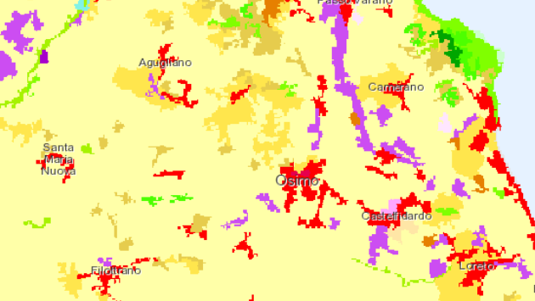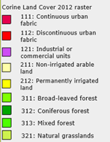
Figure 14: Map of land use in Osimo area.
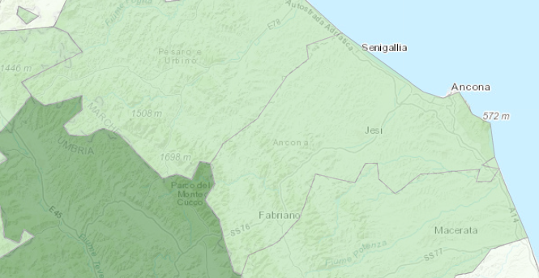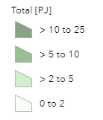
Figure 15: Map of biomass availability in Ancona province.
The biomass availability at the province level is scaled down at the municipality level proportionally to the area of the municipality out of the total area of the province; this is presented in Table 4.
Table 4: Energy available from different biomass resources in Osimo municipality.
 | Ancona  province | Osimo  municipality
Region size (km²) | 1,966.0 | 106.7
Straw (GWh) | 658.3 | 35.7
Pruning residues (GWh) | 8.3 | 0.5
Forest residues (GWh) | 44.4 | 2.4
Biowastes (GWh) | 111.1 | 6.0
Total (GWh) | 822.2 | 44.6

This biomass availability assessment is external to the MUSE GRIDS Energy Planning tool.

Geothermal
According to data reported by the GeoDH [13] project on geothermal resources, Osimo municipality is characterized by a good geothermal potential in form of hydrothermal resources, suitable for the exploitation through ground-source heat pumps. According to the methodology developed in PLANHEAT project [14], the geothermal energy potential is calculated based on the physical characteristics of the resource (density and heat capacity of soil/water) and of the depth needed to reach the resource. Assuming shallow water as an available resource and a depth of 50 m, the geothermal potential is estimated as 0.97 MWh/y/m².
The hourly profile of resource availability does not need to be calculated since geothermal resources do not present significant daily or seasonal variations and therefore can be exploited as needed.
This geothermal potential assessment is external to the MUSE GRIDS Energy Planning tool

Industrial excess heat
According to the methodology developed by RINA in the PLANHEAT project [14], industrial excess heat potential is mapped for large industries starting from their CO₂ emissions as reported on the European Pollutant Release and Transfer Register (E-PRTR) [15], and for smaller facilities or generic industrial areas based on the footprint of industrial buildings. For both cases, assumptions on typical fuel usage are collected from literature, emission factors from IPCC and a typical number of shifts and heat recovery factors based on RINA experiences from industrial energy audits are considered.
Concerning Osimo municipality, it is highlighted that the E-PRTR database does not include any industrial facilities in the area. The estimation of the potential industrial excess heat is based on the identification of generic industrial areas. As shown in Figure 16, 13 areas were identified for a total of 2,726,000 m², corresponding to a potential of 613 GWh/y.
The hourly profile of availability of this excess heat varies depending on the working schedule of the different industries; due to the absence of energy-intensive industries, it can be assumed that most of the industrial facilities work in two daily shifts, therefore the hourly profile can be built considering 16 h/d of operation only for working days.
This industrial excess heat assessment is external to the MUSE GRIDS Energy Planning tool.
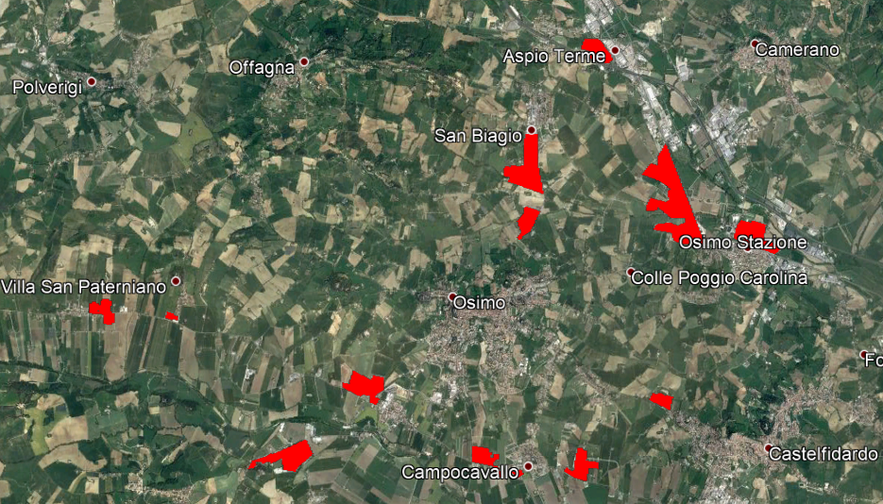
Figure 16: Localization of generic industrial areas in Osimo municipality.

Summary of demo site inputs
Osimo is a small municipality in the Ancona province of the Marche region in Italy. There is a single municipality-owned utility company that is in charge of managing, through its subsidies, different energy sectors to meet the demand of several commodities by the end-users. These are electricity, district heating, natural gas, and water. Moreover, the town can be considered a multi-energy microgrid since it has just one point of common coupling with the national transmission system and a significant amount of distributed electricity generation sources within its boundaries. Local renewable energy resources are an aqueduct mini-hydro and several PV rooftops. The total energy consumption is mainly related to heat and transportation demands. This is due to the structure of the apartment buildings where heating is supplied mostly through low-efficiency natural gas boilers. There is however potential for increased electrification of the individual heating demand and for expansion of the district heating network, as well as for the transition to e-mobility and increased penetration of renewable energy sources.

Demo site: Oud-Heverlee
Oud-Heverlee is one of 300 independent municipalities in the Flemish region of Belgium, and because of the relatively small size of the municipality, municipalities coordinate their energy and environmental planning efforts with the regional level. In 2015 the municipality developed a climate action plan [16] as part of the Covenant of Mayor initiative [17], which contains information on the local energy system and CO₂ emissions. The climate action plan furthermore presents the previous target of reducing CO₂ emissions by 20% before 2020, a goal signed by almost all Flemish municipalities who has joined the Covenant of Mayor initiative.
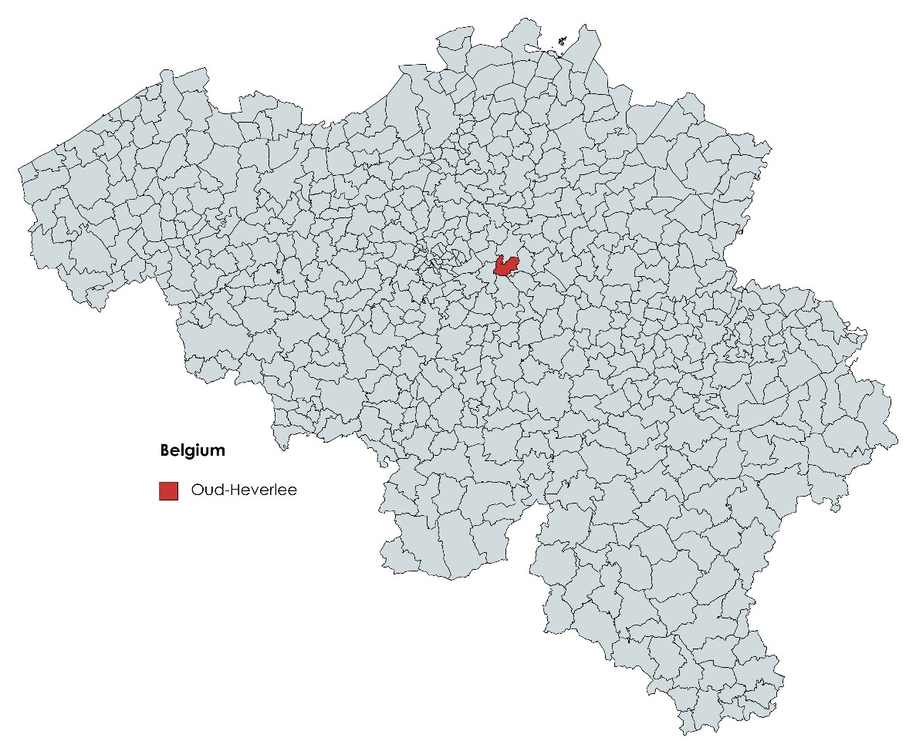
Figure 17: Oud-Heverlee municipality in Belgium.

The area
Oud-Heverlee is a municipality in Belgium with approximately 11,000 inhabitants. Oud-Heverlee already has a small amount of rooftop photovoltaics, some electric vehicles, and some households have heat pumps for heating. However, the energy system of the municipality is still largely based on fossil fuels for heating and transportation, and electricity is mainly supplied from the national electricity grid.
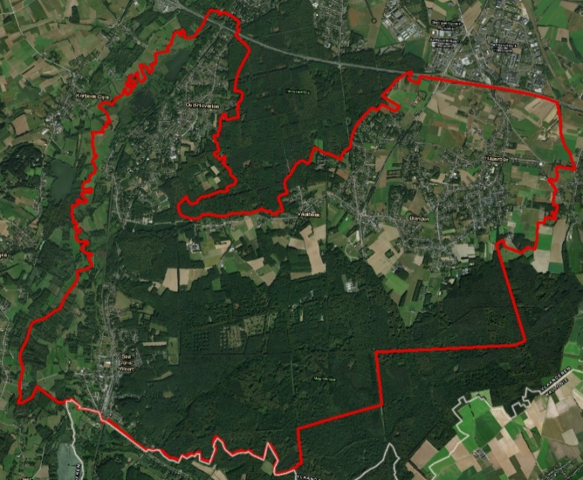
Figure 18: Outline of Oud-Heverlee municipality.
Oud-Heverlee consists primarily of single-family houses (88% in 2020), with the remaining housing facilities being mostly apartments. The municipality has experienced a slight growth in population from 2011 to 2020 by 0.9%, and a gradual increase in housing facilities, increasing by 5.4% in the same period. Both of these growth rates are however lower than the average of the Flemish region. The building stock consists of 44.3% of buildings from before 1970, 20.5% of buildings from the period 1971-1981, and the remaining 35.2% being buildings constructed after 1981.
Energy consumption, for both heat and electricity, has been decreasing slightly from 2011 to 2020, and as a result, so has the CO₂ emission. Total energy consumption has decreased by approximately 12.6%, and CO₂ emissions by 7.6%. This is caused by house renovations enabling heat savings, a gradual replacement of oil boilers with natural gas boilers, and in a few cases, the installation of electric heat pumps. The transportation sector is largely unchanged in the same period.

Energy demands
The following sections present energy demands for Oud-Heverlee and describe the methods applied to determine these. Energy demands are collected for electricity, heating and cooling, transport, and industry sectors, and are important inputs for the modelling of reference and future energy scenarios.

Electricity
Based on the national electricity demand as determined in previous research for a national model of Belgium [18] a population-based share is calculated, resulting in a demand of 66.97 GWh in Oud-Heverlee. Combined with an electricity demand of 36.74 GWh for industry, also determined from a population-based share of the national demand, the total yearly electricity demand is 103.71 GWh. It should be noted that this demand does not include electricity demand for heating and cooling, which is included separately as part of the heating and cooling demands. The industry energy demand is presented in more detail in Section 3.2.4.
Below the assumed hourly distribution of the electricity demand for Oud-Heverlee can be seen in Figure 19.

Figure 19: Hourly electricity demand distribution used in the analyses of Oud-Heverlee [19].

Heating and cooling
Heat demands are determined with the assessment tools included with the MUSE GRIDS Energy Planning Tool. For the execution of the heat demand assessment tool, the following data and inputs are needed: a GIS map of Oud-Heverlee from Open Street Map (OSM) [20] and climate data from MERRA-2 [21]. Included with the heat demand assessment tool is various input data for Belgium needed for the configuration of the tool, including:
- TABULA typologies data for residential buildings
- Building Stack Observatory typologies data for non-residential buildings
- Building Stack Observatory electricity data
- Distribution of building year of construction
- Comfort temperature levels
The resulting heat demand for Oud-Heverlee is 119.64 GWh, which includes both demands for heating and domestic hot water. While the assessment tool is also capable of assessing cooling demands, for this analysis the cooling demand of Oud-Heverlee is assumed to be zero. This is based on a practical assumption that cooling technologies are not widely implemented in Oud-Heverlee, and as such any cooling demand determined by the assessment tool is more theoretical than practical. Based on the local climate report for Oud-Heverlee [16], it is assumed that natural gas boilers are the predominant heat production technology in Oud-Heverlee, supplemented to a lesser extent by oil and biomass boilers and heat pumps.
Table 5: Distribution of individual heating technologies for Oud-Heverlee municipality.
Distribution of individual heating technologies | [%]
Natural gas | 80
Oil | 10
Biomass | 5
Coal | 0
Heat pumps | 5
In Figure 20 the resulting hourly distribution for the individual heating demand can be seen. It is assumed that heat demand during the summer period (May-September) is limited to domestic hot water demand, hence the lower demand during this period.

Figure 20: Hourly distribution for the individual heating demand used in the analyses of Oud-Heverlee.
Future scenarios for individual and district heating are described in Section 5.1.

Transport
In the MUSE GRIDS Energy Planning Tool, transport demands are limited to passenger transport (cars and busses) and freight transport. Other means of transportation, e.g., national/international air transport, railroad transport or maritime shipping are considered beyond the scope of the MUSE GRIDS Energy Planning Tool and this study on municipal energy scenarios. Data inputs on transport demands are based partly on the Climate Report for Oud-Heverlee which includes transport energy demands [16] and partly on national transport data [22].
During the tool testing, we realised that gathering the needed transport demand data for the MUSE GRIDS Energy Planning Tool, and in particular data for future transport scenarios, may be challenging to non-modelling experts. We, therefore, developed an additional assessment tool with baseline data and a functionality that allows users to design future scenarios; some of these data and assumptions are included below.
In Table 6 assumed transport demands including km/person and load factors (vehicle occupancy and tonnage) for vehicles for Oud-Heverlee can be seen. Together this allows us to calculate the total amount of traffic work to be supplied by the vehicles.
Table 6: Assumed transport demands used in the analyses of Oud-Heverlee.
 | Transport demand | Transport demand | Load factor | Traffic work | Number of vehicles
Passenger transport | km/person | Mpkm | p/vehicle | Mkm | No.
Car | 10,050 | 111.71 | 1.56 | 71.61 | 5,989
Bus | 370 | 4.11 | 24.10 | 0.17 | 15
Freight transport | tkm/person | Mtkm | t/vehicle | Mkm | No.
Lorries | 1,870 | 20.79 | 13.50 | 1.54 | 68

In Table 7 the vehicle types included are shown. The table furthermore includes a reference distribution of vehicles and fuel usage. From this, it is seen that in the reference scenario, 100% of the passenger transport traffic work is supplied through conventional cars and busses by a mixture of petrol and diesel vehicles. Likewise, for freight transport, 100% of the traffic work is supplied by conventional diesel lorries, however, some biodiesel is mixed in with the fuel.
Table 7: Vehicle types included and reference distribution of fuel types.
Passenger transport | % of traffic work | Petrol | Diesel | Bioethanol in petrol | Biodiesel in diesel | Electricity | Natural gas
Cars
Electric vehicle | 0.0% |  |  |  |  | 100.0%
Plugin - hybrid diesel ICE | 0.0% |  | 27.0% |  |  | 73.0%
Conventional | 100.0% | 52.5% | 40.5% | 3.5% | 3.5%
Bus
ICE hybrid diesel | 0.0% |  | 100.0%
Natural gas | 0.0% |  |  |  |  |  | 100.0%
Diesel bus | 100.0% |  | 92.6% |  | 7.4%
Freight transport | % of traffic work | Petrol | Diesel | Bioethanol in petrol | Biodiesel in diesel | Electricity | Natural gas
Trucks
ICE hybrid diesel | 0.0% |  | 100.0%
Natural gas | 0.0% |  |  |  |  |  | 100.0%
Diesel lorries | 100.0% |  | 93.5% |  | 6.5%
Future transport scenarios are described in Section 5.1.

Industry
Oud-Heverlee does not have significant industrial activity, and thus has insignificant energy demands. However, industrial demands are included according to a population-based share of the national industrial demand. There are different approaches to dealing with activities and demands that are generally relatively unevenly distributed geographically and including such population-based shares are one way of modelling this. This method ensures that while the actual production facilities may be unevenly distributed, the energy demand and greenhouse gas emissions can be divided equally. The data input for industries in the MUSE GRIDS Energy Planning Tool is simple; all that is needed is an annual fuel demand GWh/year split by fuel type - natural gas, oil, biomass, and coal. Electricity demands from industry are aggregated with the traditional electricity demand and included in the electricity demand tab. In Table 8 the included industry demands for Oud-Heverlee can be seen.

Table 8: Industry energy demands included in the analyses of Oud-Heverlee.
Coal | 20.82 | GWh/year
Oil | 15.53 | GWh/year
Gas | 38.03 | GWh/year
Biomass | 9.48 | GWh/year
Electricity | 36.74 | GWh/year

While the data from Table 8 is the only data needed for the tool, to illustrate how the energy demands are distributed across industrial sub-sectors a more detailed breakdown is shown in Figure 21.

Figure 21: Energy demands per sub-sector and fuel types as population-based shares in Oud-Heverlee.

Renewable energy resources
In this section, the local renewable energy resources are evaluated based on their potential for local implementation in Oud-Heverlee. This requires data on local energy resources, climate, and weather data functioning as inputs for the modelling of reference and future energy system scenarios.

Wind resources
The MUSE GRIDS Energy Planning Tool requires an hourly production profile for wind power production. This wind speed data is taken from the NASA Modern-Era Retrospective Analysis for Research and Applications (MERRA-2) [8]. The MUSE GRIDS Energy Planning Tool includes an assessment tool that assists the user in collecting this wind speed data and from this generates an hourly production profile. The hourly wind speeds observed at Oud-Heverlee are seen in Figure 22.

Figure 22: Wind speed at 150m height for Oud-Heverlee.
Based on the local wind speed shown in Figure 22 and the selection of a specific wind turbine, the renewables.ninja tool that is integrated into the MUSE GRIDS Energy Planning tool determines a wind power production profile. This is further elaborated in Section 3.4.
Figure 23 shows the wind frequency rose for the Oud-Heverlee area, where it can be noticed that the main wind direction is generally South-West.
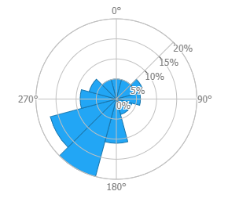
Figure 23: Annual wind frequency rose for the Oud-Heverlee area [10].

Solar resources
Like for wind resources, solar resources and an hourly production profile is needed. Again, this can easily be collected using the assessment tool included with the MUSE GRIDS Energy Planning Tool, which connects to the renewables.ninja website and imports solar irradiance and generates a PV distribution profile. The direct and diffuse solar irradiance observed at Oud-Heverlee is shown in Figure 24.

Figure 24: Direct and diffuse solar irradiance.

Industrial excess heat
In the PLANHEAT project [14], industrial excess heat potential is mapped for large industries based on their CO₂ emissions as reported on the European Pollutant Release and Transfer Register (E-PRTR) [15], and for smaller facilities or generic industrial areas based on the footprint of industrial buildings.
In Oud-Heverlee municipality the E-PRTR database does not include any industrial facility in the area, and similarly, no generic industrial areas were identified based on the analysis of the land use within the Municipality. However, a large industrial area (more than 2,000,000 m²) was identified in Heverlee Municipality, close to the border of Oud-Heverlee. This area, highlighted in Figure 25, could potentially provide 465 GWh/y of excess heat. However, as the areas are located outside of Oud-Heverlee and significant transmission of the heat would be needed if the potential is to be exploited in Oud-Heverlee, excess heat is not included in this analysis.

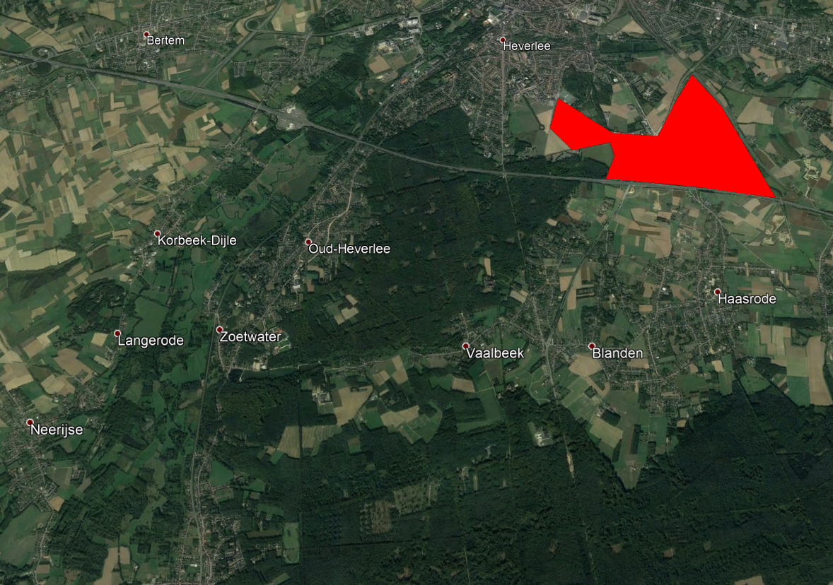
Figure 25: Generic industrial areas near Oud-Heverlee municipality.

Energy supply and production technologies
This section briefly introduces assumptions on energy supply and production technologies included in the modelling of reference and future energy scenarios.

Renewable electricity production
No existing wind power capacity was identified in Oud-Heverlee Municipality; hence no wind power capacity is included in the reference scenario. However, wind power will be included in future scenarios and data is therefore still needed.
Based on the geographic location of Oud-Heverlee and the technical specifications of a typical 3 MW wind turbine, an hourly wind power production profile is imported from the renewables.ninja website [9] and included in the MUSE GRIDS Energy Planning Tool. This is seen in Figure 26. The wind power production profile is calculated based on the wind resource available, which was included in Section 3.3.1. The production profile is needed for the energy system calculation conducted by the MUSE GRIDS Energy Planning Tool as it provides information on the temporal production and availability of wind power. To include this production profile the user only needs to include a geographic location, select a wind turbine model from a selection of options, and a personal API code from the renewables.ninja website. The MUSE GRIDS Energy Planning Tool is then able to collect and insert a production profile from the selected location.

Figure 26: Hourly production profile for wind power in Oud-Heverlee for a 3 MW wind turbine. Data from renewables.ninja [9].
Oud-Heverlee has some existing solar PV installed, mainly small-scale household systems, amounting to approximately 2 MW capacity. Based on the solar irradiance presented in Section 3.3.2, the hourly production profile shown in Figure 27 was generated. Like for the production profile for wind power, the MUSE GRIDS Energy Planning Tool includes a functionality to import the PV production profile from renewables.ninja based on few user inputs such as geographic location and PV panel orientation.

Figure 27: Hourly production profile for solar PV in Oud-Heverlee for a 2 MW capacity.
The user is able to input economic assumptions suitable for the local context being modelled; for the particular case of Oud-Heverlee economic assumptions for wind power and PV can be seen in Table 9. These assumptions are based on assumptions included in a catalogue on technical and economic assumptions of electricity generation technologies by Energinet and the Danish Energy Agency [23]. Alternatively, if the user does not have access to local data a useful resource is the freely available EnergyPLAN cost database which includes assumptions on a broad range of technologies [24].
Table 9: Economic assumptions for onshore wind power and PV [23].
Technology | Investment | Unit | Lifetime | Unit | Fixed O&M | Unit
Onshore wind power | 1.12 | k EUR/kW | 27 | Years | 1.25 | % of investment
PV | 0.8 | k EUR/kW | 35 | Years | 1.43 | % of investment

Power plants and electricity connections
No local power plants have been determined, hence it is assumed that all electricity (except what is locally generated from wind turbines/PV) is imported from the national grid at an average cost of 50.665 EUR/kWh based on the average electricity price in Belgium [25]. The MUSE GRIDS tool allows for both a fixed average electricity price, as it is assumed in this analysis, and for hourly electricity prices, based on an hourly time series with electricity prices. For this analysis, electricity price fluctuations are not considered, and it is assumed that the imported electricity has a CO₂ emission factor of 285 ton/GWh, equal to the average of all national electricity production in Belgium [26]. The electricity imported would in periods be from renewable energy sources or nuclear power, and thus the CO₂ emission factor would be lower in these periods, but this is likely to be balanced by periods with a higher CO₂ emission factor due to electricity production from coal power plants.

Transport vehicles
Transport includes passenger transport demands supplied by either cars or busses, and freight transport supplied by lorries. An overview of the vehicles included in the analysis can be seen in Table 10 and Table 11. Engine efficiencies and load factors are used to convert the transport demands in km/person to energy demands. The values included in Table 10 and Table 11 are standard values included with the transport assessment tool, however, all these values can be updated by the user necessary. Most of these vehicle types are only relevant in future scenarios, as it is assumed that all vehicles in the reference scenario are conventional.
Table 10: Passenger transport technical and economic assumptions used in the analyses of Oud-Heverlee [22].
Passenger transport | Engine efficiency | Cost | Lifetime | Fixed O&M
Cars | MJ/km | EUR/vehicle* | Years | % of investment
Electric vehicle | 0.53 | 27,007 | 13 | 1.23%
Plugin - hybrid diesel ICE | 0.85 | 25,970 | 13 | 1.37%
Conventional | 2.74 | 21,687 | 13 | 1.77%
Bus | MJ/km | EUR/vehicle* | Years | % of investment
ICE hybrid diesel | 10.23 | 290,213 | 13 | 0.21%
Natural gas | 17.90 | 184,244 | 13 | 0.22%
Conventional | 20.05 | 183,339 | 13 | 0.22%
*Incl. charging station costs

Table 11: Freight transport technical and economic assumptions used in the analyses of Oud-Heverlee [22].
Freight transport | Load factor | Engine efficiency | Cost | Lifetime | Fixed O&M
Lorries | t/vehicle | MJ/km | EUR/vehicle | Years | % of investment
ICE hybrid diesel | 13.5 | 4.38 | 145,817 | 13 | 0.30%
Natural gas | 13.5 | 13.53 | 103,173 | 13 | 0.33%
Conventional | 13.5 | 11.97 | 103,173 | 13 | 0.32%

The MUSE GRIDS Energy Planning Tool allows for the user to specify a share of the electric vehicles as capable of smart charging and vehicle-to-grid discharging. When smart charging is enabled, the tool will aim to reduce the peak load on the electricity grid, and vehicle-to-grid discharging allows the tool to discharge from the electric vehicle batteries when beneficial to the electricity system. Technical specifications for smart charging are shown in Table 12. These assumptions are included as standard values with the MUSE GRIDS Energy Planning Tool but can be updated by the user as needed.
Table 12: Smart charge vehicle assumptions (standard value included with tool) [22].
Technical data for smart-charge vehicles
Efficiency to and from the grid | 90 | %
Average EV battery size | 45 | kWh

Specifications for electric vehicle charging stations can be seen in Table 13. Charging station costs are included with the vehicle costs in the scenarios. The assumptions in Table 13 are standard values included with the transport assessment tool but can be updated as needed.
Table 13: Charging station assumptions (standard value included with tool) [22].
Charging stations
Costs pr. station | 1,430 | EUR
No. pr. BEV | 0.10 | No.
No. pr. plugin-hybrid | 0.10 | No.
Lifetime | 10 | Years

Individual heating
Heat production technologies for individual heating consist of a combination of heat-only boilers and electric heat pumps. Efficiencies for individual boilers and heat pumps are seen in Table 14 and Table 15, included as standard with the MUSE GRIDS Energy Planning Tool. Alternatively, for other analyses, the user can update these values with more local data, or review the EnergyPLAN cost database for data [24] It is assumed that the majority of households (80%) are supplied by natural gas boilers, while the remaining households are supplied through a mix of oil boilers, biomass boilers, and heat pumps.
Table 14: Efficiencies of individual boilers [27].
Individual boilers | Efficiency | Unit
Oil boiler | 92 | %
Gas boiler | 97 | %
Biomass boiler | 82 | %

Table 15: Efficiency of individual heat pumps [27].
Individual heat pumps |  | Unit
Efficiency | 3.15 | COP
Capacity limit | 100 | % of yearly peak heat demand

Costs for the individual heating technologies as included in this analysis can be seen in Table 16.
Table 16: Costs for individual heating technologies [27].
Costs for individual heating technologies | Investment* | Unit | Lifetime | Unit | Fixed O&M | Unit
Fuel boilers | 3,900 | EUR/unit | 20 | Years | 4.9 | % of investment
Heat pumps (air-water, existing single-family buildings) | 10,950 | EUR/unit | 16 | Years | 2.84 | % of investment
Electric heating (single family) | 2,690 | EUR/unit | 30 | Years | 0.89 | % of investment
*Including 4.1 kWh heat storage.

District heating
There is no district heating in the reference scenario for Oud-Heverlee, but the potential for district heating is explored in future scenarios, hence technical and economic assumptions are needed for heat production technologies. The MUSE GRIDS Energy Planning Tool includes an assessment tool for determining the potential for district heating, the investment costs for the grid and the resulting grid loss. Further details on this are included in Section 5 where the analysed scenarios are presented.
In Oud-Heverlee it is assumed that heat production for district heating is done by a combination of electric heat pumps and biomass heat-only boilers. Heat pumps are used for the majority of the demand, while biomass boilers are available for the peak demand. Installed boiler capacity is 120% of the peak demand, and the heat pump capacity is sized so heat pumps can deliver the entirety of the heat demand during 80% of the annual hours.
Table 17: District heating boiler and heat pump efficiency [23].
Technology | Efficiency | Unit
Fuel boilers | 100 | %
Compression heat pumps | 3.1 | COP

Boilers and heat pumps are supplemented by short-term storage in the form of a steel tank, which allows the system to balance production and demand. The district heating storage capacity is sized according to the average 24-hour heat demand during the winter period.
Table 18: District heating storage costs [23].
 | Investment | Lifetime | Fixed O&M
Costs of the district heating storage | EUR/MWh | Years | % of investment
Short-term storage (steel tank) | 3,000 | 40 | 0.29

Summary of demo site inputs
Oud-Heverlee is a relatively small municipality with typical energy demands and resources compared to the rest of Belgium. There are no extraordinary local renewable energy resources, but there is promising potential for implementing both PV and wind power. The most important energy demands are for households (heating and electricity) and transportation. This is natural as housing mainly consists of detached single-family houses, where heating is supplied mostly through natural gas boilers. Oud-Heverlee is a rural municipality and transportation occurs mainly through cars which results in large energy demands and CO₂ emissions. There are no significant energy-intensive industries in the municipality, and no significant local electricity production apart from some electricity production from rooftop PV, hence the electricity demand is imported from the local transmission grid. There is however potential for increased deployment of PV and wind turbines due to the experienced solar irradiance and wind speeds. It is therefore relevant to investigate how changes to the heating and transportation sector alongside implementation of local renewable electricity production capacity can contribute to the municipality’s climate and renewable energy ambitions.

Energy system scenarios: Osimo
In this chapter, the energy system of Osimo municipality is modelled and analysed. Firstly, the reference scenario, representing the present situation is described. Afterwards, several scenarios are analysed considering the transition of the heat and transportation sectors towards more renewable and sustainable systems. Electrification is integral to the transition of the heat and transportation sectors and thereby the electricity sector is inevitably also greatly affected by the changes within the heat and transportation sectors due to the interoperability and integration concept embedded in the MUSE GRIDS Energy Planning Tool. More specifically, the scenarios propose the enhancement of the district heating network integration along with electrification, for transportation an increased share of electric vehicles. The MUSE GRIDS Energy Planning Tool is used to model and simulate nine heat and nine transport scenarios, which are all compared to the reference scenario. The effect on the energy system and grid interoperability is assessed, and the results are discussed in terms of costs and fuel consumption.

Scenario overview
Osimo’s transition towards a more sustainable energy system is simulated focusing on the heat and transport sectors. For the heat sector, nine scenarios are developed considering an expanded role of the district heating network. Table 19 provides an overview of the main assumptions in terms of district heating network DHN, individual heat production, storage, and renewable energy production. The nine scenarios investigate the advantages of a DHN expansion coupled with increased renewable energy generation and thermal storage integration. The seasonal thermal storage is considered at a capacity up to 5 MWh, based on communication with the local utility company ASTEA. The increasing relevance of DHN is modelled also considering an eventual larger PV capacity (from 35.9 MW to 40 MW).
Table 19: Heat scenarios for Osimo.
# | Scenarios - heating | District heating | Individual heat  production | Storage | RE production
0 | Reference | No changes | No changes | No changes | No changes
1 | Individual HPs | No changes | 100% HP | No changes | No changes
2 | +20% DH | DH increased by 20%  (3 GWh) | Decreased of 3 GWh | 5 MWh of seasonal thermal storage | No changes
3 | 50% DH | DH supplies 50%  of total heating  demand | 50% of total heating  Demand | 5 MWh of seasonal thermal storage | No changes
4 | 90% DH | DH supplies 90%  of total heating  demand | 90% of total heating  demand | No changes | No changes
5 | Reference + RE | Individual heating | No changes | No changes | PV increased up to 40 MW
6 | Individual HPs + RE | No changes | 100% HP | No changes | PV increased up to 40 MW
7 | +20% DH + RE | DH increase of 20%  (3 GWh) | Decreased of 3 GWh | 5 MWh of seasonal thermal storage | PV increased up to 40 MW
8 | 50% DH + RE | DH supplies 50%  of total heating  demand | 50% of total heating  demand | 5 MWh of seasonal thermal storage | PV increased up to 40 MW
9 | 90% DH + RE | DH supplies 90%  of total heating  demand | 10% of total heating  demand | No changes | PV increased up to 40 MW

In Table 20, the nine scenarios modelled for the transport sector are reported. Five EV scenarios are elaborated to investigate the increasing penetration of electric vehicles. In the scenarios where the EV share reaches more than 15% of the transport demand, it is also assumed that renewable electricity production increases (PV capacity increases from 35.9 MW to 40 MW). It must be remarked that in the reference scenario Osimo has an early-stage programme of EV, led by ASTEA (two vehicles in ASTEA maintenance fleet).
Table 20: Transport scenarios for Osimo.
# | Scenarios - transport | Cars | Bus/freight | Smart charge | RE production
0 | Reference | Conventional | Conventional | None | No changes
1 | EVs 5% | 5% EVs | Conventional | None | No changes
2 | EVs 15% | 15% EVs | Conventional | None | No changes
3 | EVs 30% | 30% EVs | Conventional | None | No changes
4 | EVs 50% | 50% EVs | Conventional | None | No changes
5 | EVs 100% | 100% EVs | Conventional | None | No changes
6 | EVs 15% + RE | 15% EVs | Conventional | None | PV increased up to 40 MW
7 | EVs 30% + RE | 30% EVs | Conventional | None | PV increased up to 40 MW
8 | EVs 50% + RE | 50% EVs | Conventional | None | PV increased up to 40 MW
9 | EVs 100% + RE | 100% EVs | Conventional | None | PV increased up to 40 MW

Reference scenario
The reference scenario is based on 2018 data and it is used as a baseline for comparison with the potential pathways for improving the efficiency of the urban energy system of Osimo. The analysis focuses on the individual heating and the transportation sectors because they have the largest local impact in terms of energy consumption. The municipality is connected to the national electricity grid. The renewable electricity production is characterized by a high renewable energy penetration as a result of 35.9 MW of photovoltaics and an aqueduct mini-hydro plant of 110 kW [2]. A CHP gas engine 1.2 MW_{e} (1.3 MW_{t}) is serving the DHN and it is coupled with a high-temperature heat pump of 35 kW_{e} [2]. The district heating network covers almost 5% of the total heating demand and supplies roughly 1,250 users. The remaining heat demand is supplied through individual heating, mainly individual gas boilers. A limited cooling demand in summer relies on private air conditioning chiller units. To the purpose of the model, the industrial sector is not modelled since there are no large industries to be found locally. The transport demand consists mainly of passenger cars, and very few busses and freight transport by lorries.

Figure 28: Heat production in reference scenario distributed by technologies [GWh, %] for Osimo.

Heat scenarios
In Osimo, the heating system mainly relies on individual gas boilers as shown in Figure 28. District heating supplies around 7% of the total heat demand [2]. The scenarios elaborated consider both the district heating network and transitioning the individual heating to heat pumps. The influence of thermal heat storage is also analysed considering a 5 MWh maximum size. The main input data for the scenarios are reported in Table 21.
Table 21: Overview of main inputs for heat scenarios for Osimo.
 | Reference | Scenario 1 | Scenario 2 | Scenario 3 | Scenario 4 | Scenario 5 | Scenario 6 | Scenario 7 | Scenario 8 | Scenario 9
DH demand [GWh] | 14.39 | 14.39 | 17.27 | 104.39 | 187.90 | 14.39 | 14,39 | 17.27 | 104.39 | 187.90
Individual heating demand [GWh] | 194.39 | 194.39 | 191.51 | 104.39 | 20.88 | 194.39 | 194,39 | 191.51 | 104.39 | 20.88
Share of Heat Pumps in Individual heating [%] | 0% | 100% | 0% | 50% | 50% | 0% | 100% | 0% | 50% | 50%
Share of Gas Boilers in Individual heating [%] | 100% | 0% | 100% | 50% | 50% | 100% | 0% | 100% | 50% | 50%
DH storage capacity [MWh] | 0 | 0 | 5 | 5 | 0 | 0 | 0 | 5 | 5 | 0
PV capacity [MWe] | 35.9 | 35.9 | 35.9 | 35.9 | 35.9 | 40 | 40 | 40 | 40 | 40

Transport scenarios
In the context of the MUSE GRIDS project, efforts are made to introduce electric vehicles in Osimo. In the transport scenarios the impact of a gradual transition to complete electrification of the vehicle fleet is assessed. It is assumed that the EVs are supplied through dump-charging which means that no intelligent controlling of charging strategy is applied. The total transport demand is not changed; only the fuel consumption type changes because of the shift to EVs. The scenarios’ main inputs are reported in Table 22. Furthermore, the transport scenarios are analysed also considering the PV capacity is increased to assess the impact of the local renewable energy production on the energy system.
Table 22: Overview of main inputs for transport scenarios for Osimo.
 | Reference | Scenario 1 | Scenario 2 | Scenario 3 | Scenario 4 | Scenario 5 | Scenario 6 | Scenario 7 | Scenario 8 | Scenario 9
Dump-charge demand [GWh] | 0 | 3.6 | 10.8 | 21.6 | 36 | 72 | 10.8 | 21.6 | 36 | 72
Petrol  consumption [GWh] | 85.03 | 77.44 | 62.25 | 39.48 | 47.07 | 0 | 62.25 | 39.48 | 47.07 | 0
Diesel  consumption [GWh] | 154.88 | 147.28 | 132.1 | 109.32 | 78.96 | 1.75 | 132.1 | 109.32 | 78.96 | 1.75
Gas  consumption [GWh] | 51.82 | 51.82 | 51.82 | 51.82 | 43.18 | 0 | 51.82 | 51.82 | 43.18 | 0
PV capacity [MWe] | 35.9 | 35.9 | 35.9 | 35.9 | 35.9 | 40 | 40 | 40 | 40 | 40

Energy demands and fuel consumption
In the reference scenario, the total final energy consumption amounts to around 550 GWh. The individual heating and transport represent the highest share and account respectively for 191.4 GWh and 291.7 GWh as shown in Figure 29.
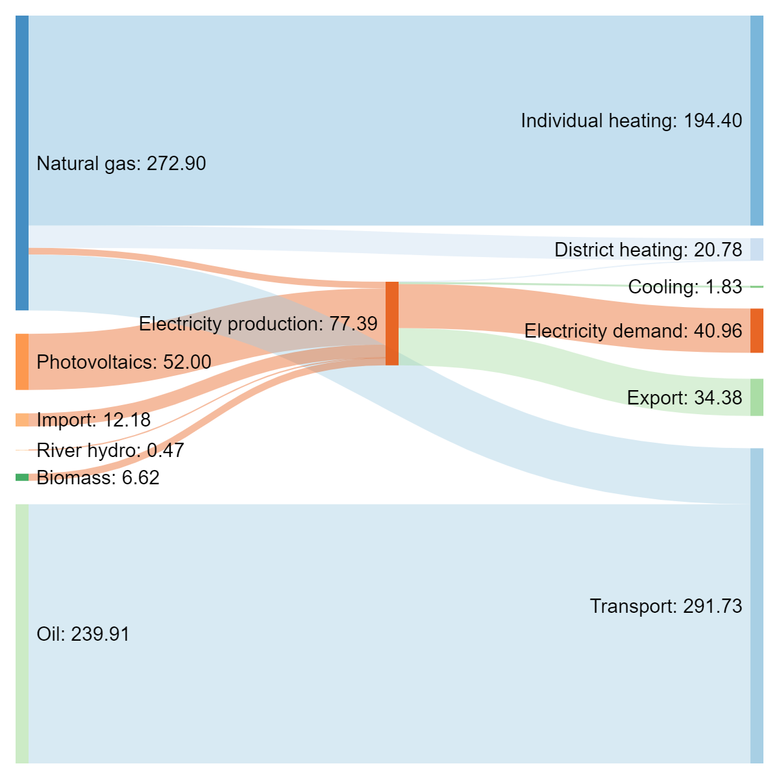
Figure 29: Reference scenario energy flows [GWh] for Osimo.
In terms of primary energy consumption, the Osimo energy system mainly relies on natural gas, around 275 GWh, and oil, around 240 GWh. The total electricity production amounts to 77.4 GWh of which only 12.2 GWh are imported and the remaining 65.2 GWh are generated locally thanks to the cogeneration plant and the renewables (PV and mini-hydro power) available in Osimo municipality.
Indeed, Osimo can rely on a very high local electricity production that often feeds the national grid. The total power capacity varies a lot during the months since it strictly depends on the PV capacity. Electricity export from Osimo to the national power grid is higher the during the spring and summer months as shown in Figure 30.

Figure 30: Reference scenario monthly average power output [kW] for Osimo.
The total energy consumption decreases in all the heat scenarios with increased electrification compared to the reference scenario. The exceptions to this are Scenarios 2, 5 and 7, where no heat pumps are assumed to be integrated. The reduction is mainly related to the substitution of the low-efficiency individual gas boilers with more efficient heat pumps and the implemented transition of the heat demand towards the district heating network. As shown in Figure 31, Scenario 1 and Scenario 6 provide higher energy savings (around 140 GWh) since the total individual heating demand is supplied by individual heat pumps. The energy savings from the connection to the DHN are assessed in Scenarios 3, 8 (around 60 GWh) and Scenarios 4 and 9 (around 90 GWh). The renewable impact on energy saving is very little because of their relatively small magnitude on the total demand. In Scenarios 2, 5 and 7, it is highlighted the fundamental role of individual heating since the savings are very little if there is no intervention on the private gas boilers. The 5 MWh thermal storage’s very little impact is assessed in Scenarios 2, 3, 7 and 8. It must be remarked that thermal storage is generally not considered a viable solution by the stakeholders in the local context of Osimo municipality.

Figure 31: Energy consumption in heat scenarios for Osimo.
The energy consumption in the transport scenarios is presented in Figure 32. It can be noticed that compared to the reference scenario, implementing electric vehicles always decreases the total energy consumption thanks to the higher efficiencies of the EV engines. The highest savings are achieved in Scenarios 5 and 9 where the total vehicles fleet is transformed into EVs. Indeed, if the share of EVs increase, a drastic reduction in the oil derivates (petrol and diesel) consumption can be achieved.

Figure 32: Energy consumption in transport scenarios for Osimo.

Renewable energy production and integration
The renewable share of fuel in the total energy consumption is analysed for the heat and transport scenarios as shown respectively in Figure 33 and Figure 35. In all the scenarios the renewable energy share increases further when combined with local renewable electricity production, namely the PV capacity increase. In absolute terms, the PV capacity is increased from 35.9 MW to 40 MW in Scenarios 5 to 9 for both the heat and transport sectors. In the heat scenarios, the highest share is obtained in Scenarios 1 and 6 (respectively 18.2% and 19.4%) where there is a more significant decrease of the total energy consumption and CO₂ emissions as shown in Figure 34.

Figure 33: Renewable share of fuel in heat scenarios for Osimo.

Figure 34: CO₂ emissions in heat scenarios for Osimo.
Similarly, in the transport sector, the renewable energy share increases more in Scenarios 5 and 9 (respectively 23.4% and 24.8%) in which it is assumed that the vehicle stock is relying on 100% EVs. In the transport scenarios, even if the increased electricity demand for EVs is imported from the national grid, the resulting CO₂ emissions decrease, as shown in Figure 36, thanks to the Italian power generation mix which is highly relying on renewable sources. Moreover, for both heat and transport scenarios, the CO₂ emissions decrease as long as the energy system electrification increases, whether that is from electric heat pumps or electric vehicles.

Figure 35: Renewable share of fuel in transport scenarios for Osimo.

Figure 36: CO₂ emissions in transport scenarios for Osimo.
Normally, electrification comes along with an increase in electricity import if it is not coupled with local generation. In the case of Osimo, all the scenarios are analysed with and without local PV power generation increase. In the heat scenarios, as shown in Figure 37, Scenarios 1 and 6 require a larger import (63.4 GWh and 62.4 GWh respectively) since the electricity demand increases as the total individual heating demand is assumed to be supplied with electric heat pumps. In the transport sector, the electricity import increases with the same trend of the power demand since EVs share penetration into the stock. In Figure 38, it can be noticed that in Scenarios 6 to 9 the import is slightly lower due to the increased local electricity generation, namely the PV capacity increase from 35.9 MW to 40 MW, however, not enough to counteract the increased electricity demand from electrification due to the seasonality of the photovoltaics systems. Finally, it must be remarked that as the local electricity demand of Osimo increases, the export to the national power grid decreases.

Figure 37: Electricity import and export in heat scenarios for Osimo.

Figure 38: Electricity import and export in transport scenarios for Osimo.

Costs
The total annual costs are analysed in terms of fuel, variable operation and maintenance, electricity exchange with the national grid, carbon emissions, fixed operation and maintenance, and annualized investment costs. The annualized investment cost represents the higher share of costs in all the scenarios. The assumptions for the heat and transport sectors have a more relevant impact on fuel consumption and costs.
In Figure 39 the heat scenarios show variable electricity exchange costs in line with the increased import or decreased export. The highest savings are obtained in the transport Scenarios 5 and 9 where the fuel costs significantly decrease because of the 100% EV penetration and the end of oil derivates consumption, as reported in Figure 40. In Figure 41, the total annual cost trend is reported for all the heat and transport scenarios.

Figure 39: Annual costs for heat scenarios by category for Osimo.

Figure 40: Annual costs for transport scenarios by category for Osimo.

Figure 41: Total annual cost heat and transport scenarios for Osimo.

Summary of scenario outcomes
Based on the analysis of the results for the different scenarios as described in the previous sections, the following conclusions can be drawn:
- Electrification (whether for heating or transportation) results in increased electricity imports from the national grid. Electrification is however a viable solution in Osimo Municipality due to the large local PV capacity and the Italian power generation mix that relies on a large share of renewables.
- The current local renewable electricity production capacity is not able to cover the increased electricity demand within the modelled local capacity due to the seasonality of the PV electricity production, hence
- The individual heating sector is responsible for a large share of total energy consumption in Osimo and the shift to electric heat pumps constitute a sustainable alternative to the less efficient gas boilers, and thereby a potential for a drastic reduction of the natural gas consumption.
- Extending the district heating grid does not provide an economic benefit, but this could be improved by lowering the currently high grid losses. However, extending the district heating grid does enable a collective transition of the heat sector from, i.e., electrification through electric heat pumps and electric boilers, or biomass boilers, significantly influencing the use of both electricity and gas grids.
- In the transport scenarios, electric vehicles need to be combined with increased local renewable electricity production capacity to increase the renewable share of fuel. However, implementing electric vehicles do result in lower annual fuel costs for the energy system, thus indicating the potential value of this transition.
- Because the MUSE GRIDS Energy Planning Tool evaluates the energy system considering cross-sector interactions and grid interoperability impacts and benefits across energy sectors stand out. This is both in terms of changes in energy demands, e.g., from natural gas to electricity, or the observed discrepancies of local renewable electricity production and electricity consumption caused by increased electrification.

Energy system scenarios: Oud-Heverlee
The following sections first present the reference scenario and the analysed future scenarios for heating and transportation. While the scenarios only explicitly model changes within the heat and transport sectors, due to the principles of sector integration and grid interoperability embedded within the MUSE GRIDS Energy Planning Tool, the changes to the future scenarios do naturally influence other sectors, most notably the electricity sector, due to increased demand and thereby resulting changes in consumption and production patterns.
The future scenarios investigate the potential for transitioning the heat sector through electrification and implementing district heating, implementing renewable transportation, and combining these scenarios with increased renewable electricity production. Finally, the results of these analyses are reported and the outcomes for Oud-Heverlee are summarised.

Scenario overview
A reference scenario is modelled along with future scenarios for the heat sector and the transport sector. Scenarios for heat and transport are not combined; this is to test the influence of the heat and transport measures separately, allowing for more details to be included in the investigation of the heat and transport sector, respectively. It is however possible to model scenarios integrating changes across multiple sectors in the MUSE GRIDS Energy Planning Tool.
In Table 23 an overview of the heat scenarios can be seen. These 10 scenarios explore pathways for the transition of the heat sector and test the capabilities of the MUSE GRIDS Energy Planning Tool in modelling different heat scenarios. The modelling of these scenarios utilises many of the options and assessment tools included with the MUSE GRIDS Energy Planning Tools, and the results and experiences from the application are therefore valuable to any further potential development of the tool.
Table 23: Heat scenarios for Oud-Heverlee.
# | Scenarios - heating | Heating sector | Heat production | Storage | RE production
0 | Reference | Individual heating | No changes | No changes | No changes
1 | Individual HPs | 100% Indiv. Electric HP | Electric HPs (individual) | No changes | No changes
2 | 30% DH | 30% DH | Electric HP (indiv./DH)  biomass boilers | 24 hour storage | No changes
3 | 60% DH | 60% DH | Electric HP (indiv./DH)  biomass boilers | 24 hour storage | No changes
4 | 90% DH | 90% DH | Electric HP (indiv./DH)  biomass boilers | 24 hour storage | No changes
5 | Mixed indiv. HPs/DH | 50% DH  50% indiv. HP | Electric HP (indiv./DH)  biomass boiler (DH) | 24 hour storage | No changes
6 | Mixed indiv. HPs/DH | 50% DH  50% indiv. HP | Electric HP (indiv./DH)  biomass boiler (DH) | 24 hour storage | +2 MW wind/PV
7 | Mixed indiv. HPs/DH | 50% DH  50% indiv. HP | Electric HP (indiv./DH)  biomass boiler (DH) | 24 hour storage | +4 MW wind/PV
8 | Mixed indiv. HPs/DH | 50% DH  50% indiv. HP | Electric HP (indiv./DH)  biomass boiler (DH) | 24 hour storage | +6 MW wind/PV
9 | Mixed indiv. HPs/DH | 50% DH  50% indiv. HP | Electric HP (indiv./DH)  biomass boiler (DH) | 24 hour storage | +8 MW wind/PV
10 | Mixed indiv. HPs/DH | 50% DH  50% indiv. HP | Electric HP (indiv./DH)  biomass boiler (DH) | 24 hour storage | +10 MW wind/PV

For the transport sector, 10 scenarios are also investigated; these are shown in Table 24. Like for the heat sector, the transport scenarios investigate different transition pathways and different combinations of vehicle types, smart charging, and renewable electricity capacity.
Table 24: Transport scenarios for Oud-Heverlee.
# | Scenarios - transport | Cars | Bus/freight | Smart charge | RE production
0 | Reference | Conventional | Conventional | None | No changes
1 | EVs 25% | 25% EVs | Conventional | None | No changes
2 | EVs 50% | 50% EVs | Conventional | None | No changes
3 | EVs 75% | 75% EVs | Conventional | None | No changes
4 | EVs 100% | 100% EVs | Conventional | None | No changes
5 | EVs and hybrid bus/freight | 100% EVs | 100% hybrid | None | No changes
6 | EVs and hybrid bus/freight (smart charge) | 100% EVs | 100% hybrid | 80% smart charge | No changes
7 | EVs and hybrid bus/freight (smart charge + RE) | 100% EVs | 100% hybrid | 80% smart charge | +2 MW wind/PV
8 | EVs and hybrid bus/freight (smart charge + RE) | 100% EVs | 100% hybrid | 80% smart charge | +4 MW wind/PV
9 | EVs and hybrid bus/freight (smart charge + RE) | 100% EVs | 100% hybrid | 80% smart charge | +6 MW wind/PV
10 | EVs and hybrid bus/freight (smart charge + RE) | 100% EVs | 100% hybrid | 80% smart charge | +8 MW wind/PV

Common for both the heat and transport scenarios is that the scenarios test the ability of the MUSE GRIDS Energy Planning Tool to run multiple scenario iterations based on a reference scenario while implementing various changes e.g., increasing RE capacity. This makes it easy to compare results across different scenarios while ensuring that all scenarios and results are confined to one data file.

Reference scenario
A reference scenario for 2020 was established, functioning as a baseline for comparison for later scenarios. Because the focus is on modelling the local system and context, efforts were focused on modelling demands and technologies with the largest local impact. This is e.g. the individual heating and transportation sectors, with significant energy consumption and a local presence. On the contrary, industrial activity in Oud-Heverlee is limited, and there are no local power plants, hence these inputs are based on national statistics and a population-based share. This way, the scenarios account for the benefits Oud-Heverlee receive from national industries and power plants, while accounting for a population-based share of the GHG emissions related to such production.
Primary characteristics for the reference scenario include approximately 11,115 inhabitants in 2020 living in predominantly single-family housing. The municipality is connected to the national electricity grid, and local electricity production is limited to some roof-top solar PV. Heating demands are supplied through individual heating, primarily individual gas boilers, and limited cooling demand exists. There is no district heating and no large industries to be found locally, however, a population-based share for the aggregated Belgian industry sector is applied. Transport demand consists mainly of passenger cars, and to lesser extent busses and freight transport by lorries.

Heat scenarios
Heating in Oud-Heverlee is supplied solely through individual heating and mainly produced on natural gas boilers. Hence, a significant GHG emission reduction potential exists in this sector. With the heat scenarios in Oud-Heverlee, we explore pathways for transitioning the heating sector and apply the assessment tools included with the MUSE GRIDS Energy Planning Tool for estimating the potential for district heating. The included assessment tool can evaluate the heat density of the area, and from that assess the potential for district heating and the cost of such conversion based on the need for grid extension.
In the following Figure 42, an exemplary cost curve for district heating expansion in Oud-Heverlee can be seen. From this it is evident that grid costs and grid losses are expected to gradually increase as an increasing share of the municipality is converted to district heating. Observed grid losses are relatively high because of the generally scattered houses in the Municipality; this naturally becomes more critical as the district heating implementation rate increases.

Figure 42: Cost curve and grid loss for district heating expansion in Oud-Heverlee. A demand of 10 GWh/year corresponds to approximately 365 houses.
In Table 25 the main inputs for the heat scenarios can be seen. Here the distribution of individual heating relative to the district heating demand is shown, and how peak demands, production capacity and storage capacity increases as the district heating demand increases.
Table 25: Overview of main inputs for heat scenarios for Oud Heverlee.
 | Reference | Scenario 1 | Scenario 2 | Scenario 3 | Scenario 4 | Scenario 5 | Scenario 6 | Scenario 7 | Scenario 8 | Scenario 9 | Scenario 10
DH demand [GWh] | 0.00 | 0.00 | 35.89 | 71.78 | 107.68 | 59.82 | 59.82 | 59.82 | 59.82 | 59.82 | 59.82
Individual heating demand [GWh] | 119.64 | 119.64 | 83.75 | 47.86 | 11.96 | 59.82 | 59.82 | 59.82 | 59.82 | 59.82 | 59.82
DH peak load [MW] | 0.00 | 0.00 | 17.44 | 34.87 | 52.31 | 29.06 | 29.06 | 29.06 | 29.06 | 29.06 | 29.06
DH storage capacity [MWh] | 0 | 0 | 194 | 388 | 582 | 388 | 388 | 388 | 388 | 388 | 388
Fuel boiler capacity [MW] | 0.00 | 0.00 | 20.92 | 41.85 | 62.77 | 34.87 | 34.87 | 34.87 | 34.87 | 34.87 | 34.87
Electric HP capacity* [MW_{e}] | 0.00 | 0.00 | 2.69 | 5.38 | 8.08 | 4.49 | 4.49 | 4.49 | 4.49 | 4.49 | 4.49

In Figure 43 the heat production by technologies is shown for the reference scenario, and Figure 44 shows heat production for Scenario 10 which consists of a combination of district heating and individual heating. In the reference scenario heat is primarily produced on natural gas boilers, and in Scenario 10 heat is primarily produced on electric heat pumps, supplemented by fuel boilers (biomass) during peak loads.

Figure 43: Heat production in reference scenario distributed by technologies [GWh, %] for Oud Heverlee.

Figure 44: Heat production in scenario 10 distributed by technologies [GWh, %] for Oud Heverlee.

Transport scenarios
Pathways for renewable transportation in Oud-Heverlee are explored in transport scenarios. The scenarios revolve around converting the current fleet of fossil fuel passenger vehicles to electricity and conversion of busses and lorries to hybrid alternatives.
The MUSE GRIDS Energy Planning Tool furthermore includes options for testing dump-charge relative to smart-charge strategies for electric vehicles. Dump-charge assumes that no intelligent controlling of charging strategy is applied, while smart-charging seeks to reduce the excess electricity production and electricity production from power plants by smart-charging of electric vehicles. Smart-charge vehicles are given the option to do vehicle-to-grid discharging, thereby assisting in balancing the grid.
It should be noted that the transport demands (in terms of passenger kilometres and ton kilometres) do not change throughout the analyses; only the energy consumption varies, as a result of using different combinations of vehicle types with different engine efficiencies and thus energy consumption.
In Table 26 the main inputs for the transport scenarios can be seen, illustrating how diesel and petrol consumption decreases as an increasing number of electric vehicles and hybrid vehicles are implemented. Furthermore, the balance between dump-charge and smart-charge vehicles and battery capacity available for Vehicle to grid charging is shown.
Table 26: Overview of main inputs for transport scenarios for Oud Heverlee.
 | Reference | Scenario 1 | Scenario 2 | Scenario 3 | Scenario 4 | Scenario 5 | Scenario 6 | Scenario 7 | Scenario 8 | Scenario 9 | Scenario 10
Diesel consumption [GWh] | 27.71 | 22.2 | 16.69 | 11.18 | 5.67 | 2.36 | 2.36 | 2.36 | 2.36 | 2.36 | 2.36
Petrol consumption [GWh] | 28.57 | 21.43 | 14.29 | 7.14 | 0 | 0 | 0 | 0 | 0 | 0 | 0
Biofuel consumption [GWh] | 4.21 | 3.26 | 2.31 | 1.36 | 0.4 | 0 | 0 | 0 | 0 | 0 | 0
Dump-charge demand [GWh] | 0 | 2.63 | 5.26 | 7.88 | 10.51 | 10.51 | 2.1 | 2.1 | 2.1 | 2.1 | 2.1
Smart-charge demand [GWh] | 0 | 0 | 0 | 0 | 0 | 0 | 8.41 | 8.41 | 8.41 | 8.41 | 8.41
Battery storage capacity* [GWh] | 0 | 0 | 0 | 0 | 0 | 0 | 215.60 | 215.60 | 215.60 | 215.60 | 215.60
*Combined battery storage capacity of smart-charge vehicles available for V2G charging.

Energy demands and fuel consumption
Total energy consumption decreases in the heat scenarios compared to the reference. Mainly because heat pumps with high efficiency compared to the previous individual boilers are implemented in individual and district heating. In scenarios with high amounts of district heating energy consumptions increases because the grid losses increase.

Figure 45: Energy consumption in heat scenarios for Oud Heverlee.
Similarly, for the transport scenarios, it is seen that compared to the reference scenario, implementing electric and hybrid vehicles decreases the total energy consumption, mainly because of the higher efficiencies of electric and hybrid engines.

Figure 46: Energy consumption in transport scenarios for Oud Heverlee.
Sankey diagrams of energy flow for the reference scenario, Heat Scenario 10, and Transport Scenario 10 can be seen in Figure 47, Figure 48 and Figure 49. Sankey diagrams are made with the online Sankeymatic tool [28], but all the inputs are prepared in the MUSE GRIDS Energy Planning Tool, and a button is included which automatically copies the inputs and take the user to the Sankeymatic website.
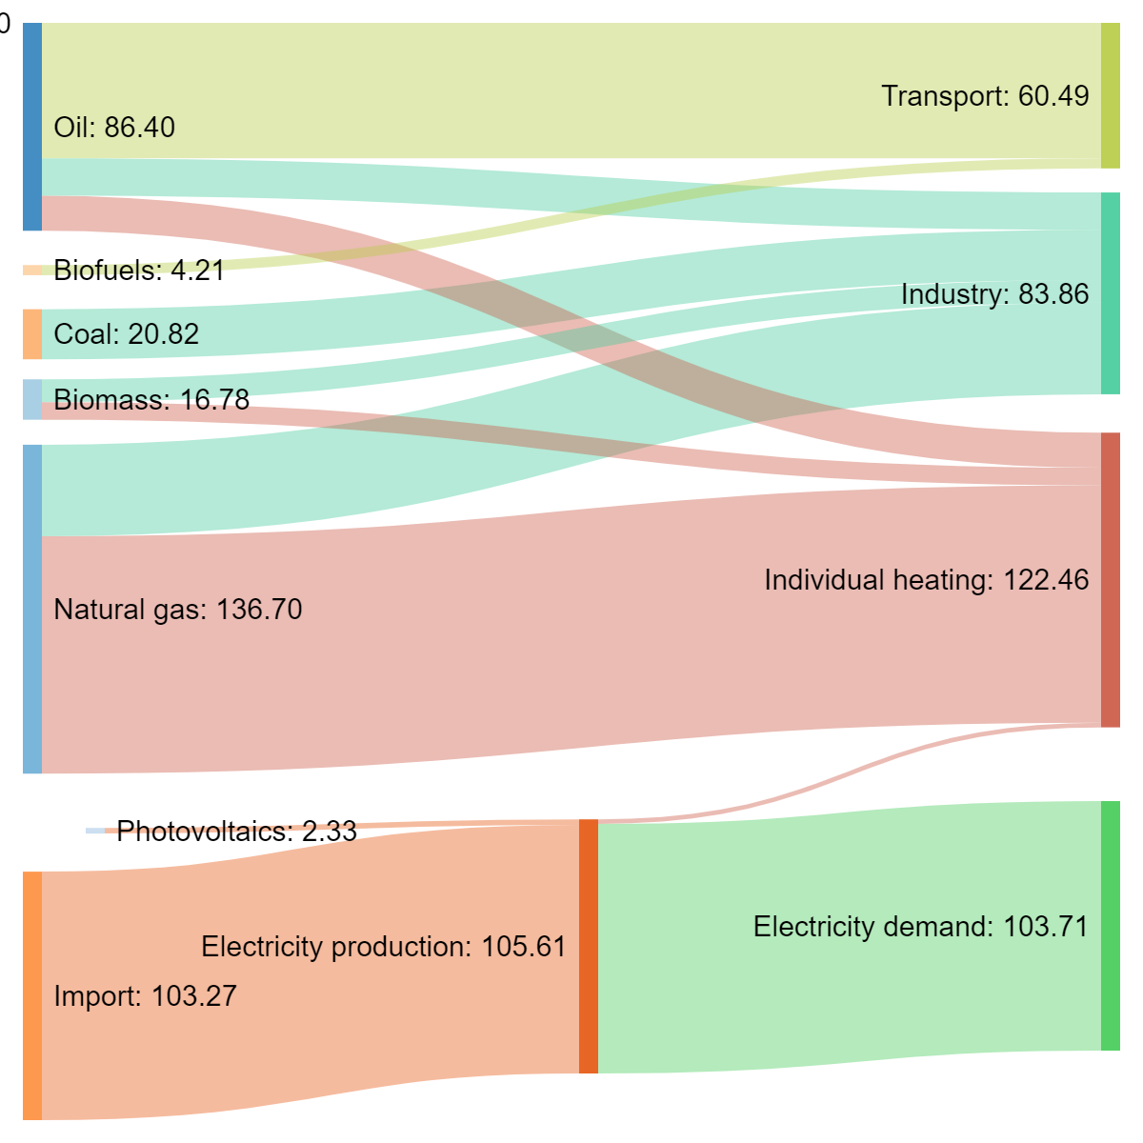
Figure 47: Reference scenario energy flows [GWh] for Oud Heverlee.
From the resulting Sankey diagram for the Reference scenario (Figure 47), energy demands per energy sector and fuel type can be seen. From this it can be seen that individual heating is the most energy consuming sector, consisting largely of a natural gas demand due to the prevalence of natural gas boilers in the households. The electricity demand is almost entirely supplied through import from the national electricity grid due to little local production capacity without any power plants. The industrial energy demand is a supplied through a combination of coal, oil, natural gas, and biofuels. The transport demand is almost entirely supplied from oil due to the prevalence of conventional fossil fuelled vehicles, and to a limited extent supplemented by biofuels due to additives.
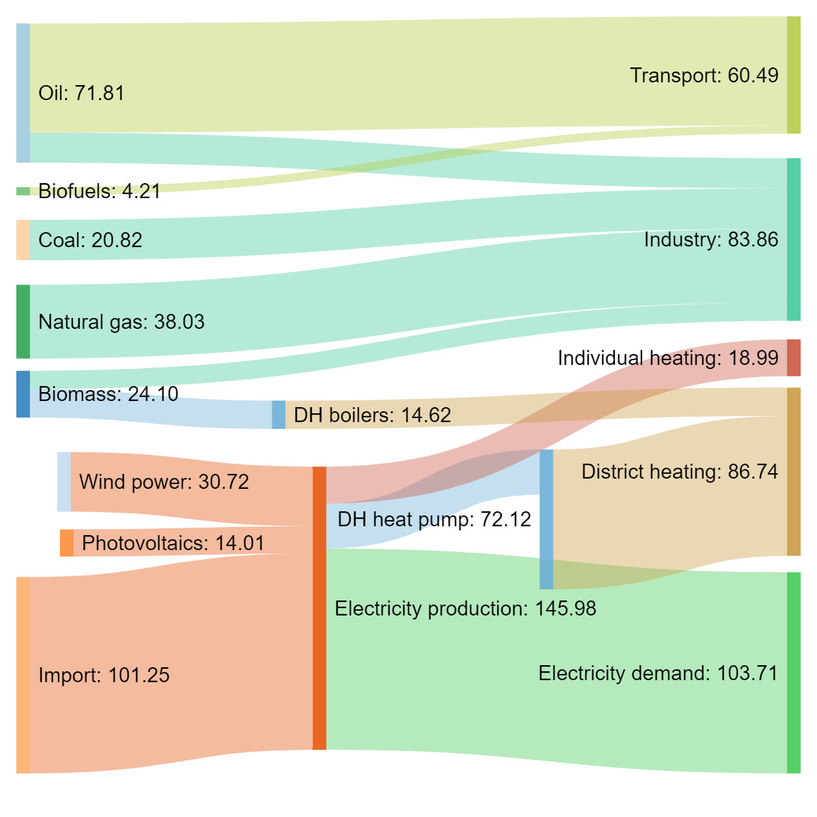
Figure 48: Heat scenario 10 energy flows [GWh] for Oud Heverlee.
In Figure 48 the resulting Sankey diagram for heat scenario 10 can be seen. In this scenario, 50% of the heat demand is shifted to district heating, and 50% is shifted to individual electric heat pumps. The electrification and introduction of district heating results in increased interaction of the heat and electricity sector, evident from the increased electricity consumption within the individual and district heating sectors. Also, it can be noted that while the total electricity consumption is increased, the imported electricity is decreased due to the increased local renewable electricity production. Hence, it is possible to supply a substantial portion of the electricity demand from local production. The total electricity import however remains significant, and if this is to be further decreased, additional local PV and wind power capacity needs to be installed.
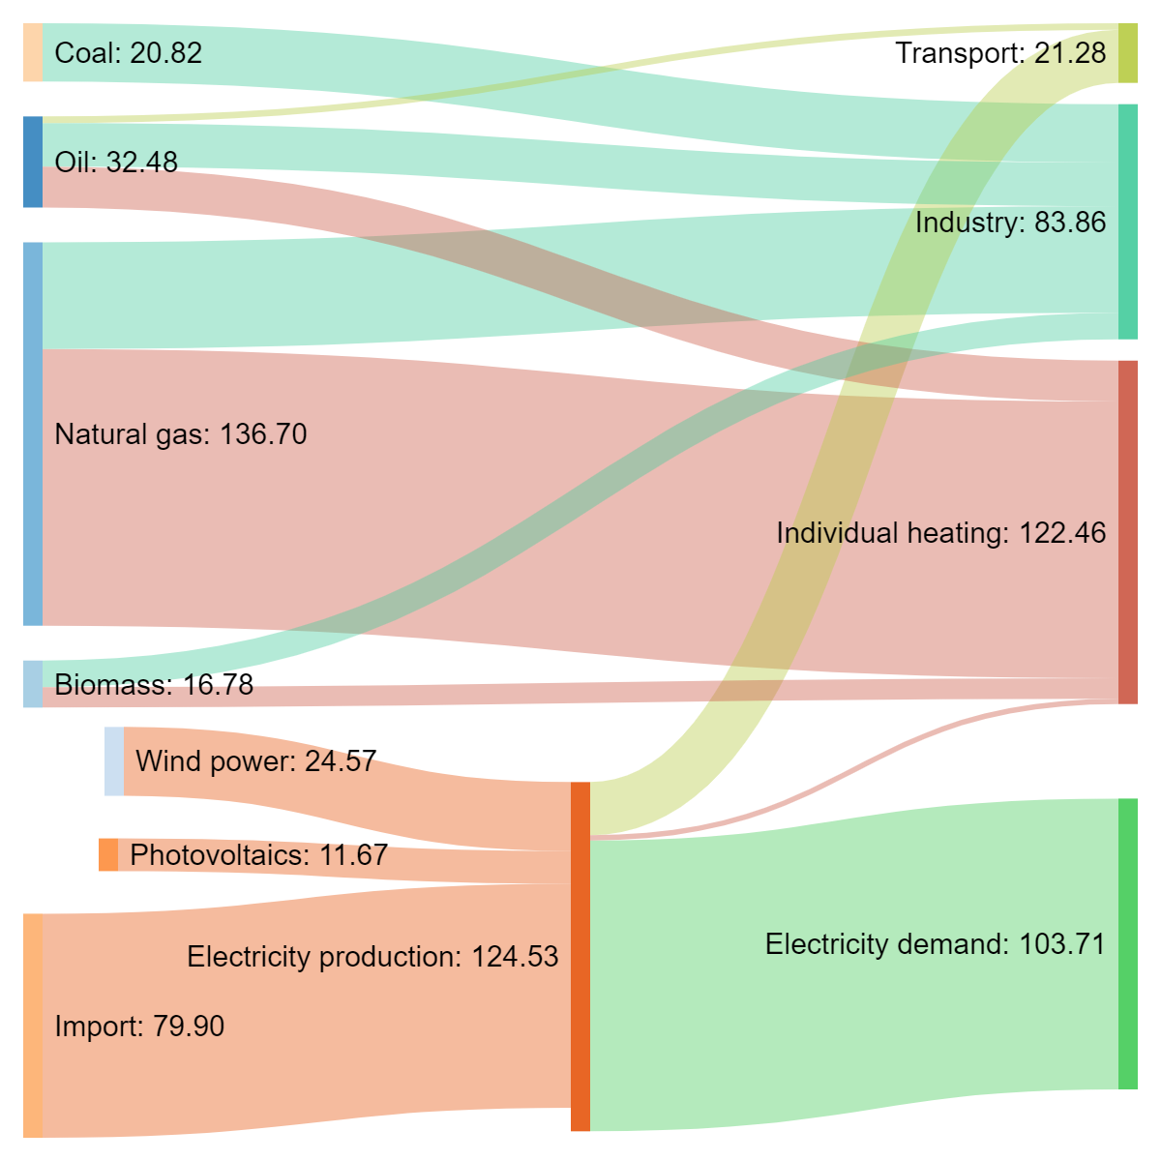
Figure 49: Transport scenario 10 energy flows [GWh] for Oud Heverlee.
In Figure 49 the resulting Sankey diagram for transport scenario 10 can be seen. In this scenario, all passenger cars are shifted to electric vehicles, and busses and lorries are shifted to hybrid technology. The electrification results in increased integration of the electricity and transport sectors due to increased electricity demand. The increased electricity demand is partially offset by the increased local renewable electricity production, but significant electricity import remains.

Renewable energy production and integration
In Figure 50 the renewable share of fuel in the heat and transport scenarios can be seen. In the heat scenarios, we can observe how increasing the share of district heating increases the renewable energy share, mainly because of the increased use of biomass in district heating fuel boilers. The renewable energy share increases further when combined with local renewable electricity production. In the transport scenarios, we observe how simply shifting to electric vehicles does not increase the renewable energy share; this is because the increased electricity demand is imported from the national grid, resulting in CO₂ emissions. In the transport scenarios, electric vehicles need to be combined with increased renewable electricity production capacity to increase the renewable share of fuel.

Figure 50: Renewable share of fuel in heat and transport scenarios for Oud Heverlee.
In Figure 51 changes to CO₂ emissions can be seen. Similarly, results can be observed for both heat and transport scenarios – generally increased electrification, whether that is from electric heat pumps or electric vehicles, reduce CO₂ emissions because of increased efficiency. This effect becomes more pronounced as the renewable electricity production capacity increases.

Figure 51: CO₂ emissions in heat and transport scenarios for Oud Heverlee.

PV production is highest in the summer period, while wind power production is higher on average in the winter period.
Figure 52: Monthly average power output in Heat Scenario 10 for Oud Heverlee.

Implementing district heating or electric vehicles without implementing local renewable electricity production capacity increases electricity import, but this effect can be negated to some extent by implementing local renewable electricity production capacity.

Figure 53: Net electricity import in heat and transport scenarios for Oud Heverlee.

Costs
Total annual costs (annualized investment costs, operation, maintenance, emission, and fuel costs) increase as the district heating implementation rate increases. These costs are all calculated within the MUSE GRIDS Energy Planning Tool. A complete conversion to individual electric heat pumps provides a lower-cost alternative compared to the reference, while a combination of individual electric heat pumps and district heating is more expensive than the reference. This can only partially be offset by local renewable electricity production. Converting to electric vehicles and hybrid busses and lorries provides a lower-cost alternative, but the difference is small.

Figure 54: Total annual cost heat and transport scenarios for Oud Heverlee.
For both the heat and transport scenarios, investment costs are by far the most significant cost.

Figure 55: Annual costs for heat scenarios by category for Oud Heverlee.

Figure 56: Annual costs for transport scenarios by category for Oud Heverlee.

Summary of scenario outcomes
- Local renewable electricity production capacity can reduce the amount of electricity imported from the national grid. This effect is however partially offset by the increasing electrification occurring in most of the scenarios, resulting in increased electricity demand.
- Local renewable electricity production furthermore reduces total system costs, increases the local renewable energy share, and thereby reduces CO₂ emissions.
- Conversion of the individual heating sector to electric heat pumps provides a lower-cost alternative to the current system consisting mainly of natural gas boilers. As a result of this electrification, it is found that the natural gas demand can be significantly reduced.
- Implementing DH does not provide an economic benefit. This is largely a result of the scattered housing and significant DH grid losses in the specific case. This result is sensitive to access to low-cost heat sources
- Shifting from conventional fossil fuel-based vehicles to electric vehicles results in lower total annual costs for the system.
- The analysis shows that the municipality of Oud-Heverlee should investigate further how individual heat pumps, electric vehicles, and local renewable energy production capacity (wind and PV) can be implemented.
- The main purpose of the analysis is to test the capability of the tool and the results that can be provided; hence the results should be considered as preliminary and not as an indisputable and elaborate depiction of energy system futures in Oud-Heverlee.
- Because the MUSE GRIDS Energy Planning Tool evaluates the energy system considering cross-sector interactions and grid interoperability impacts and benefits across energy sectors stand out. This is both in terms of changes in energy demands, e.g., from natural gas to electricity, or the observed discrepancies of local renewable electricity production and electricity consumption caused by increased electrification.

MUSE GRIDS Energy Planning Tool - application experiences
The MUSE GRIDS Energy Planning Tool has been applied to the municipalities of Osimo (Italy) and Oud-Heverlee (Belgium). The tool testing for Osimo was conducted by engineers from RINA-Consulting with no prior experience with the tool, and for Oud-Heverlee by engineers from Aalborg University who were involved in the tool development process. The different background of the tool testers provides learnings and insights both from the perspective of someone completely new to the tool and someone with a prior understanding of the tool.
Below key learnings based on the tool application and testing are summarised:
- The MUSE GRIDS Energy Planning Tool provides a simplified modelling interface enabling users to model scenarios based only on the information included within the tool and the tool manual.
- The MUSE GRIDS Energy Planning Tool provides many valuable results easily available within the tool, and relatively limited additional data handling is needed after conducting an analysis to present results.
- The MUSE GRIDS Energy Planning Tool includes functionalities that allow for modelling up to 15 scenarios based on a common reference scenario. This simplifies the process of comparative analysis for different energy system scenarios, making it possible to compare multiple different future energy scenarios quickly.
- The tool simplifies the modelling process and the assessment tools included with the MUSE GRIDS Energy Planning Tool helps the user establish relevant input data. However, still many data points are required, and good access to (local) data significantly helps the user develop scenarios.
- The MUSE GRIDS Energy Planning Tool allows the user to model and analyse the effect of energy sector integration and energy grid interoperability, providing valuable knowledge on energy transition scenarios.
- Based on the experiences from tool testing, additional standard values were included with the tool. This is to assist the user in what a sensible starting point may be in case no local data is available, and thereby lower the barrier of entry for scenario-making and analysis.
- It was found during testing it is not immediately obvious in the MUSE GRIDS Energy Planning Tool how the user can design transport scenarios within the tool. Therefore, because of this tool testing, an assessment tool for guiding this process was developed and included alongside the other assessment tools.
- Testing revealed minor technical issues that were resolved as they occurred. Most of the technical issues were related to the use of the tool on different platforms i.e., different versions of Microsoft Excel or computer operating systems. Changes were implemented in the VBA code importing and formatting data, to make it more robust to different versions of Microsoft Excel and Windows language and number formatting.
- The tool allows for simulation of hourly time series and thereby insights into the temporal correlation of demand and supply. The hourly and monthly outputs could be integrated into the tool interface in the future.
- While the MUSE GRIDS Energy Planning Tool allows the user to simulate variations of a scenario, there are no functionalities for determining “optimums” in terms of e.g. local wind power or PV capacity. Instead, the user needs to apply a simulation-based approach of trial and error; in the future, it may be relevant to include tools that assist the user in determining optimum capacities.

References
[1] Lund H, Thellufsen JZ, Østergaard PA, Sorknæs P, Skov IR, Mathiesen BV. EnergyPLAN – Advanced analysis of smart energy systems. Smart Energy 2021;1:100007. https://doi.org/10.1016/j.segy.2021.100007.
[2] ASTEA. Osimo Municipality energy demand data file 2018.
[3] Nielsen S, Moreno D, Johannsen RM, Sorknaes P, Østergaard PA, Moral GH, et al. D3.1-Mapping tool (sources and demand) prototype. 2020.
[4] UNIPOLSAI. Le abitudini di guida in Italia 2018.
[5] CEWEP. Interactive Map of Waste-to-Energy Plants 2021. https://www.cewep.eu/interactive-map/.
[6] Legambiente. Comuni Rinnovabili - Marche 2018. http://www.comunirinnovabili.it/wp-content/uploads/2018/12/Comuni-Rinnovabili-Marche.pdf.
[7] JRC European Commission. PVGIS 2021. https://ec.europa.eu/jrc/en/pvgis.
[8] NASA. MERRA-2 2021. https://gmao.gsfc.nasa.gov/reanalysis/MERRA-2/.
[9] Pfenninger S, Staffell I. Renewables.ninja 2021. https://www.renewables.ninja/.
[10] University DT, Group TWB. Global Wind Atlas 2018. https://globalwindatlas.info/.
[11] Copernicus Land Monitoring Service. Corine Land Cover Map 2012. https://land.copernicus.eu/pan-european/corine-land-cover.
[12] Heat Roadmap Europe. Country Heat Maps And Atlases 2018. https://heatroadmap.eu/resources-by-country/.
[13] GeoDH Project 2014. http://geodh.eu/geodh-project/.
[14] PLANHEAT Project 2020. http://planheat.eu/.
[15] European Environment Agency. European Pollutant Release and Transfer Register (E-PRTR) 2021. https://www.eea.europa.eu/data-and-maps/data/industrial-reporting-under-the-industrial-3.
[16] provincies.incijfers. Rapport klimaat 2020. https://provincies.incijfers.be/jive/report/?id=rapport_klimaat&input_geo=%7Bregioniveau%7D_%7Bregiocode%7D (accessed May 25, 2021).
[17] Covenant of Mayors. Covenant of Mayors for Climate and Energy 2017. https://ec.europa.eu/jrc/en/publication/covenant-mayors-climate-and-energy-default-emission-factors-local-emission-inventories-version-2017 (accessed February 4, 2021).
[18] Heat Roadmap Europe 4. Energy Models – Heat Roadmap Europe n.d. https://heatroadmap.eu/energy-models/ (accessed July 30, 2021).
[19] Heat Roadmap Europe 4. Energy Models – Heat Roadmap Europe 2019. https://heatroadmap.eu/energy-models/ (accessed May 25, 2021).
[20] OpenStreetMap. OpenStreetMap 2021. https://www.openstreetmap.org/#map=12/56.2908/9.9474 (accessed July 30, 2021).
[21] Soda-pro. MERRA - www.soda-pro.com 2021. http://www.soda-pro.com/web-services/meteo-data/merra (accessed July 30, 2021).
[22] Abid H, Strunge Kany M, Mathiesen BV, Nielsen S, Elle M, Næss P. sEEnergies D2.3 - Report on energy efficiency potentials in the transport sector and conclusions from the developed scenarios. 2021. https://doi.org/10.5281/ZENODO.4670789.
[23] The Danish Energy Agency, Energinet. Technology Data - Generation of Electricity and District heating 2016. https://ens.dk/en/our-services/projections-and-models/technology-data/technology-data-generation-electricity-and.
[24] Cost Database | EnergyPLAN 2018. https://www.energyplan.eu/useful_resources/costdatabase/ (accessed September 17, 2021).
[25] CREG. Study on the functioning and price evolution of the Belgian wholesale electricity market – monitoring report 2018. 2019.
[26] Covenant of Mayors. Emission factor for electricity consumption n.d.
[27] The Danish Energy Agency, Energinet. Technology Data for Heating Installations 2016. https://ens.dk/en/our-services/projections-and-models/technology-data/technology-data-individual-heating-plants.
[28] SankeyMATIC. SankeyMATIC: A Sankey diagram builder for everyone 2021. https://sankeymatic.com/ (accessed September 20, 2021).

